Supplemental methods

Growth curve modeling
Individual growth curves of SBP, glucose, non-HDL, and BMI by race and sex were derived by fitting repeated measures of the four VRFs over the life course using linear mixed effect models with random effects (SAS, version 9.4, proc MIXED, SAS Institute Inc., Cary, North Carolina). This approach allows for unequally spaced VRF measurements and a nonlinear change of four VRFs over time.^{9, 10, 14} Models containing conventional polynomial terms (age, age², age³, age⁻¹,age⁻², age⁻³) and fractional polynomial terms (sqrt(age), 1/sqrt(age), log (age)) for age were compared. Fractional polynomial terms are polynomials having non-integer powers; for example, sqrt (age) is age to the power of 0.5; using fractional polynomials offers additional flexibility in capturing nonlinear VRF trends with time.⁵⁰
First, nine models each including a single polynomial term of age as fixed effect (first order models) was evaluated for goodness of fit using Akaike Information Criterion (AIC). The polynomial terms compared were 1) age, 2) age², 3) age³, 4) log(age), 5) square root (sqrt) of age, 6) 1/sqrt(age), 7) 1/age 8) 1/age² 9) 1/age³. Next, the best fitting first order model was compared with a model including two terms, age and age², as fixed effects (2nd second order model), for goodness of fit using AIC. The final models for growth curve construction of each VRFs included the following fixed effects; 1) SBP: age, age², age³; 2) glucose and 3) non-HDL: age and age²; 4) BMI: log(age). Random intercept and age were the common random effects included in each model, except for glucose, where only random intercept was utilized to fit the model by race and sex. For both BMI and non-HDL, life course measurements were log-transformed prior to fitting in linear mixed models due to heteroscedasticity. Higher order terms for age were not included in the model if it made the lower order age term insignificant. Age was centered when entered into the model with age² to reduce collinearity.
VRF variability
Long-term variability in SBP, glucose, non-HDL, and BMI were evaluated using four indices (SD, CV, DEV, and residual standard deviation (RSD)). Using SBP variability as an example, SD and CV were calculated using the following formulas:
SD=$\sqrt{\frac{\sum{{(SBP i-SBP mean)}^{2}}}{n-1}}$ , CV = $\frac{SD}{SBP mean}$
where SBP i is a person’s SBP at time i, SBP mean is the average of all SBP measurements of the person during the life course, and n is the number of SBP measurements of the person during the life course. DEV and RSD were obtained from the difference of the observed SBP and the predicted mean SBP value at each time point. DEV and RSD were calculated using the following formulas:
DEV= $\frac{\sum{|SBP i-SBP }ip|}{n}$ , RSD=$\sqrt{\frac{\sum{ {(SBP i-SBP ip)}^{2} }}{n-2}}$
where SBP i is a person’s observed SBP at time i and SBP ip is a person’s predicted SBP at time i from the individual growth curve of SBP from the mixed effects model.⁹ Each variability index was categorized into tertiles; lowest, middle, and highest tertiles represented the lowest , middle, and the highest variability.

eTable 1. Characteristics of participants included and not included in the study
 | Included | Not included | P-value
 | (N= 1,010) | (N= 94)
Age, years
at cognitive assessment | 48.1 (5.17) | 47.1 (5.20) | 0.056
at enrollment | 9.35 (3.25) | 9.31 (4.22) | 0.927
Follow up, years | 38.8 (3.11) | 37.7 (4.10) | 0.020
White participants, n (%) | 667 (66.0%) | 53 (56.4%) | 0.060
Men, n (%) | 396 (39.2%) | 31 (33.0%) | 0.236
life course SBP (mmHg) | 110 (8.60) | 109 (8.49) | 0.054
life course glucose (mg/dL) | 88.8 (12.5) | 89.3 (15.0) | 0.787
Life course non-HDL (mg/dL) | 119 (26.0) | 117 (24.9) | 0.507
Life course BMI (kg/m²) | 24.4 (5.32) | 23.0 (4.52) | 0.003
Hypertension, n (%) | 637 (63.1%) | 55 (58.5%) | 0.382
T2DM, n (%) | 178 (17.6%) | 11 (11.7%) | 0.145
Dyslipidemia, n (%) | 649 (64.3%) | 56 (59.6%) | 0.366
Obesity, n (%) | 532 (52.7%) | 44 (46.8%) | 0.276
Smoking, n (%) |  |  | 0.895
never | 655 (64.9%) | 62 (66.0%)
current | 197 (19.5%) | 19 (20.2%)
former | 158 (15.6%) | 13 (13.8%)
Education, n (%)  high school or less | 589(58.3%) | 54(57.5%) | 0.87
Employment, n (%)
Yes | 645 (63.9%) | 53 (56.4%) | 0.150
Depressive symptoms, n (%) | 327 (32.4%) | 33 (35.1%) | 0.589
Medication
antihypertensive, n (%) | 356 (35.2%) | 38 (40.4%) | 0.316
diabetes, n (%) | 124 (12.3%) | 11 (11.7%) | 0.871
cholesterol, n (%) | 136 (13.5%) | 16 (17.0%) | 0.339
Values are presented as mean (SD) for continuous variables and as n, (%) for categorical variables.
eTable 2. Cognitive outcomes by race and sex
 |  | White |  | Black |  | P for race difference
Cognitive outcomes | All  (n=1,010) | Men  (n = 274) | Women  (n = 393) | Men  (n = 122) | Women  (n = 221) | Men  (n = 396) | Women  (n=614)
Global cognitive score | 0(0.6) | 0(0.6) | 0(0.7) | 0(0.5) | 0(0.6) | 0.615 | 0.637
Executive Function | 0(0.8) | 0(0.8) | 0(0.8) | 0(0.7) | 0(0.8) | 0.653 | 0.962
Episodic Memory | 0(0.8) | 0(0.9) | 0(0.9) | 0(0.8) | 0(0.9) | 0.852 | 0.759
Attention/Processing Speed | 0(0.7) | 0(0.7) | 0(0.7) | 0(0.7) | 0(0.7) | 0.839 | 0.870
Values are presented as mean (SD).

eTable 3. Correlation across vascular risk factor variability
BMIV | SBPV | GV | Non-HDLV |  | Non-HDLV | SBPV | GV | BMIV |  | SBPV | GV
SD | 0.23 | 0.16 | 0 |  | SD | 0.02 | 0.16 | 0 |  | SD | 0.15
p-value | <.001 | <.001 | 0.907 |  | p-value | 0.449 | <.001 | 0.907 |  | p-value | <.001
CV | 0.3 | 0.15 | 0 |  | CV | 0.01 | 0.16 | 0 |  | CV | 0.14
p-value | <.001 | <.001 | 0.970 |  | p-value | 0.646 | <.001 | 0.968 |  | p-value | <.001
DEV | 0.14 | 0.21 | 0.06 |  | DEV | 0.08 | 0.05 | 0.06 |  | DEV | 0.14
p-value | <.001 | <.001 | 0.069 |  | p-value | 0.012 | 0.102 | 0.069 |  | p-value | <.001
RSD | 0.14 | 0.22 | 0.090 |  | RSD | 0.07 | 0.06 | 0.09 |  | RSD | 0.11
p-value | <.001 | <.001 | 0.006 |  | p-value | 0.021 | 0.072 | 0.006 |  | p-value | <.001
Values presented are Pearson correlation coefficients and corresponding p values.
Abbreviations: BMIV, BMI variability; non-HDLV, non-HDL variability; GV, glucose variability; SBPV, systolic blood pressure variability;
SD, standard deviation; CV, coefficient of variation; DEV, deviation from age predicted values; RSD, residual SD.

eTable 4. Patterns of association of vascular risk factor variability and cognitive outcomes
 |  | MODEL 1 | MODEL 2 | MODEL 3 | MODEL 4 | DOMAINS
 |  | other VRFs/  follow up  duration | life course  mean VRF  levels | education/  employment/  depression | APOE ε4 | Executive  function | Episodic  memory | Attention/  processing  speed | GCS
SBPV
SD |  |  | xx |  |  | high
CV |  |  | x | x | x
DEV |  | o | x |  | x |  | mid, high |  | high
RSD |  |  | x | xx |  |  | high
GV
SD |  | o |  | xx |  | mid, high |  |  | high
CV |  |  |  | x |  | mid, high | high |  | high
DEV |  |  | x | xx
RSD |  |  | x | xx
Non-HDLV
SD
CV |  |  |  | o |  | mid
DEV
RSD
BMIV
SD |  |  |  | ooo |  | mid* |  | mid* | mid*
CV |  |  |  | o | o |  |  | mid* | mid*
DEV |  |  | x | o | x |  |  | mid*
RSD |  |  | x | x
Abbreviations: SBPV, systolic blood pressure variability; GV, glucose variability; non-HDLV, non-HDL variability; BMIV, BMI variability; GCS: global cognitive score; VRF, vascular risk factor.
high: Being in the highest vs. lowest tertile of variability was significantly associated with poorer performance in a cognitive domain.
mid: Same as above, except “middle” in place of “highest”.
mid*: Being in the middle vs. lowest tertile of variability was significantly associated with better performance in a cognitive domain.
x: Significant association of variability of a VRF with a cognitive domain or GCS was attenuated after adjusting for the covariates in this model.
o: Association of variability of vascular risk factor with a cognitive domain or GCS became significant after adjusting for the covariates in this model.
eFigure 1. Intercorrelation of vascular risk factor variability and associations with midlife cognitive function
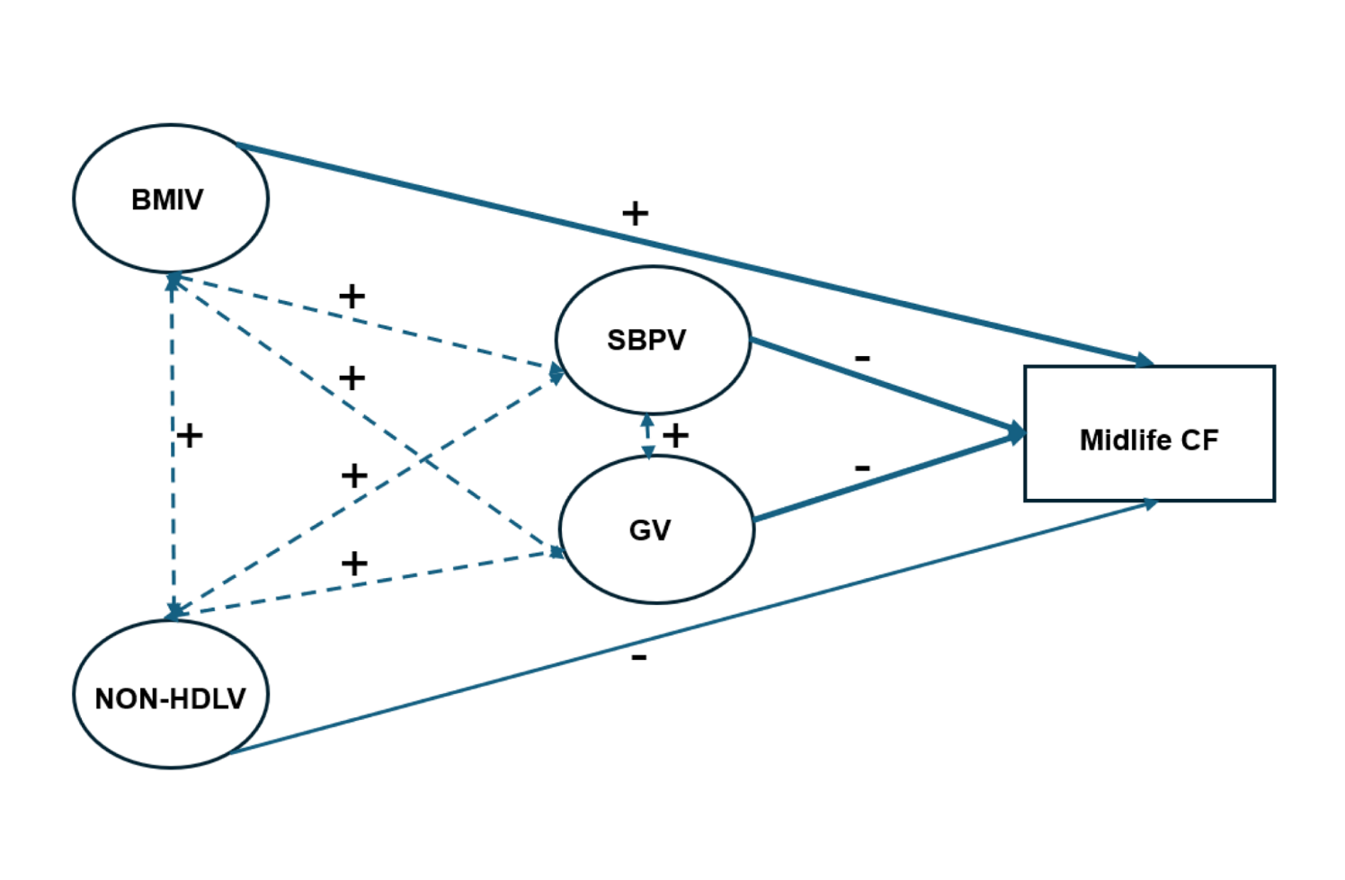
Abbreviations: BMIV, BMI variability; NON-HDLV, non-HDL variability; GV, glucose variability; SBPV, systolic blood pressure variability;
+, significant positive association; -, significant negative association
Darker arrows represent significant associations of vascular risk factor variability with global cognitive score.
Lighter arrow represent significant association of non-HDLV with executive function performance.
Dashed arrows represent significant positive correlations among vascular risk factor variability.

