Supplementary Information
Analytical methods for the bioconversion analysis of ginsenoside Rb1-derived metabolites
Fecal samples were weighed, and a 5-mg/mL fecal suspension was prepared for each sample using 50-mmol/L phosphate buffer. Subsequently, 20 µL of each substrate solution (ginsenoside Rb1; final concentration, 5 µg/mL) was added to 180 µL of this suspension and reacted at 37°C in a thermostat for 2 h. Samples without substrate reactions were measured to confirm the residual component amounts during fecal collection. Following the reaction, 20 µL of the internal standard solution (10-µL diclofenac sodium methanol solution; 250 ng/mL, 10-µL asiaticoside methanol solution; 1 µg/mL), and 300 µL of 1-butanol were added and stirred for 1 min. After stirring, centrifugation (10,000 × g, 4°C, 5 min) was performed, and 250 µL of the upper layer was collected. Moreover, 300 µL of 1-butanol was added, stirred for 1 min, and centrifuged (10,000 × g, 4°C, 5 min), and 250 µL of the upper layer was mixed with the previously collected upper layer. The mixed upper layer (500 µL) was dried using a centrifugal evaporator (50°C; SpeedVac: SPD121P, OIL-FREE VACUMM PUMP: OFP400, Refrigerated Vapor Traps: RVT5105, Thermo Fisher Scientific K.K., Tokyo, Japan). After drying, 150 µL of 50% acetonitrile was added and stirred for 5 min. The mixture was subsequently centrifuged and filtered using a Cosmospin Filter G (0.2 µm; 5,000 × g, 4°C, 5 min; NACALAI TESQUE, Inc., Kyoto, Japan) to prepare the analysis samples. Calibration samples were prepared by creating a 5-mg/mL fecal suspension using mouse blank fecal samples and adding each measured component to achieve 0.004-, 0.01-, 0.02-, 0.04-, 0.1-, 0.2-, 0.5-, 1-, 2.5-, and 5-µg/mL concentrations, followed by the same sample preparation procedure as the analytical samples.

Measurement of ginsenosides Rb1, Rd, F2, and CK levels in feces using LC-MS
Ten microliters of both the calibration and analytical samples were analyzed using an LC-MS/MS system, which comprised a pump (1290 Bin Pump; Agilent Technologies, Santa Clara, CA, USA), autosampler (1290 Sampler; Agilent Technologies), column oven (1290 TCC; Agilent Technologies), and a triple quadrupole mass spectrometer (6460 Triple Quad LC/MS; Agilent Technologies). Chromatographic separation was performed using an ACQUITY UPLC HSS T3 column (2.1 × 100 mm, 1.8 µm, Waters Corporation, Milford, MA, USA) at 40°C. The mobile phase (A, 0.1% formic acid in water; B, 0.1% formic acid in acetonitrile) was flowed at a 0.3-mL/min rate under the following gradient conditions: 20% B (0–1 min), linear increase to 95% B (1–14 min), 95% B (14–16 min), linear increase to 30% B (16–16.01 min), and reequilibration to 20% B (16.01–20 min). Each component was detected in the negative mode (multiple reaction monitoring [MRM]), with the following monitoring ions (m/z) and collision energy (CE): ginsenoside Rb1, m/z 1,107.6 > 88.9 and CE 70; ginsenoside Rd, m/z 945.5 > 100.9 and CE 61; ginsenoside F2, m/z 829.5 > 621.2 and CE 29; and ginsenoside CK, m/z 667.4 > 621.2 and CE 17. The internal standard (diclofenac) was detected at m/z 294 > 249.9 and CE 5. Delta EMV (applied voltage: −) was 200 V. The ion source was electrospray ionization (ESI), with the following source parameters: gas temperature, 350°C; gas flow rate, 12 L/min; nebulizer pressure, 50 psi; and capillary voltage, 4,000 V.
Peak waveform processing and area value calculation for each component were performed using Mass Hunter Quantitative Analysis version 10.1 (Agilent Technologies). Calibration curves were constructed using the internal standard method from the peak area values of each component, and the residual amounts of the substrate components and the amounts of the metabolic products were calculated. The quantification ranges were 0.004–5, 0.004–5, 0.004–5, and 0.01–5 µg/mL for ginsenosides Rb1, Rd, F2, and CK, respectively. Values below the limit of quantification were treated as zero. The measured values (µg/mL) for each component were calculated by subtracting the values of the substrate-free samples from those of the substrate-added samples. Furthermore, the molecular weight of each component was used for converting the concentrations to molar concentrations (µmol/L) to evaluate the metabolic activity of each sample.

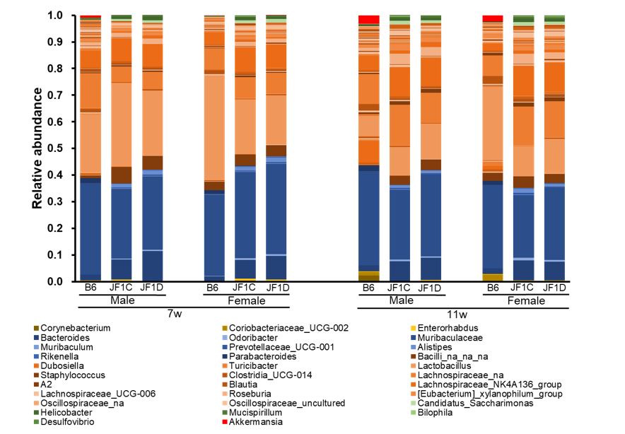
Supplementary Figure S1. Genus-level distribution and composition of the gut microbiota
Stacked bar charts represent the genus-level relative abundance of the gut microbiota across all experimental groups (B6 and JF1/Ms mice, with or without DKT treatment). Only the top [20–30] most abundant genera are individually shown.

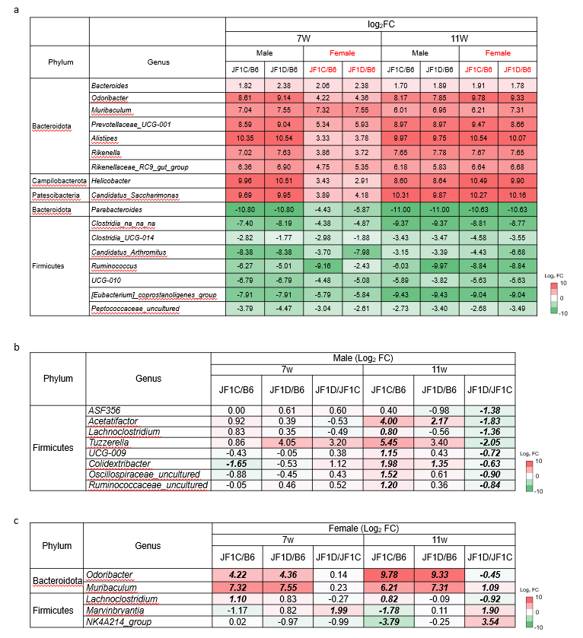
Supplementary Figure S2. Heatmaps of log2 fold changes (log2FC) in genus-level relative abundance across groups
Each heatmap shows the log2FC of the ratio of relative abundances between the indicated groups.
(a) Genera that are significantly different between JF1 and B6 across all time points and in both sexes. (b) Genera that are significantly different between the DKT-treated (JF1D) and untreated control (JF1C) groups in 11-week-old male JF1 mice. (c) Genera that are significantly different between the DKT-treated (JF1D) and untreated control (JF1C) groups in 11-week-old female JF1 mice. Positive log₂FC values indicate genera enriched in the first group of each comparison (red), whereas negative values indicate enrichment in the second group (green). Statistical significance is assessed using the Mann–Whitney U test with false discovery rate (FDR) correction; FDR-adjusted P < 0.05 is considered significant.

Supplementary Figure S3. Longitudinal changes in alpha diversity
Comparison of microbial diversity (Shannon–Wiener index) between 7 weeks (baseline) and 11 weeks (posttreatment). Data are stratified by strain, sex, and DKT treatment to illustrate temporal shifts in gut microbial richness and evenness. Statistical significance is assessed using the Kruskal–Wallis test with FDR correction; FDR-adjusted P < 0.05 is considered significant.

