Hydrophobic microenvironment remodeling drives triclosan-induced mucin repartitioning and intestinal mucus barrier disruption

Supplementary Information

Feng Yao^{1&}, Jindian Liu^{2&}, Tianchi Jiao¹, Xuan Zhang¹, Lichun Chen¹*

¹ Food Safety Key Laboratory of Zhejiang Province, School of Food Science and Biotechnology, Zhejiang Gongshang University, Hangzhou 310018, People’s Republic of China;
² State Key Laboratory for Quality and Safety of Agro-Products, Zhejiang Key Laboratory of Coastal Biological Germplasm Resources Conservation and Utilization, Institute of Hydrobiology, ZheJiang Academy of Agricultural Sciences.
& These authors contributed equally to this work and should be considered co-first authors.

Please send correspondence to
* Lichun Chen
School of Food Science and Biotechnology, Zhejiang Gongshang University, No.149 Jiaogong Road, Hangzhou, China, 310018;
Laboratory of Physical Chemistry and Soft Matter, Wageningen University and Research, 6708 WE Wageningen, Netherlands;
Phone: (+86)13777577107; Fax: (+86)571-28008902;
E-mail: clc8127@163.com; clc@zjsu.edu.cn.

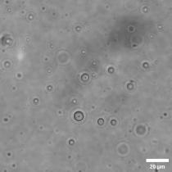
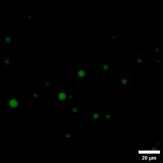
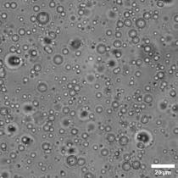
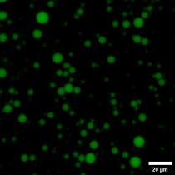
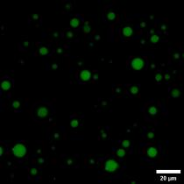
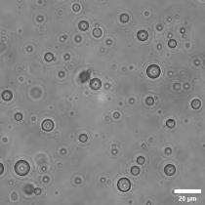
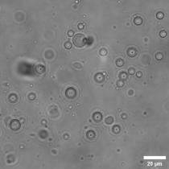
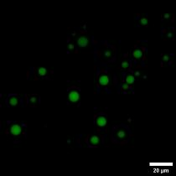
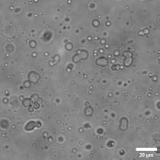
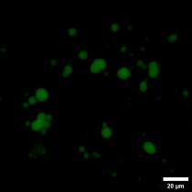
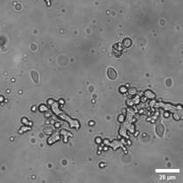
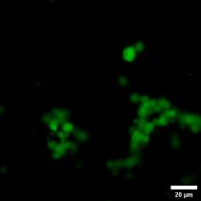
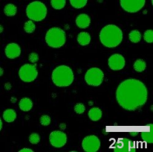
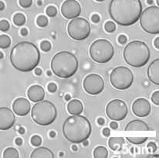
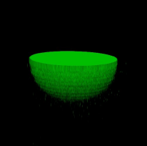
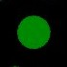

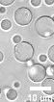
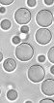
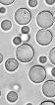
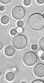
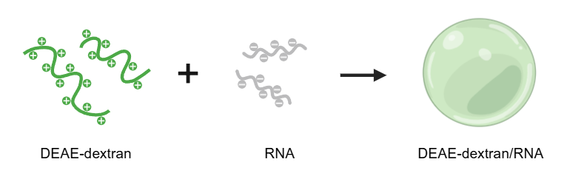
FITC-DEAE
Brightfield
1.0 1.25 1.5 1.75 2 2.25
RNA concentration (mg/mL)
DEAE-dextran 2.5 mg/mL
t₀ s t₀+8 s t₀+16 s t₀+32 s

a
b
c
d
e
f
Fig. S1 Construction and liquid-liquid phase separation characterization of DEAE-dextran/RNA host coacervates. (a) Schematic illustration of DEAE-dextran/RNA coacervate formation. Positively charged DEAE-dextran complexes with negatively charged RNA through electrostatic interactions, thereby driving LLPS and generating condensed droplets. (b) Bright-field and FITC-DEAE fluorescence images of DEAE-dextran/RNA systems prepared with different RNA concentrations. The DEAE-dextran concentration was fixed at 2.5 mg/mL. Increasing RNA concentration promoted the formation of spherical coacervate droplets, indicating that RNA effectively induced phase separation of DEAE-dextran. (c) Confocal images and three-dimensional reconstruction of DEAE-dextran/RNA coacervate droplets. The spherical morphology and homogeneous FITC-DEAE signal within the droplets further confirm the enrichment of DEAE-dextran in the condensed phase and the formation of stable micrometer-sized droplets. Scale bars: 25 μm. (d) Time-lapse bright-field images showing the fusion behavior of DEAE-dextran/RNA coacervate droplets. Adjacent droplets gradually fused and relaxed into a nearly spherical morphology after contact, demonstrating the fluidity and surface-tension-driven remodeling behavior characteristic of liquid-like phase-separated droplets. Scale bar: 10 μm. (e) ζ-potential of DEAE-dextran/RNA coacervates as a function of RNA concentration. The gradual transition from positive to negative surface charge reflects electrostatic neutralization and charge overcompensation between DEAE-dextran and RNA. (f) Quantitative analysis of DEAE-dextran/RNA coacervate size at different RNA concentrations. The overall increase in droplet size with increasing RNA concentration indicates that RNA content regulates coacervate assembly and colloidal morphology. Data are presented as mean ± SD (n=3).

Fig. S2 Fluorescence control characterization of DEAE-dextran/RNA host coacervates. To confirm the formation of the DEAE-dextran/RNA host coacervate phase and exclude background fluorescence or channel bleed-through in the Cy5 channel, DEAE-dextran/RNA coacervates without MUC were imaged by confocal microscopy. The FITC-DEAE channel shows the formation of spherical DEAE-dextran/RNA coacervate droplets, whereas no obvious fluorescence signal is detected in the Cy5 channel. Bright-field and merged images further confirm the formation of the host droplets. This control demonstrates that the Cy5 signal observed in the subsequent DEAE-dextran/RNA-MUC system originates from Cy5-MUC partitioning into the condensed phase rather than from imaging background or fluorescence crosstalk. Scale bars: 10 μm.

Fig. S3 Binary control experiments demonstrate that MUC compartmentalization depends on the DEAE-dextran/RNA host LLPS phase. (a) Phase diagram of the RNA/MUC binary system. RNA and MUC concentrations were varied, but no liquid-liquid phase separation was observed across the tested compositional range. Black crosses indicate the absence of LLPS. (b) Representative PI-RNA, Cy5-MUC fluorescence images and bright-field image of the RNA/MUC binary system. At 1.5 mg/mL RNA and 0.125 mg/mL MUC, the mixture remained homogeneous without visible droplet or aggregate formation. (c) Phase diagram of the DEAE-dextran/MUC binary system. DEAE-dextran and MUC concentrations were varied, but no visible LLPS was detected, suggesting that the binary interaction between DEAE-dextran and MUC alone is insufficient to drive coacervate formation. Black crosses indicate the absence of LLPS. (d) Representative FITC-DEAE, Cy5-MUC fluorescence images and bright-field image of the DEAE-dextran/MUC binary system. At 2.5 mg/mL DEAE-dextran and 0.125 mg/mL MUC, no obvious droplet formation was observed, further confirming that efficient MUC compartmentalization requires the DEAE-dextran/RNA host coacervate phase. All scale bars in b and d represent 20 µm.

Fig. S4 Concentration-dependent partitioning of MUC into the DEAE-dextran/RNA coacervate phase. The mean intra-droplet fluorescence intensity of Cy5-MUC was quantified to evaluate the partitioning and enrichment of MUC within the DEAE-dextran/RNA host coacervate phase at different MUC concentrations. As the MUC concentration increased from 0 to 0.125 mg/mL, the Cy5-MUC fluorescence intensity within the droplets progressively increased, indicating efficient recruitment and enrichment of MUC into the LLPS-derived condensed phase. When the MUC concentration was further increased to 0.25 mg/mL, the fluorescence intensity markedly decreased, suggesting that excessive MUC disrupted the charge balance and phase stability of the DEAE-dextran/RNA coacervate system, thereby reducing effective MUC compartmentalization. Data are presented as mean ± SD (n=3).

Fig. S5 Control evaluation of the stability of DEAE-dextran/RNA coacervates against TCS. Time-lapse confocal fluorescence (FITC-DEAE channel, green) and brightfield microscopy images (T0 to T0+180 s) of pure DEAE/RNA coacervates without MUC after the addition of TCS.

Fig. S6 Concentration-dependent TCS-induced redistribution of MUC in DEAE-dextran/RNA-MUC coacervates. Bright-field and confocal fluorescence images of DEAE-dextran/RNA-MUC composite coacervates after treatment with different TCS concentrations ranging from 0 to 1.5 mg/mL. As the TCS concentration increased, the intra-droplet Cy5-MUC fluorescence signal gradually decreased, accompanied by the appearance of newly formed MUC-enriched particulate structures at the droplet phase boundary and in the surrounding solution. These results indicate that TCS induces concentration-dependent redistribution of MUC from the host coacervate phase. The dividing line indicates the concentration range at which a distinct phase behavior transition occurs. At higher TCS concentrations, numerous small spherical structures emerged in the external solution. Based on their particulate morphology and Cy5-MUC enrichment, these structures are referred to as MUC-rich particulate assemblies rather than simple fragmentation of the original host droplets. Meanwhile, the FITC-DEAE-labeled host coacervate phase largely maintained its droplet morphology without obvious macroscopic dissolution, although adaptive morphological changes were observed at high TCS concentrations. Scale bars: 10 μm.

Fig. S7 Control observation of the MUC/TCS binary system. To determine whether TCS can directly induce MUC particulate assembly in the absence of the DEAE-dextran/RNA host coacervate phase, MUC was mixed with TCS alone and monitored by bright-field and Cy5-MUC fluorescence imaging over 180 s. No clearly discernible droplets, aggregates, or Cy5-MUC-positive particulate enriched structures were observed from T0 to T0+180 s in the MUC/TCS binary system. These results indicate that the MUC particulate redistribution observed in the complete DEAE-dextran/RNA-MUC system does not simply arise from spontaneous assembly between MUC and TCS in a homogeneous solution, but is closely associated with the MUC-compartmentalized microenvironment provided by the DEAE-dextran/RNA coacervate phase. Scale bars: 10 μm.
Fig. S8 Quantitative analysis of MUC encapsulation efficiency in DEAE-dextran/RNA-MUC coacervates after TCS treatment. The encapsulation efficiency of MUC in the coacervate system after treatment with different TCS concentrations was quantified using a protein assay kit to evaluate the effect of TCS on MUC compartmentalization. Data are presented as mean ± SD (n=3).
Fig. S9 Time-lapse confocal observation of TCS-induced dynamic redistribution of MUC from DEAE-dextran/RNA-MUC coacervates. Time-lapse confocal fluorescence images of DEAE-dextran/RNA-MUC composite coacervates after TCS treatment. The FITC-DEAE channel indicates the DEAE-dextran/RNA host coacervate phase, whereas the Cy5-MUC channel shows the spatial distribution of MUC. As the incubation time increased from T0 to T0+180 s, the intra-droplet Cy5-MUC signal gradually decreased, accompanied by the emergence and intensification of MUC-positive punctate structures outside the droplets. These observations indicate that TCS induces dynamic redistribution of MUC from the host coacervate phase. In contrast, the FITC-DEAE-labeled green host droplets maintained relatively stable spherical morphology throughout the observation period, suggesting that this process mainly reflects selective perturbation of MUC compartmentalization rather than global disassembly of the DEAE-dextran/RNA host coacervates. White arrows indicate newly formed MUC-enriched particulate structures. Scale bars: 5 μm.

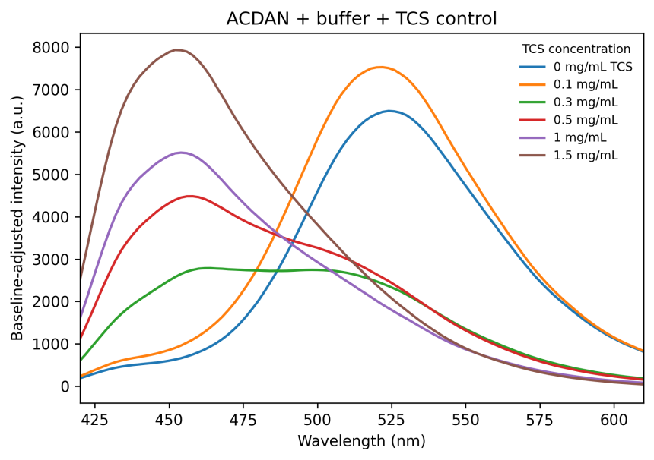
Fig. S10 Normalized ACDAN fluorescence emission spectra in buffer solution containing different concentrations of TCS. The spectra show that TCS alone can induce a concentration-dependent blue shift of ACDAN emission in aqueous solution, indicating an ACDAN-detectable shift toward a less hydrated and less polar local environment even in the absence of coacervates.

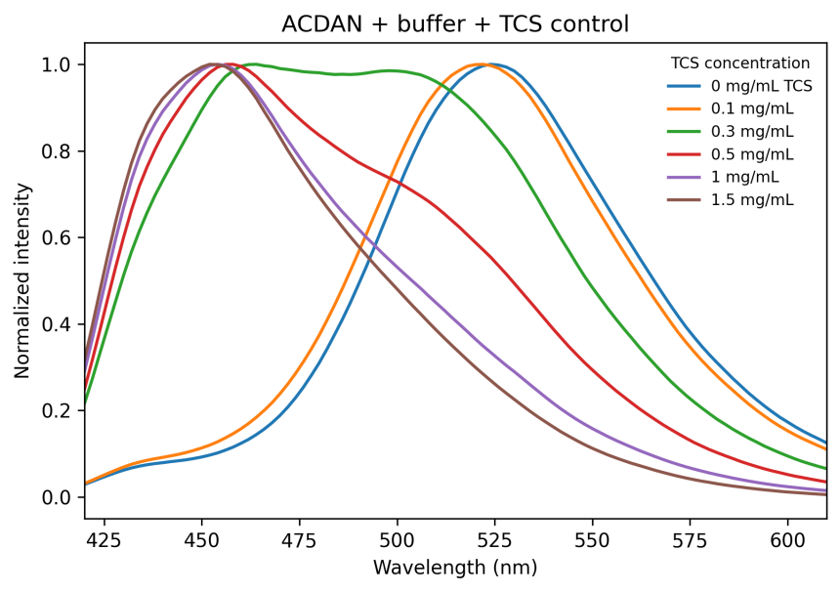
Fig. S11 Baseline-adjusted and smoothed ACDAN fluorescence emission spectra in buffer solution containing different concentrations of TCS. These spectra correspond to the normalized spectra shown in Fig. S10 and were used to evaluate TCS-associated hydrophobic microenvironment changes in aqueous solution.

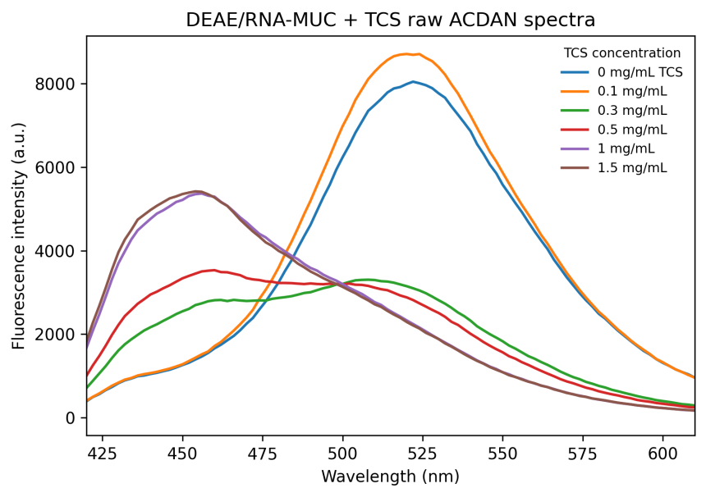
Fig. S12 Raw ACDAN fluorescence emission spectra of DEAE-dextran/RNA-MUC coacervates treated with different TCS concentrations. The spectra show progressive changes in ACDAN fluorescence emission upon increasing TCS concentration.

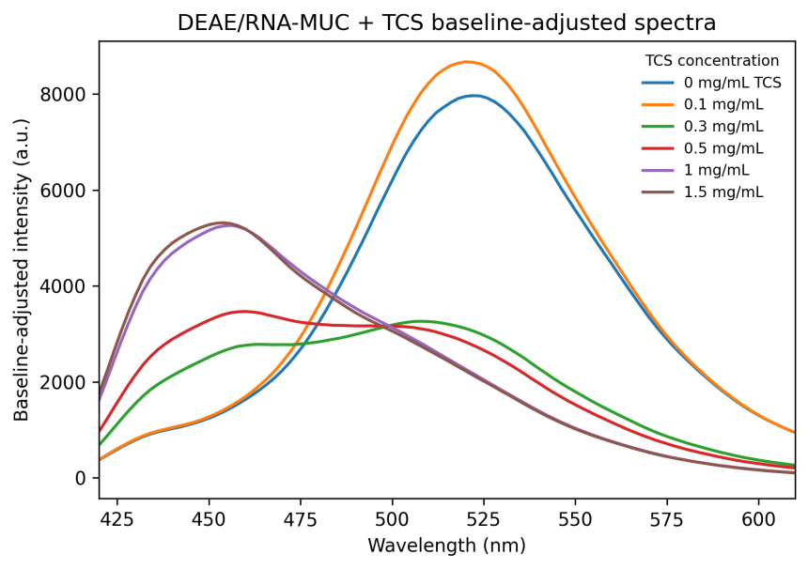
Fig. S13 Baseline-adjusted and smoothed ACDAN fluorescence emission spectra of DEAE-dextran/RNA-MUC coacervates treated with different TCS concentrations. The spectra reveal a pronounced TCS concentration-dependent blue shift, consistent with reduced local hydration and restricted dipolar relaxation within the coacervate microenvironment.

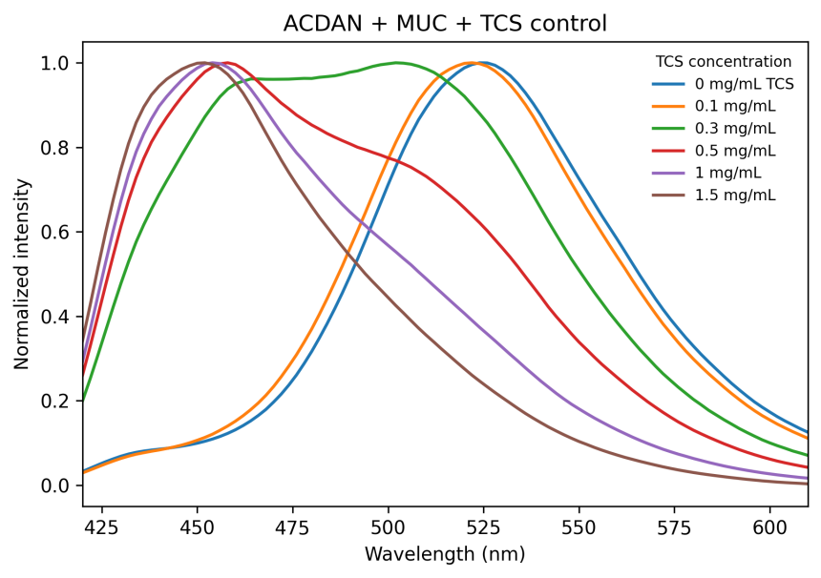
Fig. S14 Normalized ACDAN fluorescence emission spectra of MUC-containing solutions treated with different TCS concentrations. These control spectra were used to evaluate whether free MUC contributes to TCS-induced ACDAN spectral blue shift in the absence of coacervate compartmentalization.

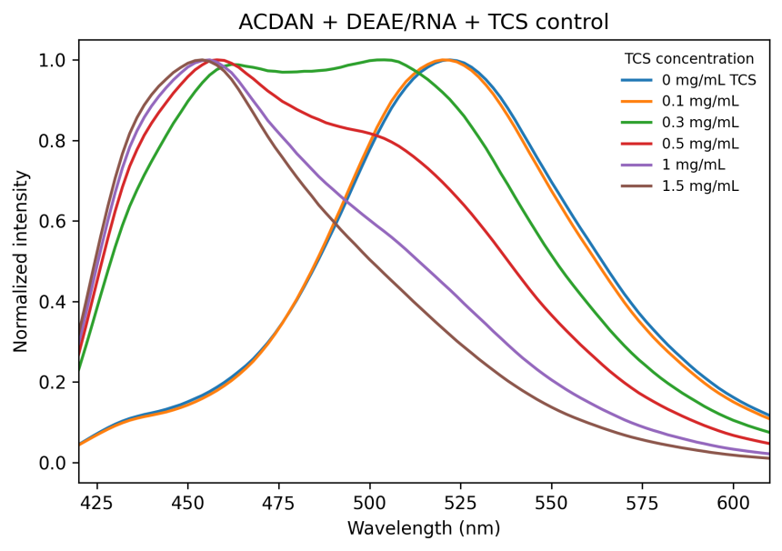
Fig. S15 Normalized ACDAN fluorescence emission spectra of DEAE-dextran/RNA coacervates treated with different TCS concentrations in the absence of MUC. These control spectra were used to assess the contribution of the host coacervate scaffold to TCS-induced ACDAN fluorescence changes.
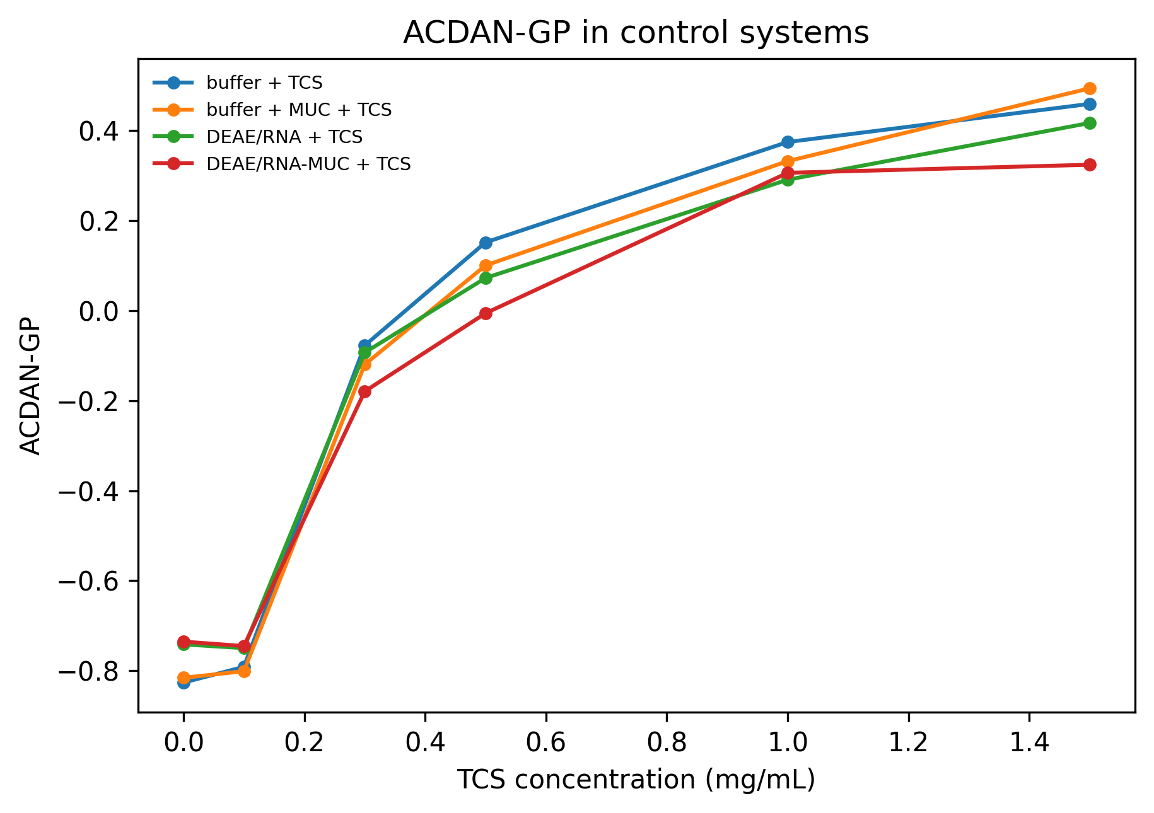
Fig. S16 Changes in ACDAN generalized polarization (GP) values in buffer solution as a function of TCS concentration. With increasing TCS concentration, increased ACDAN-GP values were observed, consistent with reduced local hydration and restricted dipolar relaxation.

Fig. S17 Changes in the ACDAN emission maximum (λmax) in buffer solution as a function of TCS concentration. The decrease in λmax with increasing TCS concentration indicates a TCS concentration-dependent blue shift of ACDAN fluorescence emission.

Fig. S18 Control observation of MUC distribution in DEAE-dextran/RNA-MUC coacervates under different pH conditions. In the absence of TCS, the fluorescence distribution of MUC in DEAE-dextran/RNA-MUC coacervates was compared at pH 7.4 and pH 8.5. Cy5-MUC signals remained enriched within the droplets under both pH conditions, indicating that weakly alkaline pH alone does not induce obvious MUC release or redistribution from the host coacervates. All scale bars represent 20 µm.

Fig. S19 Control observation of the stability of DEAE-dextran/RNA-MUC coacervates after Tween-20 treatment. In the absence of TCS, 1% Tween-20 was added to DEAE-dextran/RNA-MUC coacervates, and confocal images were recorded at different time points. Cy5-MUC signals remained enriched within the droplets before and after Tween-20 treatment, with no obvious disruption of coacervate morphology or outward MUC redistribution observed. These results indicate that Tween-20 alone does not directly induce MUC release from the host coacervates. All scale bars represent 20 µm.

Fig. S20 Effect of Tween-20 on TCS-induced MUC repartitioning in DEAE-dextran/RNA-MUC coacervates. After TCS treatment, 1% Tween-20 was added to DEAE-dextran/RNA-MUC coacervates, and bright-field and confocal fluorescence images were recorded over time. FITC-DEAE signals (green) remained enriched within the host coacervate phase throughout the process, whereas Cy5-MUC signals (blue) gradually redistributed from external particulate structures back into the host droplets during Tween-20 treatment. Over time, the number of external MUC-enriched particles progressively decreased and the morphology of the host coacervates became more stabilized, indicating that Tween-20 can compete with or attenuate TCS-associated hydrophobic microdomains and thereby partially reverse TCS-induced MUC repartitioning. All scale bars represent 10 µm.

Fig. S21 Effects of pH and Tween-20 on MUC encapsulation efficiency. MUC encapsulation efficiency in DEAE-dextran/RNA-MUC coacervates was compared under different conditions. Compared with the untreated control group (Con), TCS treatment at pH 5.5 and pH 7.4 caused a pronounced decrease in MUC encapsulation efficiency, indicating enhanced MUC repartitioning from the host coacervates. In contrast, MUC encapsulation was partially restored at pH 8.5, suggesting that weakly alkaline conditions attenuate TCS-induced outward MUC redistribution. Tween-20 treatment further increased MUC encapsulation efficiency, indicating partial reversal of TCS-induced MUC repartitioning by the surfactant. Data are presented as mean ± standard deviation (SD, n = 3).

Fig. S22 Contact angle analysis of mucus surface wettability and interfacial spreading behavior after TCS treatment. Representative images of contact angles measured by directly placing TCS-treated mucus droplets onto standard glass slides at a fixed microenvironmental pH of 5.5. The mucus samples were treated with different TCS concentrations ranging from 0 to 1.5 mg/mL. As the TCS concentration increased, the contact angle of mucus droplets gradually decreased, accompanied by an increased spreading area on the glass surface. These results indicate altered surface wettability and enhanced spreading behavior of the mucus layer after TCS treatment, suggesting weakened apparent cohesion or structural integrity of the mucus network. Scale bars: 1 mm.

Fig. S23 UV-Vis absorption spectra and standard calibration curve of Calcein. (a) UV-Vis absorption spectra of Calcein at varying concentration gradients ranging from 0.01 to 0.12 mg/mL. The vertical dashed line indicates the maximum absorption peak at approximately 480 nm. (b) The standard calibration curve for Calcein quantification based on the absorbance (Abs) at 480 nm. The plot demonstrates an excellent linear regression fit (equation: y = 0.09975 + 12.36x, correlation coefficient R² = 0.9982).
Fig. S24 Fluorescence observation of TCS-induced membrane depolarization and altered membrane status in intestinal epithelial cells. After treatment with different concentrations of TCS, DiBAC4(3) was used to evaluate membrane depolarization and membrane-state changes, while DAPI was used to stain nuclei. With increasing TCS concentration, the green DiBAC4(3) fluorescence signal gradually increased and became more pronounced within the cellular region, suggesting TCS-induced membrane depolarization or membrane-state perturbation. These results indicate that TCS alters the membrane status of intestinal epithelial cells in a concentration-dependent manner. Scale bars: 20 μm.
Group | Condition | TCS (mg/mL) | Baseline 400-410 | λmax (nm) | ACDAN-GP | Centroid (nm) | Max intensity | AUC 420-620
ACDAN + buffer + TCS | 0 mg/mL TCS | 0.000 | 12.744 | 524.000 | -0.826 | 528.761 | 6496.130 | 275793.558
ACDAN + buffer + TCS | 0.1 mg/mL | 0.100 | 15.471 | 522.000 | -0.791 | 525.450 | 7530.121 | 323687.617
ACDAN + buffer + TCS | 0.3 mg/mL | 0.300 | 25.288 | 464.000 | -0.077 | 496.114 | 2786.622 | 168707.284
ACDAN + buffer + TCS | 0.5 mg/mL | 0.500 | 39.902 | 458.000 | 0.152 | 486.665 | 4482.074 | 222488.307
ACDAN + buffer + TCS | 1 mg/mL | 1.000 | 56.728 | 454.000 | 0.374 | 477.135 | 5512.611 | 227886.027
ACDAN + buffer + TCS | 1.5 mg/mL | 1.500 | 89.789 | 452.000 | 0.459 | 472.798 | 7935.650 | 309114.773
ACDAN + buffer + MUC + TCS | 0 mg/mL TCS | 0.000 | 13.850 | 524.000 | -0.816 | 528.325 | 6837.060 | 292062.227
ACDAN + buffer + MUC + TCS | 0.1 mg/mL | 0.100 | 14.736 | 522.000 | -0.801 | 525.862 | 7838.770 | 335753.181
ACDAN + buffer + MUC + TCS | 0.3 mg/mL | 0.300 | 23.826 | 502.000 | -0.120 | 497.828 | 2796.730 | 169084.035
ACDAN + buffer + MUC + TCS | 0.5 mg/mL | 0.500 | 43.876 | 458.000 | 0.100 | 488.850 | 4427.976 | 231806.082
ACDAN + buffer + MUC + TCS | 1 mg/mL | 1.000 | 54.761 | 454.000 | 0.332 | 478.719 | 5163.344 | 221709.191
ACDAN + buffer + MUC + TCS | 1.5 mg/mL | 1.500 | 97.250 | 452.000 | 0.494 | 471.144 | 7575.490 | 287957.954
ACDAN + DEAE/RNA + TCS | 0 mg/mL TCS | 0.000 | 19.211 | 522.000 | -0.741 | 524.204 | 7375.058 | 329128.963
ACDAN + DEAE/RNA + TCS | 0.1 mg/mL | 0.100 | 21.062 | 520.000 | -0.750 | 523.598 | 8218.361 | 361115.879
ACDAN + DEAE/RNA + TCS | 0.3 mg/mL | 0.300 | 30.284 | 504.000 | -0.093 | 497.083 | 3126.737 | 193798.558
ACDAN + DEAE/RNA + TCS | 0.5 mg/mL | 0.500 | 43.502 | 458.000 | 0.072 | 489.942 | 4106.095 | 222613.699
ACDAN + DEAE/RNA + TCS | 1 mg/mL | 1.000 | 61.503 | 456.000 | 0.291 | 480.577 | 5525.636 | 246243.515
ACDAN + DEAE/RNA + TCS | 1.5 mg/mL | 1.500 | 84.207 | 454.000 | 0.417 | 474.982 | 6959.663 | 280885.719
ACDAN + DEAE/RNA-MUC + TCS | 0 mg/mL TCS | 0.000 | 21.345 | 522.000 | -0.735 | 524.060 | 7966.163 | 357501.824
ACDAN + DEAE/RNA-MUC + TCS | 0.1 mg/mL | 0.100 | 22.311 | 520.000 | -0.745 | 523.345 | 8672.054 | 382806.137
ACDAN + DEAE/RNA-MUC + TCS | 0.3 mg/mL | 0.300 | 29.631 | 508.000 | -0.179 | 500.446 | 3261.860 | 194098.955
ACDAN + DEAE/RNA-MUC + TCS | 0.5 mg/mL | 0.500 | 38.521 | 460.000 | -0.006 | 493.038 | 3465.680 | 203761.648
ACDAN + DEAE/RNA-MUC + TCS | 1 mg/mL | 1.000 | 64.922 | 456.000 | 0.306 | 479.834 | 5263.564 | 232289.812
ACDAN + DEAE/RNA-MUC + TCS | 1.5 mg/mL | 1.500 | 69.483 | 454.000 | 0.324 | 478.944 | 5316.067 | 233087.955

Table S1. Quantitative parameters extracted from ACDAN fluorescence emission spectra under different TCS treatment conditions. The table summarizes the spectral and microenvironmental parameters derived from ACDAN fluorescence analysis for different experimental systems, including ACDAN + buffer + TCS, ACDAN + buffer + MUC + TCS, ACDAN + DEAE/RNA + TCS, and ACDAN + DEAE/RNA-MUC + TCS. For each condition, the following parameters are listed: TCS concentration, baseline intensity in the 400-410 nm region, emission maximum wavelength (λmax), ACDAN generalized polarization (GP), spectral centroid, maximum fluorescence intensity, integrated fluorescence area under the curve (AUC, 420-620 nm), and apparent hydrophobic fraction. The apparent hydrophobic fraction was estimated from the relative extent of ACDAN spectral blue shift and should be interpreted as a relative microenvironmental index rather than an absolute fraction of hydrophobic domains. Increasing TCS concentration generally resulted in decreased λmax values and increased GP values, consistent with reduced local hydration and restricted dipolar relaxation.

