Table S1. GC conditions for GC-MS analysis.
GC-MS
Column | DB-1ms
Column | (30m x 0.25mm ID x 0.25 µm)
Injection temperature | 250 °C
Split | 5:1
He flow | 1.0 mL/min
Injection volume | 1 µL
Temperature program
Initial starting temperature 1 (T1) | 80 °C
Holding time | 2 min
Temperature increasing | 20 °C/min
Temperature 2 (T2) | 140 °C
Holding time (T2) | 2 min
Temperature increasing | 2 °C/min
Temperature 3 (T3) | 200 °C
Temperature increasing | 30 °C/min
Temperature 4 (T4) | 250 °C
Holding time (T4) | 5 min
Total time | 43.7 min

Table S2. List of SRA accessions (GenBank), taxon assignment at time of analysis, the sequencing strategy reported, whether we recovered the mitogenome in this study, and the GenBank accession for the recovered mitogenome, if applicable. Identical = identical sequence to conspecifics and excluded from tree and GenBank submission.
SRA | Taxon | Strategy | Mitogeome recovered | Mitogenome accession
DRR541556 | Paragorgia papillata | WGS | Yes | LC810941²
ERR9951904 | Corallium rubrum | WGS | Yes | identical
ERR9951905 | Corallium rubrum | WGS | Yes | identical
ERR9951906 | Corallium rubrum | WGS | Yes | identical
ERR9951907 | Corallium rubrum | WGS | Yes | SUB16206827
SRR18587797 | Hemicorallium niobe | Target-Capture | No | na
SRR18587813 | Paragorgia johnsoni | Target-Capture | No | na
SRR18587817 | Sibogagorgia cauliflora | Target-Capture | No | na
SRR24180080 | Sibogagorgia dennisgordoni | WGS | Yes | OQ819431³
SRR24180087 | Hemicorallium guttatum | WGS | Yes | OQ819438³
SRR25705841 | Paragorgia papillata | WGS | Yes | na⁴
SRR26955401 | Sibogagorgia dennisgordoni | WGS | Yes | SUB16206827
SRR26955436 | Hemicorallium sp.¹ | WGS | Yes | SUB16206827
SRR26955544 | Sibogagorgia sp. | WGS | Yes | SUB16206827
SRR27744979 | Sphaerasclera flammicerebra | Target-Capture | No | na
SRR28362904 | Paragorgia papillata | WGS | Yes | na⁵
SRR31405188 | Hemicorallium imperiale | WGS | Yes | SUB16206827
SRR35436100 | Paragorgia jamesi | WGS | Yes | SUB16206827
SRR35436105 | Paragorgia arborea | WGS | Yes | SUB16206827
¹Not incuded in UCE tree.
²Not incuded in PCG tree because of genetic similarity with SRR28362904.
³This accession number likely corresponds to the listed SRA, so the recovered mitogenome it was not uploaded to GenBank.
⁴This mitogenome was genetically similar to PP498686, so it was not uplodaded to GenBank.
⁵This mitogenome was genetically similar to DRR541556 (LC810941), so it was not uplodaded to GenBank.

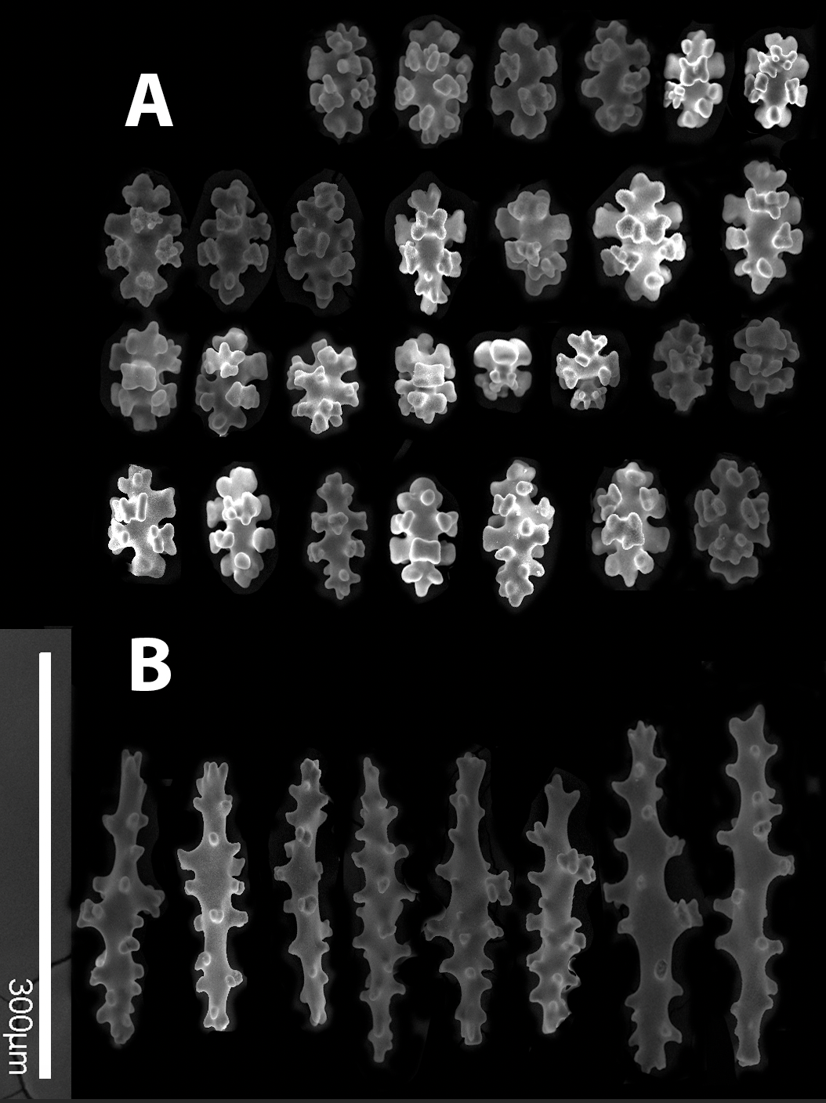Supplementary figure 1. Sibogagorgia quitinosa Sánchez & Easton n.sp. Additional SEM sclerome images taken at 160x (excepting polyp/pharynx sclerites). A. Eight radiate-derived capstan sclerites, mostly found on the surface and around canals. B. Spindles from the inner layers and medulla.

A.
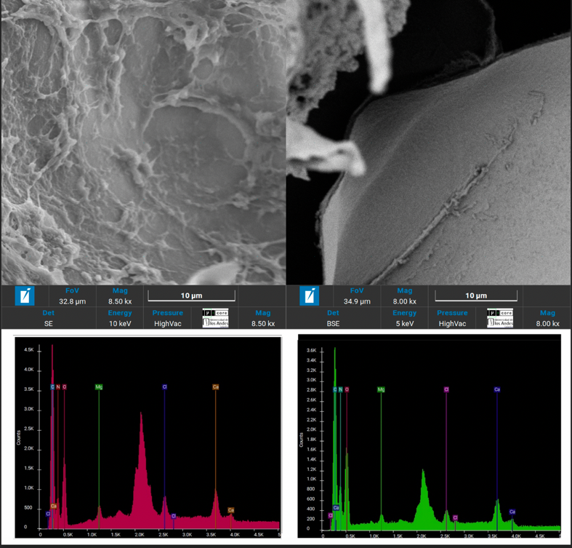
B.
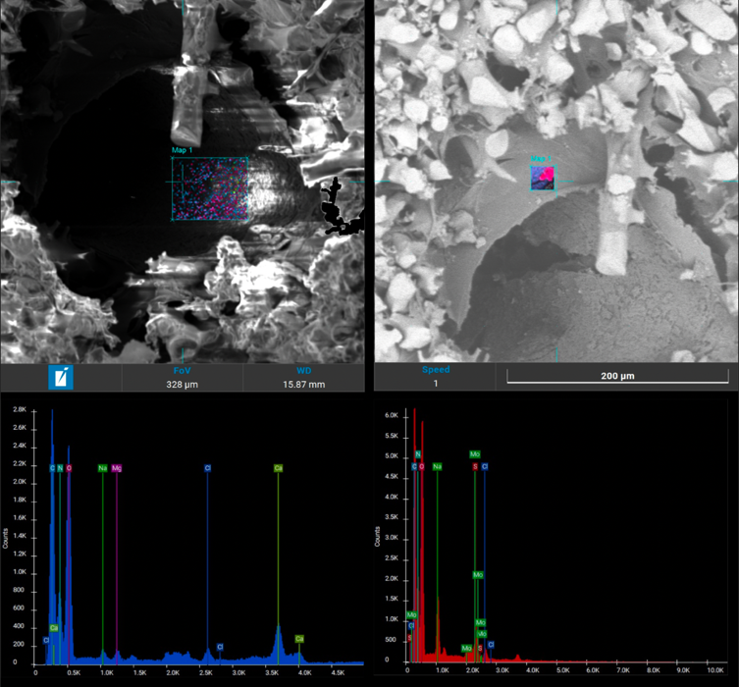
Supplementary figure 2. EDS analysis of stem canals SEM-EDS analyses of the polysaccharide substance in the rugose (left) and smooth (right) surfaces of the perforating canal. A. Paragorgia quitinosa Sánchez & Easton n.sp. B. Paragorgia sp. 9769.

Supplementary material: molecular pipeline scrips

#SRA data cleaned with TrimGalore-0.6.10 (Krueger et al. 2023)
~/TrimGalore-0.6.10/trim_galore -q 20 --cores 4 -o trim/ --paired SRAs/*.fastq.gz

#New data cleaned with Trimmomatic (Bolger et al. 2014) as implemented in Illumiprocessor (Faircloth 2013)
illumiprocessor \
--input raw-fastq/ \
--output clean-fastq \
--config Illumiprocessor.conf \
--cores 16 \

Downsample with Seqtk (Li 2025); gzip after running
seqtk sample -s25 [sample]-READ1.fastq.gz 25000000 > SRR24180080_Sibogagorgia_dennisgordoni-READ1downsampled.fastq.gz
seqtk sample -s25 [sample]-READ2.fastq.gz 25000000 > SRR24180080_Sibogagorgia_dennisgordoni-READ2downsampled.fastq.gz

#Assemble with SPAdes v. 4.2.0 (Bankevich et al. 2012; Prjibelski et al. 2020); if restarting required, used --restart-from last \
spades.py \
-1 [sample]-READ1.fastq.gz \
-2 [sample]-READ2.fastq.gz \
-o [sample]_spades \
-t 128 \
-m 250 \
--isolate \
–checkpoints all \

Finding UCE loci; probe set octo-v2-final-probes.fasta (Erickson et al. 2021)
conda activate phyluce-1.7.3
phyluce_assembly_match_contigs_to_probes \
--contigs contigs \
--min-identity 70 \
--min-coverage 70 \
--probes /Baits/octo-v2-final-probes.fasta \
--output uce-search-results-trimmed \

Make taxon configuration file (taxon-set-trimmed-quitinosa-reduced.conf)
[all]
DRR541556_Paragorgia_papillata
ERR9951904_Corallium_rubrum
ERR9951905_Corallium_rubrum
ERR9951906_Corallium_rubrum
ERR9951907_Corallium_rubrum
FKT_694_CQ11_001d_S37_Paragorgia_new
SRR18587797_Hemicorallium_niobe
SRR18587813_Paragorgia_johnsoni
SRR18587817_Sibogagorgia_cauliflora
SRR24180080_Sibogagorgia_dennisgordoni
SRR24180087_Hemicorallium_guttatum
SRR25705841_Paragorgia_papillata
SRR26955401_Sibogagorgia_dennisgordoni
SRR26955544_Sibogagorgia_sp
SRR27744979_Sphaerasclera_flammicerebra
SRR28362904_Paragorgia_papillata
SRR31405188_Hemicorallium_imperiale
SRR35436100_Paragorgia_jamesi
SRR35436105_Paragorgia_arborea

Extract UCE loci
conda activate phyluce-1.7.3
phyluce_assembly_get_match_counts \
--locus-db uce-search-results-trimmed/probe.matches.sqlite \
--taxon-list-config taxon-set-trimmed-quitinosa-reduced.conf \
--taxon-group 'all' \
--incomplete-matrix \
--output taxon-sets-trimmed-quitinosa-reduced/all/all-taxa-incomplete.conf \

Get UCE loci FASTAs
conda activate phyluce-1.7.3
phyluce_assembly_get_fastas_from_match_counts \
--contigs ../../contigs \
--locus-db ../../uce-search-results-trimmed/probe.matches.sqlite \
--match-count-output all-taxa-incomplete.conf \
--output all-taxa-incomplete.fasta \
--incomplete-matrix all-taxa-incomplete.incomplete \
--log-path log \

Explode monolithic fasta
conda activate phyluce-1.7.3
phyluce_assembly_explode_get_fastas_file \
--input all-taxa-incomplete.fasta \
--output exploded-fastas \
--by-taxon \

Mafft Align (v.7.475; Katoh and Standley 2013)
conda activate phyluce-1.7.3
phyluce_align_seqcap_align \
--input all-taxa-incomplete.fasta \
--output mafft-nexus-internal-trimmed \
--taxa 19 \
--aligner mafft \
--cores 16 \
--incomplete-matrix \
--output-format fasta \
--no-trim \
--log-path log \

Gblocks Internal Trim (v. 0.91b; Talavera and Castresana 2007)
conda activate phyluce-1.7.3
phyluce_align_get_gblocks_trimmed_alignments_from_untrimmed \
--alignments mafft-nexus-internal-trimmed \
--output mafft-nexus-internal-trimmed-gblocks \
--cores 12 \
--log-path log \

Gblocks Clean alignment (v. 0.91b; Talavera and Castresana 2007)
conda activate phyluce-1.7.3
phyluce_align_remove_locus_name_from_files \
--alignments mafft-nexus-internal-trimmed-gblocks \
--output mafft-nexus-internal-trimmed-gblocks-clean \
--cores 12 \
--log-path log

Fina data matrix (v. 0.91b; Talavera and Castresana 2007)
conda activate phyluce-1.7.3
phyluce_align_get_only_loci_with_min_taxa \
--alignments mafft-nexus-internal-trimmed-gblocks-clean \
--taxa 19 \
--percent 0.50 \
--output mafft-nexus-internal-trimmed-gblocks-clean-50p \
--cores 12 \
--log-path log

Data matrix conversion to phylip for downstream analysis
conda activate phyluce-1.7.3
phyluce_align_concatenate_alignments \
--alignments mafft-nexus-internal-trimmed-gblocks-clean-50p \
--output mafft-nexus-internal-trimmed-gblocks-clean-50p-raxml \
--phylip \
--log-path log

Tree reconstruction with IQ-tree v. 2.4.0 (Minh et al. 2020)
conda activate /home1/10879/ngarc1627/miniconda3/envs/iqtree_env
iqtree \
-s mafft-nexus-internal-trimmed-gblocks-clean-50p-raxml.phylip \
-p quitinosa_reduced_50_partitions.txt \
-m TESTNEWMERGE \
-B 1000 \
--alrt 1000 \
-nt AUTO

