Supplementary Information
Tri-modal ACC-PCC cingulate-axis linkage study

Supplementary Methods

Multimodal ACC-PCC framework
The supplementary analyses support the main tri-modal ACC-PCC cingulate-axis framework. The tri-modal linkage index integrates neurochemical similarity, sleep-dependent functional reconfiguration, and structural connectivity strength.

Neurochemical similarity and E/I mismatch
ACC-PCC neurochemical similarity was defined as cosine similarity between ACC and PCC neurochemical vectors across PRE/POST and GABA/Glx dimensions. E/I mismatch was calculated as the ACC minus PCC difference in the log-transformed Glx/GABA ratio at each time point; the sleep-dependent change was defined as POST minus PRE.
Representative ACC and PCC voxel placement and GABA-edited MEGA-PRESS spectra are provided in Supplementary Figures S4 and S5. A structured magnetic resonance spectroscopy reporting checklist is provided in Supplementary Table S7, including hardware, acquisition, processing, and quality-control details.

Structural connectivity sensitivity analyses
Structural connectivity weight (SCw) was summarized across AAL90-defined ACC-PCC edges. Sensitivity analyses tested bilateral, ipsilateral, and QC-excluded definitions to assess whether SC findings were dependent on edge definition or zero/flagged structural edges.

Tri-modal linkage index
The tri-modal index was constructed as the average of standardized neurochemical similarity, FC attenuation, and mean SCw layers. For group-specific analyses, z-standardization was performed within group; for combined-cohort analyses, standardization was performed across the combined analytic sample.

Mediation and sensitivity analyses
Mediation models used standardized variables and bootstrap confidence intervals for indirect effects. Group-specific models were adjusted for age and sex; combined-cohort models additionally adjusted for group. BMI-adjusted models and RTM-adjusted models were used as sensitivity analyses.

Regression-to-the-mean adjustment
Because change-score measures may be susceptible to regression-to-the-mean effects, the FC layer was recalculated using residualized POST FC after adjustment for PRE FC. The RTM-adjusted tri-modal index replaced the original FC-change layer in the mediation models.

Resting-state fMRI quality control
Resting-state fMRI data were visually inspected after preprocessing to assess gross artifacts, incomplete acquisition, registration failure, and atlas misalignment. All participants included in the final analytic dataset had usable pre- and post-sleep bilateral ACC-PCC functional connectivity estimates. Head motion was corrected using MCFLIRT, and the resulting rigid-body motion parameters were inspected as part of preprocessing quality control. No participant was excluded because of gross resting-state fMRI motion-correction failure, incomplete BOLD acquisition, or failed AAL90 atlas alignment in native BOLD space. In the primary FC pipeline, nuisance regression included the six rigid-body motion parameters, a linear trend, and an intercept. Global signal regression, white-matter/cerebrospinal-fluid nuisance regression, and volume scrubbing or framewise-displacement censoring were not included in the primary implementation. Accordingly, the FC analyses should be interpreted in the context of this preprocessing strategy. Future analyses may further evaluate robustness to alternative denoising strategies, including WM/CSF nuisance regression, global signal regression, and FD-based censoring.

Supplementary Figures
Supplementary Figure S1. Structural connectivity sensitivity analyses of the ACC-PCC axis.
Panel A shows a representative ACC-PCC structural connectivity schematic using lateral and axial brain views. Panel B shows bilateral ACC-PCC SCw paired plots in controls and medical trainees. Panel C shows sensitivity analyses across bilateral, ipsilateral, and QC-excluded SC definitions.

Supplementary Figure S2. Regression-to-the-mean sensitivity analyses of the two tri-modal mediation models.
Original and RTM-adjusted mediation models are shown for controls and medical trainees. The RTM-adjusted tri-modal index replaces the FC-change layer with residualized POST FC adjusted for PRE FC.

Supplementary Figure S3. Regional metabolite changes in ACC and PCC.
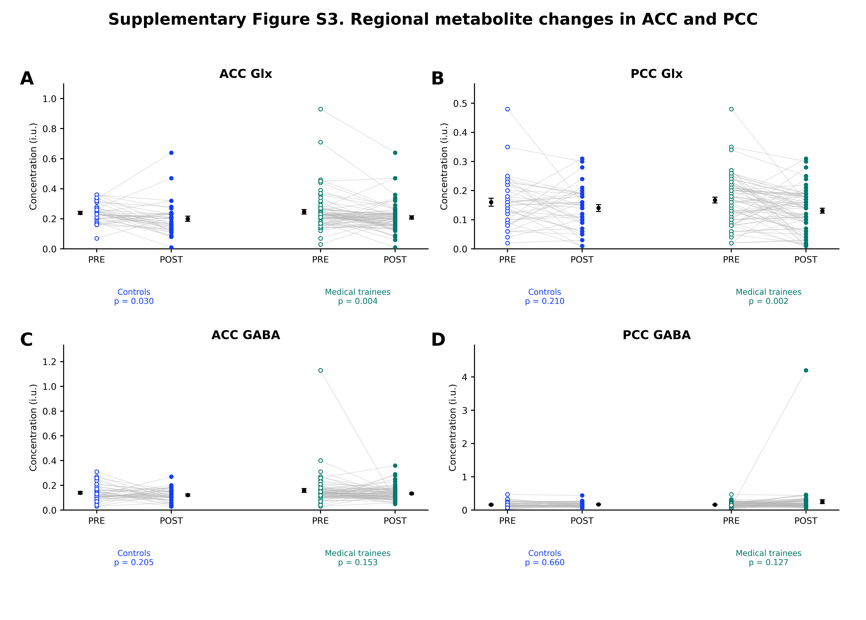
Panels show PRE-POST changes in ACC Glx, PCC Glx, ACC GABA, and PCC GABA in controls and medical trainees. Points represent individual participants; paired lines connect PRE and POST values.

Additional MRS voxel placement and spectral quality-control figures
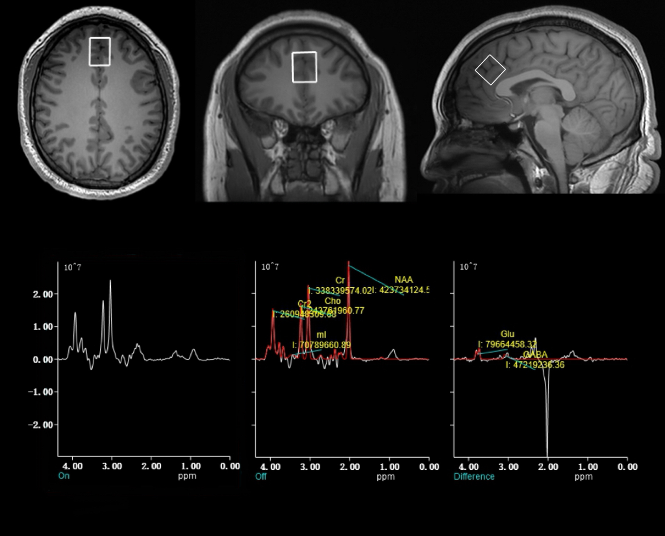
Supplementary Figure S4. Representative GABA-edited MEGA-PRESS spectrum and voxel placement in the anterior cingulate cortex (ACC). Top row: T1-weighted anatomical images (axial, coronal, sagittal) showing a 20 x 20 x 20 mm3 voxel positioned in the ACC. Bottom row: editing ON, editing OFF, and difference spectra highlighting GABA and Glx peaks. Spectra met quality-control criteria (NAA FWHM < 7 Hz; GABA CRLB < 15%). Acquisition: MEGA-PRESS, TR = 2000 ms, TE = 69 ms.

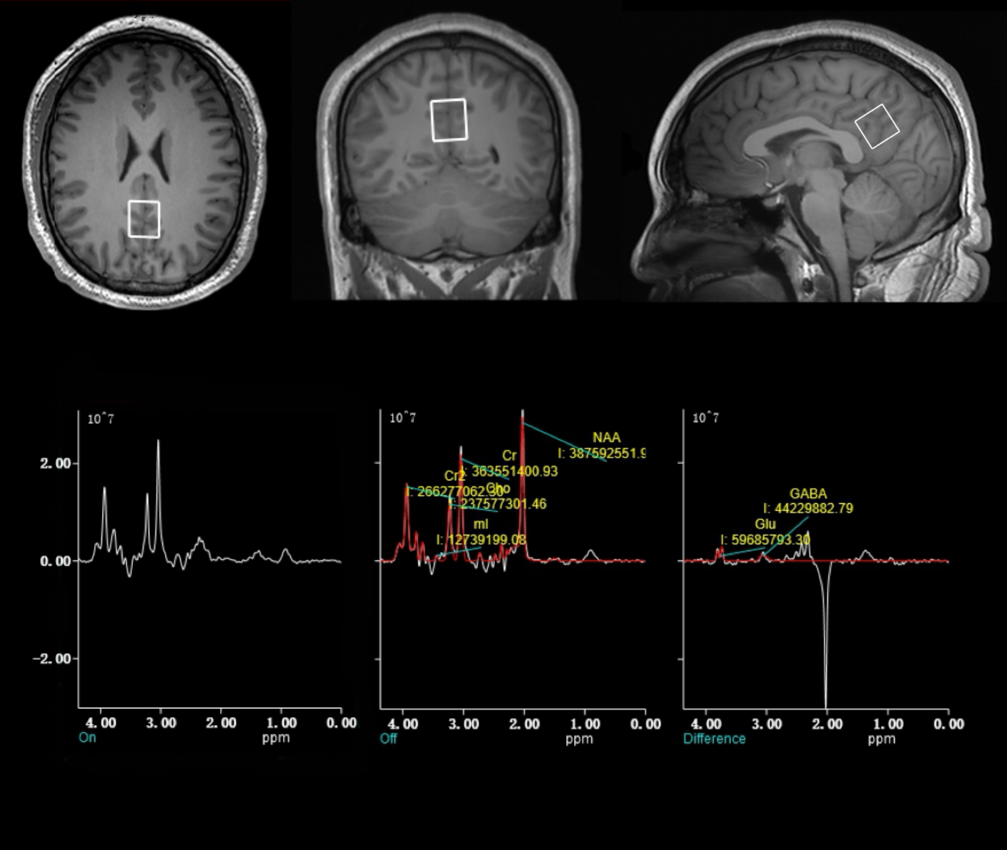
Supplementary Figure S5. Representative GABA-edited MEGA-PRESS spectrum and voxel placement in the posterior cingulate cortex (PCC). Top row: T1-weighted anatomical images (axial, coronal, sagittal) showing a 20 x 20 x 20 mm3 voxel positioned in the PCC. Bottom row: editing ON, editing OFF, and difference spectra highlighting GABA and Glx peaks. Spectra met quality-control criteria (NAA FWHM < 7 Hz; GABA CRLB < 15%). Acquisition: MEGA-PRESS, TR = 2000 ms, TE = 69 ms.

Supplementary Tables
Supplementary Table S1. Regional neurochemical measures and E/I mismatch.
Measure | Healthy controls (n = 40) | Medical trainees (n = 71) | P value
ACC Glx, PRE | 0.239 ± 0.063 | 0.246 ± 0.126 | 0.701
ACC Glx, POST | 0.200 ± 0.107 | 0.209 ± 0.093 | 0.667
ΔACC Glx | -0.039 ± 0.109 | -0.037 ± 0.104 | 0.932
PCC Glx, PRE | 0.160 ± 0.086 | 0.168 ± 0.083 | 0.647
PCC Glx, POST | 0.140 ± 0.074 | 0.131 ± 0.072 | 0.524
ΔPCC Glx | -0.020 ± 0.098 | -0.037 ± 0.094 | 0.376
ACC GABA, PRE | 0.140 ± 0.065 | 0.159 ± 0.132 | 0.318
ACC GABA, POST | 0.122 ± 0.050 | 0.134 ± 0.056 | 0.253
ΔACC GABA | -0.018 ± 0.089 | -0.025 ± 0.145 | 0.757
PCC GABA, PRE | 0.165 ± 0.091 | 0.163 ± 0.075 | 0.934
PCC GABA, POST | 0.171 ± 0.076 | 0.254 ± 0.485 | 0.163
ΔPCC GABA | 0.006 ± 0.089 | 0.091 ± 0.495 | 0.167
ACC-PCC neurochemical similarity | 0.874 ± 0.088 | 0.857 ± 0.124 | 0.409
E/I mismatch, PRE | 0.632 ± 0.963 | 0.507 ± 0.921 | 0.509
E/I mismatch, POST | 0.769 ± 1.103 | 1.010 ± 1.219 | 0.290
ΔE/I mismatch | 0.137 ± 1.413 | 0.503 ± 1.307 | 0.183
Values are mean ± SD. P values are two-tailed Welch tests comparing controls and medical trainees.

Supplementary Table S2. ACC-PCC FC, SC, neurochemical similarity, and tri-modal linkage measures.
Measure | Healthy controls (n = 40) | Medical trainees (n = 71) | P value
PRE ACC-PCC FCz, bilateral | 0.519 ± 0.201 | 0.554 ± 0.225 | 0.411
POST ACC-PCC FCz, bilateral | 0.676 ± 0.255 | 0.610 ± 0.210 | 0.170
ΔFCz, bilateral | 0.157 ± 0.257 | 0.056 ± 0.271 | 0.057
Mean SCw, bilateral | 2.300 ± 1.103 | 2.235 ± 1.060 | 0.763
Mean SCw, ipsilateral | 4.300 ± 2.252 | 4.198 ± 2.027 | 0.813
ACC-PCC neurochemical similarity | 0.874 ± 0.088 | 0.857 ± 0.124 | 0.409
Tri-modal linkage index, bilateral | 0.000 ± 0.603 | 0.000 ± 0.639 | 1.000
Tri-modal linkage index, ipsilateral | -0.000 ± 0.594 | -0.000 ± 0.640 | 1.000
Values are mean ± SD. P values are two-tailed Welch tests comparing controls and medical trainees.

Supplementary Table S3. Age- and sex-adjusted mediation models.
Sample | Path | Mediator | n | a | P(a) | b | P(b) | c' | P(c') | Indirect | CI low | CI high
Control | PSQI -> TriModal -> Internalizing | TriModal_bilat_groupZ | 40 | 0.25 | 0.118 | 0.432 | 0.009 | 0.19 | 0.226 | 0.11 | 0.004 | 0.309
Medical trainee | SWS -> TriModal -> Internalizing | TriModal_bilat_groupZ | 71 | 0.256 | 0.031 | 0.337 | 0.006 | -0.08 | 0.506 | 0.086 | 0.002 | 0.212
Combined | SWS -> TriModal -> Internalizing | TriModal_bilat_combinedZ | 111 | 0.242 | 0.013 | 0.355 | 0.000 | -0.040 | 0.675 | 0.086 | 0.014 | 0.183
Coefficients are standardized. Bootstrap confidence intervals are reported for indirect effects. Combined models additionally adjust for group.

Supplementary Table S4. BMI-adjusted mediation sensitivity models.
Sample | Path | Covariates | Indirect effect | CI low | CI high
Controls | PSQI -> Tri-modal bilateral -> Internalizing | age, sex, BMI | 0.107 | 0.000 | 0.319
Controls | PSQI -> Tri-modal ipsilateral -> Internalizing | age, sex, BMI | 0.109 | 0.004 | 0.317
Trainees | SWS -> Tri-modal bilateral -> Internalizing | age, sex, BMI | 0.091 | 0.002 | 0.221
Trainees | SWS -> Tri-modal ipsilateral -> Internalizing | age, sex, BMI | 0.081 | -0.000 | 0.201
Combined | SWS -> Tri-modal bilateral -> Internalizing | age, sex, BMI, group | 0.083 | 0.011 | 0.178
Combined | SWS -> Tri-modal ipsilateral -> Internalizing | age, sex, BMI, group | 0.078 | 0.010 | 0.168
Values summarize selected BMI-adjusted sensitivity models. CI, bootstrap 95% confidence interval.

Supplementary Table S5. RTM-adjusted mediation sensitivity analysis.
Sample | Path | Model | Mediator | n | a | P(a) | b | P(b) | c' | P(c') | Indirect | CI low | CI high
Control | PSQI -> TriModal -> Internalizing | original | TriModal_bilat_groupZ | 40 | 0.266 | 0.097 | 0.432 | 0.008 | 0.184 | 0.232 | 0.115 | 0.005 | 0.344
Control | PSQI -> TriModal -> Internalizing | RTM-residualized FC | TriModal_bilat_RTM_groupZ | 40 | 0.338 | 0.032 | 0.539 | 0.001 | 0.117 | 0.431 | 0.182 | 0.049 | 0.430
Medical trainee | SWS -> TriModal -> Internalizing | original | TriModal_bilat_groupZ | 71 | 0.256 | 0.031 | 0.337 | 0.007 | -0.091 | 0.454 | 0.086 | 0.002 | 0.212
Medical trainee | SWS -> TriModal -> Internalizing | RTM-residualized FC | TriModal_bilat_RTM_groupZ | 71 | 0.274 | 0.022 | 0.352 | 0.005 | -0.101 | 0.406 | 0.096 | 0.005 | 0.233
Combined | SWS -> TriModal -> Internalizing | original | TriModal_bilat_combinedZ | 111 | 0.242 | 0.013 | 0.355 | 0.000 | -0.040 | 0.675 | 0.086 | 0.014 | 0.183
Combined | SWS -> TriModal -> Internalizing | RTM-residualized FC | TriModal_bilat_RTM_combinedZ | 111 | 0.251 | 0.010 | 0.391 | 0.000 | -0.052 | 0.578 | 0.098 | 0.017 | 0.199
RTM-adjusted models use residualized POST FC adjusted for PRE FC in the FC layer of the tri-modal index.

Supplementary Table S6. QC and missing-data summary.
Sample | Item | n | Note
Healthy controls | Total participants | 40 | nan
Healthy controls | Usable MRS/neurochemical similarity | 40 | Non-missing ACC/PCC GABA and Glx vectors
Healthy controls | Usable FC bilateral ΔFC | 40 | Non-missing PRE/POST ACC-PCC FC
Healthy controls | Usable tri-modal bilateral index | 40 | Non-missing MC, FC, and SC layers
Medical trainees | Total participants | 71 | nan
Medical trainees | Usable MRS/neurochemical similarity | 71 | Non-missing ACC/PCC GABA and Glx vectors
Medical trainees | Usable FC bilateral ΔFC | 71 | Non-missing PRE/POST ACC-PCC FC
Medical trainees | Usable tri-modal bilateral index | 71 | Non-missing MC, FC, and SC layers
Combined | Total participants | 111 | nan
Combined | Usable MRS/neurochemical similarity | 111 | Non-missing ACC/PCC GABA and Glx vectors
Combined | Usable FC bilateral ΔFC | 111 | Non-missing PRE/POST ACC-PCC FC
Combined | Usable tri-modal bilateral index | 111 | Non-missing MC, FC, and SC layers
Healthy controls | SC QC pass | 39 | No zero/flagged bilateral SC edges
Healthy controls | SC QC flagged | 1 | Flagged bilateral SC edges
Medical trainees | SC QC pass | 69 | No zero/flagged bilateral SC edges
Medical trainees | SC QC flagged | 2 | Any zero SC edge
SC QC flags identify zero or flagged ACC-PCC structural connectivity edges. Counts are based on available analytic files.

Supplementary Table S7. Magnetic resonance spectroscopy reporting checklist.
Checklist item | Reported information
1. Hardware
a. Field strength [T] | 3.0T
b. Manufacturer | United Imaging Healthcare, Shanghai, China
c. Model (software version if available) | uMR790, United Imaging Healthcare (UIH), software version V10_3T
d. RF coils: nuclei (transmit/receive), number of channels, type, body part | ¹H, 32-channel, head coil (United Imaging Healthcare)
e. Additional hardware | Foam cushions or vacuum headrests to minimize motion
2. Acquisition
a. Pulse sequence | MEGA-PRESS (MEshcher-GArwood Point RESolved Spectroscopy)
b. Volume of Interest (VOI) locations | Anterior and posterior cingulate cortices (ACC and PCC)
c. Nominal VOI size [cm3, mm3] | VOI size =20 x 20 x 20 mm3
d. Repetition Time (TR), Echo Time (TE) [ms, s] | TR = 2000 ms, TE = 69 ms
e. Total number of excitations or acquisitions per spectrum in time series for kinetic studies i. Number of Averaged spectra per time-point ii. Averaging method (e.g. block-wise or moving average) iii. Total number of spectra (acquired / in time-series) | i. Number of averaged spectra per time-point: 100 “ON” + 100 “OFF” averages ii. Averaging method: Block-wise averaging (MEGA-PRESS default) iii. Total number of spectra: 2 (pre- and post-sleep) per region; total 4 per subject
f. Additional sequence parameters (spectral width in Hz, number of spectral points, frequency offsets) If STEAM:, Mixing Time (TM) If MRSI: 2D or 3D, FOV in all directions, matrix size, acceleration factors, sampling method | Spectral width: 2000 Hz Data points: 1024 Frequency offsets: 1.9 ppm (editing ON), 7.5 ppm (editing OFF) STEAM / MRSI: Not applicable (MEGA-PRESS single voxel acquisition used)
g. Water Suppression Method | Water Suppression Enhanced Through T1 Effect (WET)
h. Shimming Method, reference peak, and thresholds for “acceptance of shim” chosen | Shimming method: Automated Dynamic Frequency Calibration Reference peak: Cr Acceptance threshold: FWHM < 7 Hz
i. Triggering or motion correction method (respiratory, peripheral, cardiac triggering, incl. device used and delays) | None applied; head motion minimized with foam padding.
3. Data analysis methods and outputs
a. Analysis software | vendor-supplied Spectroscopy Analysis Tool in uWS-MR workstation (UIH, version 2.1).
b. Processing steps deviating from quoted reference or product | None. All spectra were processed using the vendor-supplied uWS-MR workstation analysis module with default parameters.
c. Output measure (e.g. absolute concentration, institutional units, ratio) | Spectral peak integral area and metabolite ratio
d. Quantification references and assumptions, fitting model assumptions | Vendor-supplied basis fit model with Gaussian lineshapes assumptions. No external tissue correction applied
4. Data Quality
a. Reported variables (SNR, Linewidth (with reference peaks)) | FWHM (NAA) < 7 Hz CRLB < 15% for GABA SNR and line-fitting reviewed visually Reference peaks: Water (scaling), NAA (linewidth)
b. Data exclusion criteria | CRLB > 15% FWHM > 7 Hz (NAA peak) Spectra with artifacts or poor fit excluded after visual inspection
c. Quality measures of postprocessing Model fitting (e.g. CRLB, goodness of fit, SD of residual) | CRLB < 15% (exclusion threshold) FWHM (NAA) < 7 Hz Visual inspection of fit and residual No SD of residual reported numerically
d. Sample Spectrum | Supplementary Figures S4 and S5
Abbreviations: ACC, anterior cingulate cortex; CRLB, Cramer-Rao lower bound; FWHM, full width at half maximum; Glx, glutamate plus glutamine; MEGA-PRESS, MEshcher-GArwood Point RESolved Spectroscopy; PCC, posterior cingulate cortex; TE, echo time; TR, repetition time; VOI, volume of interest.

Supplementary Table S8. Resting-state fMRI quality-control summary.
Sample | Item | n | Note
Healthy controls | Total participants | 40 | Final analytic sample
Healthy controls | Usable PRE/POST bilateral ACC-PCC FC | 40 | Non-missing PRE and POST FC estimates
Healthy controls | Visual BOLD QC pass | 40 | No gross artifact, incomplete BOLD acquisition, or failed registration/atlas alignment
Healthy controls | Gross motion-correction failure | 0 | Assessed after MCFLIRT preprocessing
Healthy controls | FD-based censoring/scrubbing applied | 0 | Not included in the primary pipeline
Medical trainees | Total participants | 71 | Final analytic sample
Medical trainees | Usable PRE/POST bilateral ACC-PCC FC | 71 | Non-missing PRE and POST FC estimates
Medical trainees | Visual BOLD QC pass | 71 | No gross artifact, incomplete BOLD acquisition, or failed registration/atlas alignment
Medical trainees | Gross motion-correction failure | 0 | Assessed after MCFLIRT preprocessing
Medical trainees | FD-based censoring/scrubbing applied | 0 | Not included in the primary pipeline
Combined | Total participants | 111 | Final analytic sample
Combined | Usable PRE/POST bilateral ACC-PCC FC | 111 | Non-missing PRE and POST FC estimates
Combined | Visual BOLD QC pass | 111 | No gross artifact, incomplete BOLD acquisition, or failed registration/atlas alignment
Table note: BOLD QC was based on visual inspection of motion-corrected images, mean BOLD images, and atlas alignment in native BOLD space. Head motion was addressed using MCFLIRT-based motion correction and regression of rigid-body motion parameters. Global signal regression, white-matter/cerebrospinal-fluid nuisance regression, volume scrubbing, and FD-based censoring were not included in the primary FC pipeline.

