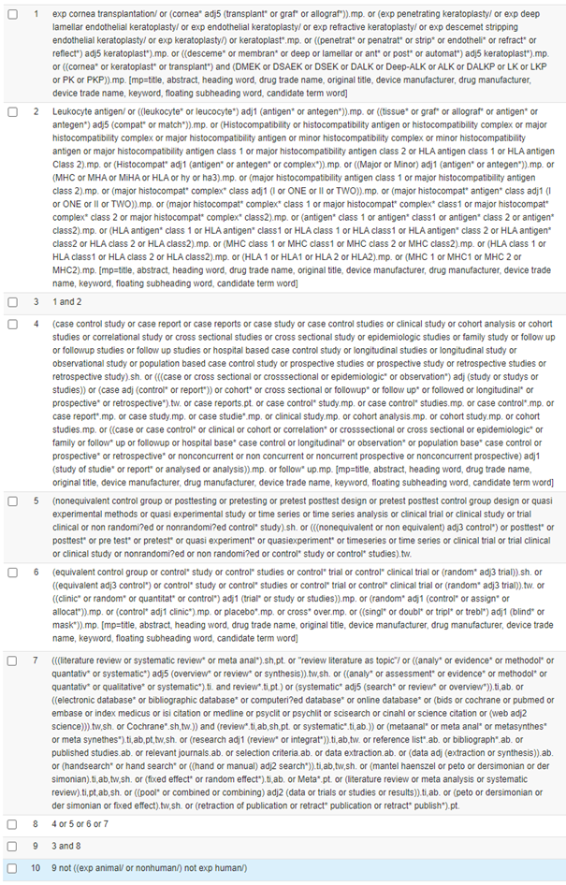
Appendix 1: Ovid Embase sample search strategy

