Triphenylphosphonium compounds preferentially inhibit long-chain fatty acid oxidation in cardiac mitochondria

Anna Faakye, B.S.^{1,2}, Satoshi Matsuzaki, Ph.D.¹, Venkateswararao Eeda, Ph.D.³,
Vibhudutta Awasthi, Ph.D.³, Kenneth M. Humphries, Ph.D. ^{1,2}

Materials included
Supplementary Figure 1
Supplementary Figure 2
Supplementary Figure 3
Supplementary Figure 4

Supplementary figures and legends
Supplementary Figure S1
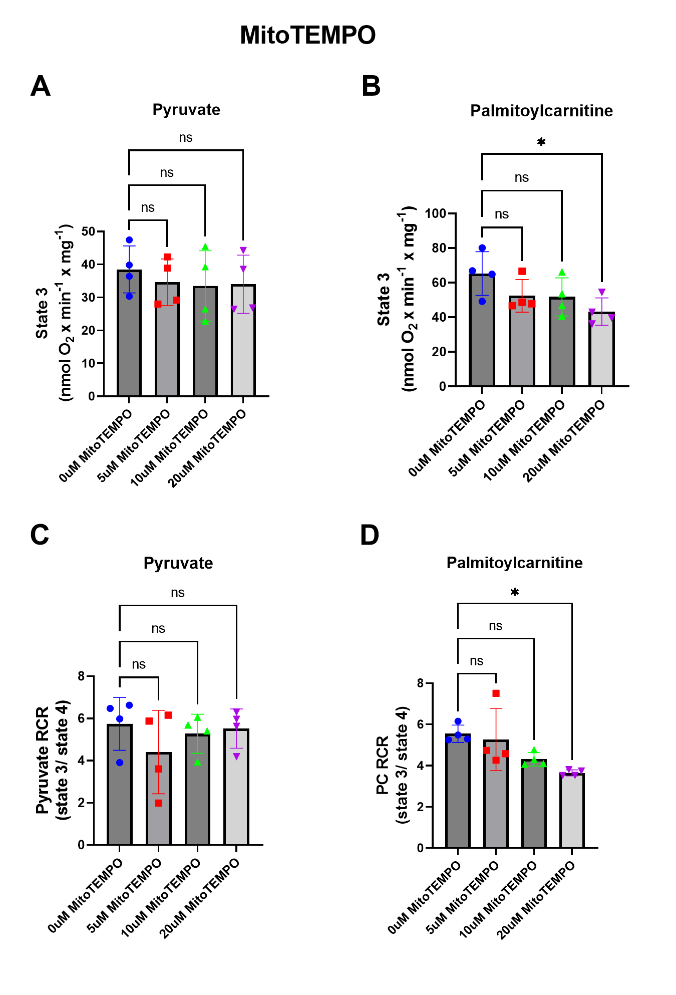
Figure S1. MitoTEMPO does not inhibit mitochondrial respiration: A, Pyruvate-supported and B, PC-supported state 3 respiration rates of individually isolated mitochondria from mice treated with increasing concentrations of MitoTEMPO (0-20μM) (n = 4 per group). C-D Respiratory control ratio (RCR, calculated as State3/State 4) of mitochondria treated with MitoTEMPO from either C pyruvate/malate or D palmitoyl carnitine/malate in the presence of ADP (n = 4 per group). Data is presented as mean ± SD and analyzed using one-way ANOVA followed by Dunnett’s post hoc test (A-D) ns indicates not significant, *p < 0.05
Supplementary Figure S2
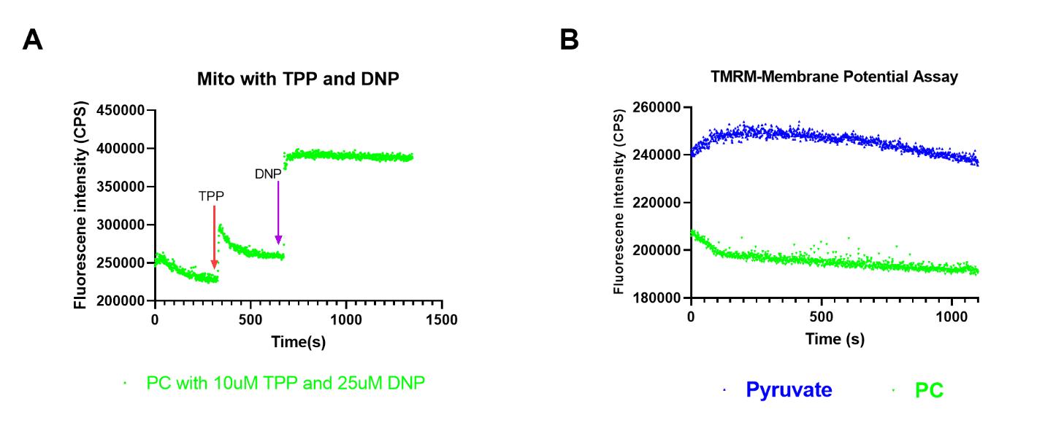
Figure S2: DNP effect on mitochondrial membrane potential. A is a TMRM response fluorescence intensity graph from the fluorospectrometric experiment. The green traces represent isolated mitochondria treated with palmitoyl carnitine as substrate. The red arrow indicates the time point at which 10μM TPP was added whereas the purple arrow indicates the addition of 25μM DNP. B The blue and green traces represent isolated mitochondria with pyruvate or palmitoyl carnitine respectively without any treatment. Graph shown is an average of 5 fluorescence intensity recordings from 5 individually isolated mitochondria (n=5).

Supplementary Figure S3
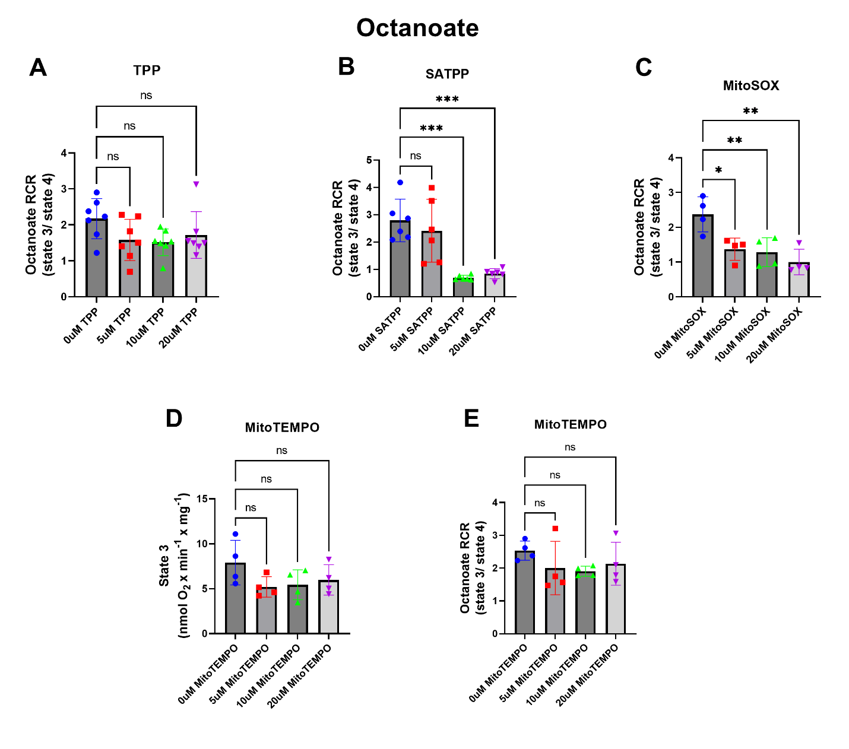

Figure S3. The effect of TPP on MCFA-supported mitochondrial respiration: Respiratory control ratio (RCR, calculated as State3/State 4) of mitochondria stimulated with octanoate in the presence of ADP and treated with increasing concentrations TPP (A), SATPP (B), MitoSOX (C) and MitoTEMPO (E). D Octanoate-supported state 3 respiration rate of individually isolated mitochondria from mice treated with increasing concentrations of MitoTEMPO. (n = 4-7 individually isolated mitochondria per group). Data is presented as mean ± SD and analyzed using one-way ANOVA followed by Dunnett’s post hoc test (A-E). ns indicates not significant, *p < 0.05, **p < 0.01, ***p < 0.001****p < 0.0001

Supplementary Figure S4
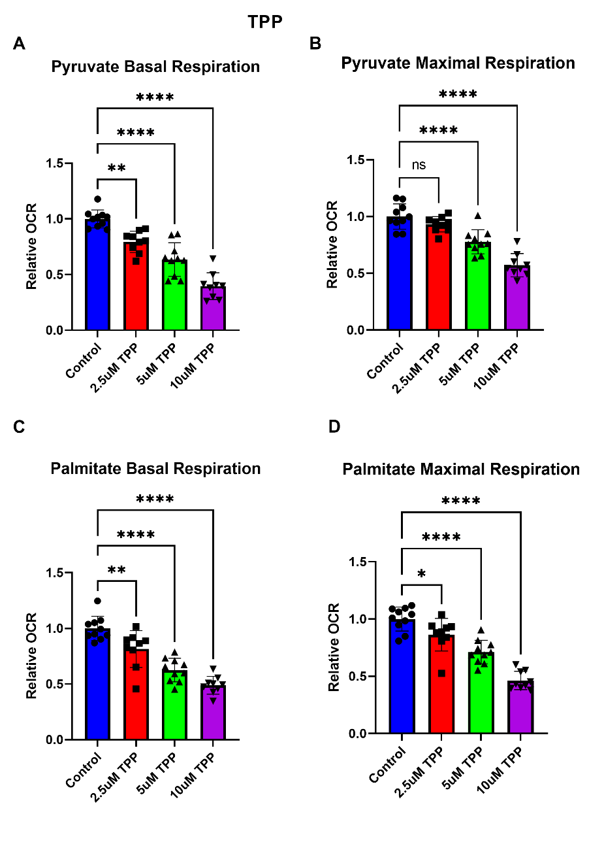
Figure S4. The chronic response of cellular respiration to TPP in intact AC16 cells: A&C. Basal respiration rate (OCR, oxygen consumption rate) and B&D. Maximal respiration rate of AC16 cells treated with increasing concentration (2.5-10μM) of TPP for 3hours in the presence of pyruvate (A&B) or palmitate (C&D) as substrates. Each point represents an individual well from a Seahorse XFe24 plate, with the experiment performed on 2 separate plates. Data were normalized to cell numbers and are presented relative to untreated control. Data are shown as mean ±SD, ns indicates not significant, *p < 0.05, **p < 0.01,***p< 0.001, ****p < 0.0001 by one-way ANOVA with multiple comparison of the mean of each test group to the mean of the untreated control.

