Carbon Nanostructures in an Unusual Carbon-Rich Mineral: Evidence for Formation under Extreme Conditions

Selene Acosta^{1*}, Roberto Bartali², José Ramón Torres-Hernández^{3,} Jaime Urrutia-Fucugauchi^{4,5}, Hiram Joazet Ojeda-Galván⁶, Verónica Pérez-Luna⁷, Mildred Quintana^{2,7}.

¹División de Materiales Avanzados, Instituto Potosino de Investigación Cientifíca y Tecnológica A.C., Camino a la Presa San José 2055, San Luis Potosí S.L.P.,78216, México.
²Facultad de Ciencias, Universidad Autónoma de San Luis Potosí, Av. Parque Chapultepec 1570, Privadas del Pedregal, San Luis Potosí, S.L.P., 78295, México.
³Instituto de Geología, Universidad Autónoma de San Luis Potosí, Av. Dr. Manuel Nava 330A, Bellas Lomas, San Luis, S.L.P. 78210, Mexico.
⁴Programa Universitario de Perforaciones en Océanos y Continentes, Instituto de Geofísica, Universidad Nacional Autónoma de México, Coyoacan 04510, Ciudad de México, Mexico.
⁵ Instituto de Investigación y Estudios Avanzados Chicxulub, Parque Científico y Tecnológico de Yucatán, Sierra Papacal, Merida 97302, Yucatán, Mexico.
⁶Coordinación para la Innovación y Aplicación de la Ciencia y la Tecnología, Universidad Autónoma de San Luis Potosí, 550 Sierra Leona Ave, San Luis Potosí 78210, Mexico
⁷Centro de Investigación en Ciencias de la Salud y Biomedicina, Universidad Autónoma de San Luis Potosí, Av. Sierra Leona 550, Lomas de San Luis, San Luis Potosí, 78210, México.

Geological and Impact-Related Context of the Studied Outcrop
The collision of an asteroid approximately 15 km in diameter, traveling at velocities exceeding 50,000 km/h, occurred 66 million years ago on the Yucatán Peninsula, Mexico, marking the end of the Cretaceous period and the beginning of the Paleogene. The global consequences of this event were catastrophic, leading to the extinction of approximately 75% of all living species within a geologically instantaneous timescale, the most iconic victims being the non-avian dinosaurs. In less than 10 minutes, an impact crater with a diameter of ~180–200 km was formed, reaching a maximum depth of ~35 km. Today, the crater lies buried beneath approximately 1,500 m of sediment but remains exceptionally well preserved. Evidence for the global extent of this event is provided by a dark ejecta layer enriched in iridium, rare earth elements, and platinum-group elements, which is distributed worldwide. The thickness of this layer ranges from several meters to only a few centimeters, depending on the distance from the crater center. This layer is known as the K/Pg (Cretaceous–Paleogene) boundary, first identified at Gubbio, Italy [1]. Within this boundary layer, nano- and micro-diamonds have been reported in nearly all outcrops worldwide. During such a collision, several minerals undergo deformation of their crystal structures due to extreme pressures and shock waves. In addition, molten and vaporized material that is not directly ejected remains suspended in the atmosphere and subsequently cools, solidifies, recrystallizes, and is deposited as microscopic spherules, which, in the case of the Chicxulub impact, have been identified globally [1–5].
Some of the events that occurred within minutes to hours after the collision included:
a) melting, evaporation, and pulverization of the Yucatán carbonate platform and the asteroid,
b) massive fragmentation of the target terrain and the seafloor,
c) high-velocity ejection of fragments over distances of thousands of kilometers, with a fraction of the ejecta exceeding Earth’s escape velocity (~40,000 km/h) and being launched into space,
d) the generation of a global tsunami with waves at least ~300 m high that propagated around the planet twice,
e) instantaneous wildfires across the American continent,
f) earthquakes with magnitudes of 11 or greater,
g) a decrease in mean global temperatures of up to ~15 °C due to particles suspended in the atmosphere,
h) a drastic reduction in sunlight and photosynthesis caused by atmospheric particulates,
i) the abrupt disappearance of plant, animal, and foraminiferal fossils in sediments above the K/Pg boundary worldwide.
During this period, most of the eastern coast of Mexico, extending more than ~100–200 km inland, was submerged beneath shallow marine waters. The region consisted of a system of lagoons and very shallow reefs (<50–150 m depth), dominated by corals and rudists. The site where the sample described in this study was collected formed part of the Valles–San Luis Potosí Platform (PVSLP), which belongs to the Cárdenas geological formation. This formation contains Upper Cretaceous fossils deposited immediately prior to the asteroid impact [6]
Within the Gulf of Mexico region, several sites related to the formation of the Chicxulub crater have been studied in detail, particularly in the states of Nuevo León and Tamaulipas to the north of the PVSLP, and Veracruz and Chiapas to the south. Nano- and micro-diamonds (up to ~30 μm in size) have been documented at two K/Pg boundary sites in Tamaulipas, Mexico; these localities are situated north of Tamasopo, San Luis Potosí [7]. In Bartali et al. (2026; submitted and under review), a new site located near the center of the PVSLP is reported, where an exceptionally well-preserved K/Pg boundary has been identified. The site from which the sample analyzed in the present study was collected is located approximately 10 km to the east of this locality, in the direction of the Chicxulub crater [8].
The formation of impact diamonds and other carbon-based structures in regions affected by asteroid collisions represents one of the most common consequences of such events. This is largely due to the high carbon content of many asteroids, the presence of extensive carbonate platforms on Earth’s surface, and the widespread occurrence of graphite-bearing deposits. Large quantities of impact diamonds have been reported, for example, at the Ries crater in Germany [9–11], and at the Popigai crater in Russia [12,13].
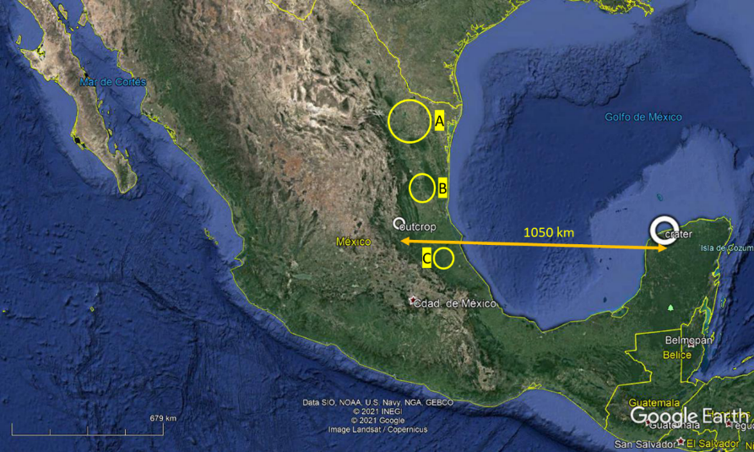
Figure S1. Geographical location of the studied outcrop and previously reported impact-related sites relative to the Chicxulub crater. The yellow circles indicate the areas investigated by other authors (12 in total) where evidence of the collision that formed the Chicxulub crater (Yucatán, Mexico) has been reported. Microdiamonds have been identified at site B. The white circle represents the study area addressed in this work. The straight-line distance between the studied outcrop and the center of the Chicxulub crater is approximately 1050 km. Image obtained from Google Earth.

Table S1. Spectral Parameters of Deconvoluted Raman Peaks for the M sample
Sample | Component | Position (cm⁻¹) |  | HWHM (cm⁻¹) | Relative area (%)
 | D4 | 1230.9 | 55 |  | 12.6
 | D1 | 1342 | 70 |  | 38.4
M | D3 | 1460.2 | 110 |  | 17.5
 | G | 1565.6 | 31 |  | 22.9
 | D2 | 1592 | 18 |  | 8.6
Table S2. Spectral Parameters of Deconvoluted Raman Peaks for the P-M sample
Sample | Component | Position (cm⁻¹) |  | HWHM (cm⁻¹) | Relative area (%)
 | D4 | 1230 | 198 |  | 32.9
 | D1 | 1344 | 89 |  | 33.8
P-M | D3 | 1505.2 | 100 |  | 13.7
 | G | 1567.6 | 36 |  | 16.9
 | D2 | 1594 | 18 |  | 2.7

Figure S2. X-ray diffraction (XRD) patterns of the M (raw material) and the P-M (nitric-acid purified material). The raw material displays a largely amorphous carbonaceous structure, evidenced by broad and poorly defined diffraction features, with contributions attributable to graphite and FeCO₃ used as reference phases. After nitric-acid purification, the diffractogram reveals a markedly enhanced crystallinity of the carbon phase, characterized by sharper and better-defined diffraction features, demonstrating that the acid treatment promotes a significant increase in structural ordering.

References
[1] L.W. Alvarez, W. Alvarez, F. Asaro, H. V. Michel, Extraterrestrial cause for the Cretaceous-Tertiary extinction, Science (1979). 208 (1980) 1095–1108. https://doi.org/10.1126/science.208.4448.1095.
[2] J. Urrutia-Fucugauchi, L. Perez-Cruz, Multiring-forming large bolide impacts and evolution of planetary surfaces, Int. Geol. Rev. 51 (2009) 1079–1102. https://doi.org/10.1080/00206810902867161.
[3] S. Goderis, H. Sato, L. Ferrière, B. Schmitz, D. Burney, P. Kaskes, J. Vellekoop, A. Wittmann, T. Schulz, S.M. Chernonozhkin, P. Claeys, S.J. de Graaff, T. Déhais, N.J. de Winter, M. Elfman, J.G. Feignon, A. Ishikawa, C. Koeberl, P. Kristiansson, C.R. Neal, J.D. Owens, M. Schmieder, M. Sinnesael, F. Vanhaecke, S.J.M. van Malderen, T.J. Bralower, S.P.S. Gulick, D.A. Kring, C.M. Lowery, J. V. Morgan, J. Smit, M.T. Whalen, Globally distributed iridium layer preserved within the Chicxulub impact structure, Sci. Adv. 7 (2021). https://doi.org/10.1126/sciadv.abe3647.
[4] S.P.S. Gulick, T.J. Bralower, J. Ormö, B. Hall, K. Grice, B. Schaefer, S. Lyons, K.H. Freeman, J. V. Morgan, N. Artemieva, P. Kaskes, S.J. De Graaff, M.T. Whalen, G.S. Collins, S.M. Tikoo, C. Verhagen, G.L. Christeson, P. Claeys, M.J.L. Coolen, S. Goderis, K. Goto, R.A.F. Grieve, N. McCall, G.R. Osinski, A.S.P. Rae, U. Riller, J. Smit, V. Vajda, A. Wittmann, The first day of the Cenozoic, Proc. Natl. Acad. Sci. U. S. A. 116 (2019) 19342–19351. https://doi.org/10.1073/pnas.1909479116.
[5] P. Schulte, L. Alegret, I. Arenillas, J.A. Arz, P.J. Barton, P.R. Bown, T.J. Bralower, G.L. Christeson, P. Claeys, C.S. Cockell, G.S. Collins, A. Deutsch, T.J. Goldin, K. Goto, J.M. Grajales-Nishimura, R.A.F. Grieve, S.P.S. Gulick, K.R. Johnson, W. Kiessling, C. Koeberl, D.A. Kring, K.G. MacLeod, T. Matsui, J. Melosh, A. Montanari, J. V. Morgan, C.R. Neal, D.J. Nichols, R.D. Norris, E. Pierazzo, G. Ravizza, M. Rebolledo-Vieyra, W.U. Reimold, E. Robin, T. Salge, R.P. Speijer, A.R. Sweet, J. Urrutia-Fucugauchi, V. Vajda, M.T. Whalen, P.S. Willumsen, The chicxulub asteroid impact and mass extinction at the cretaceous-paleogene boundary, Science (1979). 327 (2010) 1214–1218. https://doi.org/10.1126/science.1177265.
[6] R.L. Myers, Biostratigraphy of the Cardenas formation (upper Cretaceous) San Luis Potosi, México, Paleontología Mexicana (1968) 1–119. https://doi.org/10.22201/igl.05437652e.1968.0.24.265.
[7] R.M. Hough, I. Gilmour, C.T. Pillinger, F. Langenhorst, A. Montanari, Diamonds from the iridium-rich K-T boundary layer at Arroyo el Mimbral, Tamaulipas, Mexico, Geology 25 (1997) 1019. https://doi.org/10.1130/0091-7613(1997)025<1019:DFTIRK>2.3.CO;2.
[8] T.-H.J.R., U.-F.J., P.-C.L., T.-T.R.L. Bartali R., Unraveling the Cretaceous-Paleogene Boundary Event Across the Gulf of Mexico – High-Resolution Rayon Reef Section, Valles-San Luis Potosi Platform, Mexico. , PlosOne Under Review (n.d.).
[9] M. Chen, J. Shu, X. Xie, D. Tan, H.K. Mao, Natural diamond formation by self-redox of ferromagnesian carbonate, Proc. Natl. Acad. Sci. U. S. A. 115 (2018) 2676–2680. https://doi.org/10.1073/pnas.1720619115.
[10] L. Bayarjargal, T.G. Shumilova, A. Friedrich, B. Winkler, Diamond formation from CaCO3 at high pressure and temperature, European Journal of Mineralogy 22 (2010) 29–34. https://doi.org/10.1127/0935-1221/2010/0021-1986.
[11] E.M. Shoemaker, E.C.T. Chao, E.M. Shoemaker, E.C.T. Chao, Shoemaker, E. M., Chao, E.C. T., New Evidence for the Impact Origin of the Ries Basin, Bavaria, Germany, JGR 66 (1961) 3371–3378. https://doi.org/10.1029/jz066i010p03371.
[12] V. Afanasiev, N. Pokhilenko, A. Eliseev, S. Gromilov, S. Ugapieva, V. Senyut, Impact Diamonds: Types, Properties and Uses, Springer Proceedings in Earth and Environmental Sciences (2019) 179–182. https://doi.org/10.1007/978-3-030-22974-0_41.
[13] F.V. Kaminsky, Carbonado and Yakutite: Properties and Possible Genesis, International Kimberlite Conference: Extended Abstracts 5 (1991) 214–216. https://doi.org/10.29173/ikc2516.

