SUPPLEMENTARY MATERIAL
Primary-Data Carbon and Water Footprint Inventory of the Bangladesh RMG Sector under the EU CBAM
This Supplementary Material provides the facility-sample profile, the emission-factor and characterisation-factor set, the CBAM exposure-model parameters, additional figures, and the reproducibility statement referenced in the main manuscript.

S1. Facility-sample profile
Table S1 summarises the composition of the thirty-two-facility primary-data sample by product line, facility scale and process configuration. The sample was selected to span the principal product lines and a range of facility scales; it is representative rather than a statistically random draw from the sector population.
Table S1. Facility-sample composition.
Product line | Facilities (n) | Vertically integrated | With onsite ETP
Knit (T-shirts, polos) | 14 | 9 | 12
Woven (trousers, shirts) | 11 | 6 | 9
Denim (jeans) | 7 | 5 | 7
Total | 32 | 20 | 28

S2. Emission and characterisation factors
Table S2 lists the principal emission factors and characterisation factors used in the inventory, with their sources. Global warming potentials are applied on the IPCC AR6 100-year basis.
Table S2. Principal emission and characterisation factors.
Parameter | Value | Source
Grid electricity (Bangladesh) | 0.66 kg CO₂/kWh | National grid mix, gas-dominated
Natural gas combustion | 0.0561 kg CO₂/MJ | IPCC 2006 Guidelines
Diesel combustion | 0.0741 kg CO₂/MJ | IPCC 2006 Guidelines
Cotton fibre (cradle-to-gate) | ≈5.9 kg CO₂-eq/kg | ecoinvent 3.10
Polyester fibre (cradle-to-gate) | ≈3.8 kg CO₂-eq/kg | ecoinvent 3.10
Sea-freight (container) | 0.011 kg CO₂/t·km | Chattogram–Rotterdam route
Dyehouse blue water | 136 L/kg | Roy et al. (2023), field survey
Dyehouse grey water | 119 L/kg | Roy et al. (2023), field survey

S3. CBAM exposure-model parameters
The CBAM exposure model computes the embedded-carbon liability as the product of the embedded-emission intensity and the certificate price. Two accounting boundaries are modelled: a narrow Scope 1+2 boundary (9.5 kg CO₂-eq per kilogram, corresponding to installation-level direct and indirect emissions) and a broader boundary including relevant precursors (16.0 kg CO₂-eq per kilogram). The reference certificate price is EUR 100 per tonne CO₂, with sensitivity modelled from zero to EUR 150 per tonne. The ad-valorem exposure is computed against a representative FOB unit value for Bangladeshi apparel. Where a carbon price has been paid in the country of origin, the CBAM methodology permits a corresponding deduction; the present model assumes no domestic carbon price, consistent with current Bangladeshi policy.

S4. Reproducibility statement
The inventory calculations and the CBAM exposure model are implemented in a parameterised spreadsheet and Python scripts. The Monte Carlo simulation uses 10,000 iterations with triangular input distributions defined by the minimum, modal and maximum values observed across the facility sample, with a fixed random seed for reproducibility. The calculation spreadsheets, the Monte Carlo and sensitivity scripts, and the figure-generation code will be deposited in a public repository (e.g. Zenodo) under a Creative Commons Attribution 4.0 International licence on acceptance of the manuscript. Facility-level disaggregated data are provided in anonymised form subject to confidentiality undertakings.

S5. Additional figures
Figure S1 reproduces the Monte Carlo uncertainty distribution from the main text in larger format.
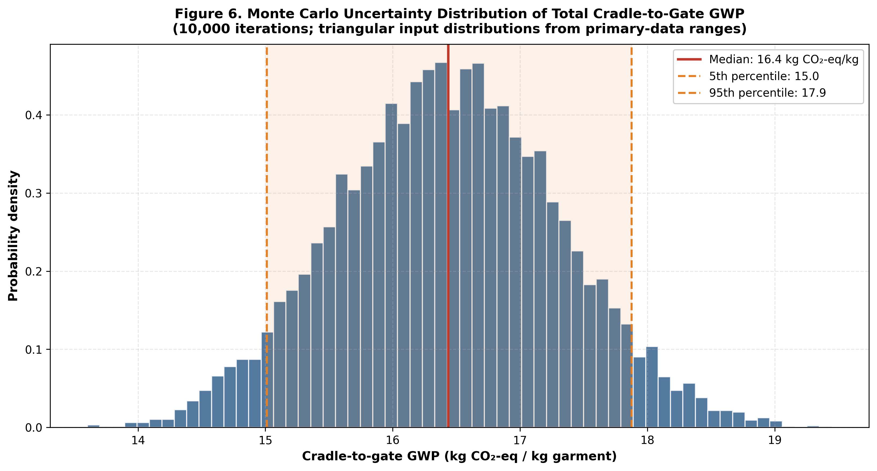
Figure S1. Monte Carlo uncertainty distribution of cradle-to-gate GWP (full-size reproduction of Figure 6 of the main manuscript).
Figure S2 reproduces the sensitivity tornado diagram from the main text in larger format.
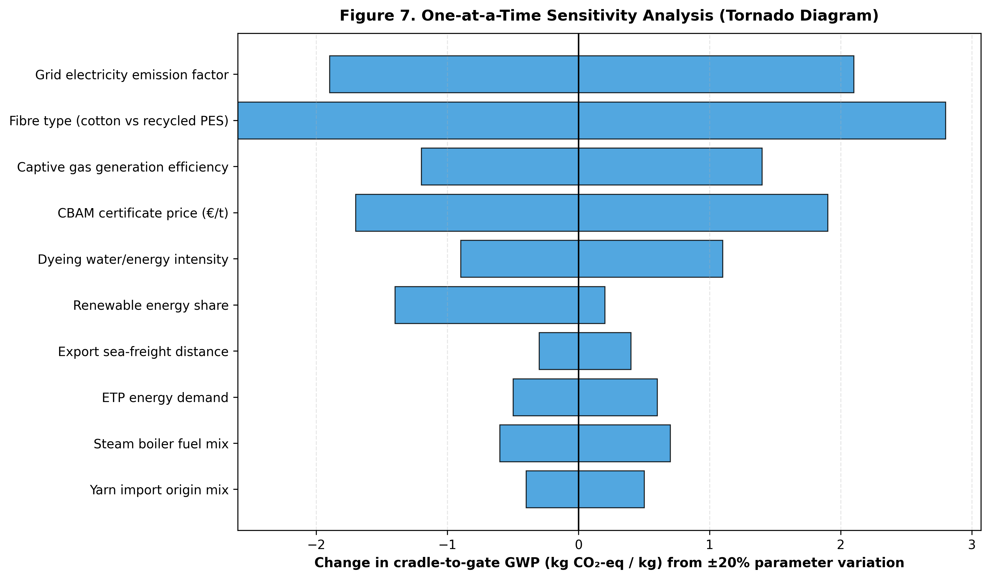
Figure S2. One-at-a-time sensitivity analysis (full-size reproduction of Figure 7 of the main manuscript).

S6. Cited references
All references cited in this Supplementary Material are listed in the main manuscript reference list.

