Supplementary Information
Genomic determinants of metastatic organotropism and dissemination tempo across 3,368 lung cancers
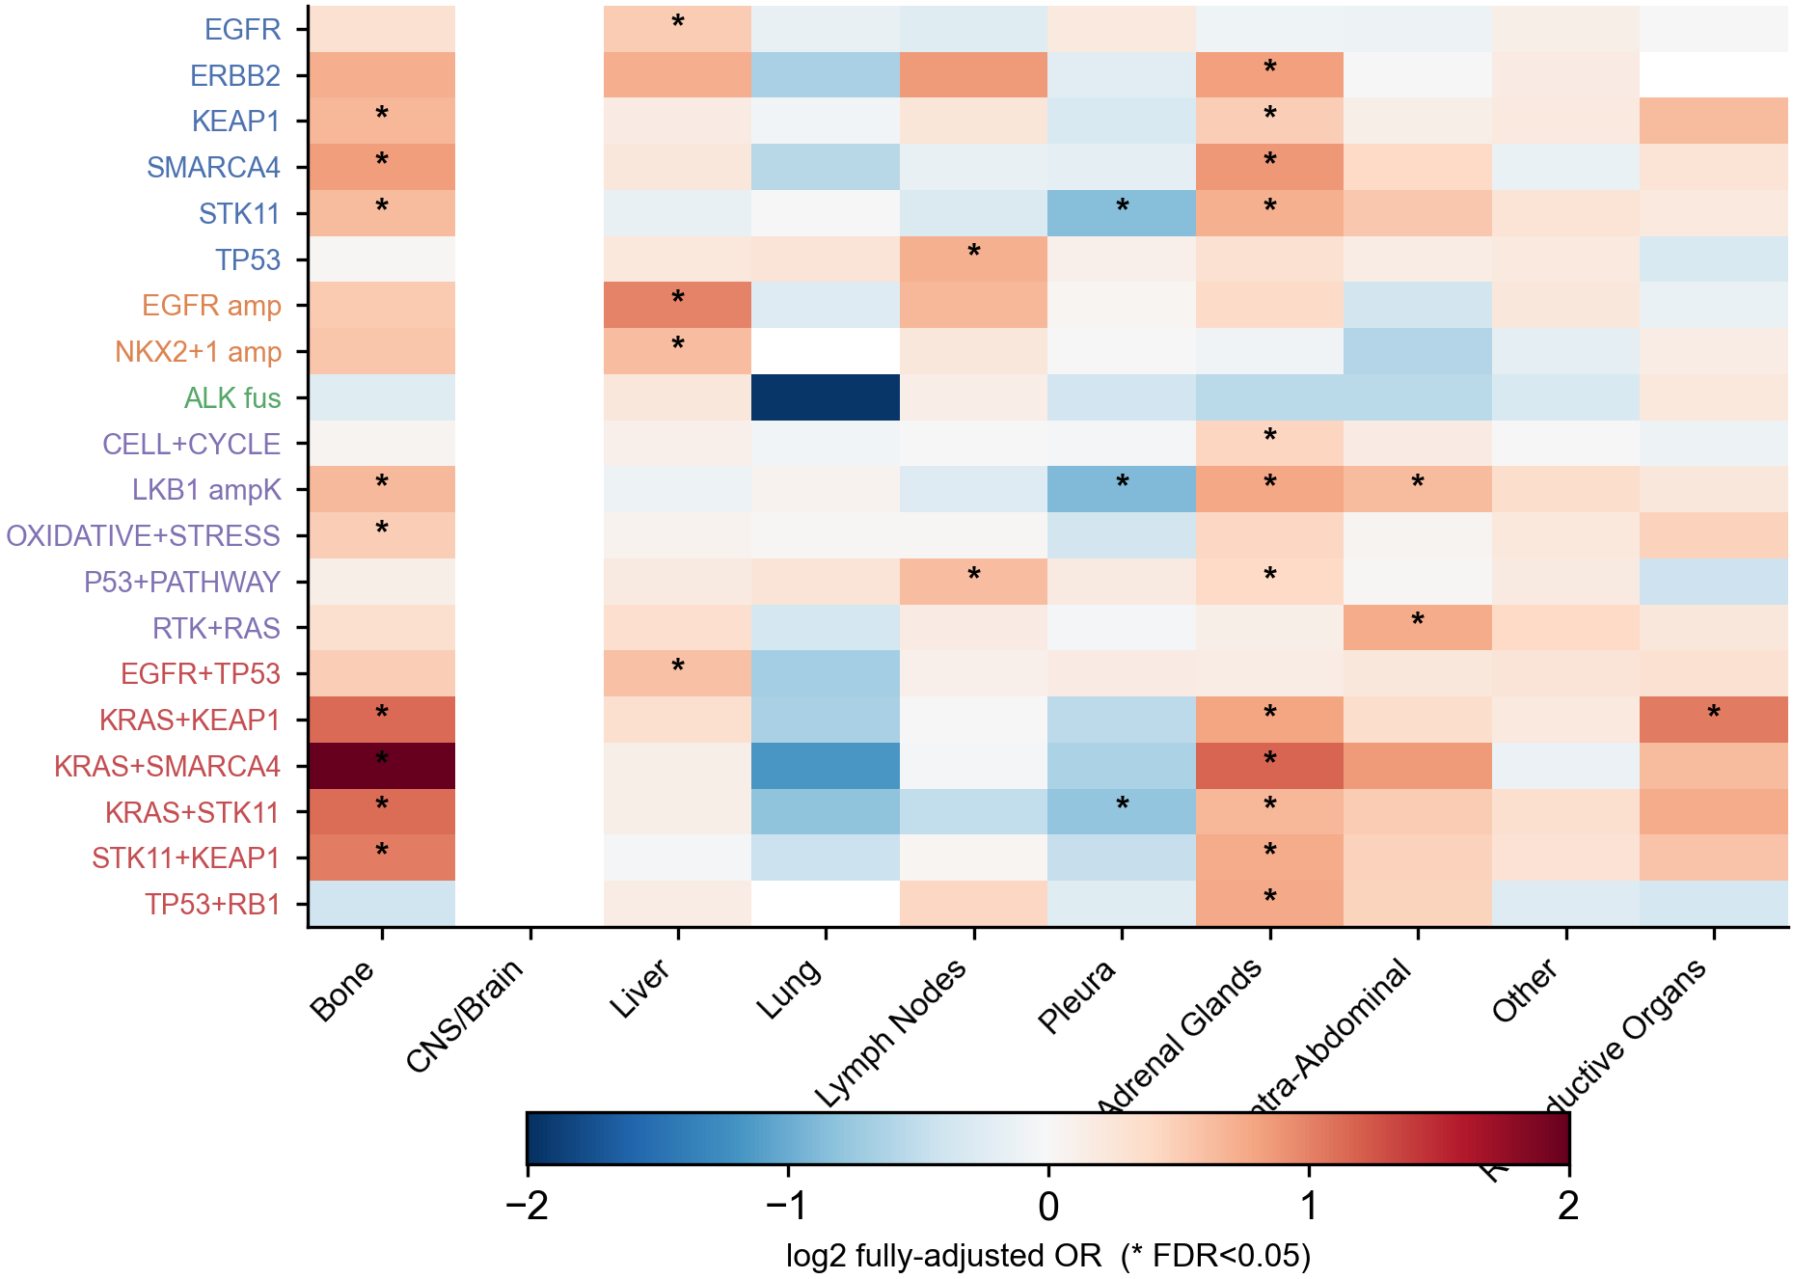
Supplementary Fig. S1. Cross-sectional odds-ratio map. Fully adjusted odds ratios (log2) for every feature-organ pair reaching FDR significance, features grouped by alteration class and y-axis labels colored by layer; asterisks mark FDR < 0.05. Companion to Fig. 2a.
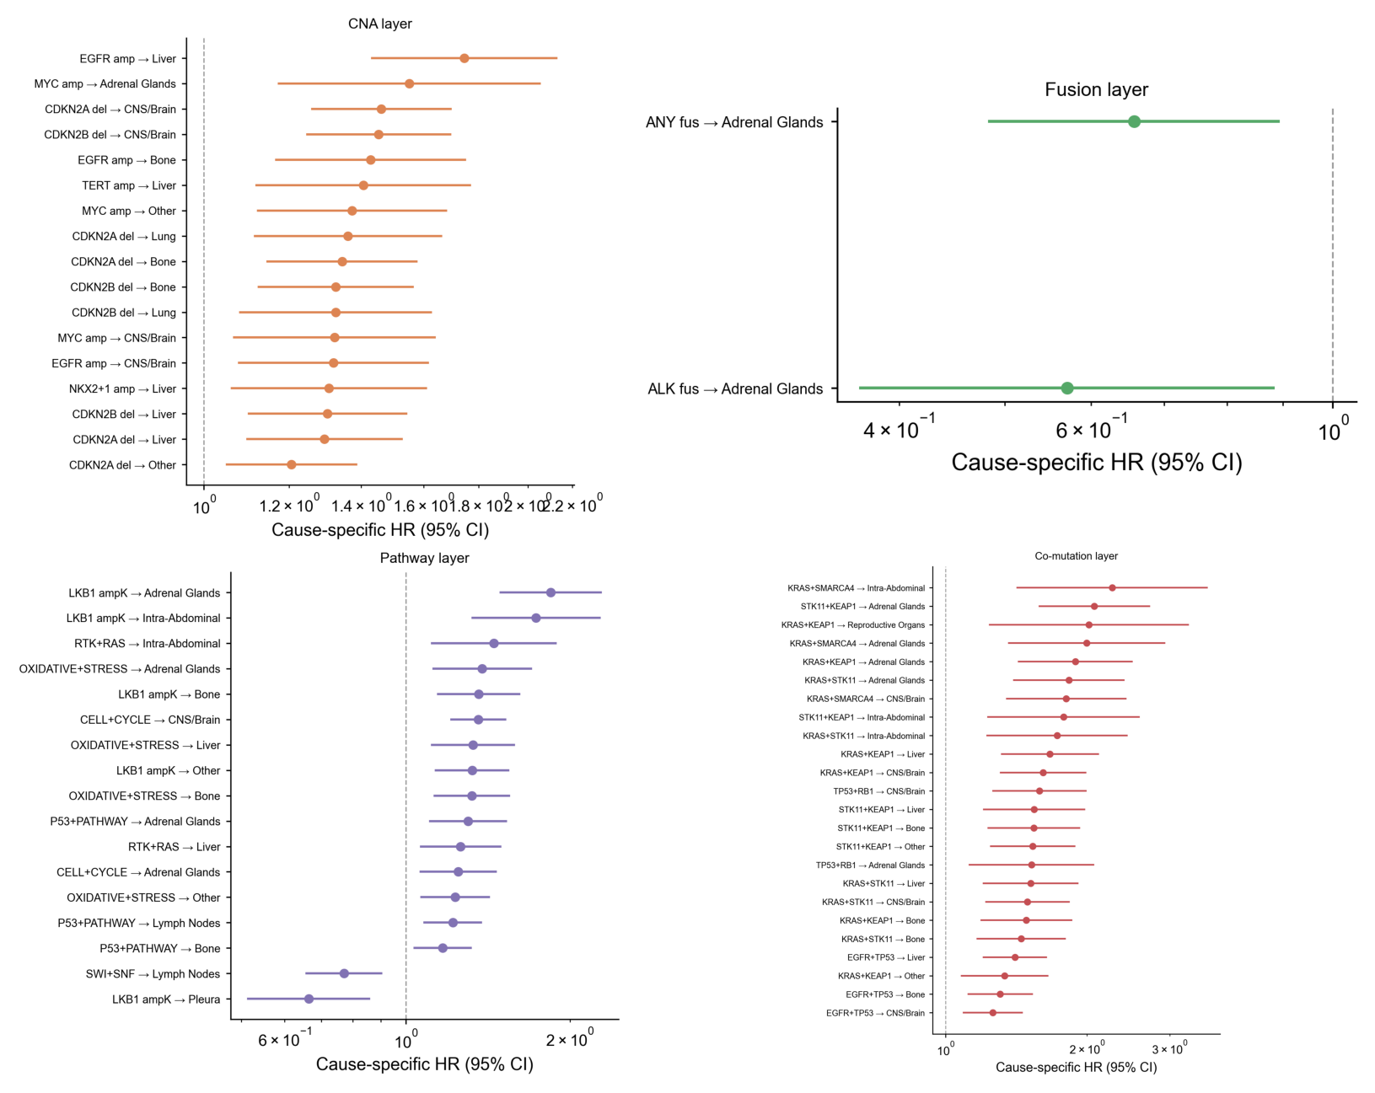
Supplementary Fig. S2. Per-layer cause-specific hazard-ratio forests. FDR-significant organ associations with 95% confidence intervals, shown separately for the copy-number, fusion, pathway and co-mutation layers.
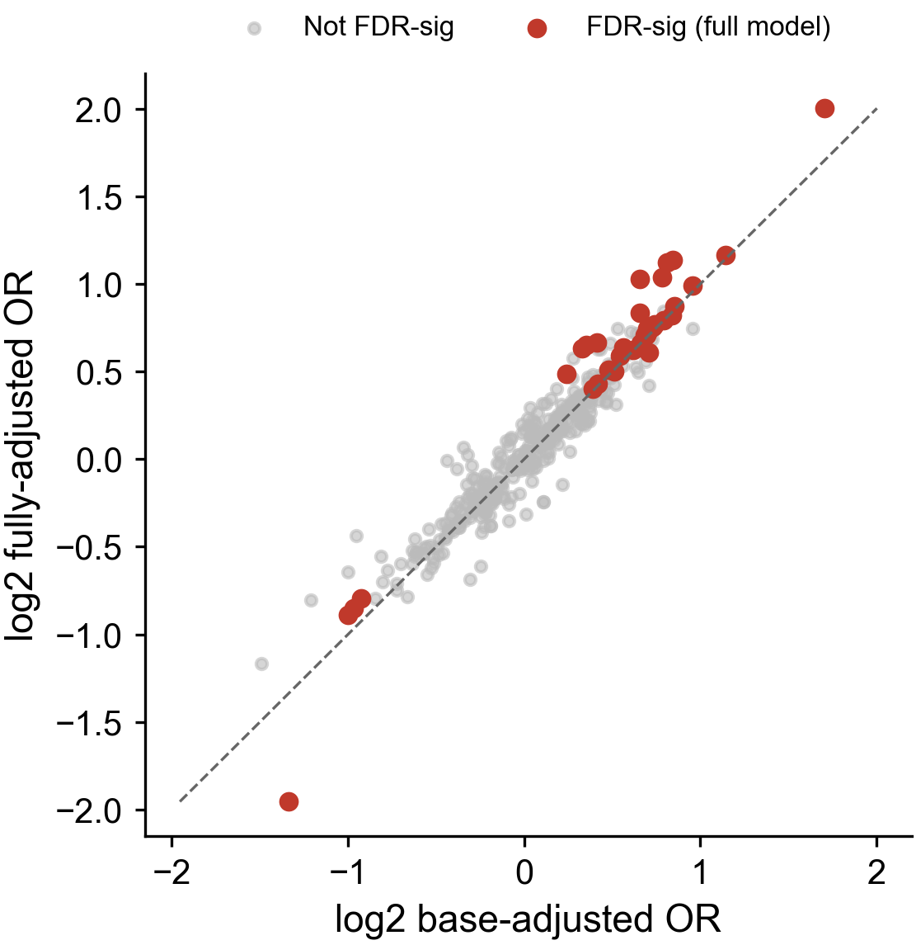
Supplementary Fig. S3. Attenuation of odds ratios under full adjustment. Base-adjusted versus fully adjusted odds ratios (log2) for all tested feature-organ pairs; points on the diagonal are unchanged by adjustment for imaging frequency and treatment exposure. FDR-significant associations are highlighted.
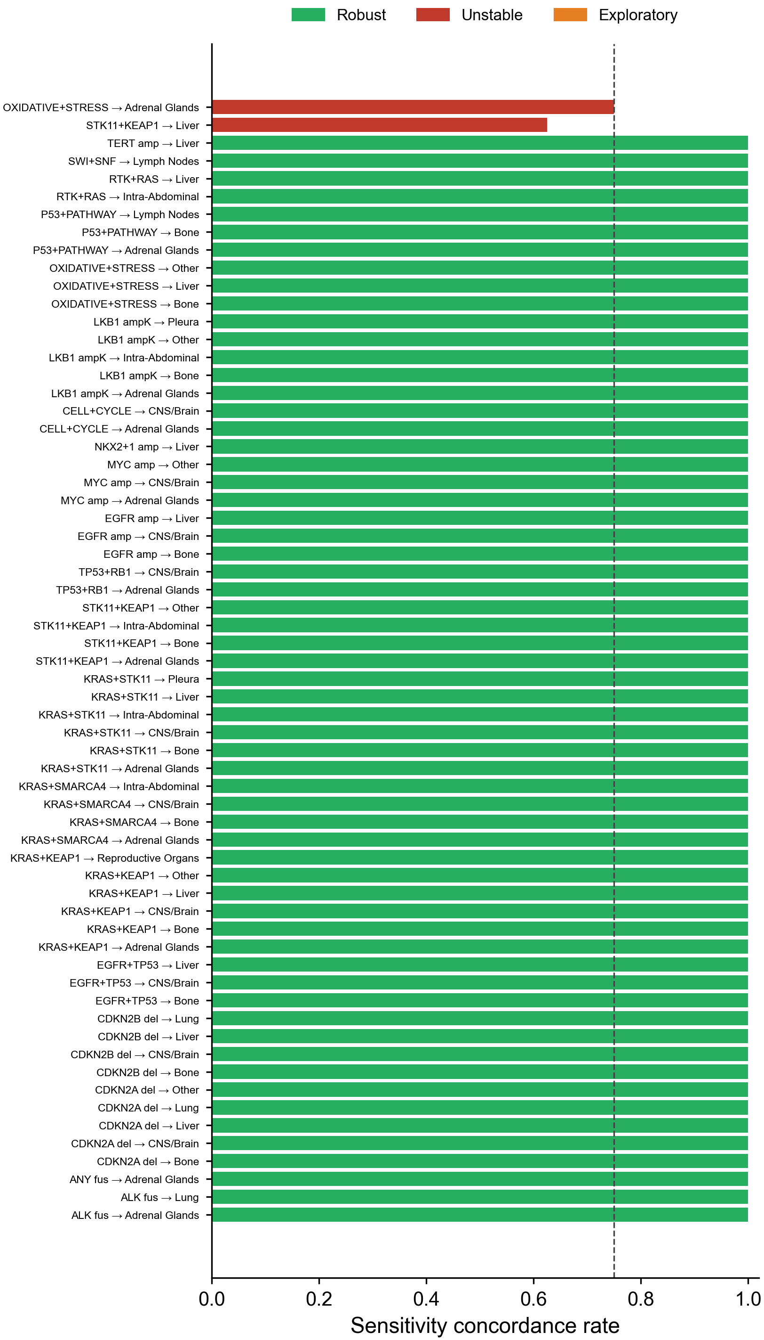
Supplementary Fig. S4. Robustness classification across sensitivity cohorts. Sensitivity concordance rate for each FDR-significant expanded association across four cohort definitions (≥6 months follow-up, ≥12 months, adenocarcinoma only, ≥3 imaging timepoints); the dashed line marks the 0.75 robustness threshold and bars are colored by classification.
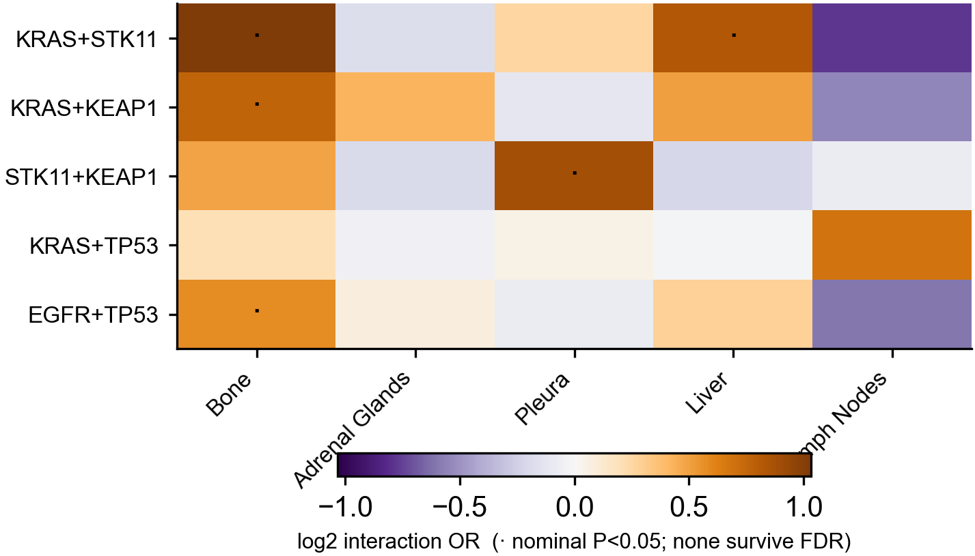
Supplementary Fig. S5. Co-mutation interaction grid. Log2 multiplicative interaction odds ratio for each gene pair across organs; dots mark nominal P < 0.05. No interaction term survived FDR correction, consistent with additive rather than synergistic co-mutation tropism.
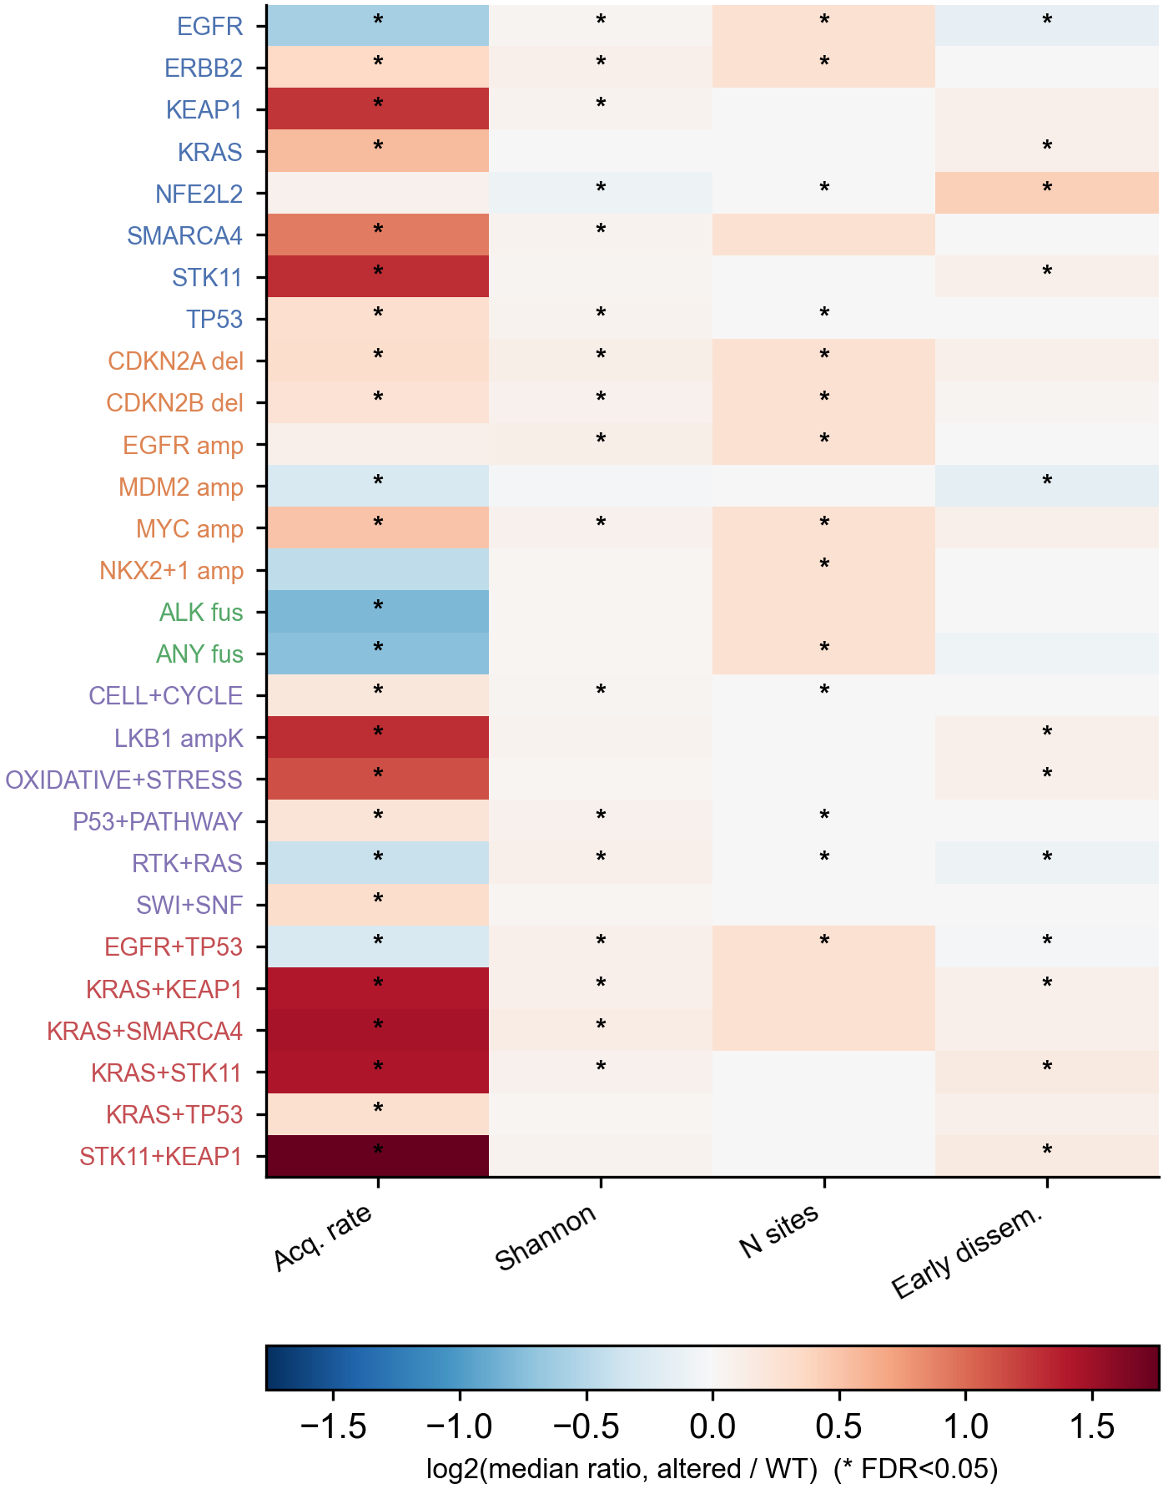
Supplementary Fig. S6. Genotype-associated dissemination metrics. Log2 median ratio (altered versus wild-type) for each feature across the four dissemination measures (acquisition rate, Shannon diversity, number of sites ever involved, early dissemination); asterisks mark FDR < 0.05.
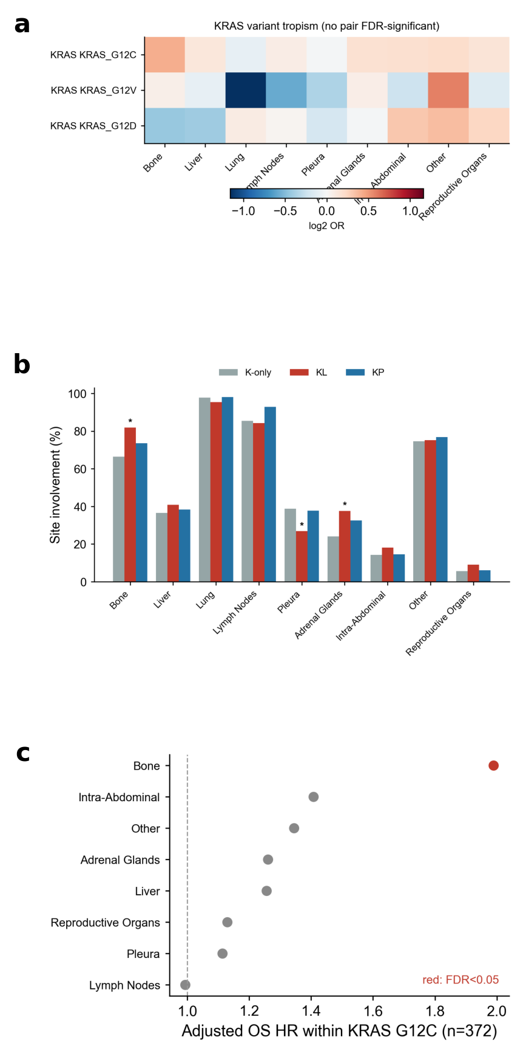
Supplementary Fig. S7. KRAS variant-level and co-mutation subgroup tropism. a, Variant-organ odds ratios (log2) for KRAS G12C, G12V and G12D; no pair reached FDR significance. b, Organ involvement by Skoulidis subgroup (K-only, KL, KP); asterisks mark FDR < 0.05. c, Adjusted overall-survival hazard ratios by organ within KRAS G12C carriers (n = 372); red marks FDR < 0.05.

