Supplementary Information for
Decoupling Na⁺ Solvation and Interfacial Chemistry via Dual-Anion Synergy Enables Wide-Temperature Sodium-Ion Batteries
Danning Yu^{1,3}, Qiao Zhang^{2,3}, Xingxing Yin², Li Liu¹, Min Zhou¹, Mingjiong Zhou¹*, Jun Wang²*, and Xing Xin¹*
¹ School of Material Science and Chemical Engineering, Ningbo University, Ningbo 315211, P. R. China
² Department of Materials Science & Engineering, School of Innovation and Entrepreneurship, Southern University of Science and Technology, Shenzhen 518055, P. R. China
³ These authors contributed equally to this work.

*Corresponding authors.
E-mail addresses: zhoumingjiong@nbu.edu.cn (M. J. Zhou); xinxing@nbu.edu.cn (X. Xin); wangj9@sustech.edu.cn (J. Wang).

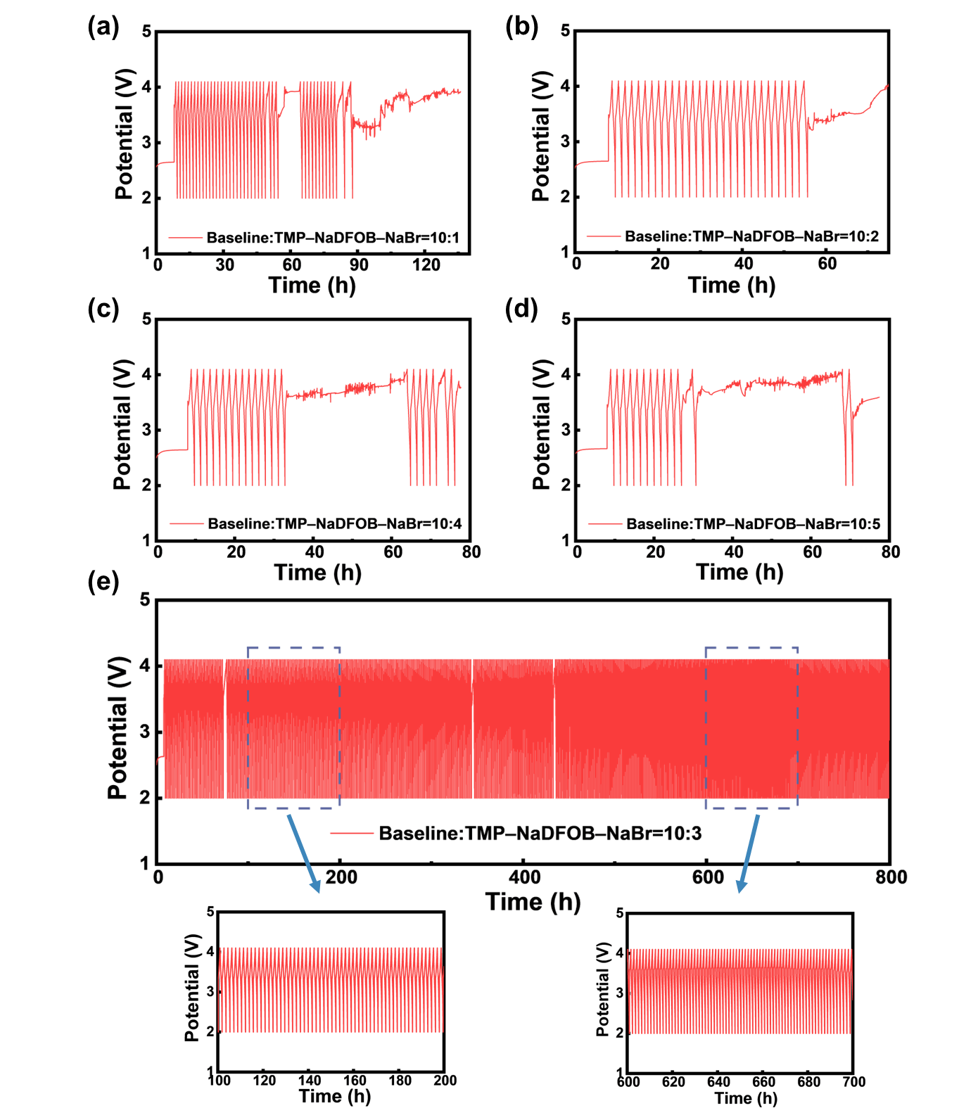
Supplementary Fig. 1. Cycling performance of Na||NMLTO cells with different electrolytes volume ratios at 1C.

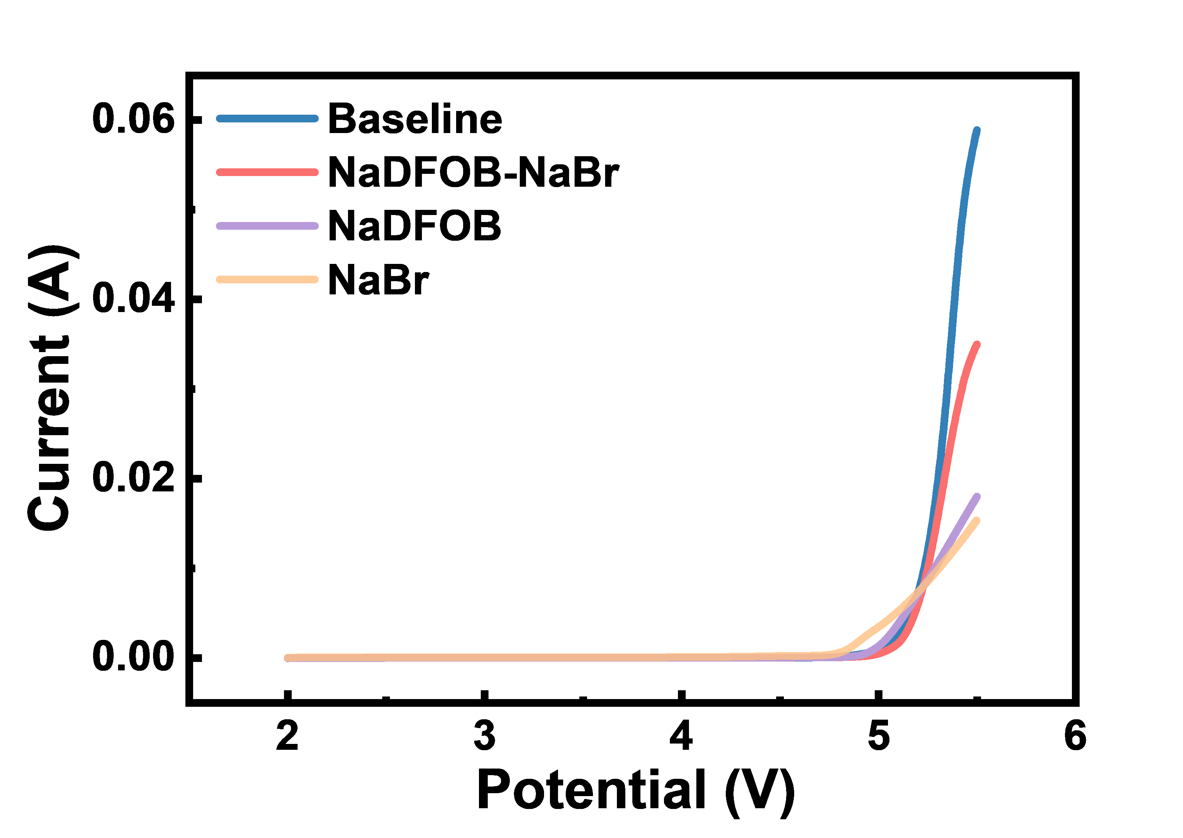
Supplementary Fig. 2. LSV curves of Na||SS cells.

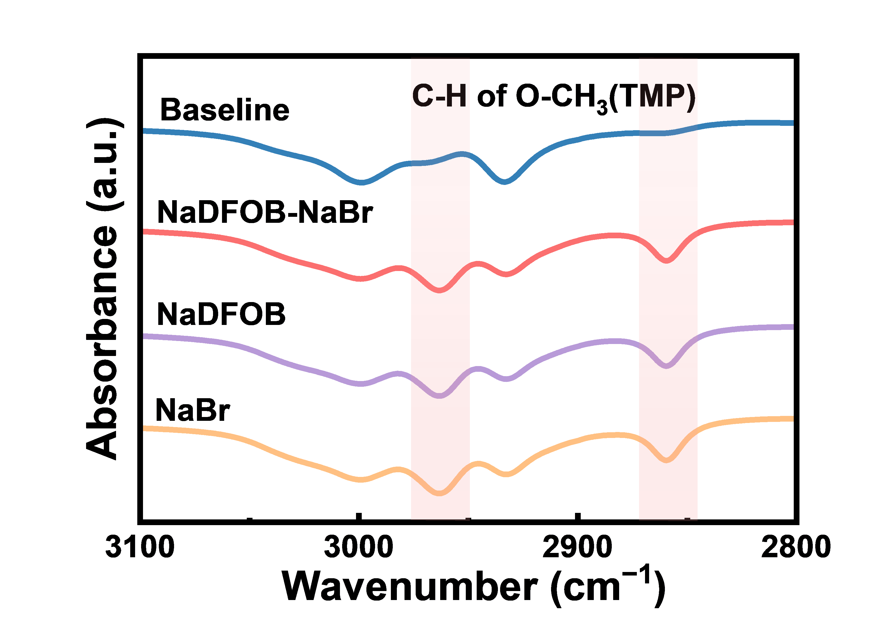
Supplementary Fig. 3. FTIR spectra of different electrolytes.

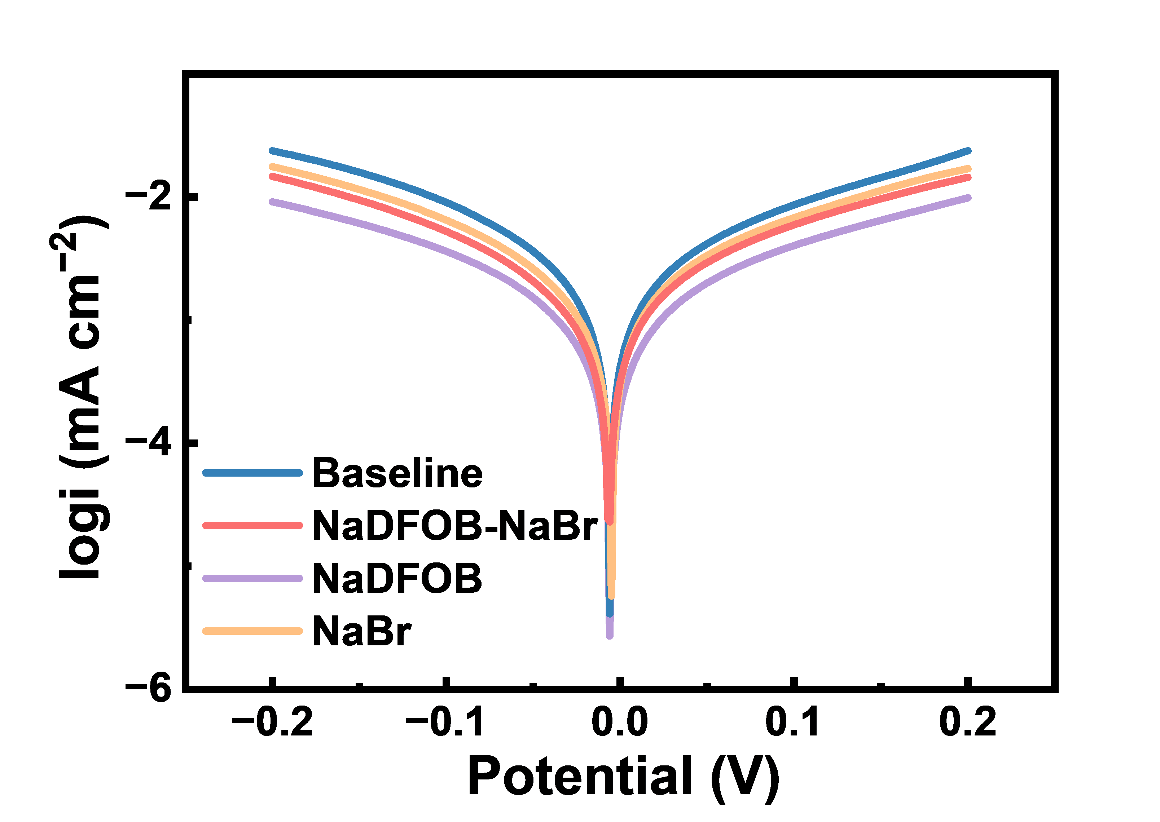
Supplementary Fig. 4. Tafel plots of Na||Na cells.

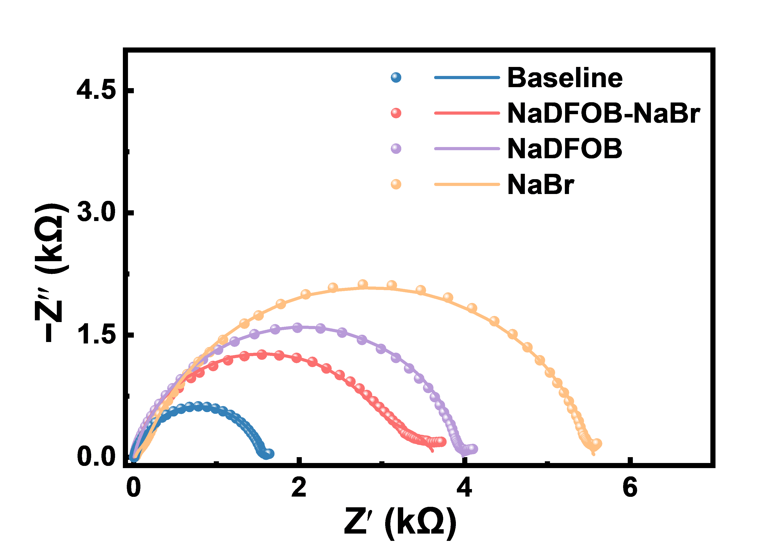
Supplementary Fig. 5. Nyquist plots of Na||Na cells.

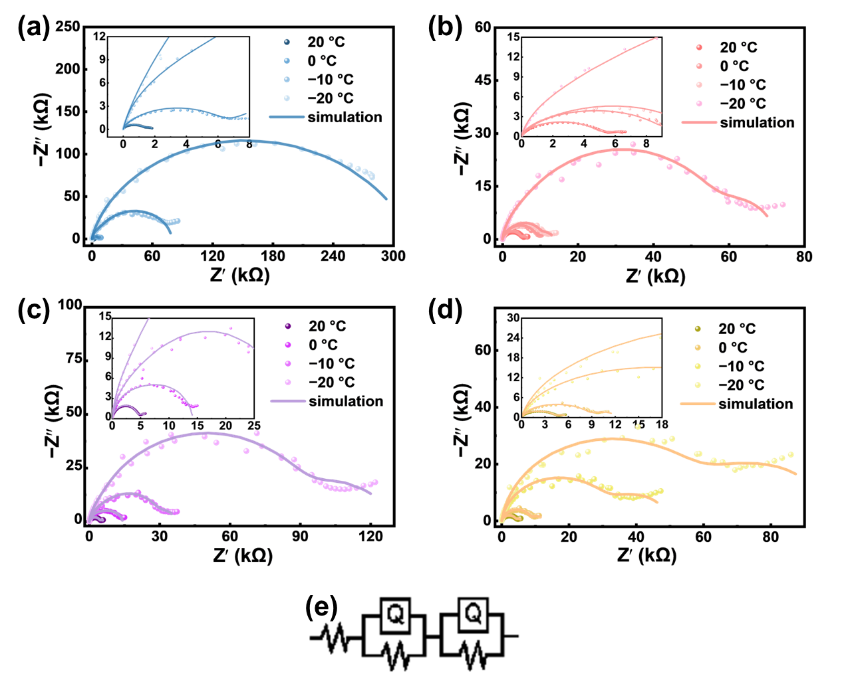
Supplementary Fig. 6. Nyquist plots of Na||Na symmetric cells with the (a) Baseline, (b) NaDFOB-NaBr, (c) NaDFOB, and (d) NaBr electrolytes measured at various temperatures. (e) Equivalent circuit model used for fitting the EIS spectra.

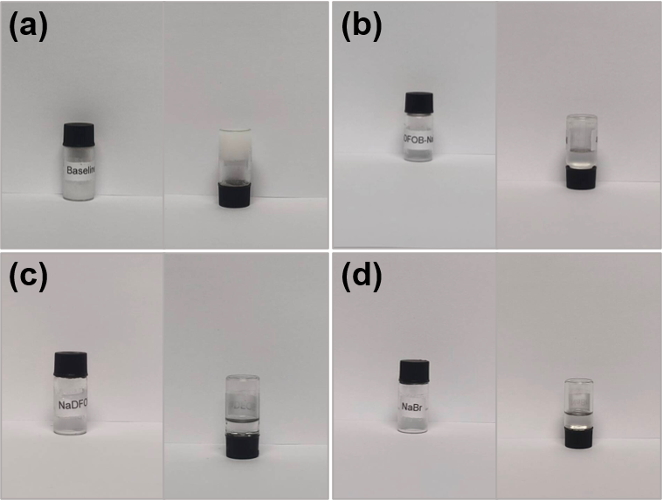
Supplementary Fig. 7. Photographs of different electrolytes at −40 °C: (a) Baseline, (b) NaDFOB-NaBr, (c) NaDFOB, and (d) NaBr.

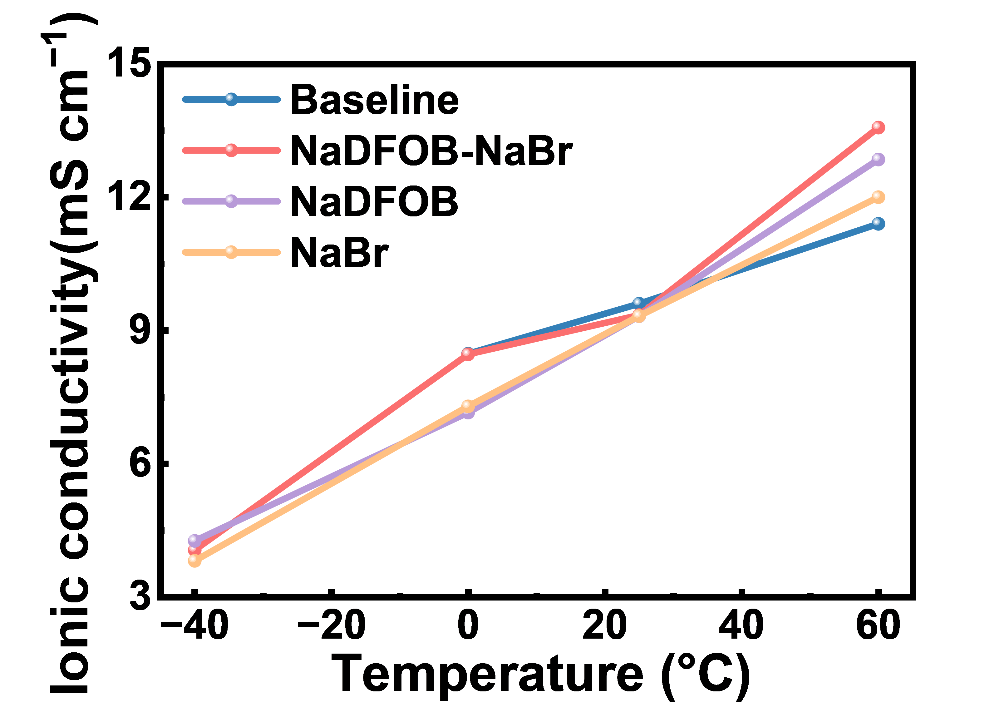
Supplementary Fig. 8. Temperature-dependent ionic conductivities of the electrolytes.

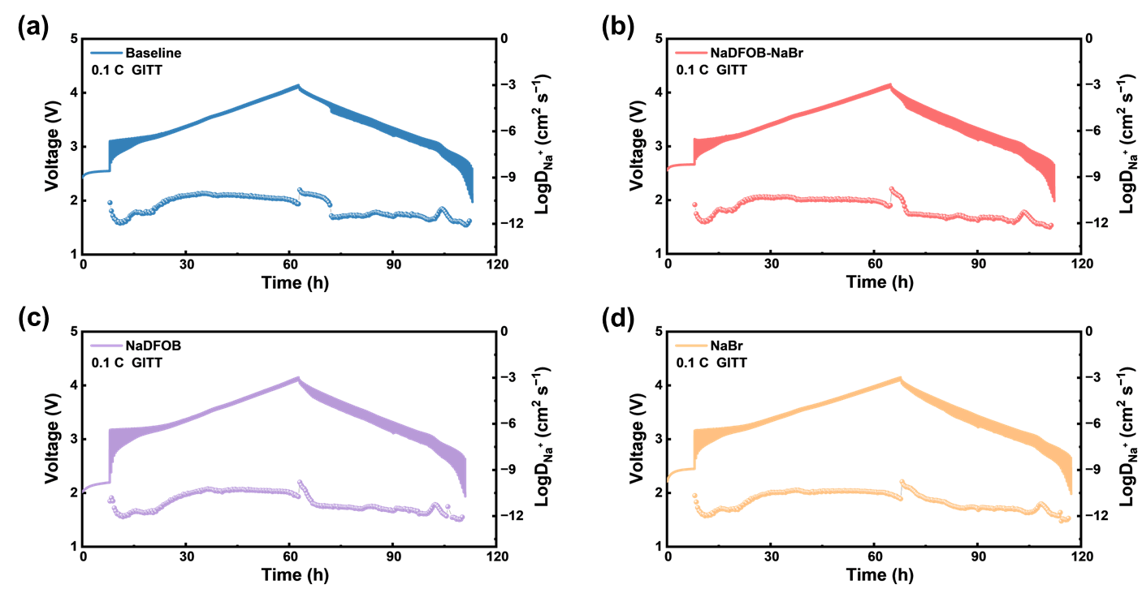
Supplementary Fig. 9. Na⁺ diffusion coefficients (D_{Na}⁺) in the cathode calculated from GITT plots during charge and discharge: (a) Baseline, (b) NaDFOB-NaBr, (c) NaDFOB, and (d) NaBr.

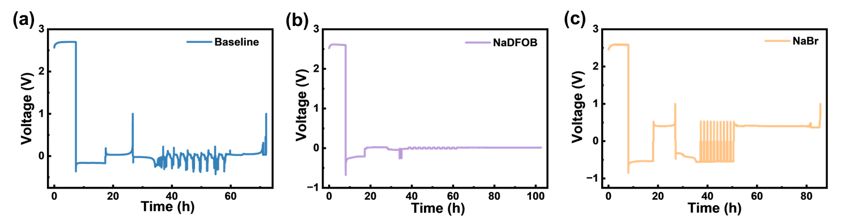
Supplementary Fig. 10. CE of Na plating/stripping measured in Na||Cu cells via the Aurbach method for (a) Baseline, (b) NaDFOB, and (c) NaBr.

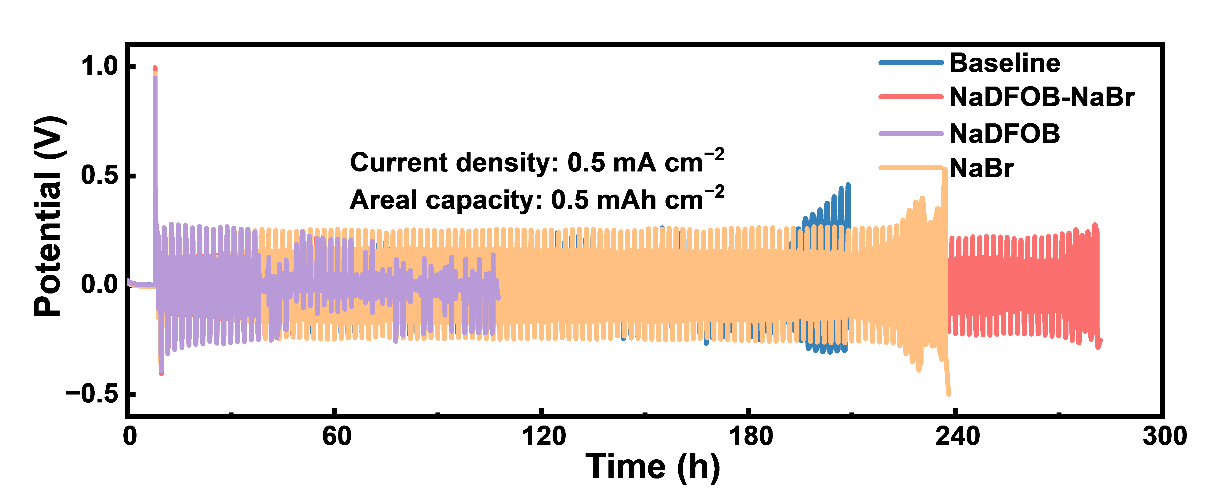
Supplementary Fig. 11. Voltage curves of Na||Na symmetric cells cycled at 0.5 mA cm⁻² and 0.5 mAh cm⁻².

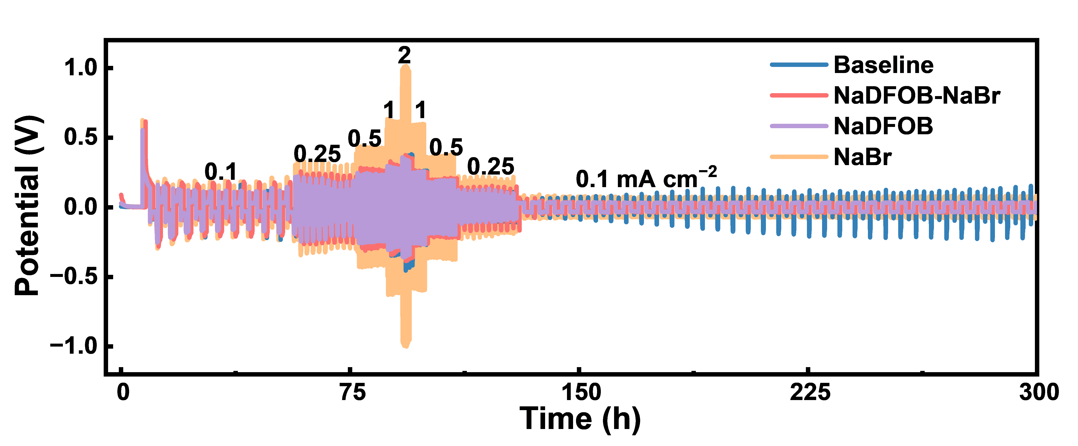
Supplementary Fig. 12. Rate capabilities of Na||Na symmetric cells with varying current densities from 0.1 to 2 mA cm⁻² and back to 0.1 mA cm⁻².

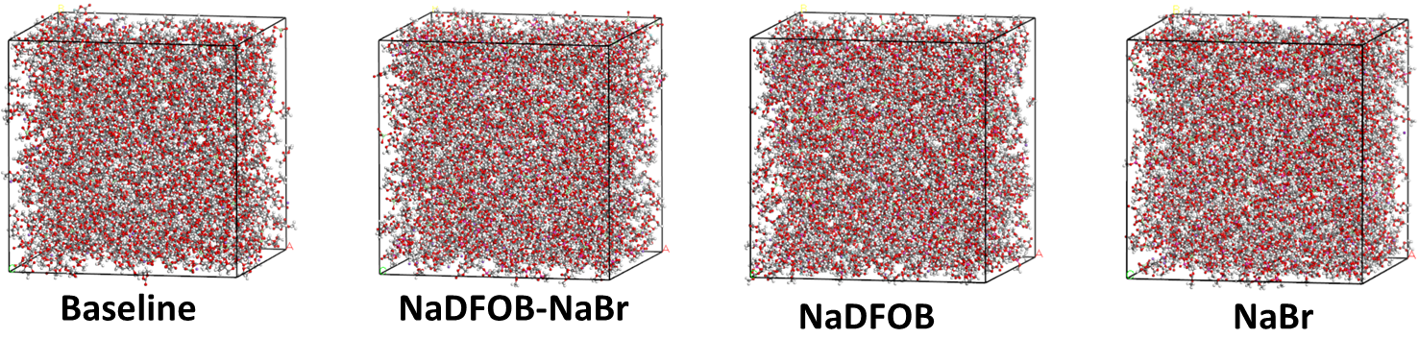
Supplementary Fig. 13. Representative solvation structure snapshots of different electrolytes obtained from MD simulations.

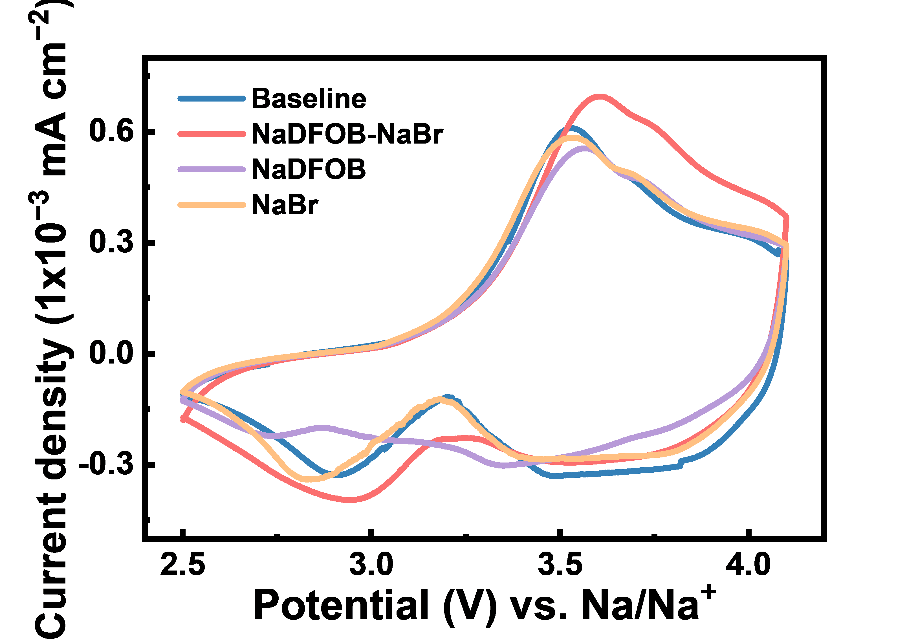
Supplementary Fig. 14. CV curves of Na||NMLTO cells with different electrolytes.

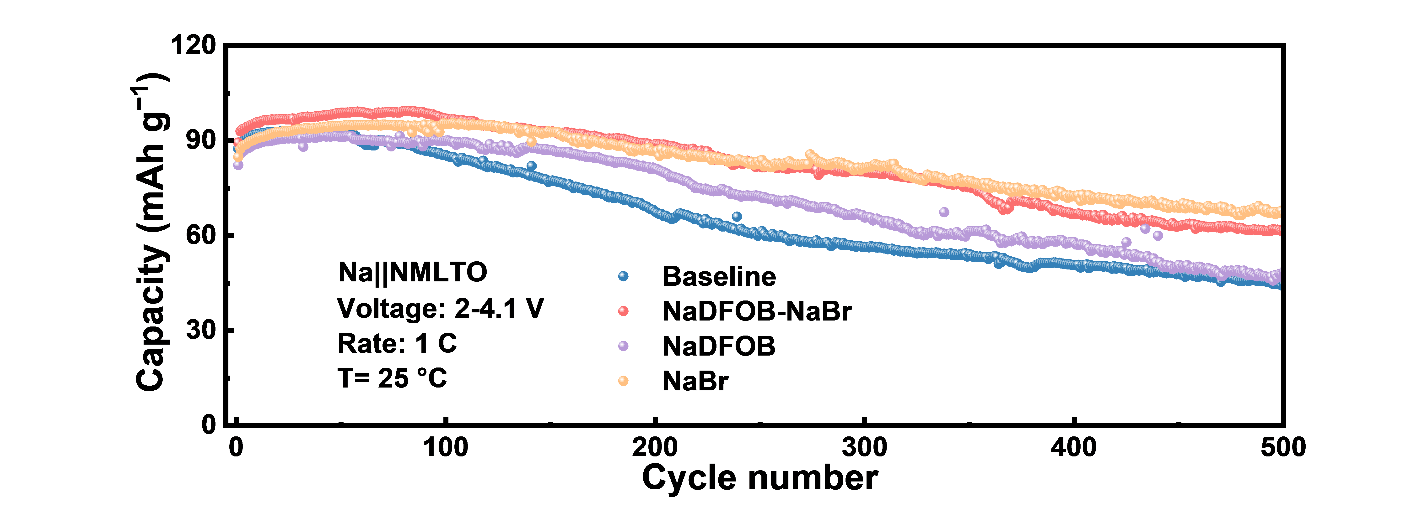
Supplementary Fig. 15. Cycling performance of Na||NMLTO cells with different electrolytes at 1 C.

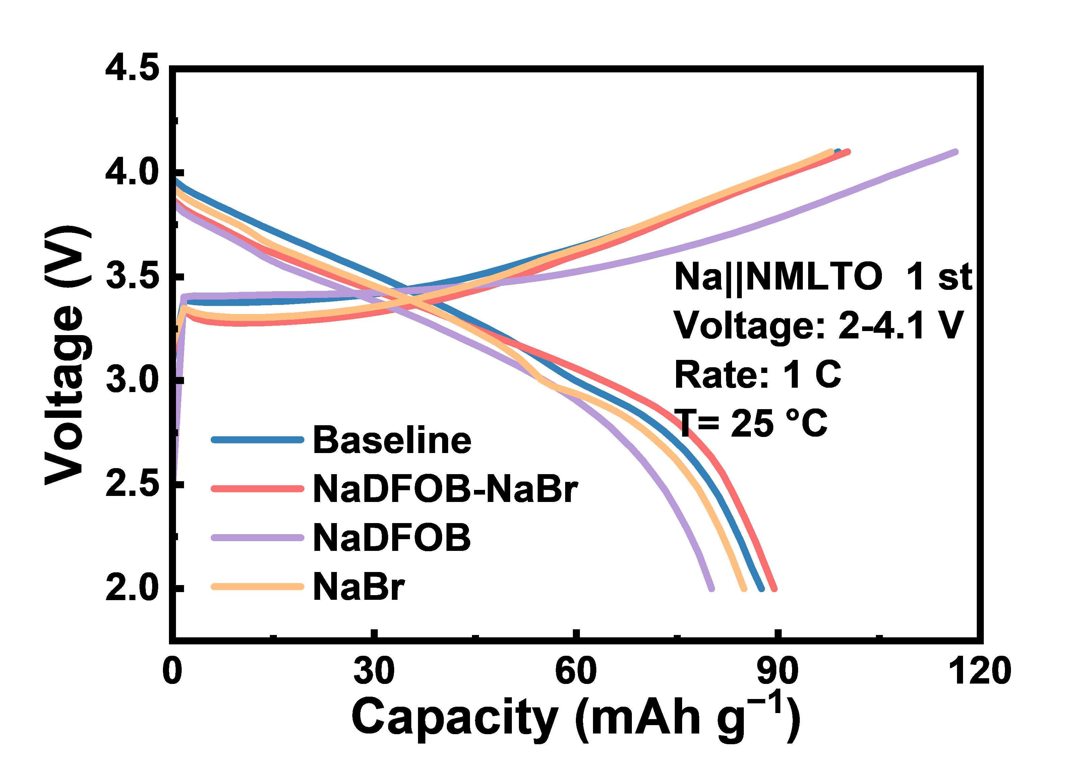
Supplementary Fig. 16. Initial charge/discharge curves of Na||NMLTO cells at 1 C.

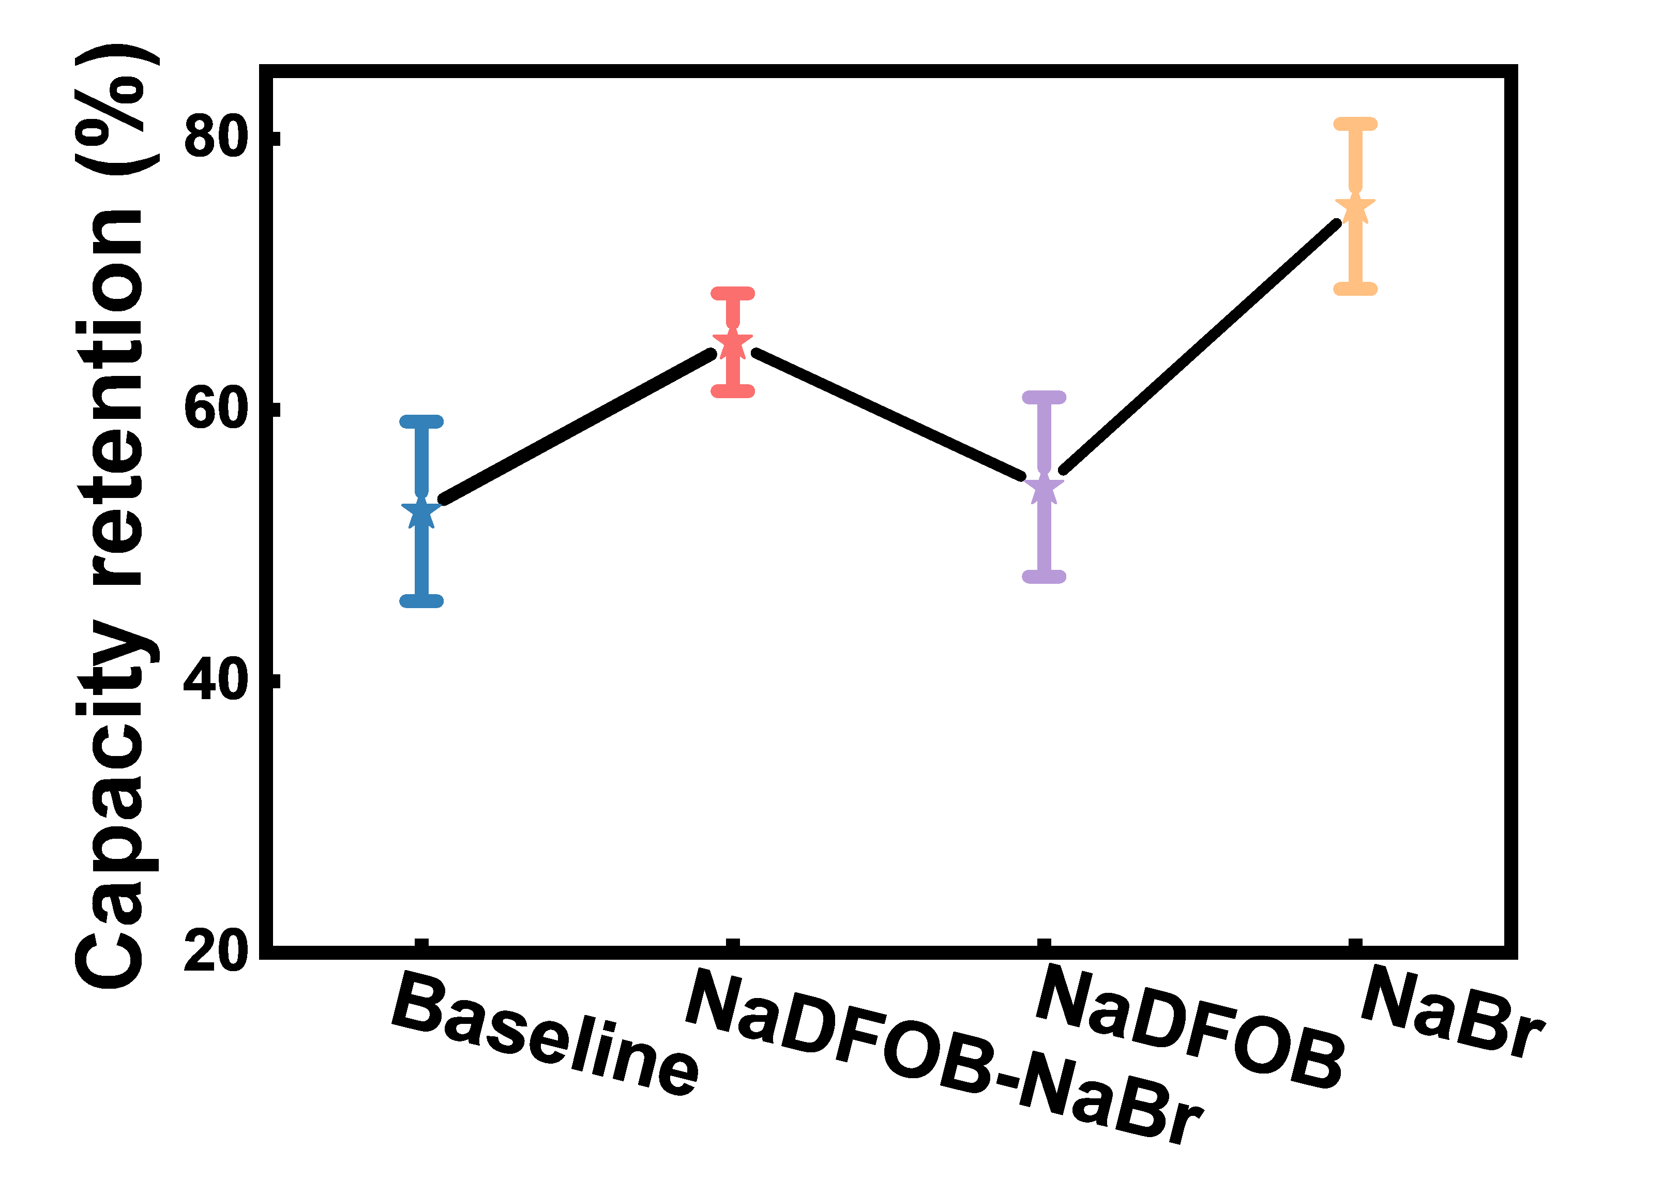
Supplementary Fig. 17. Statistical comparison of the capacity retention after 500 cycles for Na||NMLTO cells with different electrolytes at 1 C (presented as mean ± standard deviation).

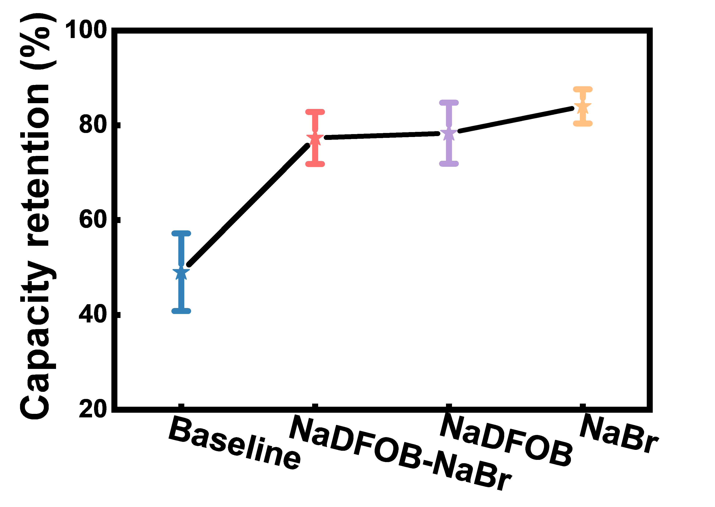
Supplementary Fig. 18. Statistical comparison of the capacity retention after 500 cycles for Na||NMLTO cells with different electrolytes at 5 C (presented as mean ± standard deviation).

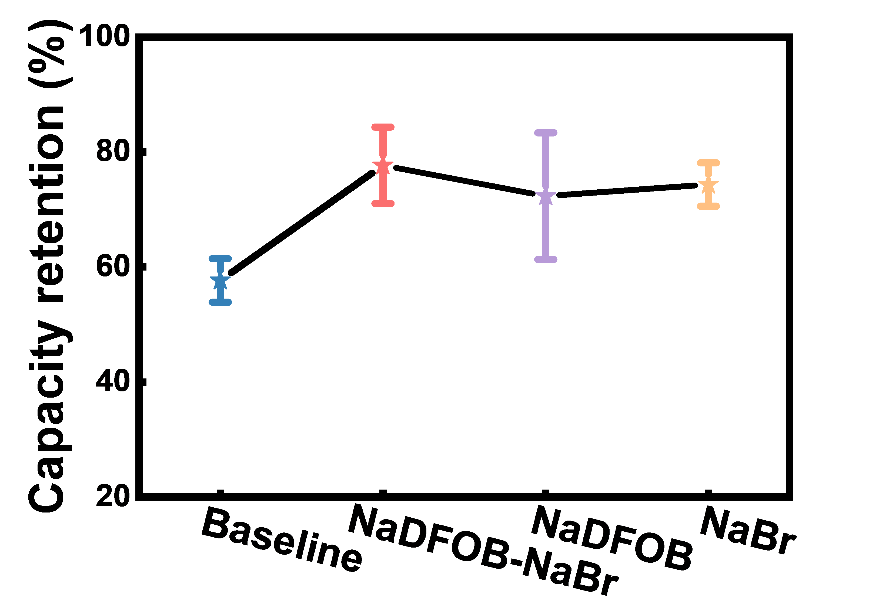
Supplementary Fig. 19. Statistical comparison of the capacity retention after 500 cycles for Na||NMLTO cells with different electrolytes at 5 C and 60 °C (presented as mean ± standard deviation).

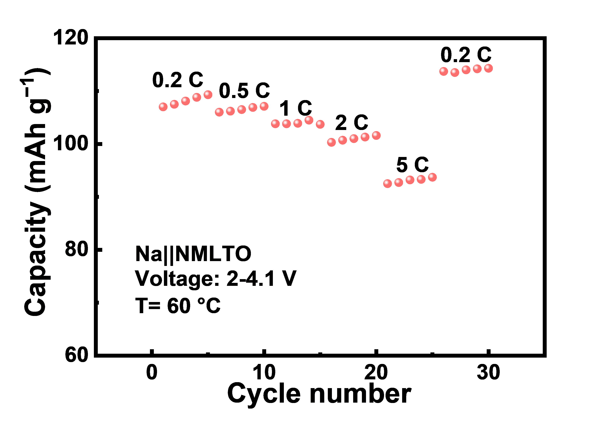
Supplementary Fig. 20. Rate capability of Na||NMLTO cell with NaDFOB-NaBr electrolyte at 60 ℃.

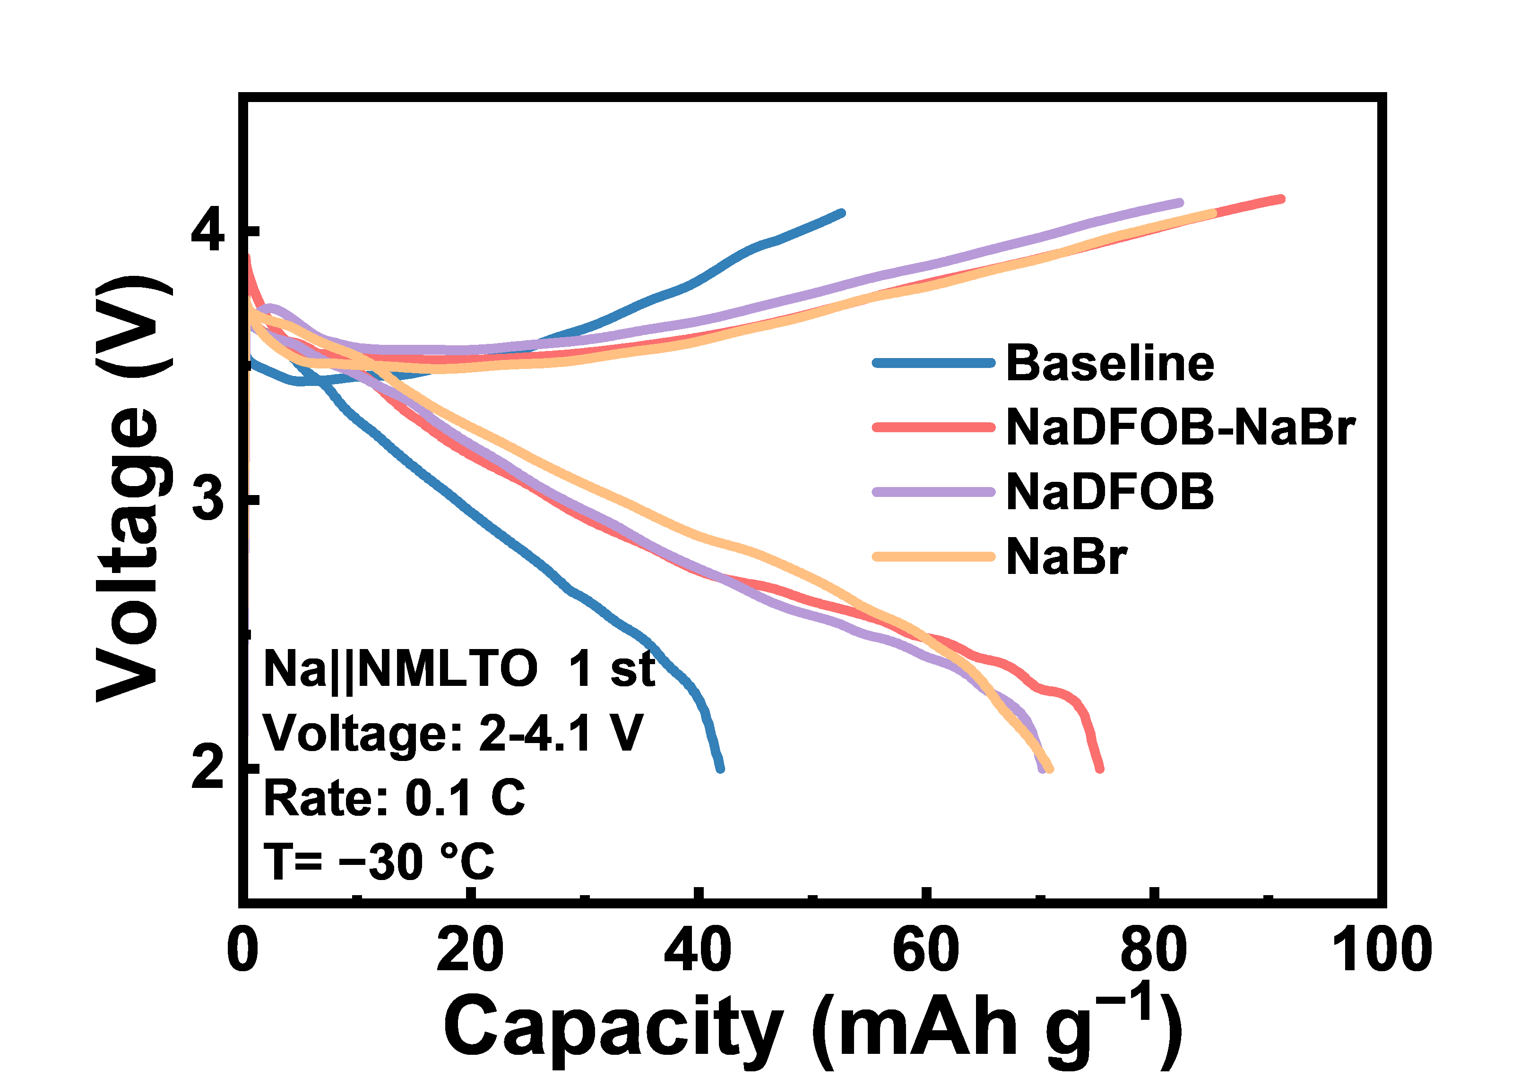
Supplementary Fig. 21. Initial charge/discharge curves of Na||NMLTO cells at 0.1 C and −30 ℃.

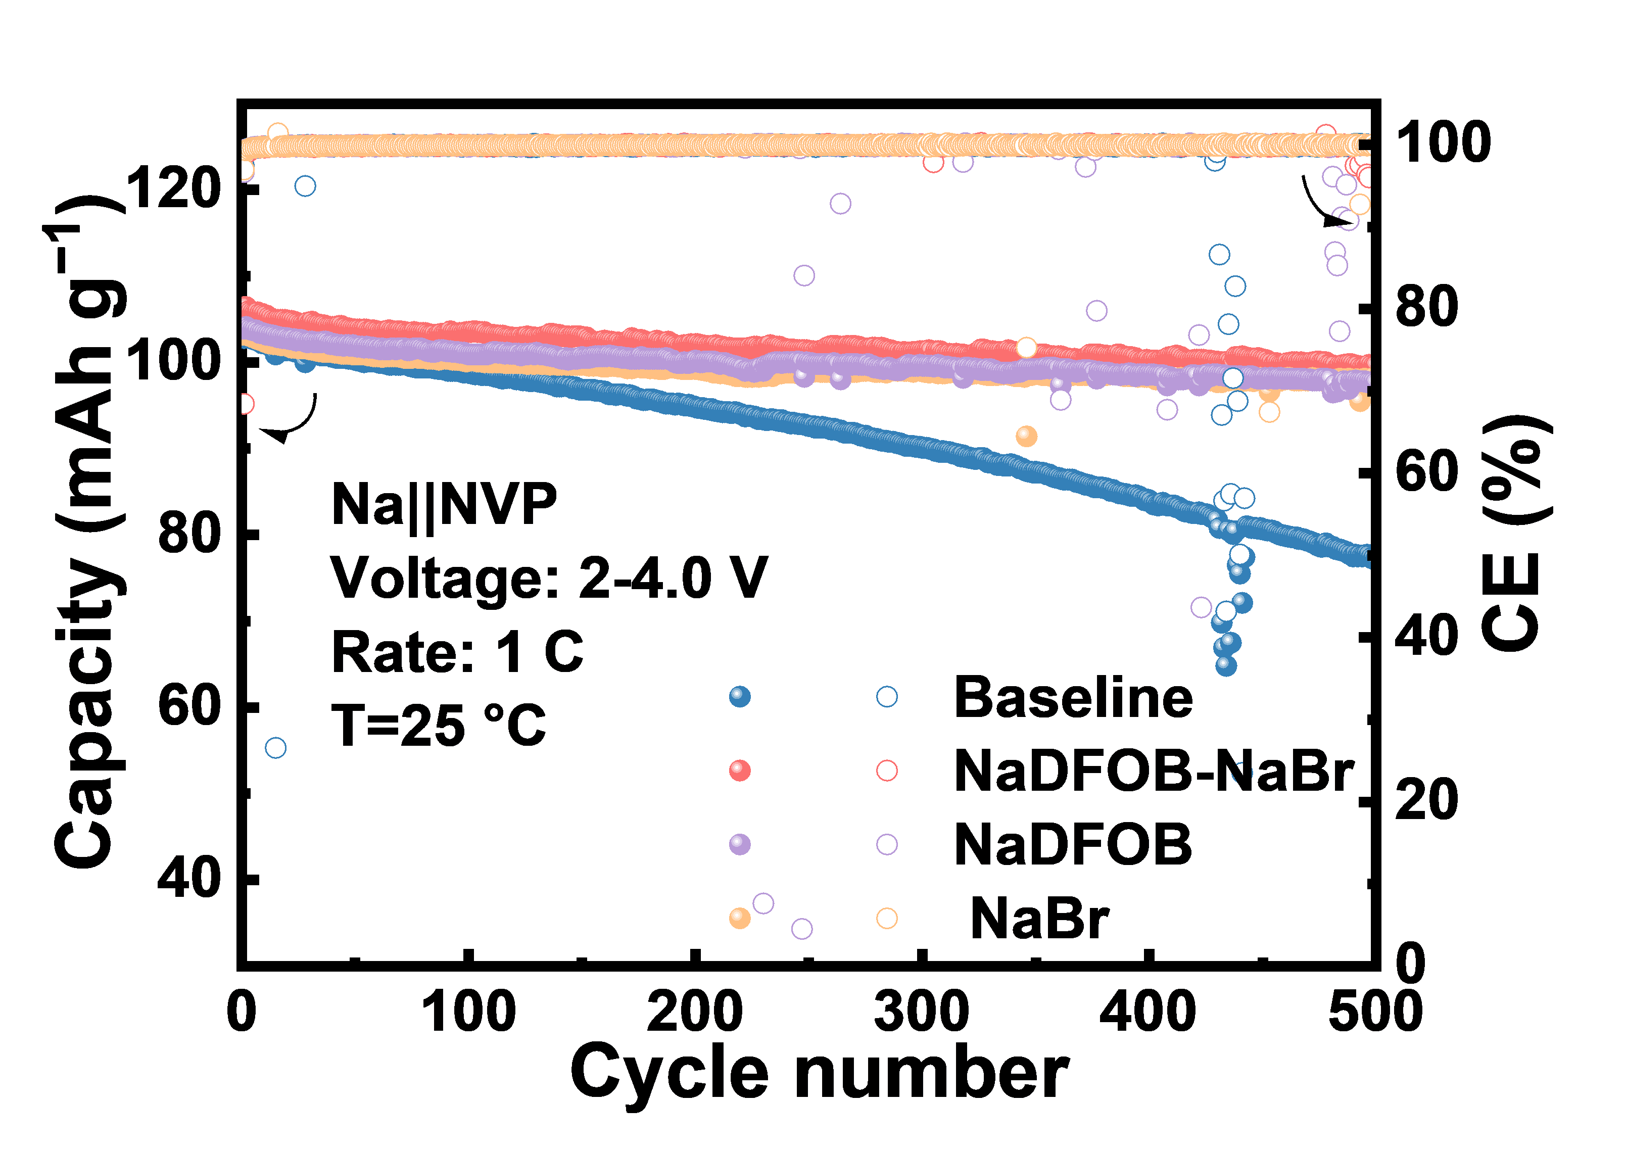
Supplementary Fig. 22. Cycling performance of Na||NVP cells with different electrolytes at 1 C.

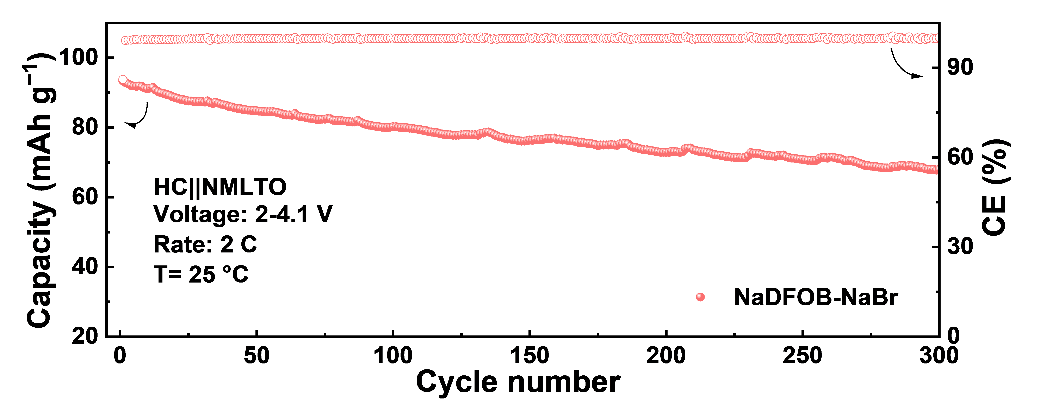
Supplementary Fig. 23. Cycling performance of HC||NMLTO cell with NaDFOB-NaBr electrolyte at 2 C.

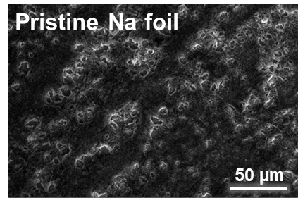
Supplementary Fig. 24. SEM image of pristine Na metal surface.

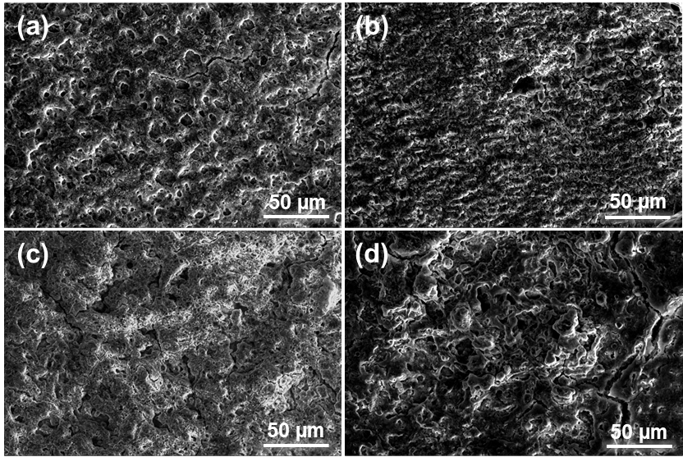
Supplementary Fig. 25. SEM images of Na metal surface after cycling with different electrolytes: (a) Baseline, (b) NaDFOB-NaBr, (c) NaDFOB, and (d) NaBr.

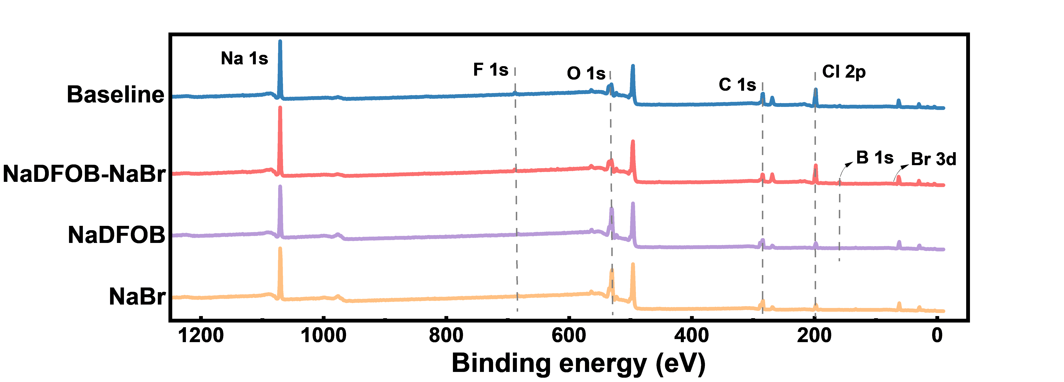
Supplementary Fig. 26. Survey XPS spectra of the cycled Na metal surface.

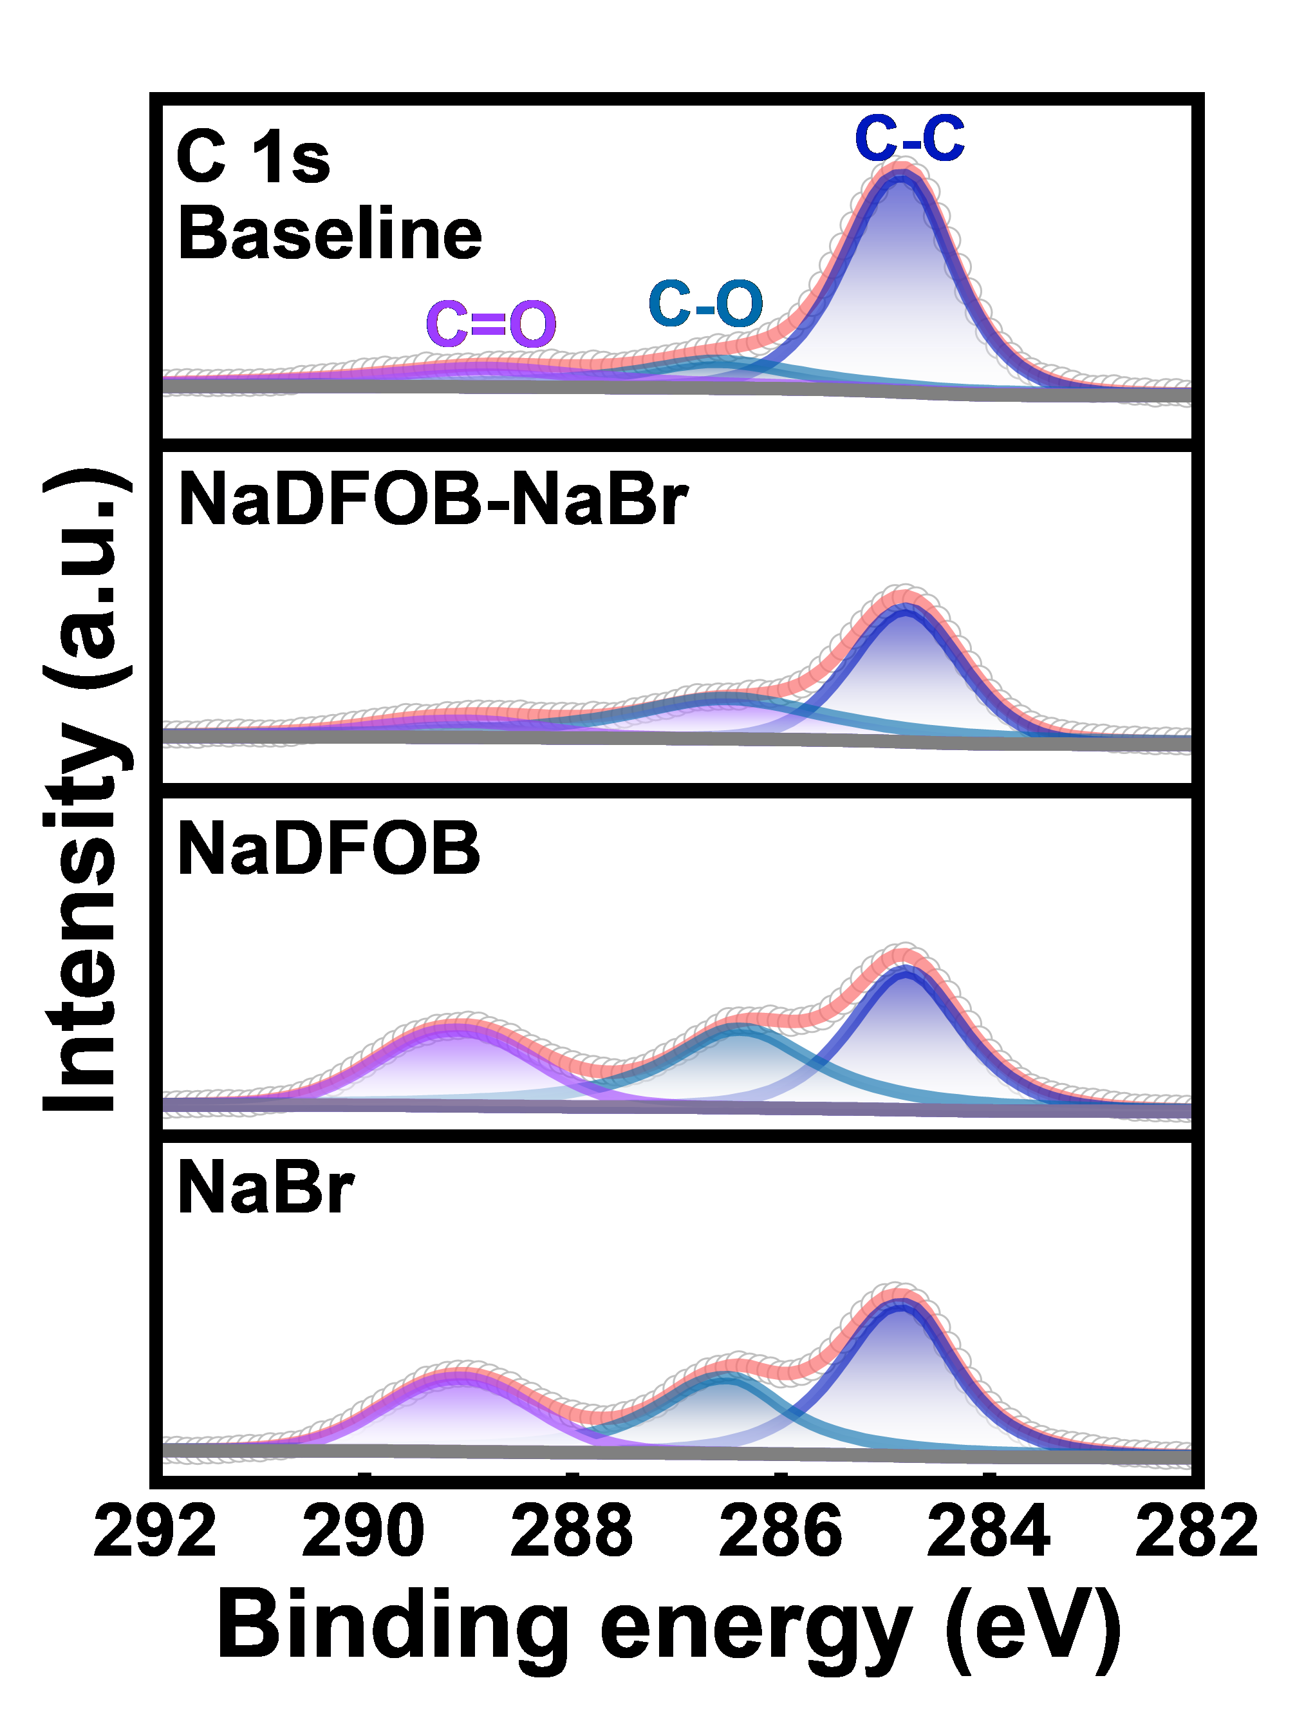
Supplementary Fig. 27. Normalized XPS fitting results of the C 1s peak.

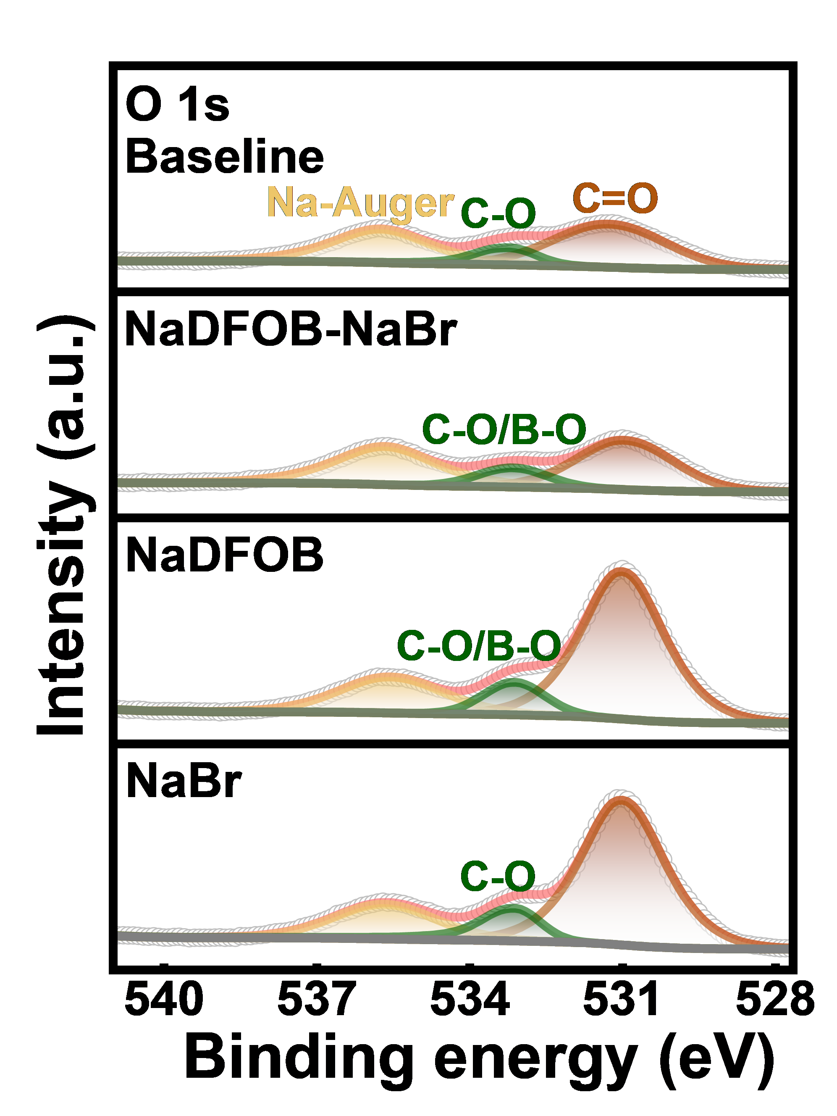
Supplementary Fig. 28. Normalized XPS fitting results of the O 1s peak.

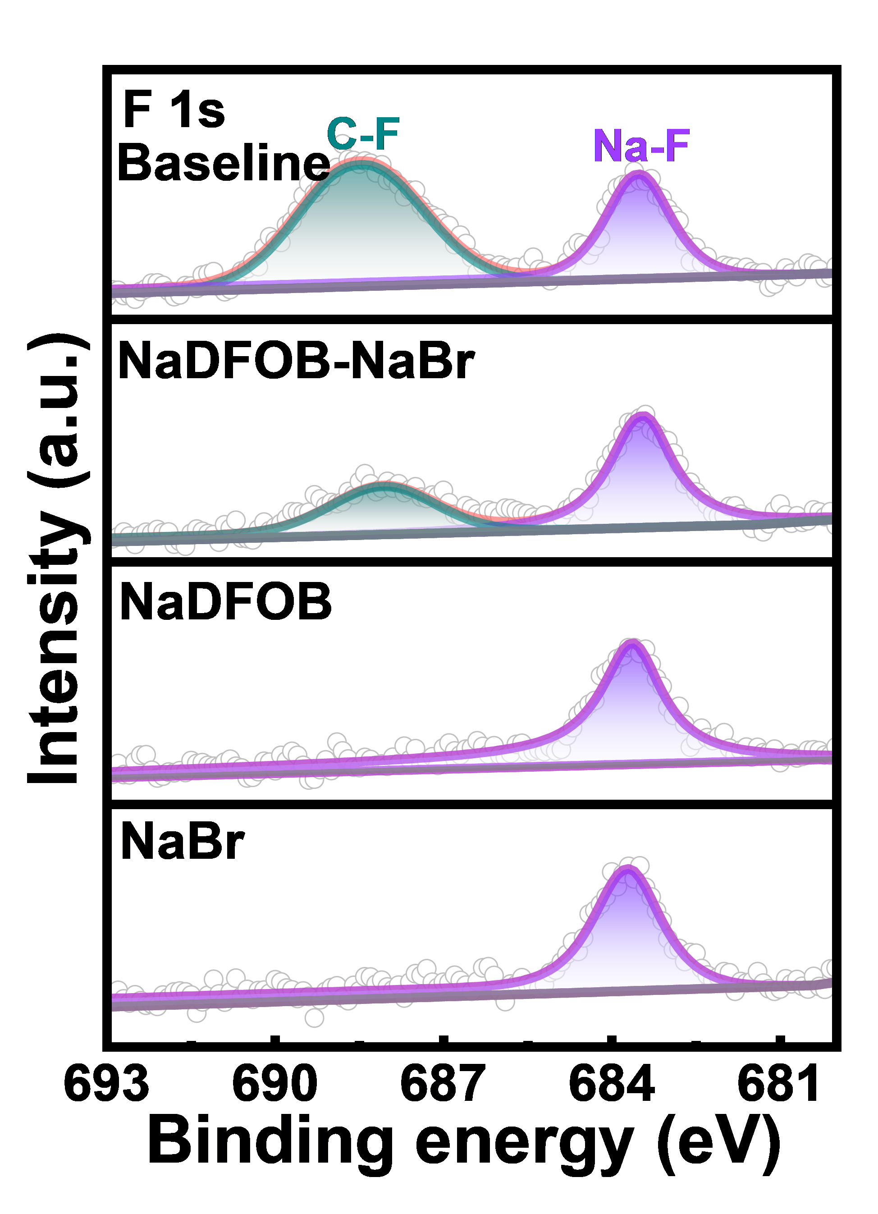
Supplementary Fig. 29. Normalized XPS fitting results of the F 1s peak.

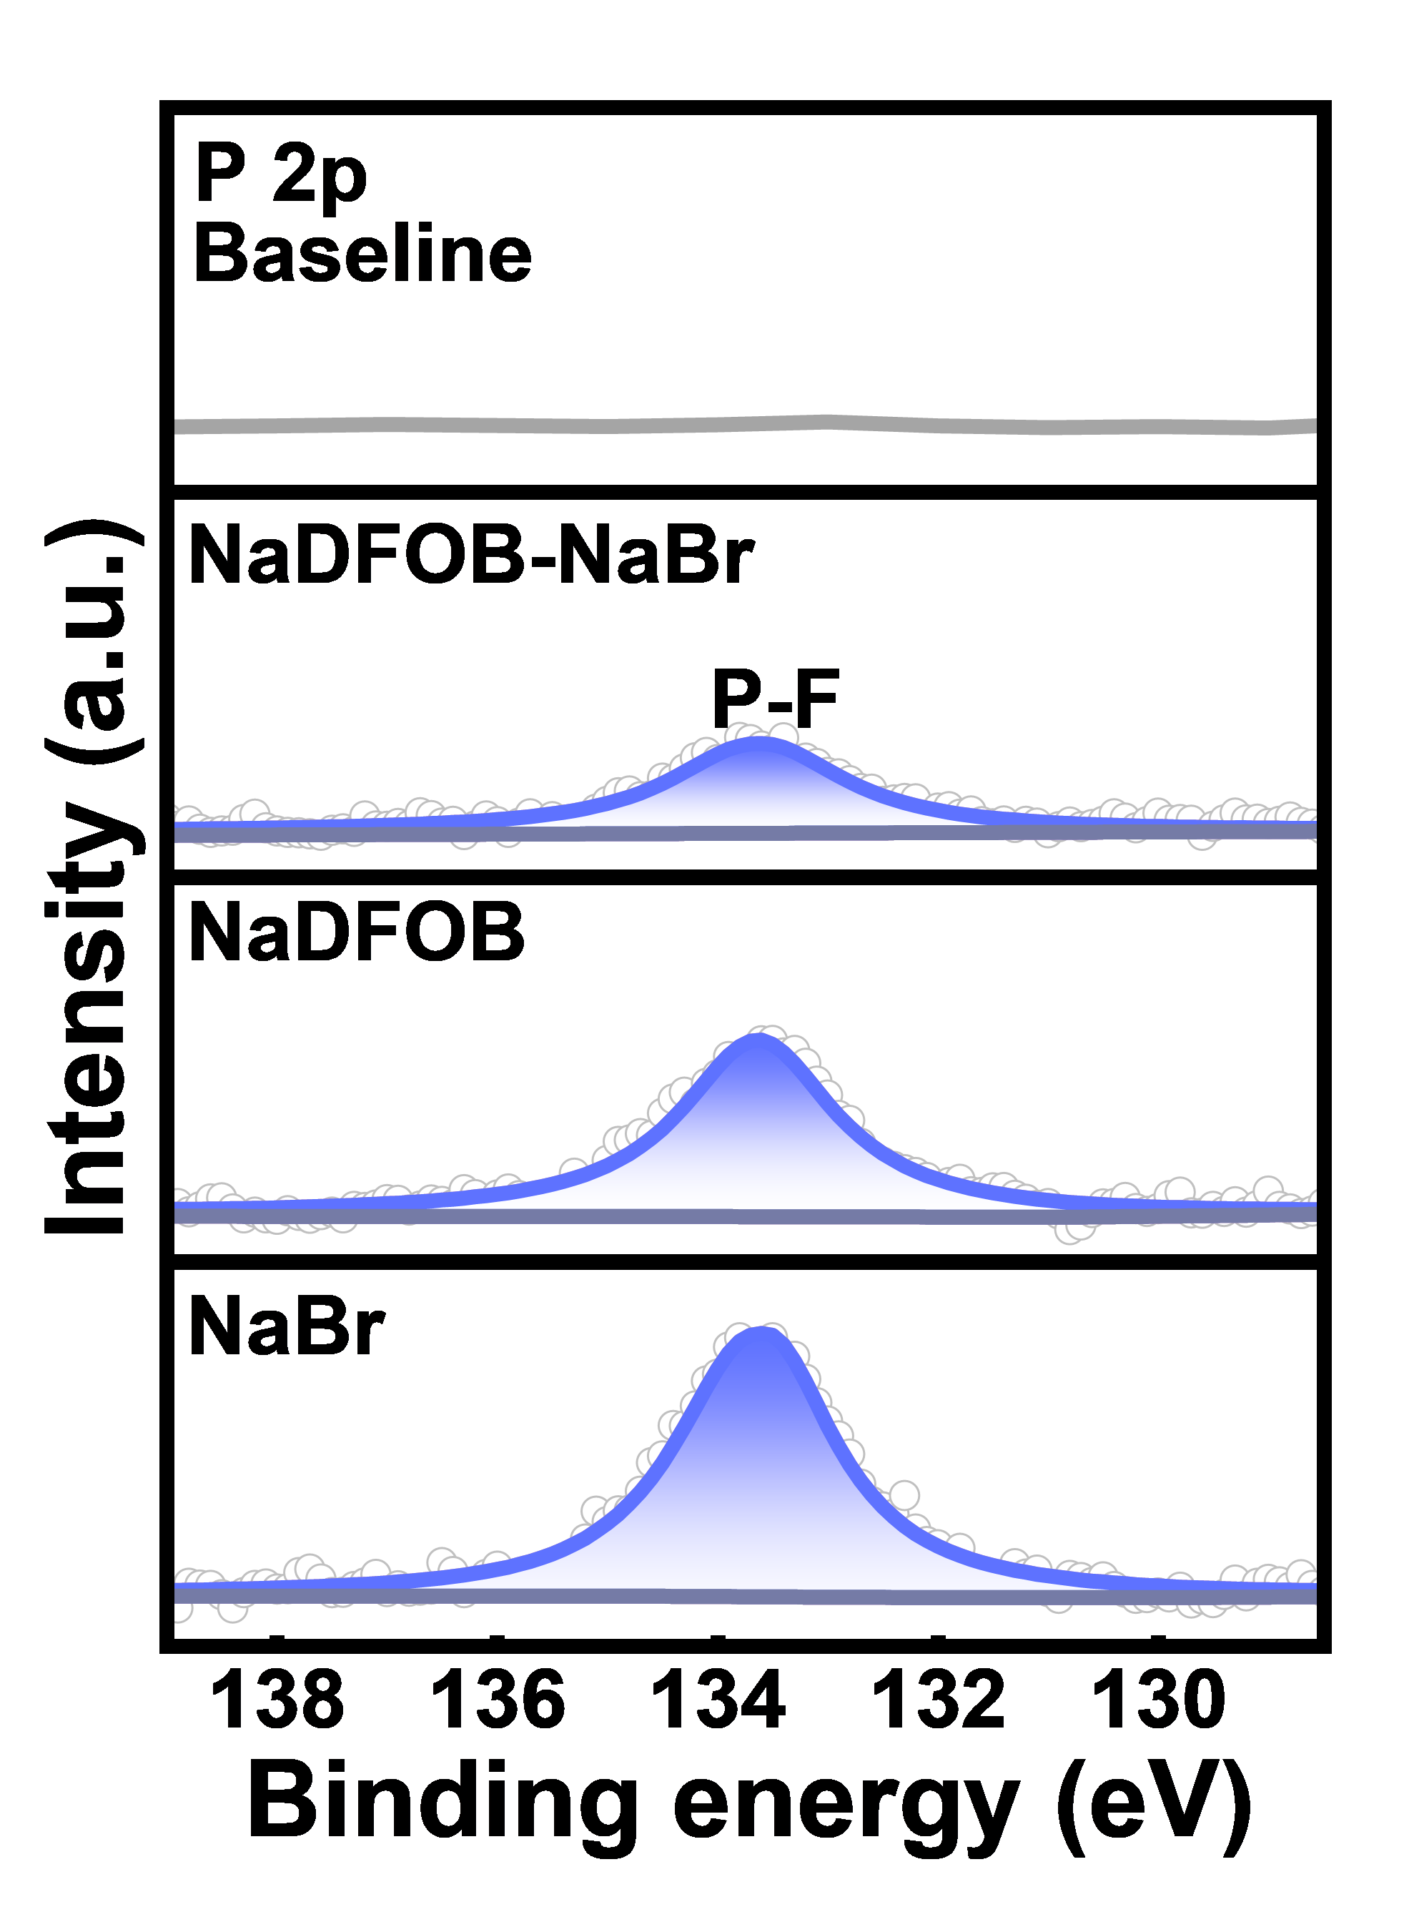
Supplementary Fig. 30. Normalized XPS fitting results of the P 2p peak.

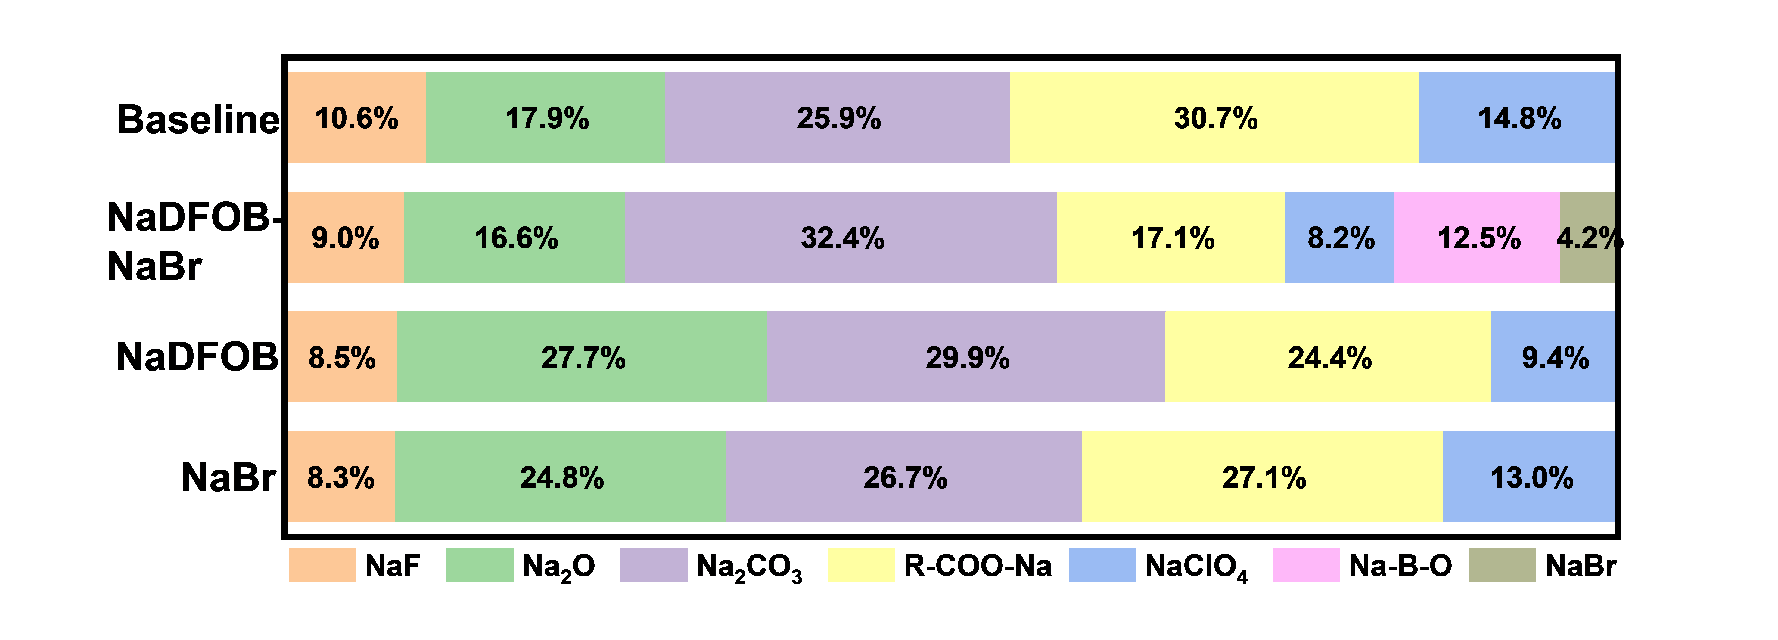
Supplementary Fig. 31. Quantitative comparison of SEI chemical components derived from the deconvolution of XPS Na 1s spectra for the four electrolytes.

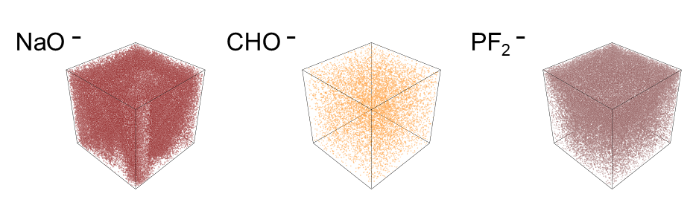
Supplementary Fig. 32. 3D reconstruction of selected secondary-ion fragments on the cycled HC anode in the NaDFOB-NaBr electrolyte (TOF-SIMS).

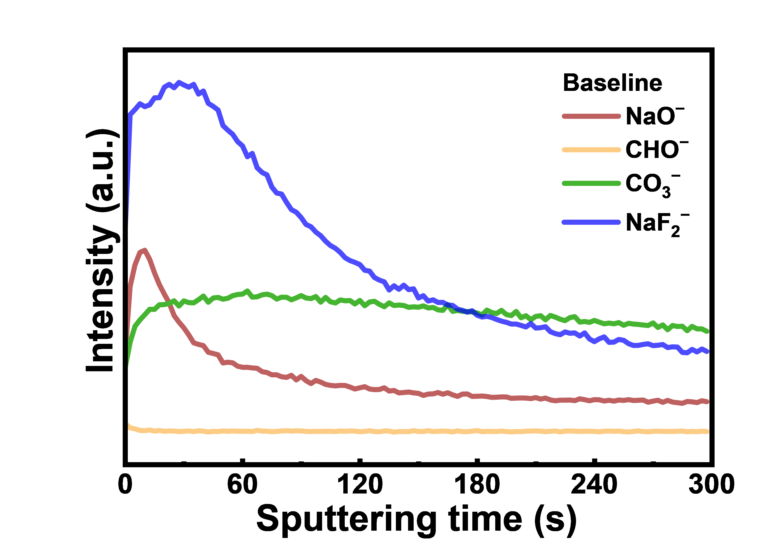
Supplementary Fig. 33. TOF-SIMS depth profiles of the cycled HC anode in the Baseline electrolyte.

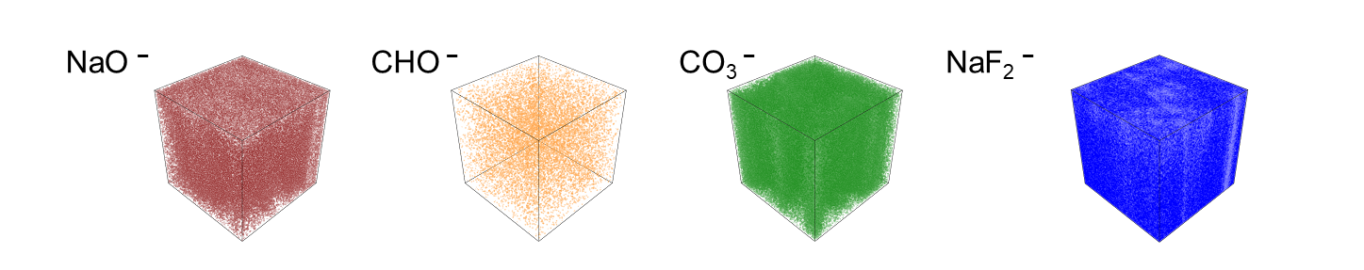
Supplementary Fig. 34. 3D reconstruction of selected secondary-ion fragments on the cycled HC anode in the Baseline electrolyte (TOF-SIMS).

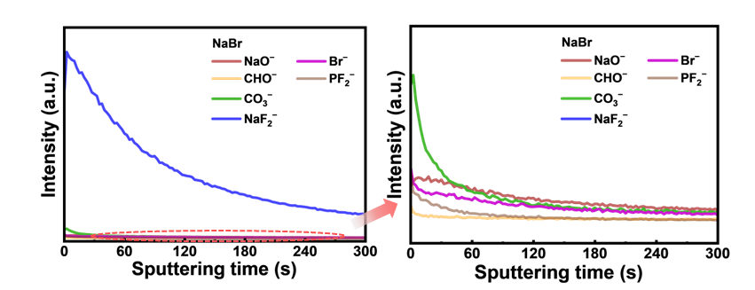
Supplementary Fig. 35. TOF-SIMS depth profiles of the cycled HC anode in the NaBr electrolyte.

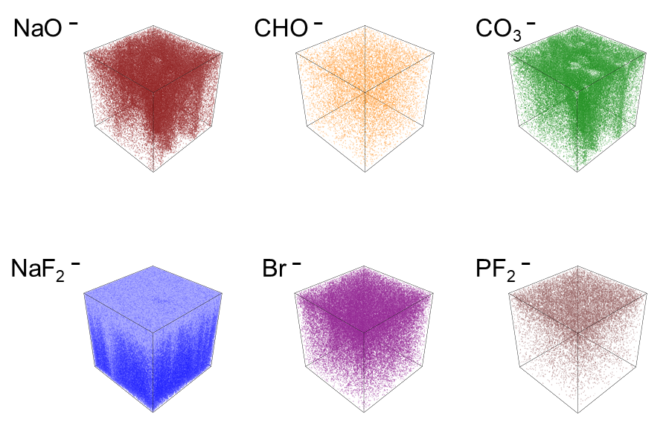
Supplementary Fig. 36. 3D reconstruction of selected secondary-ion fragments on the cycled HC anode in the NaBr electrolyte (TOF-SIMS).

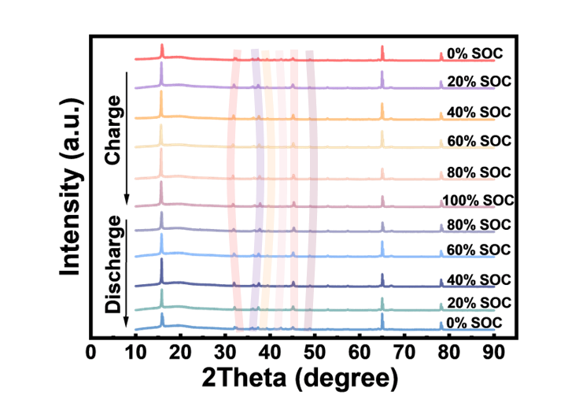
Supplementary Fig. 37. Ex situ XRD patterns of NMLTO cathode surface at different states of charge/discharge (SOC).

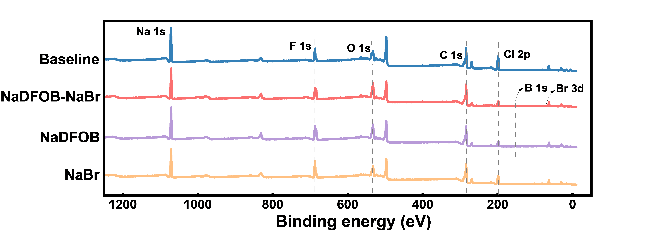
Supplementary Fig. 38. Survey XPS spectra of cycled NMLTO cathode surface.

Supplementary Table 1. Compositions of the four electrolytes.
Electrolyte | NaClO₄ | EC | DMC | FEC | TMP | NaDFOB | NaBr
Baseline | 1 M | 1 | 1 | 5 vol% | - | - | -
TMP-based (i) | - | - | - | - | 1 | 0.1 M | -
TMP-based (ii) | - | - | - | - | 1 | - | 0.01 M
TMP-based (iii) | - | - | - | - | 1 | 0.1 M | 0.01 M

Supplementary Table 2. Physicochemical properties of the solvents used in the Baseline, NaDFOB-NaBr, NaDFOB, and NaBr electrolytes.
Solvent  structure | Melting  Point  T_{m} (°C) | Boiling  Point  T_{b} (°C) | Viscosity  η (cP) | Dielectric  Constant ε (25 °C) | Density  ρ (g cm⁻³) | Donor  Number  DN (kcal  mol⁻¹)
EC | 36 | 248 | 1.90 (40 °C) | 89.8 | 1.321 | 16.4
DMC | 4 | 90 | 0.59 | 3.1 | 1.069 | 17.2
FEC | 18 | 212 | - | 7.0 | 1.454 | 9.1
TMP | −46 | 197 | 1.1 | 20.6 | 1.215 | 23

Supplementary Table 3. Fitted parameters from the EIS spectra of Na||Na symmetric cells at various temperatures.
Electrolyte | Temperaure (°C) | R_{b} (Ω) | R_{SEI} (Ω) | R_{ct} (Ω)
Baseline | 20 | 1.931 | 575.2 | 1246
Baseline | 0 | 3.108 | 3474 | 4799
Baseline | −10 | 4.58 | 8246 | 71210
Baseline | −20 | 6.421 | 45880 | 252200
NaDFOB-NaBr | 20 | 2.162 | 4936 | 1799
NaDFOB-NaBr | 0 | 3.037 | 7164 | 2729
NaDFOB-NaBr | −10 | 2.948 | 6880 | 5487
NaDFOB-NaBr | −20 | 3.618 | 51070 | 15110
NaDFOB | 20 | 9.084 | 4516 | 1735
NaDFOB | 0 | 2.971 | 5770 | 8410
NaDFOB | −10 | 3.299 | 5972 | 27410
NaDFOB | −20 | 3.787 | 24910 | 85130
NaBr | 20 | 5.038 | 1733 | 4241
NaBr | 0 | 2.682 | 3700 | 8705
NaBr | −10 | 3.282 | 31810 | 18160
NaBr | −20 | 3.71 | 38800 | 59800

Supplementary Table 4. Coordination numbers of Na⁺ with solvent molecules and anions in different electrolytes derived from MD simulations.
 | Baseline | NaDFOB-NaBr | NaDFOB | NaBr
ClO₄⁻ | 0.63472 | 0.49635 | 0.50011 | 0.58452
DMC | 0.21733 | 0.19705 | 0.169 | 0.18689
EC | 1.6655 | 1.27741 | 1.22297 | 1.37047
FEC | 0.00594 | 0.00773 | 0.00382 | 0.00499
TMP | - | 0.91413 | 0.91106 | 0.87793
DFOB⁻ | - | 0.03656 | 0.02526 | -
Br⁻ | - | 0.02246 | - | 0.02514

