Extended Figures

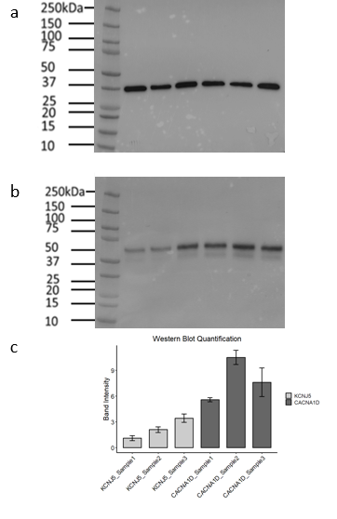
Extended Data Fig. 1. Western blot of CCM2L protein levels in KCNJ5- and CACNA1D-mutant APAs.
Frozen tissue from 3 KCNJ5- (lanes 1-3) and 3 CACNA1D-mutant (lanes 4-6) APAs was used. Immunoblotting was performed with anti-GAPDH (a) and anti-CCM2L (b) antibodies on the same blot with 3 technical replicates per sample. GAPDH molecular weight is 36kDa, CCM2L molecular weight is 62KDa. CCM2L protein expression was 3.6-fold higher in CACNA1D-mutant compared with KCNJ5-mutant APAs (Student’s T-test: p <0.0001). All CACNA1D-mutant APAs had higher values than all KCNJ5-muatant APAs. The tumour in lane 3 was atypical for a KCNJ5-mutant, showing dichotomous areas of strong and absent CYP11B2 staining, as seen on IHC (Supplementary Fig. 16 (T2).
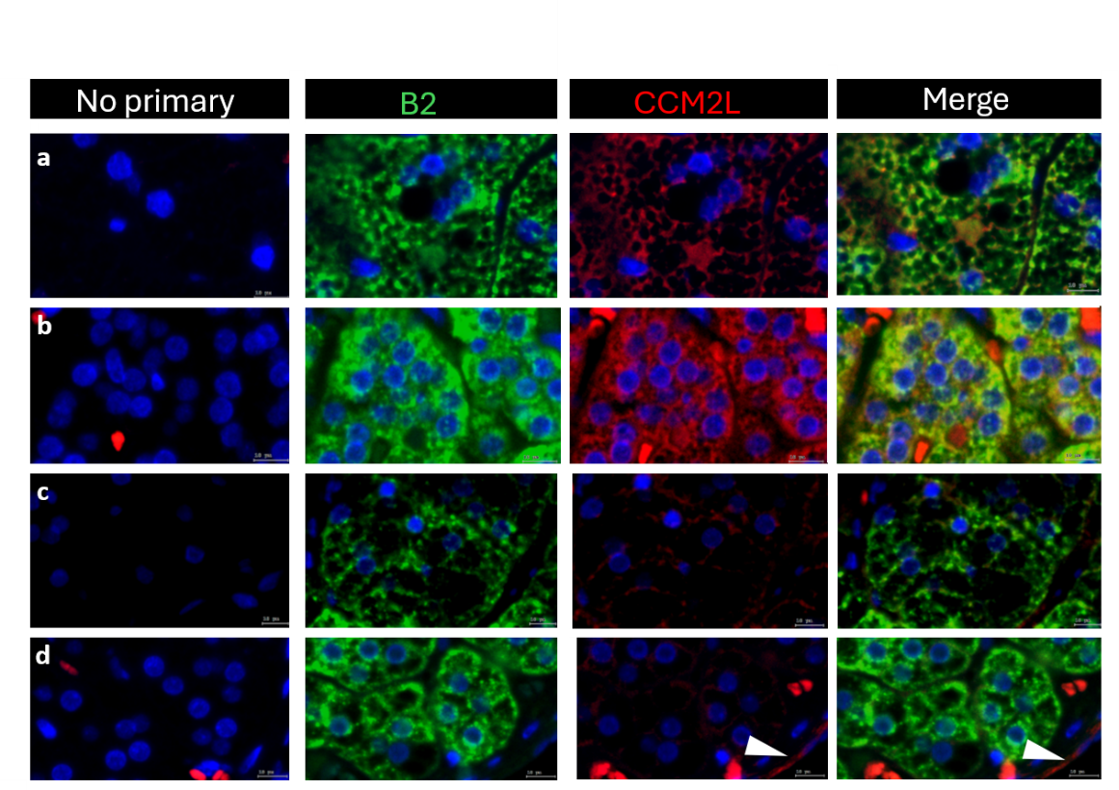
Extended Data Fig. 2. IF localisation of CCM2L in CYP11B2^{+ve} cells of CACNA1D-mutant APAs compared to KCNJ5-mutant APAs.
2 CACNA1D-mutant APA (a-b) and 2 KCNJ5-mutant (c-d) APA sections of FFPE human APA were tested with indirect IF. Sections were imaged using a TissueFAXS Q+ upright epifluorescence microscope at 20X magnification and reviewed with TissueFAXS slide viewer software.
Each row depicts an APA. CCM2L expression is prominent in medium-sized blood vessels (white arrow head). CCM2L (red) co-localises with CYP11B2^{+ve} cells (green) in CACNA1D-mutant APAs (a-b). KCNJ5-mutant APAs lack detectable CCM2L staining (c-d).
a 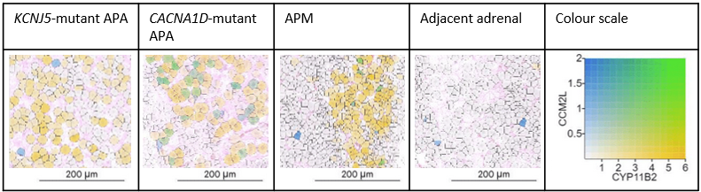
b  c 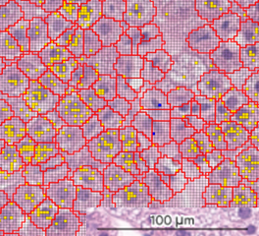
Extended Data Fig. 3. High-definition spatial transcriptomics demonstrating CCM2L and CYP11B2 expression in APAs, APMs and adjacent adrenal.
a, CCM2L expression is depicted in blue, CYP11B2 in yellow and co-expression in green (see colour scale). In the KCNJ5-mutant APA, cells either express CCM2L (blue) or CYP11B2 (yellow) suggesting distinct populations of vascular and steroidogenic cells. In both CACNA1D-mutant APAs and APMs, there are green cells demonstrating co-expression of both genes. Only blue endothelial cells are seen in the adjacent adrenal. Image generated using Loupe Browser 9.
b, Thumbnail of a KCNJ5-mutant APA with adjacent adrenal tissue. The boxed region indicates the area of the APA from which the high-definition image was acquired. c, 2 um barcodes overlaying cell-segments within a KCNJ5-mutant APA. Barcodes are coloured orange or blue where there is >=1 read for CYP11B2 or CCM2L, respectively. Green barcodes express both CYP11B2 and CCM2L(s). There are no cells expressing both orange and blue barcodes and no green barcodes.

a b
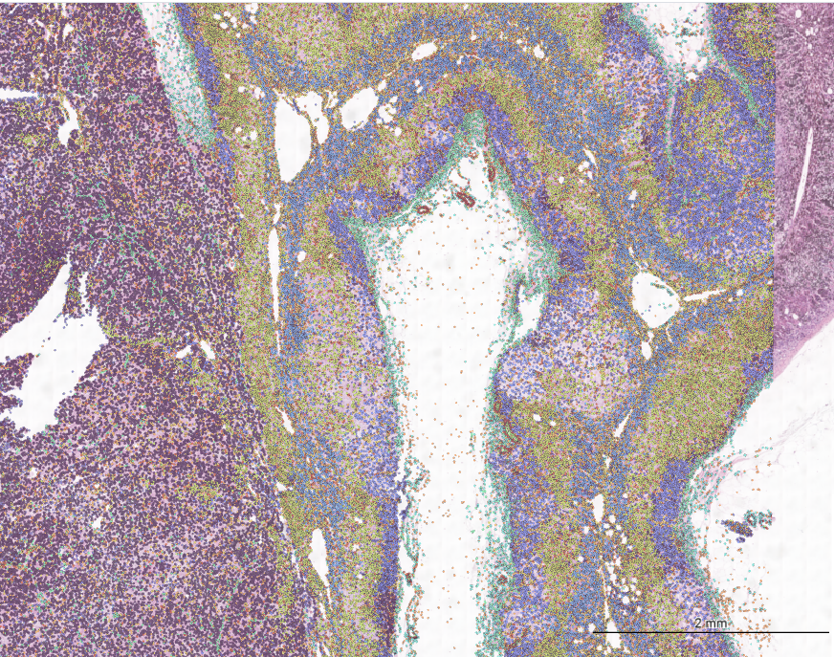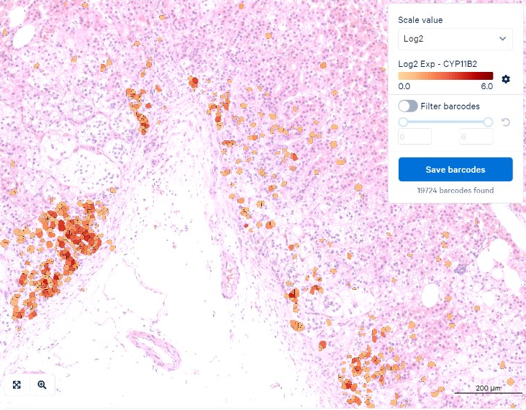
c d
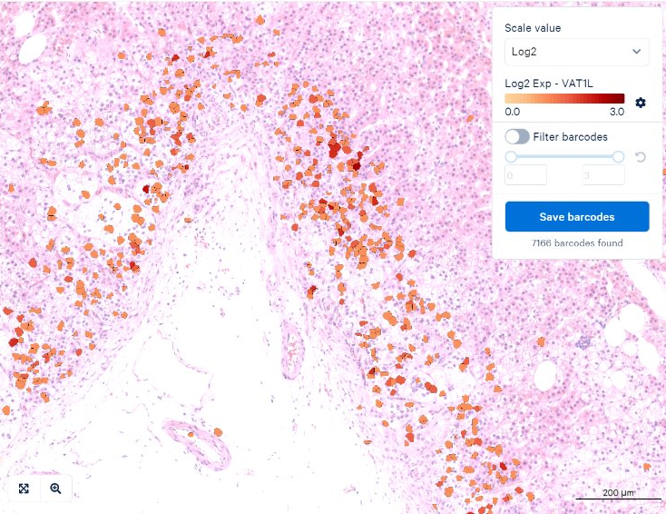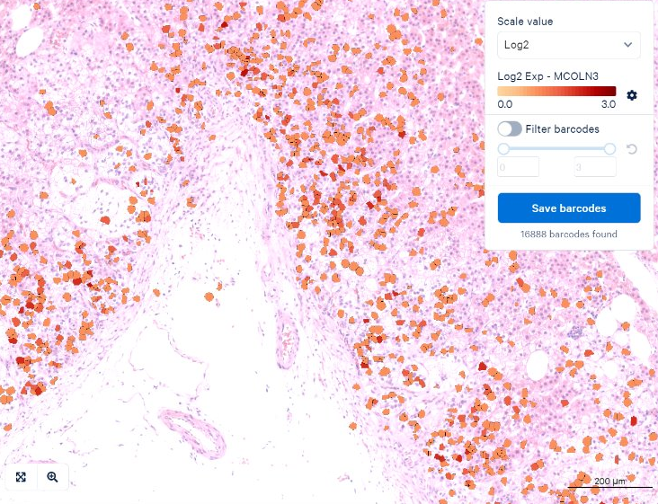
e f
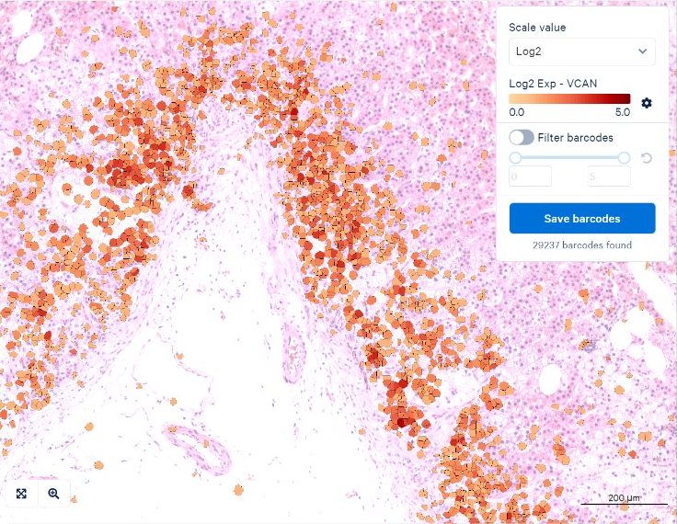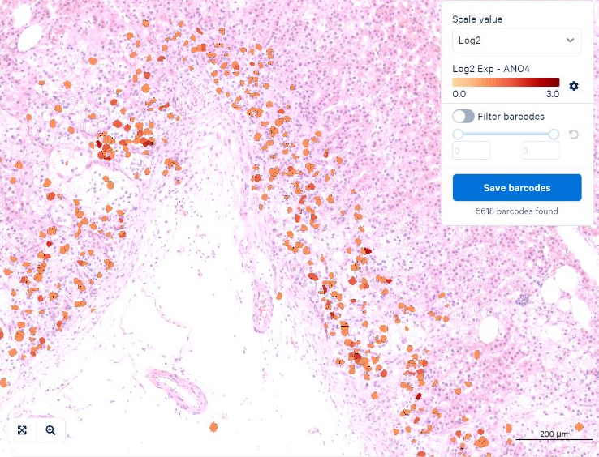

g h
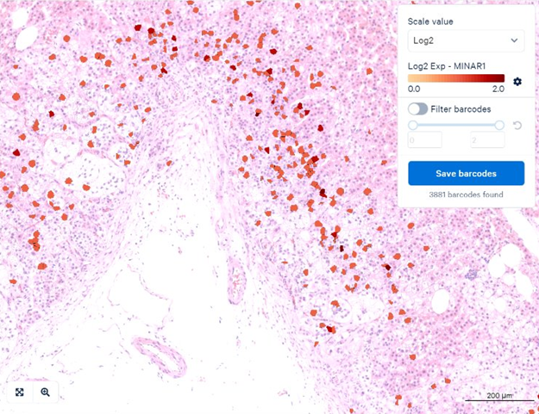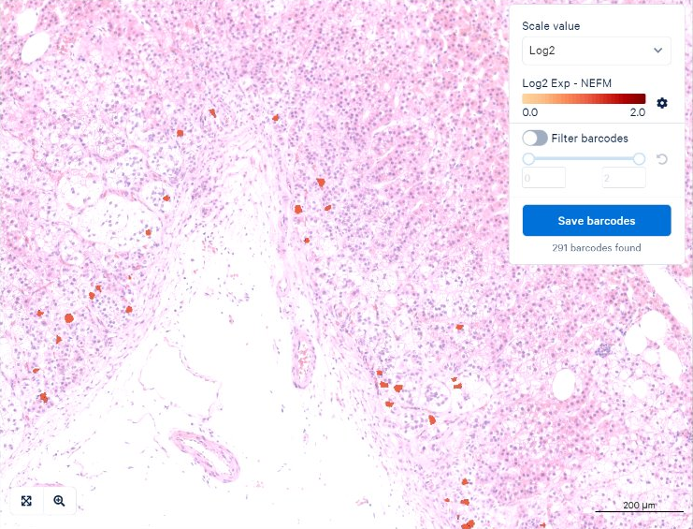
i j
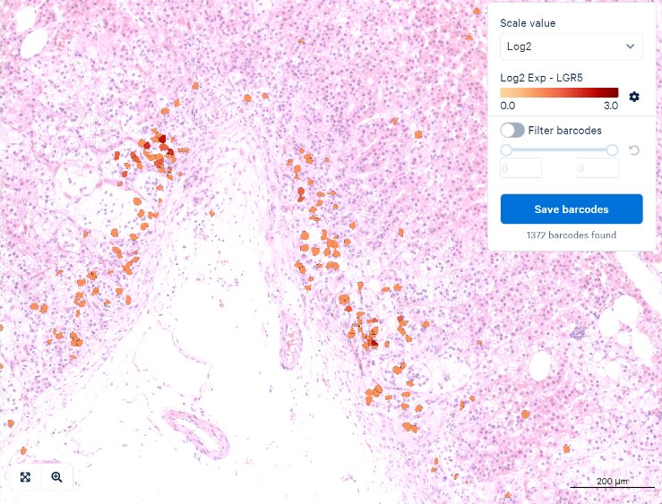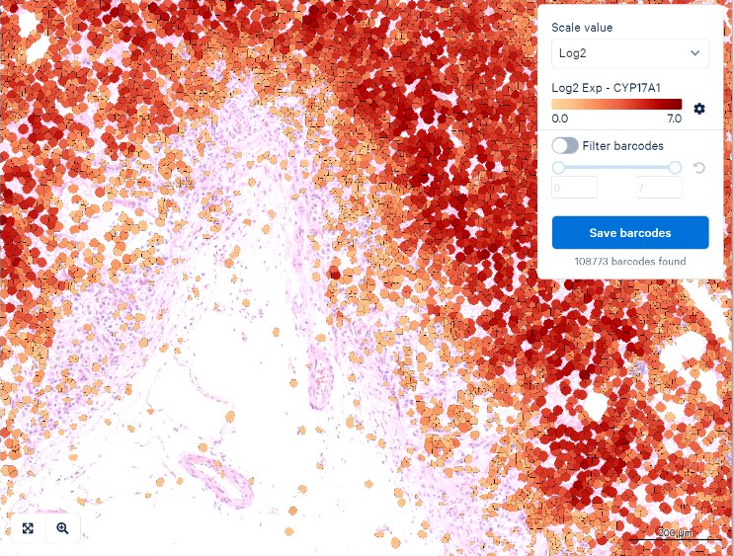
k
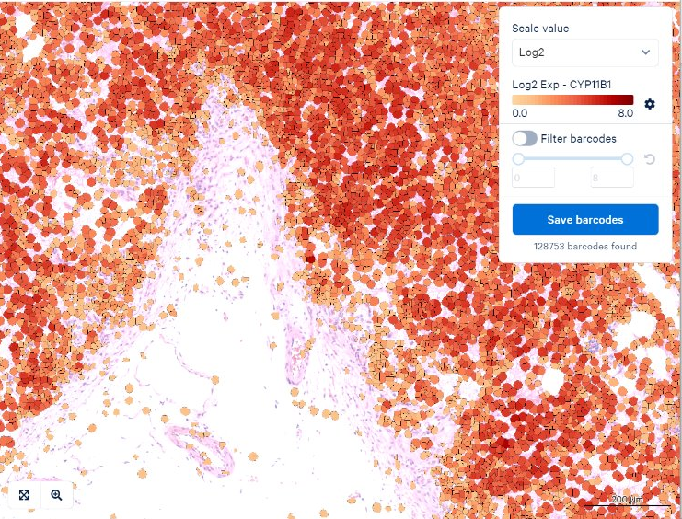
Extended Data Fig. 4. Spatial expression of ZG-associated genes in human adrenal gland by Visium HD
a, Thumbnail image of the tissue section used for HD Visium analysis. b-k, Spatial transcriptomic maps showing expression of CYP11B2 together with the ZG-associated genes VAT1L, MCOLN3, VCAN, ANO4, MINAR1, NEFM, LGR5 and KLK4. Expression of the ZF-associated genes CYP17A1 and CYP11B1 are also shown.
a 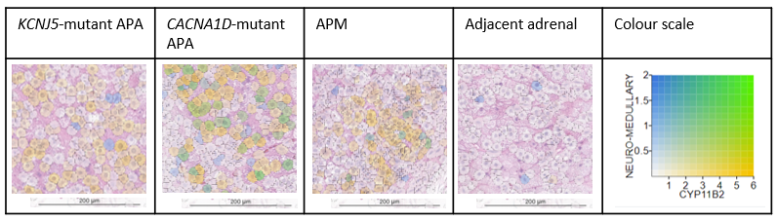
b c 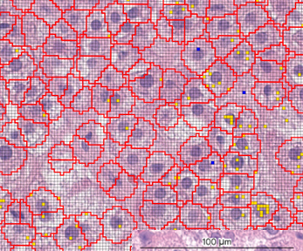
Extended Data Fig. 5. High-definition spatial transcriptomics demonstrating neuromedullary and CYP11B2 expression in APAs, APMs and adjacent adrenal.
a, Neuromedullary gene expression is shown in blue, CYP11B2 in yellow and co-expression in green (see colour scale). In the KCNJ5-mutant APA, cells express either neuromedullary genes or CYP11B2, consistent with distinct neuromedullary and steroidogenic populations. In CACNA1D-mutant APAs and APMs, cells co-expressing both CYP11B2 and a neuromedullary gene(s) are observed. In adjacent adrenal tissue, neuromedullary gene expression is restricted to medullary cells and neurones. Images were generated using Loupe Browser v9.
b, Thumbnail of a KCNJ5-mutant APA with adjacent adrenal tissue. The boxed region indicates the area of the APA from which the high-definition image was acquired. c, 2 um barcodes overlaid on cell segments within a KCNJ5-mutant APA. Barcodes are coloured orange or blue where there is ≥1 read for CYP11B2 or neuromedullary genes, respectively; green indicates co-expression. Cells with both signals are not observed, and no green barcodes are detected.
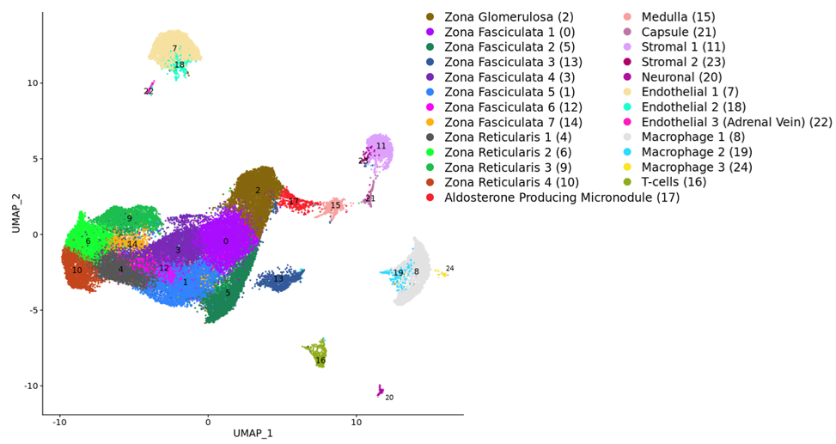
Extended Fig. 6. UMAP plot of reference map of adult human adrenal in unilateral PA.
This reference map is made up of 53,444 single nuclei from 12 adrenals adjacent to APAs with different genotypes and 1 adrenal adjacent to an NFA.
A total of 25 clusters were identified. Cluster numbering corresponds to relative cluster size, with Cluster 0 representing the largest population and Cluster 24 the smallest. To facilitate biological interpretation, the cluster order was adjusted to group nuclei with similar cellular identities. For example, ZF nuclei are organised within Clusters 1–7, while endothelial nuclei are grouped within Clusters 1–3. The automatically assigned cluster numbers are in brackets.
ZF 3 (Cluster 13) has been assigned as ZF as the ZF genes CYP11B1, CYP17A1 and HSD3B2 are expressed here. Differential expression analysis and violin plots demonstrate higher mitochondrial and ribosomal reads in this cluster which may explain why it is separated from the main ZF cluster.

a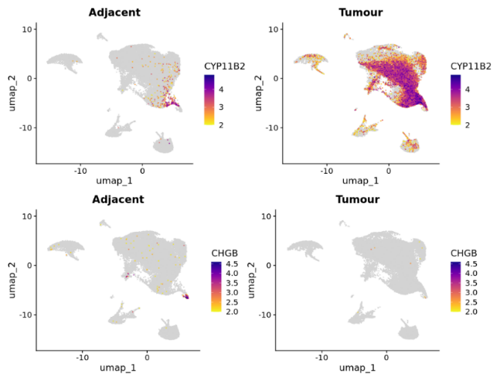b 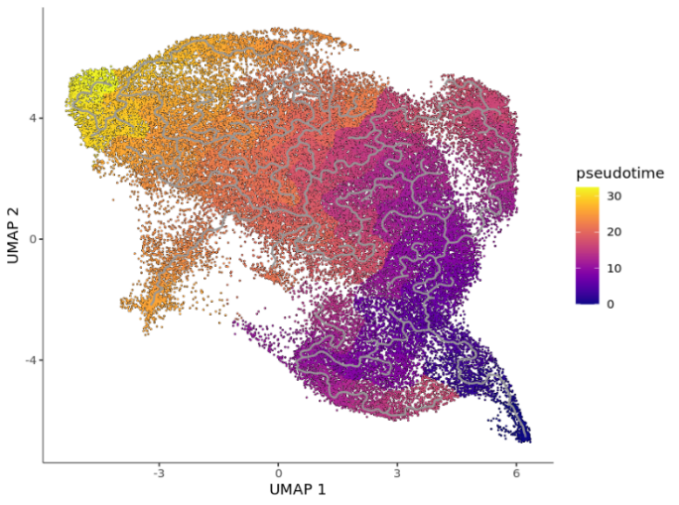
Extended data Fig. 7. Pseudotime analysis on APA nuclei and APA-adjacent nuclei samples together.
a, The UMAP plot is made up of 69,862 nuclei from 6 APAs (3 KCNJ5-mutant and 3 CACNA1D-mutant) and 8 adrenals adjacent to APAs (3 KCNJ5-mutant and 5 CACNA1D-mutant). The expression level of CYP11B2 and the medullary gene CHGB is plotted in the adjacent adrenal and APA nuclei separately. In the adjacent adrenal the CYP11B2^{+ve} APM cells are present in a cluster next to the medulla. These cells are part of a ‘bridge’ between the medulla and CYP11B2^{+ve} tumour cells.
b, Analysis was performed on the partition containing steroidogenic cells and medullary cells. The root node is marked with a red arrow and represents the medulla. The trajectory moves from the medulla into the APM/APA CYP11B2^{+ve} cells. Pseudotime is an abstract unit of progress representing the distance between a cell and the start of the trajectory. Cells at the start of the pseudotime trajectory are dark blue and yellow at the end.

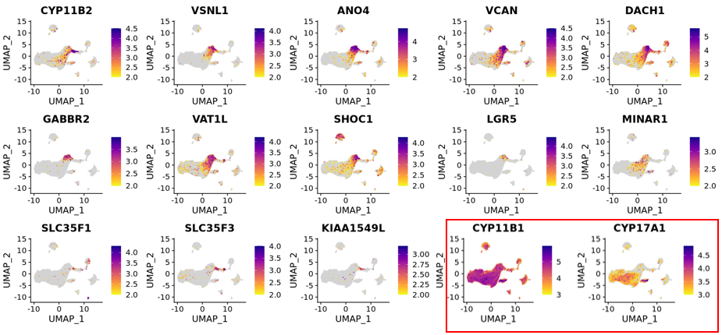
Extended Data Fig. 8. ZG and APM gene expression on the reference map of adult human adrenal in unilateral PA.
The expression level of CYP11B2 is plotted in the discovery cohort alongside the ZG genes VSNL1, ANO4, VCAN, DACH1, GABBR2, VAT1L, SHOC1, LGR5 and MINAR1. APM genes SLC35F1, SLC35F3 and KIAA1549L are expressed in the CYP11B2+ve APM cluster. The ZF/ZR genes CYP11B1 and CYP17A1 are plotted in the red box.

a 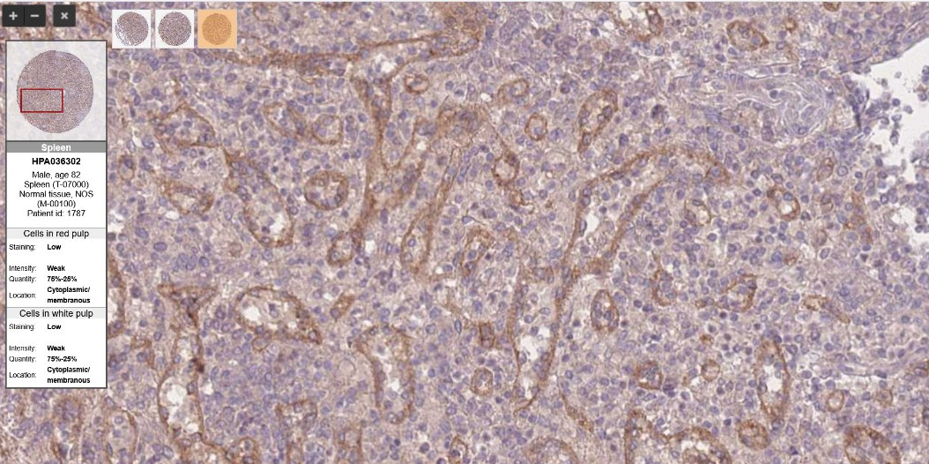
b 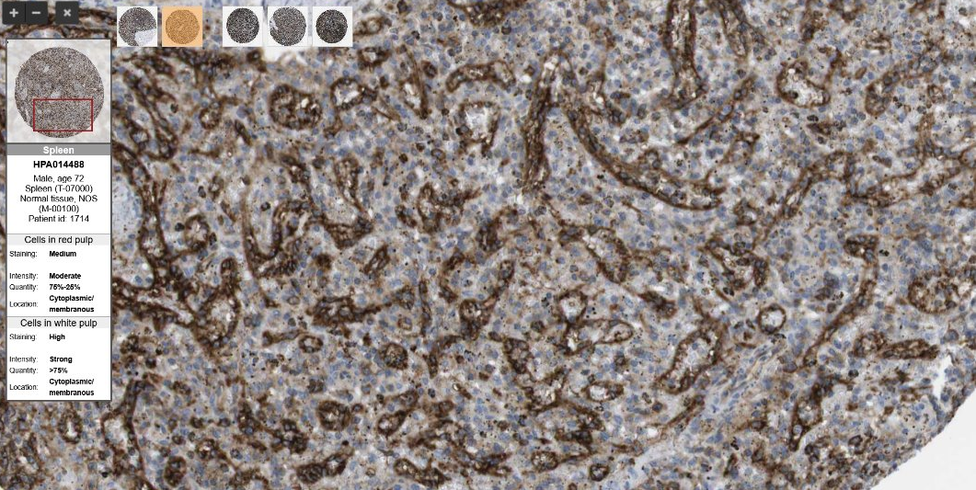
c 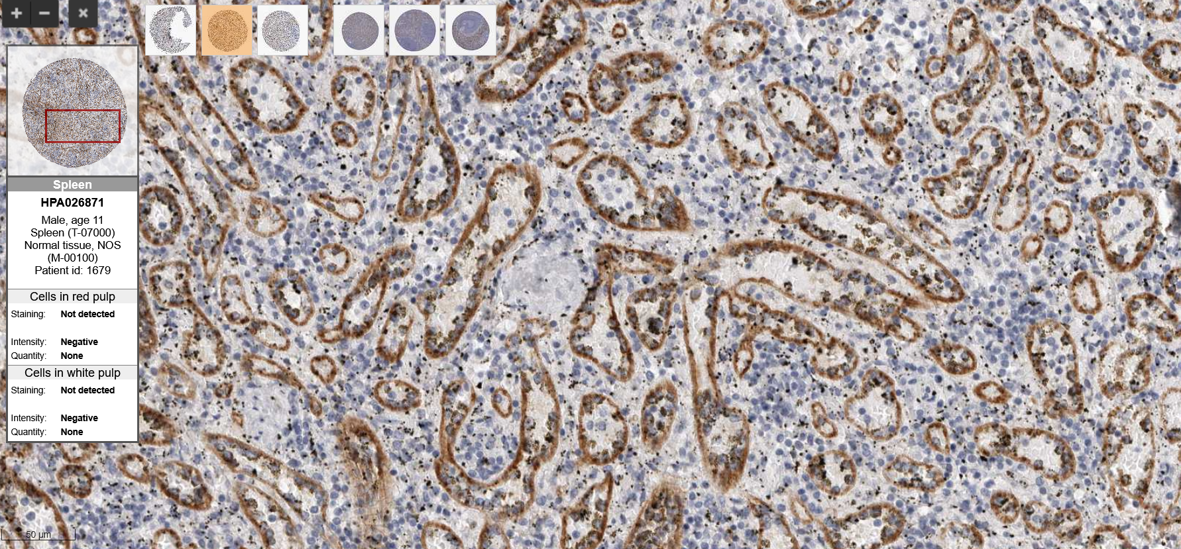
Extended Data Fig. 9. IHC for proteins enriched in splenic sinusoidal endothelial cells.
IHC staining for INSR (a), CCR6 (b) and STAB2 (c) in human spleen. All three proteins localise predominantly to sinusoidal endothelial cells within the splenic pulp [84].
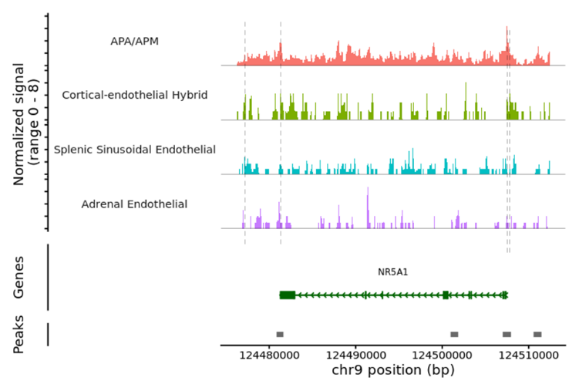
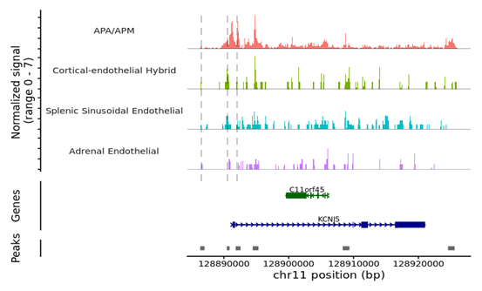
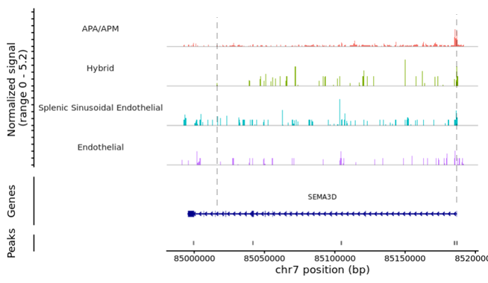
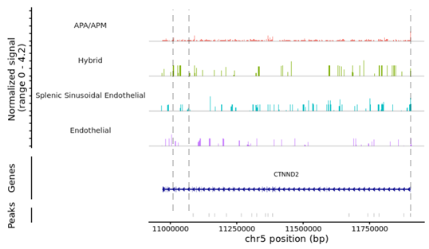
Extended Data Fig. 10. CoveragePlots demonstrating chromatin accessibility across NR5A1, KCNJ5, SEMA3D and CTNND2.
Each row represents a cluster. The y axis indicates the number of fragments mapping to each base, and the x axis denotes the corresponding genomic region. Dotted lines highlight peaks of chromatin accessibility within ATAC-seq reads that are shared between APA/APM clusters, hybrid cells and splenic sinusoidal endothelial cells.

