Supplementary Tables
Supplementary Table 1. DAVID functional annotation of genes upregulated in bulk RNA-seq from CACNA1D-mutant compared with KCNJ5-mutant APAs
Gene | log2FoldChange | Adjusted p-value
CCM2L | -5.05 | 2.01E-26
GDAP1L1 | -5.17 | 1.19E-20
SHISAL1 | -6.64 | 2.03E-17
CHRNB4 | -3.39 | 2.01E-13
CCDC141 | -3.33 | 2.67E-13
NPNT | -3.32 | 2.67E-13
ETNK2 | -2.38 | 2.67E-13
PTPRZ1 | -4.14 | 9.57E-12
NRXN2 | -3.80 | 9.73E-12
FITM2 | -2.46 | 1.04E-11
SYP | -3.15 | 2.45E-11
MYOM1 | -3.82 | 5.46E-11
KIAA1549L | -3.29 | 1.07E-10
UNC79 | -3.23 | 4.41E-10
ABLIM2 | -1.71 | 8.86E-10
CLDN19 | -4.00 | 2.38E-09
ITIH3 | -2.38 | 2.85E-09
SEC16B | -1.73 | 4.14E-09
GRIP2 | -3.71 | 8.73E-09
LRFN2 | -5.82 | 9.23E-09
NPR3 | -2.29 | 9.54E-09
TPSB2 | -4.93 | 1.16E-08
LRP4 | -1.49 | 3.58E-08
RASD2 | -3.56 | 4.71E-08
PPP1R16B | -2.39 | 6.90E-08
ITGA11 | -2.44 | 7.00E-08
SSTR2 | -3.04 | 7.81E-08
HELLS | -1.81 | 8.48E-08
PLXNA2 | -2.20 | 1.14E-07
AC006254.1 | -2.71 | 1.33E-07
AMOT | -2.54 | 1.33E-07
TPSAB1 | -6.62 | 1.34E-07
GPRC5C | -2.20 | 1.52E-07
OLFM1 | -1.75 | 1.52E-07
TLN1 | -1.27 | 1.52E-07
FHOD3 | -1.08 | 1.92E-07
SLC35F1 | -3.71 | 2.35E-07
CTRB1 | -4.71 | 2.60E-07
TMEM266 | -1.80 | 2.65E-07
SGCG | -2.63 | 2.72E-07
CASP16P | -3.24 | 4.27E-07
TRIM45 | -1.54 | 4.27E-07
RTN4RL1 | -2.23 | 4.52E-07
INSR | -1.11 | 4.57E-07
ITGA7 | -1.89 | 6.64E-07
C11orf87 | -6.27 | 8.34E-07
TYRO3 | -1.32 | 9.49E-07
SLC6A1 | -2.53 | 9.60E-07
ST6GAL1 | -1.65 | 9.60E-07
EPHX2 | -0.99 | 1.03E-06
PNLIP | -5.00 | 1.10E-06
BTN2A2 | -1.45 | 1.11E-06
TICRR | -1.96 | 1.29E-06
FRMPD4 | -5.90 | 1.49E-06
AJAP1 | -5.00 | 1.57E-06
TRO | -1.70 | 1.57E-06
SLC35F3 | -3.62 | 1.58E-06
MYH11 | -2.15 | 1.59E-06
ARSG | -1.19 | 1.91E-06
FAM189A2 | -2.02 | 2.75E-06
ZSCAN18 | -1.37 | 2.94E-06
GYG2 | -3.00 | 3.10E-06
GDF7 | -2.68 | 3.12E-06
HHIP | -1.59 | 3.48E-06
NKX3-2 | -3.60 | 3.70E-06
SLC4A3 | -2.19 | 4.18E-06
INPP5A | -1.32 | 4.32E-06
BEX1 | -2.85 | 4.44E-06
STIMATE | -1.99 | 4.64E-06
PTPRF | -1.21 | 4.73E-06
LINC00672 | -2.12 | 4.88E-06
GPR137B | -1.03 | 4.88E-06
PLEKHA7 | -2.44 | 5.32E-06
CAPS | -2.36 | 5.33E-06
C4A | -2.43 | 5.55E-06
ZPLD1 | -4.07 | 5.72E-06
PRR15 | -2.94 | 6.79E-06
ATP8A2 | -1.70 | 6.79E-06
PCLO | -1.76 | 7.12E-06
KCNMA1 | -1.68 | 7.44E-06
MAP9 | -1.85 | 7.91E-06
NMRK2 | -2.78 | 8.23E-06
HSPB7 | -2.63 | 9.13E-06
ITM2C | -1.60 | 9.13E-06
COTL1 | -0.92 | 9.13E-06
OGN | -1.40 | 1.02E-05
VPREB3 | -4.03 | 1.06E-05
GJC1 | -1.43 | 1.16E-05
APOBEC3B | -1.97 | 1.23E-05
SCAMP5 | -1.23 | 1.25E-05
SEZ6L2 | -2.49 | 1.29E-05
SNAP25 | -2.31 | 1.51E-05
TARS1 | -1.39 | 1.65E-05
BICDL1 | -1.76 | 1.74E-05
DACT3 | -1.23 | 1.84E-05
GABRB2 | -1.74 | 1.86E-05
KIF24 | -1.26 | 1.88E-05
TIMP3 | -1.21 | 1.88E-05
DSG2 | -3.34 | 1.89E-05
SLC22A17 | -2.11 | 1.93E-05

Supplementary Table 2. The top 100 genes upregulated on bulk RNA-seq in 21 CACNA1D-mutant compared to 14 KCNJ5-mutant APAs.

Gene | avg_log2FC (CACNA1D vs KCNJ5) | pct.1 (CACNA1D) | pct.2 (KCNJ5) | p_val_adj
KIAA1549L | 1.193499 | 0.741 | 0.048 | 0
MYOM1 | 1.144154 | 0.88 | 0.4 | 0
CCDC141 | 0.672691 | 0.544 | 0.14 | 0
UNC79 | 0.635278 | 0.476 | 0.087 | 0
NPNT | 0.487471 | 0.321 | 0.01 | 0
PTPRZ1 | 0.277877 | 0.188 | 0.008 | 1.07 × 10⁻²³²
GDAP1L1 | 0.218786 | 0.182 | 0.051 | 8.62 × 10⁻¹¹³
SHISAL1 | 0.162745 | 0.108 | 0.001 | 7.46 × 10⁻¹³⁸
FITM2 | 0.15619 | 0.133 | 0.046 | 1.09 × 10⁻⁶¹
CCM2L | 0.148578 | 0.102 | 0.007 | 2.12 × 10⁻¹⁰⁸
SYP | 0.096758 | 0.096 | 0.048 | 3.88 × 10⁻²²
NRXN2 | 0.093695 | 0.071 | 0.01 | 6.93 × 10⁻⁵⁹
CHRNB4 | 0.064835 | 0.045 | 0.006 | 1.10 × 10⁻³⁷
ETNK2 | 0.027106 | 0.023 | 0.007 | 5.32 × 10⁻⁸
CST2 | -0.01797 | 0 | 0.016 | 3.61 × 10⁻¹⁸
KLK4 | -0.02588 | 0 | 0.021 | 7.52 × 10⁻²⁵
LGR5 | -0.0608 | 0.025 | 0.075 | 1.07 × 10⁻³¹
NEFM | -0.01801 | 0.006 | 0.018 | 6.53 × 10⁻⁵
MINAR1 | -0.23763 | 0.014 | 0.18 | 2.27 × 10⁻²⁰⁴
SHOC1 | -0.29934 | 0.208 | 0.415 | 1.83 × 10⁻¹²⁰
CYP17A1 | -0.38192 | 0.258 | 0.588 | 3.50 × 10⁻²⁴⁸
ANO4 | -0.43758 | 0.156 | 0.474 | 1.68 × 10⁻²⁸⁰
VCAN | -0.44898 | 0.07 | 0.337 | 5.60 × 10⁻²⁸⁶
MCOLN3 | -0.48643 | 0.42 | 0.81 | 0
VAT1L | -0.42175 | 0.219 | 0.533 | 4.90 × 10⁻²⁴⁶
CYP11B1 | -1.0694 | 0.417 | 0.946 | 0

Supplementary Table 3. Differential expression of genes distinguishing CACNA1D- and KCNJ5-mutant APAs within the CYP11B2-positive cluster
The top of the table lists the 14 genes most significantly upregulated in CACNA1D-mutant compared to KCNJ5-mutant APAs on bulk RNA-seq. It examines the expression of these genes in the CYP11B2-positive cluster from three CACNA1D-mutant and three KCNJ5-mutant APAs on snRNA-seq. These genes have positive avg_log2FC values.
In addition, ZG-associated genes enriched in KCNJ5-mutant APAs are shown; these have negative Log2 fold change (avg_log2FC) values as they are downregulated in CACNA1D-mutant compared to KCNJ5-mutant APAs.
The proportion of positive cells in the CACNA1D group (pct.1), the proportion of positive cells in the KCNJ5 group (pct.2), and the adjusted P value (p_val_adj) are also shown.
Patient | Gender | Ethnicity | Age | Cohort | Tissue | Genotype | Mutation site | Nuclei extracted | Nuclei passing QC | Technique
A1 | Male | Caucasian | 60 | Discovery | Adrenal adjacent to APA | KCNJ5 | G151R | 4,892 | 4,714 | snRNA-seq
A2 | Female | Caucasian | 47 | Discovery | Adrenal adjacent to APA | KCNJ5 | G151R | 8,044 | 7,561 | snRNA-seq
A3 | Female | Caucasian | 41 | Validation | Adrenal adjacent to APA | KCNJ5 | L168R | 8,884 | 8,287 | snRNA-seq
A4 | Female | Black | 56 | Discovery | Adrenal adjacent to APA | CACNA1D | F767V | 4,241 | 3,958 | snRNA-seq
A5 | Male | Caucasian | 48 | Discovery | Adrenal adjacent to APA | CACNA1D | F747L | 2,941 | 2,841 | snRNA-seq
A6 | Male | Caucasian | 55 | Validation | Adrenal adjacent to APA | CACNA1D | R639P | 8,142 | 7,520 | snRNA-seq
A7 | Male | Caucasian | 40 | Discovery | Adrenal adjacent to APA | CACNA1D | R990H | 4,188 | 4,014 | snRNA-seq
A8 | Male | Caucasian | 61 | Discovery (P) | Adrenal adjacent to APA | CACNA1D | G403R | 367 | 362 | snRNA-seq
A9 | Female | Caucasian | 24 | Discovery | Adrenal adjacent to APA | GNAQ  CTNNB1 | Q209L  G34R | 6,849 | 6,437 | snRNA-seq
A10 | Female | Caucasian | 23 | Discovery | Adrenal adjacent to APA | GNAQ  CTNNB1 | Q209H  G34E | 3,297 | 3,130 | snRNA-seq
A11 | Female | Caucasian | 40 | Discovery | Adrenal adjacent to APA | ATP1A1 | Glu960_Leu964del | 3,267 | 3,067 | snRNA-seq
A12 | Male | Caucasian | 42 | Discovery | Adrenal adjacent to APA | ATP2B3 | G123R | 6,461 | 6,098 | snRNA-seq
A13 | Male | Black | 38 | Discovery | Adrenal adjacent to APA | Unknown | - | 5,721 | 5,405 | snRNA-seq
A14 | Male | Black | 69 | Discovery (P) | Adrenal adjacent to APA | Unknown | - | 271 | 265 | snRNA-seq
A15 | Female | Black | 61 | Discovery | Adrenal adjacent to NFA, APMs | - | - | 5,903 | 5,592 | snRNA-seq
A16 | Female | Caucasian | 43 | Validation | Adrenal adjacent to phaeochromocytoma | - | - | 9,072 | 8,340 | snRNA-seq
A17 | Male | Caucasian | 22 | Validation | Adrenal adjacent to phaeochromocytoma | - | - | 8,192 | 7,612 | snRNA-seq
A18 | Male | Caucasian | 39 | Validation | Adrenal adjacent to APA | CACNA1D | S672L | 5,422 | 4,742 | scRNA-seq
A19 | Female | Caucasian | 30 | Validation | Adrenal adjacent to APA | KCNJ5 | G151R | 4,033 | 3,261 | scRNA-seq
T1 | Male | Caucasian | 60 | Tumour | APA | KCNJ5 | G151R | 9,352 | 8,667 | snRNA-seq
T2 | Female | Caucasian | 47 | Tumour | APA | KCNJ5 | G151R | 6,881 | 6,456 | snRNA-seq
T3 | Female | Caucasian | 41 | Tumour | APA | KCNJ5 | L168R | 1,666 | 1,514 | snRNA-seq
T4 | Female | Black | 56 | Tumour | APA | CACNA1D | F767V | 6,491 | 6,020 | snRNA-seq
T5 | Male | Caucasian | 48 | Tumour | APA | CACNA1D | F747L | 3,844 | 3,670 | snRNA-seq
T6 | Male | Caucasian | 55 | Tumour | APA | CACNA1D | R639P | 4,493 | 4,278 | snRNA-seq
T9 | Female | Caucasian | 24 | Tumour | APA | GNAQ  CTNNB1 | Q209L  G34R | 6,392 | 5,826 | snRNA-seq
T10 | Female | Caucasian | 23 | Tumour | APA | GNAQ  CTNNB1 | Q209H  G34E | 4,643 | 4,121 | snRNA-seq
T20 | Male | Asian | 47 | Tumour | APA | CLCN2 | p.Asn356_Leu359del | 7,541 | 6,984 | snRNA-seq

Supplementary Table 4. Characteristics of each adrenal sample evaluated by snRNA-seq/scRNA-seq.
This includes 26 samples for snRNA-seq: 13 unilateral PA adrenals in the discovery cohort (12 adjacent to APAs and 1 adjacent to an NFA), 2 adjacent APA adrenals in the validation cohort, 2 adjacent phaeochromocytoma adrenals and 9 APAs. All the APAs, except the CLCN2-mutant APA (T20), came from paired adjacent adrenal that had also undergone snRNA-seq. A18 and A19 are 2 APA adjacent adrenals which underwent scRNA-seq. The table outlines patient demographics as well as the tumour genotype and the numbers of nuclei both extracted and passing QC for each sample. Abbreviations: P, piolet sample. Patient A12 was also found to have a second DPYSL2 somatic mutation.
There were 3 cohorts used for validation. The first consisted of snRNA-seq of adrenal tissue adjacent to a KCNJ5-mutant APA and a CACNA1D-mutant APA. It was treated in the same way as the discovery cohort. To assess if the findings in the discovery cohort were reproducible, the DEGs for each of the cell types were compared between the discovery and validation cohort. The GeneOverlap tool, designed to calculate the significance of the overlap of two sets of genes, found a strong association in the gene expression of corresponding cell types between the discovery and validation cohorts (odds ratio range 262.7-2789.8, p-values ≤1.1e-279). The second validation cohort consisted of 2 phaeochromocytomas and the third of scRNA-seq of adrenal tissue adjacent to a KCNJ5-mutant APA and a CACNA1D-mutant APA. It was treated in the same way as the discovery cohort.

Genes upregulated in the medulla (cluster 15) and APMs (cluster 17)
SLIT3 | CACNA1D | MPPED2 | ALCAM
KCNMA1 | SAMD12 | BMERB1 | DLC1
SNAP25 | SYNE1 | FAM160A1 | AC002460.2
CTNND2 | TPD52 | ATP1A1 | LRRC4C
SLC35F3 | RORB | TSPAN7 | DLG1
SNAP25-AS1 | EFNA5 | NBEA | PCLO
ADGRB3 | STXBP5L | TSC22D1 | DYNC1I1
AL390783.1 | LINC01515 | RIMS2 | AC104596.1
NTM | BICC1 | SLC25A27 | NCAM1
CTNNA3 | CACNA1C | SLC8A1 | GLCCI1
DOCK3 | RIPOR2 | ANK3 | EML5
DACH1 | AGPAT4 | LSAMP | PATJ
ATP8A2 | NFASC | AC092691.1 | REPS1
CADM1 | ANO4 | ACOT11 | ADAMTS9-AS2
AP000462.1 | PTPRN2 | HIVEP3 | FUT8
CACNB2 | RUNX1T1 | KLHL13 | KIF5C
UNC79 | AFF3 | SPOCK1 | AC098829.1
FAM135B | HS6ST3 | SGCD | ANKS1B
RAB3C | DMD | SLC4A8 | VAT1L
ATP9A | NOS1AP | KLF3-AS1 | LDLRAD4
AL355612.1 | ATP1B1 | PCNX2

Supplementary Table 5. Genes upregulated in both the medulla (cluster 15) and APMs (cluster 17).
DEGs were identified in each of the 25 clusters of the discovery cohort using the FindAllMarkers() function, log2fold > 0.25, min.pct = 0.25, p < 0.05. Those genes that were significantly upregulated in both the medulla (Cluster 15) and APMs (Cluster 17) are listed.

Cell type | Markers
Adrenocortical cell | STAR[1, 2], FDX1[3]
Zona glomerulosa | CYP11B2[4, 5, 6], VSNL1[7, 8], ANO4[8], VCAN[7, 8], DACH1[7, 8, 9], GABBR2[7], VAT1L[10], LGR5[7], CALN1 [10]
Zona fasciculata | CYP11B1*[4, 6], CYP17A1*[3, 5], HSD3B2**[3, 5]
Zona reticularis | SULT2A1[5, 11], TSPAN12[12], CYB5A[5]
Aldosterone producing micronodule | SLC35F1[10], SLC35F3[10], TMEM266[10], KIAA1549L[10], MYOM1[10], PPP4R4[10]
Medulla | CHGB[3, 13], TH[3], SYT1[14], PNMT[3, 15]
Stromal | PDGFRA[16], COL12A1[17], COL1A2[18]
Capsule | RSPO3[5], MFAP5[5], CLDN11***[19]
Endothelial | PECAM1[20, 21], TEK[21], PLVAP[22], SLCO2A1[23], PTPRB[24]
Venous endothelial cell | EMCN[25]
Arterial endothelial cell | KDR[25]
Neuronal | CRYAB[26], S100B[27], CHL1[28], ANK3[29], CDH19[30], SLC35F1[31], PTPRZ1[32], CADM2[33], NRXN1[34], NRXN2[35], PRIMA1[36], UCHL1[37],
Leukocyte | PTPRC[38], CD84[39]
Macrophages | CD14[40], CD163[41]
T-cells | CD84[39], CD3D[42], CD69[43], CD247[44], THEMIS[45], ITK[46]
B-cells | MZB1[47, 48], IGHM[47], MS4A1[47]
NK-cells | GZMB[47], GNLY[47, 48]

Supplementary Table 6. Cell specific marker genes.
Genes used to assign cell type to each cluster. *CYP11B1 and CYP17A1 are present in ZF and ZR cells, **HSD3B2 is present in ZG and ZF cells, ***migratory gene. For the adrenal cortex and APM cells, genes of interest were selected based on findings from IHC and LCM, as referenced in the table.

Primary antibody | Dilution | Number | Host
CYP11B2 | 1:500 | Gifted from Gomez Sanchez (4-13B) | Mouse
CYP17A1 | 1:1000 | Gifted from Gomez Sanchez (10-19-G6-7-10) | Mouse
PLVAP | 1:100 | HPA002279 | Rabbit
SLCO2A1 | 1:100 | HPA013742 | Rabbit
CCM2L (C20orf160) | 1:200 | ABIN1385989 | Rabbit
PODXL | 1:50 | sc-23903 | Mouse
CHGA | 1:2000 | 23342-1-AP | Rabbit
SYP | 1:100 | 101 011 | Mouse
Secondary antibody |  | Number | Host | Wavelength
Anti-rabbit IgG | 1:500 | A-11036 | Goat | 568
Anti-mouse-IgG | 1:500 | A-11029 | Goat | 488
Anti-rabbit IgG | 1:500 | A-11011 | Goat | 568
Anti-mouse-IgG | 1:500 | A-21235 | Goat | 647

Supplementary Table 7. Primary and secondary antibodies used in IF and IHC.

Supplementary Figures
a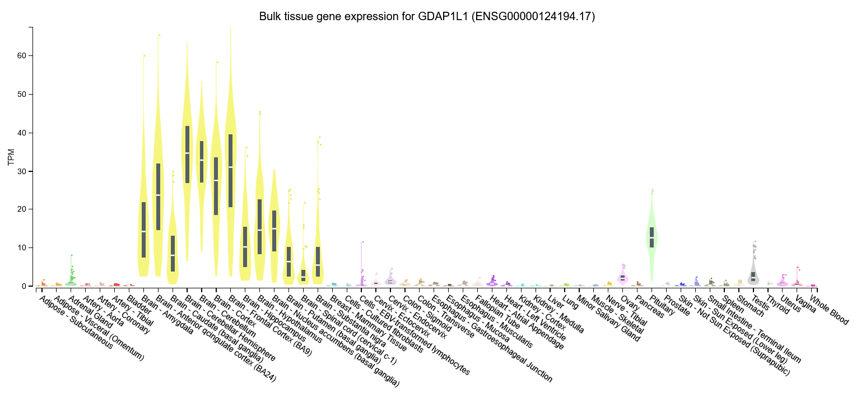
b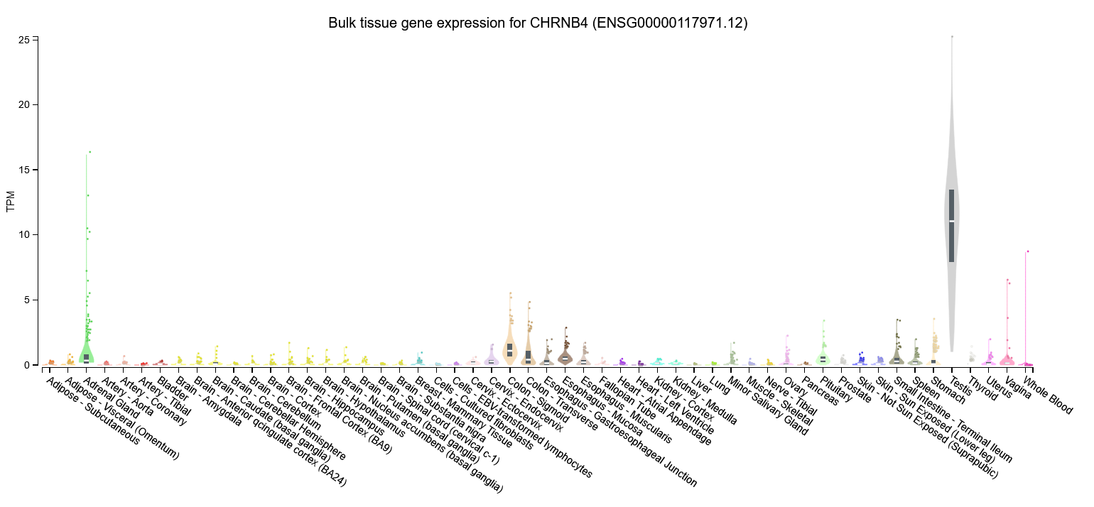
c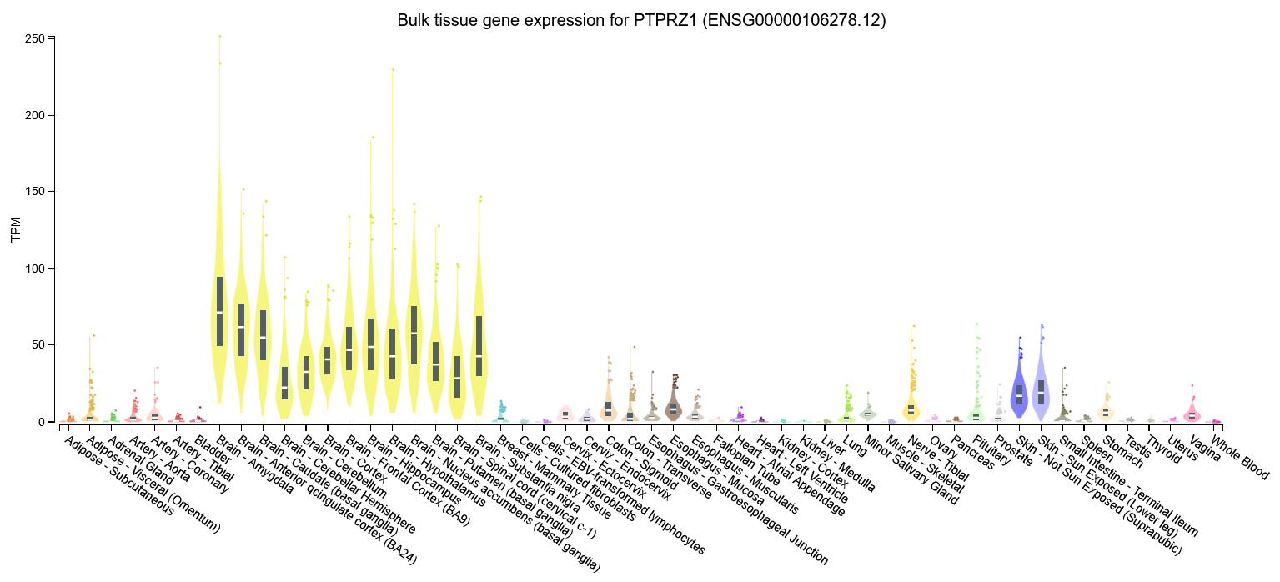
d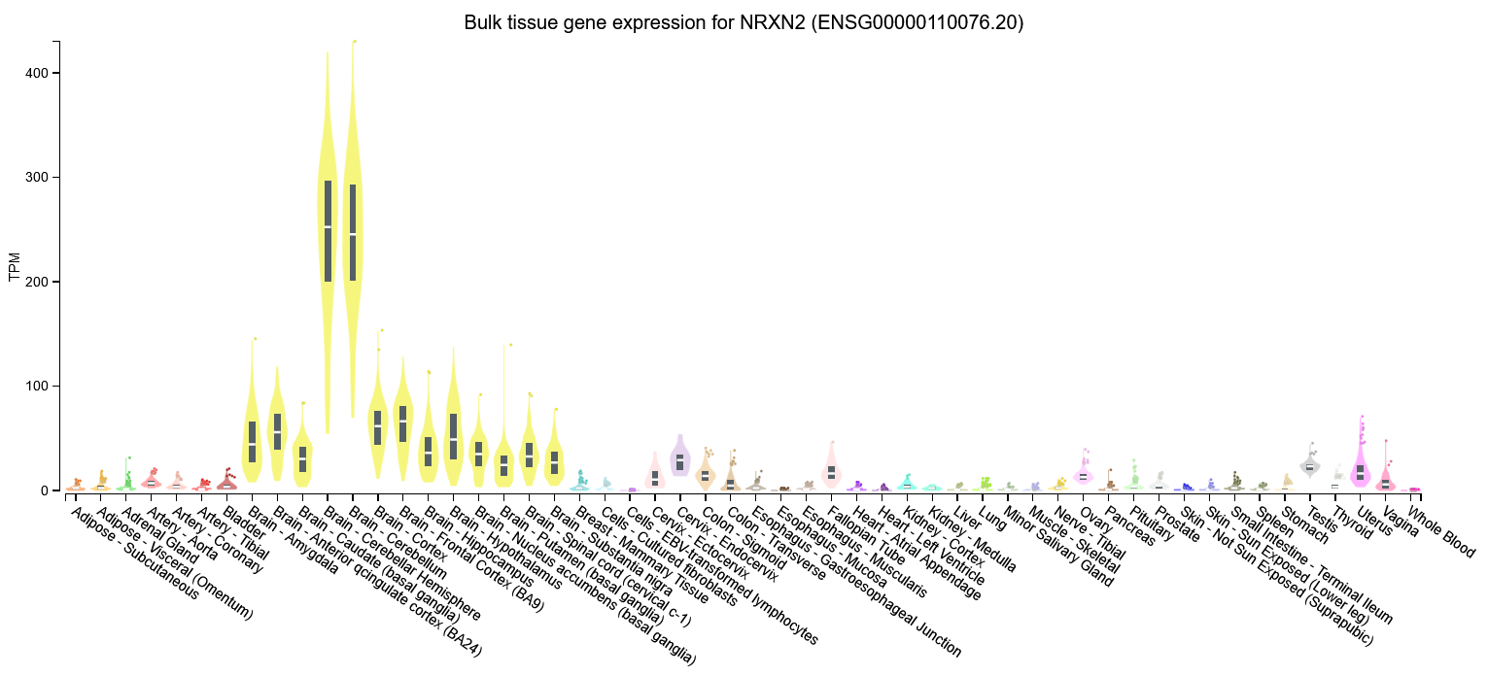
e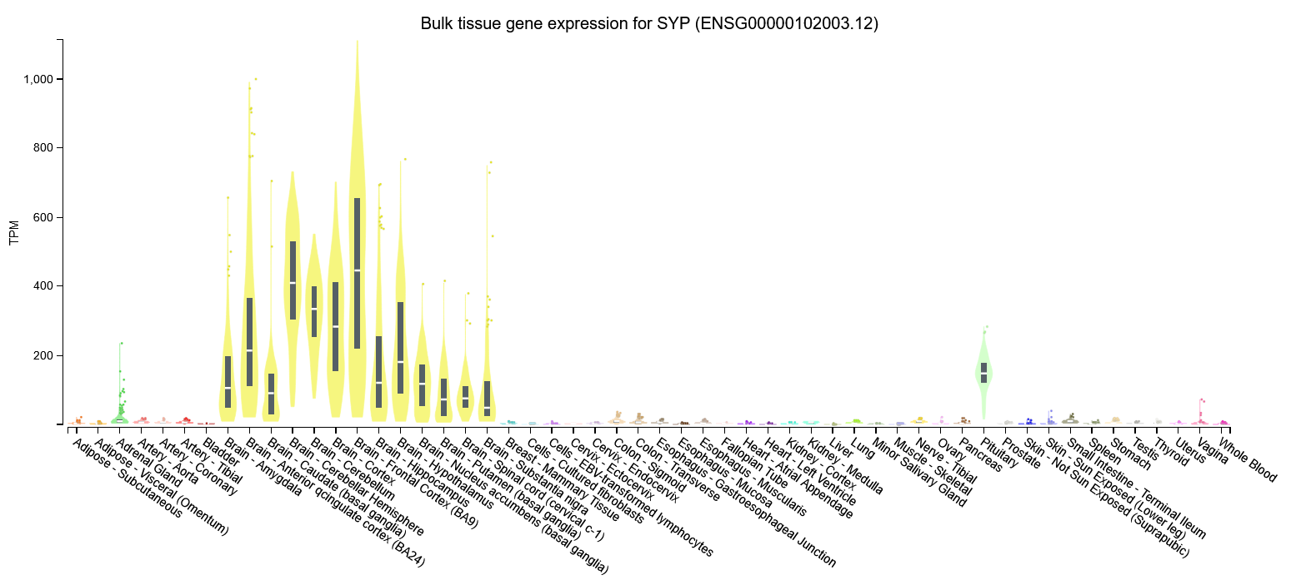
f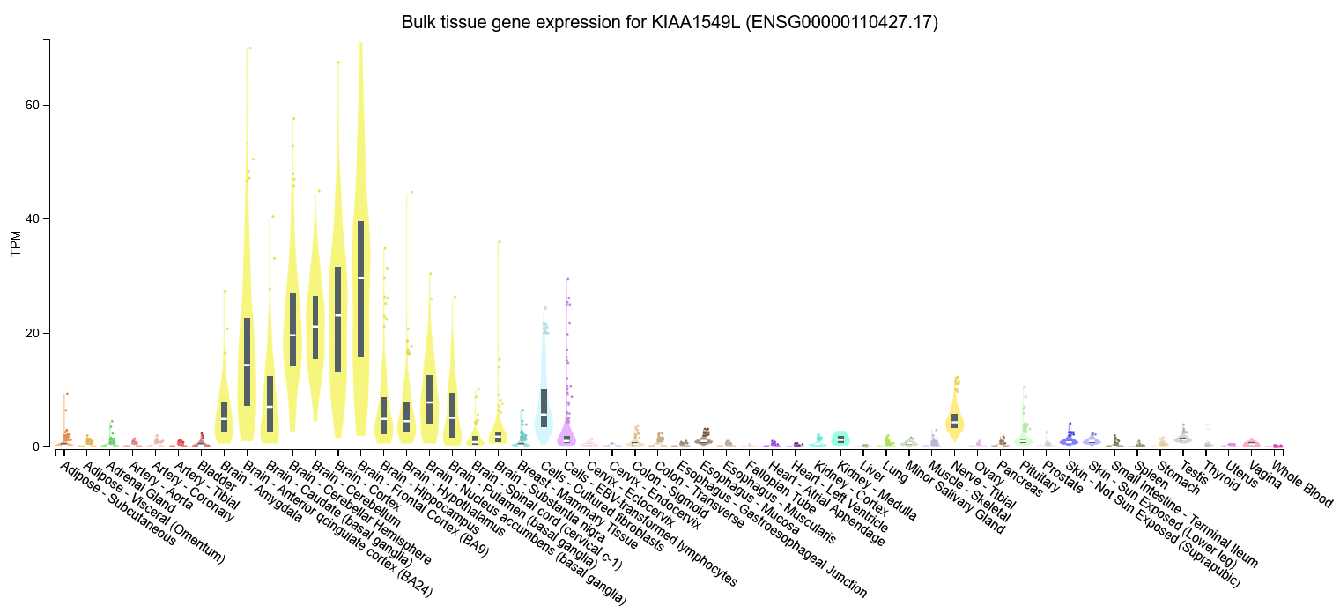
g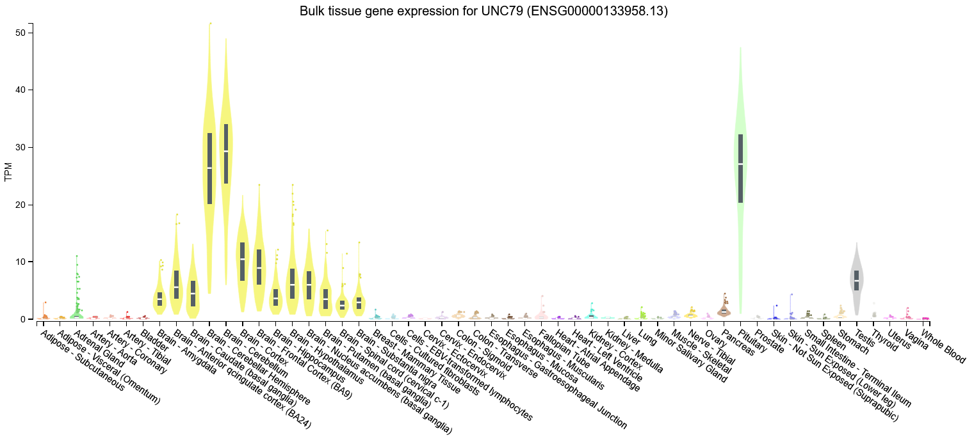

Supplementary Fig.1. GTEx expression profiles of neuro-medullary genes upregulated in CACNA1D-mutant APAs.
Expression data from the GTEx Consortium showing tissue-wide transcript levels of GDAP1L1 (a), CHRNB4 (b), PTPRZ1 (c), NRXN2(d), SYP(e), KIAA1549L (f) and UNC79 (g). These genes, identified as upregulated in CACNA1D-mutant APAs, display enriched expression across both neuronal tissues and the adrenal gland [49].

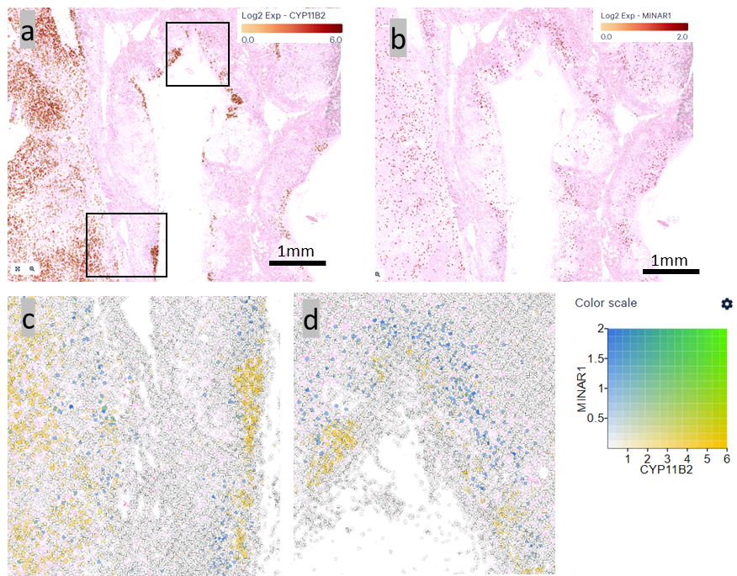
500um
500um
Supplementary Fig. 2. Spatial expression of CYP11B2 and MINAR1 in a KCNJ5-mutant APA with adjacent adrenal containing APMs.
HD Visium maps showing expression of CYP11B2 (a) and MINAR1 (b). Higher-magnification views of the boxed regions demonstrate reciprocal expression of the two genes within the KCNJ5-mutant APA (c) and adjacent zona glomerulosa containing APMs (d). MINAR1, an inhibitor of neurite outgrowth, was selectively expressed in non-APM regions of the zona glomerulosa.

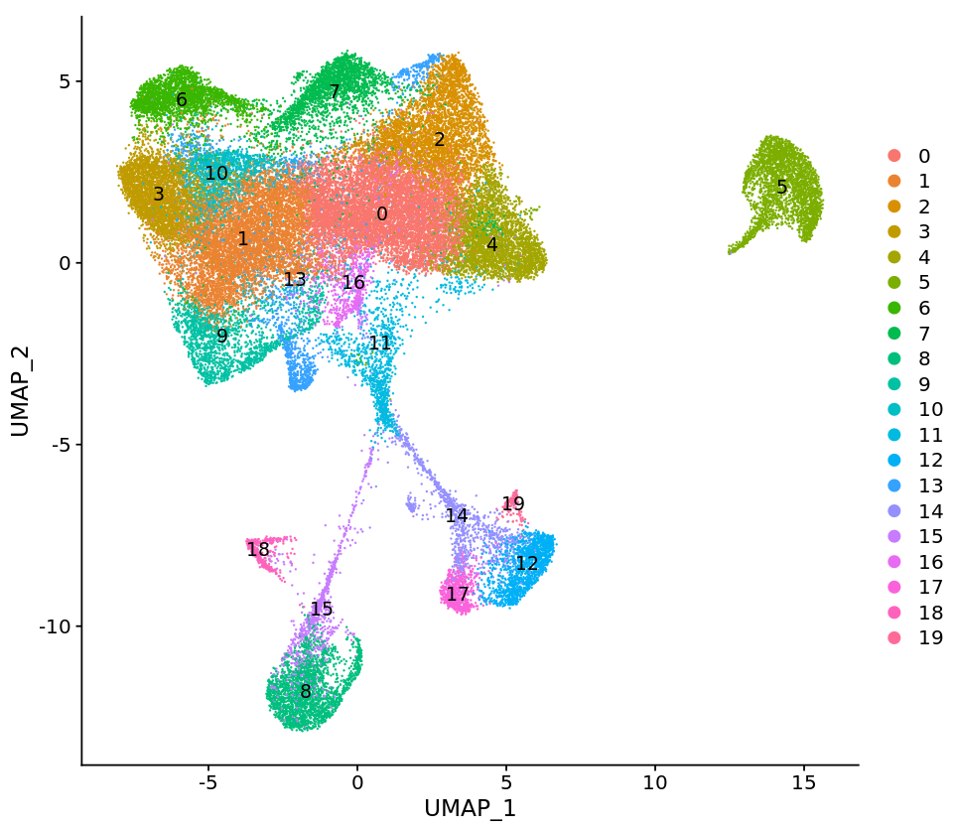
Supplementary Fig. 3. UMAP plot demonstrating a reference map for APAs.
This APA reference map is made up of 47,536 single nuclei from 9 APAs with different genotypes. This includes 3 KCNJ5-, 3 CACNA1D-, 2 GNAQ/CTNNB1- and 1 CLCN2-mutant APA. A total of 20 clusters were identified. Cluster numbering corresponds to relative cluster size, with Cluster 0 representing the largest population and Cluster 19 the smallest. The largest aggregate of clusters (clusters 0, 1, 2, 3, 4, 6, 7, 9, 10, 11, 13 and 16) contains nuclei that express steroidogenic markers.

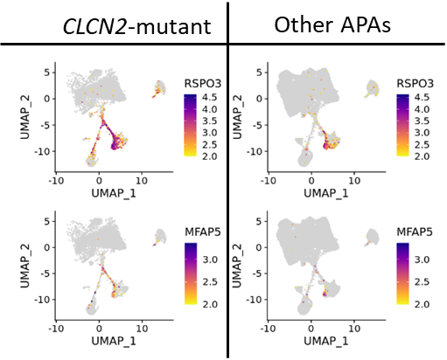
Supplementary Fig. 4. Expression of stromal/adrenal capsular markers in CLCN2-mutant APAs.
UMAP plots showing expression of RSPO3 and MFAP5 in CLCN2-mutant APAs compared with all other APA genotypes. These genes are upregulated in CLCN2-mutant APAs on bulk RNA-seq. snRNA-seq identified that CLCN2-mutant tumours contained a larger population of RSPO3- and MFAP5-expressing cells, consistent with enrichment of stromal/adrenal capsular-like cells. This increase was not observed within the CYP11B2-positive cell population, indicating an excess of stromal cells within the tumours rather than excess RSPO3- and MFAP5 expression within aldosterone-producing cells.

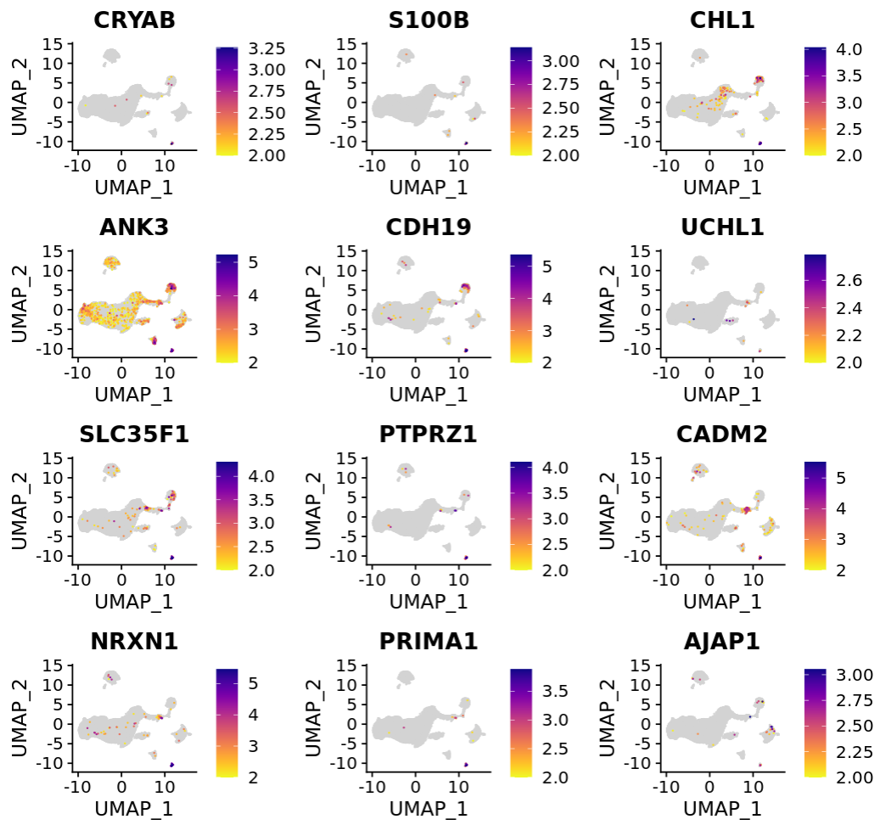
Supplementary Fig. 5. UMAP plots of neuronal gene expression in the discovery cohort.
The UMAP plot demonstrates expression levels of neuronal genes CRYAB, S100B, CHL1, ANK3, CDH19, UCHL1, SLC35F1, PTPRZ1, CADM2, NRXN1, PRIMA1 and AJAP1 in a neuronal cluster, distinct from the adrenal medulla, in the discovery cohort. The neuronal cluster is circled in red.

CRYAB | S100B | CHL1
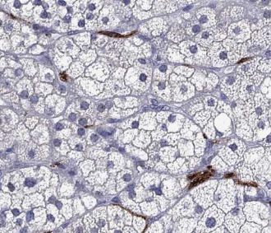 | 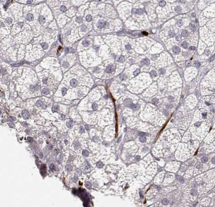 | 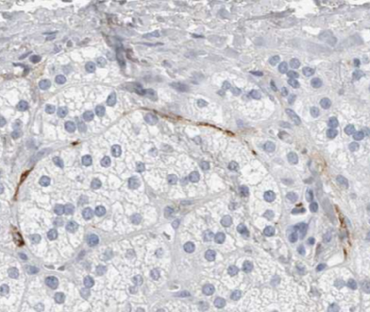
ANK3 | CDH19 | UCHL1
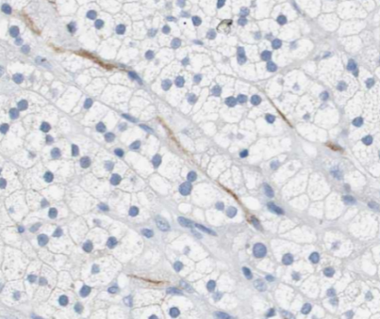 | 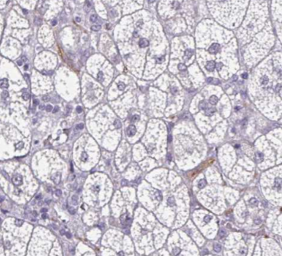 | 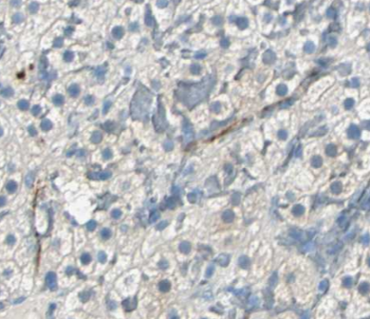
SLC35F1 | PTPRZ1 | CADM2
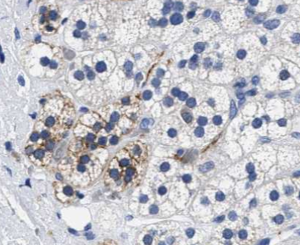 | 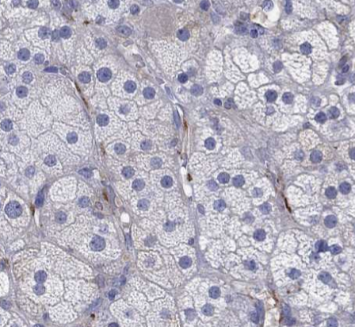 | 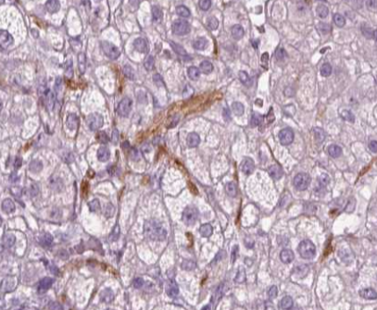

Supplementary Fig. 6. IHC for selected genes upregulated in the neuronal cluster.
IHC from the Human Protein Atlas of CRYAB, S100B, CHL1, ANK3, CDH19, UCHL1, SLC35F1, PTPRZ1 and CADM2 in the adrenal cortex[50]. Neuronal cells are visualised. Cortical cells contain lipid droplets, seen in the IHC, as compared to the medulla with its granular cytoplasm and no stored lipid. SLC35F1 stains neuronal cells adjacent to an APM, also positive for SLC35F1.

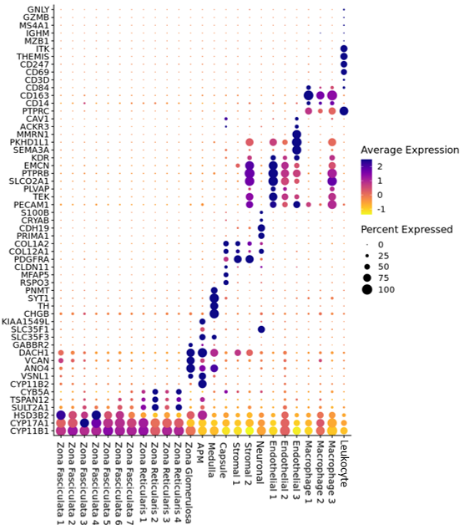
Supplementary Fig. 7. Dot plot illustrating expression of cell specific marker genes in each cluster.
The size of each dot represents the percentage of cells expressing each gene and the colour represents the average expression.

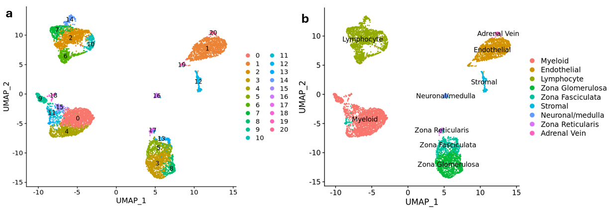Supplementary Fig. 8. UMAP plots for scRNA-seq from 2 adrenals adjacent to APAs.
The UMAP plot is made up of 8003 cells from 2 samples of adrenal tissue adjacent to an APA (one CACNA1D- and one KCNJ5-mutant APA). a, demonstrates 21 clusters on unsupervised clustering. b, is an annotated map. Where the unsupervised clustering identified more than one cluster for a cell type, clusters have been merged to simplify the UMAP plot

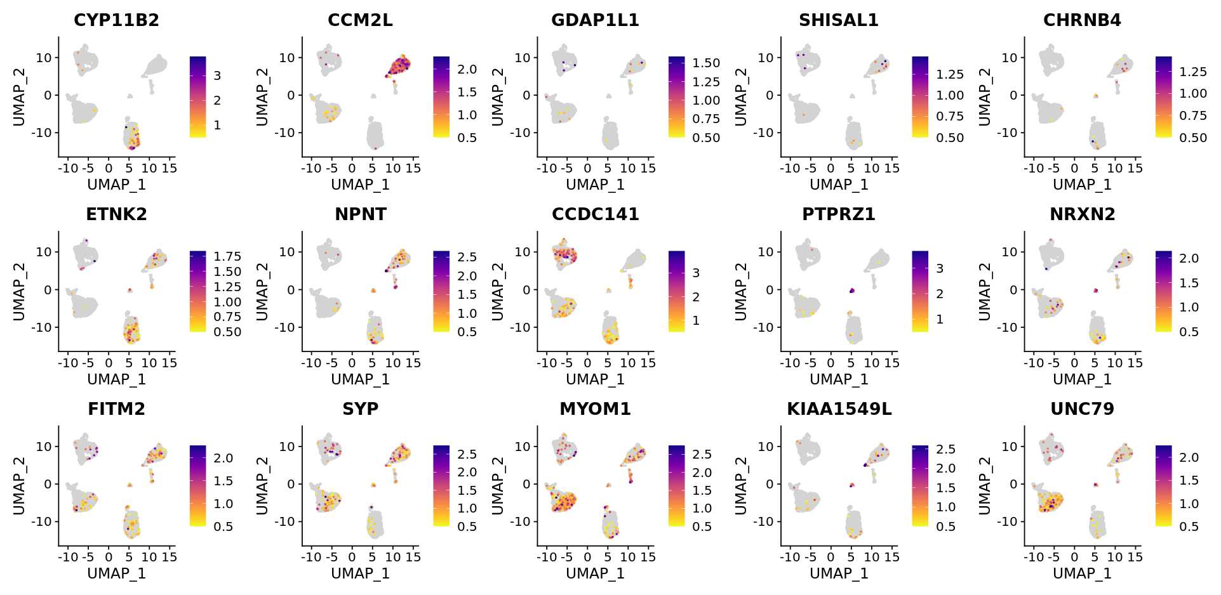
Supplementary Fig. 9. Expression of the top 14 CACNA1D-mutant APA genes on UMAP of 8003 cells from scRNA-seq of 2 adrenals adjacent to APAs.
The expression level of CYP11B2 is plotted alongside the endothelial gene CCM2L (red circle) and the neuronal and medullary genes (blue circle). In this UMAP the neuronal and medullary genes are present in the same cluster. The bottom tip of the ZG cluster expresses CYP11B2. This represents APM cells and expression of CCM2L, CHRNB4, ETNK2, NPNT, CCDC141, NRXN2, FITM2, MYOM1, KIAA1549L and UNC79 can be visualised in these cells. See Supplementary Fig. 8 for cell clustering.

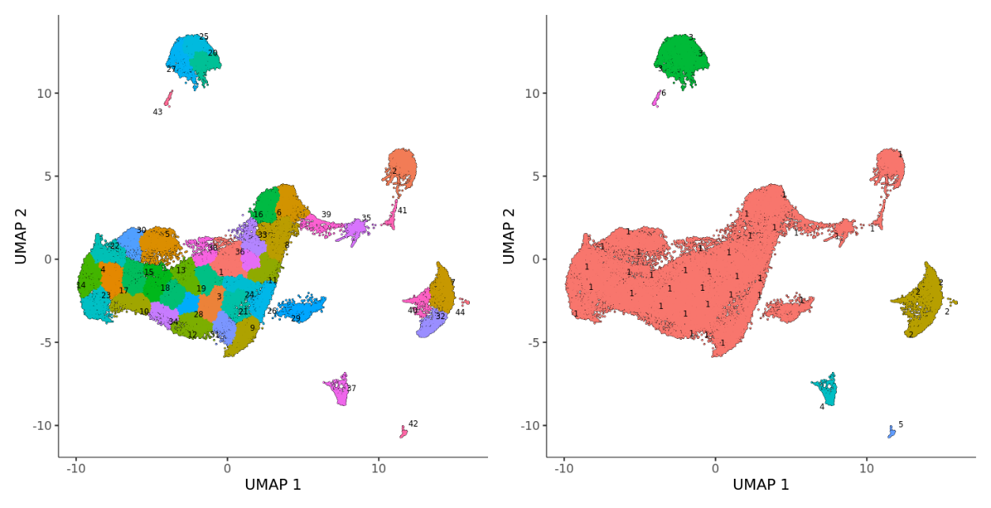
Supplementary Fig. 10. Partitions within the discovery dataset for trajectory analysis.
To prepare the discovery dataset for trajectory analysis, the dataset analysed in Seurat was imported to Monocle3 using preprocess_cds and clustered using cluster_cells. 44 clusters were identified within the dataset and 5 partitions. Each of these partitions could be used for lineage tracing. The largest partition, in red, is partition 1.

a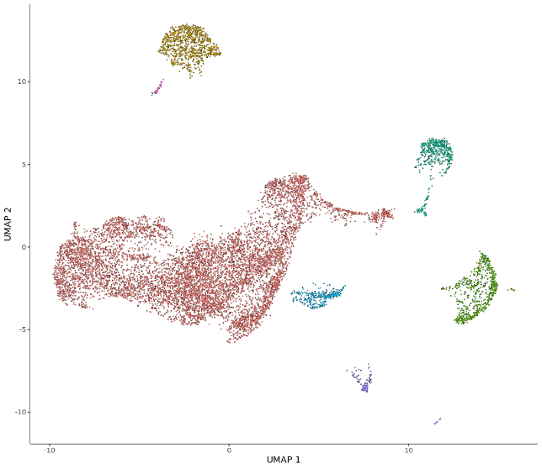 b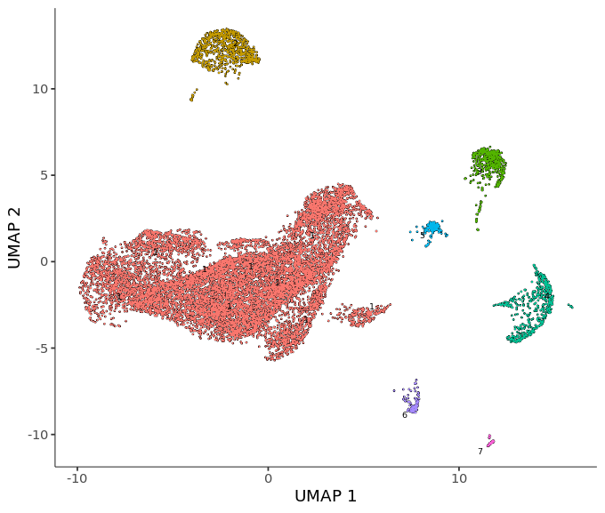
Supplementary Fig. 11. Monocle 3 partitions of nuclei adjacent to CACNA1D-mutant and KCNJ5-mutant APAs.
Monocle 3 subdivides the UMAP into partitions according to graph connectivity between transcriptionally similar nuclei. In CACNA1D-adjacent tissue (a), a single partition containing the medulla, APMs, and ZG is identified (partition 1 in red). In KCNJ5-adjacent tissue (b), the medulla is separated from the cortical compartments and does not fall within the same partition as the cortex. (partition 1 in red and partition 5 in blue).

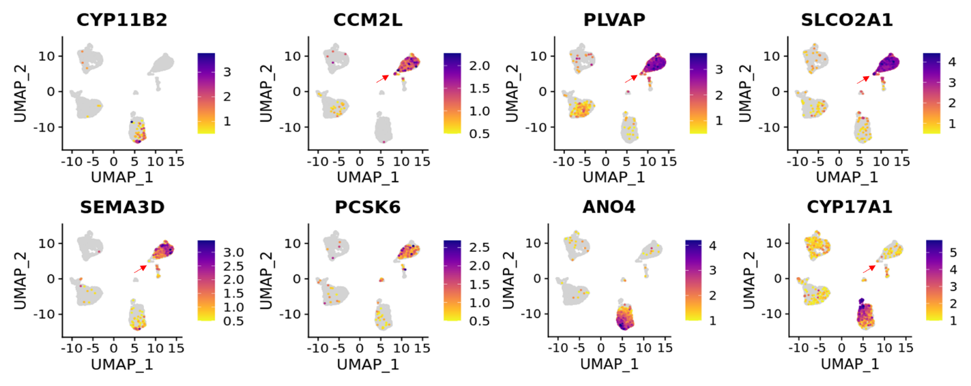
Supplementary Fig. 12. Steroidogenic gene expression in the endothelial cluster on UMAP of 8003 cells from scRNA-seq of 2 adrenals adjacent to APAs.
CCM2L, PLVAP SLCO2A1 mark the endothelial cluster, Steroidogenic genes CYP11B2 and CYP17A1 and the ZG gene ANO4 are plotted. The red arrows point to endothelial cells expressing adrenocortical genes. See Supplementary Fig. 8 for cell clustering.

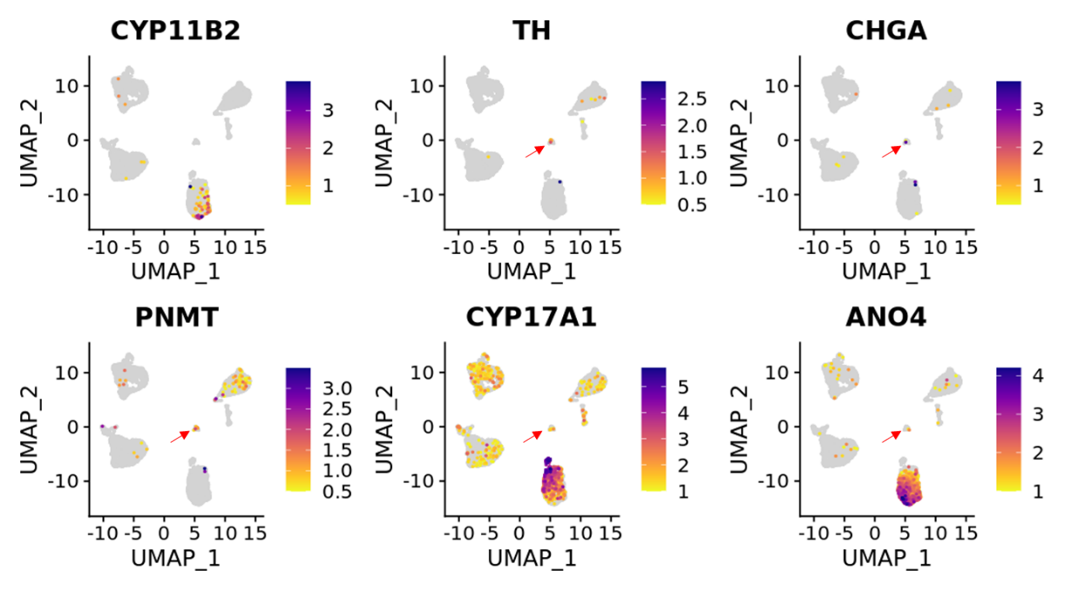
Supplementary Fig. 13. Steroidogenic gene expression in the medullary cluster on UMAP of 8003 cells from scRNA-seq of 2 adrenals adjacent to APAs.
TH, CHGA and PNMT mark the medullary cluster. Steroidogenic genes CYP11B2 and CYP17A1 and the ZG genes ANO4 are plotted and visible in the medullary cell population. The red arrows point to medullary cells expressing these genes. See Supplementary Fig. 8 for cell clustering.

a
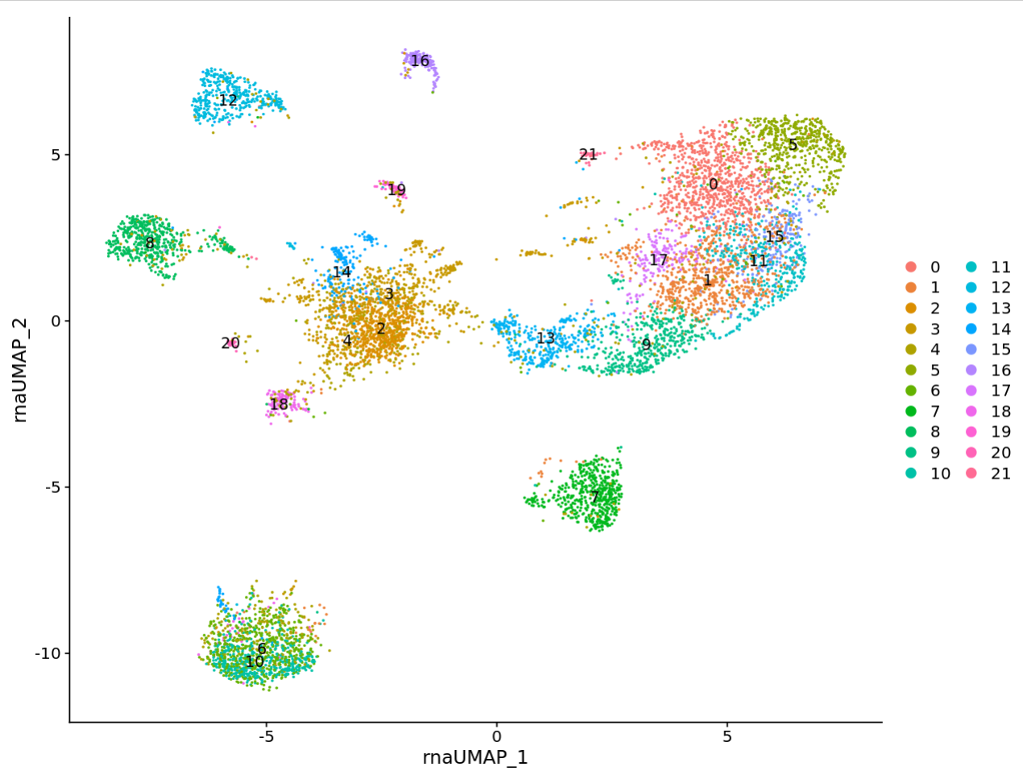
b
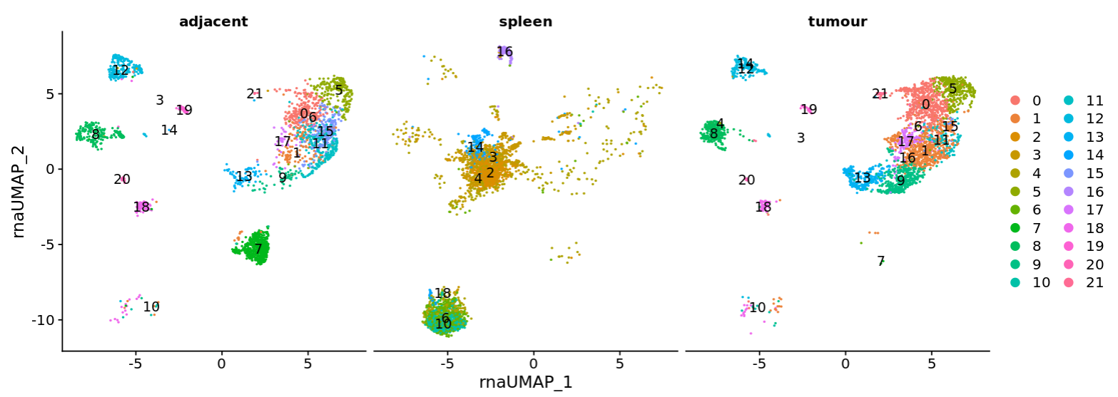
c
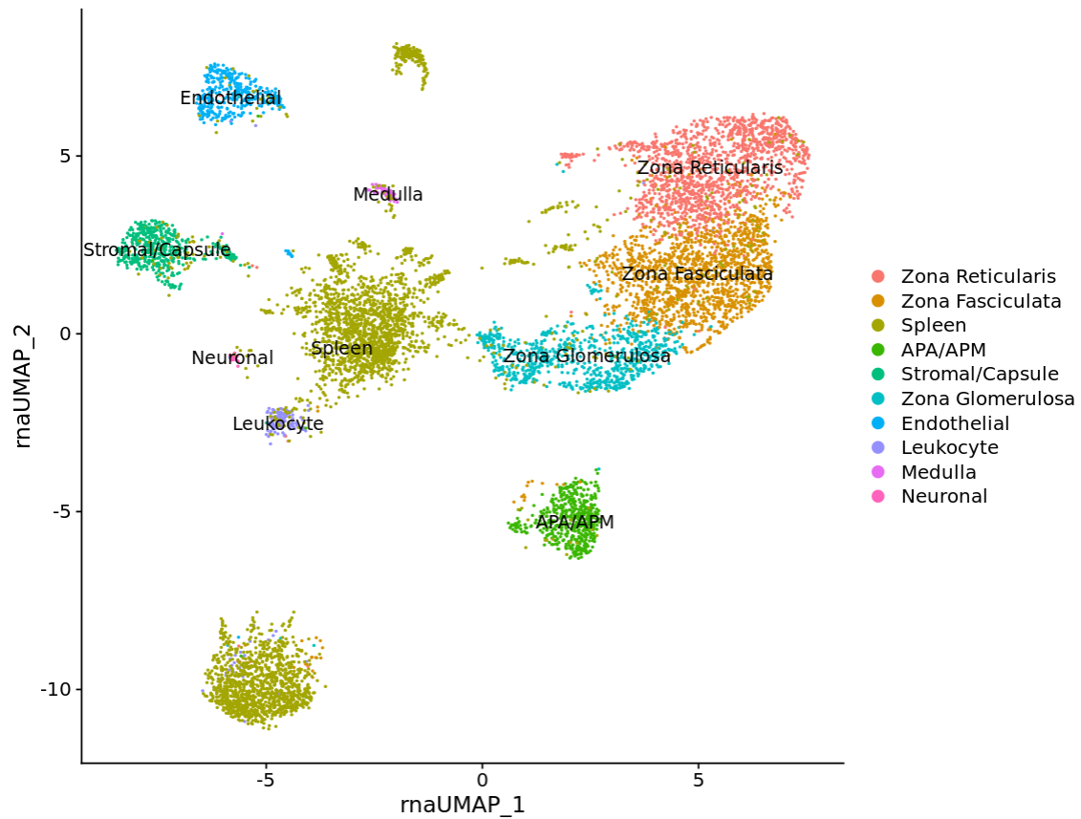
d
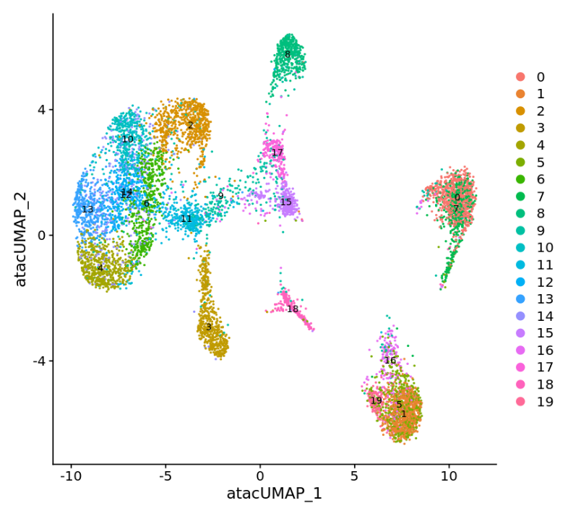
e
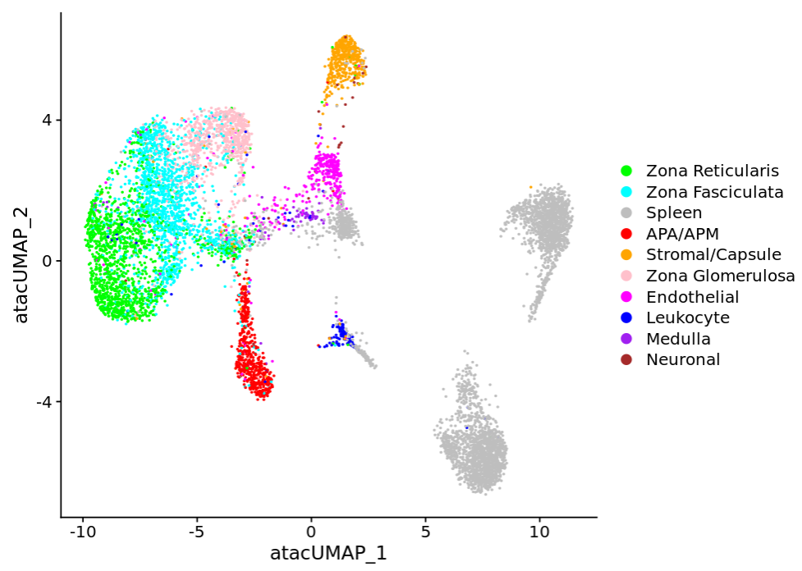
f
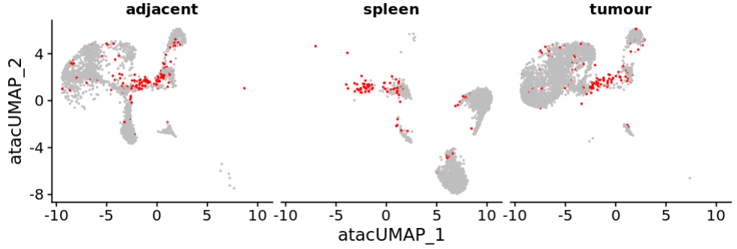
Supplementary Fig. 14. UMAP plots underlying the clustering in Fig. 8b.
UMAP visualizations of 8,646 nuclei from three samples: a CACNA1D-mutant APA, APA-adjacent adrenal tissue and spleen.
a-c use the snRNA-seq assay to cluster and annotate the cells. a Unsupervised clustering identifies 22 clusters. b, Same UMAP split by sample. c, Annotation based on RNA expression. For spleen-derived clusters, limited transcriptional resolution precluded detailed annotation; these are labelled collectively as spleen.
d, UMAP clustering based on snATAC-seq data. e, Transfer of snRNA-seq annotations (from 20c) onto the snATAC-seq UMAP, used to guide annotation in Fig. 8b. f, snATAC-seq UMAP split by sample; cluster 9 (red) is present across all three samples, unlike most clusters (except leukocytes).

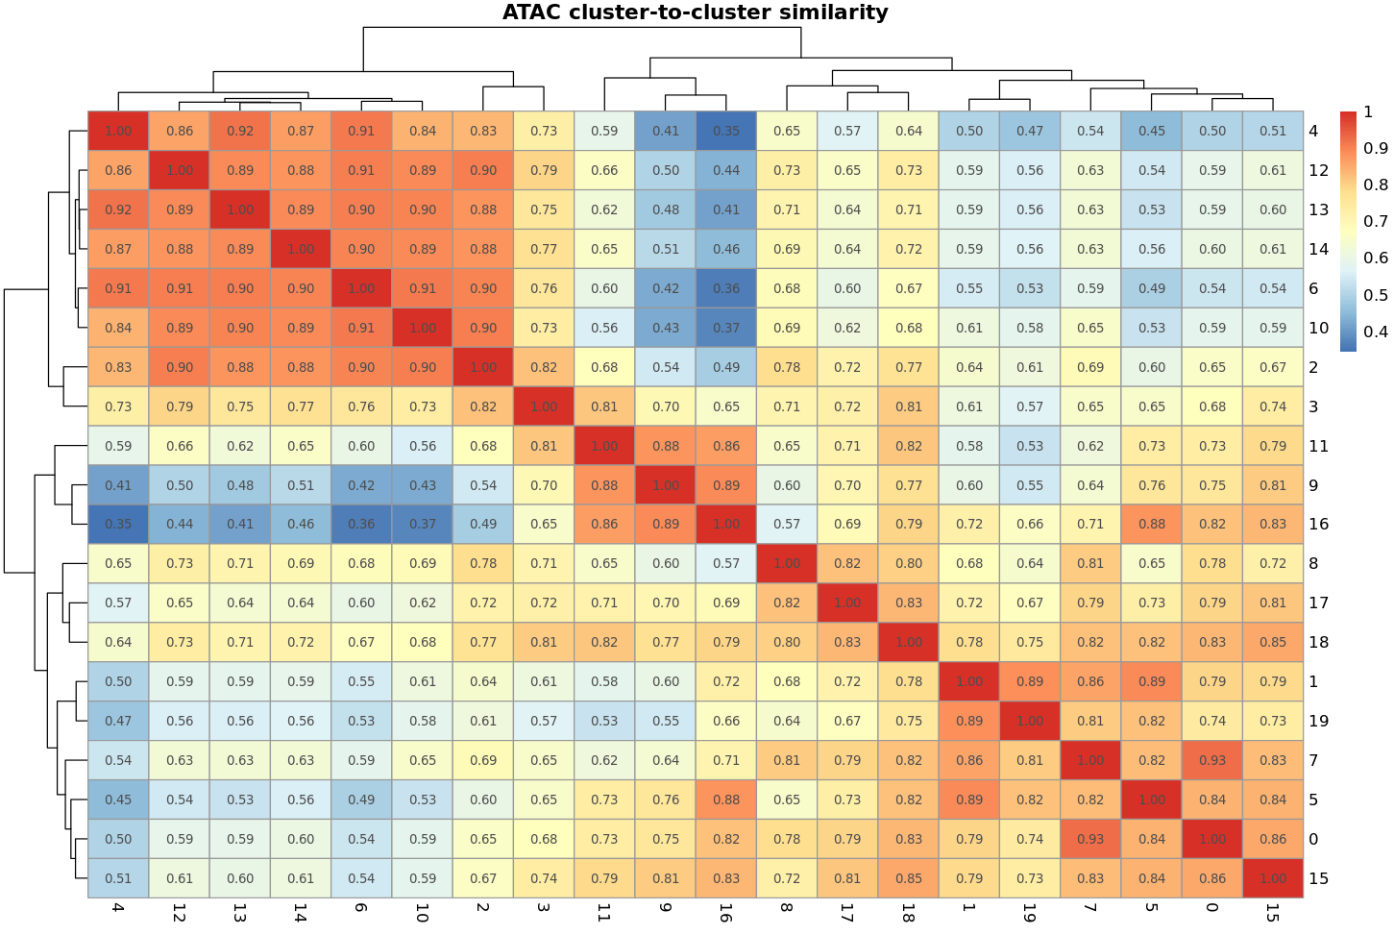
Supplementary Figure 15. Cluster-level chromatin accessibility similarity across adrenal cell populations.
Heatmap showing pairwise Pearson correlation coefficients between cluster-level pseudobulk ATAC-seq profiles. Cells were grouped by cluster, and low-abundance clusters (<30 cells) were excluded. Accessibility profiles were computed using the top 10,000 most variable peaks across the genome, with mean accessibility calculated per cluster. Hierarchical clustering was applied to the resulting similarity matrix to visualize relationships between cell populations based on chromatin accessibility signatures.
High similarity (r > 0.8) and moderate similarity (r = 0.5–0.7) are indicated by the colour scale. Notably, the putative hybrid cluster (cluster 9) exhibits strong similarity to multiple populations, including steroidogenic endothelial cells (r = 0.81), adrenocortical progenitor-like cells (r = 0.70), and mixed steroidogenic cells (r = 0.88), suggesting a hybrid chromatin accessibility profile.

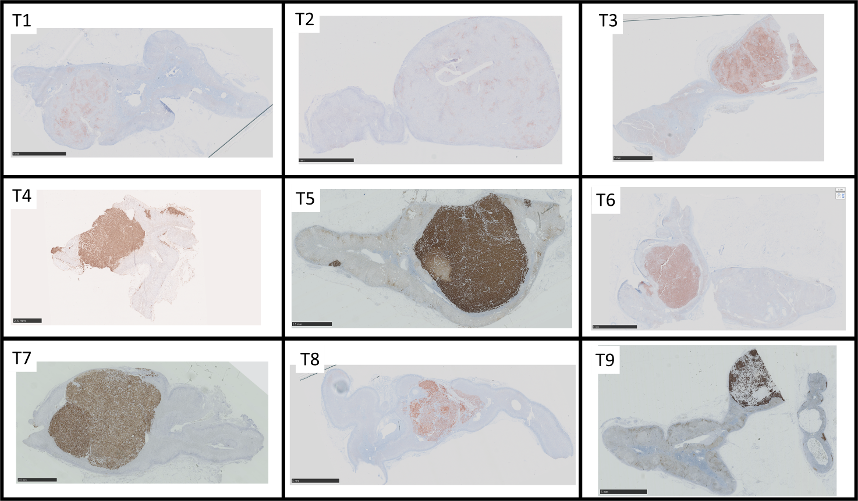
Supplementary Fig. 16. IHC for CYP11B2 on tumours undergoing snRNA-seq.
FFPE human adrenal tissue adjacent to an APA was tested with IHC, using the automated Ventana Discovery ULTRA machine. Slides were scanned at X20 magnification using the NanoZoomer S210 and analysed with NDP.view2. The KCNJ5-mutant tumours demonstrate patchier staining of CYP11B2 when compared to other tumours. There is not a clear capsule for all of the tumours with irregular CYP11B2 margins with the adjacent adrenal demonstrated seen in T01, T04, T09 and T10.

1. Peters B, Teubner P, Clausmeyer S, Puschner T, Maser-Gluth C, Wrede HJ, et al. StAR expression and the long-term aldosterone response to high-potassium diet in Wistar-Kyoto and spontaneously hypertensive rats. Am J Physiol Endocrinol Metab. 2007;292(1):E16-23.
2. Stocco DM. StAR protein and the regulation of steroid hormone biosynthesis. Annu Rev Physiol. 2001;63:193-213.
3. Bergman J, Botling J, Fagerberg L, Hallstrom BM, Djureinovic D, Uhlen M, et al. The Human Adrenal Gland Proteome Defined by Transcriptomics and Antibody-Based Profiling. Endocrinology. 2017;158(2):239-51.
4. Rainey WE. Adrenal zonation: clues from 11beta-hydroxylase and aldosterone synthase. Mol Cell Endocrinol. 1999;151(1-2):151-60.
5. Baker JE, Plaska SW, Qin Z, Liu CJ, Rege J, Rainey WE, et al. Targeted RNA sequencing of adrenal zones using immunohistochemistry-guided capture of formalin-fixed paraffin-embedded tissue. Mol Cell Endocrinol. 2021;530:111296.
6. Nishimoto K, Nakagawa K, Li D, Kosaka T, Oya M, Mikami S, et al. Adrenocortical zonation in humans under normal and pathological conditions. J Clin Endocrinol Metab. 2010;95(5):2296-305.
7. Shaikh LH, Zhou J, Teo AE, Garg S, Neogi SG, Figg N, et al. LGR5 Activates Noncanonical Wnt Signaling and Inhibits Aldosterone Production in the Human Adrenal. J Clin Endocrinol Metab. 2015;100(6):E836-44.
8. Zhou J, Lam B, Neogi SG, Yeo GS, Azizan EA, Brown MJ. Transcriptome Pathway Analysis of Pathological and Physiological Aldosterone-Producing Human Tissues. Hypertension. 2016;68(6):1424-31.
9. Zhou J, Shaikh LH, Neogi SG, McFarlane I, Zhao W, Figg N, et al. DACH1, a zona glomerulosa selective gene in the human adrenal, activates transforming growth factor-beta signaling and suppresses aldosterone secretion. Hypertension. 2015;65(5):1103-10.
10. Nishimoto K, Tomlins SA, Kuick R, Cani AK, Giordano TJ, Hovelson DH, et al. Aldosterone-stimulating somatic gene mutations are common in normal adrenal glands. Proc Natl Acad Sci U S A. 2015;112(33):E4591-9.
11. Rainey WE, Nakamura Y. Regulation of the adrenal androgen biosynthesis. J Steroid Biochem Mol Biol. 2008;108(3-5):281-6.
12. Rege J, Nakamura Y, Wang T, Merchen TD, Sasano H, Rainey WE. Transcriptome profiling reveals differentially expressed transcripts between the human adrenal zona fasciculata and zona reticularis. J Clin Endocrinol Metab. 2014;99(3):E518-27.
13. Winkler H, Fischer-Colbrie R. The chromogranins A and B: the first 25 years and future perspectives. Neuroscience. 1992;49(3):497-528.
14. Stubbusch J, Narasimhan P, Huber K, Unsicker K, Rohrer H, Ernsberger U. Synaptic protein and pan-neuronal gene expression and their regulation by Dicer-dependent mechanisms differ between neurons and neuroendocrine cells. Neural Dev. 2013;8:16.
15. Santana MM, Chung KF, Vukicevic V, Rosmaninho-Salgado J, Kanczkowski W, Cortez V, et al. Isolation, characterization, and differentiation of progenitor cells from human adult adrenal medulla. Stem Cells Transl Med. 2012;1(11):783-91.
16. Uezumi A, Fukada S, Yamamoto N, Ikemoto-Uezumi M, Nakatani M, Morita M, et al. Identification and characterization of PDGFRalpha+ mesenchymal progenitors in human skeletal muscle. Cell Death Dis. 2014;5(4):e1186.
17. Sen A, Ta M. Altered Adhesion and Migration of Human Mesenchymal Stromal Cells under Febrile Temperature Stress Involves NF-kappabeta Pathway. Sci Rep. 2020;10(1):4473.
18. Picard D, Miller S, Hawkins CE, Bouffet E, Rogers HA, Chan TS, et al. Markers of survival and metastatic potential in childhood CNS primitive neuro-ectodermal brain tumours: an integrative genomic analysis. Lancet Oncol. 2012;13(8):838-48.
19. Li CF, Chen JY, Ho YH, Hsu WH, Wu LC, Lan HY, et al. Snail-induced claudin-11 prompts collective migration for tumour progression. Nat Cell Biol. 2019;21(2):251-62.
20. Aird WC. Phenotypic heterogeneity of the endothelium: II. Representative vascular beds. Circ Res. 2007;100(2):174-90.
21. Schnurch H, Risau W. Expression of tie-2, a member of a novel family of receptor tyrosine kinases, in the endothelial cell lineage. Development. 1993;119(3):957-68.
22. Guo L, Zhang H, Hou Y, Wei T, Liu J. Plasmalemma vesicle-associated protein: A crucial component of vascular homeostasis. Exp Ther Med. 2016;12(3):1639-44.
23. Ariake C, Hosoe N, Sakurai H, Tojo A, Hayashi Y, Jl Limpias Kamiya K, et al. Chronic Enteropathy Associated with Solute Carrier Organic Anion Transporter Family, Member 2A1 (SLCO2A1) with Positive Immunohistochemistry for SLCO2A1 Protein. Intern Med. 2022;61(17):2607-11.
24. Fachinger G, Deutsch U, Risau W. Functional interaction of vascular endothelial-protein-tyrosine phosphatase with the angiopoietin receptor Tie-2. Oncogene. 1999;18(43):5948-53.
25. Huang L, Liao J, Chen Y, Zou C, Zhang H, Yang X, et al. Single-cell transcriptomes reveal characteristic features of cell types within the human adrenal microenvironment. J Cell Physiol. 2021;236(11):7308-21.
26. Liu H, Bell K, Herrmann A, Arnhold S, Mercieca K, Anders F, et al. Crystallins Play a Crucial Role in Glaucoma and Promote Neuronal Cell Survival in an In Vitro Model Through Modulating Muller Cell Secretion. Invest Ophthalmol Vis Sci. 2022;63(8):3.
27. Schmitt LI, Leo M, Kutritz A, Kleinschnitz C, Hagenacker T. Activation and functional modulation of satellite glial cells by oxaliplatin lead to hyperexcitability of sensory neurons in vitro. Mol Cell Neurosci. 2020;105:103499.
28. HumanProteinAtlas. CHL1 [Available from: https://www.proteinatlas.org/ENSG00000134121-CHL1/tissue/adrenal+gland#img.
29. HumanProteinAtlas. ANK3 [Available from: https://www.proteinatlas.org/ENSG00000151150-ANK3/tissue/adrenal+gland#img.
30. Lu J, Wang D, Xu J, Zhang H, Yu W. New Insights on the Role of Satellite Glial Cells. Stem Cell Rev Rep. 2023;19(2):358-67.
31. Qian C, Wu Z, Sun R, Yu H, Zeng J, Rao Y, et al. Localization, proteomics, and metabolite profiling reveal a putative vesicular transporter for UDP-glucose. Elife. 2021;10.
32. HumanProteinAtlas. PTPRZ1 [Available from: https://www.proteinatlas.org/ENSG00000106278-PTPRZ1/tissue/adrenal+gland#img.
33. HumanProteinAtlas. CADM2 [Available from: https://www.proteinatlas.org/ENSG00000106278-PTPRZ1/tissue/adrenal+gland#img.
34. Ushkaryov YA, Petrenko AG, Geppert M, Sudhof TC. Neurexins: synaptic cell surface proteins related to the alpha-latrotoxin receptor and laminin. Science. 1992;257(5066):50-6.
35. Azizan EAB, Drake WM, Brown MJ. Primary aldosteronism: molecular medicine meets public health. Nat Rev Nephrol. 2023.
36. Perrier AL, Massoulie J, Krejci E. PRiMA: the membrane anchor of acetylcholinesterase in the brain. Neuron. 2002;33(2):275-85.
37. Liu H, Povysheva N, Rose ME, Mi Z, Banton JS, Li W, et al. Role of UCHL1 in axonal injury and functional recovery after cerebral ischemia. Proc Natl Acad Sci U S A. 2019;116(10):4643-50.
38. Donovan JA, Koretzky GA. CD45 and the immune response. J Am Soc Nephrol. 1993;4(4):976-85.
39. Sintes J, Romero X, de Salort J, Terhorst C, Engel P. Mouse CD84 is a pan-leukocyte cell-surface molecule that modulates LPS-induced cytokine secretion by macrophages. J Leukoc Biol. 2010;88(4):687-97.
40. Landmann R, Muller B, Zimmerli W. CD14, new aspects of ligand and signal diversity. Microbes Infect. 2000;2(3):295-304.
41. Kim WK, Alvarez X, Fisher J, Bronfin B, Westmoreland S, McLaurin J, et al. CD163 identifies perivascular macrophages in normal and viral encephalitic brains and potential precursors to perivascular macrophages in blood. Am J Pathol. 2006;168(3):822-34.
42. de la Hera A, Muller U, Olsson C, Isaaz S, Tunnacliffe A. Structure of the T cell antigen receptor (TCR): two CD3 epsilon subunits in a functional TCR/CD3 complex. J Exp Med. 1991;173(1):7-17.
43. Cibrian D, Sanchez-Madrid F. CD69: from activation marker to metabolic gatekeeper. Eur J Immunol. 2017;47(6):946-53.
44. Clevers H, Alarcon B, Wileman T, Terhorst C. The T cell receptor/CD3 complex: a dynamic protein ensemble. Annu Rev Immunol. 1988;6:629-62.
45. Lesourne R, Uehara S, Lee J, Song KD, Li L, Pinkhasov J, et al. Themis, a T cell-specific protein important for late thymocyte development. Nat Immunol. 2009;10(8):840-7.
46. Zhong Y, Johnson AJ, Byrd JC, Dubovsky JA. Targeting Interleukin-2-Inducible T-cell Kinase (ITK) in T-Cell Related Diseases. Postdoc J. 2014;2(6):1-11.
47. Arazi A, Rao DA, Berthier CC, Davidson A, Liu Y, Hoover PJ, et al. The immune cell landscape in kidneys of patients with lupus nephritis. Nat Immunol. 2019;20(7):902-14.
48. Chen J, Cheung F, Shi R, Zhou H, Lu W, Consortium CHI. PBMC fixation and processing for Chromium single-cell RNA sequencing. J Transl Med. 2018;16(1):198.
49. Consortium GT. The Genotype-Tissue Expression (GTEx) project. Nat Genet. 2013;45(6):580-5.
50. Uhlen M, Fagerberg L, Hallstrom BM, Lindskog C, Oksvold P, Mardinoglu A, et al. Proteomics. Tissue-based map of the human proteome. Science. 2015;347(6220):1260419.

