Supplementary Materials
Table S1. List of primers
 | Forward 5’ | Reverse 5’
Primers for generation of PABPN1 variants
dAla-FLAG | TCGCAGTACTAAGATCTCCATCCAATGGGGGCTGCGGGCGGTCGGGGC | ATTGGATGGAGATCTTAGTACTGCGA  TGAATTCGAAGCTTGAGCTCG
dIDR-FLAG | TCGCAGTACTAAGATCTCCATCCA  ATGGAGGACCCGGAGCTGGAAGCTATC | CATTGGATGGAGATCTTAGTACTGCGA  TGAATTCGAAGCTTGAGCTCG
dCCD-FLAG | TCGCAGTACTAAGATCTCCATCCA  ATGCCTCCAGGCAATGCTGGCCCG | CATTGGATGGAGATCTTAGTACTGCGATGAATTCGAAGCTTGAGCTCG
trPAB-FLAG | AGCTCAAGCTTCGAATTCAATGGAGGAAGAAGCTGAG | TGAATTCGAAGCTTGAGCTCGAGATCTG
A16-FLAG | GACTACAAGGATGACGATGACAAGTAAATTAGGAGGAGAGAGAGG | TTACTTGTCATCGTCATCCTTGTAGTCGTAAGGGGAATACCATGATG
RT-qPCR
HPRT1 | TGGTCAGGCAGTATAATCCAAAGA | TCAAATCCAACAAAGTCTGGCTTA
FLAG | ACAGTGGTTTTAACAGCAGGC | CTTGTCATCGTCATCCTTGTAGTC
trPAB | GGAAGAAGCTGAGAAGCTAAA | CTTAACTCGCCATGGAATGA
PABPN1_3’-UTR | ATGGACACGTCTCAACTGCG | ACGGAGGGAAGGTAACAAGC
Distal (D) and proximal (P) primer sets for APA analysis in cancer and muscle
D_ASB5 | CACTATTTTCAACAACCCAGGGC | AGCTTAGTGATCTGGGGGTC
P_ASB5 | ACCCCAAGCTCTCTTTACCA | AGTAACGTTGGC AGCTGGAG
D_TMEM123 | CTTCGTAGACCGACCTGAAGT | TGCAGAGGAAACTTTCAAGGCA
P_TMEM123 | ACTCAAGAAGAGGCATTCGGT | TGATAGGGCAGCATCAATCTGT
D_CYBRD1 | AAAGCCTTTTCTCTCAAAGCG T | TGACACAAGCAGCACAGGAA
P_CYBRD1 | GGATGAGGCTGGGCAGAGAT | GGCTAATAGGAGAAGCAAAACTGT
D_LRP1 | AAGACGTGGCTCTGGGTGAG | CTCATAGGTGCCCCTGGAGTTG
P_LRP1 | GCACGGACGAGAAGCGAGAA | GCTTTCTGGGGGCAGTCC
D_PSTPIP2 | CACCTGTGCACTATGAGAAAATGG | CTGCACAGAGCAGGAGAGGAA
P_PSTPIP2 | TTTCCGGCTAGTGCTTCTGT | ATAGCAAGGGTTCACTTCAAAGTC T
D_CDKN1A distal | GTGAGGGTCCCATGTGGTG | GCCAGTGTCTCCCTCCTAGA
CDKN1A proximal | ACTCTCAGGGTCGAAAACGG | ATGTAGAGCGGGCCTTTGAG
Distal (d) and proximal (p) primer sets for APA analysis in mice
D_DMD | TGGCATGTATCATCATTGTCTCC | TGTTGTGAAAATGCAGTAAAACTGA
P_DMD | TGGCAGATGATTTGGGCAGA | CCATGCGGGAATCAGGAGTT
D_Oaz2 | CTGGACTGCAGAAATGGCCT | ACACCCCCACACCCAATGTA
P_Oaz2 | TACCCCCTGGACCAGAACTT | TCCCTAGACAGCCAG AGACC
D_Tmed3 | GGATCTTGCAAGGGGAAAACTAC | ACCAACAAACTGCTGCAAGG
P_Tmed3 | TTTGAAGTCCGGAGGGTTGT | TGACCAAGGTGTTTGGTAAACAAG
D_Phtf2 | AGTAAGTGACATCCCTGCCTT | CAGCACACAGCATTTGCCAT
P_Phtf2 | TTGTTGAAAGGGTGGCAGAGC | TGCTTAGCAATGGCTTCTGTT T

Table S2. List of antibodies
Primary antibodies
 | Dilution |  |  |  | Host | Supplier | Cat. Number
 | Immunofluorescence (IF) |  | Western blot (WB) |  | Host | Supplier | Cat. Number
GAPDH | - |  | 1:5000 |  | Mouse | Invitrogen | MA5-15738
PABPN1 (PAB2) | 1:1000 |  | 1:4000 |  | Rabbit | Homemade (10)
FLAG | 1:1000 |  | 1:1000 |  | Mouse | Sigma-Aldrich | F1804
RPS3 | - |  | 1:500 |  | Mouse | Proteintech | 66046
MATR3 | - |  | 1:1000 |  | Rabbit | Invitrogen | 68280
MyHC | 1:250 |  | 1:200 |  | Mouse | DSHB | MF20
MYOG | 1:1000 |  | - |  | Mouse | BD Pharmingen | 556358
IGF2BP1/2 | - |  | 1:200 |  | Mouse | DSHB | PCRP-IGF2BP1-2D4
Dystrophin | 1:1000 |  | - |  | Mouse | Gene Tex | GTX27163
Dystrophin | 1:250 |  | - |  | Mouse | DSHB | 6A9
Secondary antibodies
Application | Fluorophore | Dilution |  | Supplier
IF | Anti-R-Cy5 | 1:2000 |  | ThermoFisher Scientific
IF | Anti-M-Alexa488 | 1:2000 |  | ThermoFisher Scientific
IF | Anti-M-Alexa594 | 1:2000 |  | ThermoFisher Scientific
WB | Anti-R/M-800/680 | 1:10000 |  | IRDye 800CW or IRDye 680RD (LI-COR)

Table S3: FLAG-trap protein binders in muscle and blader cancer cells
Table S4: Differentially expressed and APA-shift transcripts in trPAB bladder cancer cells

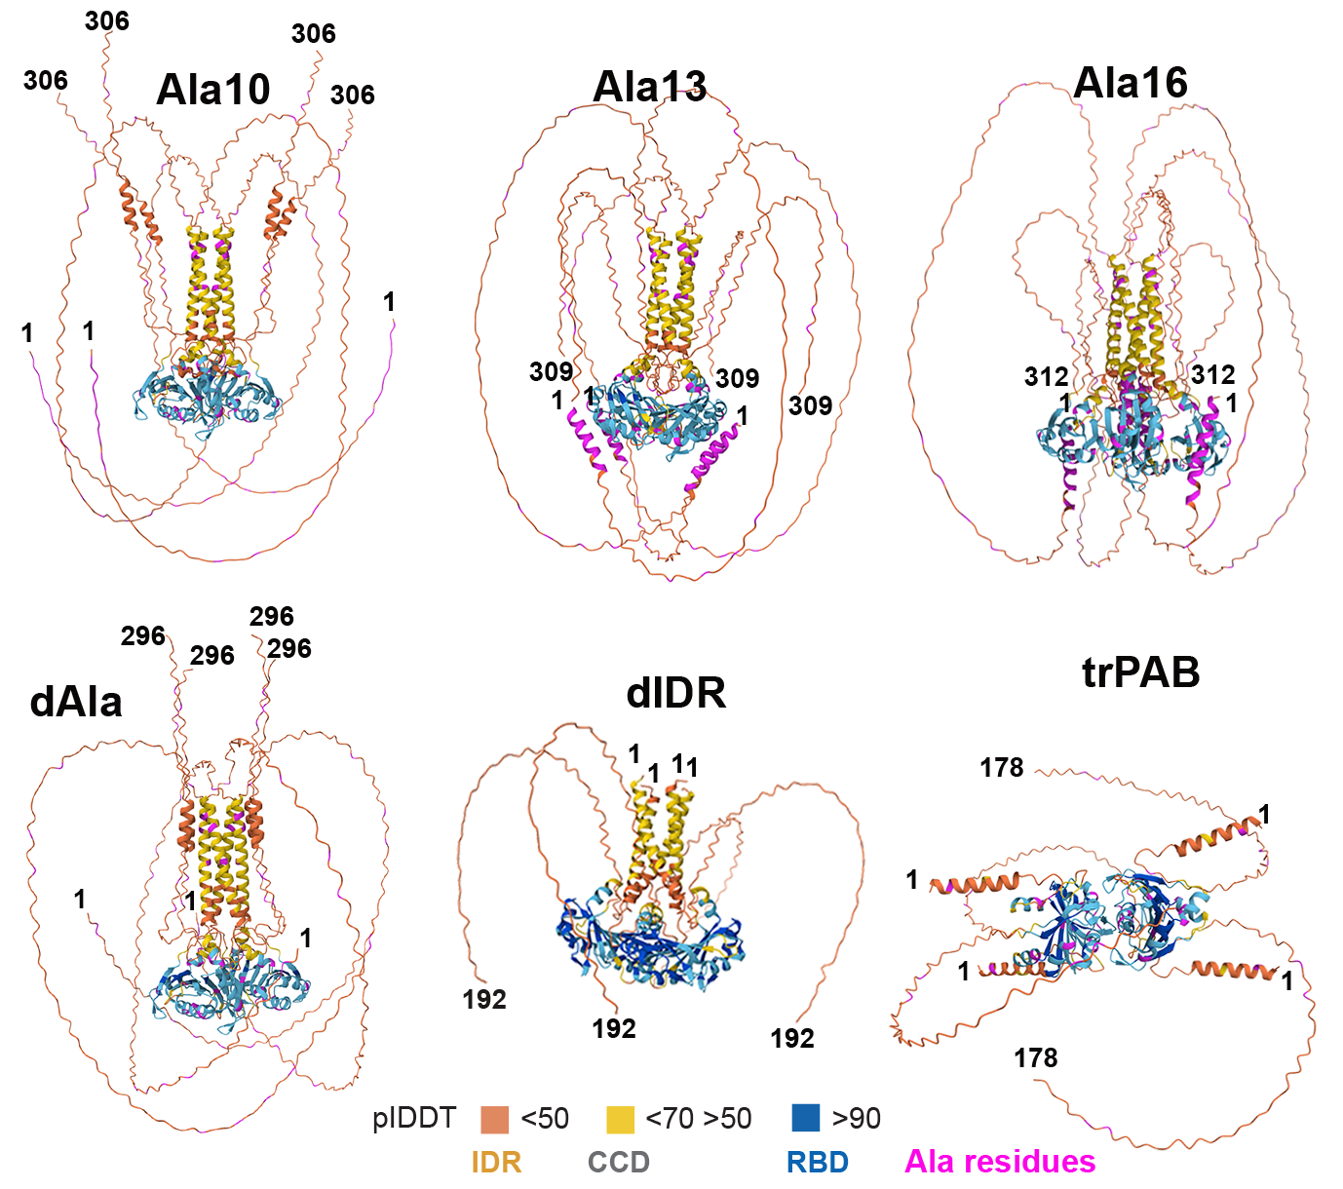
Figure S1. AlphaFold prediction of full-length PABPN1 (upper row) and truncated isoforms (lower row). The full amino acid sequence was used for all predictions, with the positions of the first and last residues indicated. Predicted local distance difference test (pLDDT) scores are shown as a colour scale: blue (high confidence, RNA-binding domain), cyan to yellow (moderate to low confidence, coiled-coil domain), and orange (low confidence, intrinsically disordered region). Alanine residues are highlighted in pink. In all models the orientation of the RBD is horizontal.
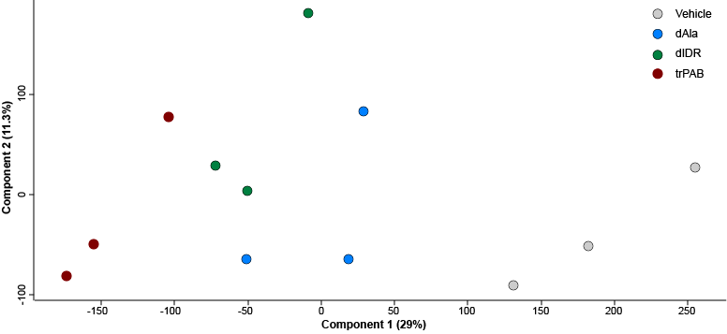
Figure S2. A PCA plot of the 12 samples in muscle cells.

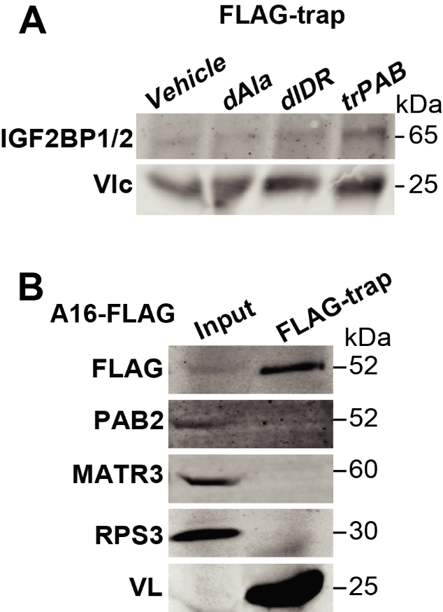
Figure S3. Immunoblot of FLAG-trap.
- Immunoblot of FLAG-TRAP with anti-IGF2BP2 in muscle cells. B. Immunoblot of input and FLAG-trap in A16-FLAG cells with anti-Flag, PABs, anti-MATR3, anti-RPS3 antibodies. Molecular weight in kDa are depicted. The variable light chain (V) shows IP control.

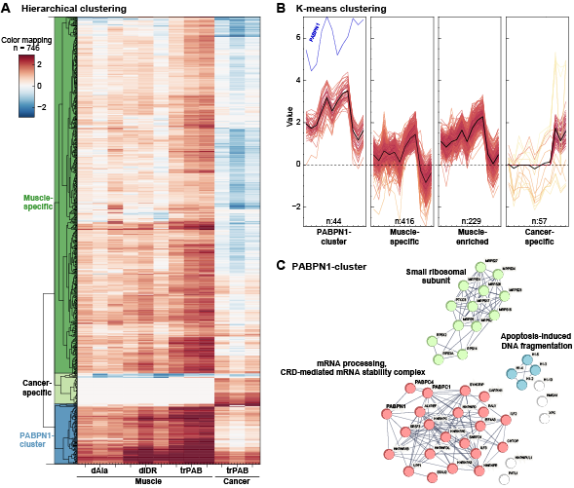
Figure S4: Clustering of the PABPN1-interactome across different cell types
Clustering was made with the fold-change (log2) values in muscle: dAla, dIDR, trPAB, and in cancer trPAB. A. Hierarchical clustering. B. K-means clustering. C. Protein-protein interaction network enrichment analysis of proteins within the k-means PABPN1 clusters. Clusters are color-coded, while non-clustered proteins are shown in white. PABPN1, PABPC4, and PABPC1 are highlighted.
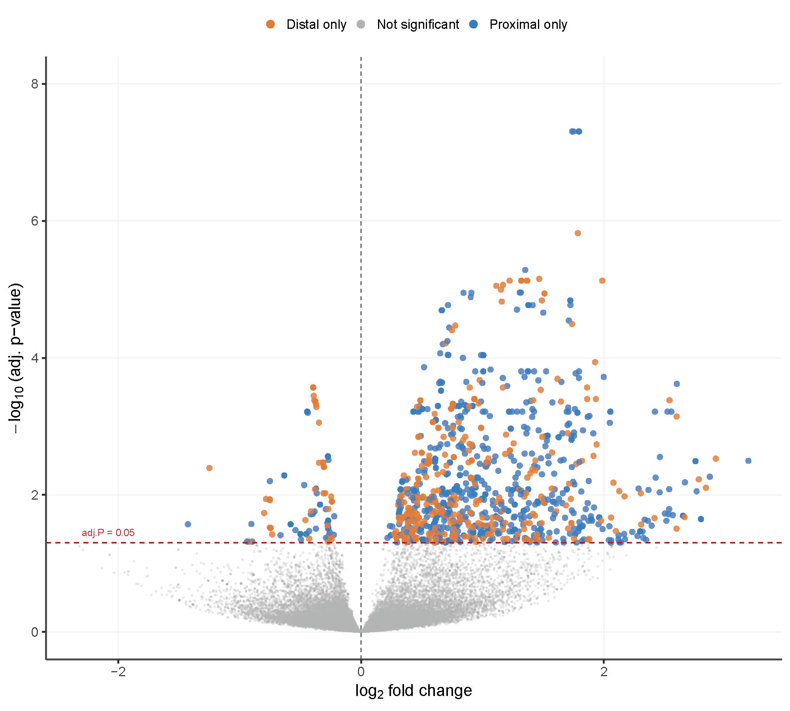Figure S5. Vehicle and trPAB in cancer cells 1C RNAseq. Volcano of DE analysis at the 3’-UTR of transcripts tr-PAB vs. Vehicle. Positive fold change and colored shows significant higher levels in tr-PAB, P<0.05, FDR.

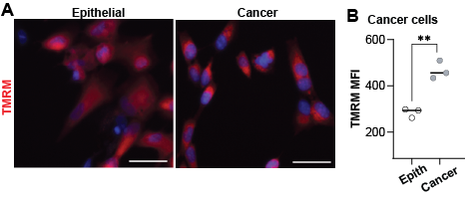Figure S6. Mitochondrial activity. A-B. Epithelial and bladder cancer cells. A. Representative images are shown, with TMRM in red and the nuclear counterstain in blue. The Scale bar is 50 μm. B. The dot plot displays TMRM mean fluorescence intensity (MFI). Each dot represents a biological replicate, averaging ~3,000 cells. Statistical analysis was performed using one-way ANOVA; p < 0.01 (***).

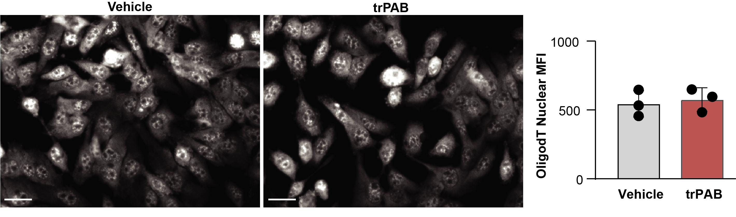Figure S7. Oligo-dT in situ hybridization in cancer expressing trPAB. A. Cancer cells. Representative images show oligo(dT)-Cy5 staining in vehicle- and trPAB–treated cancer cells. Scale bar: 20 µm. Box plot shows oligo-dT MFI in the cell nucleus. Each dot represents a biological replicate of >1000 cells per replica.

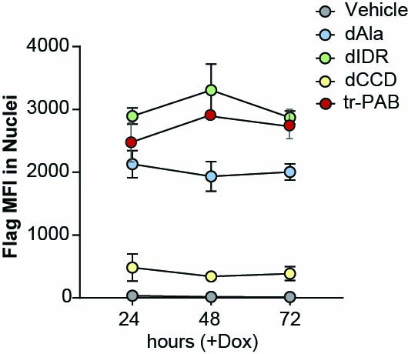
Figure S8. Accumulation of Flag signal over time. Cancer cells were treated with Dox for the indicated time. Flag signal was detected by immunofluorescence and was measured using the Cell-Insight imaging. Average and standard variation are from N=3 replicates.

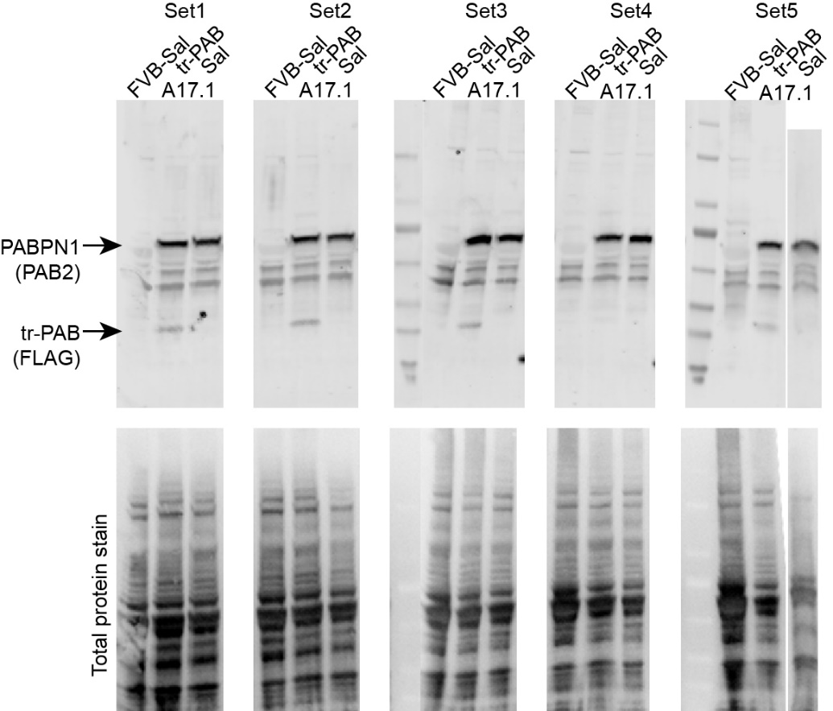
Figure S9. Supplementary to Figure 5C: Western blots of protein extracts from TA muscle. Blots were probed with PAB2 and anti-FLAG antibodies. A total protein stain is shown as the loading control. For each genotype, N = 5 mice were analyzed, loaded across five sets.

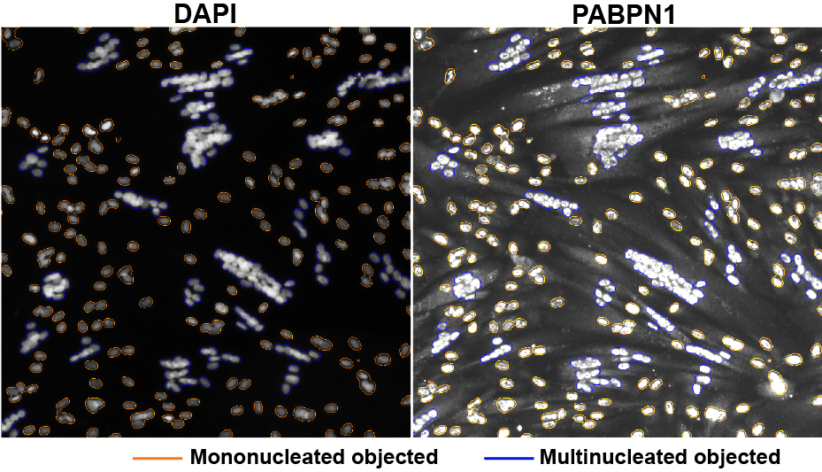
Figure S10. An example of nuclear segmentation in differentiating cell cultures using nuclear counterstaining. PABPN1 appears elongated and shows cytoplasmic localization. Multinucleated objects are outlined in blue, and mononucleated objects in orange.
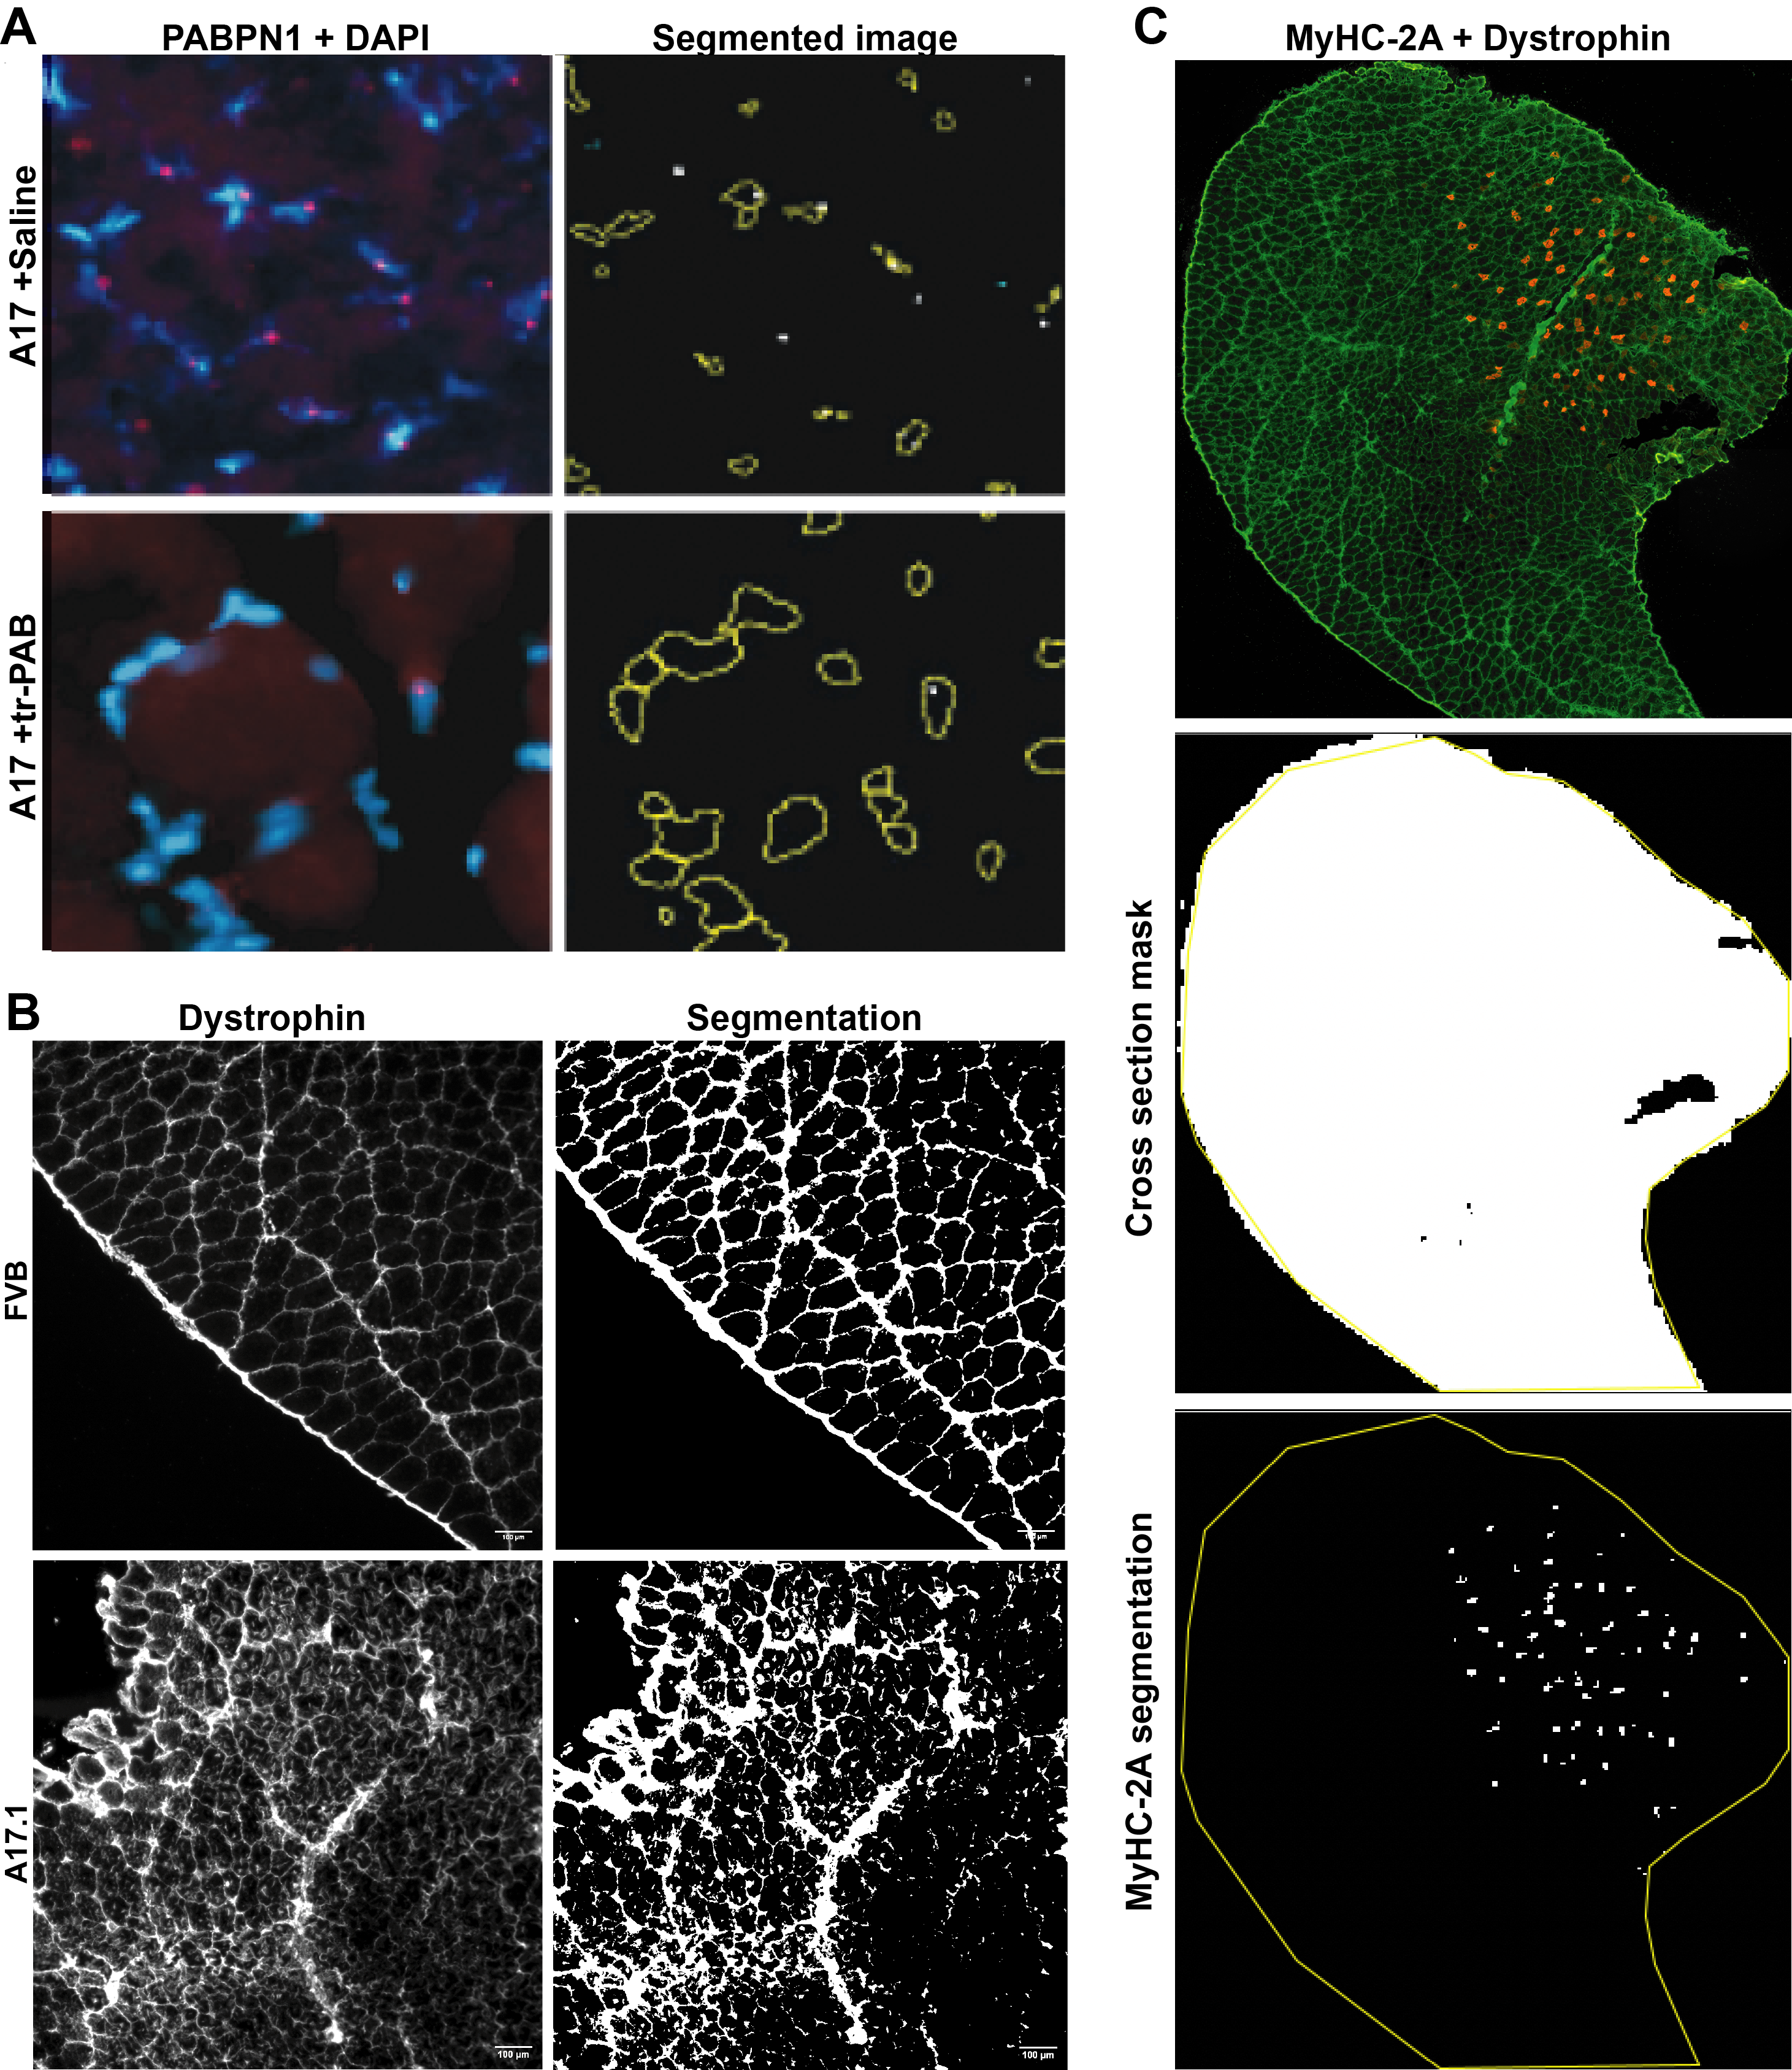
Figure S11. Image analysis in muscle cross sections.
A. Representative images (left) showing PABPN1 and DAPI signals, with corresponding segmentation (right) in A17 + saline– and A17 + tr-PAB–treated muscle. Nuclei areas are outlined in yellow, and PABPN1 puncta are indicated by white dots. B. Dystrophin, staining (left) and mask (right) in FVB and A17.1. C. MyHC-2A and dystrophin staining (top), cross-sectional area mask generated from the dystrophin channel (middle), and MyHC-2A segmentation with the cross-sectional area ROI outlined in yellow (bottom).

