Supplementary
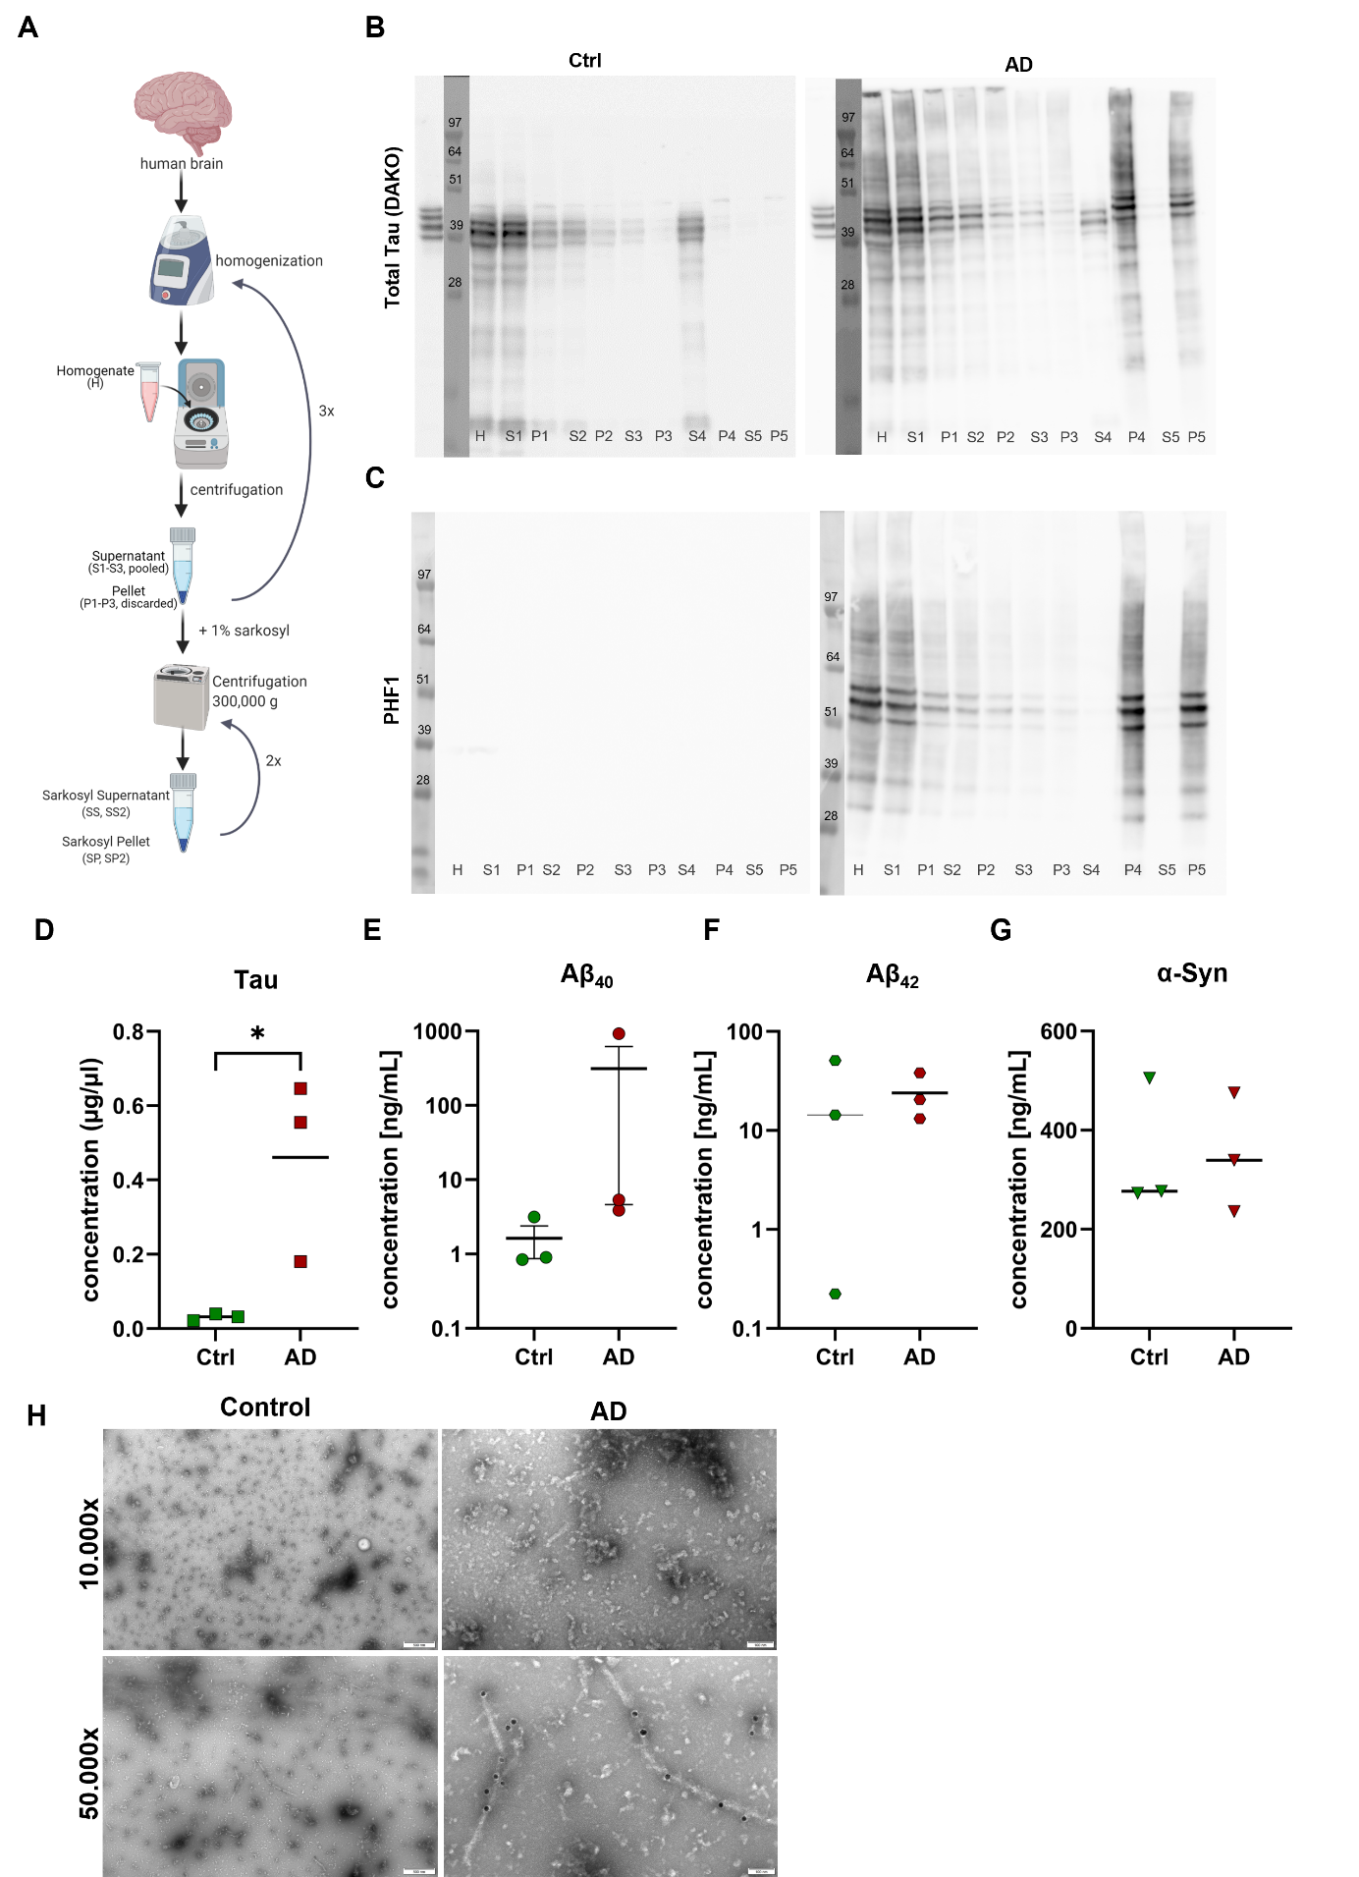

Supplementary Figure 1. Biochemical characterization of AD brain-derived sarkosyl-insoluble Tau seeds (AD-Tau).
A. Schematic overview of the sarkosyl-insoluble protein extraction protocol.
B. Western blot showing total Tau staining in control (Ctrl) and AD PHF fractions.
C. Western blot analysis of the phospho-epitope PHF1 in Ctrl and AD fractions.
D. Quantification of Tau levels by Western blot.
E. Measurement of Aβ₄₀ concentrations using Meso Scale Discovery (MSD) (p = 0.3697).
F. Measurement of Aβ₄₂ concentrations using MSD (p = 0.9059).
G. α-Synuclein quantification by dot blot analysis (p = 0.9905).
H. Representative electron micrographs of PHF fractions from control and AD brain extracts immunolabeled with Tau-5 and HT7 antibodies, followed by 15 nm gold-conjugated secondary antibodies. Lower panels show magnified views of the indicated regions.
Values are presented as mean ± SEM. Statistical analysis was performed using an unpaired t-test. *p < 0.05

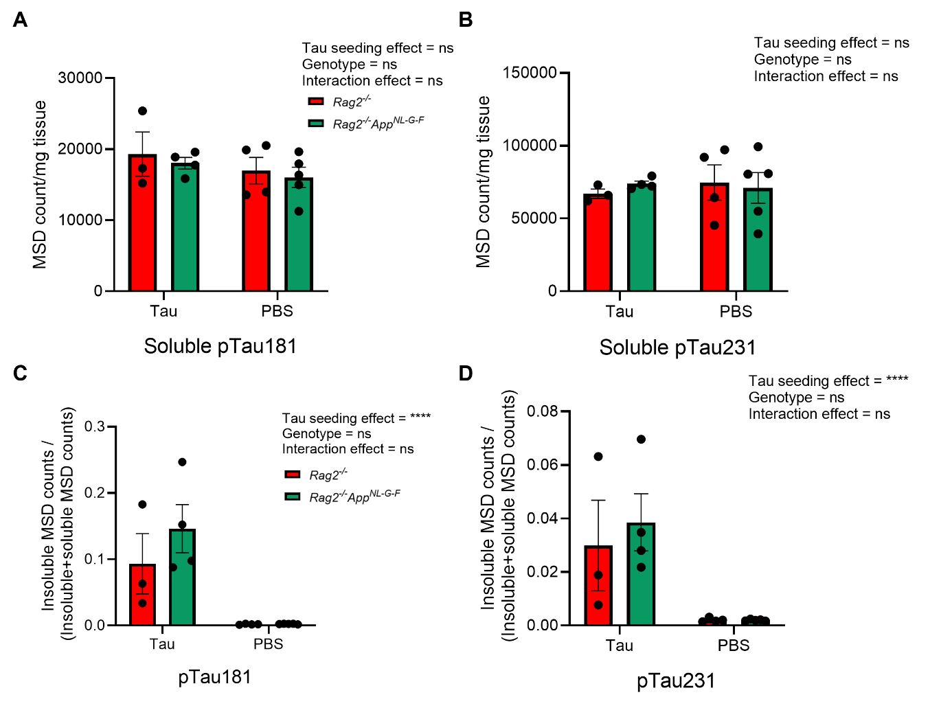
Supplementary Figure 2. Soluble and ratio of sarkosyl-insoluble protein extracts analysed by ELISA to quantify pTau levels in Rag2^{-/-} and Rag2^{-/-} App^{NL-G-F} mice at 7 MPT.
A-B. Human neurons express high levels of soluble (A) pTau181 and (B) pTau231 independent of amyloid or AD-Tau exposure likely due to developmental age. No significant effects were detected in two-way ANOVA.
C-D. Significant effect of tau seeding in fraction that shows insoluble pTau MSD counts/soluble+insoluble pTau MSD counts (pTau181 p<0.0001; pTau231 p<0.0001) was detected. No significant effect on genotype or interaction effect was measured.
For all graphs: Rag2^{-/-} mice n=3 (AD-Tau) and n=4 (PBS); Rag2^{-/-} App^{NL-G-F} mice n=4 (AD-Tau) and n=5 (PBS). Data are presented as mean ± SEM. Statistical analysis was performed using two-way ANOVA. ****p < 0.0001, between indicated groups (Supplementary Table 1).
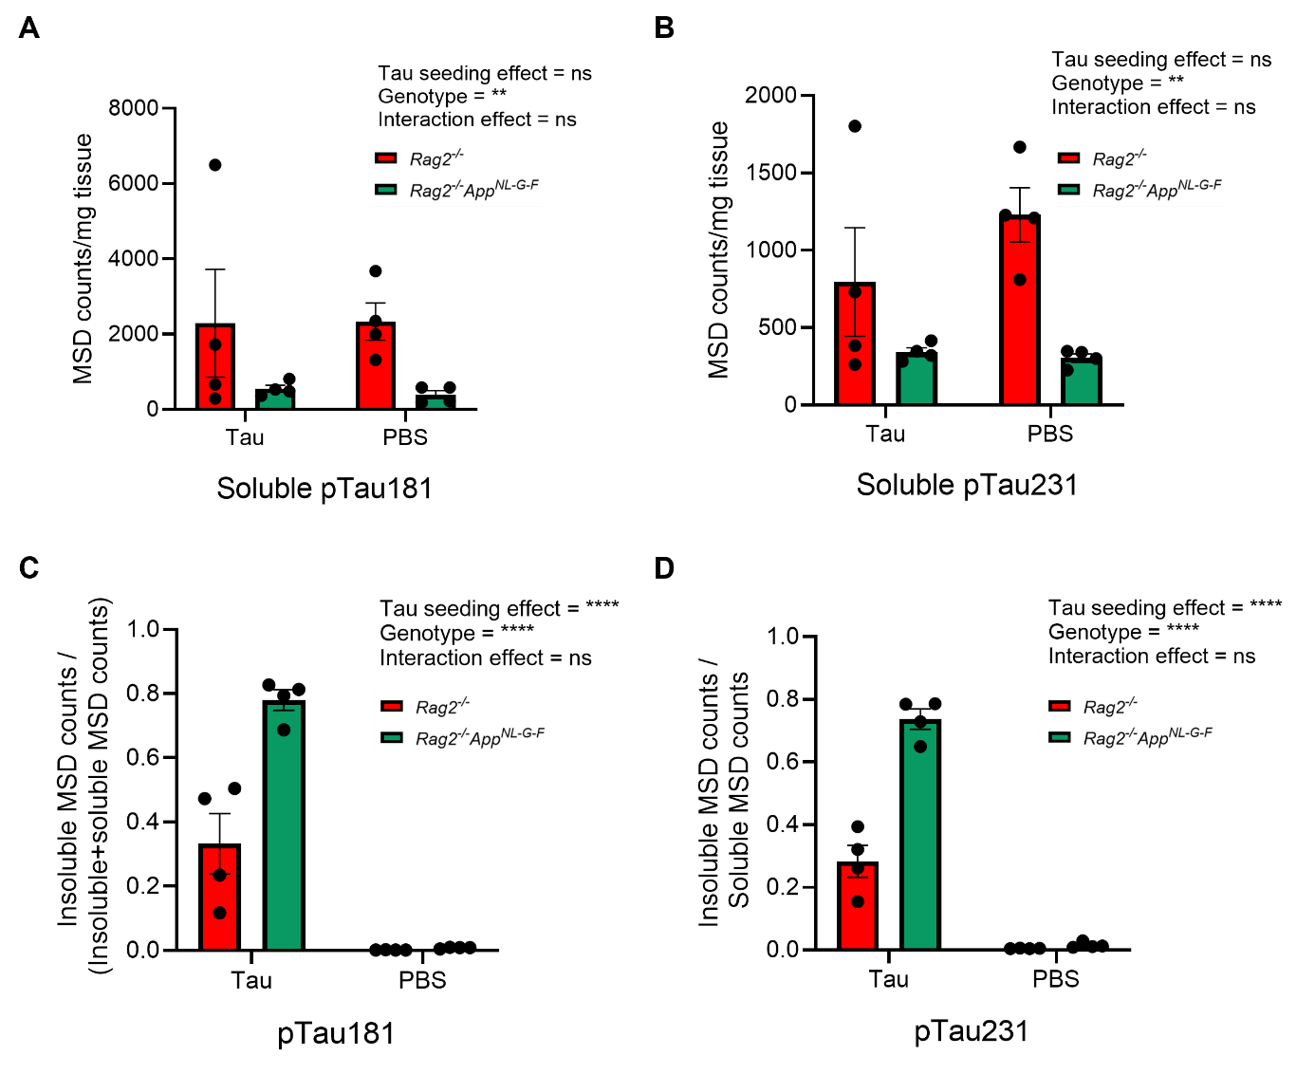
Supplementary Figure 3. Soluble and sarkosyl-insoluble protein extracts analysed by ELISA to quantify pTau levels in Rag2^{-/-} and Rag2^{-/-} App^{NL-G-F} mice at 18 MPT.
A-B. Significant effect of genotype in soluble (A) pTau181 (p=0.0049) and (B) pTau231 (p=0.0012) levels in Rag2^{-/-} App^{NL-G-F} mice compared to Rag2^{-/-} mice, which possibly reflects advanced neurodegeneration at 18MPT in Rag2^{-/-} App^{NL-G-F} mice.
C-D. Significant effect of tau seeding in fraction that shows insoluble counts/(soluble+insoluble counts) (pTau181 p<0.0001; pTau231 p<0.0001) and on genotype (pTau181 p<0.0001; pTau231 p<0.0001) was detected. No significant interaction effect was measured.
Data are shown as mean ± SEM. Statistical significance was determined by two-way ANOVA with Tukey’s post hoc test. **p < 0.01, ****p<0.0001

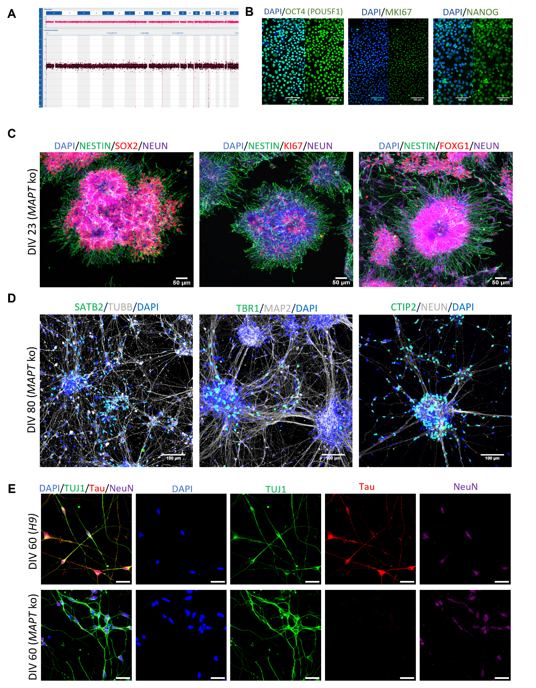
Supplementary Figure 4. Quality control of gene editing and neuronal differentiation of the H9-Tau KO line.
A. CGH array showing no chromosomal aberrations after gene editing except for the MAPT locus.
B. Immunolabelling of pluripotency markers for OCT4, MKI67 and NANOG (scale bar: 100µm).
C. NPC generation from the H9-Tau KO line expressing NESTIN, SOX2, KI67, FOXG1 and NEUN at DIV32 (scale bar: 50µm).
D. Neuronal immunolabelling of Tau KO neurons (DIV 80); cells express SATB2, TUBB, MAP2, TBR1, CTIP2 and NEUN (scale bar: 100µm).
E. Neuronal labelling of low-density Tau KO and H9-control neurons at DIV60 expressing TUJ1, NeuN, Tau labelling is absent in Tau KO neurons (scale bar: 25µm).

