Supplementary Information
MULTIMODAL CHARACTERIZATION OF THE TIN RELIEF DECORATIONS ON THE VAN EYCK’S GHENT ALTARPIECE AND THEIR DEGRADATION PROCESS.
S. Kirkpatrick, J. Sanyova, K. Janssens, H. Dubois, I. Geelen, M. Koch, C. Berberich, C. Glaude, M. Stillhammerova, L. Decq, E. Avranovich, S. De Meyer, A. Marchetti, V. Beltran, F. Borondics, and G. Van der Snickt.
Table of contents
2
2
3
3
4
5
6
7
7
8
8
9
10
10
Supplementary Data……………………………………………………………………………………………………………………….
Figure S1. SEM-EDX spectra taken in the gold leaf……………………………………………………………………………...
Figure S2. SEM-EDX spectra taken in the tin foil…………………………………..…………………………………………….
Figure S3. SEM-EDX spectra taken in the tin foil…………………………………..…………………………………………….
Figure S4. SEM-EDX spectra taken in the adhesive under the tin foil………………………………………………….
Figure S5. SEM-EDX spectra taken in the adhesive under the tin foil………………………………………………….
Figure S6. SEM-EDX mapping...................................................................................................................
Figure S7. FTIR measurement of the filler under the tin foil....................................................................
Figure S8. FTIR measurement of the adhesive under the tin foil.............................................................
Figure S9. FTIR measurement of the filler under the tin foil....................................................................
Figure S10. FTIR measurement of the adhesive under the tin foil...........................................................
Figure S11. MRS measurement of paint layer..........................................................................................
Figure S12. SR-XRPD mapping..................................................................................................................
Figure S13. SR-XRPD diffraction patterns.................................................................................................

In Figures S1-5, examples of SEM-EDX images and analyses taken from applied brocades containing samples from the Ghent Altarpiece are shown. EDX measurements were conducted on various areas of each layers of the stratigraphy (adhesive, filler, tin foil, gold leaf, glazes, etc.) in order to obtain the elemental composition of the pigments and metal foils. Each EDX spectra (A.) is presented with the SEM image showing the location of the measurement (B.), alongside with a table of quantification (C.).
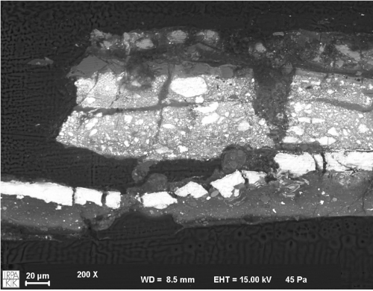
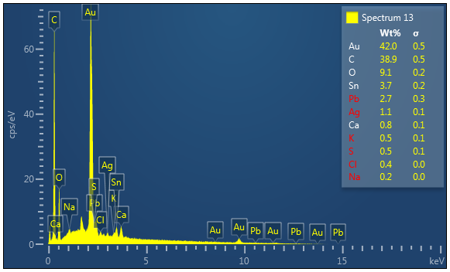
Au
C
O
Sn
Pb
Ag
Ca
K
S
Cl
Na
42.0 0.5
38.9 0.5
9.1 0.2
3.7 0.2
2.7 0.3
1.1 0.1
0.8 0.1
0.5 0.1
0.5 0.1
0.4 0.0
0.2 0.0
C.
A.
B.
+
Figure S1. SEM-EDX measurement performed on applied brocade containing sample from the Ghent Altarpiece. A) Result of the EDX measurement showing the presence of mainly Au, with few amount of Ag, and some amount of Sn, Pb. B) SEM image of the sample (P033.056_C32.067) with the EDX location in the gold leaf indicated by the red cross. C) Table of quantification in weight and atomic percentages, elements lower than 1 wt% are not considered and indicated in red.

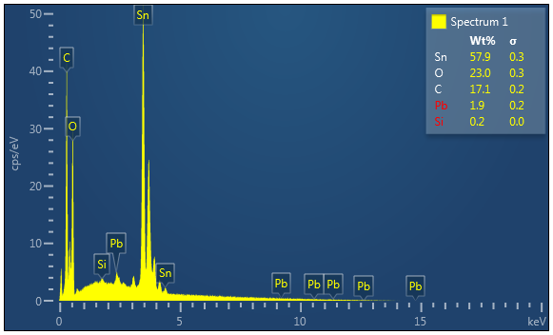
57.9 0.3
23.0 0.3
17.1 0.2
1.9 0.2
0.2 0.0

Sn
O
C
Pb
Si

+
Figure S2. SEM-EDX measurement performed on applied brocade containing sample from the Ghent Altarpiece. A) Result of the EDX measurement showing the presence of mainly Sn, with few amount of Pb. B) SEM image of the sample (P033.056_C32.067) with the EDX location in the tin foil indicated by the red cross. C) Table of quantification in weight and atomic percentages, elements lower than 1 wt% are not considered and indicated in red.
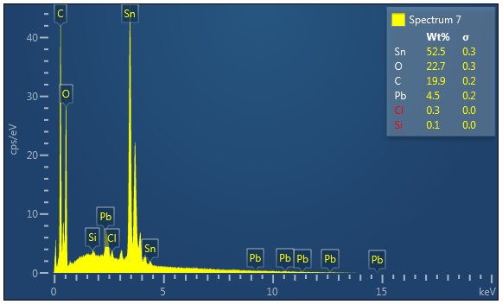
+
Figure S3. SEM-EDX measurement performed on applied brocade containing sample from the Ghent Altarpiece. A) Result of the EDX measurement showing the presence of mainly Sn, with few amount of Pb. B) SEM image of the sample (P033.056_C32.067) with the EDX location in the tin foil indicated by the red cross. C) Table of quantification in weight and atomic percentages, elements lower than 1 wt% are not considered and indicated in red.
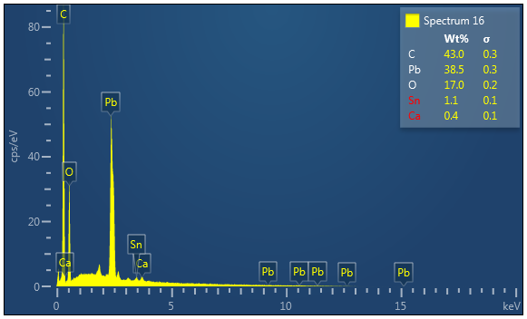
C
Pb
O
Sn
Ca

43.0 0.3
38.5 0.3
17.0 0.2
1.1 0.1
0.4 0.1

+
Figure S4. SEM-EDX measurement performed on applied brocade containing sample from the Ghent Altarpiece. A) Result of the EDX measurement showing the presence of mainly Pb, with few amount of Sn. B) SEM image of the sample (P033.056_C32.067) with the EDX location in the adhesive indicated by the red cross. C) Table of quantification in weight and atomic percentages, elements lower than 1 wt% are not considered and indicated in red.

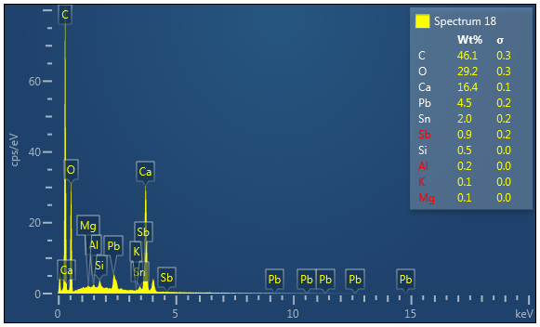
46.1 0.3
29.2 0.3
16.4 0.2
4.5 0.1
2.0 0.1
0.9 0.2
0.5 0.0
0.2 0.0
0.2 0.0
0.1 0.0

C
O
Ca
Pb
Sn
Sb
Si
Al
K
Mg

+
Figure S5. SEM-EDX measurement performed on applied brocade containing sample from the Ghent Altarpiece. A) Result of the EDX measurement showing the presence of mainly Ca, with some amounts of Pb and Sn. B) SEM image of the sample (P033.056_C32.067) with the EDX location in adhesive indicated by the red cross. C) Table of quantification in weight and atomic percentages, elements lower than 1 wt% are not considered and indicated in red.

VIS-500X | UV-500X | BSE Image | carbone
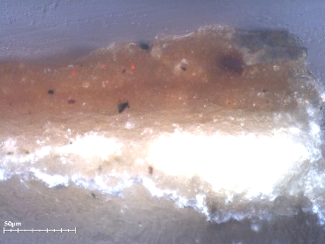 | 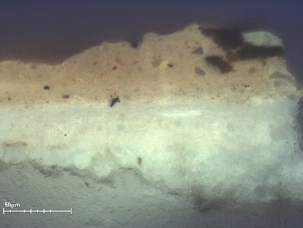 |  | 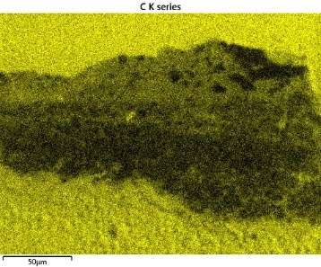
Oxygène | Silicium | Aluminium | Fer
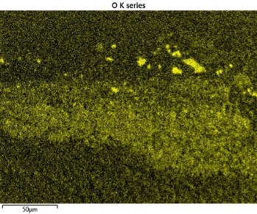 | 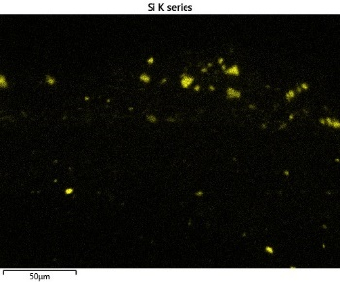 | 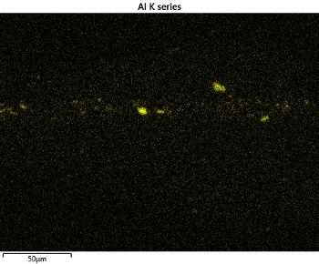 | 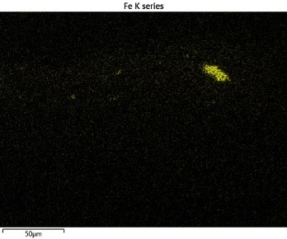
Phosphore | Calcium | plomb | Mercure
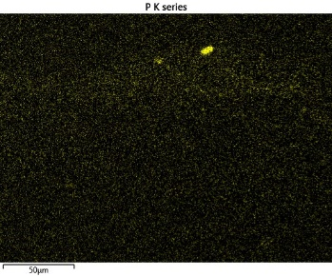 | 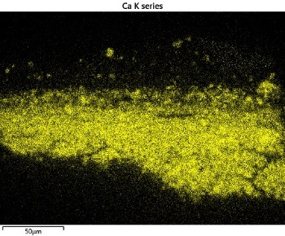 | 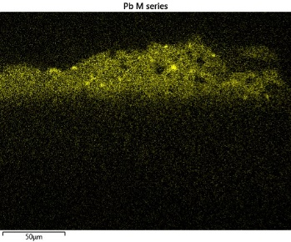 | 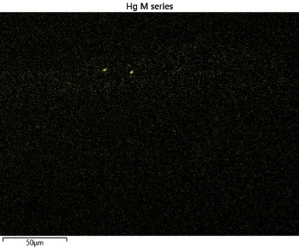
Sodium | cuivre | Etain
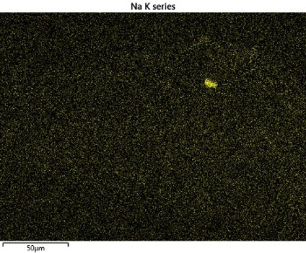 | 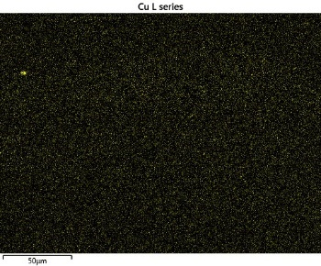 | 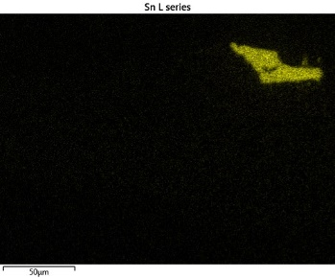

Figure S6. An example of SEM-EDX mapping is shown in order to illustrate the localization of the elements on a sample from the Ghent Altarpiece that contains the preparation, the isolation, the priming, and the adhesive. A fragment of the tin foil is present as well, but the above layers are not. The EDX measurements conducted on this sample (P033.031 _C103.088) show the presence of mainly Ca, Pb, Sn, Si, Al, and few particles of P, Cu, Na, Fe, and Hg.

In Figures S7-10, examples of FTIR analyses taken from the filler and the adhesive of the applied brocades from Ghent samples are shown. Each spectrum (A.) is presented with the images in visible light (B.) and ultraviolet light (C.) showing the location of the analyze.
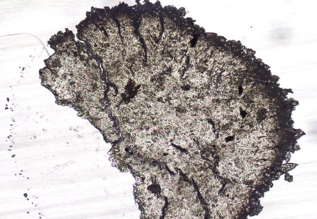
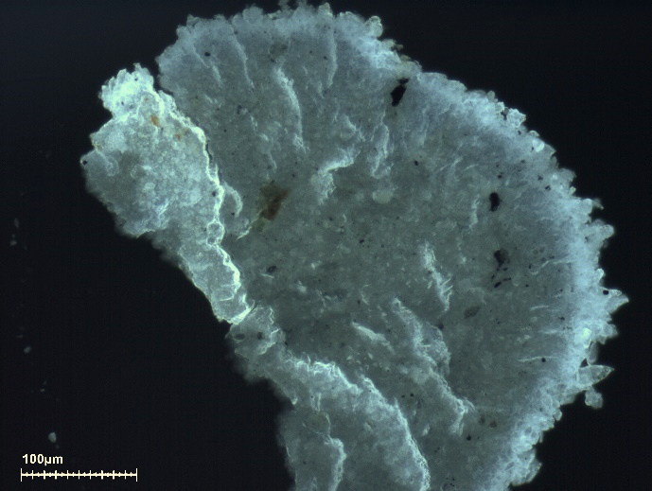
C.
B.
A.
Figure S7. FTIR measurement performed on applied brocade containing sample from the Ghent Altarpiece. A) FTIR spectra taken from the area of the filler (under the tin foil) showing the presence of metal soaps (unspecified), with fatty substance such as oil and/or wax. B) Image in visible light of the sample of filler (taken from P259.024) with the location of the analyses indicated by the yellow square. C) Image in ultraviolet light of the sample.
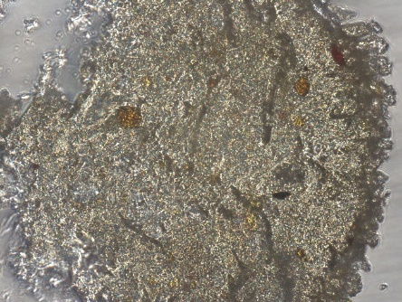
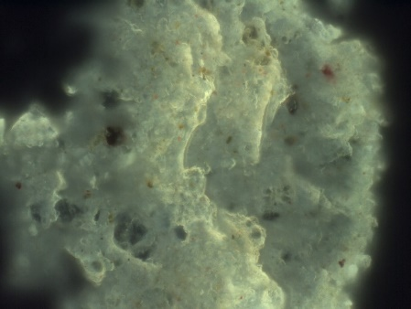
C.
B.
A.

Figure S8. FTIR measurement performed on applied brocade containing sample from the Ghent Altarpiece. A) FTIR spectra taken from the area of the adhesive (under the tin foil) showing the presence of metal soaps (unspecified), with fatty substance such as oil and/or wax. B) Image in visible light of the sample of adhesive (taken from P259.024) with the location of the analyses indicated by the yellow square. C) Image in ultraviolet light of the sample.

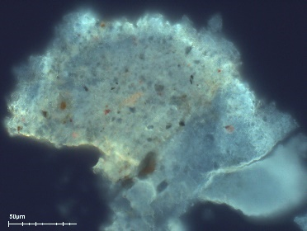
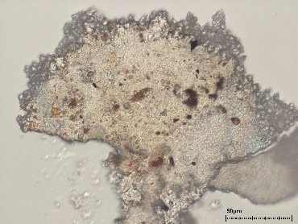
B.
C.
A.
Figure S9. FTIR measurement performed on applied brocade containing sample from the Ghent Altarpiece. A) FTIR spectra taken from the area of the filler (under the tin foil) showing the presence of metal soaps (unspecified), with fatty substance such as oil and/or wax. B) Image in visible light of the sample of filler (taken from P259.066) with the location of the analyses indicated by the yellow square. C) Image in ultraviolet light of the sample.
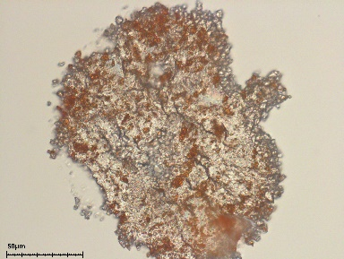
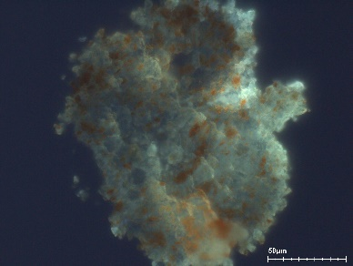
A.
B.
C.
Figure S10. FTIR measurement performed on applied brocade containing sample from the Ghent Altarpiece. A) FTIR spectra taken from the area of the adhesive (under the tin foil) showing the presence of metal soaps (unspecified), with fatty substance such as oil and/or wax. B) Image in visible light of the sample of adhesive (taken from P259.066) with the location of the analyses indicated by the yellow square. C) Image in ultraviolet light of the sample.

Parameters: | LP (%) | 1 | Exposure | 120 | Accumulation(s) | 3 | Obj. | 10x 20x  50x 100x
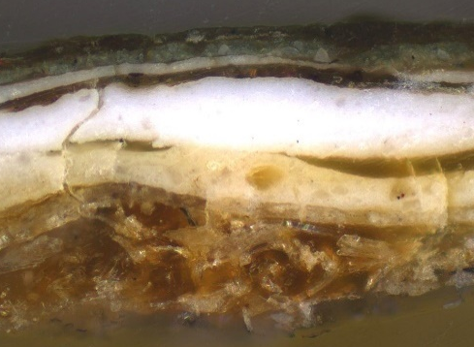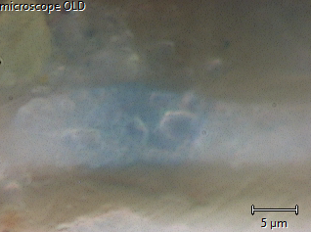  C.  B. |  |  | A.  Lead white  Azurite  22/151007/04
Figure S11. Example of MRS measurement performed on applied brocade containing sample from the Ghent Altarpiece. A) MRS spectra taken from the area of a paint layer, showing the presence of lead white and azurite. B and C) Image in visible light of the sample (taken from P033.055_C051.009) with the location of the analyze indicated by the yellow circle.

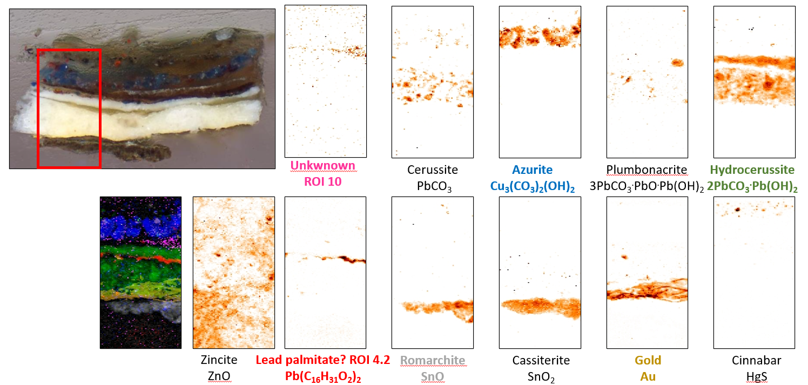
Figure S12. SR-XRPD mapping from an applied brocade containing sample (taken from P033.057_C007.016) from the Ghent Altarpiece.

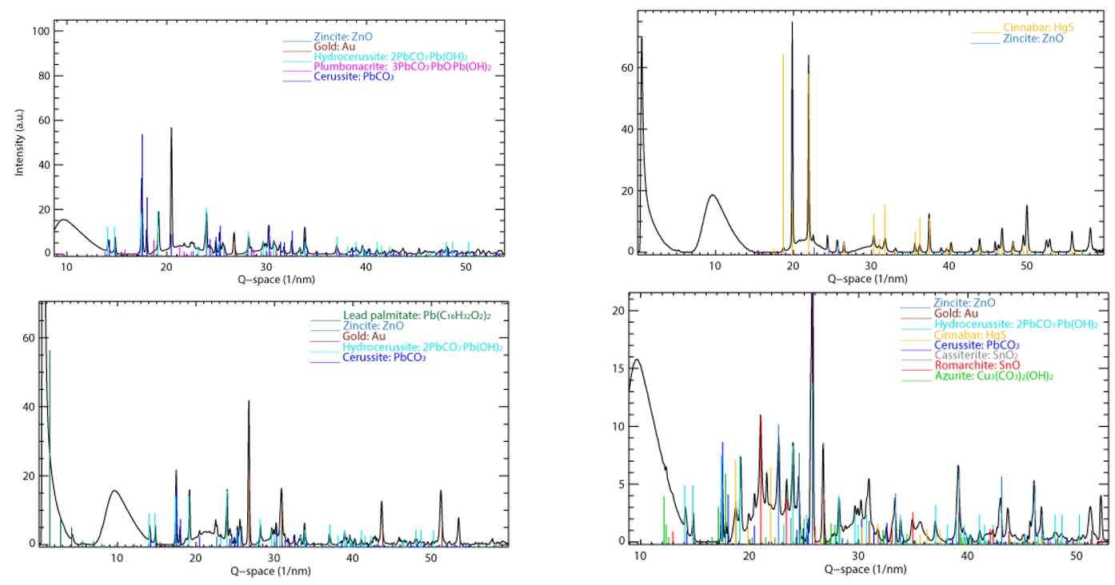

Figure S13. Examples of SR-XRPD diffraction patterns of an applied brocade containing sample (taken from P033.057_C007.016) from the Ghent Altarpiece.

