Supplementary information
Hyper Triplet-Triplet Fusion Blue Fluorescent Organic Light-Emitting Diode
¹Chia-Hsun Chen, ²Pei-Hsi Lee, ²Hung-Yi Lin, ³Bo-Yen Lin, ¹Man-kit Leung, ³Tien-Lung Chiu*
and ²Jiun-Haw Lee*
¹Department of Chemistry, National Taiwan University, Taipei, Taiwan
²Graduate Institute of Photonics and Optoelectronics, and Department of Electrical Engineering,
National Taiwan University, Taipei, Taiwan
³Department of Electrical Engineering, Yuan Ze University, Taoyuan, Taiwan
Table of Contents
Figure S1 PLQY values of (a) DMPPP, (b) DMPPP: Alq3 and (c) DMPPP: DPaNIF (5%) in solid state thin film.
Figure S2 Kinetic model of upconversion electron-only device (EOD) and hole-only device (HOD).
Figure S3 (a) PL spectra at 400−500 nm (ADN emission), (c) TrPL signal probed at 440 nm and (e) PL spectra at 600−680 nm (PtOEP emission) of TTF-upconversion electron-only device (EOD) and those for (b) (d) (e) hole-only device (HOD) under 532 nm photoexcitation and driving voltages (current).
Figure S4 (a) Absorption of Alq3 and PL spectrum of DMPPP and ADN. (b) PL spectrum and (c) time-resolved photoluminescence (TrPL) of ADN, DMPPP, DMPPP: Alq₃ (5%) and ADN: Alq₃ layer (5%) by 355 nm laser excitation. The blue and green components of mixing layer were recorded at 420 nm and 520 nm by monochromator in front of PMT.
Figure S5 (a) Current density (J)−Luminance (L) −voltage (V) characteristics, (b) CE−L, (c) PE−L, (d) EQE−L, (e) normalized EL spectra at J = 2.5 mA/cm2 and (f) CIE coordinates of selectively dopant devices.
Figure S6 PLQY values of (a) ADN, (b) ADN: Alq3 and (c) ADN: DPaNIF (3%) in solid state thin film.
Figure S7 (a) J−V−L, (b) CE−L, (c) PE−L, (d) CIE coordinate and (e) normalized EL spectra at 4.5 V of TTF-OLED in Figure 3.
Figure S8 Low temperature fluorescence (LTFL) and phosphorescence (LTPh) spectra of DPaNIF in toluene at 77 K.
Figure S9 PLQY values of (a) NPAN, (b) NPAN: DPaNIF (3%) in solid state thin film.
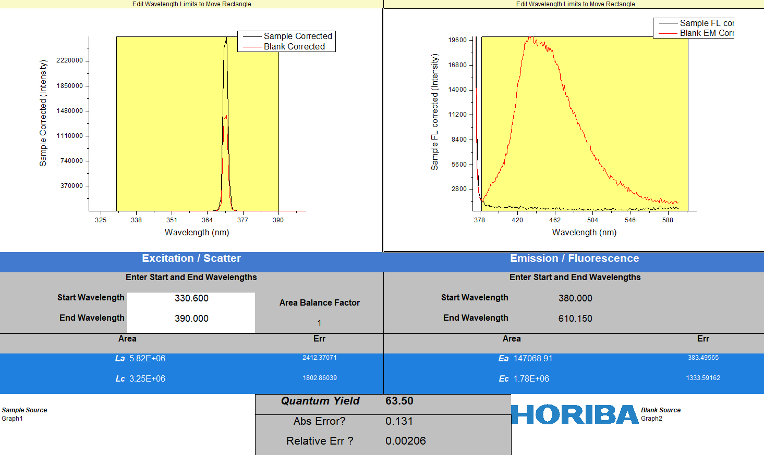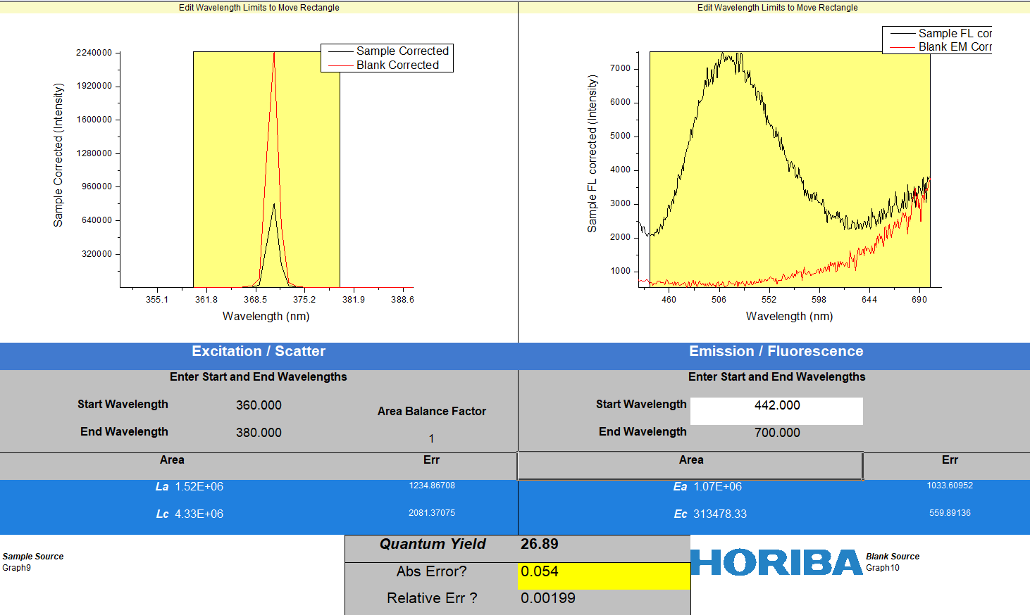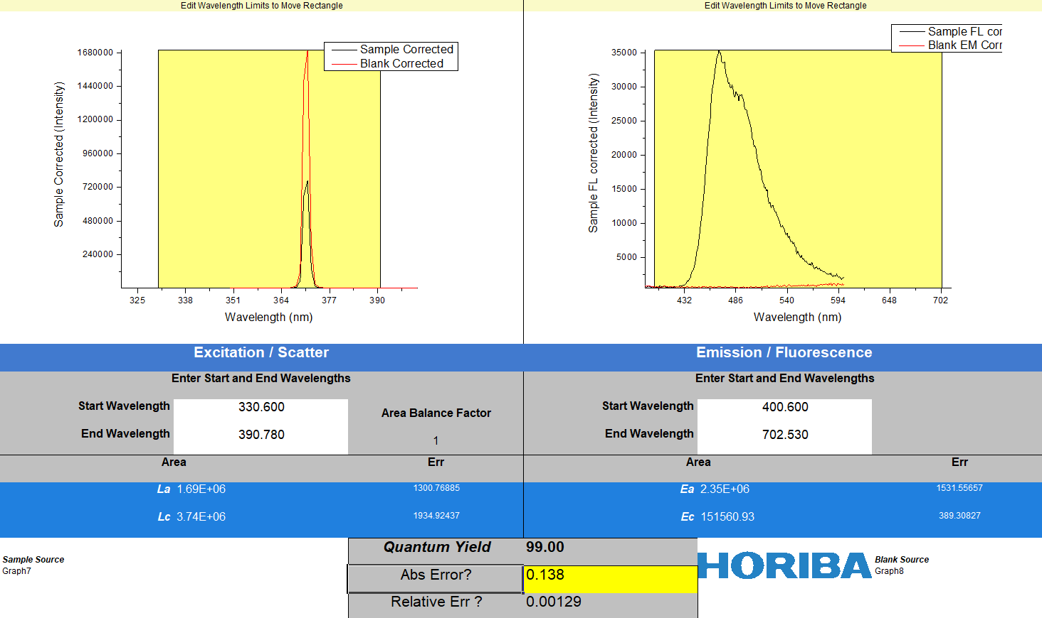
c
b
a
Figure S1 PLQY values of (a) DMPPP, (b) DMPPP: Alq₃ and (c) DMPPP: DPaNIF (5%) in solid state thin film.

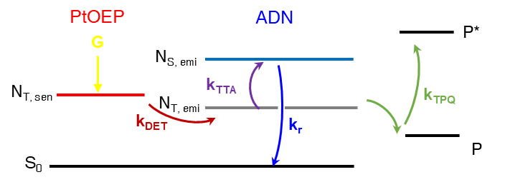
Figure S2 Kinetic model of upconversion electron-only device (EOD) and hole-only device (HOD).

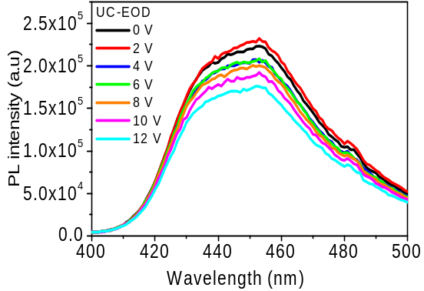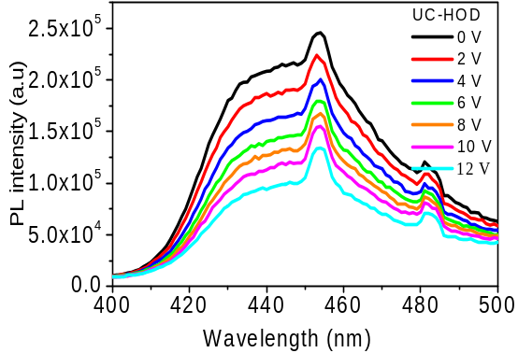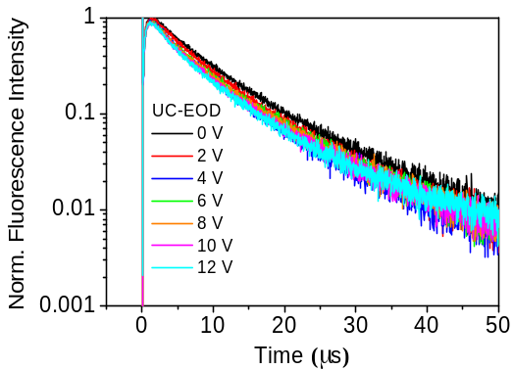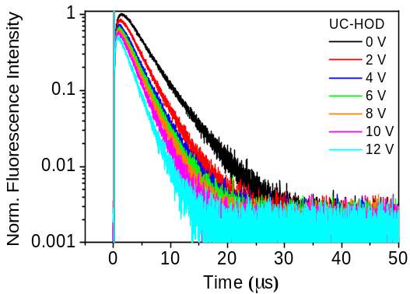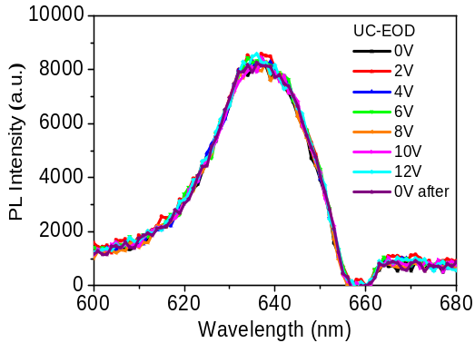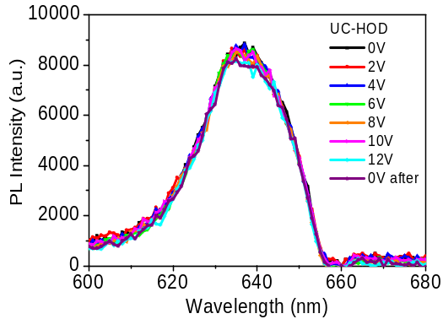
c
b
a
f
e
d
Figure S3 (a) PL spectra at 400−500 nm (ADN emission), (c) TrPL signal probed at 440 nm and (e) PL spectra at 600−680 nm (PtOEP emission) of TTF-upconversion electron-only device (EOD) and those for (b) (d) (e) hole-only device (HOD) under 532 nm photoexcitation and driving voltages.
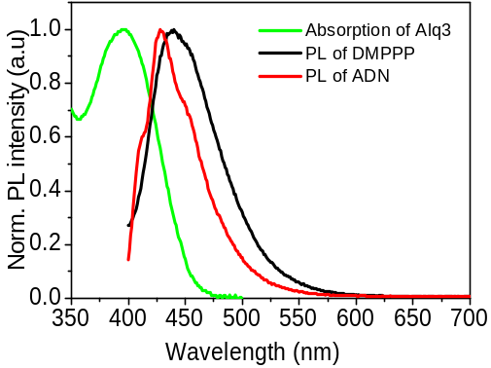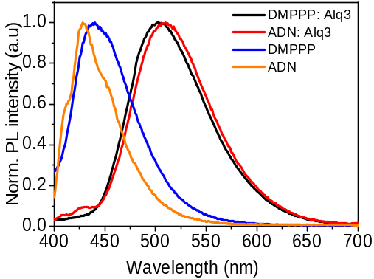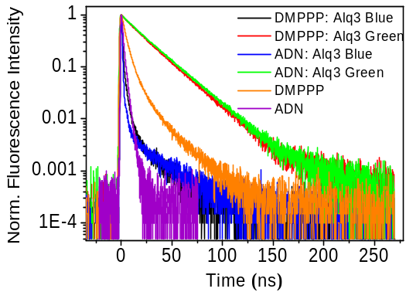
c
b
a
Figure S4 (a) Absorption of Alq₃ and PL spectrum of DMPPP and ADN. (b) PL spectrum and (c) time-resolved photoluminescence (TrPL) of ADN, DMPPP, DMPPP: Alq₃ (5%) and ADN: Alq₃ layer (5%) by 355 nm laser excitation. The blue and green components of mixing layer were recorded at 420 nm and 520 nm by monochromator in front of PMT.

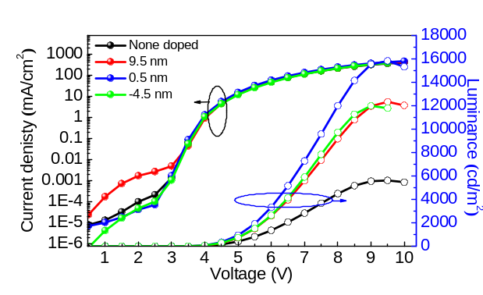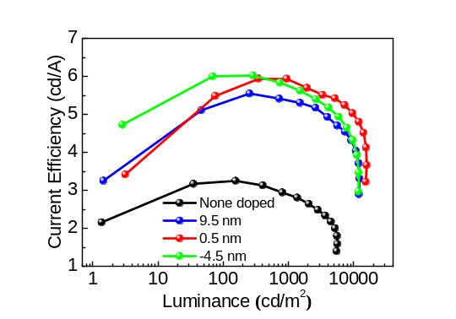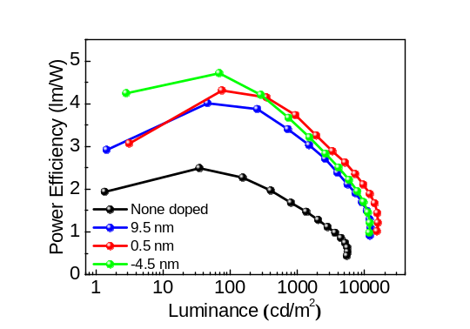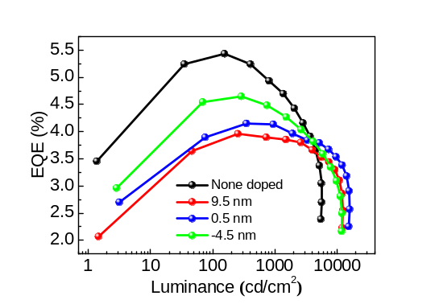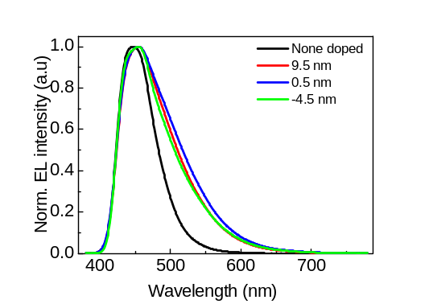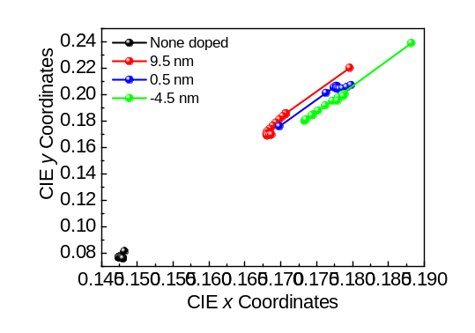
f
e
d
c
a
b
Figure S5. (a) Current density (J)−Luminance (L) −voltage (V) characteristics, (b) CE−L, (c) PE−L, (d) EQE−L, (e) normalized EL spectra at J = 2.5 mA/cm² and (f) CIE coordinates of selectively dopant devices.

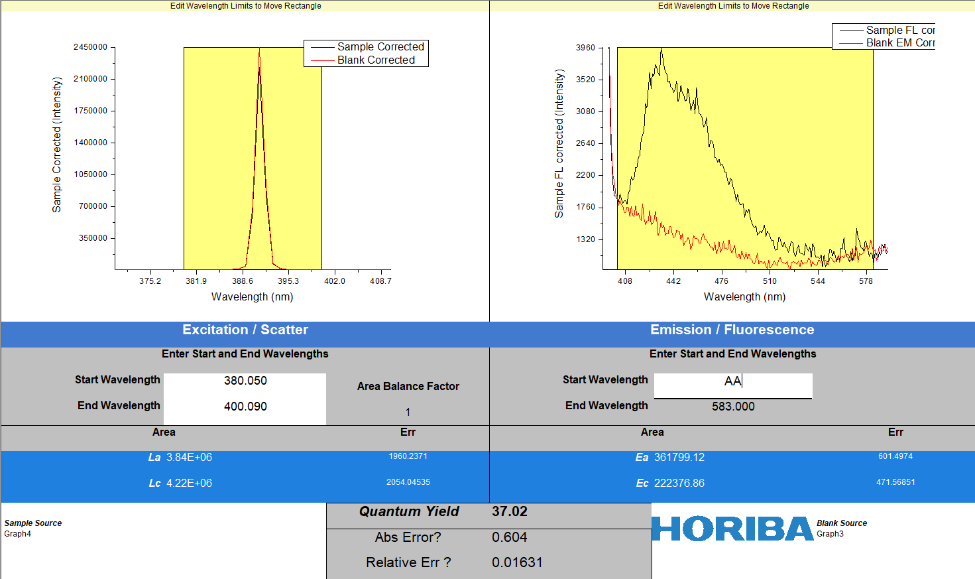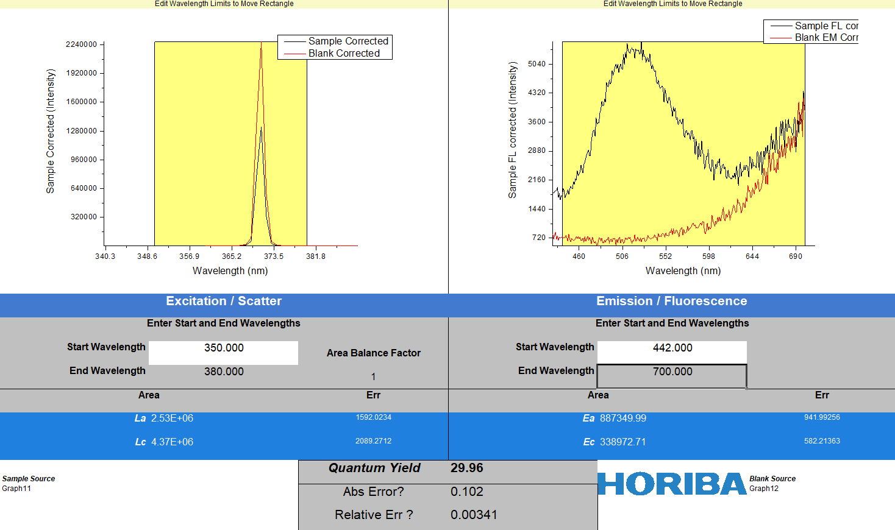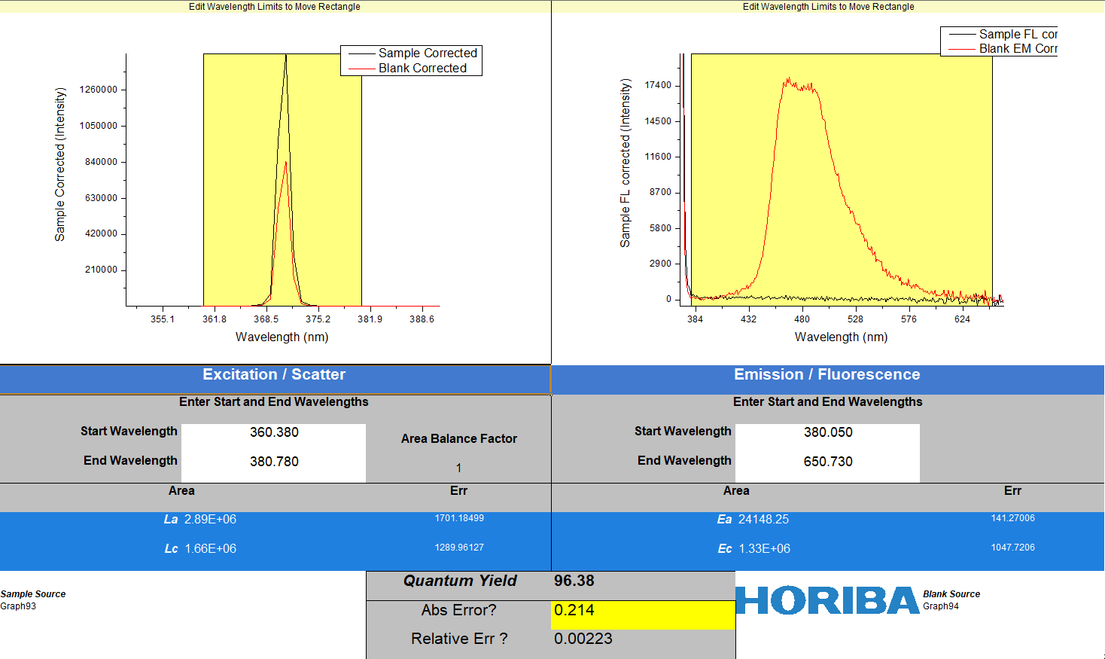
b
a
c
Figure S6 PLQY values of (a) ADN, (b) ADN: Alq₃ and (c) ADN: DPaNIF (3%) in solid state thin film.

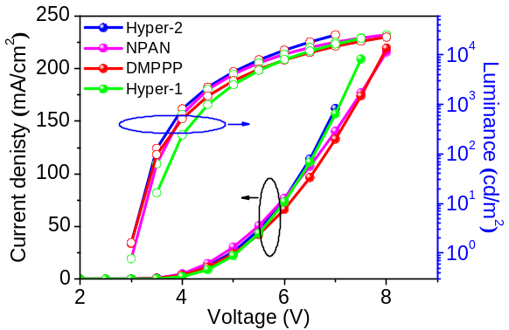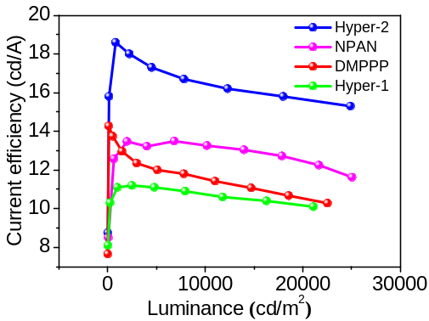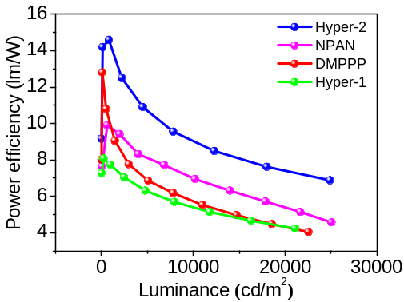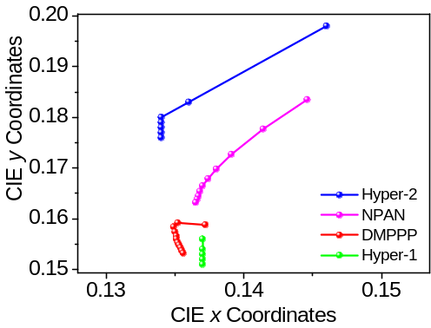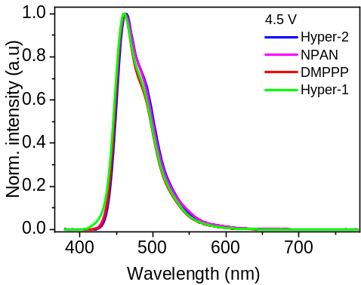
e
d
b
c
a
Figure S7 (a) J−V−L, (b) CE−L, (c) PE−L, (d) CIE coordinate and (e) normalized EL spectra at 4.5 V of TTF-OLED in Figure 3.

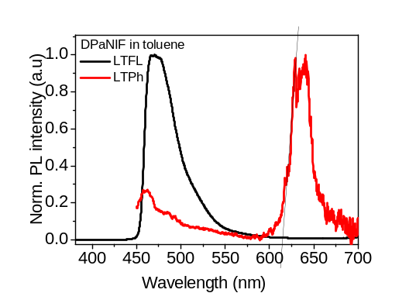
Figure S8 Low temperature fluorescence (LTFL) and phosphorescence (LTPh) spectra of DPaNIF in toluene at 77 K.
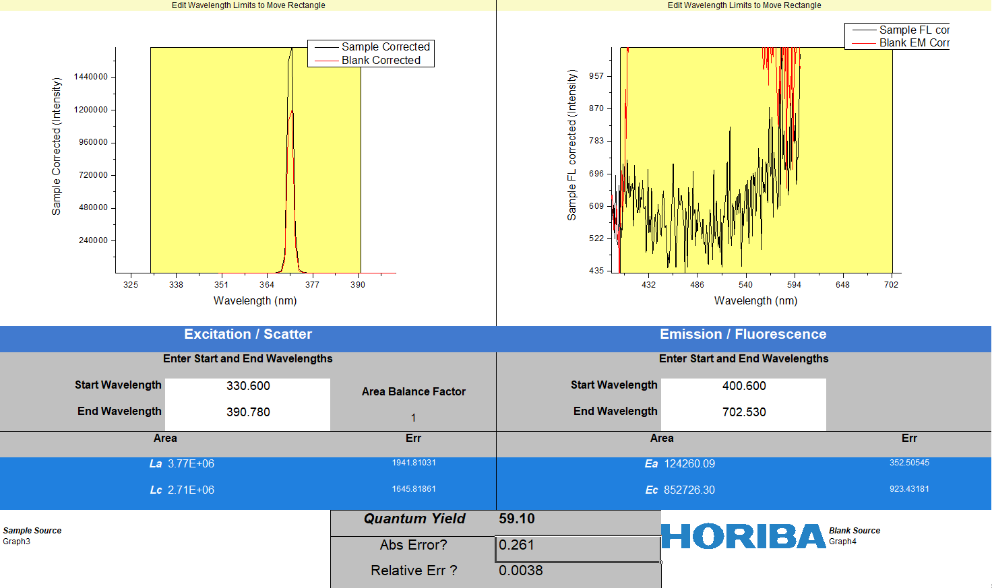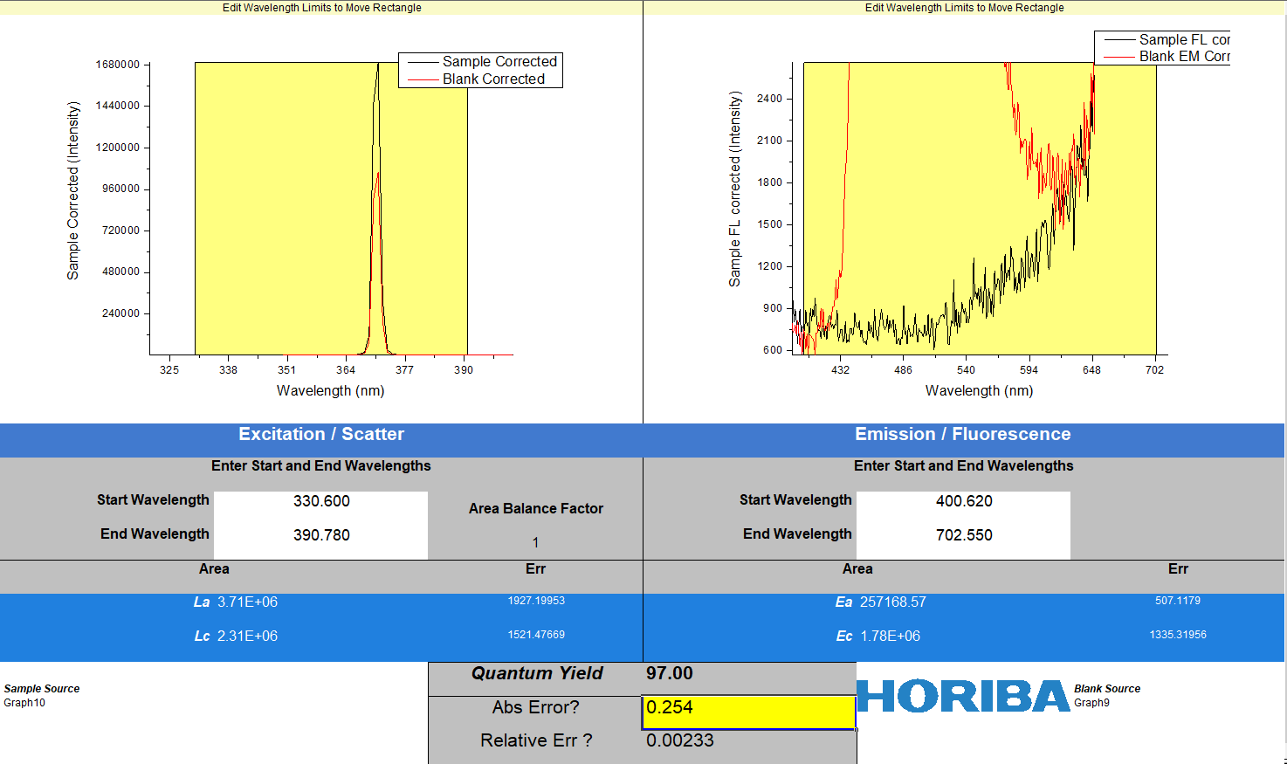
a
b
Figure S9 PLQY values of (a) NPAN, (b) NPAN: DPaNIF (3%) in solid state thin film.

Table S1. Material and device performances TTF OLEDs.
Device | Driving voltage (V) | Max. EQE(%) | Delay Ratio | Ref
HE-DEML | 2.95 | 15.4 | 0.32 | This work
HE-Reference | 2.95 | 10.1 | 0.10 | This work
BD3 (□) | 3.7 | 12/5.3/4.2 | 0.15 | Adv. Funct. Mater. 24, 2064–2071 (2014)
MBAn-(4)-F:BBPA (■) | 3.6 | 10.27 | 0 | iScience 9, 532–541 (2018)
DMPPP: TSTA (○) | 3.8 | 10.2 | 0.15 | Chem. Commun. 50, 6869–6871 (2014)
PIAnCN (∇) | 3.0 | 9.44 | 0.3 | Adv. Funct. Mater. 28, 1705813 (2018)
3CzAnBzt (∆) | 3.0 | 10.06 | 0.25 | J. Mater. Chem. C 7, 1014–1021(2019)
2PPIAn (◊) | 3.0 | 8.9 | 0.25 | ACS Appl. Mater. Interfaces 12, 15422−15429 (2020)

