Trait | Trait state(modality) | Code
Life history
Voltinism | Semivoltine (1<generation/y) | Volt 1
 | Univoltine | Volt 2
 | Bi-or multivoltine (≧1 generation/y) | Volt 3
Ecology
Thermal preference | Cool eurythermal (5-15℃) | Ther 1
 | Cool/warm eurythermal (5-30℃) | Ther 2
 | Warm eurythermal (15-30℃) | Ther 3
Habits | Burrow | Habi 1
 | Climb | Habi 2
 | Sprawl | Habi 3
 | Cling | Habi 4
 | Swim | Habi 5
Trophic habits | Collector-gatherers | Trop 1
 | Collector-filterers | Trop 2
 | Herbivore | Trop 3
 | Predators | Trop 4
 | Shredders | Trop 5
Morphology
Size at maturity | Small(<9mm) | Size 1
 | Medium(9-16mm) | Size 2
 | Large(>16mm) | Size 3
Respiration | Tegument | Resp1
 | Gills | Resp2
 | Plastron/spiracle | Resp3
Resistance and resilience
Dispersal strategy | Aquatic passive | Disp 1
 | Aquatic active | Disp 2
 | Aerial active | Disp 3
Rheophily | Depositional only | Rheo 1
 | Depositional and erosional | Rheo 2
 | Erosional | Rheo 3
Occurrence in drift | Rare(catastrophic) | Drft 1
 | Common (typically observed) | Drft 2
 | Abundant (dominant in drift samples) | Drft 3
Supplementary Material

Table S1 Life history, ecology, morphology, and resistance and resilience traits of macroinvertebrates and their classification standards.

Table S2 VIFs of the remained variables (VIF<10)

Variables | VIF
Velocity of flow | 3.800
Temperature | 9.450
Electrical conductivity | 3.878
Dissolved oxygen | 4.626
Total nitrogen | 8.464
Total phosphorus | 5.085
Permanganate index | 3.399
Nitrate nitrogen | 2.719
Total suspended solids | 4.083
The proportions of boulders | 4.866
The proportions of cobbles | 7.840

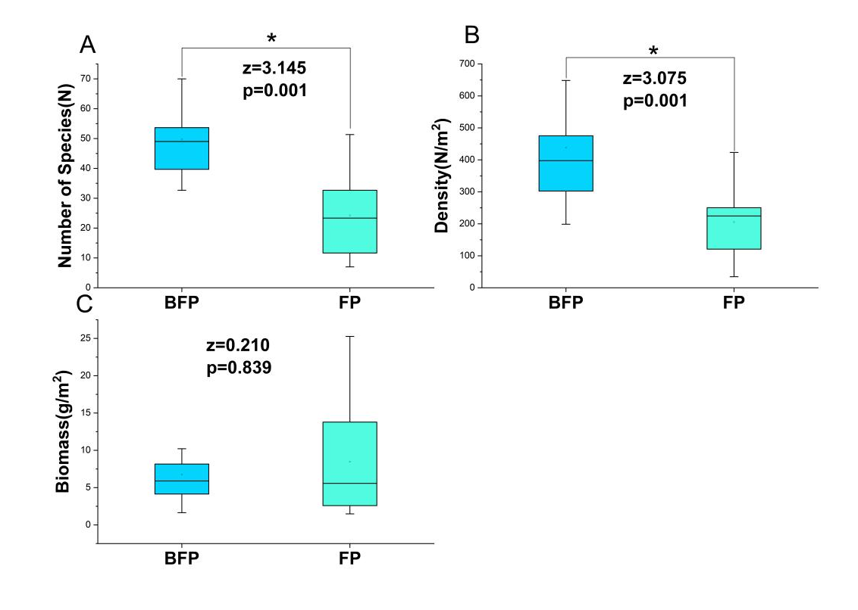
Figure S1 Temporal (BFP, before freezing period; FP, freezing period) changes of macroinvertebrate Number of species (A), density (B), biomass (C) of stream macroinvertebrate species in two periods. Box plots indicated interquartile ranges (box part), 25th and 75th percentiles (lower and upper error bars), and mean vales (dash lines in the box), * denotes a significant difference between the two periods (p <0.05).

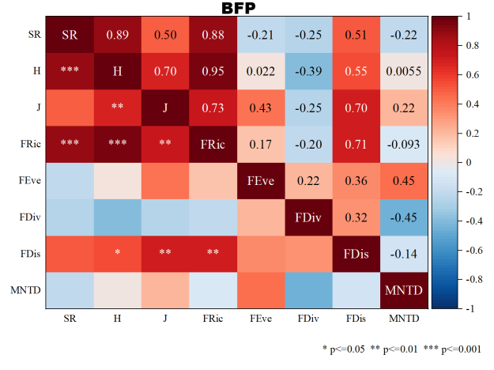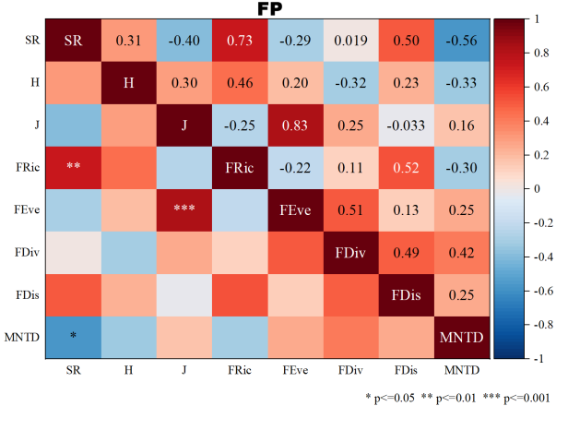
Figure S2 Correlation analysis of α-diversity indices during the before-freezing period (BFP) and the freezing period (FP).SR: species richness, H: Shannon diversity index, J: Pielou evenness, FRic: functional richness, FEve: functional evenness, FDiv: functional divergence, FDis: functional dispersion, MNTD: mean nearest taxon distance.

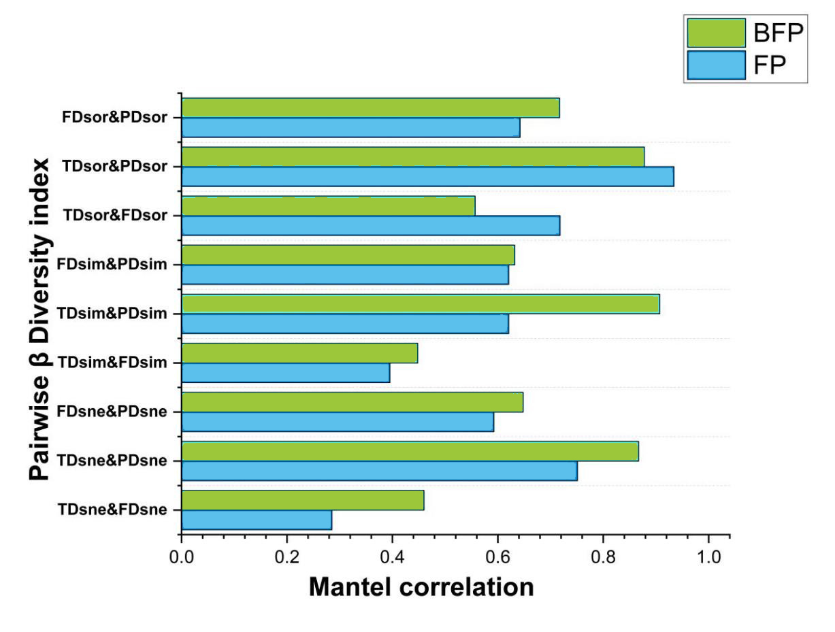
Figure S3 Correlation analysis of β-diversity indices during the before-freezing period (BFP) and the freezing period (FP). TD beta.SOR, TD beta.SIM, and TD beta.SNE: total beta diversity, species turnover, and nestedness in taxonomic diversity, respectively; FD beta.SOR, FD beta.SIM, and FD beta.SNE: total beta diversity, species turnover, and nestedness in functional diversity, respectively; PD beta.SOR, PD beta.SIM, and PD beta.SNE: total beta diversity, turnover, and nestedness in phylogenetic diversity, respectively.

