Supplementary Information
Waveguide-Integrated Bias-Free Graphene Mid-IR Photodetector and its Use for On-Chip Carbon Dioxide Gas Sensing
Shayan Parhizkar,†‡ Pen-Sheng Lin,§ Aron W. Cummings,¶ Arne Quellmalz,§ Nour Negm,†‡ Stephan Suckow,† Alba Centeno,# Maria Garcia Ibarrondo,# Amaia Zurutuza,# Floria Ottonello-Briano,^{þ} Stephan Schröder,^{þ} Charalampos Zervos,⊥ Frank Niklaus,§ Kristinn B. Gylfason,§ Max C. Lemme†‡
†AMO GmbH, Otto-Blumenthal-Str. 25, Aachen 52074, Germany
‡Electronic Devices, RWTH Aachen University, Otto-Blumenthal-Str. 2, Aachen 52074, Germany
§Department of Micro and Nanosystems, School of Electrical Engineering and Computer Science, KTH Royal Institute of Technology, Stockholm SE-10044, Sweden
¶Catalan Institute of Nanoscience and Nanotechnology (ICN2), CSIC and BIST, Campus UAB, Bellaterra 08193, Barcelona, Spain
#Graphenea SA, Paseo Mikeletegi 83, 20009, San Sebastian, Spain
^{þ}Senseair AB, 824 08 Delsbo, Sweden
⊥Photonics Communications Research Laboratory, National Technical University of Athens, Iroon Polytechniou Street 9, Zografou Athens 15773, Greece

S1. Simulated propagation loss of supported waveguides
The simulated propagation loss of the supported waveguides (WGs), with the burried silicon dioxide layer underneath, for different rib heights is shown in Figure S1. The rib height ranges from 50 nm to 400 nm, corresponding to fully etched WGs. In the realized device design, the supported photodetector WG is only 194 µm long, resulting in a loss of ~0.13 dB, which is negligible compared with the total optical loss of the system.
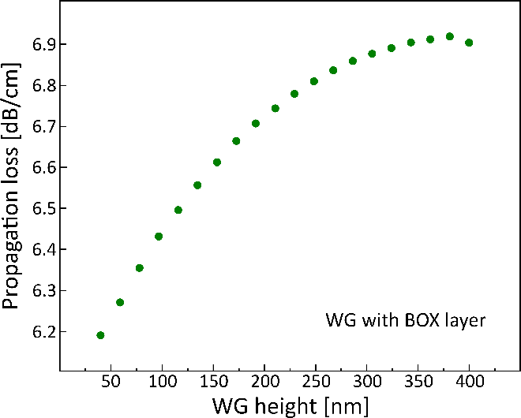
Figure S1. Simulated propagation loss of the supported rib WGs as a function of WG rib height.

S2. Cladding height and optical profile
The complex effective refractive index of the guided mode in the suspended waveguide was calculated as a function of the aluminum oxide (Al₂O₃) top cladding thickness by using Lumerical MODE (Ansys Optics). The imaginary part of the effective refractive index corresponds to the extinction coefficient and is used here as a measure of optical loss. The optical mode profile was evaluated using the same device geometry. Metallic split gates are positioned directly above the suspended WG and separated from it by the Al₂O₃ cladding layer. The split gates are separated by a 1 µm gap and are 100 nm thick. In the simulations, the metal was modeled as Au, whereas Ti was used for the split gates in the final fabricated devices.
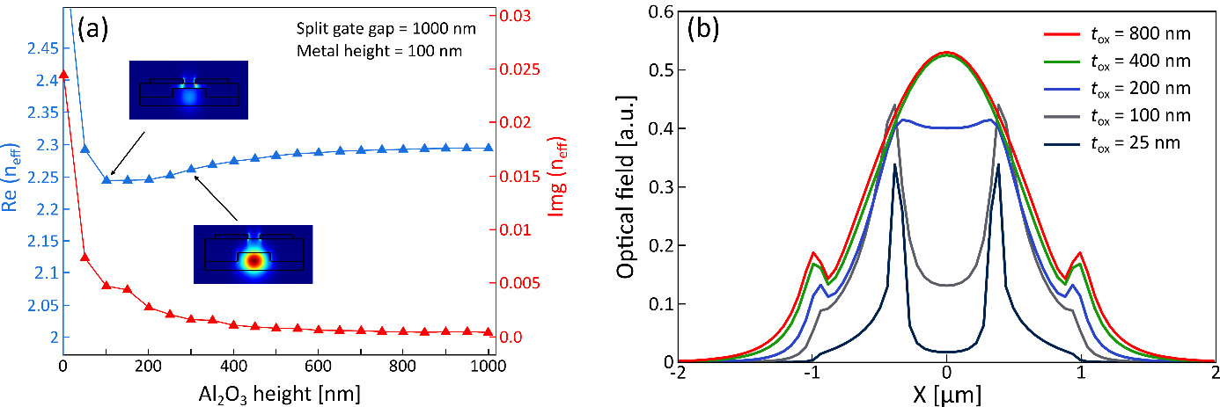
Figure S2. (a) Real and imaginary parts of the effective refractive index of the guided mode as a function of the Al₂O₃ thickness; the imaginary part corresponds to the extinction coefficient (optical loss). (b) Simulated optical mode profiles for different Al₂O₃ cladding thicknesses with split-gate electrodes positioned on top of the WG.

S3. Device fabrication and suspended platform
Device fabrication was performed on a Soitec silicon-on-insulator (SOI) wafer with a 400 nm top silicon (Si) device layer and a 3 µm buried oxide (BOX) layer. The wafer was laser-diced from 200 mm to 150 mm to ensure compatibility with the AMO cleanroom facility. Si WGs and grating couplers (GCs) were defined via optical lithography with a Canon FPA-3000 i5+ stepper, followed by reactive ion etching (RIE) with an Oxford Instruments Plasmalab 100 system. Etch-holes along the WGs were patterned by the same lithography and etching process. Following the definition of the photonic layer, the sensing WGs were fully suspended by immersing the wafer in a 5% hydrofluoric acid (HF) solution, which etches the BOX layer isotropically, causing an undercut. Support pillars were introduced every 150 µm by locally modifying the etch-holes pattern and controlling the under-etch time. Scanning electron microscopy (SEM) images of the suspended WGs are shown in Figure S3. The HF under-etch process resulted in cylindrical undercuts with a circular cross-section and a diameter of approximately 15 µm. The support pillars exhibited a diamond-shaped geometry with lateral dimensions of 6.5 µm and 11.7 µm at the top surface of the BOX, which increased to approximately 8 µm and 18 µm at the bottom surface of the BOX.
Next, a monolayer graphene film was transferred onto the wafer by a dry-transfer technique by Graphenea SL. Metal contacts, consisting of 5 nm titanium (Ti) and 50 nm gold (Au), were deposited via electron-beam evaporation (FHR Star 200 EVA) and patterned by a lift-off process. Graphene encapsulation was realized by depositing a 400 nm-thick Al₂O₃ by using a combination of water-based and plasma-enhanced atomic layer deposition (ALD) on an Oxford Instruments Plasmalab 100 system. Split-gate electrodes were then fabricated by evaporating a 100 nm Ti layer (FHR Star 200 EVA) and patterning via an RIE process. Finally, the vias were opened through the encapsulation layer by using a sequence of optical lithography, RIE, and wet etching steps to expose the contact pads. A photograph of the fully fabricated photothermoelectric (PTE) photodetectors, along with an image of the fabricated 150 mm wafer, is shown in Figure S3.
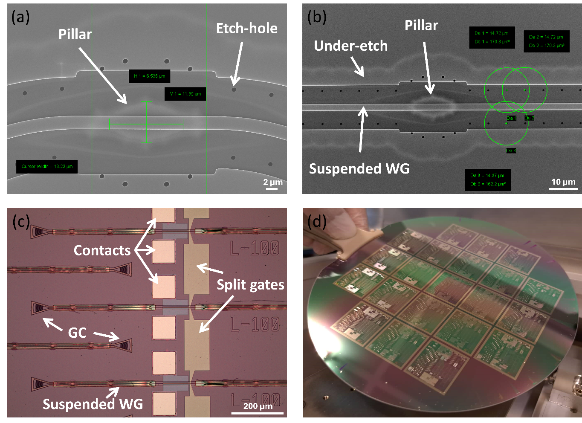
Figure S3. (a), (b) Top-view SEM images of the suspended WGs, with the support pillars and under-etched regions indicated. (c) A top-view optical image of the fully fabricated device comprising suspended WGs, GCs, and graphene-based PTE photodetectors. (d) Optical image of the fabricated 150 mm SOI wafer with suspended WGs and graphene-based PTE photodetectors. The wafer contains 21 dies.

S4. Raman analysis of graphene
The quality of the graphene layer after device fabrication was evaluated by Raman spectroscopy using a 512 nm excitation laser (Horiba system). A representative Raman spectrum is shown in Figure S4, exhibiting the characteristic G and 2D peaks at 1599 and 2685 cm⁻¹, respectively. A D peak was not detected, indicating a low defect density. The inset of Figure S4a presents the full width at half maximum (FWHM) of the graphene 2D peak after encapsulation with a 400 nm Al₂O₃ layer. The 2D peak FWHM is highly sensitive to strain, which strongly influences carrier mobility.^{1–3} In our devices, the FWHM is predominantly above 30 cm⁻¹, suggesting strain-induced mobility degradation. This strain is attributed to the underlying WG topography and the amorphous Al₂O₃ encapsulation layer. The correlation between the G and 2D peak positions is shown in Figure S4b, providing insight into the doping and strain levels in the graphene layer.⁴ The blue circles correspond to the Raman data acquired after dry transfer and PMMA removal, measured at multiple locations on and off the WGs across the wafer. The green circles represent measurements taken at the center of the photodetector on the WGs for randomly selected devices across the wafer after encapsulation. The data indicate that the graphene layer is highly doped.
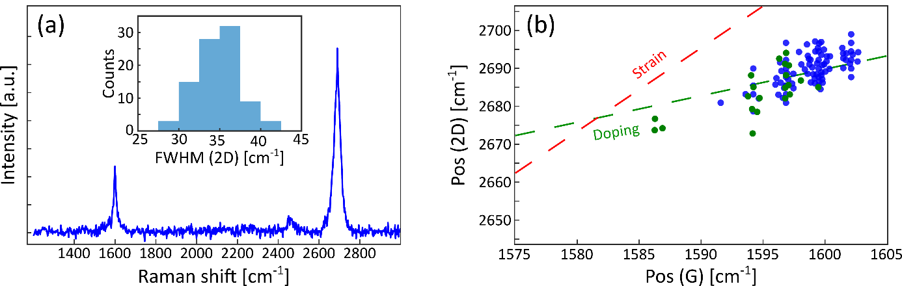
Figure S4. (a) A representative Raman spectrum of graphene measured from a PD. Inset: FWHM of the 2D peaks after encapsulation. (b) Correlations between the 2D and G peak positions from Raman maps after dry transfer of graphene to the substrate (blue circles) and on a device area on the WG post-encapsulation (green circles). The graphene layer is already highly doped after dry transfer, and although encapsulation modifies the Raman peak positions, the overall doping level remains high, consistent with electrical measurements and the observed shift in the Dirac point (Supporting Information section 7).

S5. Electrical characterization of graphene
The carrier mobility and sheet resistance of graphene were measured on-wafer by using a four-probe configuration. The field-effect mobility was extracted by using the transconductance method via $μ_{F}=\left(\frac{∂\left(\frac{I_{ds}}{V_{diff}}\right)}{∂V_{g}}\right)\frac{Lt_{ox}}{Wε_{r}ε_{0}}$,⁵ where $I_{ds}$ is the drain-source current, $V_{diff}$ is the voltage measured between the inner contacts, $V_{\text{g}}$ is the top gate voltage, L is the channel length between the inner contacts, W is the channel width, $t_{ox}$ is the Al₂O₃ encapsulation thickness, $ε_{\text{r}}$ is the relative permittivity of Al₂O₃, and $ε_{0}$ is the vacuum permittivity. Representative mobility extractions as a function of gate voltage are shown in Figure S5a. A violin plot of the extracted field-effect mobilities obtained from top-gate transconductance measurements of seven four-probe graphene test structures across the wafer is shown in Figure S5b. Electron and hole mobilities are shown separately, with individual data points corresponding to different gate sweeps and test structures. Mobility values were extracted from the regions of the transfer characteristics away from the Dirac point. Data points close to the Dirac point were excluded from the statistical analysis. Near charge neutrality, small changes in the gate voltage can shift the dominant carrier type from electrons to holes, whereas disorder and charge puddles introduce local inhomogeneity, resulting in a very small or noisy transconductance slope.^{5–7} The median hole mobility is 1068 cm²/Vs, while the median electron mobility is 495 cm²/Vs, which is consistent with typical values reported for CVD-grown graphene.^{5,8} The sheet resistance was extracted from the same four-probe measurements by using $R_{sheet}=V_{diff}.\frac{W}{I_{ds} . L}$, as shown in Figure S5c. The average sheet resistance at the Dirac point is 2267 Ω/□.
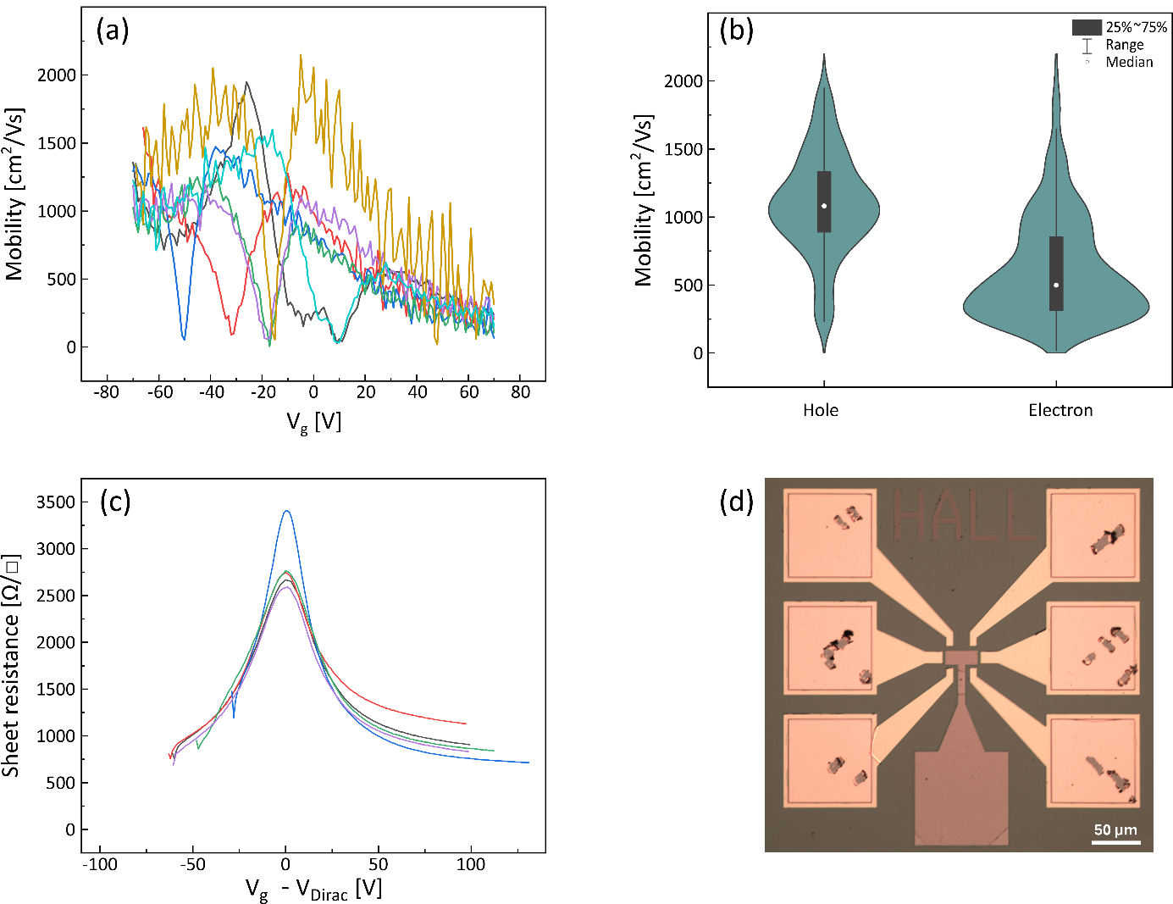
Figure S5. (a) Field-effect mobility of graphene as a function of the gate voltage extracted from a few four-probe structures across the wafer. (b) Statistical distribution of the graphene mobility. The median value for the hole mobility is 1068 cm²/Vs, with a standard deviation of 414 cm²/Vs, and the median electron mobility is 495 cm²/Vs, with a standard deviation of 387 cm²/Vs. (c) The sheet resistance of graphene was measured by using the same four-probe configuration. The average sheet resistance is 2267 Ω/□. (d) Optical image of a four-probe structure. The scratches on the contact pads from the probe contact are visible.

S6. Graphene optical absorption
The optical absorption of graphene integrated on the WG at a wavelength of 4.2 µm was evaluated by incrementally increasing the graphene width (along the WG) from 0 to 200 µm and measuring the corresponding transmission (loss) (Figure S6). The slope of the linear fit corresponds to an optical absorption coefficient of approximately 0.01 dB/µm. The data points are obtained from multiple dies across the wafer and exhibit significant scatter, attributed to various process-induced contaminants on the suspended WGs during fabrication. Despite this variability, the measurements can provide a reasonable estimate of the evanescent absorption of graphene at a wavelength of 4.2 µm.
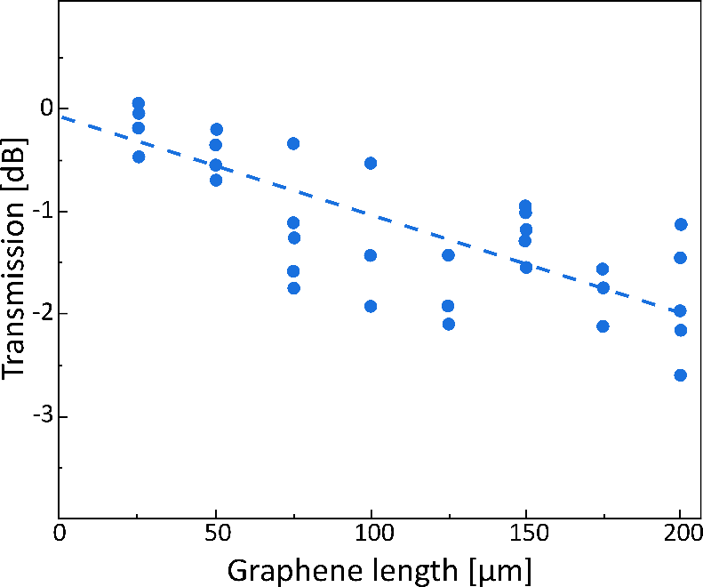
Figure S6. Transmission of the graphene-integrated WGs as a function of the graphene width. The average optical absorption of graphene at a wavelength of 4.2 µm is estimated to be 0.01 dB/µm.

S7. Optoelectronic measurement setup
A free-space mid-IR laser (MLQD4232, Thorlabs) was modulated at a frequency of 22.7 kHz and subsequently coupled into an InF₃ fiber (Thorlabs). The fiber delivered light to the wafer and injected it into one end of the WG. The local CO₂ concentration near the wafer and along the free-space optical path was actively controlled by continuous nitrogen purging. Low-frequency gate voltages (13.3 Hz) were applied to the split gates after amplification. The photodetector contact electrodes were connected to a lock-in amplifier (HF2LI, Zurich Instruments) to record the PTE signals. The transmitted light was collected from the opposite end of the WG, coupled into an optical fiber, and directed to a commercial photodiode (Lab M-I-5, Vigo Photonics) for active alignment and as a reference detector.
To measure the noise equivalent power (NEP), we used the noise spectral density function of the Zurich Instruments lock-in amplifier under dark conditions but used gate voltages for the same PD when measuring the photovoltage under light illumination. A schematic of the experimental setup is shown in Figure S7.
The optical power incident on the graphene PD was estimated from the measured WG transmission. Accurate calibration was required to account for the insertion losses of the grating couplers, the propagation losses of the WGs, and the optical absorption in graphene. The calibration was performed by using a cutback method to determine the WG and grating coupler losses, while the graphene absorption was calculated as described in Section 6 of the Supporting Information.
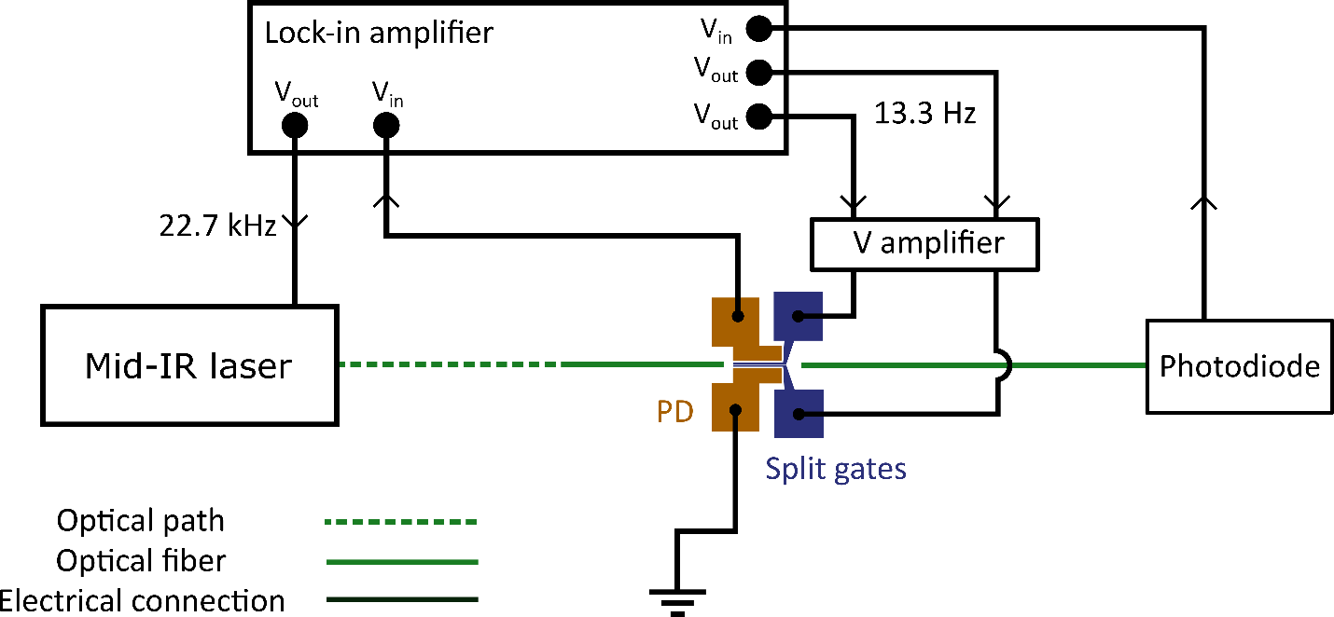
Figure S7. Schematic diagram of the measurement setup.

S8. Electrical characterization of the PDs
Figure S8a shows the drain−source current−voltage ($I_{DS}-V_{DS}$) characteristics of a representative die on the wafer with various devices with different widths (10 to 100 µm). All the devices exhibit linear behavior, indicating good ohmic contact with the graphene layer. The extracted device resistances vary significantly with device geometry, ranging from approximately 100 Ω to 400 Ω for devices with a channel width of 100 µm. These variations originate from differences in graphene quality across the channel area and variations in the metal–graphene contact resistance.
The transfer characteristics of two representative devices with a channel width of 100 µm are shown in Figures S8b and S8c. Pronounced hysteresis and long-term drift are observed, which are characteristic signatures of charge trapping in the gate dielectric (Al₂O₃). Charge trapping in oxide layers can lead to long-term variations in transfer characteristics during device operation under a gate bias, a phenomenon commonly referred to as bias-temperature instability (BTI). In graphene devices, this effect appears as a shift in the Dirac voltage. When the Dirac point shifts toward more positive gate voltages, it is referred to as positive bias temperature instability (PBTI), whereas a shift toward negative voltages is referred to as negative BTI (NBTI).
In Figure S8b, the gate voltage of the single-gate devices was swept from −80 V to 80 V (forward sweep, V⁺) and back (backward sweep, V⁻) with a sweep rate S = V_{step}/t_{step} of 25 Vs⁻¹ (corresponding to a step frequency of 25 Hz). Under these conditions, the hysteresis width (ΔV_{H}) of the representative device is approximately 40 V. The magnitude of the hysteresis depends strongly on both the gate voltage range and the sweep rate.
As shown in Figure S8c, repeated transfer measurements (V⁺) reveal a gradual shift of the Dirac point toward more positive gate voltages. When the sweep rate is reduced to 6 Vs⁻¹, the PBTI becomes significantly more pronounced, and the Dirac voltage shifts to values exceeding 100 V. Previous studies have shown that the defect band in Al₂O₃ responsible for charge capture and emission processes is dominated by electron traps.⁹ Al₂O₃ is widely used as a top-gate dielectric or encapsulation layer in many two-dimensional (2D) material devices, owing to its high dielectric constant and compatibility with direct deposition on 2D materials without causing significant damage.¹⁰ However, it typically exhibits a relatively high density of oxide trap states.^{11,12} PBTI originates from electron trapping in oxide defects under positive gate bias. As electrons are captured by these defect states, the trapped charge shifts the Dirac point of graphene progressively toward higher gate voltages. This effect becomes particularly pronounced in our devices because of the relatively thick Al₂O₃ layer (400 nm), which increases the total number of available trap states. The electron traps in Al₂O₃ exhibit a broad distribution of capture and emission time constants.⁹
For the PTE measurements, an alternating gate voltage with a modulation frequency of 13.3 Hz was applied. Although this AC gating scheme reduces the accumulation of trapped charges compared with static DC gating, where oxide traps can become fully charged, it is not sufficiently high to completely suppress charge trapping due to experimental limitations. Consequently, we associate the unusual photothermoelectric voltage map as a function of the two split-gate voltages shown in Figure 3 of the main text with shifts in the graphene Dirac point induced by defect-related charge trapping in the thick Al₂O₃ layer.
Electrical measurements across the wafer were conducted by Cascade Summit 12000 A semiautomatic prober connected to a Hewlett-Packard 4156B Precision Semiconductor Parameter Analyzer and a Hewlett-Packard E5250A Low Leakage Switch Mainframe, and executed by Keysight WaferPro Express test routine software.
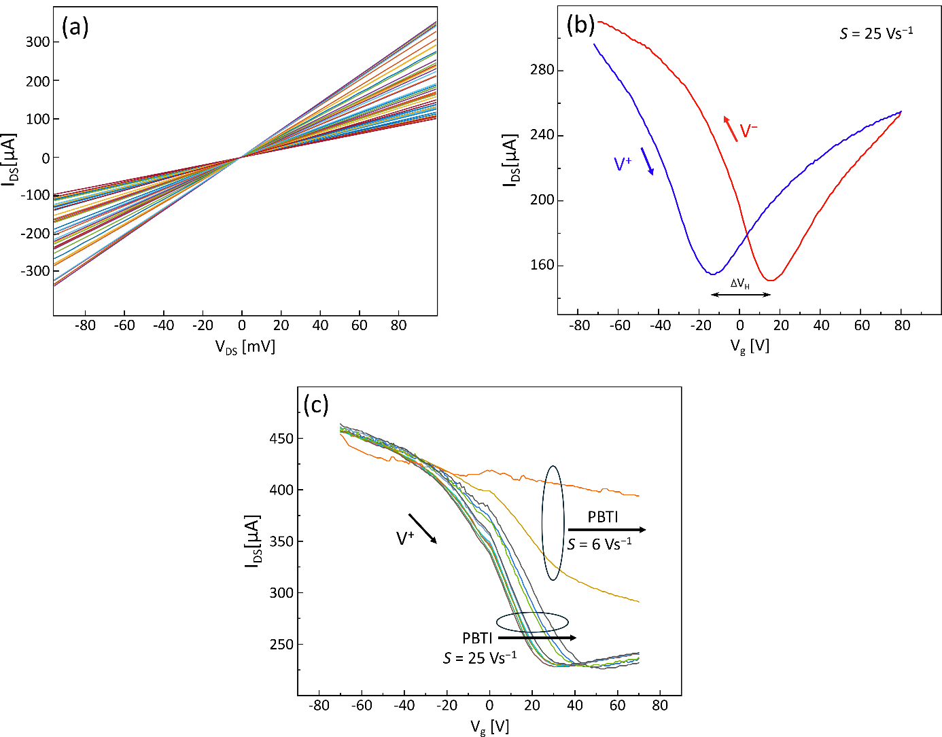
Figure S8. (a) I−V characteristics of PTE detectors on a representative die across the wafer, showing linear behavior for all devices. (b) Transfer characteristics of a representative device measured by sweeping the gate voltage from −80 V to +80 V in the forward (V⁺) and backward (V⁻) directions. The sweep rate is 25 Vs⁻¹, resulting in a hysteresis width of approximately 40 V associated with positive bias temperature instability (PBTI). (c) Transfer characteristics of another representative device obtained by repeatedly sweeping the gate voltage (V⁺ only) from −80 V to +80 V. Measurements were first performed with a sweep rate of 25 Vs⁻¹, showing a gradual shift in the Dirac point, and subsequently with a reduced sweep rate of 6 Vs⁻¹, which resulted in a pronounced shift in the Dirac point to values exceeding 100 V.

S9. Optoelectrical measurements
We investigated the photovoltage response of the graphene-based PTE photodetectors under both DC and AC split-gate biasing conditions. In addition, on−off measurements of the optical excitation were performed to verify that the detected signal originated from the graphene photodetector. All measurements were carried out by using a lock-in amplifier, as described in Section S7 of the Supporting Information. The photovoltage of a representative detector measured under static DC gating, where +25 V and +100 V are applied to the two split-gate electrodes, is shown in Figure S9a. As time progresses, the measured photovoltage gradually decreases and approaches the noise level of the LIA. This behavior arises from charge trapping in defect states within the thick Al₂O₃ encapsulation layer (Section S8 in the Supporting Information). The resulting electrostatic charging induces shifts in graphene's electronic properties, including the position of the Fermi level. The photovoltage measured by using the AC gating scheme is shown in Figure S9b. In this configuration, AC square-wave voltages at a frequency of 13.3 Hz are applied to the split-gate electrodes, with amplitudes corresponding to +100 V and +50 V. Compared with the DC case, the AC scheme partially mitigates the influence of charge trapping, resulting in a more stable photovoltage response. In both panels, the secondary y-axis shows the transmitted optical signal measured with a commercial mid-infrared detector at the output of the WG, coupled through the outcoupling GC. Figure S9c shows an on–off measurement of the same device by manually blocking the laser light while operating under the same AC gating scheme. These measurements confirm that the detected photovoltage originates from the graphene photodetector. In Figure S9c, the secondary y-axis corresponds to the transmitted optical power. The applied AC split-gate voltages are schematically shown in Figure S9d, while Figure S9e presents the measured photovoltage as a function of the phase difference between the two gate voltages. By varying the phase difference between the AC gate signals, the photovoltage can be tuned. The maximum photovoltage is obtained for zero phase difference between the two gate voltages.
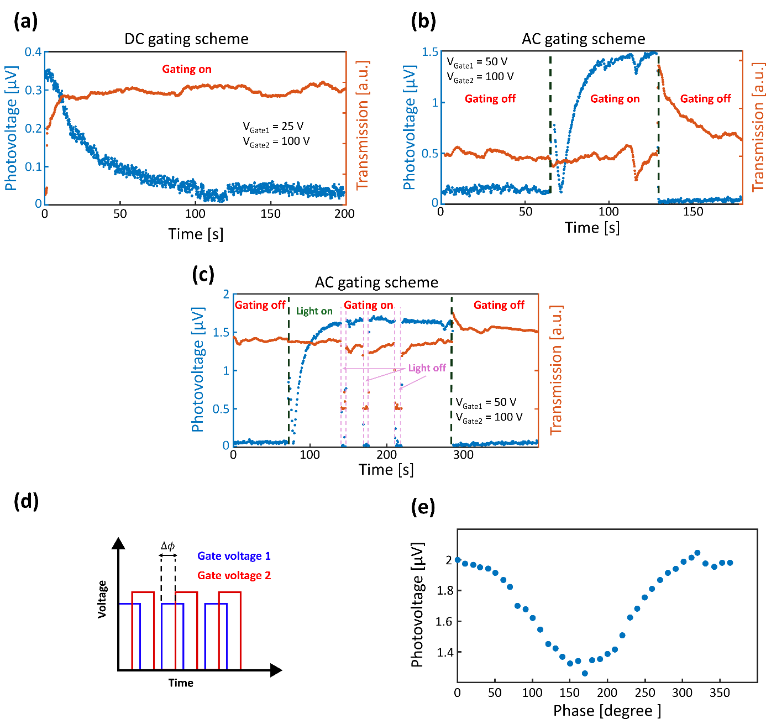Figure S9. (a) Photovoltage as a function of time measured under DC split-gate biasing for a representative device, with gate voltages of +25 V and +100 V applied to the two split gates. The photovoltage gradually decreases over time and approaches the LIA noise floor after ~100 s, due to changes in the electronic properties of graphene, caused by charge trapping in the Al₂O₃ dielectric. (b) Photovoltage measured by using the AC gating scheme, where square wave voltages with amplitudes of +50 V and +100 V are applied to the split gates, resulting in a more stable photovoltage response. (c) On−off measurement of the photodetector obtained by manually blocking the laser illumination. (d) Schematic illustration of the AC gating scheme. (e) Measured photovoltage as a function of the phase difference between the two gate voltages for a representative PD with peak voltages of V_{G1} = 25 V and V_{G2} = 100 V. The maximum photovoltage is obtained at zero phase difference between the two gate voltages.

S10. Details on the simulation and PTE photodetector modeling
Assuming that the photoresponse of our photodetector is dominated by the PTE, the photovoltage is given by^{13,14}
$$V_{PTE}= -\int{S\left(x\right)\frac{dT_{e}\left(x\right)}{dx}dx}$$
where T_{e}(x) is the electronic temperature profile along the length of the graphene channel and S(x) is the spatially varying Seebeck coefficient. The temperature profile is determined from the 1D heat equation:^{13,15}
$$\frac{d}{dx} \left(κ\left(x\right)\frac{dT_{e}\left(x\right)}{dx}\right)-\frac{κ\left(x\right)}{ L_{c}^{2}\left(x\right)} T_{e}\left(x\right)+\frac{αP\left(x\right)}{W}=0$$
where κ is the electronic part of the thermal conductivity, L_{c} is the cooling length of hot electrons, $α=1-\exp\left(-\frac{W}{L_{α}}\right)$ is the fraction of light absorbed along the graphene channel width (W), L_{α} is the optical absorption length of graphene, and P(x) is the power profile of the WG optical mode incident on the graphene layer. The parameters S, κ, L_{c}, and L_{α} all depend explicitly on the doping level and DC conductivity of graphene. Here, we assume that the DC conductivity is given by σ₀ = σ_{min} + enμ, where σ_{min} is the conductivity at the charge neutrality, μ is the carrier mobility, e is the electron charge, and n is the carrier density. The carrier density is expressed as $n=\frac{{\left(\frac{ϕ}{ℏν_{F}}\right)}^{2}}{π}$, where ħ is the reduced Planck constant, v_{F} is the graphene Fermi velocity, and ϕ is the electrostatic potential in the graphene layer. The Seebeck coefficient and the thermal conductivity are then given as follows:¹⁶
$$S\left(ϕ\right)= -\frac{1}{eT_{e}}\frac{κ_{1}\left(ϕ\right)}{κ_{0}\left(ϕ\right)}$$
$$κ\left(ϕ\right)= \frac{2}{hT} \left(κ_{2}\left(ϕ\right)- \frac{κ_{1}^{2}\left(ϕ\right)}{κ_{0}\left(ϕ\right)}\right)$$
$$κ_{j}\left(ϕ\right)= \int{{\left(ϵ-ϕ\right)}^{j}\acute{σ}\left(ϵ\right) \left(-\frac{∂f}{∂ϵ}\right)dϵ}$$
where $\acute{σ}=\frac{σ_{0}}{\frac{2e^{2}}{h}}$ is the normalized conductivity, T is the temperature, h is the Planck constant, and f is the Fermi-Dirac distribution. The cooling length of hot electrons is given by:¹⁵
$$L_{c}\left(ϕ\right)= \sqrt{\frac{κ(ϕ)}{γ\left(ϕ\right)C_{e}\left(ϕ\right)}}$$where $C\left(ϕ\right)=\frac{{\left(πk_{B}\right)}^{2}TD\left(ϕ\right)}{3}$ is the electronic heat capacity of graphene, k_{B} is the Boltzmann constant, D(ϕ) = 2|ϕ|/(ħv_{F})²/π is the density of states of graphene, and γ is the carrier cooling rate. We consider three different contributions to γ: direct acoustic phonon emission, disorder-assisted cooling, also known as supercollision, and direct optical phonon emission. Expressions for the first two can be found in Ref.¹⁷, and the final mechanism is described in Ref.¹⁸. The absorption length depends on the intrinsic absorption of graphene, plus its coupling to the WG, which is given by the following equation:¹⁹
$$L_{α}\left(ϕ\right)=\frac{{\left[2ωk\left(ϕ\right)\right]}^{-1}}{η}$$
$$k\left(ϕ\right)=Im\left\{\sqrt{εμ\left(1+i\frac{4πσ\left(ϕ\right)}{εωd}\right)}\right\}$$
$$σ\left(ϕ\right)≈\frac{σ_{0}\left(∅\right)}{1-iωτ}+ \frac{e^{2}}{4ℏ} Θ\left(ℏω-2ϕ\right)$$
where ω is the optical frequency, k is the refractive index of graphene, ε and μ are the surrounding permittivity and permeability, respectively, d = 0.35 nm is the graphene thickness,²⁰ σ₀ is the DC conductivity of graphene, τ is the carrier scattering time, and Θ is the Heaviside step function. This expression includes both the Drude and the interband contributions to the optical conductivity of graphene. Finally, the parameter η describes how well the graphene layer is coupled to the optical mode of the WG. Specifically, it is the proportion of the optical power of the WG mode that is incident on the graphene layer. Using WG simulations, we estimated that η ≈ 0.024%. However, to match the measured absorption in graphene (≈ 0.01 dB/µm, corresponding to L_{α} = 434 µm), we found that η ≈ 0.0033%.
Finally, we calculated the variation in the electrostatic potential along the graphene channel, ϕ(x). The electrostatic potential depends on the split gate voltages and can be determined through a self-consistent calculation of the charge and potential in the graphene photodetector.
$$∇.\left(ε∇ϕ\right)=-ρ$$
$$ρ= -\frac{e}{π} sgn\left(ϕ\right){\left(\frac{ϕ}{ℏυ_{F}}\right)}^{2}+ρ_{0}$$
where ε is the spatially varying permittivity, ρ is the charge density, and ρ₀ is the residual doping of the graphene layer, chosen to account for shifts in the Dirac point away from a gate voltage of V_{G} = 0 and to account for hysteresis in the measurements. Here, the Poisson equation is solved over a 2D cross section of the photodetector to get the 2D electrostatic profile, and the charge density ρ is determined from the value of ϕ at the graphene layer (and is equal to zero everywhere else). We solve the above equations over a range of split gate voltages using the device dimensions indicated in Figure 1 of the main text. The parameters are set to σ_{min} = 0.275 mS (corresponding to the measured resistance of a reference device), μ = 1000 cm²/Vs, and an optical power profile P(x) described by a Gaussian distribution with a width of 0.67 µm, which is consistent with WG simulations, and an input power of 1 µW incident on the graphene channel. The absorption length is taken as L_{α} = 434 µm at zero applied gate voltages, corresponding to a measured absorption of 0.01 dB/µm.

References:
1. Yamada, T., Okigawa, Y., Hasegawa, M., Watanabe, K. & Taniguchi, T. Relationship between mobility and strain in CVD graphene on h-BN. AIP Advances 10, 085309 (2020).
2. Neumann, C. et al. Raman spectroscopy as probe of nanometre-scale strain variations in graphene. Nat Commun 6, 8429 (2015).
3. Canto, B. et al. Plasma-Enhanced Atomic Layer Deposition of Al2O3 on Graphene Using Monolayer hBN as Interfacial Layer. Advanced Materials Technologies 6, 2100489 (2021).
4. Das, A. et al. Monitoring dopants by Raman scattering in an electrochemically top-gated graphene transistor. Nature Nanotech 3, 210–215 (2008).
5. Zhong, H., Zhang, Z., Xu, H., Qiu, C. & Peng, L.-M. Comparison of mobility extraction methods based on field-effect measurements for graphene. AIP Advances 5, 057136 (2015).
6. Samaddar, S., Yudhistira, I., Adam, S., Courtois, H. & Winkelmann, C. B. Charge Puddles in Graphene near the Dirac Point. Phys. Rev. Lett. 116, 126804 (2016).
7. Cho, S. & Fuhrer, M. S. Charge transport and inhomogeneity near the minimum conductivity point in graphene. Phys. Rev. B 77, 081402 (2008).
8. Esteki, A. et al. Tunable Doping and Mobility Enhancement in 2D Channel Field-Effect Transistors via Damage-Free Atomic Layer Deposition of AlOX Dielectrics. Preprint at https://doi.org/10.48550/arXiv.2408.07183 (2024).
9. Illarionov, Y. Y. et al. Energetic mapping of oxide traps in MoS2 field-effect transistors. 2D Mater. 4, 025108 (2017).
10. Piacentini, A. et al. Stable Al2O3 Encapsulation of MoS2-FETs Enabled by CVD Grown h-BN. Advanced Electronic Materials 8, 2200123 (2022).
11. Knobloch, T. et al. Improving stability in two-dimensional transistors with amorphous gate oxides by Fermi-level tuning. Nat Electron 5, 356–366 (2022).
12. Illarionov, Y. Y. et al. Long-Term Stability and Reliability of Black Phosphorus Field-Effect Transistors. ACS Nano 10, 9543–9549 (2016).
13. Song, J. C. W., Rudner, M. S., Marcus, C. M. & Levitov, L. S. Hot Carrier Transport and Photocurrent Response in Graphene. Nano Lett. 11, 4688–4692 (2011).
14. Lemme, M. C. et al. Gate-Activated Photoresponse in a Graphene p–n Junction. Nano Lett. 11, 4134–4137 (2011).
15. Antidormi, A. & Cummings, A. W. Optimizing the Photothermoelectric Effect in Graphene. Phys. Rev. Appl. 15, 054049 (2021).
16. Sivan, U. & Imry, Y. Multichannel Landauer formula for thermoelectric transport with application to thermopower near the mobility edge. Phys. Rev. B 33, 551–558 (1986).
17. Song, J. C. W., Reizer, M. Y. & Levitov, L. S. Disorder-Assisted Electron-Phonon Scattering and Cooling Pathways in Graphene. Phys. Rev. Lett. 109, 106602 (2012).
18. Pogna, E. A. A. et al. Hot-Carrier Cooling in High-Quality Graphene Is Intrinsically Limited by Optical Phonons. ACS Nano 15, 11285–11295 (2021).
19. Dresselhaus, M. S. Solid state physics part ii optical properties of solids. Lecture Notes (Massachusetts Institute of Technology, Cambridge, MA) 17, 15–16 (2001).
20. Shearer, C. J., Slattery, A. D., Stapleton, A. J., Shapter, J. G. & Gibson, C. T. Accurate thickness measurement of graphene. Nanotechnology 27, 125704 (2016).

