Supplementary Materials for

Implied Motion as a Mechanism for Spontaneous Belief Computation in Humans

Patricia Christian^{1#}, James Cahill², Adeline Fecker², Martha Paskin¹, Ronja Löfström¹, Zane A. Zook², Ahmed Raslan², Kelly L. Collins^{2*}, and Arvid Guterstam^{1*}

¹ Department of Clinical Neuroscience, Karolinska Institutet, Stockholm, Sweden
² Department of Neurological Surgery, Oregon Health & Science University, Portland, USA
#Correspondence: patricia.christian@ki.se
*shared senior authorship

Supplementary Materials
Eye-tracking equipment
Eye-tracking analysis
Fig. S1
Fig. S2
Table S1
Table S2
Supplementary references

Eye-tracking equipment
Participants eye movements were recorded via a desktop-mounted eye tracker (Tobii Pro Spectrum) sampling at 1200 Hz in experiments 1-4, and a laptop-mounted eye tracker in experiment 5 (Tobii Pro Fusion) sampling at 250 Hz. An on-screen calibration routine featuring nine locations was used and repeated until the maximum error for any point was less than 1°. Due to technical issues, the eye-tracking recording of three participants in experiment 2, three participants in experiment 3, and two participants in experiment 4, failed.

Eye-tracking analyses
Pupil Diameter
In experiment 2 and 5, eye-tracking data were analyzed to assess whether participants’ autonomic responses were modulated by the agent’s “belief state”. Pupil diameter was preprocessed and analyzed in the no-ball-outcome trials during ball detection task phase. Only no-ball-outcome trials were included in this analysis, because these trials were all presented for exactly 1-s (no button press) in contrast to ball-outcome trials. In ball-outcome trials, participants speeded button-press response led to the immediate conclusion of the trial, thus involving a rapid and variable change in visual stimulation which is likely to interfere with pupil size responses.
Raw pupil diameter was sampled at 1200 Hz and preprocessed to remove physiological artifacts following the preprocessing guidelines by^{1,2}. First, data with most extreme (large or small) absolute pupil diameter was rejected, removing non-finite values and values outside of the expected physiological range. Blink-related artifacts were addressed by expanding periods of missing data by 100 ms before and after each detected blink, thereby removing samples potentially affected by eyelid closure or reopening. Short gaps in the data (≤ 250 ms) were subsequently interpolated using linear interpolation, whereas longer gaps were retained as missing values. Following interpolation, the pupil signal was low-pass filtered with a cutoff frequency of 4 Hz in order to remove high-frequency noise. Finally, trials containing excessive missing data (trial containing less than 50% of data points) were excluded based on the proportion of valid samples remaining after preprocessing. This criterion ensured that only trials with sufficient data for reliable analysis were retained. Finally, data from both eyes were averaged together.
First, mean pupil diameter (in mm) was calculated based on raw pupil size. We hypothesized that participants would show a greater increase in pupil size in trials where the agent’s expectation (i.e., false belief that the ball is behind the occluder) is violated (Agent-Belief condition), compared to the no-belief control conditions (Fig 2E and Fig 4D). A paired t-test was computed to compare the mean pupil diameter between the Agent-Belief and Agent-NoBelief_{B} conditions.
Second, a baseline-corrected pupil diameter was calculated to control for individual differences in pupil size across participants. The pupil signal for each trial epoch was baseline-normalized by calculating the signal change relative to the baseline (in percentage). This baseline was calculated as the mean pupil diameter across all trials and conditions. For each time point, the percentage signal change relative to this baseline was computed. Pupil signals were then averaged within each condition to obtain a mean pupil time course for each subject.
The time course of the condition effect on pupil dilation was measured by computing paired-samples t-tests between the Agent-Belief and Agent-No-Belief conditions, recording the t-statistic at each sample over the 1-s trial period. Periods of significance in this time series of t-statistics were identified using cluster-based permutation statistic, in accordance with the approach in ¹. The absolute t-statistics were summed for the largest consecutive series (cluster) of values exceeding ∣t∣>2.0. This observed cluster mass was then compared with the equivalent largest cluster mass obtained across 10,000 iterations of the same process following a random permutation of condition labels for each participant. Clusters whose observed mass exceeded the 95th percentile of the permuted distribution were considered statistically significant (p < 0.05). Observed clusters were further classified according to direction: positive clusters reflected greater pupil percentage change for Agent-Belief > Agent-NoBelief_{B}, whereas negative clusters reflected greater pupil percentage change Agent-NoBelief_{B} > Agent-Belief. Results of the cluster-based permutation analysis are shown in Fig 2D and Fig 4CEye movements

Eye movements
We analyzed eye position in experiment 1 during the dot-motion task phase of the trial to rule out that an asymmetric distribution of the subjects’ overt attention might have affected their motion judgments. The results are shown in Fig. S1. Eye position was coded relative to the head shown in the preceding display (flipping the x axis when the head was to the left of the display). For each subject, we computed a horizonal eye position difference score (in pixels): ΔX = [mean horizontal eye position for the Agent-Belief trials] – [mean horizontal eye position for the Agent-NoBelief_{A} trials]. We then performed a t-test among the 27 subjects and found that ΔX was not significantly different from zero (mean ΔX = 0.09, t₂₆ = -1.74, p = 0.094), demonstrating that the Agent-Belief did not cause a systematic shift in horizontal eye position relative to the Agent-NoBelief_{A} condition. This result was expected given that subjects were instructed to fixate centrally and that the two conditions were visually identical 4.5s before task onset, and replicates the findings of Guterstam & Graziano (2020b). In Experiment 2, again, we analyzed eye position during the dot-motion task phase of the trial to rule out that an asymmetric allocation of participants’ overt attention might have affected their performance, using the same procedures as described in experiment 1. Again, we found that ΔX was not significantly different from zero for the dot motion task (mean ΔX = -0.02, t₂₉ = -0.45, p = 0.658), demonstrating that the Agent-Belief did not cause a systematic shift in horizontal eye position relative to the Agent-NoBelief_{B} condition.
Similarly, we calculated eye position in experiments 2-4 for the ball detection task during the task phase (i.e., when the occluder opened) using the same procedures. The results are shown in Fig. S2. We computed ΔX for each experiment: The results show no significant differences between the Agent-Belief and Agent-NoBelief_{B} condition in experiment 2 (mean ΔX = 0.09, t₂₉ = 0.676, p = 0.505), no significant differences between the Congruent Agent-Belief and Incongruent Agent-Belief condition in experiment 3 (mean ΔX = 0.14, t₂₈ = 0.89, p = 0.385) and experiment 4 (mean ΔX = 0.002, t₂₆ = 0.116, p = 0.991). These findings rule out the alternative explanation that the behavioral differences observed between conditions in experiments 2-4 were driven by systematic differences in participants’ overt attention during the task phase.
Additionally, to rule out that differences in ball-detection latencies between belief and no-belief conditions in experiments 2-4 could be explained by systematic differences in gaze position during the belief representation phase, we calculated mean gaze duration within predefined areas of interest (AOIs) encompassing the agent and the occluder. In experiment 2, we found no significant differences in mean gaze duration neither the agent AOI (Agent-Belief = 0.135 s; Agent-NoBelief_{B} = 0.138 s, t₂₆ = -0.458, p = 0.651) nor the occluder AOI (Agent-Belief = 0.525 s; Agent-NoBelief_{B} = 0.531 s, t₂₆ = -0.573, p = 0.571). A similar pattern of results was observed in experiments 3 for the agent AOI (Congruent Agent-Belief = 0.154 s; Incongruent Agent-Belief = 0.164 s, t₂₈ = -1.185, p = 0.246) and the occluder AOI (Congruent Agent-Belief = 0.299 s; mean Incongruent Agent-Belief = 0.303 s, t₂₈ = -0.391, p = 0.699), and in experiment 4 for the agent AOI (Congruent Agent-Belief = 0.073 s; Incongruent Agent-Belief = 0.067 s, t₂₆ = 1.01, p = 0.322) and the occluder AOI (Congruent Agent-Belief = 0.473 s; Incongruent Agent-Belief = 0.478 s, t₂₉ = -0.359, p = 0.722)
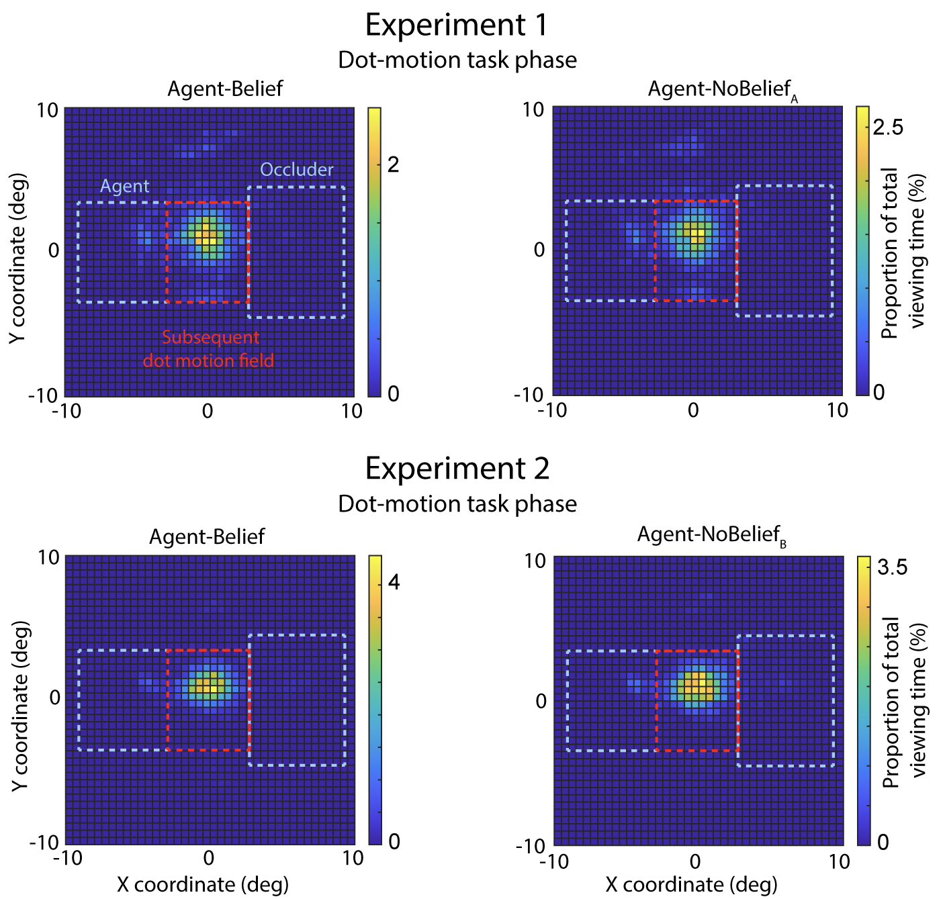

Figure S1. Distribution of gaze position in experiments 1-2 during the dot-motion task phase for the Agent-Belief and Agent-NoBelief conditions. For trials in which the agent’s head appeared on the right side, the X coordinates were flipped so that all trials were coded as though the head appeared on the left. Data is shown from the dot-motion task phase, during which participants viewed the dots stimulus and performed a motion direction discrimination task. Heatmaps show the proportion of total viewing time (%). The location of agent (right blue dashed line), occluder (left blue dashed line), and the empty space in-between agent and occluder (central red dashed line) in the preceding belief representation phase, are outlined for reference. Grid squares indicate the percentage of time participants’ gaze fell within each region during the belief-representation phase.

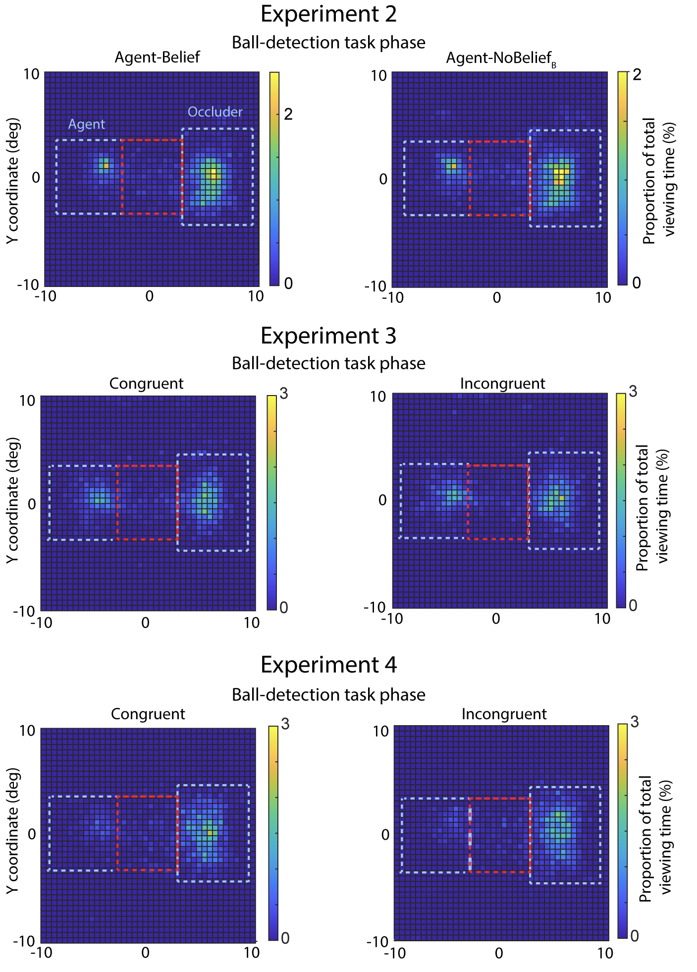

Figure S2. Distribution of gaze position in experiments 2-4 during the ball detection task. Data are shown for the Agent-Belief and Agent-NoBelief_{B} conditions in experiment 2, and the Congruent and Incongruent Agent-Belief conditions in experiments 3-4. For trials in which the agent’s head appeared on the right side, the X-coordinates were flipped so that all trials were coded as though the head appeared on the left. Data is shown from the task phase, during which the occluder dropped down and participants performed the ball detection task. Heatmaps display the proportion of total viewing time (%). The locations of agent (right blue dashed line), occluder (left blue dashed line), and the empty space in-between agent and occluder (central red dashed line), are outlined for reference.

Participant | Anatomical location | Agent-Belief (decoding accuracy) | Agent-NoBelief_{B} (decoding accuracy) | Agent-Belief  vs. chance | Agent-Belief  vs.  Agent-NoBelief_{B} | Combined corrected p value*
P2 | L SMG | 62.5% | 45.0% | p = 0.021 | p = 0.018 | p = 0.035
P3 | R AG | 72.5% | 50.0% | p = 0.004 | p = 0.034 | p = 0.019
P4 | L AG | 60.0% | 42.5% | p = 0.034 | p = 0.017 | p = 0.028
P7 | L pSTG | 57.5% | 47.5% | p = 0.030 | p = 0.026 | p = 0.034
P10 | L pSTG | 60.0% | 45.0% | p = 0.018 | p = 0.010 | p = 0.010
P11 | R pSTS | 60.0% | 52.5% | p = 0.030 | p = 0.041 | p = 0.020
P14 | R pSTS | 60.0% | 47.5% | p = 0.013 | p = 0.013 | p = 0.018

Table S1. Experiment 5 results. Significant electrode contacts revealed by our decoding analysis. P values are based on permutation testing with 10,000 iterations. *The permutation tests for Agent-Belief vs. chance and Agent-Belief vs. Agent-NoBelief_{B} were combined using the Tippett approach as described in ³, and Bonferroni-corrected across different electrodes within-subject. SMG, supramarginal gyrus. pSTS, posterior superior temporal sulcus. pSTG, posterior superior temporal gyrus. AG, angular gyrus.

Participant | Age | Sex | Handed-ness | Years of education | Neurocognitive concerns | Reason for surgery | Other Pertient Medical History
1 | 67 | Female | Right | 10 | None | Idiopathic epilepsy | Traumatic brain injury, abnormal enlargment of right amygdala, migraine, depression, anxiety, hypertension, sleep apnea
2 | 18 | Male | Right | 11 | Mild neurocognitive disorder secondary to epilepsy | Intractable focal epilepsy | Adjustment disorder, anxiety, diplopia, nonintractable headaches
3 | 31 | Male | Left | 13 | Language and memory deficits | Epilepsy | ADD, anxiety, depression, migraines
4 | 33 | Male | Right | 10 | None | Idiopathic epilepsy | Depression, anxiety, PTSD, migraines
5 | 34 | Female | Right | 12 | None | Refractory epilepsy | Hypothyroidism, anxiety, depression, PTSD, psychotic disorder
6 | 31 | Female | Right | 9 | Mild neurocognitive disorder secondary to epilepsy | Refractory autoimmune epilepsy | Anxiety, depression, ADHD, sleep apnea
7 | 42 | Female | Right | 16 | None | Idiopathic epilepsy | Anxiety, depression
8 | 41 | Female | Left | 13 | Mild language impairment | Idiopathic epilepsy | Anxiety, depression, migraines
9 | 42 | Male | Right | 12 | Short-term episodic memory difficulties | Intractable focal epilepsy | Traumatic brain injury, bilateral frontotemporal encephalomalacia, communication disorder, depression, anxiety
10 | 32 | Male | Left | 12 | Impaired perceptual reasoning | Idiopathic epilepsy | Autism spectrum disorder, neuronal migration disorder (left hemispheric heterotopia/schizencephaly)
11 | 34 | Male | Right | 12 | None | Refractory epilepsy | Neurofibromatosis type 1, resection of low grade glioma, obstructive hydrocephalus, alcohol use disorder, depression, adjustment disorder, conversion mutism
12 | 42 | Male | Right | 9 | Memory, executive, and learning difficulties | Intractable focal epilepsy | Right frontal ganglioma resection, depression, psychosis following use of phencyclidine
13 | 19 | Male | Right | 12 | None | Intractable focal epilepsy | Parasomnia, monoallelic mutation of DEPDC5 gene
14 | 27 | Male | Right | 16 | None | Intractable focal epilepsy | Episodic mood disorder, anxiety, depression, ADHD, encephalocele
15 | 16 | Male | Left | 11 | Moderate intellectual disability | Intractable focal epilepsy | Traumatic brain injury, left hemispheric encephalomalacia and right hemiparesis, disruptive behavior disorder, depression, mixed receptive-expressive language disorder

Table S2. Experiment 5. Patient characteristics.
Supplementary References

S1. Graves, J. E., Egré, P., Pressnitzer, D. & de Gardelle, V. An implicit representation of stimulus ambiguity in pupil size. Proceedings of the National Academy of Sciences 118, e2107997118 (2021).
S2. Kret, M. E. & Sjak-Shie, E. E. Preprocessing pupil size data: Guidelines and code. Behav Res 51, 1336–1342 (2019).
S3. Winkler, A. M. et al. Non‐parametric combination and related permutation tests for neuroimaging. Human Brain Mapping 37, 1486–1511 (2016).

