SUPPLEMENTAL TEXT

Phytoplankton dominate marine organic matter for the past half-billion years
Caitlyn R. Witkowski, Jingyi Wei, Matthew J. Roche, B. David A. Naafs, and Rich D. Pancost

Theoretical sources of phytane and pristane
For pristane, most literature also supports the provenance from chlorophyll, where pristane is liberated under oxidising conditions via decarboxylation and reduction of phytol (Volkman and Maxwell, 1986; ten Haven et al., 1987; Didyk et al., 1978). Proposed sources of pristane include: (iv) catagenesis of the kerogen-bound/chlorophyll phytyl chain (Ishiwatari et al., 1991; Rontani and Volkman, 2003), dihydrophytol (Ishiwatari and Ishiwatari, 2004), tocopherols of land plants (Goossens et al., 1984; Rontani et al., 2010), tocopherol trimeric oxidation products (Rontani et al., 2010), methyltrimethyltridecylchromans (Li et al., 1995), or diphytanylglycerol diethers (Chappe et al., 1982); (i) calanoid copepods (zooplankton), that produce pristane and use it to achieve buoyancy (Blumer et al., 1963; Blumer & Snyder, 1965; Avigan & Blumer, 1968); (ii) anaerobic bacterial degradation of trimers (Rontani et al., 2010; Rontani and Bonin, 2011); (iii) anaerobic bacterial or clay-catalysed reduction of pristene isomers (De Leeuw, 1977; Rontani and Grossi, 1995); (v) the phytanyl core of archaeal ether lipids as precursors, derived from methanogens or thermoacidiphilic/halophilic archaea (Rowland, 1990; Navale, 1994; Risatti et al., 1984); and (vi) biohydrogenation of pristene (Rontani et al., 2010). However, many of these theoretical sources are unlikely, especially the loss of a single carbon atom.
For phytane, most literature supports the provenance from chlorophyll, where phytane is liberated under anoxic conditions via dehydration and reduction of phytol (Ten Haven et al., 1987; Didyk et al., 1978). Proposed sources for phytane include: (i) anaerobic degradation of phytol (Grossi et al., 1998); (ii) archaeal ether lipids derived from methanogens or thermoacidiphilic/halophilic archaea (Risatti et al., 1984; Rowland, 1990; Tornabene et al., 1979; Allen et al., 2010; Jahnke et al., 2008; Fox et al., 2020); (iii) bacterial reduction of isomeric phytenes/phytadienes (De Leeuw, 1977); (iv) biohydrogenation of phytene (Rontani et al., 2010); (v) reductive desulphurisation of phyt-2-en-1-thiol (Hebting et al., 2006); and (vi) clay-catalysed hydrogenation of isoprenoid alkenes produced during catagenesis of the kerogen-bound phytyl chain (Gelin et al., 1995), dihydrophytol (Ishiwatari and Ishiwatari, 2004), and diphytanylglycerol diethers (Pease et al., 1998). However, many of the theoretical sources of phytane (iii)-(vi) are highly unlikely in thermally immature sediments, given that C-C bonds are not readily broken.

δ¹³C compilation of pristane and phytane
There is no difference between sediment versus oil samples (Fig. S2); both were included in this study. There is also no difference between sulphur-bound versus free pristane and phytane (Fig. S3); both were included in this study. Sulphur reacts rapidly with functionalised lipids such as phytol during very early diagenesis (Sinninghe Damsté et al., 1989), forming C₁₉ isoprenoid thiophenes as a result of reaction with H2S-saturated seawater via a pristene/pristadiene/pristatriene intermediate (Fukushima et al., 1992; De Graaf et al., 1992; Rowland et al., 1993; Koopmans et al., 1999). Sulphurisation increases the preservation of organic compounds (Rosenberg et al., 2018), and its rapid reaction with phytol means that sulphur-bound samples likely formed in situ, thus more accurately reflecting the δ¹³C of the original phytol with which sulphur-bound species may selectively react (van Bentum et al., 2012; Koopmans et al., 1999; De Graaf et al., 1992). Free and sulphur-bound phytane have been suggested to have a small offset of ca. 2 per mil but a more comprehensive study over the Phanerozoic has shown that there is little difference between the two and thus both can be used for analyses (Witkowski et al., 2018), which is further support by our work here (Fig. S2).
To ensure high fidelity of marine-derived organic material, we removed studies that reported significant, e.g. from runoff into coastal marine settings, identified via: i) n-alkane distributions typical of land plants (high molecular weight and strong odd-over-even preference); ii) terrestrial biomarkers such as terpenoids; and iii) supporting evidence for the reconstructed depositional environment (e.g., sedimentology, fossils), shown in Fig. S1 and Fig. S4.

Calculating ε_{p} and pCO₂
We calculate the stable carbon isotopic fractionation associated with photosynthesis (ε_{p}), which measures the offset between the inorganic carbon source in the water (δ¹³C of dissolved CO₂, derived from biogenic carbonate) and the organic carbon of the once-living organism (δ¹³C of photosynthetic biomass, in this case, pristane and phytane) and is calculated using Eq. 1 (Popp et al., 1989; Freeman and Hayes, 1992):
ε_{p} = 1000 x [(δ_{d} + 1000) / (δ_{p} + 1000) – 1] (1)
where δ_{p} is derived from the δ¹³C of pristane and phytane, corrected for its isotopic offset from biomass (3.5 ‰, Witkowski et al., 2018). δ_{d} is constrained using the δ¹³C of biogenic carbonate, preferably from planktonic foraminifera or bulk carbonate from the same site as pristane and phytane; where unavailable, the δ_{d} is obtained using the global compiled average of δ¹³C of carbonate at the time of deposition (Hayes et al., 1999). δ¹³C of carbonate is corrected for temperature-dependent carbon isotopic fractionation between dissolved CO₂ with respect to HCO₃⁻ (Mook et al., 1974), using the sea surface temperature (SST) from the same or a nearby site. Where accurate SST values were lacking, SST was estimated from a model-based approach using the palaeolatitude and age of the site (using findsst.org).
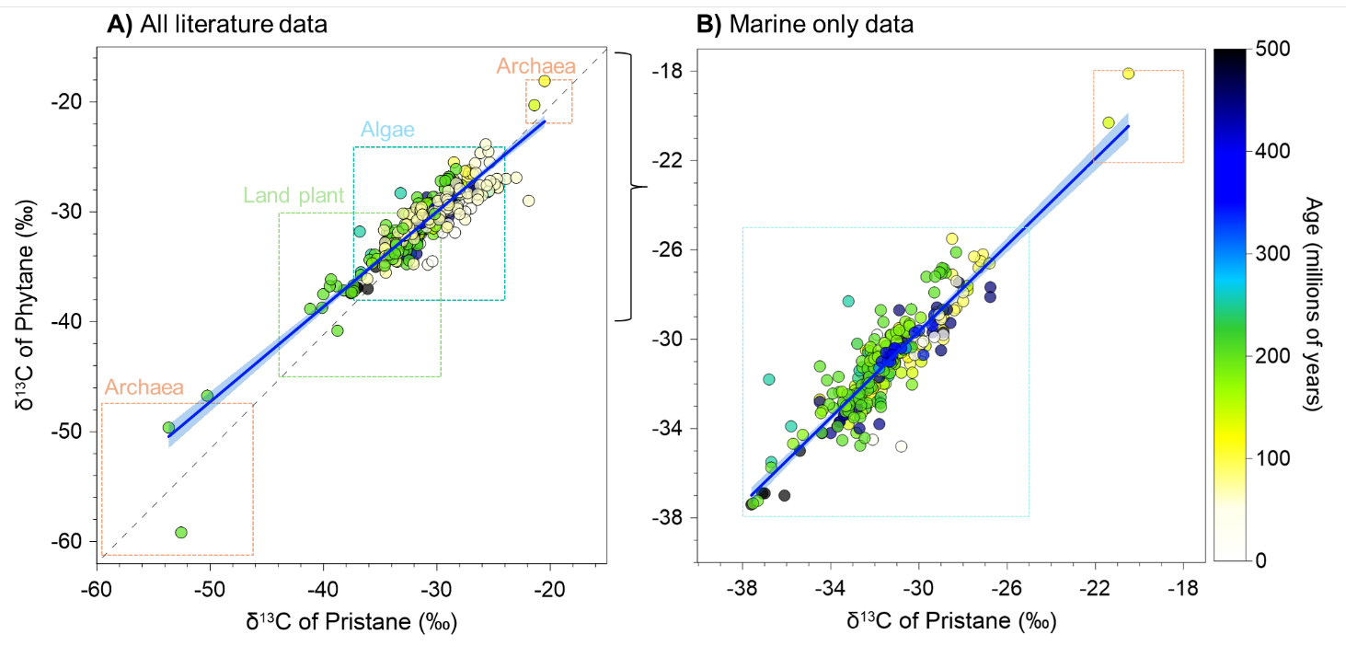
Fig. S1. δ¹³C values of pristane versus phytane across the last 500 million years. δ¹³C values of pristane and phytane from the same archives, A) All literature data and B) Marine-only data that has been screened for terrestrial input. The grey dash line represents the 1:1 line, dark blue line represents linear fit to the data, orange box represents expected range for marine photoautotrophs, and colour bar represents age of each marine archive in millions of years.

