Supporting Information
Ultrafast Hydride Transfer Pathway in Dinitrogen Fixation
Zijian Zhao^{1,2,6}, Yun-Shu Cui^{2,6}, Geng-Mu Li², Dan-Dan Zhai²*, Limei Tian², Weijian Yang², Tinghao Wu², Jing-Ao Fan², Pengju Li², Suze Ma², Lai Jiang⁴, Menghui Jia⁵, Renato N. Sampaio³, Gerald J. Meyer³, Chi Zhang¹*, Zhang-Jie Shi²* and Ke Hu^{1,2}*

1 School of Chemical Science and Engineering, Tongji University, 1239 Siping Road, Shanghai 200092, China;
2 Department of Chemistry, Fudan University, 2005 Songhu Road, Shanghai 200438, China;
3 Department of Chemistry, University of North Carolina at Chapel Hill, Chapel Hill, North Carolina 27599, United States;
4 Instrument Analysis Center, Tongji University, 1239 Siping Road, Shanghai 200092, China;
5 State Key Laboratory of Precision Spectroscopy, East China Normal University, Shanghai 200241, China;
6 These authors contributed equally: Zijian Zhao, Yun-Shu Cui.

Correspondence to D.-D. Z.* (zhaidandan@fudan.edu.cn), C. Z.* (chizhang@tongji.edu.cn), Z.-J. S.* (zjshi@fudan.edu.cn) and K. H.* (khu@tongji.edu.cn)

Table of Contents
1. Materials 4
2. Instrumentation 4
3. Transformation of 4DPAIPN to PAC-AcrH₂ 5
4. Synthesis and characterization of PAC-AcrH₂ 6
5. Synthesis and characterization of molybdenum nitride complexes 11
6. The interaction between PAC-AcrH₂ and MoN complex 14
7. Femtosecond transient absorption spectroscopy 16
8. Reference spectra of PAC-AcrH₂^{·+}, PAC-AcrH· and PAC-AcrH⁺. 20
9. Photocatalytic quinoline hydrogenation 23
10. Synthesis of PAC-AcrH₂-d₁ 26
11. Photocatalytic NH₃ synthesis from N₂ 28
12. Detection of NH₃ 29
13. Photocatalytic reaction conditions optimization 31
14. Thermodynamic analysis 34
15. DFT calculations 36
16. X-ray crystallography 38
17. XYZ Coordinates for Optimized Structures 39
18. References 65

Materials
All manipulations of air- and moisture-sensitive compounds were performed under an Ar/N₂ atmosphere by using standard Schlenk techniques or in Vigor gloveboxes. THF and Et₂O were dried by distillation over sodium/benzophenone. The chemical solvents and reagents were purchased from commercial sources. THF-d₈ was purchased from J&K and dried over CaH₂. All other reagents were purchased from commercial source and used as received unless otherwise noted. The 4DPAIPN, 4CzIPN and PDI were synthesized from the previous report without modification¹⁻². Mo[N(TMS)Ar]₃ and MoN were prepared according to our recent work³.

Instrumentation
UV-Vis-NIR absorption spectra were collected on an Agilent Cary 60 spectrometer. The fluorescence spectra were collected on Agilent Cary Eclipse fluorimeter and Edinburgh FLS1000 photoluminescence spectrometer. ¹H-NMR and ¹³C-NMR spectra were collected on Bruker AVANCE III HD spectrometer. High-performance liquid chromatography (HPLC) analysis was performed on Agilent 1260 Infinity II. The gases generated in the headspace were analyzed and quantified by gas chromatography (FULI GC9790PLUS).
Cyclic voltammetry was carried out on a CHI 760E electrochemical workstation. Substrates (1mM) were dissolved in N₂-degassed THF with 0.1 M tetrabutylammonium perchlorate (TBAClO₄) as the electrolyte. A typical three-electrode cell was used with glassy carbon as the working electrode, Ag/AgCl as the reference electrode and Pt wire as the counter electrode with ferrocene (Fc) solution as an external standard. The scan rate was 100 mV/s.

Transformation of 4DPAIPN to PAC-AcrH₂
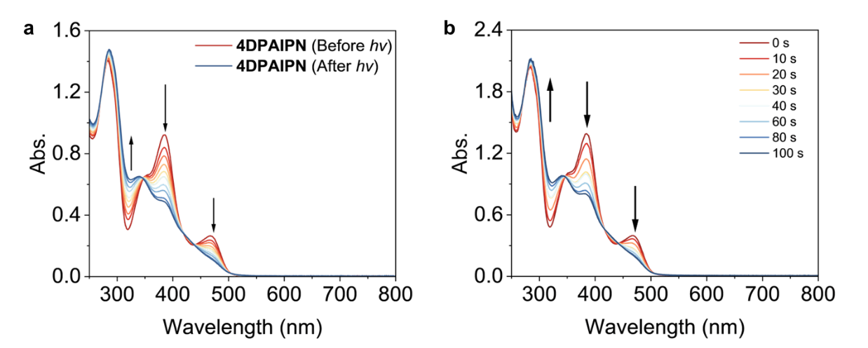
Figure S1. UV-vis absorption spectral changes of 4DPAIPN in the (a) absence and (b) presence of AcrH₂ (100 μM) under 450 nm laser irradiation within 2 min in an inert atmosphere.

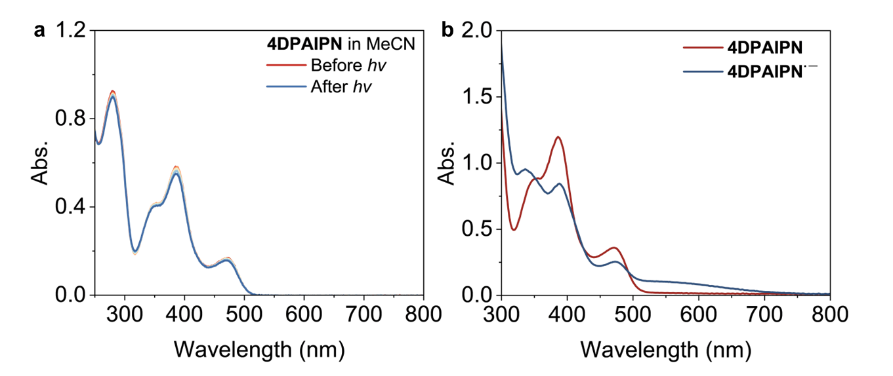
Figure S2. (a) UV-vis absorption spectral change of 4DPAIPN (20 μM) in MeCN under 450 nm laser irradiation after 10 min in an inert atmosphere. (b) UV-vis absorption spectra of 4DPAIPN^{·-} in MeCN, obtained from the photoreduction of 4DPAIPN (40 μM) by DIPEA (30 mM) under 450 nm laser irradiation for 1 min in an inert atmosphere.
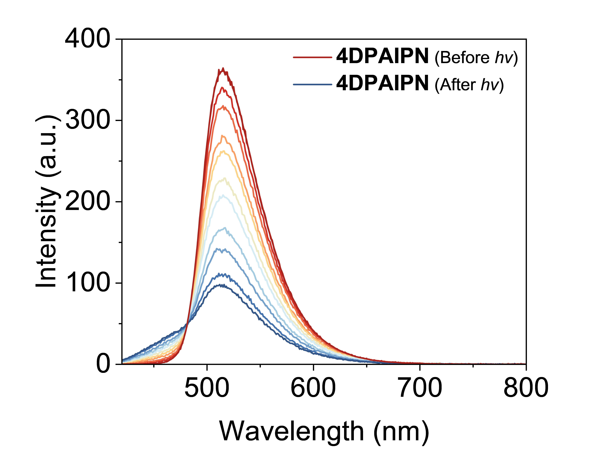
Figure S3. Fluorescence spectral changes of 4DPAIPN (20 μM) in THF under 450 nm laser irradiation in an inert atmosphere.

Synthesis and characterization of PAC-AcrH₂
800 mg of 4DPAIPN was dissolved in 50 mL THF under an inert atmosphere. The solution was irradiated with a 450 nm LED for 12 hours. After irradiation, the solvent was removed under reduced pressure using a rotary evaporator. The crude product was purified by silica gel column chromatography (PE:EA, 20:1 to 4:1, v:v) to obtain an orange solid product (288 mg) with 36% yield. The product was dissolved in PE:EA (4:1, v:v) mixed solvent to allow slow evaporation at room temperature to give reddish-orange crystals suitable for X-ray crystallography.
Figure S4. ¹H-NMR spectra of PAC-AcrH₂ in MeCN-d₃.
Figure S5. ¹³C-NMR spectra of PAC-AcrH₂ in CDCl₃-d₁.
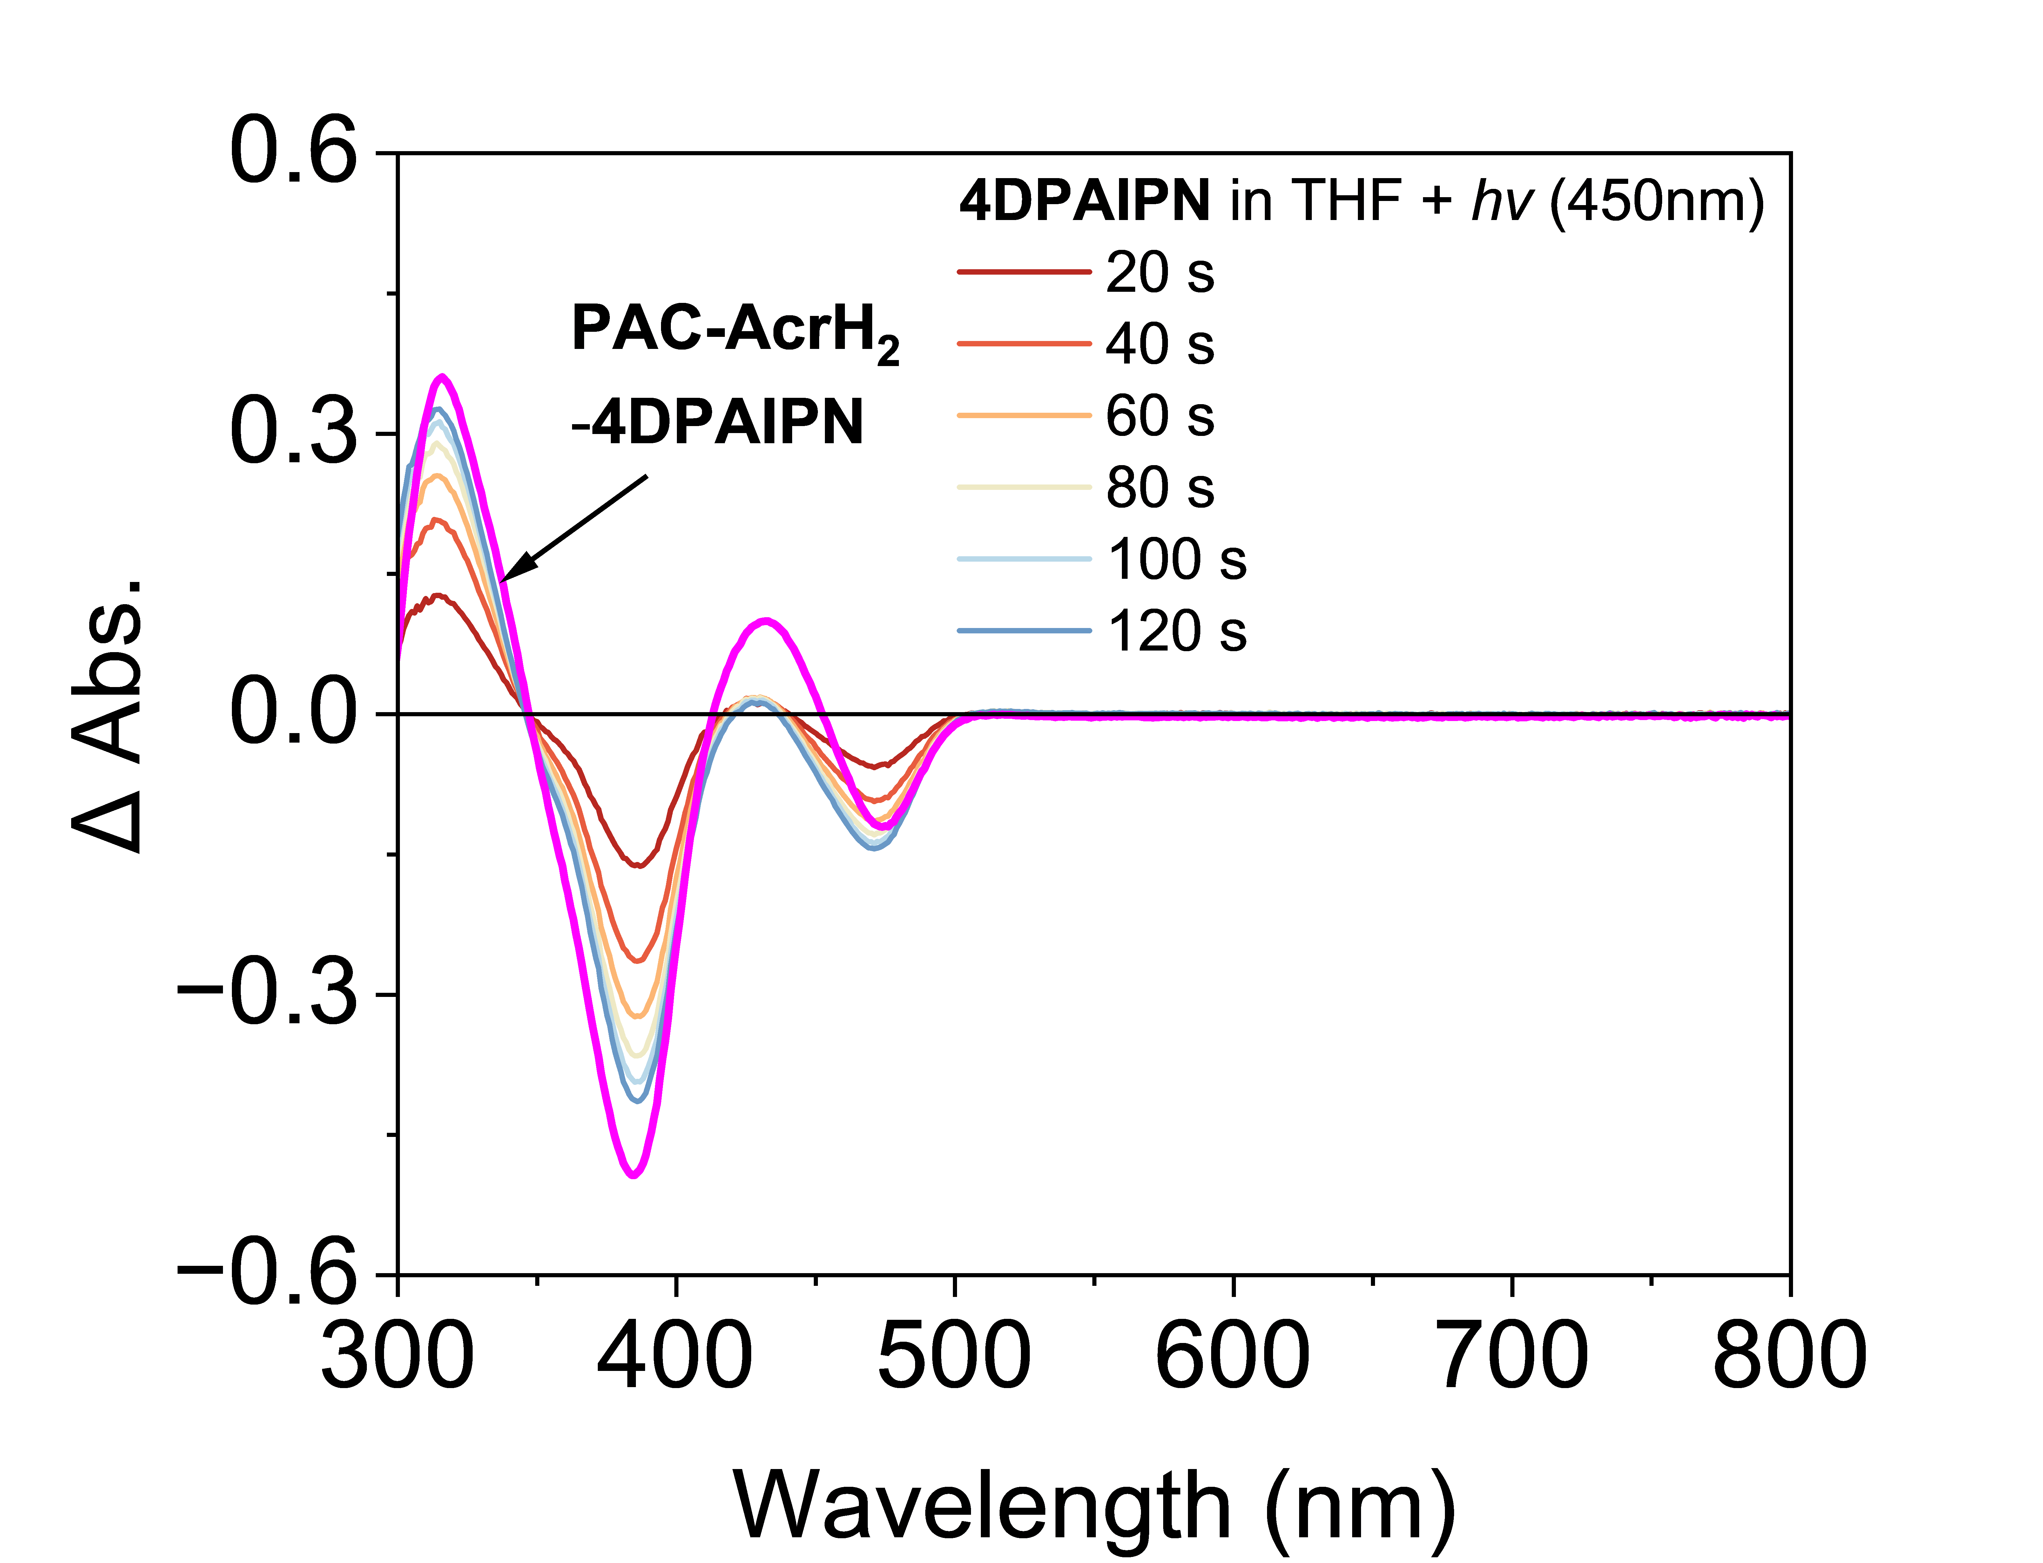
Figure S6. The UV-vis difference absorption spectra of 4DPAIPN in THF under 450 nm laser irradiation in an inert atmosphere. The pink line is the absorption spectrum difference between PAC-AcrH₂ and 4DPAIPN.
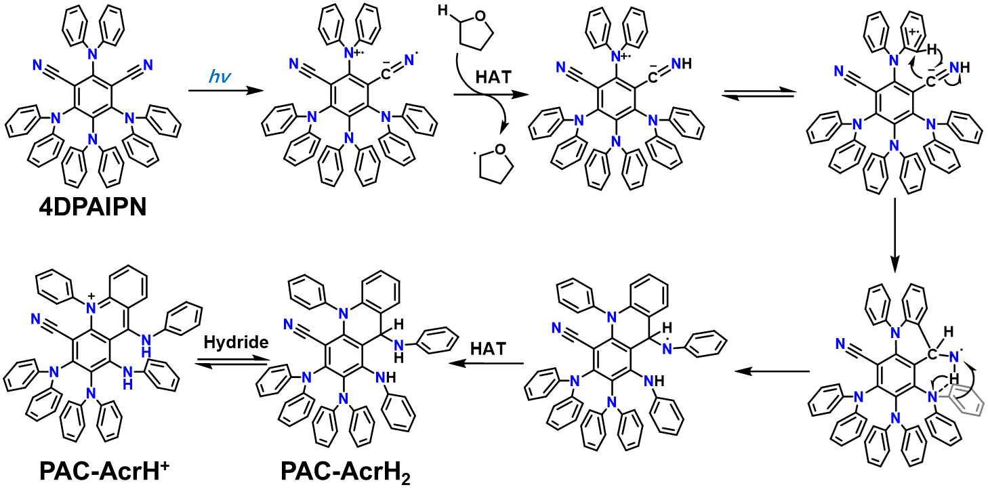
Figure S7. Proposed mechanism for the photo-driven conversion of 4DPAIPN to PAC-AcrH₂ in THF solutions.
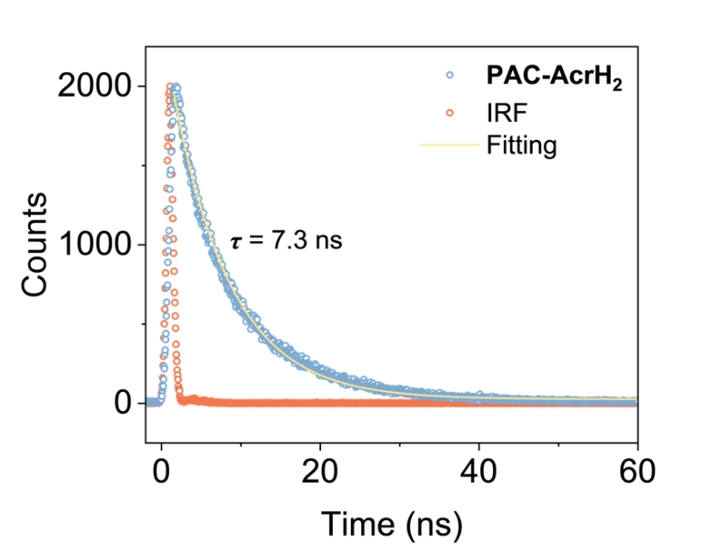
Figure S8. Time-resolved photoluminescence decay of PAC-AcrH₂ in THF solution. λ_{ex} = 440 nm, λ_{em} = 580 nm. Overlaid in yellow is the fitting curve with single exponential decay.
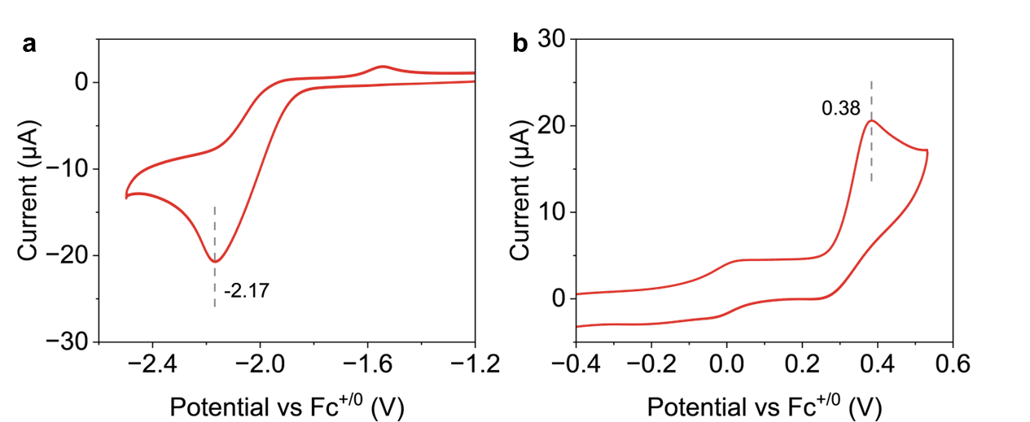
Figure S9. Cyclic voltammetry of PAC-AcrH₂ in 0.1 M TBAClO₄ / THF, scan rate 100 mV/s.

Table S1. Photophysical properties of 4DPAIPN and PAC-AcrH₂
PC | λ (abs) / nm | λ (em) / nm | τ / ns | / V  $$E_{}^{red}$$ | / V  $$E_{}^{ox}$$ | / V  $$E_{0,0}^{S_{1}}$$ | / V  $$E_{red}^{S_{1}}$$ | / V  $$E_{ox}^{S_{1}}$$
4DPAIPN | 467 | 517 | 2.2 | -2.07 | 0.58 | 2.57 | 0.50 | -1.99
PAC-AcrH₂ | 424 | 526 | 7.3 | -2.17 | 0.38 | 2.65 | 0.48 | -2.27

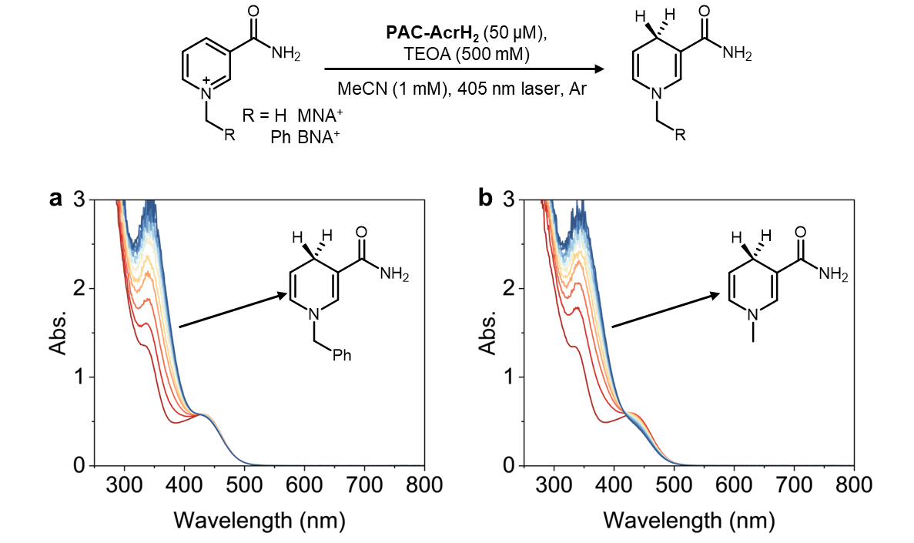
Figure S10. Photocatalytic hydride transfer of (a) BNA⁺ and (b) MNA⁺ monitored by UV-vis absorption spectra.

Synthesis and characterization of molybdenum nitride complexes
The MoI₃(PCP) and PCP-MoN were synthesized according to the previous reports without modification⁴⁻⁵.
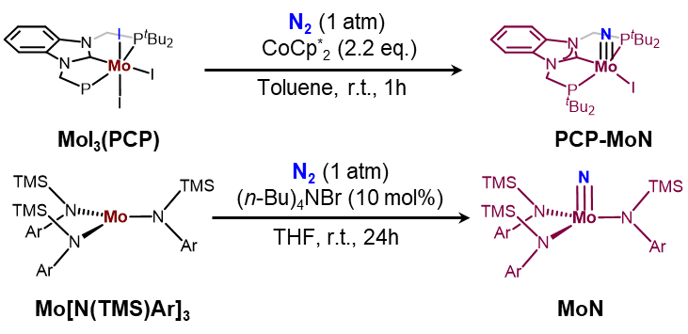
Figure S11. ¹H-NMR spectra of PCP-MoN in THF-d₈.
Figure S12. ³¹P-NMR spectra of PCP-MoN in THF-d₈.
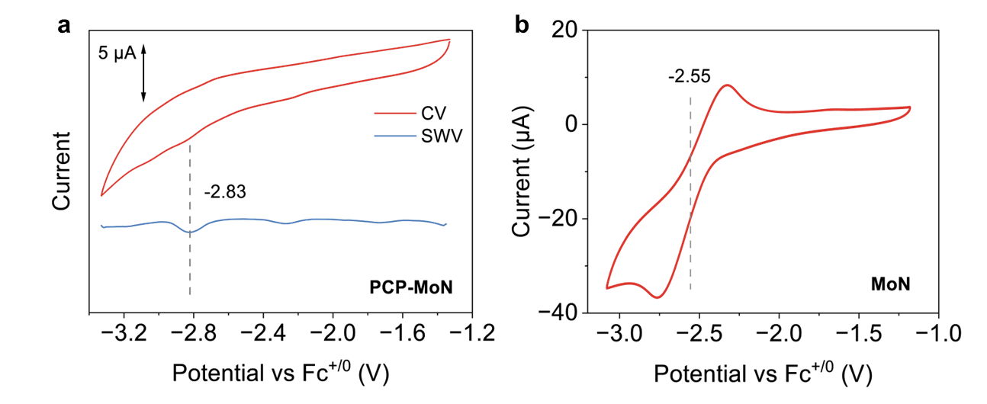
Figure S13. Cyclic voltammetry and square wave voltammetry of PCP-MoN and MoN in 0.1 M TBAClO₄ / THF, scan rate 100 mV/s.
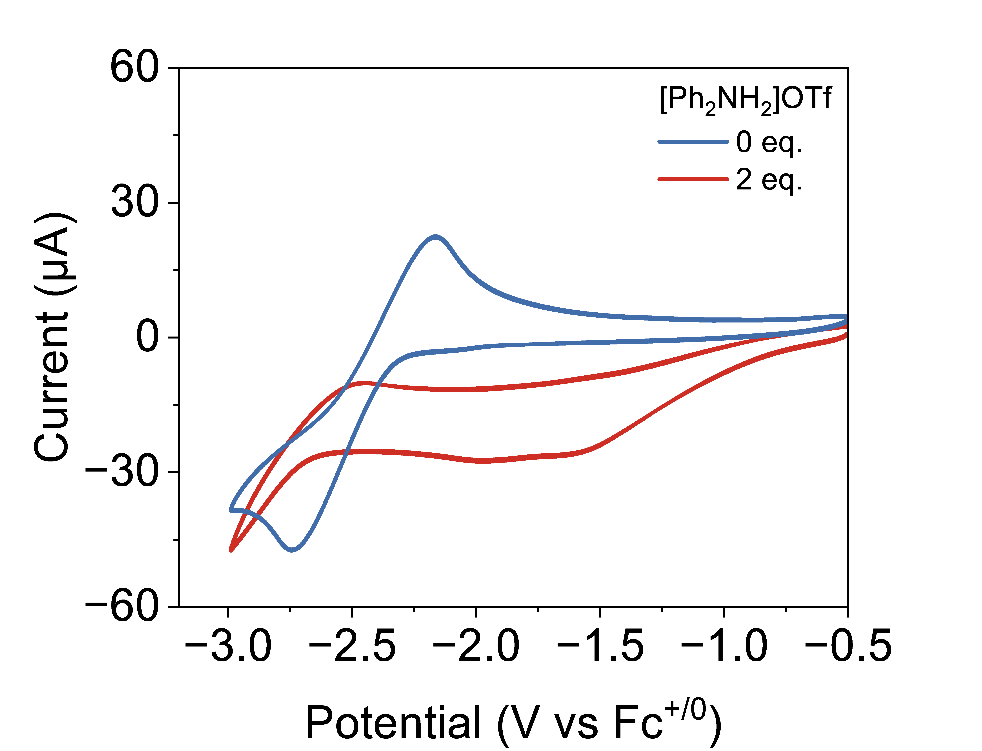
Figure S14. Cyclic voltammetry of MoN in the absence and presence of [Ph₂NH₂]OTf in 0.1 M TBAClO₄ / THF, scan rate 100 mV/s.
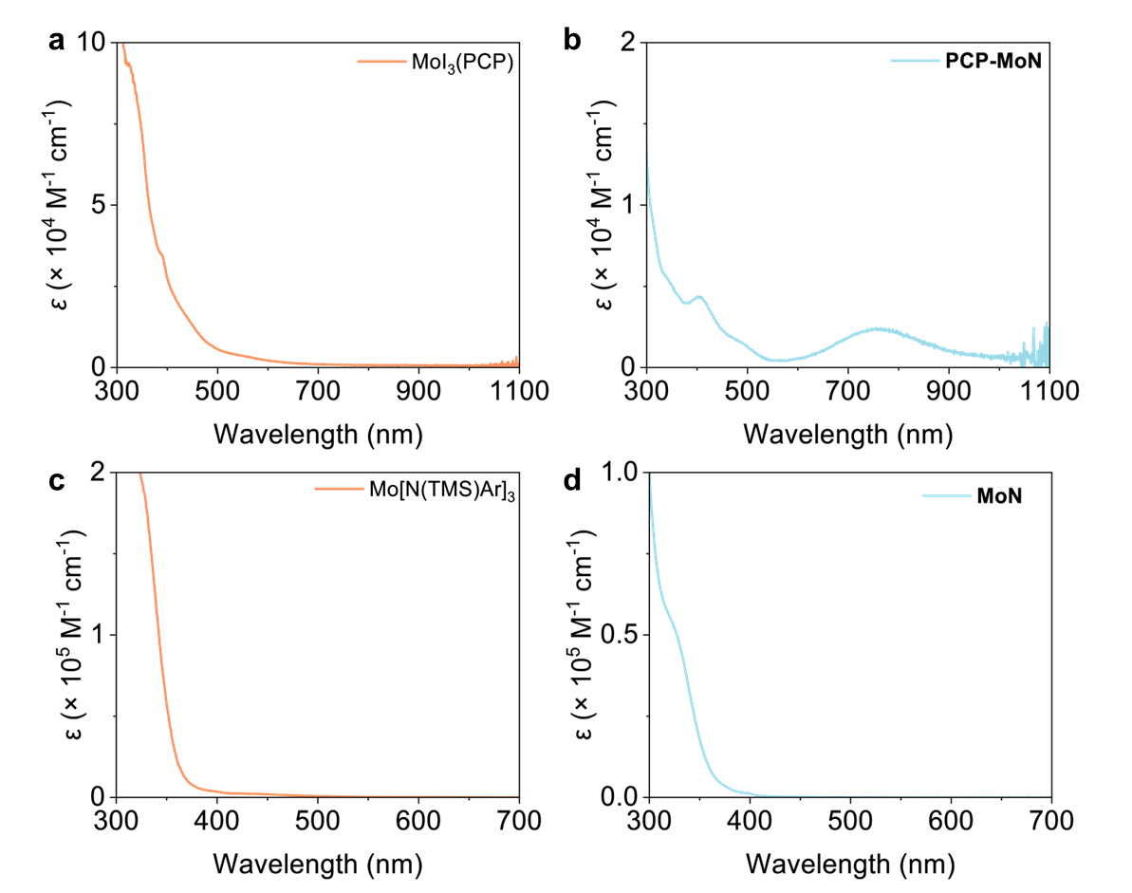

Figure S15. UV-vis absorption spectra of (a) MoI₃(PCP), (b) PCP-MoN, (c) Mo[N(TMS)Ar]₃ and (d) MoN in THF.

The interaction between PAC-AcrH₂ and MoN complex
The Job plot analysis was performed to investigate the possible binding mode between PAC-AcrH₂ and MoNH⁺. Different concentration ratios of PAC-AcrH₂ and MoNH⁺ were added in THF solution under an inert atmosphere. The total concentration of PAC-AcrH₂ and MoNH⁺ was kept at 50 μM. The absorbance change in the 520 nm was recorded
As the fraction of MoNH⁺ increased, the absorption at the indicated wavelength initially increased and gradually decreased with a maximum around the ratio of 0.5. 1 to 1 binding mode is the most likely scenario. Based on this model, the change of absorbance at indicated wavelength upon the ratio of PAC-AcrH₂ and MoNH⁺ was fitted to the following equation⁶. c and K_{eq} represent the adjustable parameters, and X_{A} represents the ratio of reduced PC and OS.
$$∆A=\frac{1+cK_{eq}-\sqrt{1+2cK_{eq}+{\left[cK_{eq}\left(1-2X_{A}\right)\right]}^{2}}}{2K_{eq}}$$
Based on the 1:1 binding mode, the binding constant K_{a} was obtained by UV-vis absorption spectra. By fitting the change of the representative absorbance upon the titration of MoNH⁺, K_{a} was calculated by a modified Benisi−Hildebrand analysis based on the equation below. The R₀ represents the concentration of PAC-AcrH₂ (50 μM), X₀ represents the concentration of MoNH⁺.
$$∆A=\frac{∆ε}{2}\left(R_{0}+X_{0}+\frac{1}{K_{a}}\right)-∆ε*\sqrt{{\left[\frac{1}{2}\left(R_{0}+X_{0}+\frac{1}{K_{a}}\right)\right]}^{2}-R_{0}X_{0}}$$

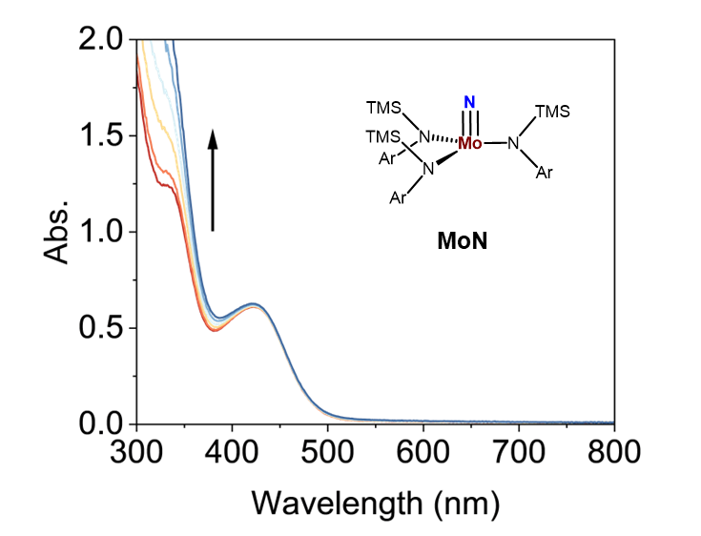
Figure S16. UV-vis absorption spectral change of PAC-AcrH₂ (40 μM) in THF upon the titration of MoN in an inert atmosphere.
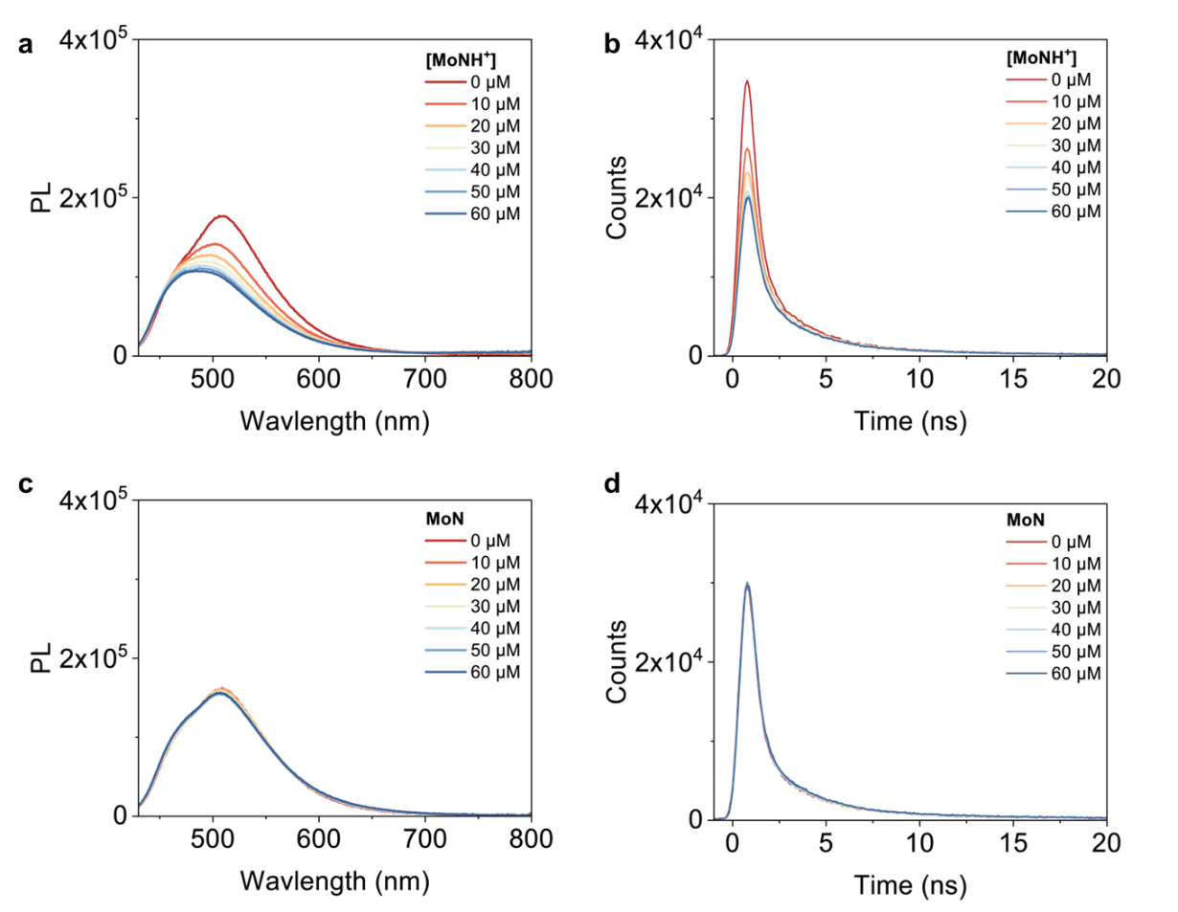
Figure S17. Photoluminescence intensity (a) and kinetic decay (b) change of PAC-AcrH₂ (40 μM) in THF upon the titration of MoNH⁺ under an inert atmosphere. Photoluminescence intensity (c) and kinetic decay (d) change of PAC-AcrH₂ (40 μM) in THF upon the titration of MoN under an inert atmosphere.

Femtosecond transient absorption spectroscopy
Femtosecond transient absorption spectra were collected on a commercial spectrometer (Helios fire, Ultrafast System) with two laser systems. One of the laser systems including the fundamental beam was generated by the femtosecond Ti:sapphire laser system (Astrella, 800 nm, 100 fs, 7 mJ/pulse, and 1 kHz repetition rate, Coherent Inc.) and was split into two beams. One of them was converted to the continuum white light probe by focusing onto a sapphire crystal, and the other one was used as the pump beam via an optical parametric amplifier (OPerA Solo, Coherent Inc.). The fundamental beam of another laser system was generated by the femtosecond Ti:sapphire laser system (HYPERION, 1035 nm, 190 fs, 1 mJ/pulse, and 2 kHz repetition rate, Ultrafast System), with an optical parametric amplifier (APOLLO-Y, Ultrafast System) to generate the pump laser. The instrument response function was determined to be ∼120 fs. The excitation wavelength was set to 420 and 520 nm. The experiment was performed at room temperature. The absorbance of the solution sample was adjusted to ~0.8 at 420/520 nm in a sealed silica cuvette (optical path length: 1mm) in the N₂ glovebox before the experiment. All data were analyzed using a global fit procedure by TAPAS software⁷. A sequential decay kinetic model was used to obtain the evolution-associated spectra.
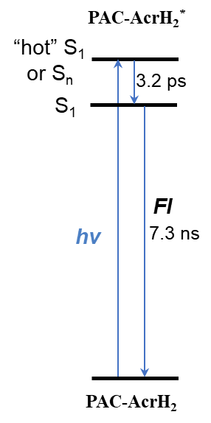
Figure S18. Kinetic diagram of PAC-AcrH₂ after excitation based on transient absorption and photoluminescence data.

PAC-AcrH₂ + MoN
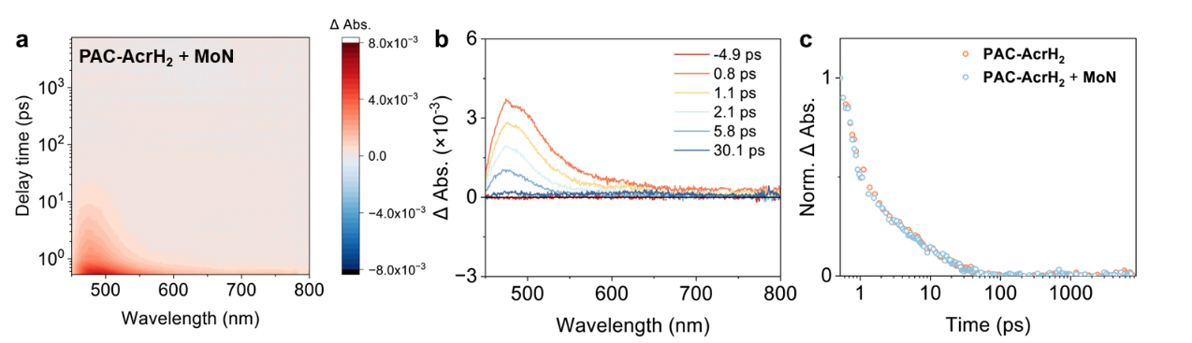
Figure S19. Femtosecond transient absorption difference spectra of (a) PAC-AcrH₂ (500 μM) + MoN (500 μM) in THF solution (b) at indicated time delay after 420 nm pulsed laser excitation. (c) Normalized absorbance changes of PAC-AcrH₂ and PAC-AcrH₂ + MoN monitored at 480 nm after 420 nm pulsed laser excitation.
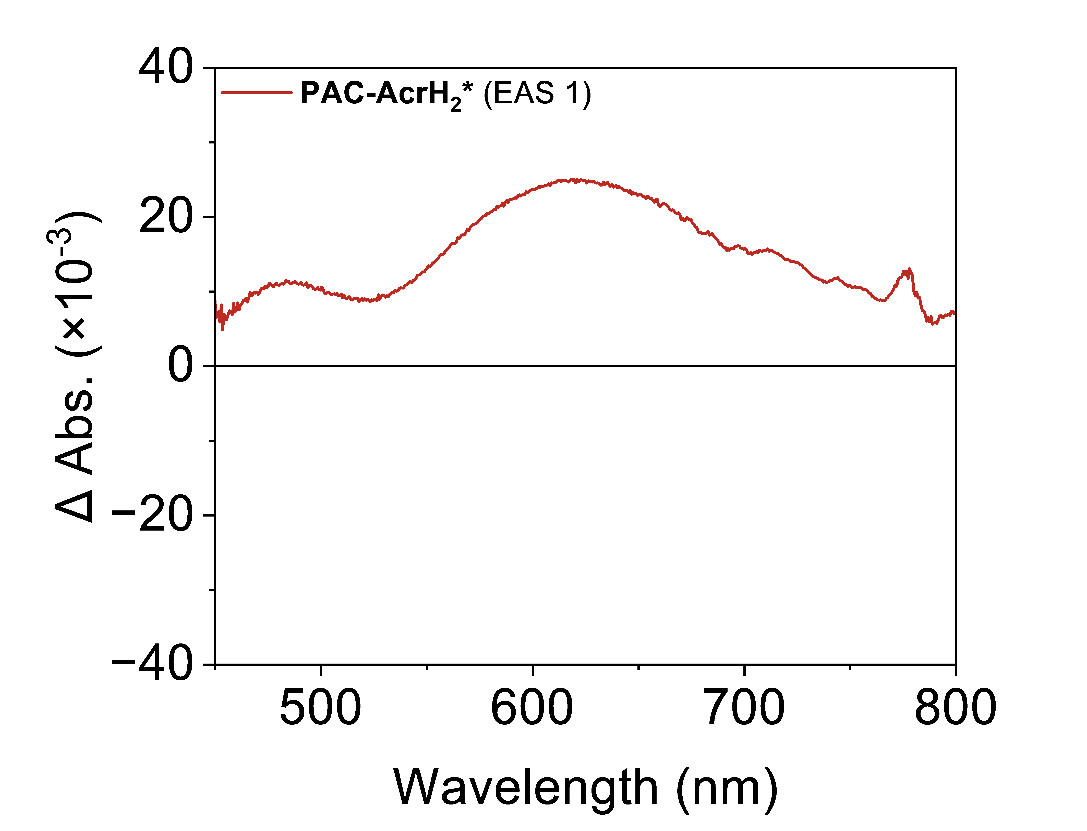
Figure S20. The EAS1 derived from global analysis of the femtosecond transient absorption difference spectra of [PAC-AcrH₂⋯MoNH⁺].

Comment: The EAS1 represents the Frank-Condon excited state of [PAC-AcrH₂⋯MoNH⁺] upon 420nm excitation, with the characteristic absorption peak of PAC-AcrH₂* (470 nm) and PAC-AcrH₂^{·+} (630 nm), indicating the mixed local-excitation and charge-transfer character of the Frank-Condon excited state.

Kinetic isotope effect
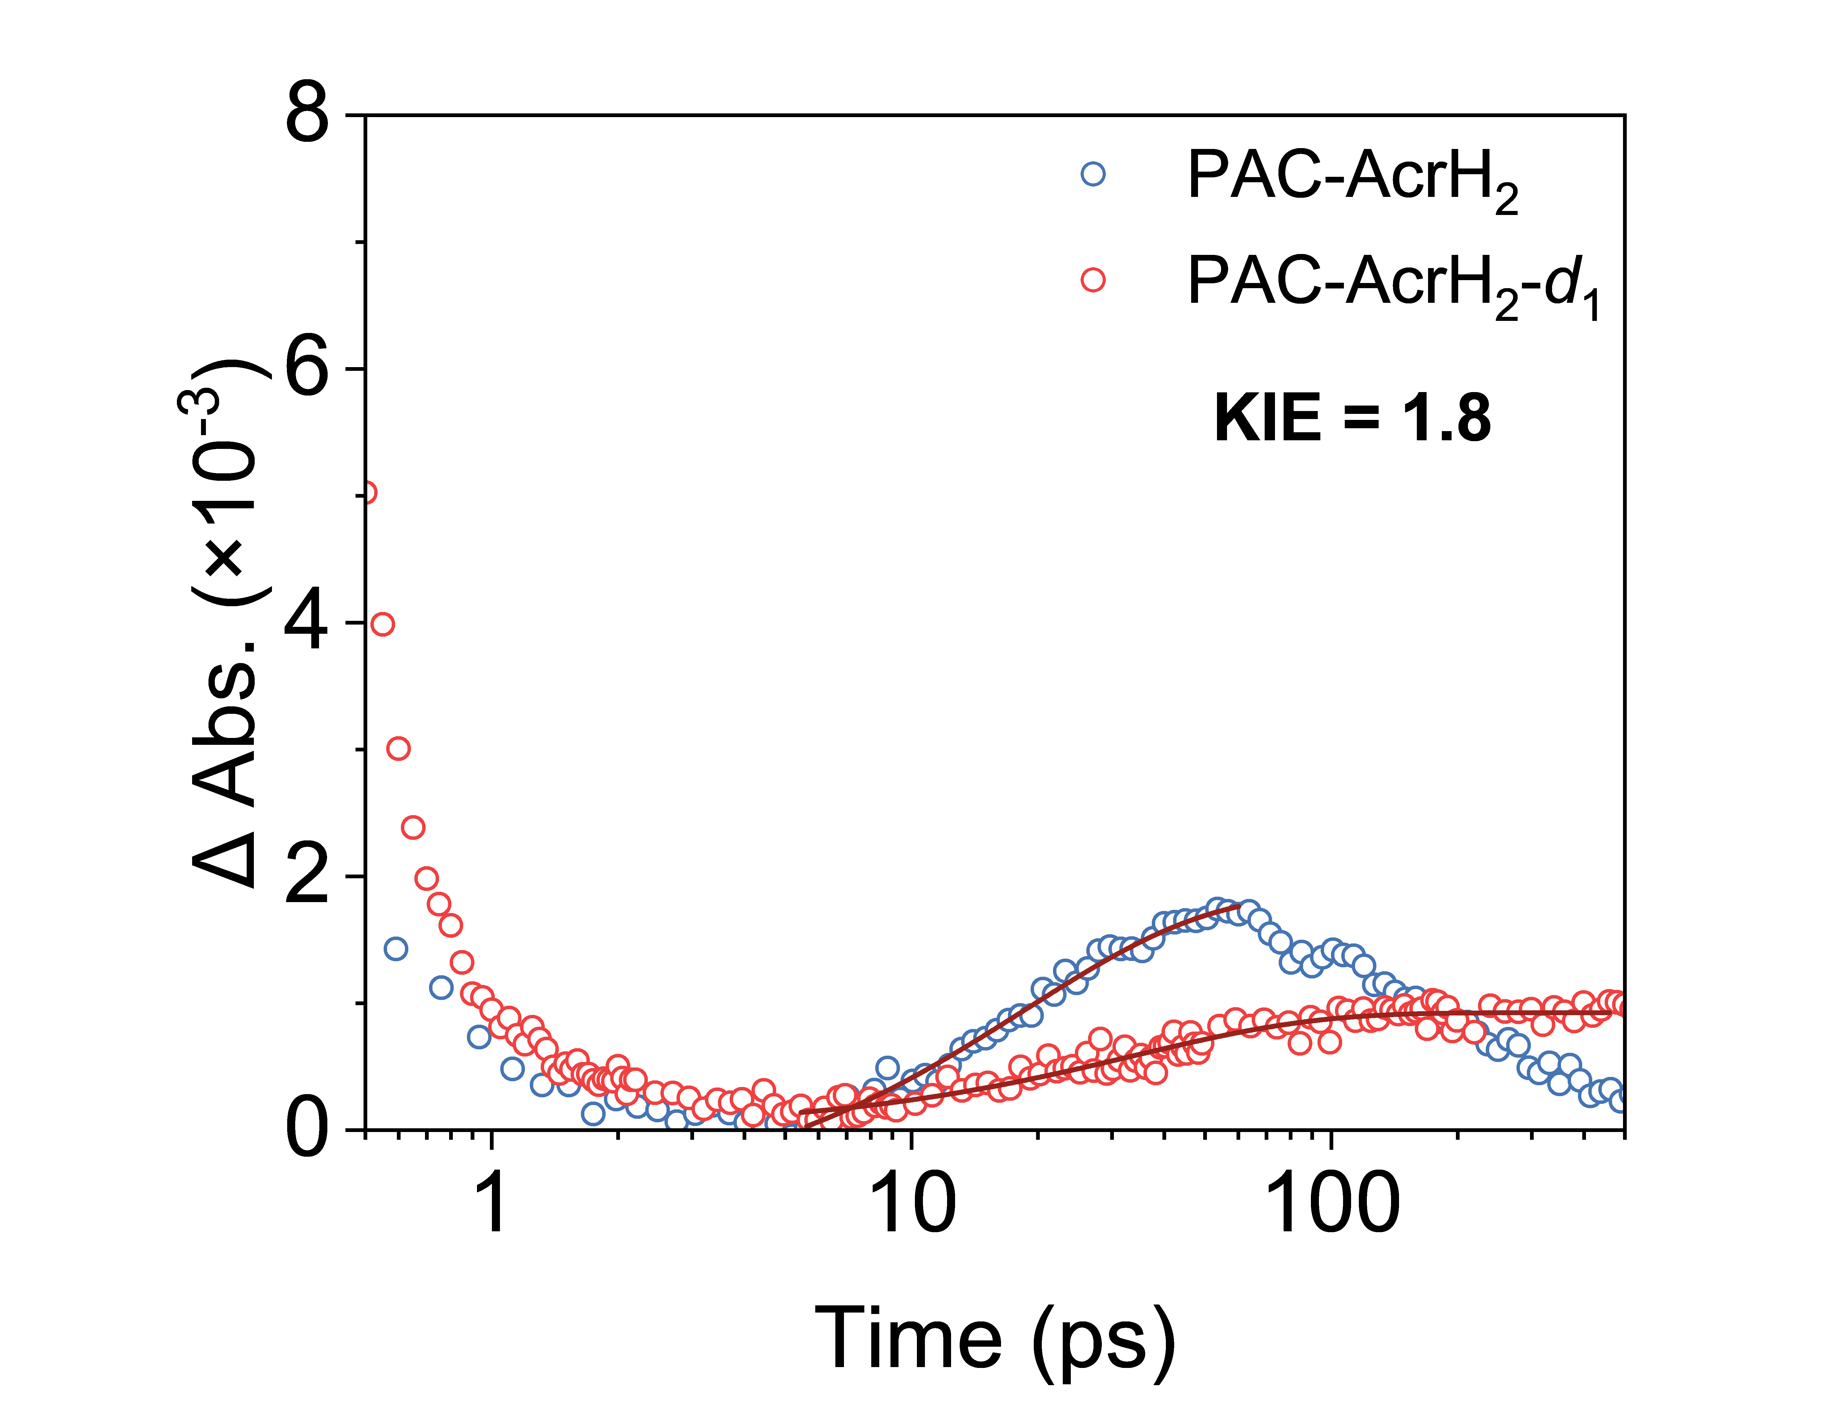
Figure S21. Absorbance changes of [PAC-AcrH₂⋯MoNH⁺] and [PAC-AcrH₂-d₁⋯MoNH⁺] monitored at 520 nm after 420 nm pulsed laser excitation. The delta absorbance data in the rising phase were fitted using a single-exponential kinetic model.

PAC-AcrH₂ + MoNH⁺ (520 nm pump)
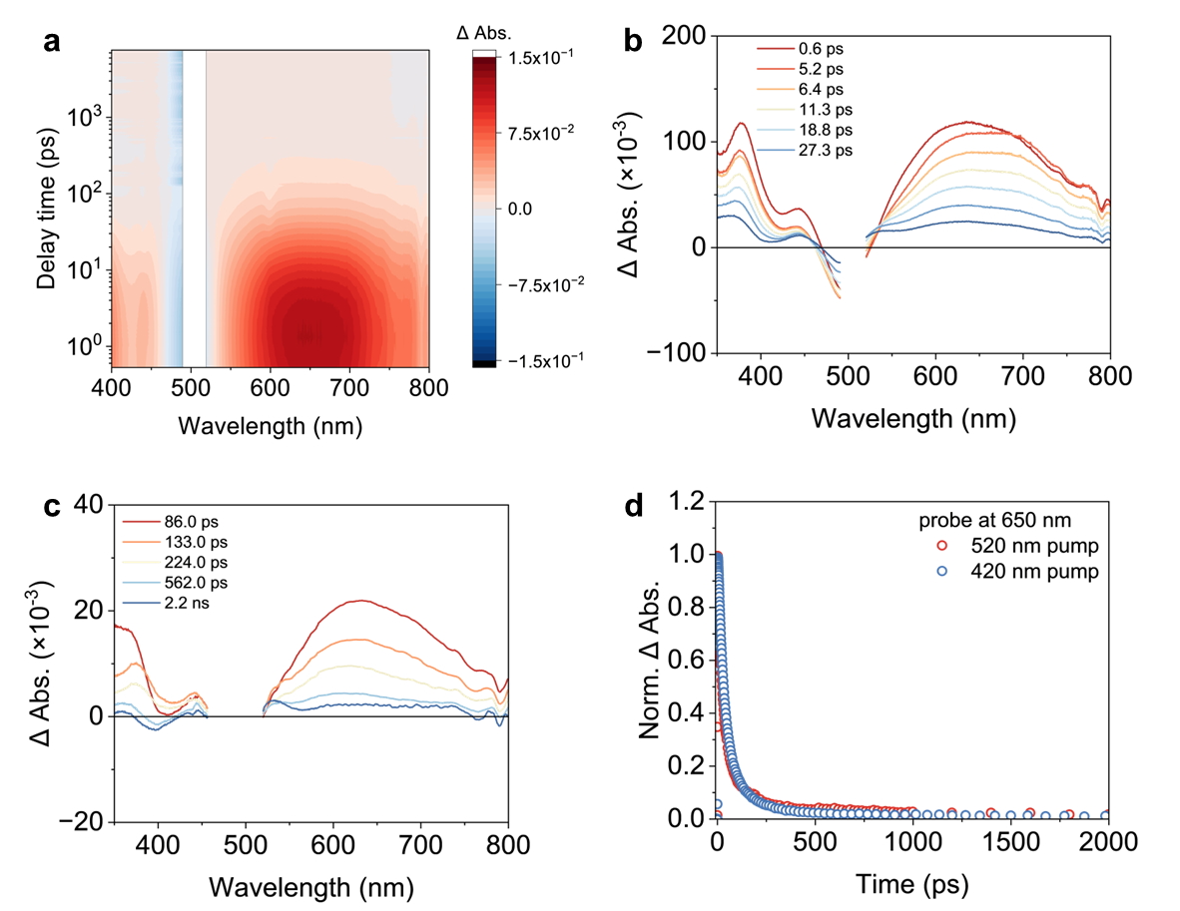 Figure S22. Femtosecond transient absorption difference spectra of (a) [PAC-AcrH₂⋯MoNH⁺] (500 μM) in THF solution (b) (c) at indicated time delays after 520 nm pulsed laser excitation. (c) Normalized absorbance changes of [PAC-AcrH₂⋯MoNH⁺] monitored at 650 nm after 420 nm / 520 nm pulsed laser excitation.

PAC-AcrH₂ + QH⁺
The fs-TA spectra of [PAC-AcrH₂⋯QH⁺] CT complex show similar decay mode following the ultrafast hydride transfer mechanism. The global analysis also resolves four different components, clearly showing the stepwise electron-proton-electron transfer in this CT complex, with a faster second electron transfer rate (τ = 120.6 ps) compared to [PAC-AcrH₂⋯MoNH⁺].
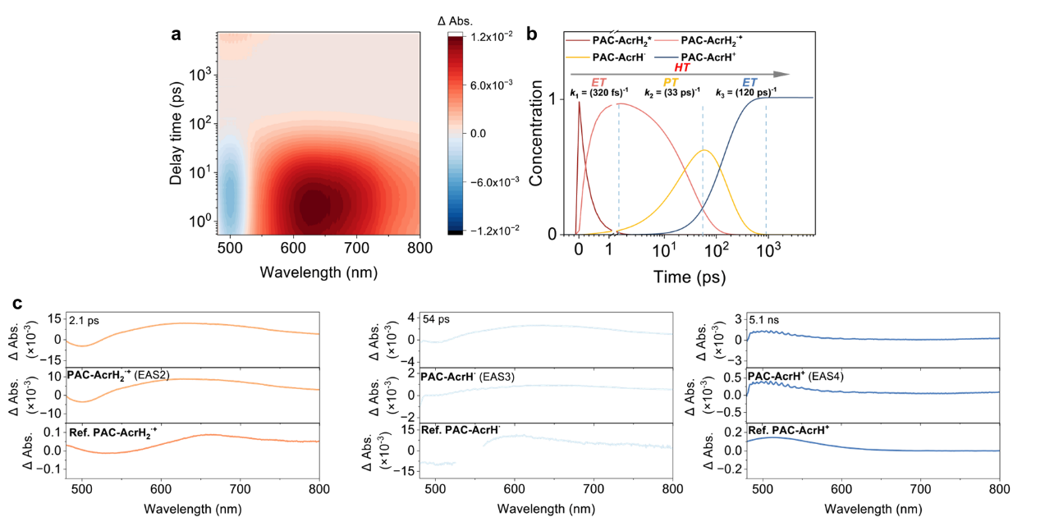
Figure S23. Absorption difference spectra of (a) PAC-AcrH₂ (500 μM) + QH⁺ (500 μM) in THF solution after 420 nm pulsed laser excitation. (b) Population dynamics of the respective states based on a sequential kinetic model. (c) Top panels: The transient absorption spectra of [PAC-AcrH₂⋯QH⁺] at indicated time delays; Middle panels: The evolution-associated spectra derived from global analysis of (a); Bottom panels: The obtained reference spectra of PAC-AcrH₂^{·+}, PAC-AcrH· and PAC-AcrH⁺.

Reference spectra of PAC-AcrH₂^{·+}, PAC-AcrH· and PAC-AcrH⁺.
PAC-AcrH₂^{·+}
According to the previous report about the radical cation of dihydroacridine derivatives⁸⁻⁹, the reference spectra of PAC-AcrH₂^{·+} was obtained by chemical oxidation of PAC-AcrH₂ in the acid solution, monitored by UV-vis absorption spectroscopy. The characteristic absorbance of PAC-AcrH₂^{·+} at 650 nm is consistent with the literature⁸⁻⁹.
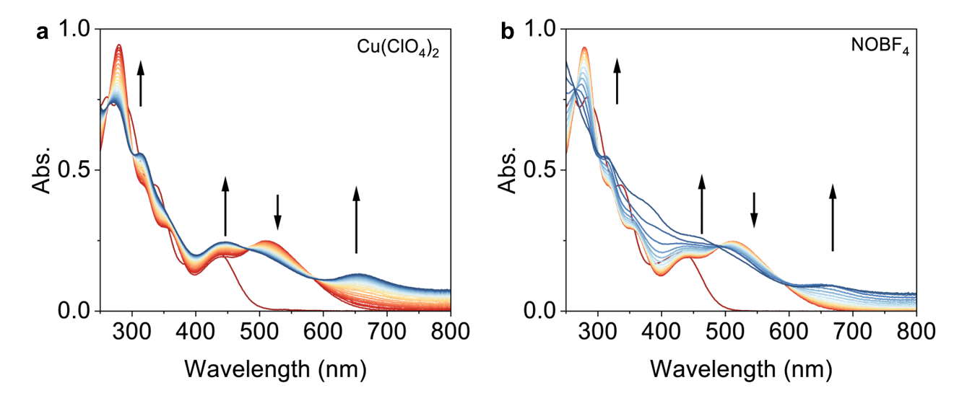
Figure S24. Absorption spectral changes of PAC-AcrH₂ (20 μM) upon the titration of Cu(ClO₄)₂ (400 μM) or NOBF₄ (70 μM) in MeCN solution in the presence of HClO₄ (50 mM) under an inert atmosphere.

PAC-AcrH·
The reference spectra of PAC-AcrH· was generated by Eosin Y (EY)-mediated photoinduced hydrogen atom transfer (HAT)¹⁰, monitored by nanosecond transient absorption spectroscopy (ns-TA).
A TSP-2000 (Unisoku) laser flash photolysis system was used to record nanosecond transient absorption spectra. This experiment utilized a Q-switched frequency-doubled Nd:YAG laser (Quantel Q-Smart 450, 10 Hz) equipped with an OPO (MagicPRISM VIS, OPOtek) as the excitation light source, emitting laser pulses tuned at 532 nm (full width at half maximum of 5-8 nm, energy density of 10 mJ/cm² per pulse). A 75 W xenon lamp was employed as the detection beam, focused onto the sample in a 10 mm cuvette. The detection beam was aligned perpendicular to the excitation laser pulses and directed into an ICCD detector (Andor iStar 320T) for full spectra collection. All sample solutions were purged with N₂/Ar for 15 min before transient absorption experiments.
To obtain the difference absorption spectra between PAC-AcrH₂ and PAC-AcrH·, the difference absorption spectra between EYH· and EY was first estimated. The hydroquinone (HQ) was selected as the hydrogen atom donor to quench the excited state of EY (EY*). Considering the negligible signal of HQ and Q· in the visible region and the slow charge recombination between EYH· and Q·, the EYH· could be obtained by monitoring the ns-TA spectra in the visible region of EY upon excitation in the presence of HQ after 5 μs time delay, to preclude the influence of EY* signal. In the presence of PAC-AcrH₂ as the hydrogen atom donor, the reference spectra of PAC-AcrH· could be obtained by subtracting the spectra of EYH· in the ns-TA spectra in the visible region of EY upon excitation.
EY + hv → EY* (1)
EY* + PAC-AcrH₂ → EYH· + PAC-AcrH·· (2)
EY* + HQ → EYH· + Q· (3)
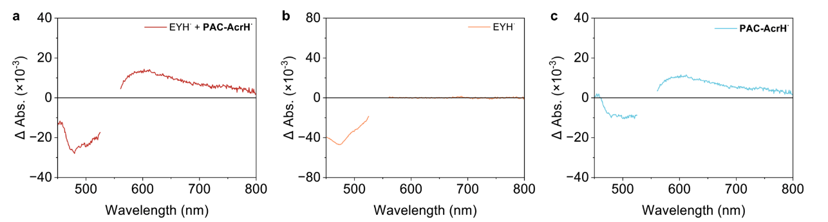
Figure S25. Nanosecond transient absorption difference spectra of (a) EY (800 μM) + PAC-AcrH₂ (50 μM) at 5 μs time delay and (b) EY (800 μM) + HQ (200 μM) at 0.4 μs time delay in MeCN solution after 520 nm pulsed laser excitation under an inert atmosphere. (c) The reference difference spectra of PAC-AcrH· derived from (a) and (b).

PAC-AcrH⁺
The reference spectra of PAC-AcrH⁺ was obtained by electrochemical oxidation of PAC-AcrH₂ in the THF, monitored by UV-vis absorption spectroscopy.
Spectroelectrochemistry was performed on a CHI 1232C electrochemical workstation and Agilent Cary 60 spectrometer. PAC-AcrH₂ in N₂-degassed MeCN with 0.1 M TBAClO₄ as the electrolyte. A typical three electrode cell was used with Pt mesh as the working electrode, Ag/AgCl as the reference electrode and Pt wire as the counter electrode. Spectra at specific potentials were recorded once the spectra after multiple scans stabilized.
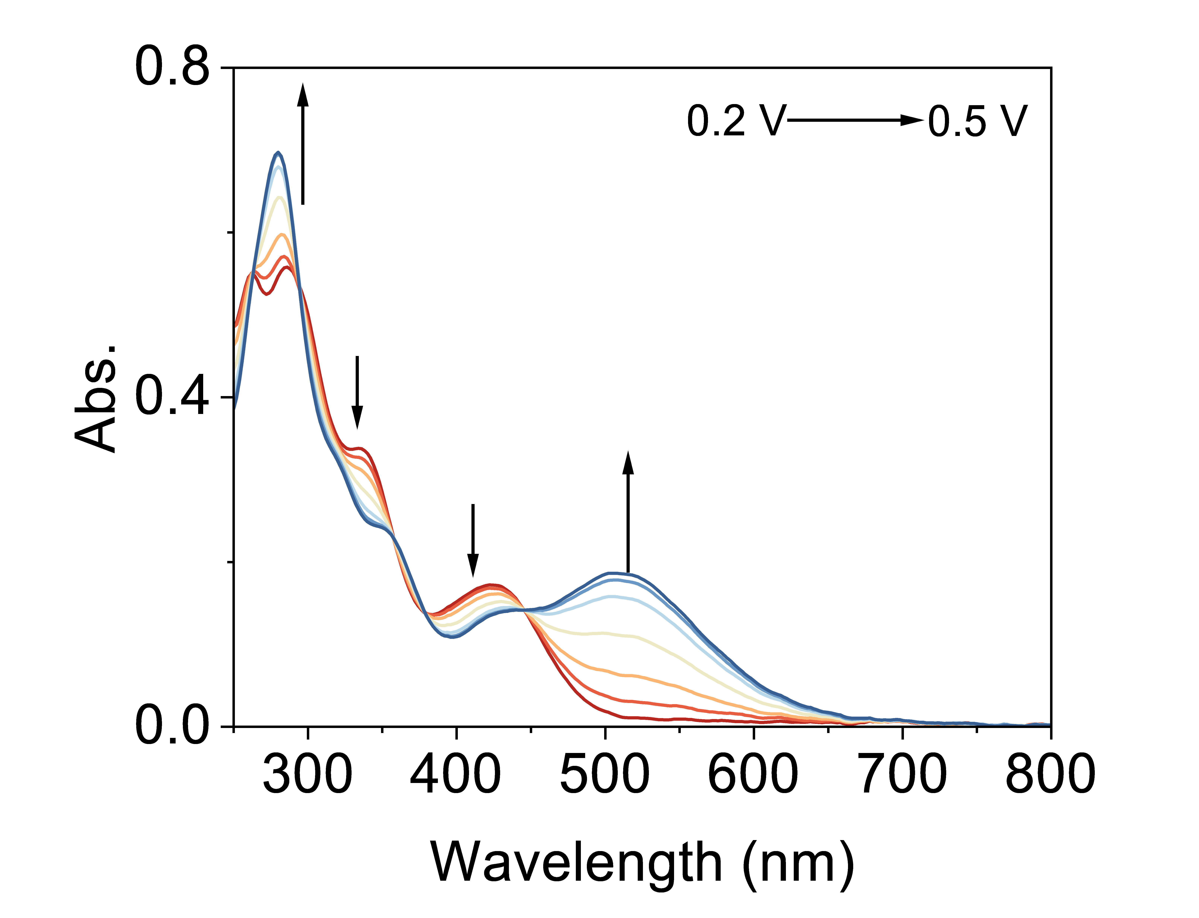
Figure S26. Spectroelectrochemistry oxidation of PAC-AcrH₂ in 0.1 M TBAClO₄ / THF. The applied potential was referenced to Fc^{+/0}.

Photocatalytic quinoline hydrogenation
Preparation of QH⁺
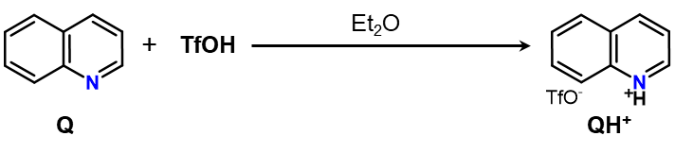
The quinoline Q (1.29 g, 10.0 mmol) was dissolved in 10 mL Et₂O. 2.3 equivalents of trifluoromethanesulfonic acid (3.4 g) were slowly added to the quinoline solution at 0℃ (ice bath). After stirring for 5 min, the white solid formed was filtered and washed with Et₂O (10 mL), then dried under vacuum to afford the corresponding quinoline triflate salt (QH⁺).
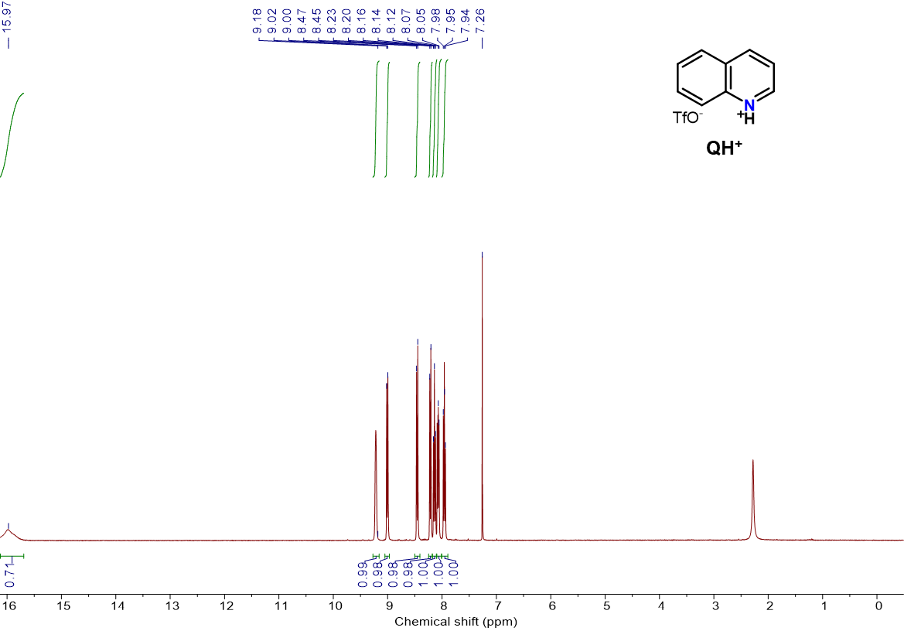
Figure S27. ¹H-NMR spectra of QH⁺ in CDCl₃-d₁.
Figure S28. ¹³C-NMR spectra of QH⁺ in CDCl₃-d₁.
Figure S29. ¹⁹F-NMR spectra of QH⁺ in CDCl₃-d₁.

Ground-state interaction between quinoline and PAC-AcrH₂
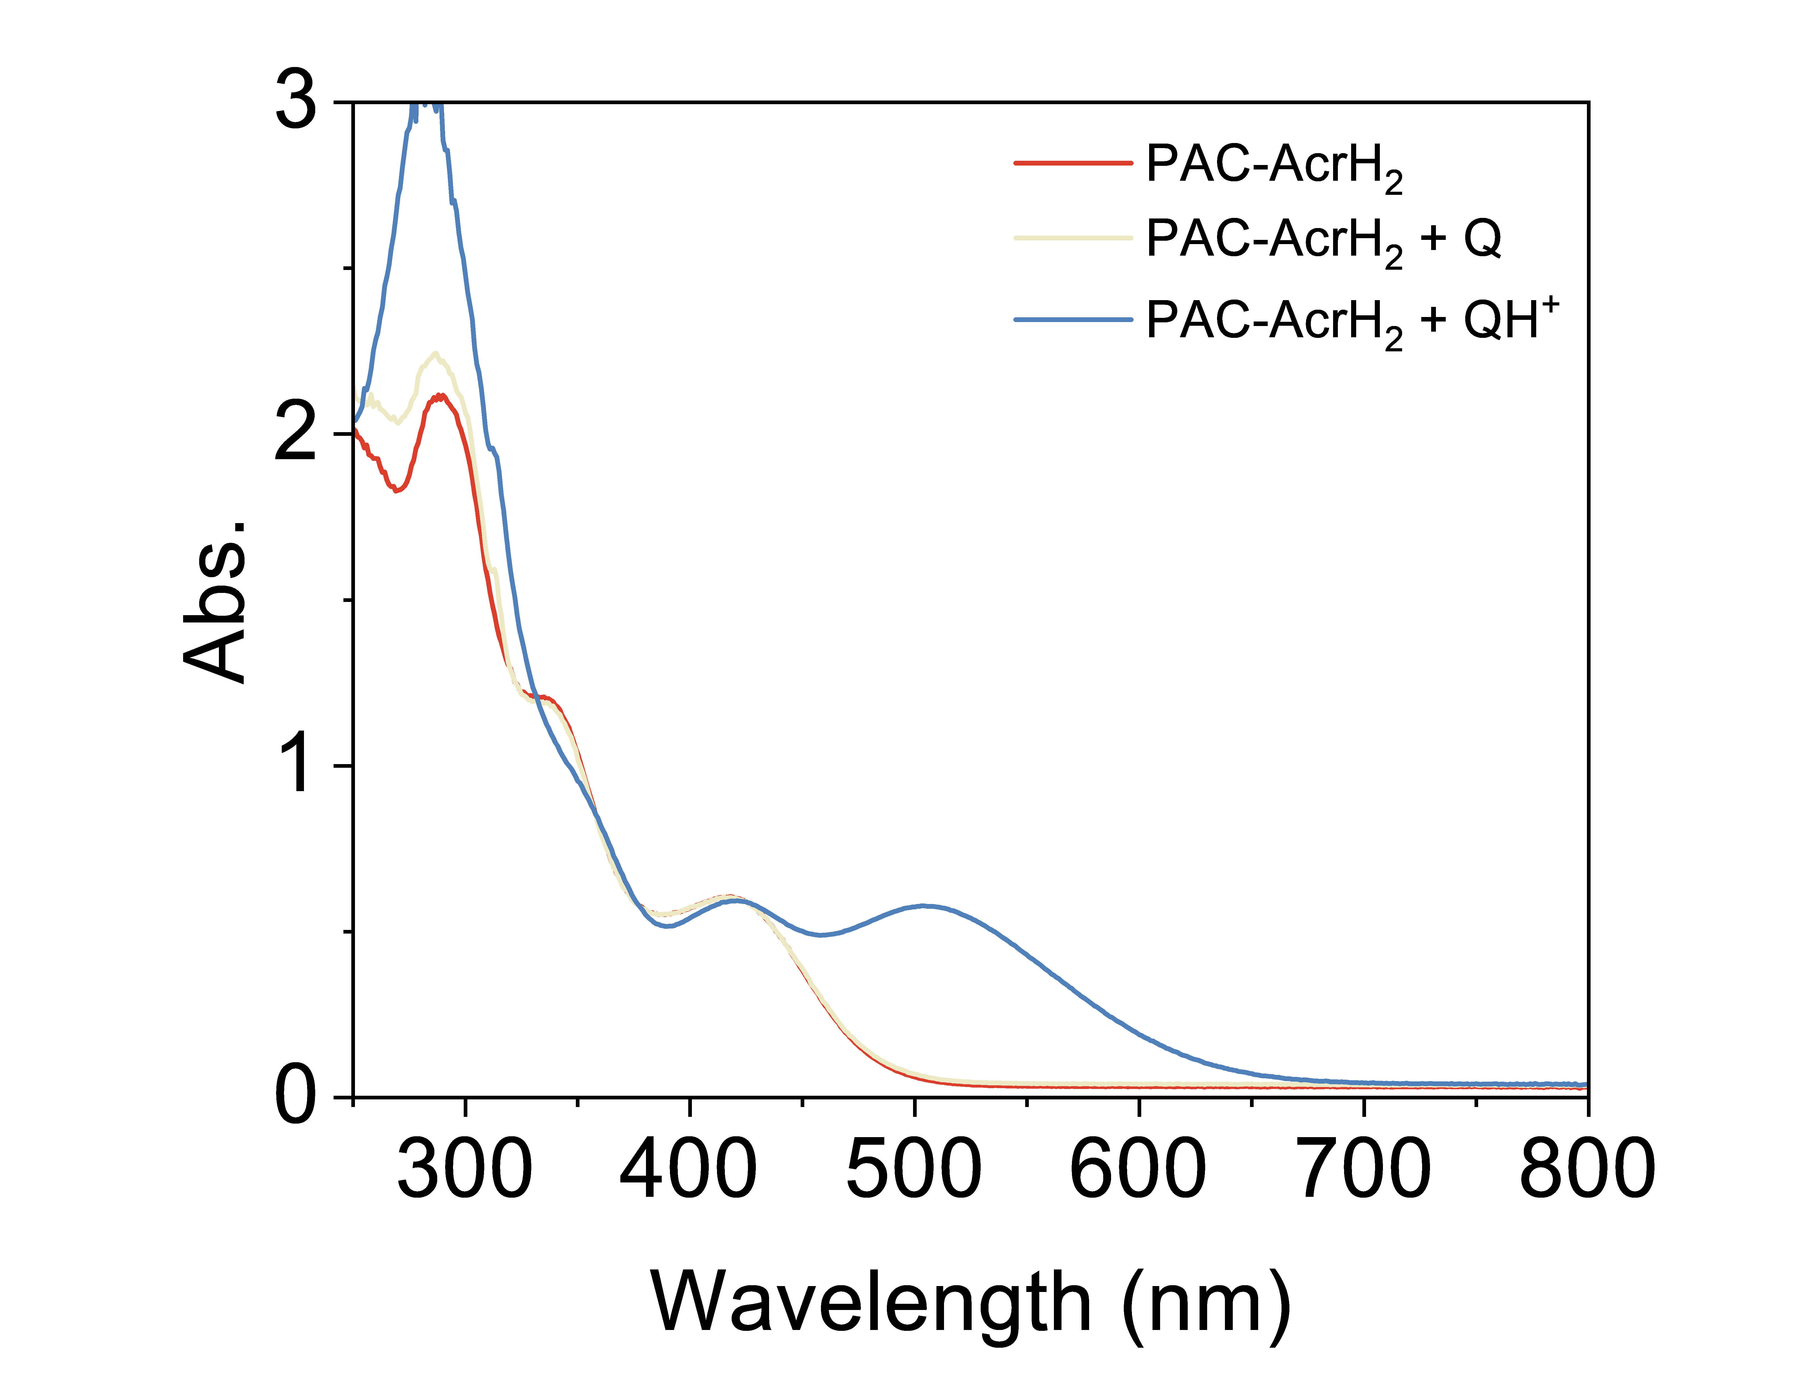
Figure S30. UV-vis absorption spectra of (a) PAC-AcrH₂ (50 μM), (b) PAC-AcrH₂ (50 μM) + Q (50 μM) and (c) PAC-AcrH₂ (50 μM) + QH⁺ (50 μM) in THF.

Photocatalytic hydrogenation of quinoline
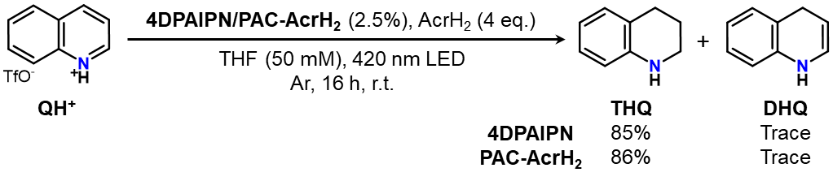
QH⁺ (0.2 mmol, 1 eq.), 4DPAIPN/PAC-AcrH₂ (5 μmol, 2.5 mol%), AcrH₂ (0.8 mmol, 4 eq.) and 4 mL of THF were added into a 20 mL gas-tight glass vial inside a N₂ glovebox. The photocatalytic quinoline reduction experiment was performed in a PerfectLight PCX-50C Discover multi-channel photocatalytic reactor, where the system was irradiated from the bottom with a blue LED (λ = 420 nm) for 16 hours. The reaction system was cooled by circulating water, maintaining the temperature at 25 °C. During the photocatalysis process, the reaction system was stirred using a polytetrafluoroethylene (PTFE) stir bar. After the irradiation, the solvent was removed in vacuo, then the crude residue was analyzed via ¹H NMR using dibromomethane as an internal standard.
The hydrogenation product 1,2,3,4-tetrahydroquinoline (THQ) was obtained in 85% yield, as determined by ¹H NMR, with negligible 1,4-dihydroquinoline. Hence, PAC-AcrH2 or its pre-catalyst 4DPAIPN could be a potent photohydride donor platform for the hydrogenation of inert unsaturated bonds by photoinduced ultrafast hydride transfer.
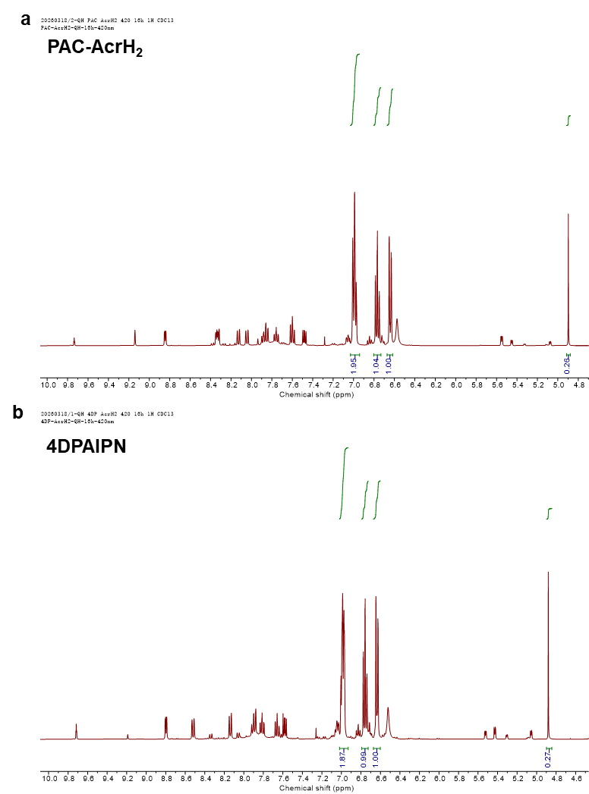
Figure S31. ¹H-NMR spectra of photocatalytic hydrogenation of QH⁺ by PAC-AcrH₂ or 4DPAIPN in CDCl₃-d₁.

Synthesis of PAC-AcrH₂-d₁
20 mg of PAC-AcrH₂ was dissolved in 5 mL CD₃CN-d₃/D₂O-d₂ (10:1 v:v) mixed solvent and stirred for 7 h. The deuteration of PAC-AcrH₂ was monitored by 1H NMR. The solvent was removed in vacuo to afford the PAC-AcrH₂-d₁.
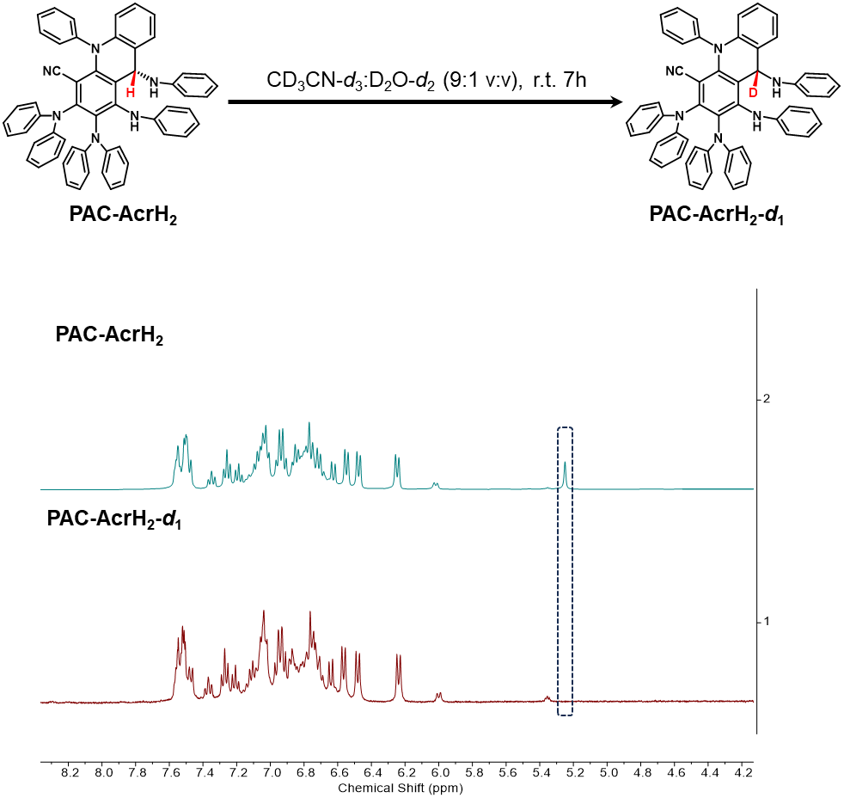
Figure S32. ¹H-NMR spectra of PAC-AcrH₂ and PAC-AcrH₂-d₁ in MeCN-d₃.

Photocatalytic NH₃ synthesis from N₂
In the typical photocatalytic N₂ reduction procedure: 2 μmol of photocatalyst, 1 μmol of molybdenum catalyst, 200 μmol of AcrH₂, and 3 mL of THF were added into a 40 mL gas-tight glass vial inside a N₂ glovebox, as shown in Figure S33. The photocatalytic N₂ reduction experiment was performed in a PerfectLight PCX-50C Discover multi-channel photocatalytic reactor, where the system was irradiated from the bottom with a white light LED for 12 hours. The reaction system was cooled by circulating water, maintaining the temperature at 25 °C. During the photocatalysis process, the reaction system was stirred using a polytetrafluoroethylene (PTFE) stir bar. The gases generated in the headspace were analyzed and quantified by gas chromatography (FULI GC9790PLUS).
After irradiation, 3 mL of HCl-Et₂O solution (2 M) was added to the system to adjust the pH to acidic. After rotary evaporation, 10 mL of deionized water was added, and the pH of the solution was adjusted to 10 with saturated NaOH solution. The mixture was filtered to obtain a clear and transparent solution, which was used for subsequent colorimetric detection.
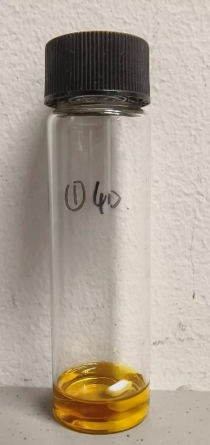
Figure S33. Picture of photocatalytic reaction vial.
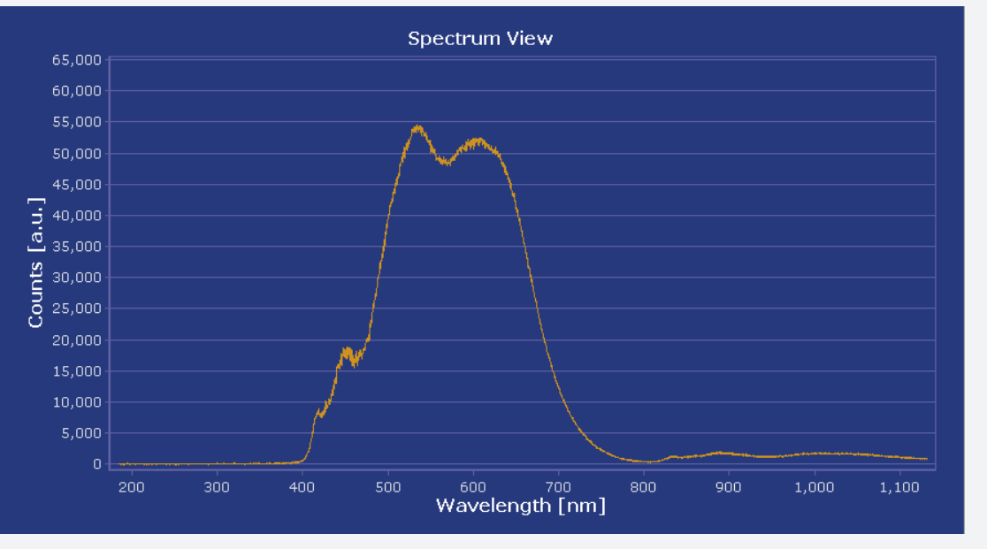
Figure S34. Spectral power distribution of white LED light source.

Detection of NH₃
The ammonia produced by photocatalytic dinitrogen reduction was detected by the standard indophenol blue colorimetric method. The reagents required for detection included: (A) Oxidizing solution: 0.75 M sodium hydroxide solution dissolved in sodium hypochlorite (effective chlorine content ρCl = 4~4.9); (B) Coloring solution: 0.4 M salicylic acid solution dissolved in 0.32 M sodium hydroxide; (C) Catalyst solution: 0.1 g of sodium nitroprusside dihydrate dissolved in 10 mL of deionized water. Standard aqueous ammonium chloride solutions: 30 μM, 60 μM, 90 μM, 120 μM, 150 μM, 180 μM.
The standard procedure was as follows: 50 μL of (A) oxidizing solution was added to 4 mL of the solution to be detected, followed by 500 μL of (B) coloring solution and 50 μL of (C) catalyst solution. The mixture was placed in the dark for 1 hour and analyzed using a UV-vis absorption spectrometer. A calibration curve was established using the absorbance of the standard solutions at 660 nm, to calculate the ammonia concentration of the samples. The sample was diluted to the required concentration before detection.
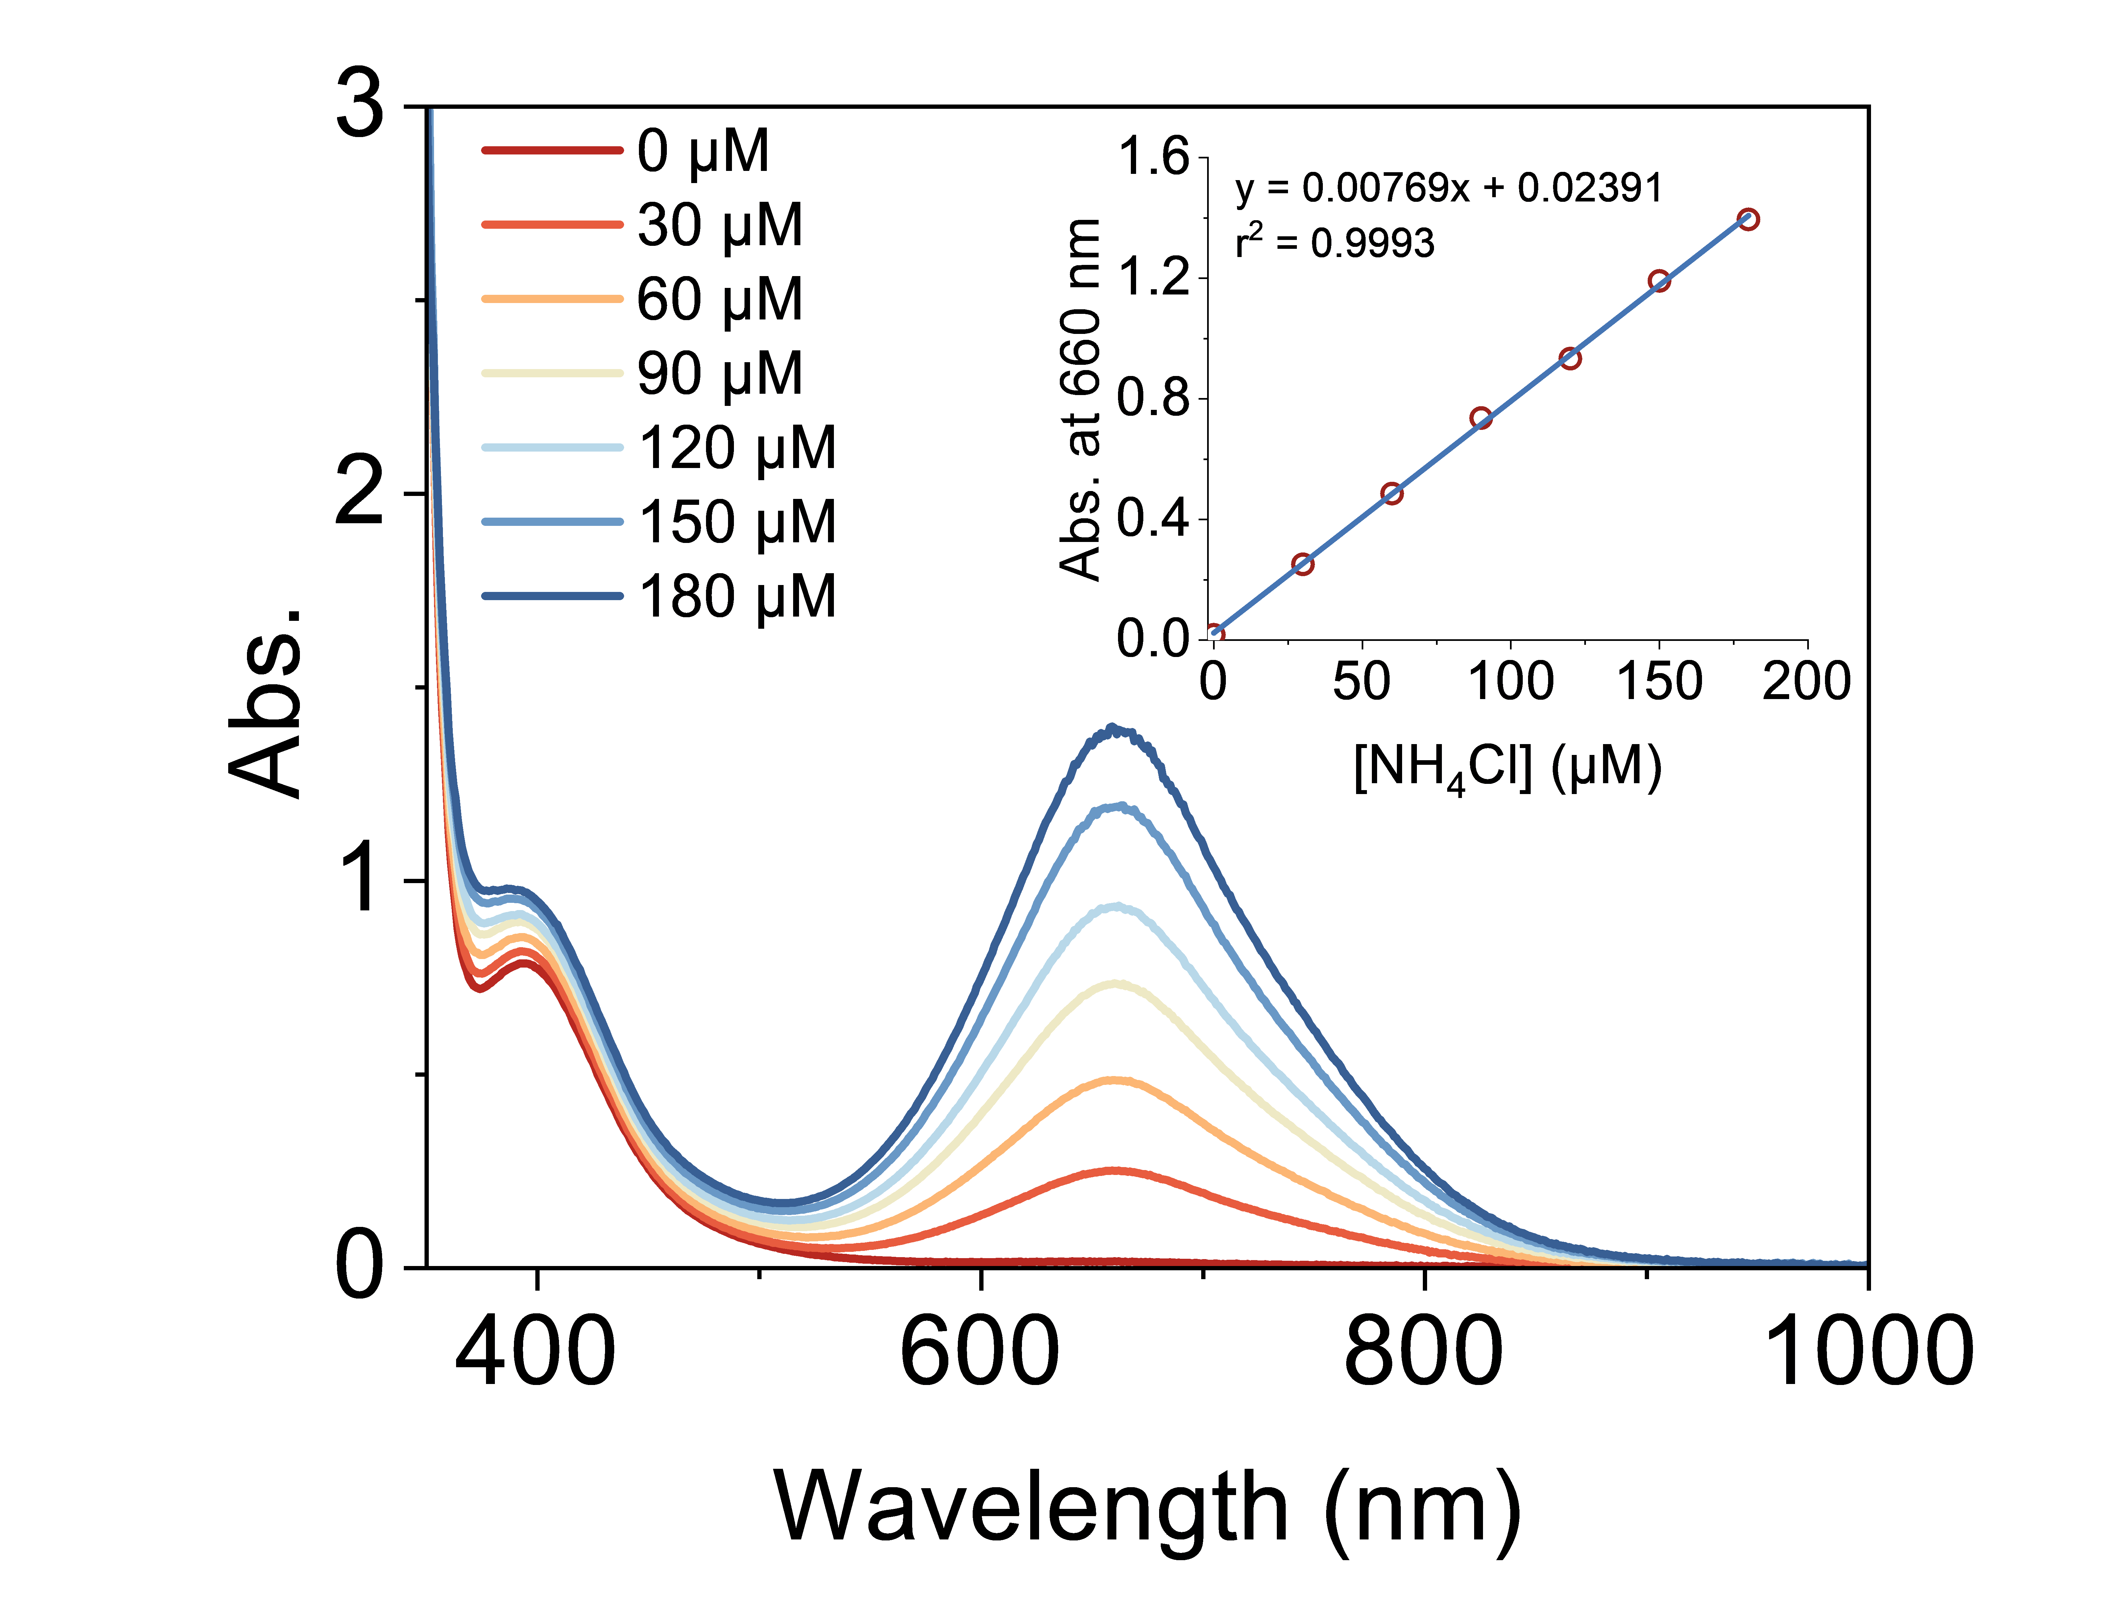
Figure S35. UV-vis absorption spectra of the standard NH₄Cl solution at indicated concentrations. The inset shows the calibration curve of absorbance at 660 nm as a function of NH₄Cl concentration.

Detection of ¹⁵NH₃ from ¹⁵N₂
In the typical photocatalytic N₂ reduction procedure: 2 μmol of photocatalyst, 1 μmol of molybdenum catalyst, 200 μmol of AcrH₂, and 3 mL of THF were added into a 40 mL gas-tight glass vial (40 mL volume capacity) inside a N₂ glovebox, as shown in Figure S33. The photocatalytic N₂ reduction experiment was performed in a PerfectLight PCX-50C Discover multi-channel photocatalytic reactor, where the system was irradiated from the bottom with a white light LED for 12 hours
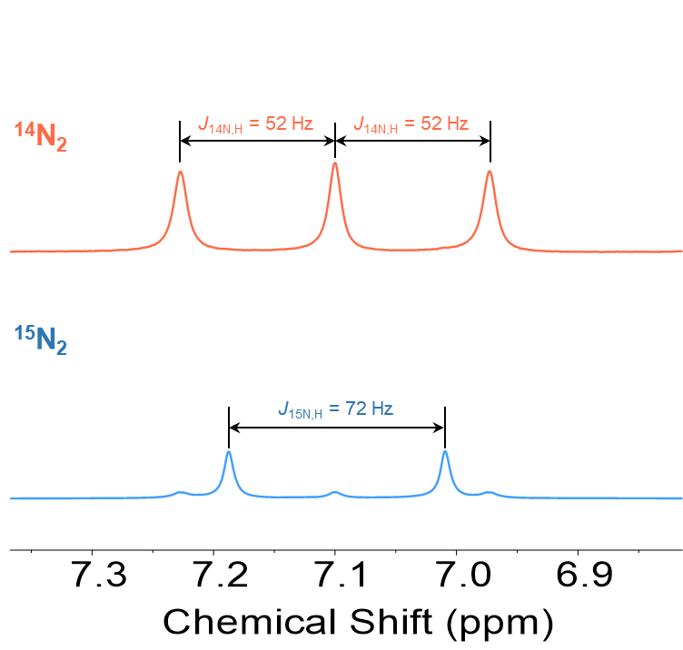
Figure S36. ¹H-NMR spectra of HCl trapped NH₃ in DMSO-d₆ after photocatalysis experiment in ¹⁴N₂/¹⁵N₂ atmosphere.

Photocatalytic reaction conditions optimization
Electron donor
Table S2. Photocatalytic NH₃ synthesis from N₂: effect of electron donor.
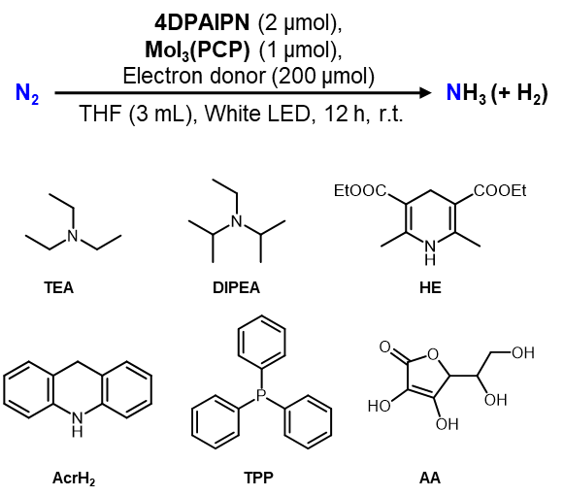
Entry | PC | Electron  donor | NH₃ production (equiv. based on Mo) | H₂ production (equiv. based on Mo)
1 | 4DPAIPN | TEA | 0.2 | 0
2 | 4DPAIPN | DIPEA | 0.3 | 0
3 | 4DPAIPN | HE | 2.7 | 2.2
4 | 4DPAIPN | AcrH₂ | 4.7 | 4.8
5 | 4DPAIPN | TPP | 0.3 | 0
6 | 4DPAIPN | AA | 0.5 | 0

Photocatalyst
Table S3. Photocatalytic NH₃ synthesis from N₂: effect of photocatalyst.
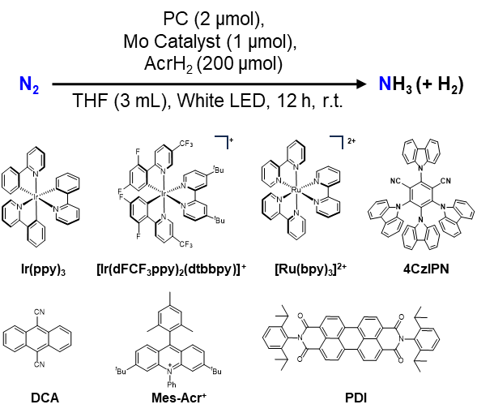
Entry | PC | Mo Catalyst | NH₃ production (equiv. based on Mo) | H₂ production (equiv. based on Mo)
1 | 4DPAIPN | MoI₃(PCP) | 4.7 | 4.8
2 | 4DPAIPN | PCP-MoN | 1.4 | 0
3 | 4DPAIPN | PCP-MoN | 4.8ª | 6.4
4 | 4DPAIPN | Mo[N(TMS)Ar]₃ | 2.4 | 0
5 | 4DPAIPN | MoN | 3.0 | 0.1
6 | PAC-AcrH₂ | PCP-MoN | 1.7 | 0.5
7 | PAC-AcrH₂ | MoN | 1.9 | 0
8 | Ir(ppy)3 | MoI₃(PCP) | 5.0 | 31.7
9 | [Ir(dFCF₃ppy)₂(dtbbpy)]⁺ | MoI₃(PCP) | 4.8 | 41.6
10 | [Ru(bpy)₃]²⁺ | MoI₃(PCP) | 0.1 | 6.3
11 | 4CzIPN | MoI₃(PCP) | 1.8 | 0
12 | DCA | MoI₃(PCP) | 3.0 | 0
13 | Mes-Acr⁺ | MoI₃(PCP) | 1.4 | 0
14 | PDI | MoI₃(PCP) | 2.4 | 0.1
ª3 μmol TBAI was added.

Control experiments
Table S4. Photocatalytic NH₃ synthesis from N₂: control experiments.
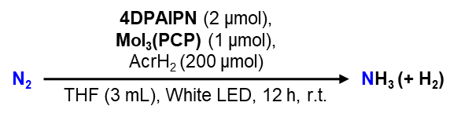
Entry | Deviation | NH₃ production (equiv. based on Mo) | H₂ production  (equiv. based on Mo)
1 | No 4DPAIPN | 0.3 | 0
2 | No MoI₃(PCP) | 0.2 | 0
3 | No AcrH₂ | 0.2 | 0
4 | Dark | 0.2 | 0
5 | Ar | 0.1 | 0

Thermodynamic analysis
The potential E⁰ mentioned below is referenced to Fc^{+/0} unless stated.
The BDFE of PAC-AcrH₂ in the ground state was obtained by DFT calculations, C_{G} = 52.6 kcal/mol¹¹.
PAC-AcrH₂ → PAC-AcrH· + H· (4)
∆Gº = 23.06 [E_{ox} (PAC-AcrH₂^{·+/0})] + 1.37 [pK_{a} (PAC-AcrH₂^{·+})] + C_{G} = 58.2 kcal/mol
The pK_{a} of PAC-AcrH₂ in the ground state was obtained by machine learning prediction¹²:
PAC-AcrH₂ → PAC-AcrH‒ + H⁺ (5)
∆Gº = 1.37 (pK_{a}) = 1.37 × 17.7 =24.2 kcal/mol
Combining the eq (4) and eq (5), we can obtain the E_{ox} of PAC-AcrH‒ = -0.81 V
PAC-AcrH‒ → PAC-AcrH· + e‒
∆Gº = 23.06 (E_{ox}) = 23.06 × (-0.81) = -18.6 kcal/mol
The hydricity (free energy required to generate a hydride ion from hydride donor)¹³ of PAC-AcrH₂ in the ground state was obtained by DFT calculations, C_{H‒} = 79.6 kcal/mol¹³.
PAC-AcrH₂ → PAC-AcrH⁺ + H‒ (6)
∆Gº = 23.06 [E_{ox} (PAC-AcrH₂^{·+/0})] + 23.06 [E_{ox} (PAC-AcrH^{+/·})] +
1.37 [pK_{a} (PAC-AcrH₂^{·+})] + C_{H‒} = 57.1 kcal/mol
Combining the eq (4) and eq (6), we obtain the E_{ox} of PAC-AcrH· = -1.18 V.
PAC-AcrH· → PAC-AcrH⁺ + e‒ (7)
∆Gº = 23.06 (E_{ox}) = 23.06 × (-1.18) = -27.2 kcal/mol
The E_{ox} of PAC-AcrH₂ in the ground state was estimated as 0.38 V by CV.
PAC-AcrH₂ → PAC-AcrH₂^{·+} + e‒ (8)
∆Gº = 23.06 (E_{ox}) = 23.06 × (0.38) = 8.8 kcal/mol
Combining the eq (4) and eq (8), we obtain the pK_{a} of PAC-AcrH₂^{·+} = -2.3.
PAC-AcrH₂^{·+} → PAC-AcrH· + H⁺ (9)

∆Gº = 1.37 (pK_{a}) = 1.37 × (-2.3) = -3.2 kcal/mol
Combining the eq (7) and eq (9), the BDFE of PAC-AcrH₂ is 22.24 kcal/mol.
PAC-AcrH₂^{·+} → PAC-AcrH⁺ + H· (10)
∆Gº = 23.06 [E_{ox} (PAC-AcrH^{+/·})] + 1.37 [pK_{a} (PAC-AcrH₂^{·+})] + C_{G} = 23.06 × (-1.18) +1.37 × (-2.3) + 52.6 = 22.2 kcal/mol
According to the excited state energy of PAC-AcrH₂ (E₀₋₀ = 2.65 eV = 61.1 kcal/mol), The E_{ox} (PAC-AcrH₂^{·+/*}) is -2.27 V.
PAC-AcrH₂* → PAC-AcrH₂^{·+} + e‒ (11)
E_{ox}* = E_{ox} - E₀₋₀ = 0.28 - 2.65 = -2.27 V
The BDFE of PAC-AcrH₂* is -2.9 kcal/mol.
PAC-AcrH₂* → PAC-AcrH· + H· (12)
∆Gº =23.06 [E_{ox} (PAC-AcrH₂^{·+/*})] + 1.37 [pK_{a} (PAC-AcrH₂^{·+})] + C_{G} = -2.9 kcal/mol
The hydricity of PAC-AcrH₂* is -4.0 kcal/mol.
PAC-AcrH₂* → PAC-AcrH⁺ + H‒ (13)
∆Gº = 23.06 [E_{ox} (PAC-AcrH₂^{·+/*})] + 23.06 [E_{ox} (PAC-AcrH^{+/·})]+
1.37 [pK_{a} (PAC-AcrH₂^{·+})] + C_{H‒} = -4.0 kcal/mol

DFT calculations
All density functional theory (DFT) calculations were performed using the Gaussian16 program package¹⁴. Geometry optimizations of all stationary points and transition states were conducted with def2-SVP basis set for all atoms. Frequency calculations at the same level were used to confirm the nature of the stationary points, with zero imaginary frequencies indicating local minima and one imaginary frequency indicating transition states. These calculations also provided thermal corrections for Gibbs free energy. Gas-phase single-point energy calculations were performed using the def2-TZVP basis set. For mechanistic studies involving solution-phase thermodynamics, solvation Gibbs free energies were computed using the SMD solvation model¹⁵. The solvation free energy ΔG(solvation) was calculated according to the following expression:
ΔG(solvation) = E_{sol} − E_{gas}
where E_{sol} is the electronic energy calculated in solvent using the M05-2X/6-31G(d) level with SMD solvation model, and E_{gas} is the gas-phase energy at the same level of theory. And final solvated Gibbs free energy (G_{sol}) was given as follows:
G_{sol} = E_{sp, gas} + ΔG(solvation) + ΔG(correlation)
where E_{sp, gas} is the gas-phase single-point energy, and ΔG(correlation) denotes the thermal corrections for Gibbs free energy. The frontier molecular orbitals involving vertical excitation energies were calculated based on the optimized ground-state geometries and visualized via Multiwfn+VMD molecular viewer package.

Table S5. Solvated Gibbs free energy (G_{sol}) at TPSSh-D3BJ, SMD(THF)/def2-TZVP// TPSSh-D3BJ/def2-SVP level used for free energy profile displayed in Figure 39. Energy values are given in Hartree.
Compound | E_{sp, gas} | ΔG(solvation) | ΔG(correlation) | G_{sol}
MoN | -2446.986656 | -0.028526 | 0.696941 | -2446.318242
AcrH₂^{·+} | -556.806052 | -0.080940 | 0.169072 | -556.717919
AcrH | -556.429912 | -0.019559 | 0.157049 | -556.292422
MoNH⁺ | -2447.388036 | -0.072559 | 0.712555 | -2446.748040
PAC-AcrH₂ | -2489.009390 | -0.057533 | 0.747958 | -2488.318965
[PAC-AcrH₂⋯MoNH⁺] | -4936.447192 | -0.116799 | 1.486674 | -4935.077317
[PAC-AcrH₂^{·+}⋯MoNH] | -4936.398699 | -0.099855 | 1.491101 | -4935.007454
[PAC-AcrH·⋯MoNH₂⁺] | -4936.403341 | -0.120882 | 1.486457 | -4935.037766
PAC-AcrH⁺ | -2488.222872 | -0.099218 | 0.739798 | -2487.582292
MoNH₂ | -2448.154455 | -0.031670 | 0.709227 | -2447.476898

Table S6. Solvated Gibbs free energy (G_{sol}) at PBE0-D3BJ, SMD(THF)/def2-TZVP//PBE0-D3BJ/def2-SVP level for BDFE and hydricity calculation used in Section S14. Energy values are given in Hartree.
Compound | E_{sp, gas} | ΔG(solvation) | ΔG(correlation) | G_{sol}
PAC-AcrH₂ | -2485.854692 | -0.056819 | 0.757181 | -2485.154330
H· | -0.501036 | 0.000466 | -0.010650 | -0.511223
PAC-AcrH· | -2485.237015 | -0.057524 | 0.744202 | -2484.550337
H⁻ | -0.499282 | -0.144294 | -0.010000 | -0.653575
PAC-AcrH⁺ | -2485.059667 | -0.099096 | 0.749082 | -2484.409680

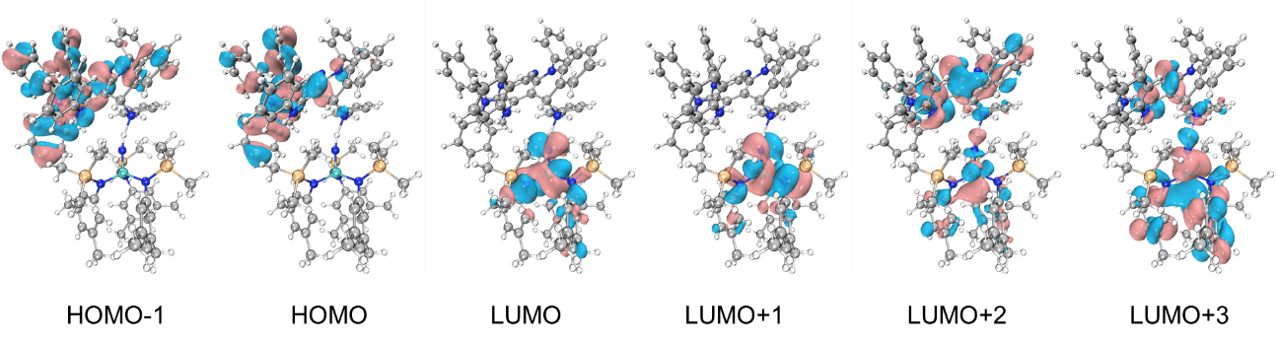
Figure S37. The contour of frontier molecular orbitals of [PAC-AcrH₂⋯MoNH⁺].
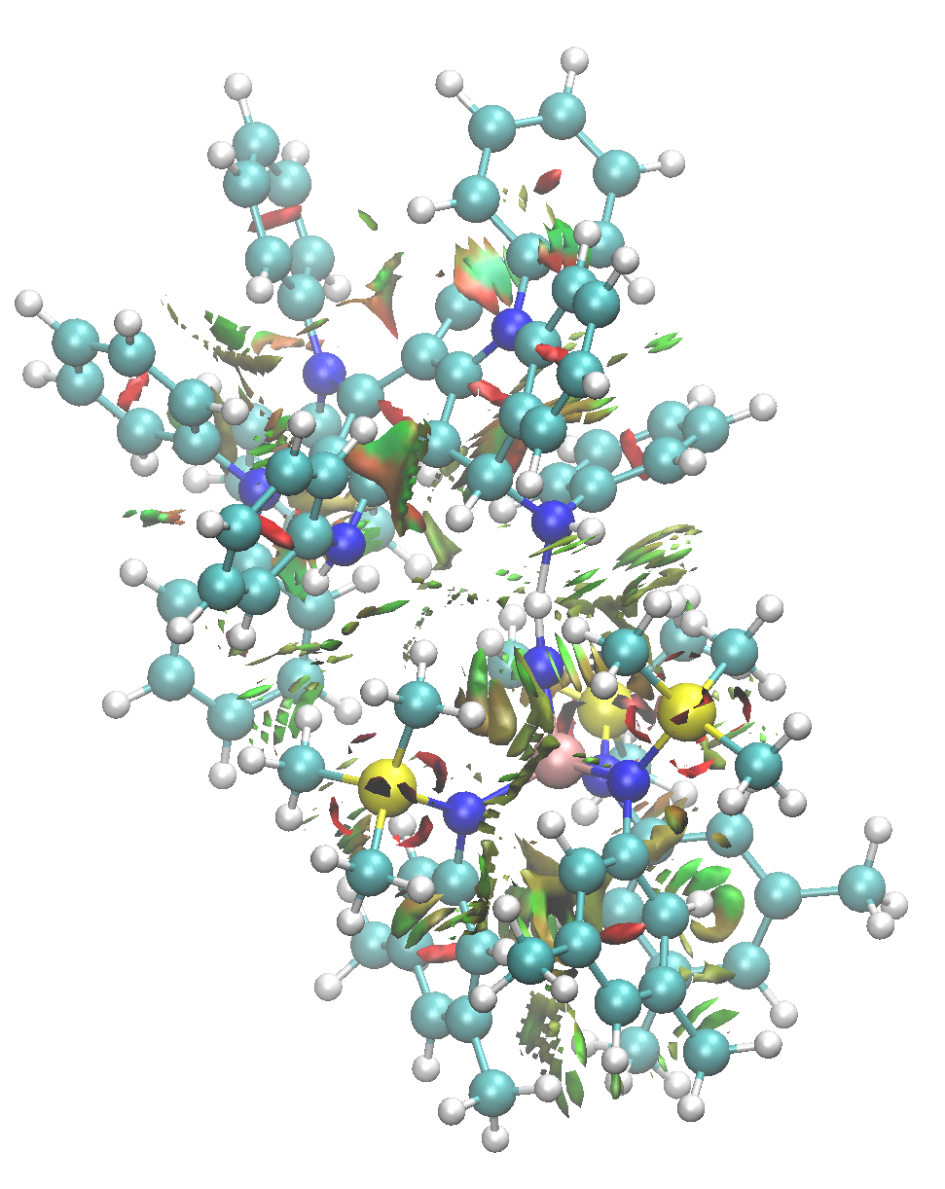
Figure S38. Interaction region indicator (IRI) analysis of the PAC-ArcH₂ and MoN fragments. In addition to hydrogen bond, there are only weak van der Waals interactions between the two fragments.
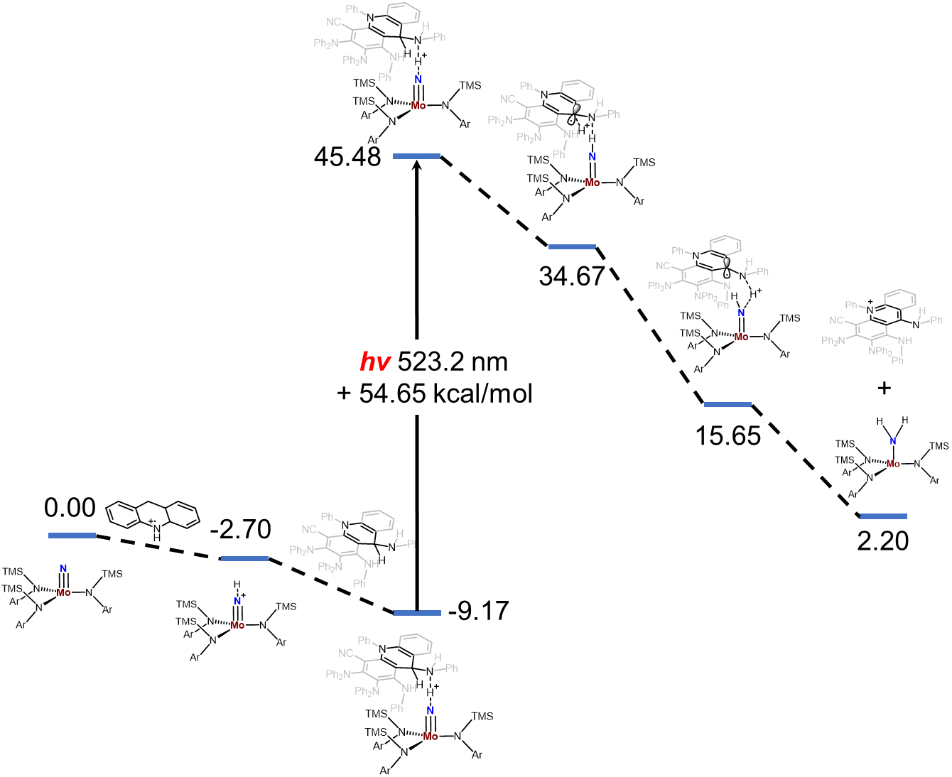
Figure S39. DFT-computed free energy profile of the ground-state interaction mediated photoinduced hydride transfer in Mo≡N activation.

X-ray crystallography
The crystal data were collected on a Bruker D8 Venture diffractometer. The structures were solved using intrinsic phasing method (ShelXT)¹⁶, refined with the ShelXL program and expanded using Fourier techniques¹⁷. All non-hydrogen atoms were refined anisotropically. Hydrogen atoms were included in structure factor calculations. Unless otherwise noted, all hydrogen atoms were assigned to idealized positions. Crystallographic data have been deposited with the Cambridge Crystallographic Data Centre as supplementary publication no. CCDC 2454621.

Identification code | mo_ZZJ_4DH2_0ma_a
CCDC Number | 2454621
Empirical formula | C₅₆H₄₂N₆
Formula weight | 798.95
Temperature/K | 199.94
Crystal system | monoclinic
Space group | P2₁/c
a/Å | 16.261(3)
b/Å | 18.322(5)
c/Å | 16.183(4)
α/° | 90
β/° | 116.078(5)
γ/° | 90
Volume/Å³ | 4330.7(18)
Z | 4
ρ_{calc} g/cm³ | 1.225
μ/mm⁻¹ | 0.073
F(000) | 1680.0
Crystal size/mm³ | 0.2 × 0.2 × 0.2
Radiation | MoKα (λ = 0.71073)
2Θ range for data collection/° | 4.446 to 56.56
Index ranges | -21 ≤ h ≤ 18, -19 ≤ k ≤ 24, -21 ≤ l ≤ 20
Reflections collected | 29349
Independent reflections | 10591 [R_{int} = 0.0488, R_{sigma} = 0.0664]
Data/restraints/parameters | 10591/282/725
Goodness-of-fit on F² | 1.037
Final R indexes [I>=2σ (I)] | R₁ = 0.0588, wR₂ = 0.1428
Final R indexes [all data] | R₁ = 0.1251, wR₂ = 0.1791
Largest diff. peak/hole / e Å⁻³ | 0.26/-0.65

XYZ Coordinates for Optimized Structures
24
AcrH·
C -3.65206300 -0.72845900 -0.00026700
C -2.42445800 -1.39871700 -0.00010000
C -1.22690400 -0.67261600 0.00015000
C -1.23927400 0.75919800 0.00011800
C -2.50264700 1.40347000 -0.00003200
C -3.68821700 0.67488200 -0.00019600
C 1.23927400 0.75919800 0.00011700
C 1.22690400 -0.67261600 0.00014900
C 2.42445800 -1.39871700 -0.00010100
H 2.39078700 -2.49169400 -0.00015900
C 3.65206300 -0.72845900 -0.00026700
C 3.68821700 0.67488200 -0.00019600
C 2.50264600 1.40347000 -0.00003100
H 0.00000000 -2.32801200 0.00081500
H -4.58030400 -1.30352300 -0.00043200
H -2.39078700 -2.49169400 -0.00015900
H -2.52634200 2.49589400 -0.00003200
H -4.64793000 1.19609500 -0.00029900
H 4.58030400 -1.30352300 -0.00043200
H 4.64793000 1.19609500 -0.00029800
H 2.52634200 2.49589400 -0.00003100
C 0.00000000 1.45485200 0.00025400
H 0.00000000 2.54690600 0.00035700
N 0.00000000 -1.31352100 0.00044000
25
AcrH₂^{·+}
C 3.63419100 -0.80340500 -0.00059200
C 2.40409000 -1.43772100 -0.00026700
C 1.22324700 -0.65732600 0.00011300
C 1.27020600 0.76404100 0.00014600
C 2.52709100 1.37130400 -0.00009900
C 3.69747700 0.60462200 -0.00050600
C -1.27020700 0.76404000 0.00034200
C -1.22324700 -0.65732600 0.00057200
C -2.40409000 -1.43772100 0.00029500
H -2.33420300 -2.52800400 0.00051200
C -3.63419100 -0.80340500 -0.00039000
C -3.69747700 0.60462200 -0.00088100
C -2.52709200 1.37130400 -0.00053800
H 0.00000000 -2.30475900 0.00071600
H 4.55205800 -1.39309600 -0.00090300
H 2.33420300 -2.52800400 -0.00028500
H 2.59391700 2.46136700 0.00003300
H 4.66879100 1.10251700 -0.00083600
H -4.55205800 -1.39309600 -0.00062700
H -4.66879100 1.10251600 -0.00144500
H -2.59391600 2.46136700 -0.00092100
C 0.00000000 1.56981300 0.00105100
H 0.00011600 2.24395800 0.87787400
H -0.00011600 2.24621000 -0.87398200
N 0.00000000 -1.28400500 0.00062700
95
MoN
Mo -1.26930800 -0.36200500 0.00720100
Si -2.14729700 0.40750600 3.10832000
N -0.31245000 -1.94962100 -0.65229100
C 0.48760200 0.00160300 2.26608100
Si -2.51266500 1.56271200 -2.38725400
N -1.21398800 1.17790300 -1.21664000
C 1.38753400 1.04147800 1.99390600
H 1.02412700 1.93782300 1.48901400
N -0.88267800 0.08982300 1.88242900
Si -1.02500900 -3.59159300 -0.69102600
C 2.73631900 0.93773300 2.37325300
C 3.16845700 -0.22405400 3.02569200
H 4.21710000 -0.30867100 3.32630500
C 2.28685000 -1.28326200 3.30662100
C 0.94744000 -1.15510600 2.92633800
H 0.23691900 -1.96194400 3.12099100
C 2.78595800 -2.54648700 3.96416600
H 1.96700900 -3.09705300 4.44996500
H 3.55505200 -2.32890700 4.72092100
H 3.24160100 -3.22077500 3.21811500
C 3.69675100 2.06161600 2.07305300
H 4.64166100 1.93906200 2.62247100
H 3.26160300 3.03739100 2.33789600
H 3.92821700 2.10152800 0.99668700
C -1.26839000 1.01053200 4.66232500
H -0.64831200 1.89581100 4.44566100
H -0.60701800 0.23583900 5.08199700
H -2.00409100 1.28845800 5.43564700
C -3.13004600 -1.15600400 3.46234600
H -3.90932800 -0.96660200 4.21991700
H -2.47869000 -1.96231900 3.83675900
H -3.62215300 -1.50738800 2.54195600
C -3.27689800 1.75531300 2.44081500
H -2.70579600 2.67684400 2.24045900
H -4.07479900 1.99673000 3.16313600
H -3.75033600 1.43323200 1.50088700
C -0.13495600 2.08852600 -1.02013600
C 2.19672700 2.73245500 -1.32465900
C 1.95358200 3.89550000 -0.58440000
H 2.77396100 4.59826300 -0.41029400
C 0.68127200 4.18009600 -0.05482200
C -0.35416400 3.26952700 -0.28205400
H -1.34956400 3.44902200 0.13068200
C 1.14146900 1.82813500 -1.53612200
H 1.30640800 0.91074500 -2.10360900
C 0.44332300 5.44428400 0.73399800
H 0.41198300 6.32388000 0.06874000
H 1.24985100 5.61705100 1.46396600
H -0.51087300 5.40205200 1.27904100
C 3.56171800 2.44746600 -1.90027300
H 3.52752600 2.43345500 -3.00225700
H 3.92365600 1.45836400 -1.58227700
H 4.29466400 3.20750100 -1.59258100
C -2.81096800 0.03674800 -3.44570100
H -3.10389400 -0.81814300 -2.81753100
H -1.89653200 -0.23817200 -3.99680600
H -3.61418500 0.21413300 -4.18049400
C -1.88283700 2.97932100 -3.45889600
H -2.61128200 3.21251600 -4.25361900
H -0.92611500 2.71459800 -3.93822500
H -1.71707300 3.89407700 -2.86775600
C -4.08879800 2.05781800 -1.48909100
H -4.88838800 2.30544200 -2.20764300
H -3.92330400 2.93742400 -0.84608500
H -4.43846200 1.22717600 -0.85632600
C 0.95952000 -1.70823600 -1.24885900
C 1.05886100 -1.62093100 -2.65244700
H 0.14887300 -1.72642200 -3.24758100
C 2.28764800 -1.38455600 -3.27437600
C 3.43234200 -1.24317500 -2.46793000
H 4.40170500 -1.06569700 -2.94360200
C 3.36098200 -1.32408300 -1.07190300
C 2.11280900 -1.55533900 -0.46808300
H 2.02978900 -1.62314300 0.61762400
C 4.59515000 -1.15756800 -0.22026400
H 5.51165500 -1.22534500 -0.82457200
H 4.63919800 -1.92346200 0.56908200
H 4.59136500 -0.18013400 0.28813200
C 2.38912700 -1.26586800 -4.77522600
H 1.41985400 -1.45617000 -5.25811900
H 3.12204500 -1.98073200 -5.18307300
H 2.72189600 -0.25627100 -5.06901600
C -1.64248700 -4.00064200 1.03782200
H -2.40863600 -3.27767700 1.35669200
H -0.81370700 -3.96705400 1.76402500
H -2.08692100 -5.00960500 1.07107800
C -2.43807000 -3.66607800 -1.92920000
H -3.22991300 -2.95767300 -1.63927200
H -2.87616200 -4.67781300 -1.96631400
H -2.09408900 -3.40539900 -2.94325100
C 0.35525400 -4.77755900 -1.18118100
H 0.73048000 -4.56729200 -2.19544500
H -0.00721500 -5.81900200 -1.15915800
H 1.20826700 -4.69699300 -0.48763000
N -2.85997200 -0.82014500 0.01606800
96
MoNH⁺
Mo 0.18319600 -0.03880000 -1.40819300
Si -3.03202400 -0.62422500 -2.14515300
N 1.53999600 -1.15351600 -0.64094300
C -1.74114600 -1.40263500 0.19575200
Si 1.34598100 3.10529900 -1.61311300
N 0.37685600 1.77972100 -0.82984800
C -2.11008900 -0.71839300 1.35889100
H -2.26814200 0.35935400 1.31897600
N -1.58262100 -0.69198500 -1.04737900
Si 2.46915400 -2.46535400 -1.49823400
C -2.28581100 -1.42026300 2.56437100
C -2.06270100 -2.80273800 2.57699900
H -2.18632900 -3.35155900 3.51487500
C -1.68683800 -3.50829000 1.41766400
C -1.53792300 -2.79395600 0.22491300
H -1.24558500 -3.30600200 -0.69304000
C -1.44383700 -4.99560700 1.46877500
H -1.16224500 -5.39119100 0.48270300
H -2.34452300 -5.53151300 1.80782200
H -0.63620300 -5.23812500 2.17833300
C -2.73016300 -0.68937700 3.80564300
H -2.57288500 -1.29553100 4.70880500
H -3.80465900 -0.44778500 3.74741100
H -2.19058700 0.26188900 3.91733800
C -4.48826400 -0.20576000 -1.04041800
H -4.33594600 0.75726700 -0.52786000
H -4.64962000 -0.98016600 -0.27463400
H -5.40638600 -0.12909600 -1.64641600
C -3.21791400 -2.30665500 -2.95267100
H -4.06386300 -2.30478100 -3.65997200
H -3.40957900 -3.08966300 -2.20222500
H -2.30847800 -2.57932300 -3.51247800
C -2.75095600 0.72354300 -3.42369500
H -2.41786100 1.66961400 -2.96815100
H -3.70259000 0.92243200 -3.94455400
H -2.01176000 0.42988400 -4.18338200
C -0.41835900 2.15034600 0.31367300
C -0.65798600 2.43131200 2.71675600
C -1.95683800 2.91155600 2.50311300
H -2.56149500 3.21029900 3.36417400
C -2.50654200 3.02447400 1.21218700
C -1.71896200 2.64794700 0.11918600
H -2.11375000 2.72170600 -0.89545700
C 0.10668300 2.03544500 1.60595500
H 1.11633400 1.64729100 1.74092800
C -3.91475800 3.52784900 1.01874300
H -4.05147200 4.51321600 1.49102900
H -4.64314800 2.84233800 1.48188500
H -4.16562700 3.62141500 -0.04723100
C -0.06834500 2.37069100 4.10321700
H 0.49201800 3.29548200 4.32184400
H 0.63472000 1.53159600 4.19828300
H -0.84833200 2.27102300 4.87190800
C 2.65575700 2.32555600 -2.70941300
H 2.22866900 1.87989400 -3.61974500
H 3.22918900 1.54706800 -2.18233600
H 3.36693300 3.10792000 -3.02329900
C 2.13764600 4.06117500 -0.20707300
H 2.75827800 4.87663100 -0.61448100
H 2.78579200 3.41093500 0.40192300
H 1.38063000 4.50823600 0.45559100
C 0.16147300 4.16632700 -2.60804000
H 0.70592500 4.97740500 -3.11958100
H -0.59933100 4.62990500 -1.96042200
H -0.35474500 3.56881800 -3.37710300
C 1.96528700 -0.77949600 0.68233000
C 3.04769200 0.10604900 0.83468300
H 3.53128400 0.51420300 -0.05454700
C 3.49175700 0.47080900 2.10921500
C 2.83710700 -0.07940500 3.22840400
H 3.18481500 0.18975800 4.22987500
C 1.76077300 -0.96604000 3.09715200
C 1.32425300 -1.31067200 1.80575600
H 0.49471200 -2.00451800 1.66993500
C 1.06232300 -1.52940600 4.30847000
H 1.69555700 -1.46224300 5.20431000
H 0.78427000 -2.58204500 4.15278700
H 0.13106700 -0.97568200 4.51090500
C 4.63489000 1.43772000 2.28749900
H 5.07958600 1.71735600 1.32205300
H 5.42685900 1.00304600 2.91722300
H 4.29379400 2.35989200 2.78582600
C 1.28494500 -3.38562700 -2.62849800
H 0.83607300 -2.73138800 -3.39091400
H 0.47100400 -3.85842400 -2.05684900
H 1.83149800 -4.18693300 -3.15331800
C 3.84772900 -1.64715000 -2.47379800
H 3.44338800 -0.92927700 -3.20511700
H 4.43205600 -2.40136100 -3.02650700
H 4.54116300 -1.10841500 -1.80862200
C 3.12137800 -3.58943700 -0.14879100
H 3.79895000 -3.05306100 0.53359600
H 3.68012000 -4.42792800 -0.59658800
H 2.29723900 -4.00970900 0.44972600
N 0.42767300 -0.08146000 -3.10799800
H 0.55852400 -0.08932300 -4.11864300
97
MoNH₂
Mo 0.27840000 0.78498900 0.85303800
Si 0.34518100 -1.16161100 3.55309800
N -1.25425600 1.73332400 0.02301400
C -1.10679200 -1.68202400 1.22349800
Si 3.30731500 1.91687100 -0.16875300
N 2.03740900 0.67887500 -0.06158300
C -0.61367800 -2.58784400 0.27054600
H 0.46137400 -2.62172500 0.08138500
N -0.23029900 -0.79701700 1.91382200
Si -2.29279500 2.96631700 0.75257900
C -1.48387100 -3.44669900 -0.42111800
C -2.85705800 -3.37928700 -0.14856300
H -3.54032000 -4.05031300 -0.67842400
C -3.37860500 -2.47579600 0.79500700
C -2.49179000 -1.63846700 1.47859400
H -2.86156600 -0.92311600 2.21660900
C -4.86584500 -2.39285600 1.03731500
H -5.09089500 -1.85276000 1.96854900
H -5.31940000 -3.39437900 1.09971200
H -5.36718700 -1.85853600 0.21186100
C -0.94774900 -4.41476300 -1.44667200
H -1.62563400 -5.27088600 -1.58147400
H 0.04399700 -4.79214200 -1.15806300
H -0.83066000 -3.92237800 -2.42599000
C -0.14641100 -2.93838100 3.94405900
H 0.27344300 -3.63389900 3.19917200
H -1.24133900 -3.06226100 3.93288100
H 0.22244600 -3.23631000 4.93988000
C -0.41943500 0.00742800 4.82007900
H -0.09768500 -0.24997500 5.84353900
H -1.52010400 -0.03781900 4.78570700
H -0.11536700 1.04664000 4.61947200
C 2.22455400 -1.00224200 3.59140000
H 2.68291400 -1.78041700 2.96005400
H 2.61632200 -1.11629200 4.61615700
H 2.55701100 -0.02543600 3.20650800
C 2.16319100 -0.54070900 -0.78465800
C 1.58040000 -1.94714000 -2.69620600
C 2.36807100 -2.97186800 -2.15920900
H 2.44874000 -3.92084600 -2.69803900
C 3.06223300 -2.80936900 -0.94514700
C 2.95656300 -1.58896400 -0.27303700
H 3.47907300 -1.43098300 0.67282700
C 1.47982200 -0.73220300 -1.99626600
H 0.87377100 0.08457400 -2.39451300
C 3.87876300 -3.94273300 -0.37384800
H 4.55809400 -4.36777500 -1.12982300
H 3.22560700 -4.76143300 -0.02663300
H 4.48229900 -3.60923600 0.48275200
C 0.85660500 -2.12748100 -4.00690800
H 1.14860700 -1.34840300 -4.72936500
H -0.23106900 -2.03655200 -3.86838900
H 1.07180500 -3.10950200 -4.45274800
C 2.52558900 3.59847700 -0.48719200
H 1.77284500 3.81563800 0.28618900
H 2.02916200 3.61255000 -1.47117300
H 3.28464800 4.39878800 -0.47558000
C 4.42605800 1.44256900 -1.61177800
H 5.21710000 2.19805200 -1.75421600
H 3.84768000 1.37097700 -2.54749900
H 4.90999000 0.46652000 -1.44611000
C 4.34373800 1.97064200 1.41136800
H 5.20075200 2.65556800 1.29158100
H 4.74066200 0.97145500 1.65495900
H 3.76064200 2.32537200 2.27620900
C -1.39950200 1.36717100 -1.34478000
C -0.81638400 2.15577600 -2.35720800
H -0.26775600 3.05353700 -2.06410800
C -0.90663600 1.78574100 -3.70296500
C -1.61599200 0.61668900 -4.03245400
H -1.69767600 0.32035200 -5.08272800
C -2.21739400 -0.17985200 -3.04881300
C -2.09463500 0.19998300 -1.70243800
H -2.54073600 -0.40863500 -0.91306700
C -3.01318800 -1.40713000 -3.41982200
H -2.76835100 -1.75730700 -4.43372400
H -4.09510200 -1.19039000 -3.39570900
H -2.83157500 -2.22438600 -2.70676100
C -0.22026700 2.59629200 -4.77501000
H -0.00819400 3.61898300 -4.43030400
H -0.83239800 2.65746200 -5.68801600
H 0.74216800 2.13448000 -5.05616300
C -2.77466700 2.38508100 2.48299000
H -1.90214600 2.08144900 3.08259100
H -3.43902400 1.50847300 2.41151200
H -3.30875400 3.17432700 3.03813500
C -1.39330900 4.62114900 0.84660000
H -0.45574300 4.51971400 1.41597700
H -2.01280100 5.39711800 1.32757900
H -1.13032800 4.97362900 -0.16450300
C -3.83739000 3.12702500 -0.31468600
H -3.58069700 3.44995700 -1.33666500
H -4.53597200 3.86600300 0.11242600
H -4.36249100 2.16094800 -0.39239900
N 0.84327200 2.15879300 2.18216700
H 0.15868200 2.60240000 2.79741800
H 1.70967600 2.03040100 2.70798800
103
PAC-AcrH⁺
N -0.42453400 -2.12463300 0.73227000
N -2.52223600 -0.77983400 -0.58518000
N 0.19917800 3.26467500 -0.41965700
N 2.12356800 -0.98204100 0.70838200
H 2.07169200 -1.99653000 0.61177700
N -3.09664400 2.32682000 -2.04766300
C -1.17595900 1.24449400 -0.68904000
C 1.24006000 1.08234900 -0.28210000
C 0.06905800 1.89190600 -0.44117400
C -1.29948900 -0.14972900 -0.42769800
C 2.50364800 1.68112100 -0.53496400
C -0.18509400 -0.88898200 0.08679500
C 1.07766100 -0.28733000 0.14689300
C 2.63054100 3.10327800 -0.32966800
C 0.34027400 -3.27484700 0.43976000
C 1.43938200 3.87378300 -0.22959600
C -1.25573000 -2.06672500 1.89199400
C -2.58208600 -2.05028000 -1.22538100
C -2.23999800 1.89098100 -1.38604400
C -3.73681200 -0.14550400 -0.17529400
C -3.49686900 -3.02298200 -0.79279200
H -4.15760600 -2.80403200 0.04621100
C -2.20905200 -3.06543300 2.14140900
H -2.29861900 -3.90366600 1.45042400
C 3.87994200 3.75561100 -0.19890000
H 4.80728600 3.18263300 -0.26279400
C -1.11416200 -1.00008200 2.79386100
H -0.34997400 -0.24195800 2.61219200
C -1.76077600 -2.30467900 -2.33369700
H -1.09858500 -1.51769500 -2.70042700
C 0.93185200 -3.42302600 -0.82910700
H 0.77593900 -2.65570900 -1.58610200
C 0.57836300 -4.26129400 1.41915600
H 0.16251800 -4.14522800 2.41994000
C 3.95467200 5.11300300 0.05874900
H 4.92534900 5.59684500 0.17537600
C 1.52809500 5.25738900 0.03729300
H 0.61681400 5.84525100 0.13333000
C -3.55130600 -4.25534200 -1.44403700
H -4.26058400 -5.01205400 -1.10203400
C 2.76787100 5.86094000 0.18186300
H 2.81799200 6.92989500 0.39719200
C -3.02520700 -2.97990100 3.27064400
H -3.76902300 -3.75799200 3.45544900
C -3.78291000 0.51817100 1.05799800
H -2.90401100 0.51269000 1.70291100
C 1.92329000 -5.53557600 -0.15618300
H 2.52727000 -6.41445900 -0.38823600
C 1.71515100 -4.54262400 -1.11693500
H 2.15898200 -4.63628900 -2.10950400
C 1.35221900 -5.38071900 1.11248200
H 1.51999700 -6.13549700 1.88395000
C -1.93949300 -0.91902600 3.91845800
H -1.82053700 -0.08731100 4.61650900
C -4.86981400 -0.18536800 -0.99962000
H -4.81821400 -0.68555600 -1.96743200
C -1.81392900 -3.54615700 -2.96996500
H -1.16858200 -3.74039400 -3.82927100
C -2.70326500 -4.52811500 -2.52471400
H -2.74896500 -5.49615600 -3.02686400
C -2.90255000 -1.90397900 4.15782200
H -3.54757200 -1.84070400 5.03619500
C -4.95859800 1.15538200 1.45692900
H -4.99287600 1.66488800 2.42253400
C -6.04432300 0.44126300 -0.58416600
H -6.92298300 0.41689900 -1.23169200
C -6.09342000 1.11782300 0.64026900
H -7.01457500 1.61106800 0.95661600
C 3.04034800 0.69975100 2.26110700
H 2.13224400 1.30004900 2.19555200
C 4.29388800 -1.30191300 1.69978100
H 4.35940500 -2.25342400 1.16727400
C 5.33421600 -0.87922000 2.52915100
H 6.21778100 -1.51083200 2.64443300
C 4.09510400 1.12039000 3.07299300
H 4.00187700 2.05998300 3.62217300
C 5.25059200 0.34192700 3.20691600
H 6.06789200 0.67377400 3.84963700
C 3.14434700 -0.50679100 1.54497300
C 3.58236300 -0.23776700 -1.69280800
C 4.69788200 -1.08076100 -1.59458700
H 5.49662700 -0.83911300 -0.89076400
C 2.55405300 -0.52986600 -2.60416200
H 1.70542800 0.14673800 -2.71099300
C 2.64582000 -1.67281100 -3.39784000
H 1.85313900 -1.88869400 -4.11755300
C 4.77777500 -2.22187800 -2.39581000
H 5.64972900 -2.87400100 -2.31682800
C 3.75255800 -2.52446300 -3.29652000
H 3.82249800 -3.41102000 -3.92949500
C -0.98275700 4.09859400 -0.42100900
C -1.25738200 4.90994600 -1.52473200
H -0.58259400 4.90933100 -2.38221000
C -1.83223300 4.06353900 0.68909600
H -1.59048600 3.42242300 1.53886800
C -2.99867600 4.83073600 0.67428900
H -3.68038700 4.79521500 1.52585000
C -3.29342400 5.63451600 -0.43109200
H -4.21064900 6.22614200 -0.44396400
C -2.42036400 5.68029200 -1.52400400
H -2.65650300 6.30304500 -2.38848600
H 4.47935200 1.41344800 -0.84928300
N 3.57373100 0.96271500 -0.93853900
200
[PAC-AcrH₂^{·+}⋯MoNH]
N -3.77740900 -2.43468800 0.54508800
N -4.97070500 -1.03685100 -1.52247100
N -3.81540600 3.06427300 0.83135300
N -1.42407100 -1.01923800 1.78791400
H -0.44199800 -0.79006400 1.48799000
N -5.20293800 2.18617600 -2.67553800
C -4.27103900 1.07692600 -0.53071000
C -2.54341100 1.03342900 1.19704700
C -3.55290600 1.75575000 0.50976300
C -4.27165500 -0.32627900 -0.53168000
C -1.54359300 1.80848500 2.00325700
H -1.12227000 1.14990100 2.77544600
C -3.48240900 -1.07311200 0.39847200
C -2.46367800 -0.37322900 1.13132400
C -2.17814900 3.01790900 2.63302900
C -2.80844700 -3.45823500 0.50773900
C -3.22524100 3.67552100 1.96192800
C -5.13096800 -2.77220700 0.83160800
C -4.18413800 -1.85333200 -2.38788800
C -4.82335700 1.73949200 -1.66656000
C -6.32359000 -0.74178600 -1.82295900
C -4.63473900 -3.11694600 -2.80010300
H -5.61195000 -3.47166600 -2.47225700
C -5.71978100 -3.91786800 0.26873500
H -5.13707000 -4.54370800 -0.40675400
C -1.65509700 3.58101600 3.80308800
H -0.84881600 3.05758800 4.32316100
C -5.86948600 -1.96989700 1.71822500
H -5.39921100 -1.09434800 2.16858400
C -2.94836200 -1.36721200 -2.84565800
H -2.62540800 -0.36608700 -2.55469000
C -1.69875800 -3.34375000 -0.34640500
H -1.58206200 -2.45201200 -0.96022800
C -2.96922500 -4.60961700 1.30540400
H -3.79909400 -4.66865400 2.00850100
C -2.14141400 4.79200500 4.29787200
H -1.72520100 5.22031200 5.21136600
C -3.71855400 4.89770800 2.45537100
H -4.53392500 5.40440400 1.94082300
C -3.83521100 -3.89541800 -3.63830900
H -4.18557600 -4.88141700 -3.95078400
C -3.16959800 5.44979600 3.61100300
H -3.55980100 6.39833700 3.98503100
C -7.03882100 -4.24046300 0.58123800
H -7.49593600 -5.12457300 0.13232200
C -7.17397000 -0.26210800 -0.81125500
H -6.78325900 -0.11453800 0.19419400
C -0.95936400 -5.54984600 0.33900000
H -0.23734500 -6.36517400 0.26668100
C -0.78699100 -4.39182700 -0.43063400
H 0.05952500 -4.30574400 -1.11122800
C -2.04823500 -5.64858000 1.21297100
H -2.17309700 -6.53293700 1.84016800
C -7.18785400 -2.30660500 2.02880900
H -7.75258900 -1.68403800 2.72576300
C -6.82478900 -0.90311700 -3.12660500
H -6.16112600 -1.22549600 -3.92881000
C -2.15702700 -2.15250200 -3.68643400
H -1.20286800 -1.76123300 -4.04236300
C -2.59246900 -3.42217400 -4.07785300
H -1.97402900 -4.03649200 -4.73496800
C -7.77911200 -3.43808600 1.45962200
H -8.81082800 -3.69899400 1.70196900
C -8.50696600 0.02562600 -1.09471400
H -9.15660900 0.39255300 -0.29690300
C -8.16388300 -0.62236300 -3.39559900
H -8.53974900 -0.74694200 -4.41317300
C -9.01490100 -0.16085900 -2.38535400
H -10.06033400 0.06319300 -2.60497900
C -2.73637100 -2.14759500 3.50924100
H -3.53758700 -1.41684400 3.38792100
C -0.51248400 -2.94038700 2.93020000
H 0.38258800 -2.84623500 2.31844800
C -0.62723800 -3.94189600 3.89099400
H 0.20117400 -4.63807100 4.03834400
C -2.84611500 -3.16578000 4.45616800
H -3.75447300 -3.24148500 5.05829000
C -1.79556500 -4.07043200 4.65319700
H -1.88238100 -4.86013100 5.40174000
C -1.57179700 -2.03707900 2.72421100
C -0.68435200 3.01131600 0.00258100
C -0.60902000 4.41257800 0.02739700
H -0.32153600 4.91996900 0.95109500
C -1.05935500 2.36141000 -1.18507400
H -1.07794500 1.27066900 -1.20147000
C -1.37912300 3.10262500 -2.32314000
H -1.67777300 2.59028700 -3.23959700
C -0.90056500 5.15067500 -1.12429900
H -0.82492600 6.24001200 -1.09952200
C -1.29500200 4.50012100 -2.29806000
H -1.53127600 5.07735900 -3.19411300
C -4.90481300 3.75042800 0.18320300
C -4.63012500 4.77560000 -0.72450200
H -3.59367100 5.04005900 -0.93479500
C -6.21937400 3.36943900 0.47511700
H -6.40382100 2.57541900 1.20129600
C -7.27388800 3.99888900 -0.18880200
H -8.30223900 3.69474100 0.01506800
C -7.00998200 5.01184200 -1.11622600
H -7.83530300 5.49639600 -1.64143400
C -5.69218400 5.40517300 -1.37507700
H -5.48920800 6.19345800 -2.10228200
H 0.25364500 2.74996800 1.76271600
N -0.37765700 2.22623700 1.15317200
H 0.71872200 0.65888000 0.76836500
N 1.19505100 -0.27372400 0.88092500
Mo 2.92500300 -0.23116500 0.38418900
N 3.87743800 0.99204800 1.60534300
N 3.84136600 -1.97134300 0.39380100
N 2.95521300 0.28298800 -1.51647300
Si 3.25610400 2.05058700 2.90273700
C 5.27915900 1.13725600 1.32929800
Si 3.69094900 -3.10821900 1.77522100
C 4.78388600 -2.30173800 -0.62663100
Si 2.25734800 -0.70090800 -2.83801100
C 3.49966400 1.54517100 -1.89484900
C 2.73398600 3.69784900 2.13291300
C 1.80437800 1.26265600 3.80801400
C 4.64880700 2.35835800 4.12697500
C 6.17815800 0.20795900 1.87500400
C 5.76710000 2.19159400 0.53856100
C 3.08209400 -2.12195500 3.25710100
C 5.39260400 -3.82370300 2.13431100
C 2.47542400 -4.50061500 1.39377500
C 4.73494400 -3.56060700 -1.25103100
C 5.77959800 -1.39173100 -1.02444300
C 3.55987500 -1.29006200 -4.05910700
C 1.00246700 0.37004900 -3.75291800
C 1.39208400 -2.17274300 -2.05280800
C 4.69374100 1.60234000 -2.63461500
C 2.84556900 2.74019100 -1.55171700
H 2.08201500 3.55132500 1.25777300
H 3.62106300 4.24356800 1.77310800
H 2.21401100 4.34612800 2.85901000
H 1.07164300 0.82104000 3.11755400
H 1.30564200 2.01938700 4.43722000
H 2.15508900 0.45817400 4.47223800
H 5.00411700 1.41431900 4.57071100
H 4.29698300 3.00826800 4.94591400
H 5.50948000 2.84857600 3.64584000
H 5.78064600 -0.60476200 2.48478500
C 7.55269500 0.29581700 1.61981000
C 7.14274700 2.32182600 0.29977800
H 5.06381500 2.90494300 0.10531300
H 2.15760600 -1.56751200 3.03914500
H 3.84105400 -1.39342400 3.58233800
H 2.87886000 -2.80304500 4.10052400
H 5.35540900 -4.45974700 3.03463700
H 6.12880400 -3.02380900 2.31078900
H 5.76012500 -4.43636500 1.29685900
H 2.22137000 -5.05489400 2.31298700
H 2.89561700 -5.22587900 0.67901400
H 1.54178600 -4.10651200 0.96651400
C 5.66102600 -3.92066200 -2.24132800
H 3.95539800 -4.26903400 -0.96441500
C 6.71795700 -1.72857800 -2.00690800
H 5.83818500 -0.41477800 -0.54650800
H 4.38412600 -1.81233300 -3.55031700
H 3.97998000 -0.45440200 -4.64012900
H 3.09794400 -1.99358100 -4.77346700
H 0.64115000 -0.13429700 -4.66510000
H 1.45644500 1.32695700 -4.05733700
H 0.13512100 0.60287800 -3.11696600
H 2.11048000 -2.83740400 -1.55132900
H 0.87027300 -2.75317600 -2.83174100
H 0.65910400 -1.83815600 -1.30372600
H 5.20312300 0.67007400 -2.87898000
C 5.23251900 2.83038100 -3.03867600
C 3.38156200 3.98354200 -1.91958300
H 1.90131100 2.68393500 -1.00591500
C 8.01742800 1.36210100 0.83647100
C 8.49379300 -0.76475000 2.13238400
C 7.68327200 3.48101600 -0.49966600
C 6.65088700 -2.99763600 -2.60525700
C 5.56052800 -5.25991100 -2.92910200
C 7.79043300 -0.74502800 -2.40531800
C 4.57259400 4.01021200 -2.66176000
C 6.48569800 2.87681100 -3.87691700
C 2.67266400 5.26608500 -1.56320400
H 9.09002200 1.44963000 0.63937500
H 8.18406600 -1.13340300 3.12191000
H 9.52428100 -0.38878100 2.20913000
H 8.50296700 -1.62974600 1.44677500
H 8.28738600 4.14587100 0.13974100
H 6.86993000 4.07273300 -0.94018900
H 8.33785900 3.13337300 -1.31409200
H 7.38318800 -3.27080900 -3.37043100
H 6.54895200 -5.62235400 -3.24776100
H 4.93007300 -5.18717600 -3.83212400
H 5.10954000 -6.01792500 -2.27127600
H 8.79459000 -1.17104000 -2.24851000
H 7.71574300 0.17906400 -1.81549700
H 7.71290400 -0.48634200 -3.47424200
H 4.99245700 4.97559600 -2.95908000
H 6.98815900 3.85162600 -3.79783400
H 6.24576500 2.71219200 -4.94126500
H 7.19671400 2.09322400 -3.57750900
H 1.78198400 5.40636100 -2.19691900
H 3.32966600 6.13644700 -1.70405100
H 2.32589600 5.25769000 -0.51923800
104
PAC-AcrH₂
N -2.53471500 0.79409500 -0.02855800
N -1.69948000 -1.91076700 0.05615600
N 2.95885200 -0.45717500 -0.36324200
N -0.59534800 2.81643800 0.04153300
H -1.45580700 2.98675600 0.55739600
N 1.06296900 -3.69415500 0.58925700
C 0.63611500 -1.21449900 -0.02479500
C 1.19851500 1.16583100 -0.00764100
C 1.61292400 -0.17986900 -0.15773100
C -0.74041700 -0.87609200 0.03601200
C 2.23364000 2.19496000 0.35185200
H 1.88911900 3.20023500 0.08664800
C -1.15283800 0.46912000 0.03933200
C -0.17274500 1.48834300 0.02349400
C 3.52045200 1.91187700 -0.37428100
C -3.12822400 1.57255700 0.98154900
C 3.88390100 0.57484500 -0.62315200
C -3.21088800 0.47732800 -1.23726700
C -2.60489700 -1.97928400 1.14121800
C 0.94122700 -2.58119800 0.25781100
C -1.67785800 -2.90366500 -0.95814000
C -3.93334000 -2.39807300 0.95059800
H -4.26486600 -2.68693400 -0.04721200
C -4.51334200 -0.04791100 -1.21801800
H -5.01579200 -0.19322800 -0.26150200
C 4.40361800 2.94257700 -0.71950000
H 4.09428100 3.97657100 -0.54059700
C -2.56307400 0.67261500 -2.46773800
H -1.55989200 1.10286000 -2.48073000
C -2.17146400 -1.63174600 2.43057100
H -1.12728000 -1.35320900 2.58151500
C -2.54241600 1.62869300 2.26341400
H -1.65055800 1.03751600 2.46856000
C -4.26692500 2.36674200 0.72834900
H -4.71389400 2.37003900 -0.26591200
C 5.65443400 2.66691300 -1.27338200
H 6.33497200 3.47930200 -1.53594100
C 5.14959200 0.29200400 -1.17256900
H 5.44097300 -0.74025400 -1.36327000
C -4.81256900 -2.43606900 2.03294500
H -5.84472900 -2.75701600 1.87221500
C 6.02333200 1.33278000 -1.48467300
H 7.00031700 1.09482400 -1.91162500
C -5.14559400 -0.38704500 -2.41509100
H -6.15519100 -0.80412600 -2.38821100
C -1.30500900 -2.55514900 -2.26612000
H -1.06220600 -1.51764500 -2.49463200
C -4.23790200 3.19705000 3.01548700
H -4.66945900 3.82082400 3.80058500
C -3.09268600 2.43330100 3.26146700
H -2.61769900 2.45442900 4.24505200
C -4.81361300 3.15653000 1.74047400
H -5.69690600 3.76088500 1.51967100
C -3.19973100 0.32042300 -3.65971000
H -2.68323800 0.47382700 -4.61012600
C -1.99303700 -4.24018800 -0.66464300
H -2.24254600 -4.52227000 0.35860500
C -3.06363400 -1.65570300 3.50393700
H -2.71367900 -1.37153800 4.49898800
C -4.38954300 -2.05396900 3.31227500
H -5.08627600 -2.07579900 4.15264400
C -4.49134800 -0.21451600 -3.64055000
H -4.98710200 -0.49188200 -4.57308700
C -1.25406700 -3.52885500 -3.26397700
H -0.96653000 -3.24012300 -4.27796700
C -1.95846800 -5.20227700 -1.67423500
H -2.20093400 -6.23930100 -1.43042400
C -1.58789600 -4.85685200 -2.97861000
H -1.55467200 -5.61624700 -3.76272600
C 0.57510300 3.58555200 -1.98771800
H 0.98620400 2.59018900 -2.16386700
C -0.78723200 5.10630500 -0.67729800
H -1.43828900 5.28852800 0.18172200
C -0.48797800 6.13650200 -1.56726900
H -0.91251900 7.12874500 -1.39625900
C 0.87453800 4.63005000 -2.86516800
H 1.52532300 4.43094400 -3.72011600
C 0.35082900 5.91111200 -2.66566800
H 0.58954500 6.72191300 -3.35664800
C -0.25603700 3.81573300 -0.87405900
C 2.75676400 1.04083600 2.51608000
C 4.07222800 0.76618300 2.93123500
H 4.86512800 1.48149900 2.69691200
C 1.74569900 0.10728200 2.81662400
H 0.71841900 0.33932700 2.53256600
C 2.05242400 -1.08535400 3.47210800
H 1.26139800 -1.81132500 3.67345200
C 4.36830400 -0.40989400 3.62753200
H 5.39465700 -0.60115300 3.95071400
C 3.36404300 -1.34869100 3.88653900
H 3.59786900 -2.27755000 4.41104400
C 3.39947400 -1.80706000 -0.57718400
C 4.11727500 -2.46151000 0.42728100
H 4.31089500 -1.94146200 1.36609300
C 3.11991300 -2.43922100 -1.79403700
H 2.56178900 -1.90253300 -2.56361500
C 3.52557200 -3.76094900 -1.98749400
H 3.28506200 -4.27118300 -2.92239300
C 4.22493300 -4.43126300 -0.97907900
H 4.53074200 -5.46923900 -1.12706600
C 4.52770300 -3.77907600 0.22149100
H 5.06821900 -4.30682900 1.01000400
H 3.14981300 2.94084900 2.01806900
N 2.42896300 2.24047400 1.83831000
200
[PAC-AcrH₂⋯MoNH⁺]
N -3.53419500 -2.55202700 0.65513000
N -5.21146900 -1.43995000 -1.35495900
N -4.07199900 3.01562000 0.28362200
N -1.73824800 -0.86253100 2.00506900
H -1.43879500 -1.79676800 1.72849400
N -5.72900900 1.54094500 -2.86017900
C -4.53039400 0.79791300 -0.68931900
C -2.75999500 1.09615600 0.96491900
C -3.81057200 1.65549100 0.19581100
C -4.39253800 -0.60894900 -0.57432000
C -1.71355400 2.02090300 1.50197900
H -1.14831700 1.54784000 2.31354500
C -3.48217900 -1.16506300 0.35204300
C -2.64716700 -0.30230700 1.09004900
C -2.33421200 3.30229400 1.97025800
C -2.44464000 -3.40554300 0.42841900
C -3.45504600 3.80241500 1.27723600
C -4.71098200 -2.98821500 1.33619700
C -4.61104300 -2.40346800 -2.20046700
C -5.23933500 1.26652300 -1.83685700
C -6.62193900 -1.23620100 -1.35455500
C -5.21845600 -3.65203300 -2.41849400
H -6.17286100 -3.87322900 -1.93954300
C -5.40764600 -4.12745900 0.90694700
H -5.02166900 -4.70289900 0.06512100
C -1.77001200 4.04688900 3.01539100
H -0.91518500 3.62960500 3.55528600
C -5.19274500 -2.24714200 2.42634200
H -4.63863500 -1.37277100 2.77155600
C -3.40528200 -2.10138600 -2.85322900
H -2.96502400 -1.11146700 -2.72058300
C -1.43049700 -3.04387500 -0.48212300
H -1.50159000 -2.09480200 -1.01165100
C -2.31828500 -4.62985800 1.12121000
H -3.06638500 -4.90875400 1.86350000
C -2.28315100 5.29601200 3.36394000
H -1.83903400 5.86917900 4.17965300
C -3.96845000 5.06698000 1.62514900
H -4.83570600 5.46328200 1.09845800
C -4.60200300 -4.58979200 -3.24682400
H -5.07886900 -5.55987200 -3.40444000
C -3.37888500 5.80177300 2.65246900
H -3.79406500 6.77846600 2.90996400
C -6.58454600 -4.50723100 1.55448000
H -7.12793200 -5.38917200 1.20799100
C -7.27295500 -0.92618400 -0.15140100
H -6.69824900 -0.88518400 0.77447200
C -0.27695400 -5.14942400 -0.09508100
H 0.54946600 -5.82943700 -0.30995200
C -0.37177800 -3.91526400 -0.74315400
H 0.38084000 -3.62252100 -1.47719900
C -1.25196000 -5.48745500 0.85019800
H -1.18426400 -6.43358500 1.39217100
C -6.37468000 -2.63078200 3.06487700
H -6.74096000 -2.04792800 3.91295100
C -7.35868400 -1.31935000 -2.54531500
H -6.84549200 -1.53019500 -3.48424300
C -2.78930500 -3.05132700 -3.67010700
H -1.84683000 -2.80603700 -4.16512300
C -3.37933900 -4.30235700 -3.86697700
H -2.89993300 -5.04430400 -4.50830300
C -7.07823700 -3.75782200 2.62887000
H -8.00390100 -4.05506300 3.12564900
C -8.64930700 -0.69454400 -0.14315700
H -9.14757900 -0.46136700 0.80079400
C -8.73759800 -1.10647000 -2.52264500
H -9.30332500 -1.16809500 -3.45485900
C -9.39003500 -0.78840200 -1.32613300
H -10.46824100 -0.61620200 -1.31673600
C -2.63760400 0.26378200 4.02495300
H -3.15427500 1.01582200 3.42822600
C -1.30596800 -1.75065200 4.20926900
H -0.77522900 -2.57539600 3.73041700
C -1.40544300 -1.69085000 5.59821400
H -0.93640200 -2.47180100 6.20140800
C -2.73053100 0.31252200 5.41980100
H -3.30394500 1.11982200 5.88130000
C -2.11074500 -0.65199800 6.21770500
H -2.18843900 -0.60584000 7.30537500
C -1.90547300 -0.76369800 3.40465600
C -1.10092300 2.67675100 -0.87961700
C -1.04526800 4.00309300 -1.33117000
H -0.68829000 4.78709900 -0.65866300
C -1.56228000 1.66750900 -1.73987900
H -1.58249100 0.63412400 -1.39380700
C -2.00898800 1.99530900 -3.02096600
H -2.40258800 1.21379500 -3.67359700
C -1.45486500 4.31775700 -2.63013100
H -1.40077800 5.35186900 -2.97711600
C -1.95485600 3.31845100 -3.47147200
H -2.30194700 3.56803900 -4.47569000
C -5.21810300 3.56794000 -0.39111100
C -5.03283500 4.43415600 -1.47091900
H -4.01958300 4.67009000 -1.79670600
C -6.50166100 3.22652000 0.05014100
H -6.61990400 2.54935100 0.89823300
C -7.61345300 3.72651300 -0.63034400
H -8.61751500 3.44085100 -0.31117800
C -7.43756900 4.57989600 -1.72401700
H -8.30791000 4.96228100 -2.26101700
C -6.14986300 4.94032200 -2.13672800
H -6.01578600 5.60217100 -2.99456900
H -0.14432700 3.14371100 0.81313500
N -0.65431000 2.33796400 0.43902300
H 0.53416900 1.33799200 0.26879800
N 1.51856500 0.85466800 0.08744700
Mo 3.12946000 0.35071100 -0.08515300
N 4.17524500 1.79113600 0.67962100
N 3.38388100 -1.25466700 0.95786200
N 3.41461500 0.17360200 -1.98988800
Si 3.59794200 3.48055000 0.94568300
C 5.44839500 1.39880000 1.21927300
Si 2.62176400 -1.71985800 2.53546300
C 4.32427900 -2.18989900 0.40635400
Si 2.15474500 0.16492800 -3.29656200
C 4.77680400 0.32683600 -2.42319200
C 2.73014300 4.06319100 -0.61455500
C 2.41052100 3.50554500 2.40788100
C 5.12046500 4.51950500 1.28874800
C 5.55928800 1.13641100 2.59818400
C 6.57302300 1.28787500 0.39552000
C 1.66196300 -0.24137000 3.16942500
C 4.02743700 -2.16741000 3.70002000
C 1.54415200 -3.22535500 2.25118500
C 3.86580700 -3.18363300 -0.47740200
C 5.67800300 -2.12957200 0.75863400
C 2.99266100 -0.54382900 -4.81967900
C 1.56011000 1.91500700 -3.61212300
C 0.76643700 -0.96646100 -2.73754700
C 5.63790100 -0.77490700 -2.47706700
C 5.22760500 1.59349100 -2.83829300
H 1.88633400 3.41613200 -0.89491900
H 3.42885100 4.08794100 -1.46563900
H 2.34204900 5.08582400 -0.47309900
H 1.61372800 2.75577700 2.28611100
H 1.94061300 4.49789400 2.51479800
H 2.93500700 3.28170200 3.35059100
H 5.64215800 4.18409400 2.19871900
H 4.83917100 5.57690000 1.42464900
H 5.83336700 4.46022300 0.45064800
H 4.67160800 1.22671100 3.22761900
C 6.78220900 0.75285200 3.15562700
C 7.81639800 0.91167500 0.93605800
H 6.47836500 1.50265700 -0.66870400
H 0.77873300 -0.04179600 2.54476400
H 2.28885700 0.66282100 3.19607200
H 1.30713100 -0.44152100 4.19303300
H 3.61525700 -2.41203600 4.69366400
H 4.74050800 -1.33854600 3.81938200
H 4.58198800 -3.04726500 3.33813600
H 1.17252200 -3.62006900 3.21079600
H 2.12201700 -4.02920700 1.76896300
H 0.68054800 -3.00692700 1.60573700
C 4.75468700 -4.11788900 -1.01838300
H 2.80565800 -3.20783200 -0.73673100
C 6.58522000 -3.06825700 0.23925100
H 6.01669900 -1.35328100 1.44584900
H 3.40922600 -1.54353400 -4.61647000
H 3.81405300 0.10039100 -5.17015100
H 2.26072600 -0.63915500 -5.63921400
H 0.81938400 1.91847400 -4.42831100
H 2.39232500 2.57155000 -3.91086700
H 1.07267400 2.34730200 -2.72593600
H 1.10550600 -2.01381200 -2.75491600
H -0.09730000 -0.87739500 -3.41597700
H 0.42898800 -0.72911400 -1.71885000
H 5.27159800 -1.75377500 -2.16652900
C 6.95317000 -0.62366500 -2.94859300
C 6.53407700 1.76892800 -3.30519600
H 4.54466700 2.44253200 -2.78027800
C 7.90066400 0.64164900 2.30633400
C 6.90876800 0.45505400 4.62863800
C 9.03002700 0.82565200 0.04546900
C 6.11035700 -4.04554900 -0.64550300
C 4.27809000 -5.16722400 -1.99151500
C 8.03248000 -3.03082000 0.66064900
C 7.38151400 0.64699500 -3.35559500
C 7.88642600 -1.80689000 -3.00253200
C 7.03139600 3.12673000 -3.73325900
H 8.86309100 0.34412300 2.73234100
H 5.96871700 0.65487300 5.16205500
H 7.70085900 1.06695200 5.08835200
H 7.17655800 -0.60112300 4.79479200
H 9.88567600 0.37940500 0.57161900
H 9.33116200 1.82892000 -0.29873800
H 8.81638300 0.22942700 -0.85365200
H 6.81352600 -4.77580700 -1.05621000
H 4.62850500 -6.16939900 -1.70000000
H 4.66642200 -4.96915600 -3.00460900
H 3.18030100 -5.18985800 -2.05004400
H 8.14876700 -3.43738600 1.67934600
H 8.41177800 -1.99891900 0.67987100
H 8.66462300 -3.62871500 -0.01102500
H 8.40228600 0.76974200 -3.72917300
H 8.62814300 -1.69447100 -3.80654000
H 7.33333800 -2.74336100 -3.16090200
H 8.43775000 -1.91217200 -2.05345500
H 6.23336200 3.88107100 -3.68319600
H 7.41495100 3.10113800 -4.76544700
H 7.85941000 3.46309100 -3.08782000
200
[PAC-AcrH·⋯MoNH₂⁺]
N 3.77830300 -2.20867400 -0.07962200
N 6.34938700 -1.13291200 0.50867100
N 4.41624400 3.34318500 0.17792900
N 1.54633900 -0.51883100 -0.12140000
H 1.36000600 -1.41147400 0.33862200
N 7.71383100 1.90310100 1.34354000
C 5.38555500 1.11682600 0.52252600
C 2.94456900 1.42507800 0.48400900
C 4.26693300 1.97844000 0.38016600
C 5.22579000 -0.29677900 0.43820300
C 1.87300900 2.31302200 0.78990300
C 3.93248000 -0.83306600 0.23613100
C 2.81276700 0.01746100 0.26898700
C 2.05583700 3.72918400 0.64462600
C 2.91241200 -3.02409000 0.67182800
C 3.32570700 4.22736900 0.22591300
C 4.42326600 -2.69163900 -1.25625300
C 6.35544300 -2.18234000 1.46156000
C 6.67083200 1.59634300 0.92036800
C 7.49113500 -0.85962000 -0.29572600
C 6.97670000 -3.41109600 1.17939900
H 7.47030000 -3.55388600 0.21792800
C 5.05451000 -3.94548900 -1.26612800
H 5.05180400 -4.55500200 -0.36256900
C 1.02006400 4.67247700 0.85978800
H 0.06266600 4.34250900 1.26432200
C 4.42566500 -1.90701200 -2.41927400
H 3.91550100 -0.94269600 -2.41679200
C 5.74288000 -1.98901000 2.71047800
H 5.31094600 -1.01409500 2.94551300
C 2.57612100 -2.67072800 1.99421000
H 3.03045500 -1.78837300 2.43984000
C 2.31790700 -4.17801700 0.11642900
H 2.54892900 -4.46462400 -0.90953900
C 1.18773400 6.02136900 0.56661000
H 0.36814200 6.72196600 0.73859200
C 3.47507400 5.58304700 -0.10449400
H 4.43444000 5.94602800 -0.46943200
C 6.95307800 -4.43469600 2.12703600
H 7.43610600 -5.38729100 1.89725000
C 2.41034900 6.47249700 0.05342400
H 2.54868200 7.52403600 -0.20415900
C 5.68375000 -4.39892300 -2.42679800
H 6.17744500 -5.37342100 -2.42234700
C 7.32244000 -0.33166700 -1.58508500
H 6.31592100 -0.16500300 -1.96730600
C 1.11138700 -4.59776300 2.18823600
H 0.42501900 -5.21097200 2.77544300
C 1.68135800 -3.44363500 2.73466000
H 1.44100600 -3.13884200 3.75539400
C 1.44072300 -4.95428700 0.87549500
H 1.00258500 -5.84824600 0.42495400
C 5.06732900 -2.36373100 -3.57210000
H 5.06272000 -1.74159700 -4.46987300
C 8.78691800 -1.07466400 0.19923500
H 8.92291500 -1.44664300 1.21521700
C 5.70844600 -3.02608500 3.64426700
H 5.22406400 -2.86475900 4.61004100
C 6.30883000 -4.25549000 3.35747900
H 6.28833300 -5.06366600 4.09107100
C 5.70036300 -3.60992000 -3.58271800
H 6.20164200 -3.96639900 -4.48470100
C 8.43590100 -0.02762000 -2.36857200
H 8.28950000 0.37910700 -3.37213600
C 9.89311200 -0.78425100 -0.59909400
H 10.89643700 -0.95005500 -0.20077500
C 9.72750900 -0.25837300 -1.88531100
H 10.59803200 -0.02573900 -2.50178300
C 1.63890900 0.49743400 -2.35024400
H 1.96413000 1.43716600 -1.90292400
C 0.92605700 -1.80852100 -2.10865100
H 0.73746300 -2.67741500 -1.47526400
C 0.80522000 -1.90967300 -3.49798900
H 0.50197900 -2.86151500 -3.93831200
C 1.50780200 0.38469700 -3.73549700
H 1.72930800 1.25103900 -4.36311100
C 1.10151200 -0.82031100 -4.32192700
H 1.01695900 -0.90768900 -5.40659400
C 1.37022400 -0.60986200 -1.52017400
C 0.52019400 1.32405900 2.59931500
C -0.66386900 1.56991700 3.31724600
H -1.44064700 2.18695500 2.85947300
C 1.54135500 0.58490100 3.21949500
H 2.48223600 0.41548400 2.70017300
C 1.35967900 0.09245100 4.51511400
H 2.16770500 -0.47703200 4.98084400
C -0.83345600 1.08172200 4.61243300
H -1.75898900 1.29833000 5.15022600
C 0.17656500 0.32962000 5.22086900
H 0.04774000 -0.05495900 6.23391300
C 5.69398000 3.84767000 -0.25990100
C 6.43157700 4.70901300 0.55792000
H 6.03832700 4.99603200 1.53424800
C 6.18463200 3.44311600 -1.50605600
H 5.59084400 2.76859100 -2.12590700
C 7.44372700 3.88059400 -1.92173500
H 7.84226300 3.54866900 -2.88225100
C 8.19164800 4.73533900 -1.10671500
H 9.17925500 5.07038300 -1.42950400
C 7.68127700 5.15454900 0.12697000
H 8.27046200 5.81214800 0.76866200
H -0.10651200 2.52086400 1.11309000
N 0.63477800 1.84825000 1.29067600
Mo -3.28594000 0.04631600 -0.44011700
N -3.86092100 1.87054900 -0.77464200
N -4.03851000 -1.08121000 -1.81280400
N -3.65364400 -0.86977300 1.20875200
Si -2.90381700 3.40707200 -0.88555700
C -5.28399300 2.03226900 -0.91420600
Si -3.53285600 -1.16423900 -3.54803600
C -5.20300800 -1.84595400 -1.44968900
Si -2.84076100 -2.41261700 1.74360100
C -4.60909700 -0.30056000 2.10975500
C -2.84844800 4.10926000 0.86293100
C -1.18911600 3.13780300 -1.59748300
C -3.83732000 4.60369000 -1.99183700
C -5.83361000 2.05203200 -2.20783200
C -6.11895400 2.18049300 0.20232200
C -2.38820400 0.28737300 -3.87262200
C -5.10158100 -1.03509600 -4.57096400
C -2.68109000 -2.80910800 -3.86272100
C -5.10227100 -3.24185800 -1.30200600
C -6.43611400 -1.21586600 -1.24810900
C -4.16783000 -3.64587500 2.23642600
C -1.76878200 -1.98881800 3.21762300
C -1.78286200 -3.05756200 0.33019200
C -5.91102300 -0.82275500 2.17225700
C -4.24446700 0.77313300 2.93278300
H -2.32655300 3.43921900 1.56381700
H -3.87304500 4.24542200 1.24528100
H -2.34541700 5.08970700 0.88718900
H -0.57363000 2.41310800 -1.04967400
H -0.65901900 4.10509800 -1.59546800
H -1.25139100 2.78920800 -2.63973400
H -3.91343000 4.23604800 -3.02722100
H -3.28907500 5.56090700 -2.01595100
H -4.85522600 4.80284900 -1.62362000
H -5.16574500 1.93431800 -3.06269500
C -7.21069500 2.20331800 -2.40111700
C -7.50293600 2.35297000 0.03216800
H -5.68458000 2.16068600 1.20306200
H -1.41849800 0.20702200 -3.36024900
H -2.85960300 1.23817000 -3.57891900
H -2.17403800 0.33647600 -4.95313400
H -4.85972800 -1.06756300 -5.64638100
H -5.64358300 -0.09870700 -4.36861800
H -5.78147500 -1.87306400 -4.34994900
H -2.23485000 -2.81920100 -4.87113500
H -3.39674000 -3.64393700 -3.80382200
H -1.87464100 -2.98697000 -3.13542300
C -6.21789300 -4.00333600 -0.93869200
H -4.14023400 -3.73030200 -1.46119600
C -7.56960500 -1.96001700 -0.87738300
H -6.51603400 -0.13933000 -1.38811100
H -4.87238000 -3.84190900 1.41530300
H -4.73855000 -3.29210700 3.10883400
H -3.68505300 -4.59875100 2.51267100
H -1.32546400 -2.91064800 3.62832300
H -2.35441300 -1.50789500 4.01600700
H -0.94483500 -1.31330200 2.94196100
H -2.25563900 -2.94510700 -0.65601400
H -1.57786600 -4.12754500 0.49329200
H -0.81520000 -2.53777100 0.31077600
H -6.18503200 -1.64848300 1.51536900
C -6.84660400 -0.28349400 3.06391900
C -5.16893700 1.34115500 3.82124600
H -3.22516800 1.15183900 2.87369900
C -8.02854200 2.35287100 -1.26823800
C -7.80630000 2.16021700 -3.78554600
C -8.40546300 2.57493200 1.21966200
C -7.44305200 -3.34460300 -0.72054100
C -6.11489000 -5.49963700 -0.77901300
C -8.88577300 -1.25748800 -0.66132700
C -6.46109400 0.79746500 3.87618200
C -8.24290300 -0.84761600 3.14817400
C -4.76547200 2.48534500 4.71800000
H -9.10660500 2.47753800 -1.40511900
H -7.05979800 2.41216400 -4.55246100
H -8.65120700 2.85800300 -3.88115600
H -8.18736900 1.14940900 -4.01097500
H -9.33423900 1.99065700 1.13089500
H -8.69668500 3.63629700 1.28997600
H -7.90398000 2.29768700 2.15612900
H -8.31913500 -3.93188300 -0.43105900
H -6.73599800 -6.01780500 -1.52769400
H -6.47129100 -5.81770200 0.21372500
H -5.07861000 -5.84629200 -0.89883100
H -9.24717800 -0.80763800 -1.60034900
H -8.77417100 -0.43720300 0.06363400
H -9.65716200 -1.94873000 -0.29398100
H -7.18794400 1.22481700 4.57329000
H -8.48162200 -1.15458500 4.17870800
H -8.35940600 -1.72221100 2.49354600
H -8.99231300 -0.09586600 2.85232400
H -3.95905600 3.08318200 4.26791600
H -4.39867800 2.11005300 5.68854200
H -5.61523700 3.15184300 4.92603900
H -0.70896700 0.41372200 0.15372400
N -1.40194400 0.07271200 -0.53535100
H -0.89474100 -0.38106500 -1.30527100

References

1. Chernowsky, C. P. et al. Electrochemical Activation of Diverse Conventional Photoredox Catalysts Induces Potent Photoreductant Activity. Angew. Chem. Int. Ed. 60, 21418-21425 (2021).
2. Ghosh, I. et al. Reduction of aryl halides by consecutive visible light-induced electron transfer processes. Science 346, 725-728 (2014).
3. Zhai, D. D. et al. (n-Bu)(4)NBr-Promoted N(2) Splitting to Molybdenum Nitride. J Am Chem Soc 144, 14071-14078 (2022).
4. Eizawa, A. et al. Remarkable catalytic activity of dinitrogen-bridged dimolybdenum complexes bearing NHC-based PCP-pincer ligands toward nitrogen fixation. Nat. Commun. 8, 14874 (2017).
5. Eizawa, A. et al. Catalytic Reactivity of Molybdenum–Trihalide Complexes Bearing PCP-Type Pincer Ligands. Chem. Asian J. 14, 2091-2096 (2019).
6. Renny, J. S. et al. Method of Continuous Variations: Applications of Job Plots to the Study of Molecular Associations in Organometallic Chemistry. Angew. Chem. Int. Ed. 52, 11998-12013 (2013).
7. Frech, P.&Scheele, M. TAPAS: Transient Absorption Processing and Analysis Software. ChemPhotoChem 10, e202500236 (2026).
8. Yuasa, J. et al. Detection of a Radical Cation of an NADH Analogue in Two-Electron Reduction of a Protonated p-Quinone Derivative by an NADH Analogue. Angew. Chem. Int. Ed. 47, 1068-1071 (2008).
9. Yuasa, J. et al. One-Step versus Stepwise Mechanism in Protonated Amino Acid-Promoted Electron-Transfer Reduction of a Quinone by Electron Donors and Two-Electron Reduction by a Dihydronicotinamide Adenine Dinucleotide Analogue. Interplay between Electron Transfer and Hydrogen Bonding. J. Am. Chem. Soc. 130, 5808-5820 (2008).
10. Fan, X.-Z. et al. Eosin Y as a Direct Hydrogen-Atom Transfer Photocatalyst for the Functionalization of C−H Bonds. Angew. Chem. Int. Ed. 57, 8514-8518 (2018).
11. Agarwal, R. G. et al. Free Energies of Proton-Coupled Electron Transfer Reagents and Their Applications. Chem. Rev. 122, 1-49 (2022).
12. Yang, Q. et al. Holistic Prediction of the pKa in Diverse Solvents Based on a Machine-Learning Approach. Angew. Chem. Int. Ed. 59, 19282-19291 (2020).
13. Wiedner, E. S. et al. Thermodynamic Hydricity of Transition Metal Hydrides. Chem. Rev. 116, 8655-8692 (2016).
14. Frisch, M. J. et al. Gaussian 16 Rev. C.01, Wallingford, CT, 2016.
15. Marenich, A. V. et al. Universal Solvation Model Based on Solute Electron Density and on a Continuum Model of the Solvent Defined by the Bulk Dielectric Constant and Atomic Surface Tensions. J. Phys. Chem. B 113, 6378-6396 (2009).
16. Sheldrick, G. A short history of SHELX. Acta Crystallographica Section A 64, 112-122 (2008).
17. Sheldrick, G. Crystal structure refinement with SHELXL. Acta Crystallographica Section C 71, 3-8 (2015).

