Supplementary Figures: Sediment organic carbon sources, accumulation and stock estimates in a temperate lake over the past 10,000 years in Ireland

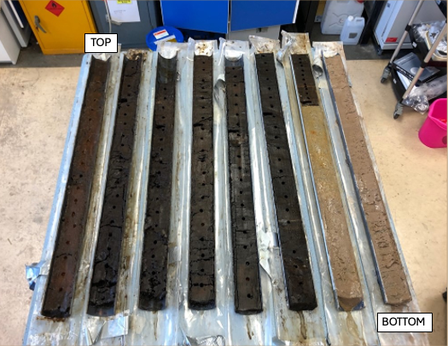

Figure S1 The long sediment core (LF17) retrieved from Lough Feeagh. The top and bottom of the core are labelled, with each section extending 1 m in length.
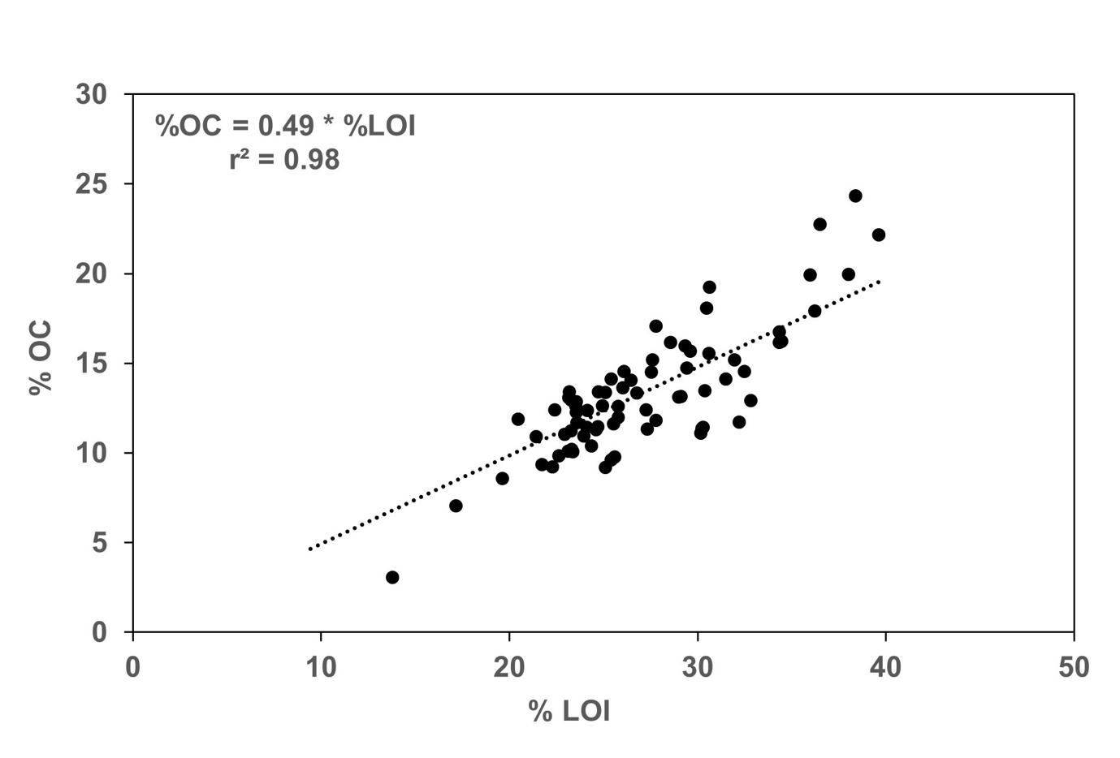
Figure S2 Scatterplot showing the relationship between % loss on ignition (LOI) and % organic carbon (OC).
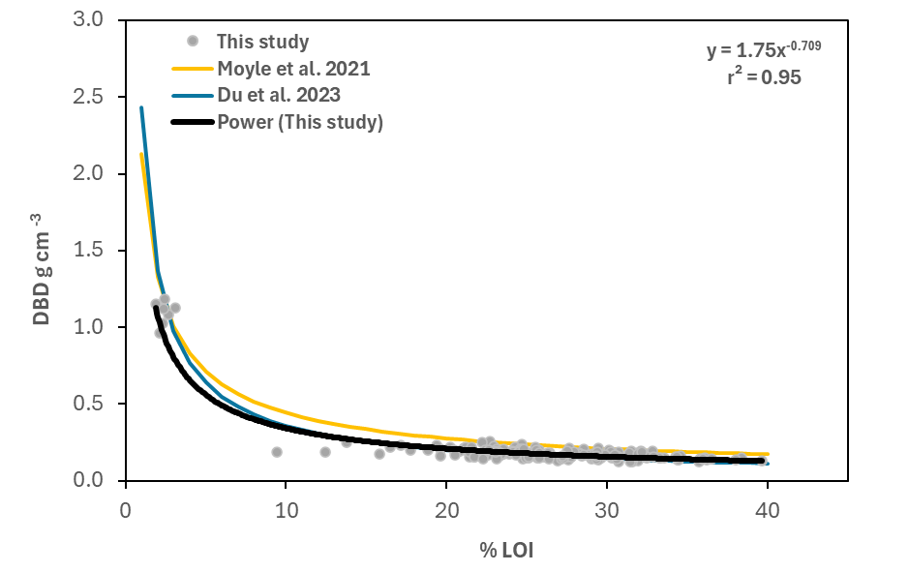
Figure S3 Power law relationship between %LOI and DBD for core LF17 (n = 174). Power law relationships from Moyle et al. (2021) and Du et al. (2023) are shown for comparison.
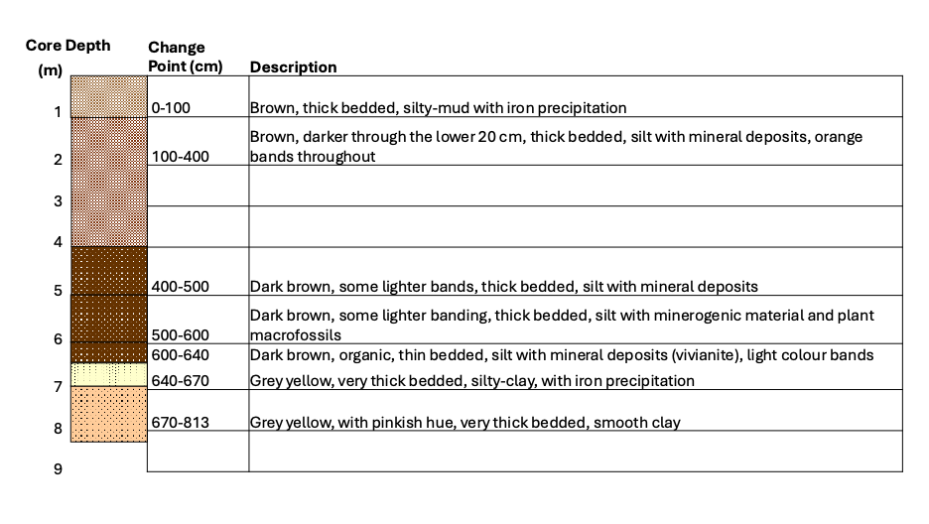
Figure S4 Lithological overview of the long sediment core (LF17) Lough Feeagh with grey yellow, thick bedded, silty-clay glacial clay from 8.13 m to 6.4 m, transitioning sharply to dark brown, organic lake sediment which extends through the top of the core (6.4 to 0.0 m).

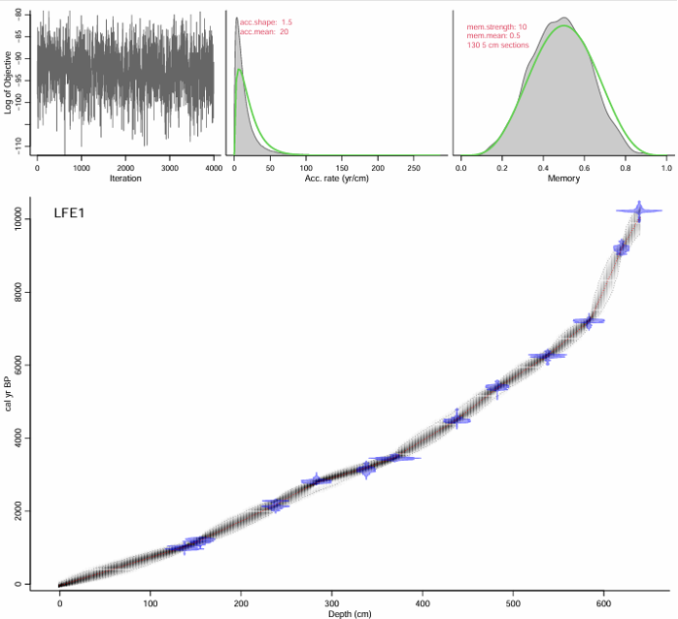

Figure S5 The age-depth model of the long core reconstructed from 12 radiocarbon dates. The graphs above the model from left to right: Trace plot of MCMC runs of the log-posterior distribution, prior in green and posterior shaded, and distributions for accumulation rate and the memory models. The age depth model is below, with 95% intervals shaded in grey. The green shapes reflect the distribution of the individual dates.

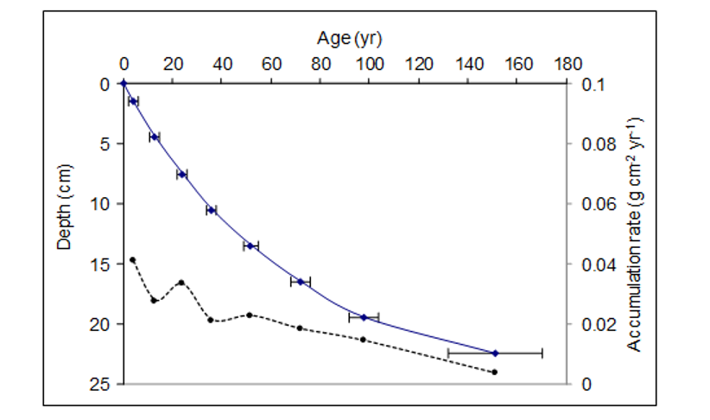

Figure S6 Accumulation rate model from the LF21 sediment core from Lough Feeagh. Radiometric chronology of core LF21 from Lough Feeagh showing the CRS model ²¹⁰Pb dates and sedimentation rates. The solid line shows age while the dashed line indicates sedimentation rate.
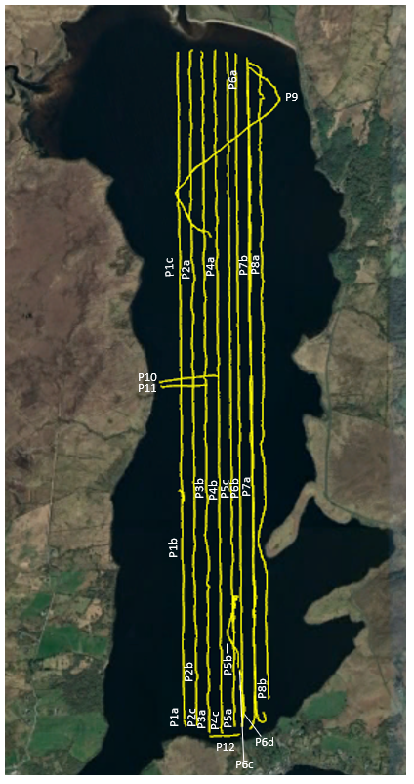
Figure S7 Path and data points of the hydroacoustic survey of Lough Feeagh (Smith, 2023).

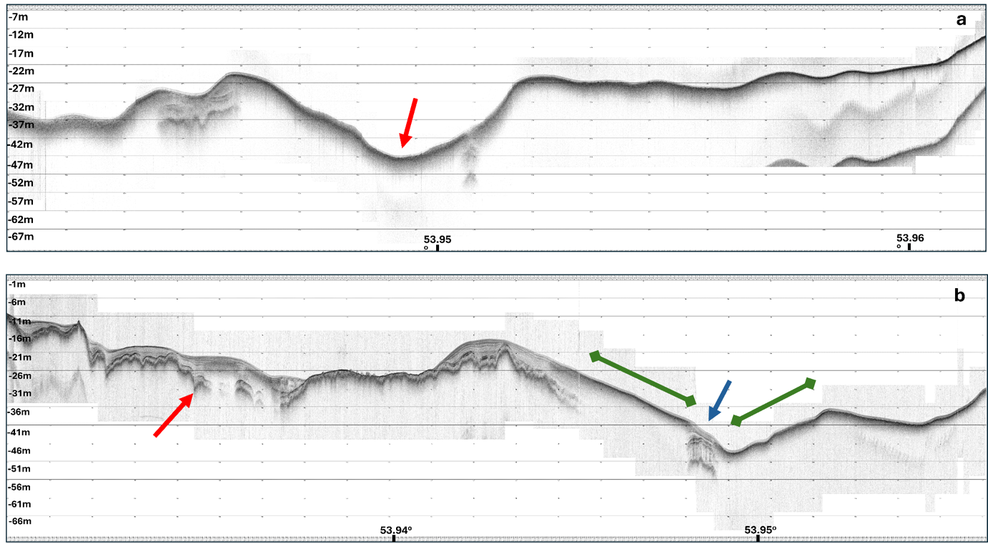

Figure S8 Detail from hydroacoustic profiles from Lough Feeeagh based on Smith (2023): a. seismic profile P3 showing the maximum depth of the lake floor at - 50.05 m (red arrow); b. seismic profile showing acoustic penetration to depths of approximately 7 m (red arrow), acoustic blanking (green arrows) and penetration between areas of blanking (blue arrow).

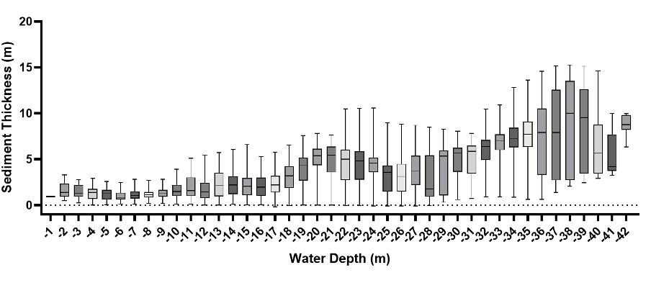
Figure S9 Box and whisker plot showing the variation in sediment thickness (m) at 1 m water depth bathymetry intervals in Lough Feeagh.

Supplementary Tables

Table S1 Median (p50), 5th percentile (p5) and 95th percentile for % loss-on-ignition (LOI) and OC density for the top 40 cm for cores collected in this study (LF17 and LF21), and four short cores from previous studies (LF06 and LF10A, B and C). The overall values for the top 40 cm and for all samples to a depth of 640 cm are also included. The values in bold were those used in the calculation of the total OC store.

Core code | Study year | Length  cm  (n) | LOI  %  p50 | LOI  %  p5 | LOI  %  p95 | OC  kg m⁻³  p50 | OC  kg m⁻³  p5 | OC  kg m⁻³  p95 | Reference
LF06 | 2006 | 40 (38) | 37.1 | 23.4 | 46.6 | 24.7 | 21.6 | 26.4 | Dalton et al. 2014
LF10A | 2010 | 39 (19) | 23.0 | 16.1 | 32.3 | 21.5 | 19.4 | 23.7 | Dalton et al. 2018
LF10B | 2010 | 39 (39) | 29.7 | 20.0 | 43.8 | 23.1 | 20.6 | 25.9 | Dalton et al. 2018
LF10C | 2010 | 40 (20) | 37.7 | 25.5 | 46.8 | 24.8 | 22.1 | 26.4 | Dalton et al. 2018
LF17 | 2017 | 40 (14) | 24.2 | 18.7 | 29.3 | 25.5 | 19.6 | 28.8 | This study
LF21 | 2021 | 40 (40) | 20.3 | 11.5 | 34.0 | 14.6 | 9.6 | 23.6 | This study
Feeagh top 40cm |  | 40 (249) | 25.8 | 16.1 | 45.3 | 22.4 | 11.0 | 26.4
Feeagh all depths |  | 640 (416) | 26.2 | 16.3 | 40.7 | 22.4 | 12.1 | 26.5

Table S2 ²¹⁰Pb chronology of core LF17 from Lough Feeagh
Depth | Dry mass | Chronology |  |  | Sedimentation Rate
 |  | Date | Age
cm | g cm⁻² | CE | yr | ± | g cm⁻² yr⁻¹ | cm yr⁻¹ | ± %
0 | 0 | 2021 | 0
1.5 | 0.1473 | 2017 | 4 | 2 | 0.041 | 0.395 | 12.7
4.5 | 0.4676 | 2008 | 13 | 2 | 0.0278 | 0.25 | 9.7
7.5 | 0.8143 | 1997 | 24 | 2 | 0.0334 | 0.307 | 15.7
10.5 | 1.1213 | 1985 | 36 | 2 | 0.0213 | 0.196 | 12.3
13.5 | 1.4636 | 1969 | 52 | 3 | 0.0227 | 0.181 | 10.3
16.5 | 1.8749 | 1949 | 72 | 4 | 0.0183 | 0.13 | 13.2
19.5 | 2.3101 | 1923 | 98 | 6 | 0.0143 | 0.101 | 23.7
22.5 | 2.7253 | 1870 | 151 | 19 | 0.0035 | 0.024 | 27.7

