Extended Data
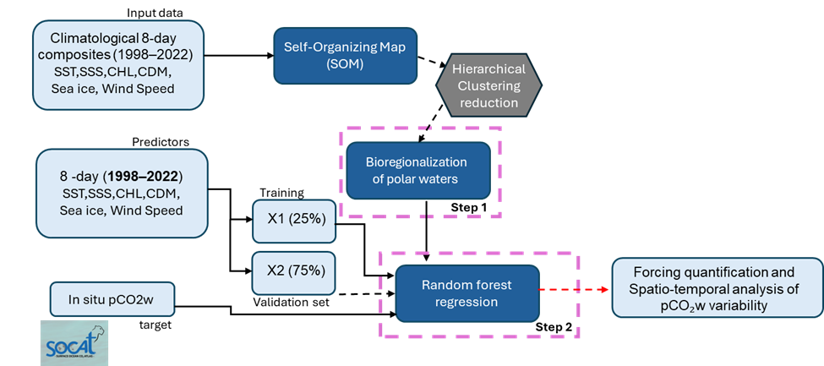
Extended Data Fig. 1. Schematic overview of the SOM–RF framework for pCO₂w reconstruction. Climatological and 8-day environmental variables (sea surface temperature, sea surface salinity, Chl-a, a_{CDM}(443), sea-ice concentration and surface wind fields) were used to derive biogeochemical provinces using a Self-Organizing Map (SOM) followed by hierarchical clustering. In situ pCO₂w observations (SOCAT) were matched to these provinces and randomly partitioned into training (25%) and validation (75%) subsets. Random Forest regression models were then trained within each province to reconstruct pCO₂w, enabling subsequent quantification of environmental drivers and spatio-temporal variability.
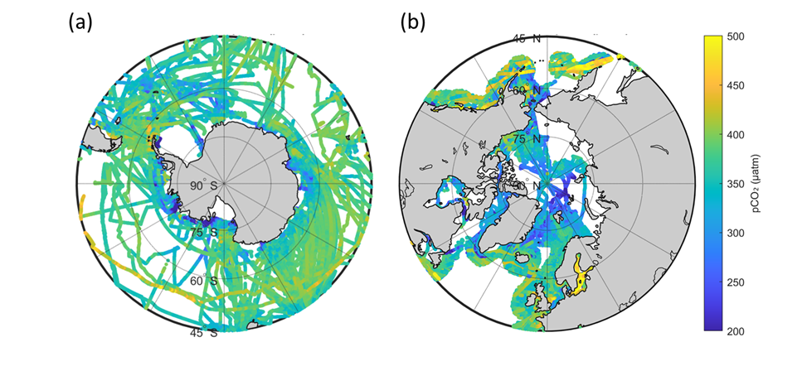Extended Data Fig. 2. Spatial distribution of in situ pCO₂w observations. (a, b) Distribution of surface ocean pCO₂w measurements from the SOCAT database across the Southern Ocean (a) and Arctic Ocean (b) for the period 1998-2022. Colours indicate pCO₂w values (µatm). Data coverage is heterogeneous, with denser sampling along ship tracks and in seasonally ice-free regions, and sparse observations in ice-covered and remote areas.

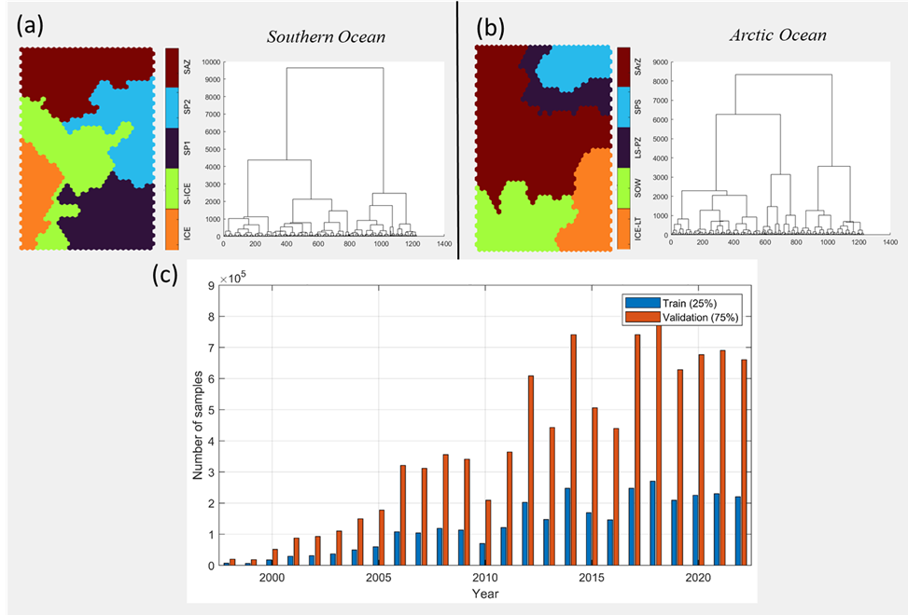
Extended Data Fig. 3. SOM-HAC regionalization and data partitioning. (a, b) Spatial distribution of biogeochemical provinces derived from the Self-Organizing Map (SOM) and Hierarchical Agglomerative Clustering (HAC) framework for the Southern Ocean (a) and Arctic Ocean (b). Colours indicate the five clusters identified from the 8-day climatology of environmental variables. Insets show the corresponding HAC dendrograms based on Ward’s linkage applied to SOM neurons, illustrating the hierarchical relationships among clusters. (c) Temporal distribution of pCO₂w observations used for model development, showing the number of samples assigned to training (25%) and validation (75%) subsets for each year over the 1998-2022 period.
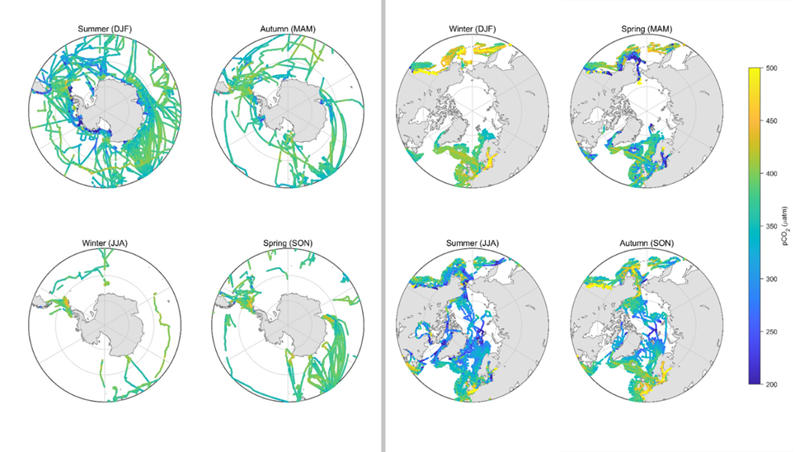Extended Data Fig. 4. Seasonal distribution of in situ pCO₂w observations and matchup data. Seasonal spatial distribution of surface ocean pCO₂w measurements (SOCAT) across the Southern Ocean (left) and Arctic Ocean (right) for the period 1998-2022. Panels are arranged by climatological seasons (DJF, MAM, JJA, SON). Colours indicate pCO₂w values (µatm). Sampling is strongly seasonally biased, with dense coverage during summer months and limited observations during winter, particularly in ice-covered regions. Overall, observations are concentrated along ship tracks and in open-water areas, highlighting the uneven spatial and seasonal coverage of the dataset.

