Supplementary Information
1. SOM-based separation of polar environmental regimes
The SOM-HAC framework separated the Southern and Arctic Oceans into ten environmental regimes, providing a compromise between resolving the dominant polar biogeochemical processes and maintaining an interpretable number of provinces (Supplementary Fig. 1). This classification captured the main gradients in sea-ice influence, hydrography, biological activity and wind forcing, while avoiding excessive fragmentation of physically coherent regions. To evaluate the similarity among provinces independently of hemisphere, we applied hierarchical agglomerative clustering to the seasonal environmental signatures of the ten provinces, integrating the temporal evolution of all predictor variables across the climatological cycle. The resulting dendrogram shows both cross-hemisphere similarities and basin-specific organization: some provinces cluster according to shared environmental structure, whereas others form Arctic- or Southern Ocean-dominated groups. This indicates that the classification captures comparable polar process regimes while preserving the distinct environmental organization of each hemisphere.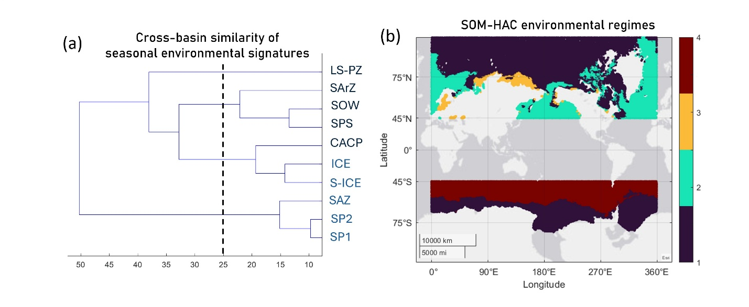 Supplementary Fig. 1. Cross-basin similarity and spatial distribution of SOM-HAC environmental regimes. (a) Hierarchical agglomerative clustering of the normalized seasonal environmental signatures of the ten SOM-HAC provinces, computed independently of hemisphere. The analysis integrates the climatological evolution of sea surface temperature, sea surface salinity, Chl-a, colored dissolved and detrital matter absorption, sea-ice fraction and wind components. The dashed vertical line indicates the selected clustering threshold. (b) Spatial distribution of the resulting SOM-HAC clusters across the Arctic and Southern Oceans. Colors indicate the cluster assignment derived from hierarchical clustering of the SOM best-matching units.
The strongest gradients structuring the SOM space were associated with sea-ice fraction, SST and SSS, which separated ice-covered from open-water systems and defined the major thermal-freshwater contrasts across both basins. Chl-a and a_{CDM}(443) further differentiated provinces according to the biological and optical response to seasonal sea-ice retreat, freshwater inputs and light availability, whereas the zonal and meridional wind components contributed to separating regions with contrasting exposure to mixing, upwelling and open-ocean forcing. This combination of variables allowed the classification to resolve provinces not only by physical state, but also by the seasonal coupling between hydrography and ecosystem response.
Unlike several previous biome frameworks^{12,14,60–62}, mixed-layer depth (MLD) was deliberately excluded as a clustering variable. In polar and coastal environments, MLD estimates remain highly uncertain due to sparse winter observations, strong haline stratification, and complex bathymetry. Instead, sea surface salinity (SSS) and wind forcing were utilized, providing a more robust representation of upper-ocean stratification and mixing regimes in regions where freshwater accumulation and sea-ice processes dominate the near-surface structure. Additionally, the inclusion of sea-ice fraction was critical for resolving transitional environments often oversimplified by fixed-threshold classifications^{12,16}. Rather than grouping all ice-influenced waters into a single class, the SOM-HAC framework separates permanently ice-covered, seasonally ice-covered, and marginal/open-water systems based on their full seasonal behavior. This distinction is crucial in polar oceans, where meltwater stratification, brine rejection, and the timing of ice retreat strongly modulate surface biogeochemistry and pCO₂w.
2. Province-specific environmental contrasts
The environmental separation among provinces is further resolved in Supplementary Fig. 2. In the Southern Ocean, the two subpolar provinces (SP1 and SP2) occupy a similar latitudinal band but differ markedly in their seasonal expression, reflecting the basin’s strong meridional gradients driven by the continuous zonal flow of the Antarctic Circumpolar Current (ACC)¹⁸. SP1 is characterized by weaker biological seasonality, lower Chl-a amplitude, and stronger autumn enhancement in a_{CDM}(443), consistent with a regime more heavily influenced by deep mixing and detrital input. SP2, by contrast, exhibits a more pronounced biological response, warmer surface conditions, and persistently stronger winds. These features align with the dynamically active transitions and wind-driven upwelling characteristic of the major frontal zones (e.g., the Polar Front), which physically separate ice-influenced waters from open subpolar domains^{3,17,63}
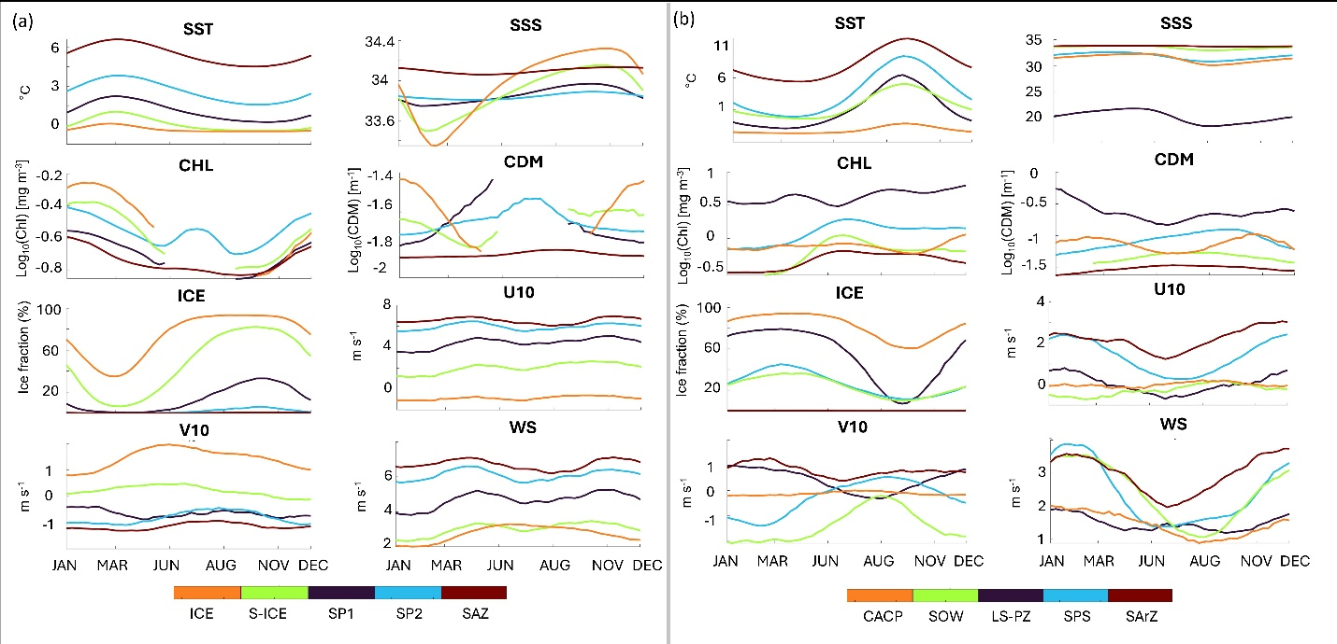Supplementary Fig. 2. Seasonal cycles of environmental variables across biogeochemical provinces. (a, b) Climatological seasonal cycles (8-day means, 1998-2022) of sea surface temperature (SST), sea surface salinity (SSS), chlorophyll-a (CHL), coloured dissolved and detrital matter (CDM), sea-ice fraction (ICE), zonal (U10) and meridional (V10) wind components, and wind speed (WS), spatially averaged within each biogeochemical province. Panels show the Southern Ocean (a) and Arctic Ocean (b). Colours indicate individual provinces as defined in Fig. 1.
Unlike the largely zonal organization of the Southern Ocean, environmental contrasts in the Arctic are heavily shaped by continental boundaries, restricted oceanic gateways, and complex thermohaline circulation patterns^{64,65}. Here, the strongest environmental distinction occurs between the two shelf-influenced provinces (LS-PZ and SPS), which both exhibit strong seasonality but differ fundamentally in hydrographic structure. LS-PZ is defined by persistently low salinity, elevated a_{CDM}(443), and strong terrestrial influence, directly reflecting the massive riverine freshwater and dissolved organic matter inputs that accumulate along the coastal margins^{6,66}. SPS, conversely, is characterized by stronger summer warming, broader seasonal salinity variability, and a more pronounced open-water seasonal bloom, indicative of regions influenced by the inflow of relatively warm and saline Atlantic and Pacific waters^{8,21}. These circulation-driven differences in stratification and light availability likely explain the much broader and more asymmetric pCO₂w distributions observed in Arctic shelf systems relative to the central basin and open-water inflow provinces.
3. Reconstruction challenges and uncertainty in high-latitude pCO₂w
Reconstructing surface pCO₂w in polar oceans remains challenging as a consequence of sparse observational records, seasonally biased and environmentally uneven. Despite this, the province-based Random Forest framework demonstrates robust predictive skill with negligible systematic bias. The mean bias between predicted and observed pCO₂w is exceptionally low (-0.085 µatm in the Southern Ocean and -0.379 µatm in the Arctic Ocean), and the predicted distributions accurately replicate the medians and overall shapes of the observational datasets (Supplementary Fig. 3c, d). Notably, the model's error margins are comparable to the typical observational uncertainty inherent to SOCAT surface CO₂ measurements themselves^{11,22}. The performance achieved here represents a significant improvement over previous machine-learning reconstructions in high-latitude or coastal environments, which often report RMSEs ranging from ~29 µatm for the Arctic¹⁶ to over 30 µatm globally¹⁴. Furthermore, reconstruction skill remains consistently robust when evaluated within individual biogeochemical provinces (Supplementary Fig. 4).
Despite this strong overall performance, quantifying surface pCO₂w in polar oceans remains subject to distinct spatial uncertainties. Analysis of the out-of-bag standard deviation (OOB STD) reveals that the largest prediction uncertainties (up to ~16 µatm) are concentrated in coastal regions and marginal ice zones (Supplementary Fig. 5). In the Arctic, higher uncertainty patches are particularly prominent along the continental shelves of the Baltic, Barents, and Kara Seas. These are dynamically complex areas characterized by massive terrestrial inputs, episodic mixing, and high natural short-term pCO₂w variability that is difficult to constrain^{67,68}. Similarly, in the Southern Ocean, elevated OOB STD is tightly coupled to regions influenced by seasonal sea-ice dynamics, where observational scarcity traditionally limits model constraints^{69,70}.
These regional uncertainties are fundamentally linked to the limitations of the observational record. Beyond the spatial scarcity of data prior to 2010, the most significant constraint is the severe lack of wintertime measurements under sea-ice conditions (Supplementary Fig.6). Sea-ice presents a compounding challenge: it severely reduces observational coverage while simultaneously altering air-sea gas exchange, freshwater budgets, and upper-ocean stratification. To maximize data utilization and mitigate the loss of satellite optical products during polar night or heavy cloud cover, we employed a dual-model strategy separating the CHLCDM and SEAICE configurations (Supplementary Fig. 3). This approach ensures continuous reconstruction across transitional and fully ice-covered waters, minimizing data loss and robustly resolving the extreme environmental heterogeneity of polar oceans.
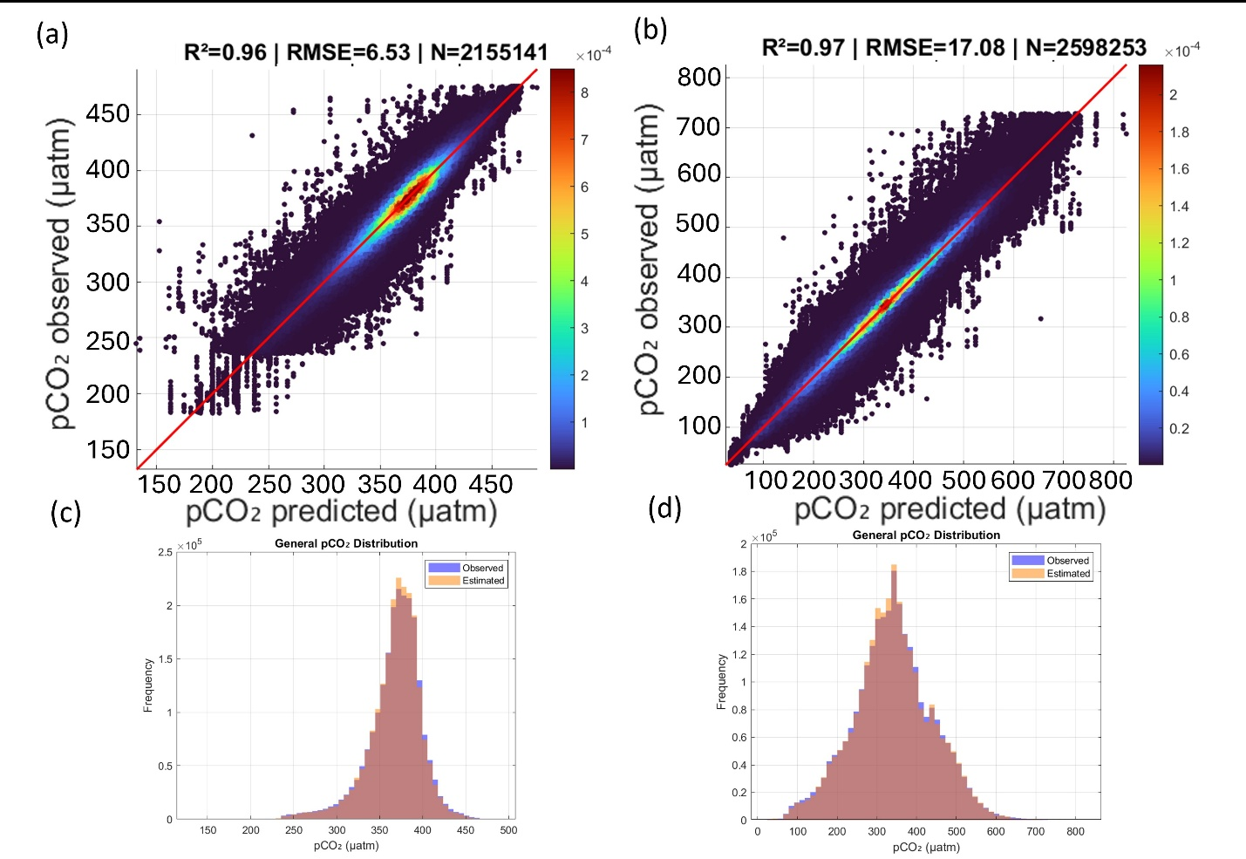Supplementary Fig. 3. Model performance for pCO₂w reconstruction. (a, b) Density scatterplots comparing observed and predicted pCO₂w values for the validation dataset (75% of observations) in the Southern Ocean (a) and Arctic Ocean (b). The coefficient of determination (R²), root mean square error (RMSE) and number of observations (N) are reported for each region. (c, d) Distributions of observed and predicted pCO₂w values for the Southern Ocean (c) and Arctic Ocean (d).
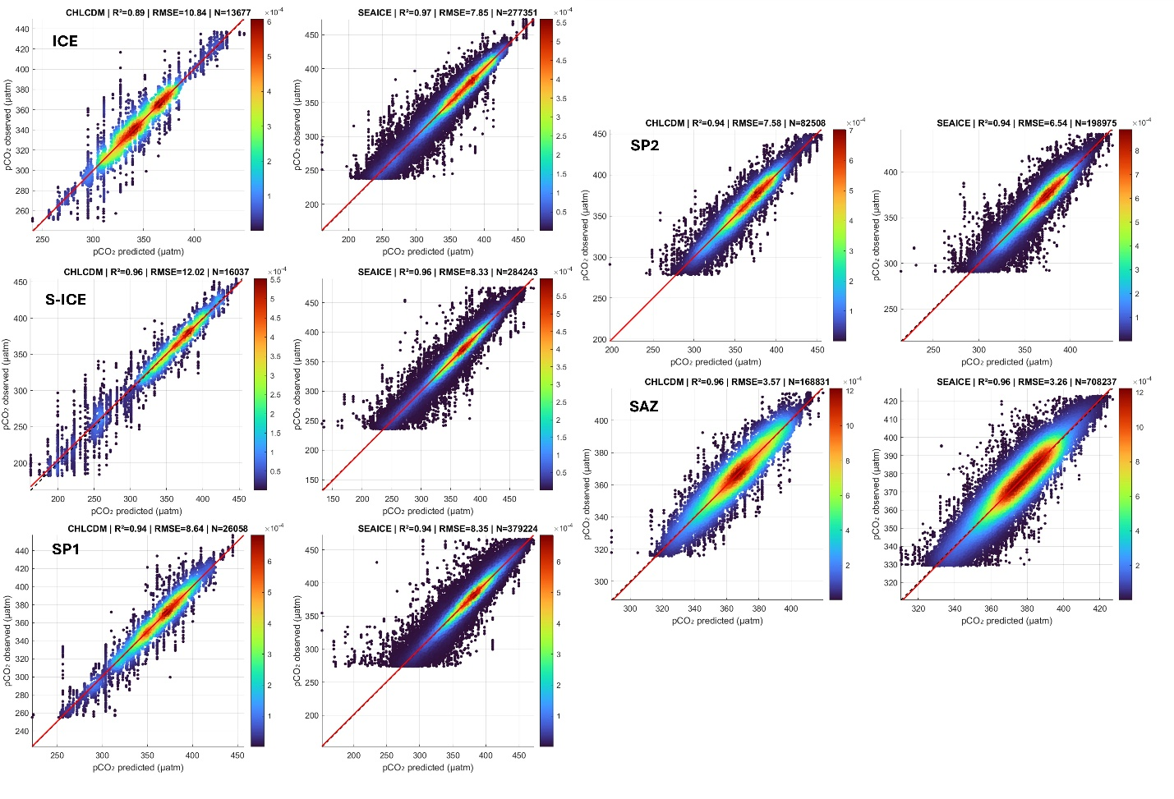Supplementary Fig. 4. Performance of the Random Forest (RF) models for reconstructing pCO₂w within each SOM-defined biogeochemical province of the Southern Ocean. Scatter density plots show predicted versus observed pCO₂w for the SEAICE and CHLCDM model configurations. Colors indicate point density, and the red line denotes the 1:1 relationship. R², RMSE, and the number of observations (N) are reported for each province.
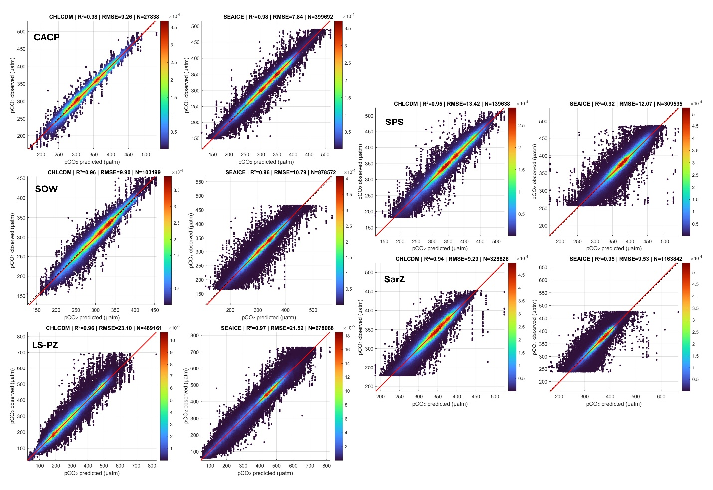Supplementary Fig. 4. cont. Performance of the Random Forest (RF) models for reconstructing pCO₂w within each SOM-defined biogeochemical province of the Arctic Ocean. Scatter density plots show predicted versus observed pCO₂w for the SEAICE and CHLCDM model configurations. Colors indicate point density, and the red line denotes the 1:1 relationship. R², RMSE, and the number of observations (N) are reported for each province.
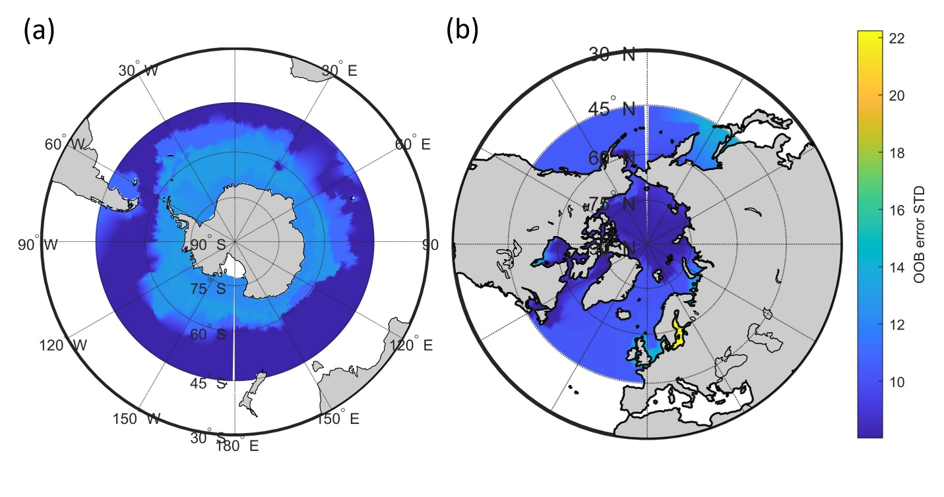
Supplementary Fig. 5. Spatial distribution of model uncertainty (a, b) Spatial distribution of model uncertainty, expressed as the out-of-bag standard deviation (OOB STD) of Random Forest predictions, for the Southern Ocean (a) and Arctic Ocean (b).
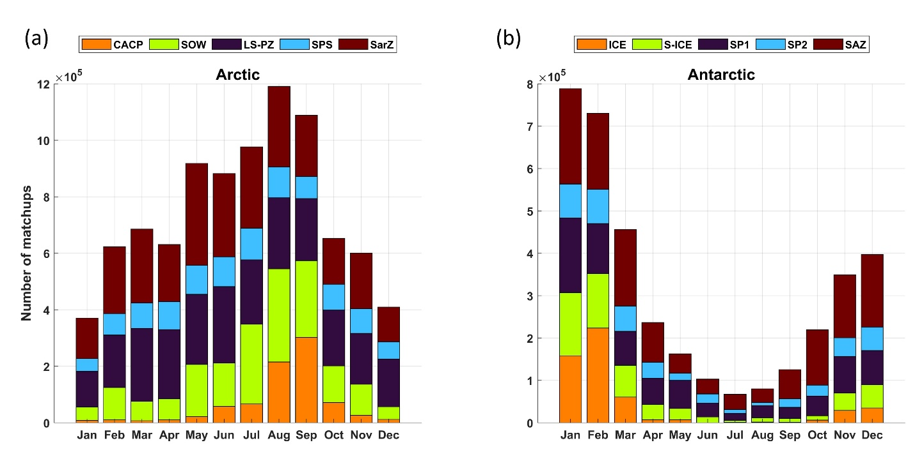Supplementary Fig.6. Monthly sampling distribution across biogeochemical provinces. (a, b) Monthly distribution of in situ pCO₂w matchups across biogeochemical provinces in the Arctic Ocean (a) and Southern Ocean (b). Stacked bars indicate the number of co-located model-SOCAT observations assigned to each SOM class. Variations reflect seasonal and regional differences in data availability.

4. Seasonal structure and interannual variability within provinces
The province-scale time series demonstrate that the reconstruction accurately captures not only the dominant seasonal phase but also the interannual variability of pCO₂w across all distinct biogeochemical domains over the full 1998-2022 period (Supplementary Fig. 7). Furthermore, examining this temporal evolution at the province level reveals critical differences in seasonal amplitude and localized mechanistic controls that drive the broader hemispheric asymmetry in pCO₂w climatology (Supplementary Fig. 8).
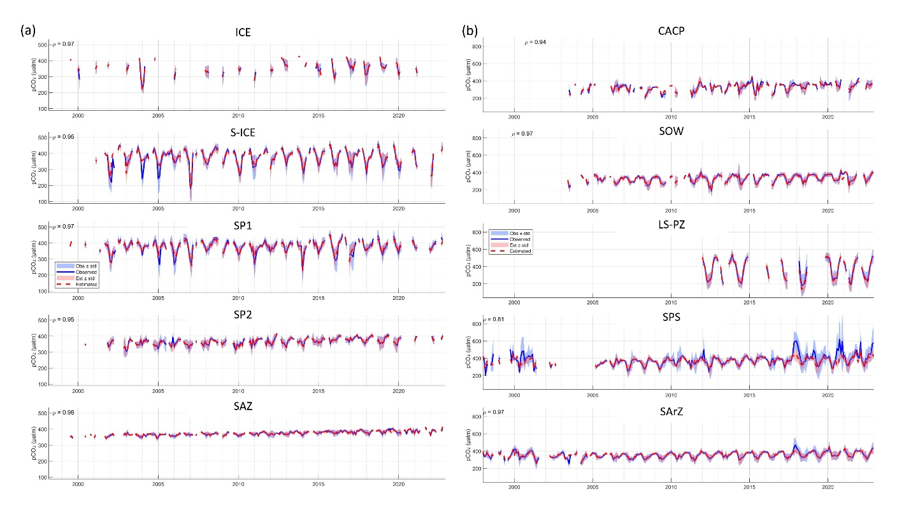Supplementary Fig.7. Temporal variability of observed and reconstructed pCO₂w (µatm) within each biogeochemical province for the (a) Southern Ocean and (b) Arctic Ocean. The red line represents RF-reconstructed pCO₂w and the blue line SOCATv2024 observations. Shaded areas indicate ±1 standard deviation. Each panel corresponds to a SOM-HAC biogeochemical province.
In the Southern Ocean, although the temporal phasing remains relatively coherent across the basin, the seasonal amplitude varies markedly by province (Supplementary Fig. 8a). Highly productive and ice-influenced subpolar sectors (such as ICE and S-ICE) exhibit deep spring-summer pCO₂w drawdowns and elevated autumn-winter values. This marked amplitude is driven by the strong seasonal interplay of biological carbon uptake, meltwater stratification, deep winter mixing, and light limitation^{1,3,7}. Moving northward, this amplitude becomes progressively dampened, resulting in a nearly flat seasonal pCO₂w cycle in the SAZ.
In the Arctic Ocean, the province-level temporal structures further illustrate why pCO₂w variability cannot be described by a single basin-wide seasonal mode (Supplementary Fig. 8b). The open-water and central-basin provinces generally display classic, pronounced summer drawdowns. However, the shelf-dominated systems (specifically LS-PZ and SPS) exhibit fundamentally different temporal shapes, characterized by much broader, less uniform, and higher-amplitude seasonal ranges. This temporal divergence is consistent with the overwhelming, localized influence of rapid freshwater dilution, massive terrestrial inputs, episodic coastal processes, and regional asymmetries in the timing of sea-ice retreat, which locally supersede the broader basin-scale forcing^{6,20}. These spatio-temporal structures confirm that polar surface pCO₂w is regulated by a superposition of distinct regional carbon regimes.
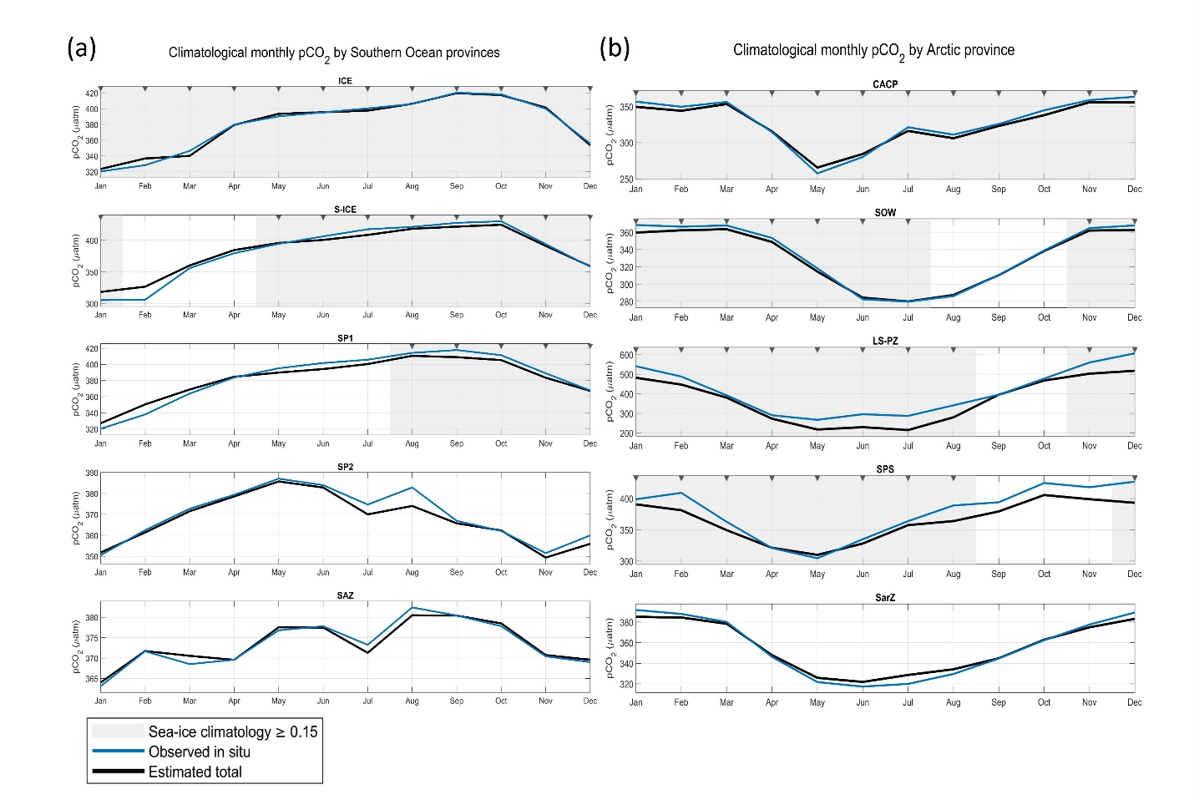Supplementary Fig. 8. Seasonal evolution of observed (blue) and reconstructed (black) surface pCO₂w. Curves represent monthly climatological averages within each SOM-HAC province. Grey shaded intervals indicate months when the climatological sea-ice fraction exceeds 0.15, highlighting periods of reduced air–sea gas exchange. Note that y-axis scales differ across panels.
5. Thermal and non-thermal organization of pCO₂w variability
The cumulative weighted predictor importance shows that the hemispheric asymmetry in pCO₂w regulation reflects a real contrast in process dominance, rather than a simple difference in environmental setting (Supplementary Fig. 9). In the Southern Ocean, the strongest contributions are generally associated with SSS, wind forcing and Chl-a, indicating that seasonal pCO₂w variability is organized primarily by non-thermal processes, particularly in the sea-ice and subpolar provinces. In this basin, the importance of SSS likely reflects the strong coupling between sea-ice melt, freshwater stratification, brine rejection and mixed-layer adjustment, all of which modulate the exposure of the surface ocean to carbon-rich subsurface waters^{27,28}. Wind forcing is also physically consistent with enhanced Ekman transport, ventilation and vertical exchange, especially in the subpolar Southern Ocean where the upward supply of dissolved inorganic matter might weaken or reverse seasonal biological drawdown^{3,29,30}.
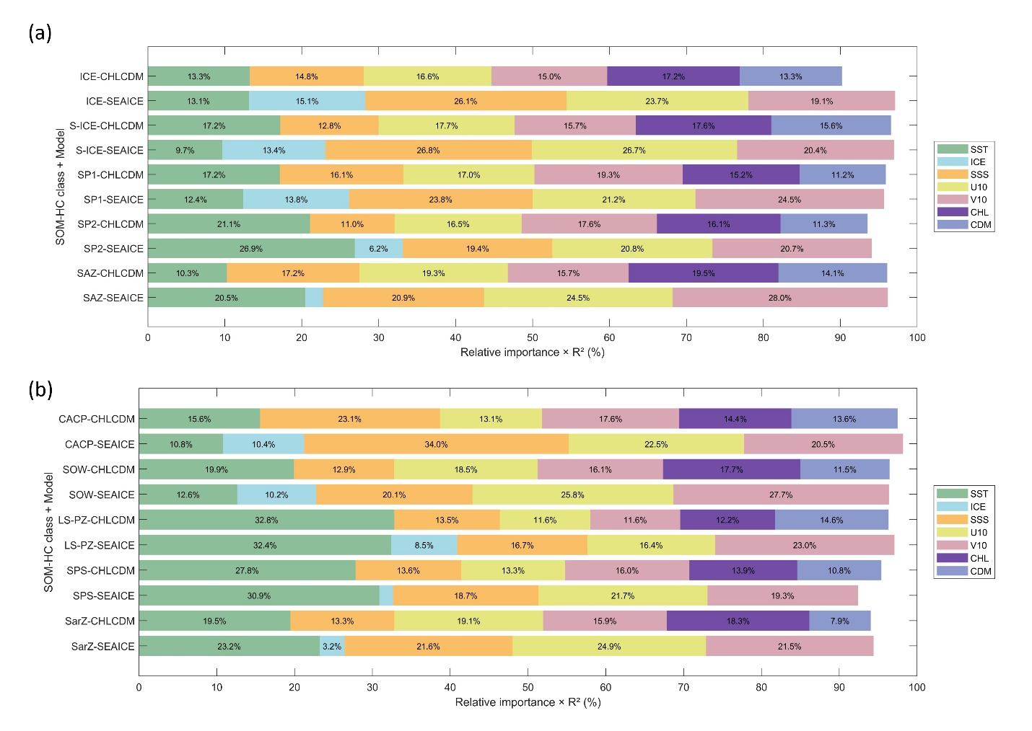Supplementary Fig. 9. Relative contribution (%) of environmental predictors to pCO₂w variability across Southern (a) and Arctic (b) Ocean biogeochemical provinces. Each bar shows the cumulative weighted importance (R² × variable importance) for the CHLCDM and SEAICE models.
The emergence of Chl-a as the dominant predictor in the SAZ (Supplementary Fig. 9) is particularly consistent with previous work showing that biological production exerts strong control on seasonal pCO₂ minima in this region^{7,10,31,32}. In this setting, the seasonal increase in the thermal component of pCO₂ during summer is partially or largely offset by phytoplankton CO₂ uptake, whereas autumn and winter are characterized by renewed carbon supply through mixing and advection. This seasonal compensation between warming and biological drawdown appears to be a defining feature of Southern Ocean carbon seasonality and is consistent with recent conceptual descriptions of latitudinal shifts in pCO₂ control mechanisms¹⁰.
In the Arctic, by contrast, the broader contribution of SST across open-water inflow regions (Supplementary Fig. 9) indicates a larger role for thermodynamic forcing, particularly in Atlantic- and Pacific-influenced waters where seasonal warming and cooling are not strongly masked by persistent sea-ice cover³³. This broader thermal footprint contrasts with the Southern Ocean, where SST rarely dominates at basin scale.

6. Freshwater and riverine influence in Arctic shelf systems
The Arctic shelf provinces likely represent the clearest departure from purely thermodynamic pCO₂w regulation. In these systems, the prominence of SSS and the weaker contribution of biological proxies (Supplementary Fig. 8) suggest that surface carbon variability is strongly shaped by freshwater forcing, terrestrial influence and coastal hydrography. River discharge is particularly relevant in this context. Arctic rivers contribute large freshwater fluxes and substantial loads of dissolved and particulate carbon to shelf seas, and river waters are often supersaturated in CO₂ relative to the atmosphere^{6,34}. These inputs can directly elevate surface pCO₂w or indirectly alter it through stratification, optical attenuation and nutrient redistribution. This likely contributes to the broader and more asymmetric pCO₂w distributions observed in Arctic low-salinity and shelf provinces.
7. Biological and hydrographic responses
Long-term trends in biological and hydrographic indicators further support the asymmetry. In the Southern Ocean, Chl-a trends are weakly positive in the more northerly provinces and negative in the southern ice-influenced provinces, suggesting that biological responses are not uniform and may depend on the competing effects of light availability, stratification and nutrient resupply. In the Arctic, Chl-a trends are generally weak or negative despite substantial sea-ice decline, consistent with the possibility that increasing stratification may limit vertical nutrient supply in several provinces^{19,71}. This is especially relevant in freshwater-influenced and shelf environments, where changes in salinity and upper-ocean stability may exert stronger control on productivity than sea-ice retreat alone.
Overall, the long-term trends indicate that the recent evolution of pCO₂w in polar oceans is tightly coupled to the reorganization of the upper ocean, but that the sign and structure of that response differ fundamentally between hemispheres. The Southern Ocean shows a more buffered and regionally variable response, whereas the Arctic exhibits a more coherent shift toward higher surface pCO₂w across contrasting environmental regimes.
60. McKinley, G. A., Fay, A. R., Takahashi, T. & Metzl, N. Convergence of atmospheric and North Atlantic carbon dioxide trends on multidecadal timescales. Nature Geoscience 2011 4:9 4, 606–610 (2011).
61. Fay, A. R. & McKinley, G. A. Global trends in surface ocean pCO2 from in situ data. Global Biogeochem. Cycles 27, 541–557 (2013).
62. Roobaert, A. et al. The Spatiotemporal Dynamics of the Sources and Sinks of CO2 in the Global Coastal Ocean. Global Biogeochem. Cycles 33, 1693–1714 (2019).
63. Kim, Y. S., Orsi, A. H., Kim, Y. S. & Orsi, A. H. On the Variability of Antarctic Circumpolar Current Fronts Inferred from 1992–2011 Altimetry. J. Phys. Oceanogr. 44, 3054–3071 (2014).
64. Serreze, M. C., Barrett, A. P., Stroeve, J. C., Kindig, D. N. & Holland, M. M. The emergence of surface-based Arctic amplification. Cryosphere 3, 11–19 (2009).
65. Rudels, B., Jones, E. P., Anderson, L. G. & Kattner, G. On the Intermediate Depth Waters of the Arctic Ocean. 33–46 (2013) doi:10.1029/gm085p0033.
66. McClelland, J. W., Holmes, R. M., Peterson, B. J. & Stieglitz, M. Increasing river discharge in the Eurasian Arctic: Consideration of dams, permafrost thaw, and fires as potential agents of change. Journal of Geophysical Research Atmospheres 109, (2004).
67. Terhaar, J., Lauerwald, R., Regnier, P., Gruber, N. & Bopp, L. Around one third of current Arctic Ocean primary production sustained by rivers and coastal erosion. Nature Communications 2021 12:1 12, 169- (2021).
68. Parmentier, F.-J. W. et al. Geological Survey, Alaska Cooperative Fish and Wildlife Research Unit. Geophysical Research Abstracts 15, 2013–5758 (2013).
69. Fay, A. R. et al. SeaFlux: Harmonization of air-sea CO2 fluxes from surface pCO2 data products using a standardized approach. Earth Syst. Sci. Data 13, 4693–4710 (2021).
70. Bushinsky, S. M. et al. Reassessing Southern Ocean Air-Sea CO2 Flux Estimates With the Addition of Biogeochemical Float Observations. Global Biogeochem. Cycles 33, 1370–1388 (2019).
71. Hofmann, M., Worm, B., Rahmstorf, S. & Schellnhuber, H. J. Declining ocean chlorophyll under unabated anthropogenic CO2 emissions. Environmental Research Letters 6, (2011).

