Chromosome-level genome assembly of landrace ‘Huangzhou’ provides insights into high cellulose accumulation in radish
Shisheng Li^{1,*}, Ke Xu¹, Yujia Liu¹, Huan Liu ^{2,3,4}, Yuanyuan Tan¹, Wei Tu¹, Hongjin Dong¹, Haiping Xin², Changjun Ge⁵, Lei Gao^{2,3}, Xiaofen Yu^{2, *}
¹ Economic Forest Germplasm Improvement and Comprehensive Utilization of Resources of Hubei Key Laboratories, Collaborative Innovation Center for the Characteristic Resources Exploitation of Dabie Mountains, College of Biology and Agricultural resource, Huanggang Normal University, Huanggang, Hubei 438000, China
² State Key Laboratory of Plant Diversity and Specialty Crops, Wuhan Botanical Garden, Chinese Academy of Sciences, Wuhan, Hubei 430074, China
³ Hubei Hongshan Laboratory, Wuhan, Hubei 430070, China
⁴ Bioinformatics Center, College of Plant Science and Technology, Beijing University of Agriculture, Beijing 102206, China
⁵ Huanggang Acadamy of Agriculture, Huanggang, Hubei 438000, China

*Corresponding authors: shishengli@hgnu.edu.cn; yuxiaofen@wbgcas.cn

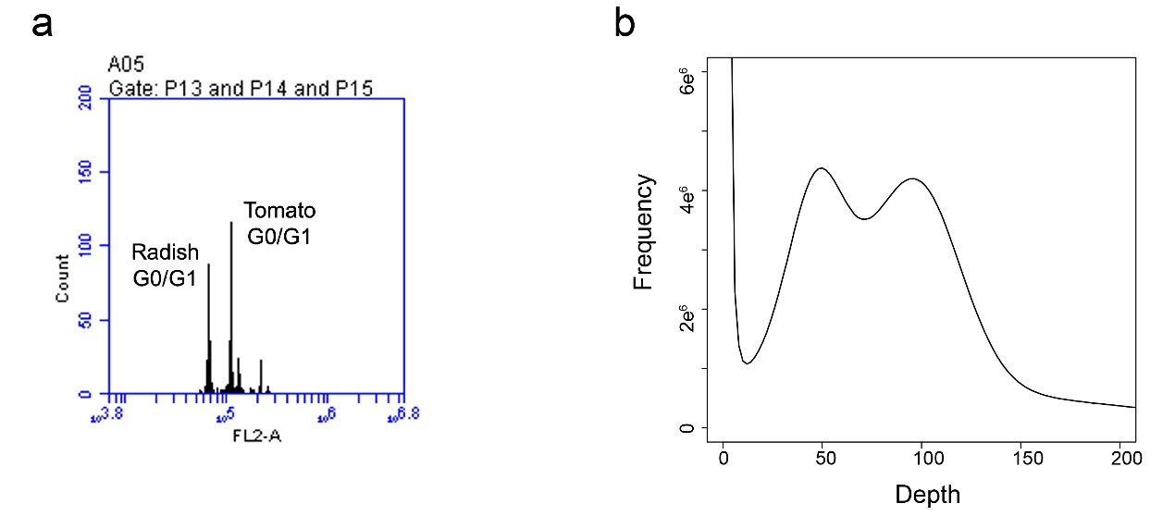
Figure S1. Flow cytometry analysis (a) and genome survey (b) of ‘Huangzhou’ radish. Tomato leaf cells were used as internal reference for flow cytometry analysis.

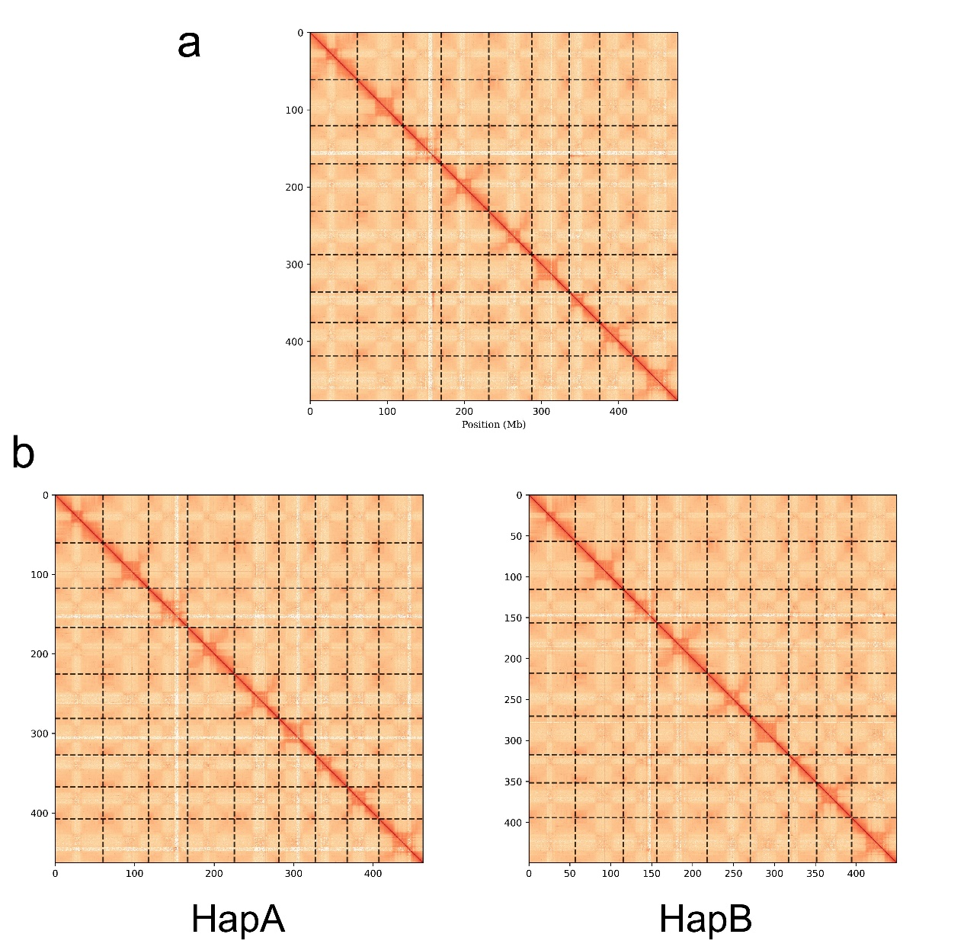
Figure S2. Hi-C interaction heat map of HZ radish primary genome (a) and haplomes (b). Strong interactions are indicated in dark red and weak interactions are indicated in yellow.

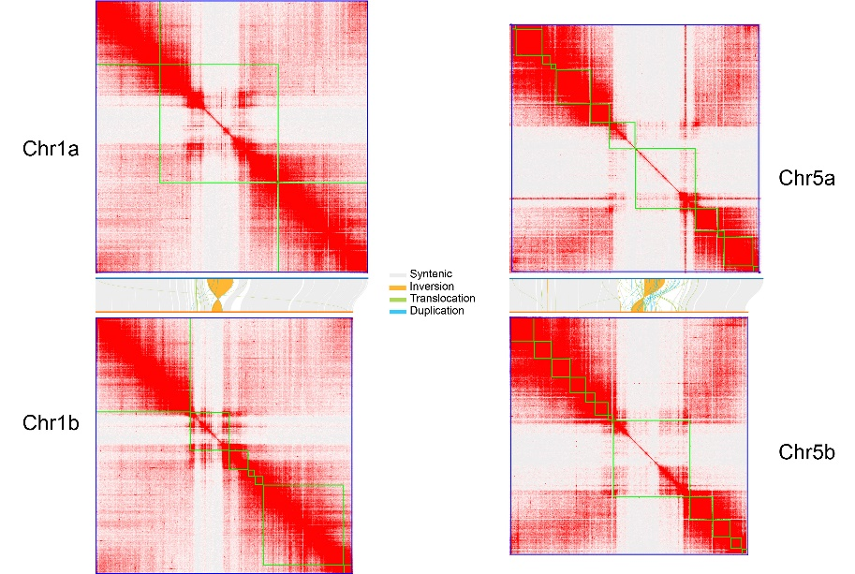
Figure S3. Hi-C interaction heat map of chromosomes 1 and 5 from HapA and HapB. Syntenic regions between the two haplotypes were shown in the center of the figure.

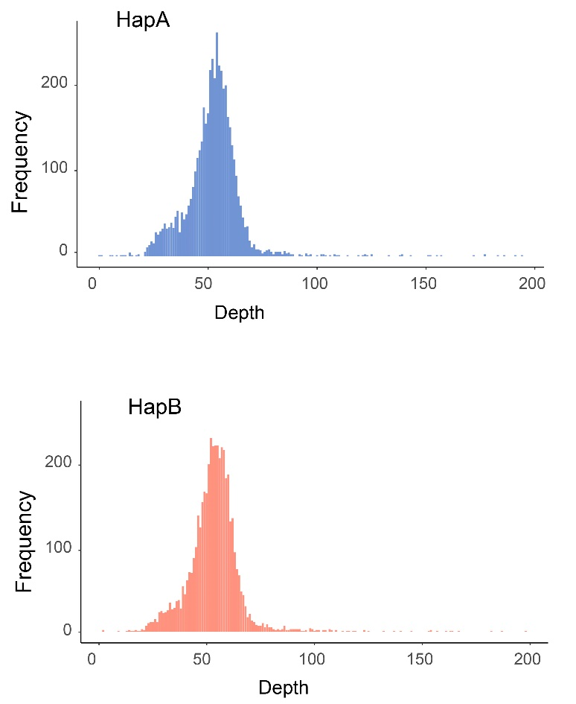
Figure S4. Mapping depth on each haplome by HZ HiFi reads.

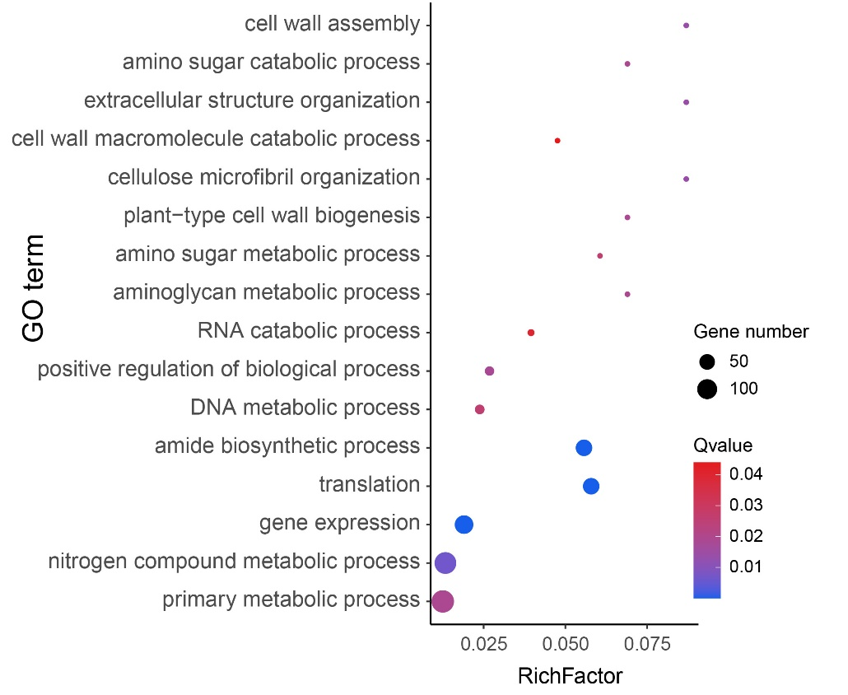
Figure S5. GO enrichment analysis of gene families unique in the HapB genome of ‘Huangzhou’ radish.

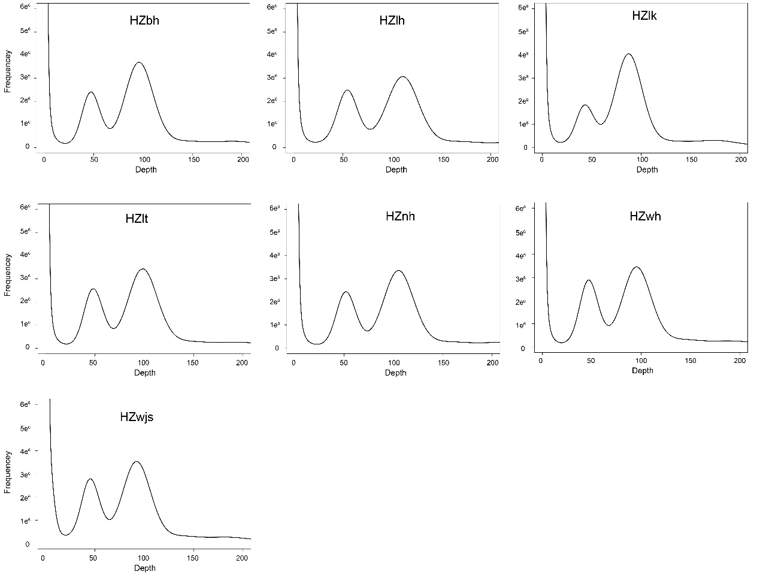
Figure S6. Genome survey of seven ‘Huangzhou’ radish accessions.

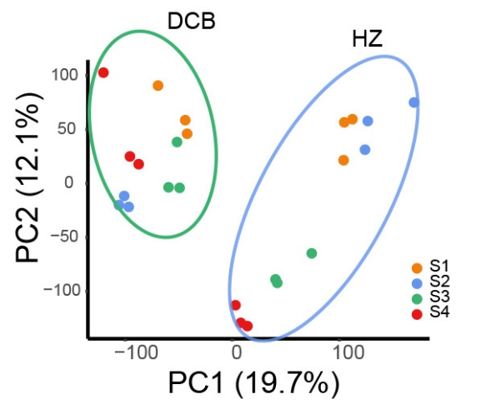
Figure S7. PCA of transcriptomic profiles from ‘Huangzhou’ (HZ) and ‘Dachangbai’ (DCB) taproots at four developmental stages.

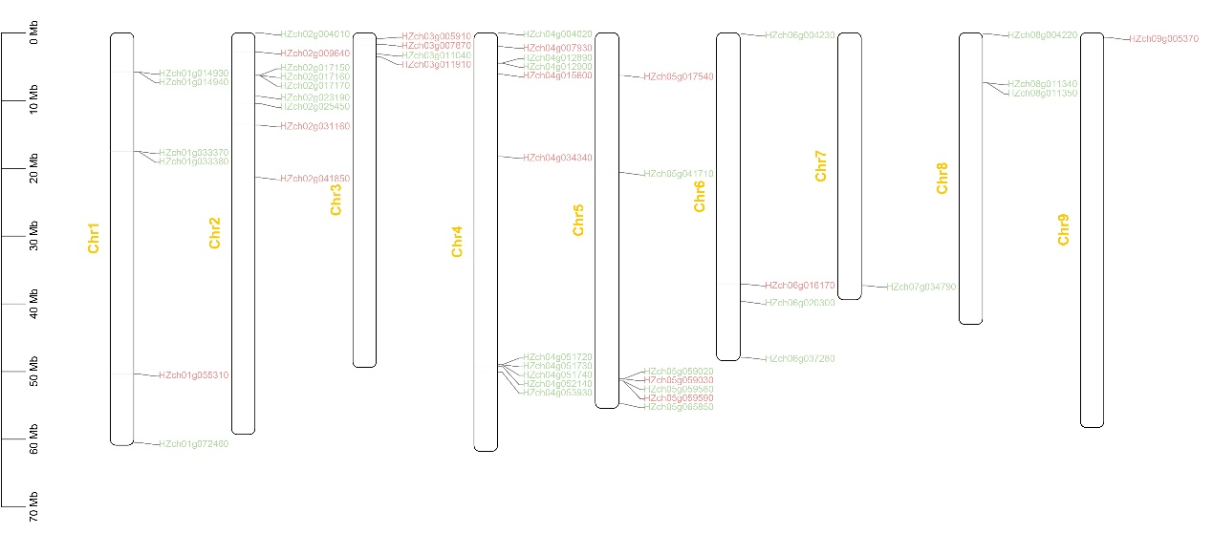
Figure S8. Chromosomal locations of CesA and Csl gene families. CesA and Csl genes are indicated by red and green text, respectively.

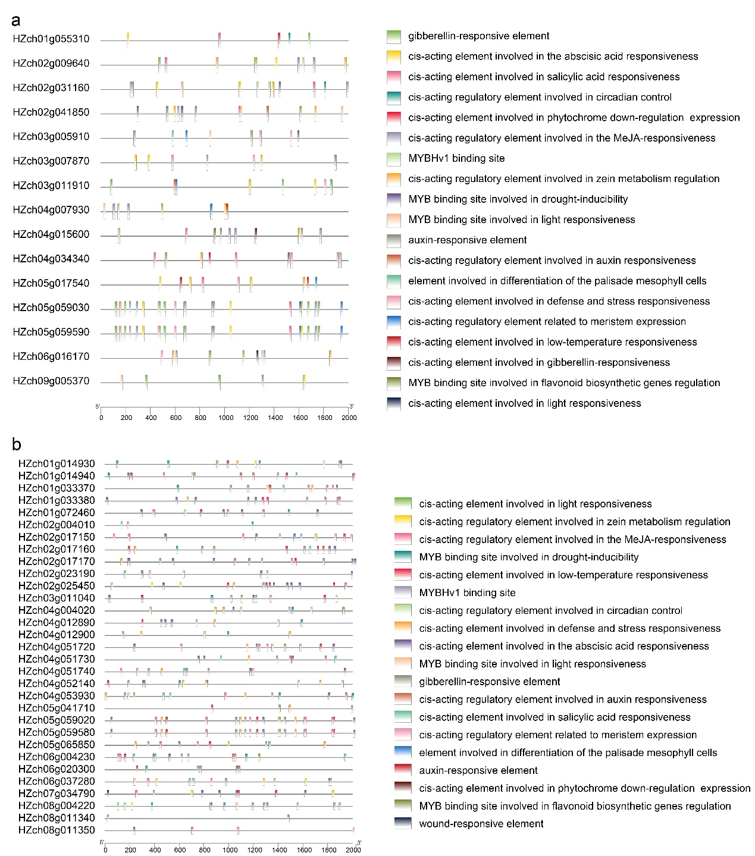
Figure S9. The cis-regulatory elements within the CesA (a) and Csl (b) gene promoters. The upstream 2000-bp region of genes were used.

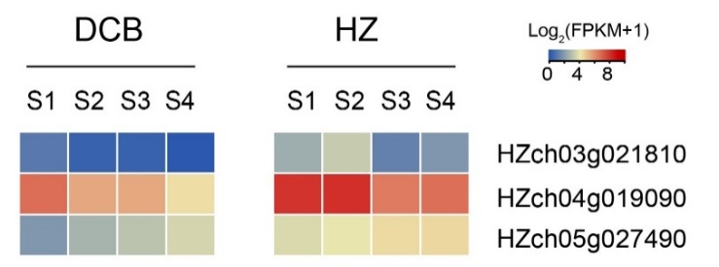
Figure S10. Expression levels of three MYB genes in four stages of ‘Huangzhou’ (HZ) and ‘Dachangbai’ (DCB) taproots.

