Vitamin D Supplementation on Metabolic and Endocrine Profiles in Women with polyendocrine metabolic ovarian syndrome: An Updated Systematic Review and Meta-Regression of Randomized Controlled Trials
Rui Zhang¹, Zhiwen Zhang¹, Jiayue Xia¹, Yanli Gao¹, Ligang Yang¹, Hui Xia¹, Wang Liao¹, Shaokang Wang¹, Guiju Sun¹, MD HELAL SIKDER¹, Han Gao^{2*}, Da Pan^{1*}
¹ Key Laboratory of Environmental Medicine and Engineering of Ministry of Education, and Department of Nutrition and Food Hygiene, School of Public Health, Southeast University, Nanjing, 210009, P.R. China.
² Department of Pharmacology, School of Medicine, Southeast University, Nanjing, 210009, China.
*Corresponding author: Da Pan and Han Gao.
Email: pantianqi92@foxmail.com and han.gao@seu.edu.cn
Content
1. Search Strategy 1
(1) PubMed 1
(2) Scopus 1
(3) Web of Science 1
(4) Embase 2
(5) Cochrane Library 2
2. Supplementary Figures 3
(1) Risk of Bias Plots 3
(2) Forest Plots 4
(3) Subgroup Analysis Forest Plots 4
(4) Meta-Regression Analysis Plot 5
(5) Leave-one-out Sensitivity Analysis Plots 6

Search Strategy

PubMed
((("Polycystic Ovary Syndrome"[Mesh]) OR ("Polycystic Ovarian Syndrome"[Title/Abstract]) OR ("Stein-Leventhal Syndrome"[Title/Abstract]) OR ("Sclerocystic Ovary Syndrome"[Title/Abstract]) OR ("Ovarian Syndrome, Polycystic"[Title/Abstract])) AND (("Vitamin D"[Mesh]) OR ("25-hydroxyvitamin D"[Title/Abstract]) OR ("25(OH)D"[Title/Abstract])) AND (("Randomized Controlled Trial"[Publication Type]) OR ("randomized"[Title/Abstract]) OR ("placebo"[Title/Abstract]) OR ("RCT"[Title/Abstract]))) AND ("Humans"[Mesh]) AND ("English"[Language])

Scopus
TITLE-ABS-KEY ( "polycystic ovary syndrome" OR "polycystic ovarian syndrome" OR "stein-leventhal syndrome" OR "sclerocystic ovary syndrome" OR "polycystic ovarian disease" OR "sclerocystic ovaries" ) AND TITLE-ABS-KEY ( "vitamin d" OR "25(OH)D" OR "25-hydroxyvitamin D" ) AND TITLE-ABS-KEY ( "randomized controlled trial" OR "randomized" OR "placebo" OR "RCT" ) AND TITLE-ABS-KEY ( "human" OR "humans" ) AND LANGUAGE ( english )

Web of Science
#1: TOPIC: ( "polycystic ovary syndrome" OR "polycystic ovarian syndrome" OR "stein-leventhal syndrome" OR "sclerocystic ovary syndrome" OR "polycystic ovarian disease" )
#2: TOPIC: ( "vitamin d" OR "25(OH)D" OR "25-hydroxyvitamin D" )
#3: ABSTRACT: ( "randomized controlled trial" OR "randomized" OR "placebo" OR "RCT" )
#4: TOPIC: ( "human" OR "humans" )
#5: LANGUAGE: ( english )
#6: #1 AND #2 AND #3 AND #4 AND #5

Embase
#1: 'polycystic ovary syndrome'/exp OR 'polycystic ovarian syndrome' OR 'stein-leventhal syndrome' OR 'sclerocystic ovary syndrome' OR 'polycystic ovarian disease' (ab,ti)
#2: 'vitamin d'/exp OR '25-hydroxyvitamin d' OR '25(OH)D' (ab,ti)
#3: 'randomized controlled trial'/exp OR 'randomized' OR 'placebo' OR 'RCT' (ab,ti)
#4: 'human'/exp (ab,ti)
#5: language english
#6: #1 AND #2 AND #3 AND #4 AND #5

Cochrane Library
#1: MeSH descriptor: [Polycystic Ovary Syndrome] explode all trees
#2: (Polycystic Ovarian Syndrome:ti,ab,kw OR Stein-Leventhal Syndrome:ti,ab,kw OR Sclerocystic Ovary Syndrome:ti,ab,kw OR Polycystic Ovarian Disease:ti,ab,kw)
#3: #1 OR #2
#4: MeSH descriptor: [Vitamin D] explode all trees
#5: (vitamin D:ti,ab,kw OR 25(OH)D:ti,ab,kw OR 25-hydroxyvitamin D:ti,ab,kw)
#6: #4 OR #5
#7: MeSH descriptor: [Randomized Controlled Trials] explode all trees OR (randomized controlled trial:ti,ab,kw OR randomized:ti,ab,kw OR placebo:ti,ab,kw OR RCT:ti,ab,kw)
#8: #3 AND #6 AND #7
#9: Language: English
#10: #8 AND

Supplementary Figures

Risk of Bias Plots
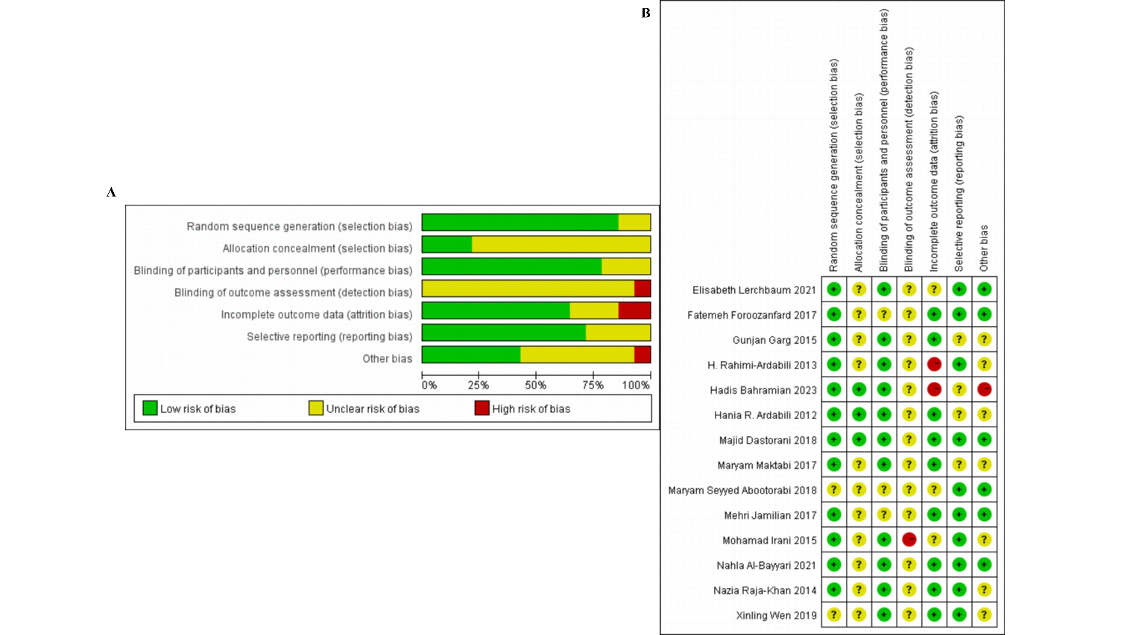
Supplementary Figure 1. Risk of bias plots. (A) Risk of bias assessment of included randomized controlled trials using the Cochrane RoB 1 tool. Overall risk of bias per study is shown in the rightmost column. (B) Risk of bias assessment of included randomized controlled trials using the Cochrane RoB 1 tool. Colors indicate risk level: green: low risk, yellow: some concerns, red: high risk.

Forest Plots
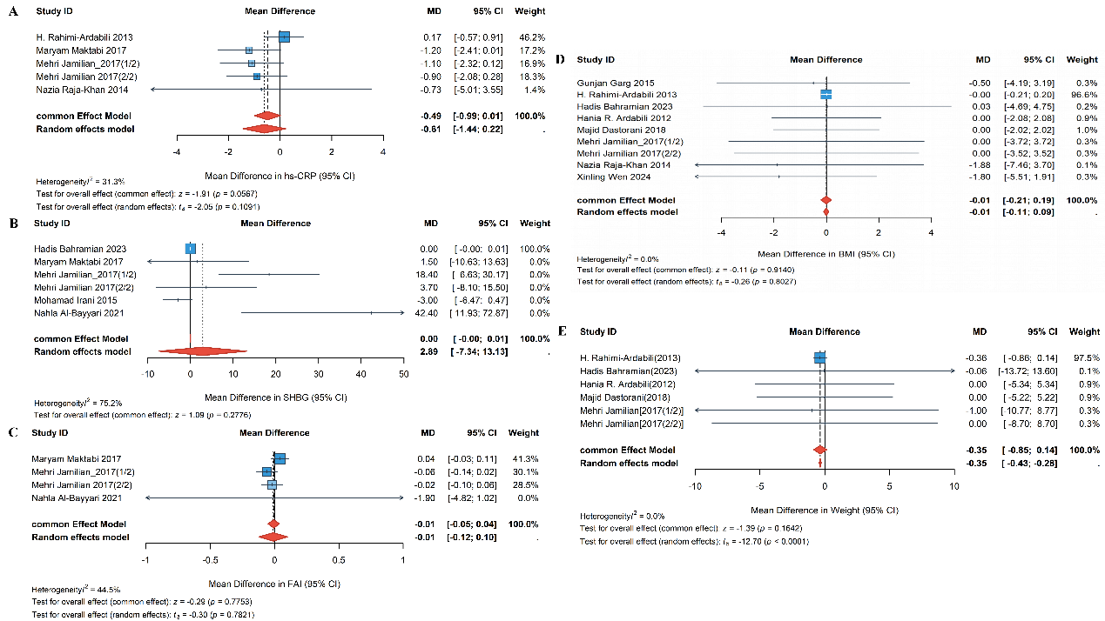
Supplementary Figure 2. Forest plots of inflammatory, androgen-related, and anthropometric outcomes following vitamin D supplementation in women with PMOS. (A) hs-CRP: Five studies showed a non-significant reduction in hs-CRP levels (MD = −0.49 mg/L, 95% CI: −0.99 to 0.01, P = 0.057; I² = 31.3%). (B) SHBG: Six studies found no significant effect on SHBG levels (MD = 2.89 nmol/L, P = 0.500). (C) FAI: Four studies showed no significant effect on FAI (MD = −0.01, P = 0.782). (D) BMI: Nine studies reported no significant change in BMI (MD = −0.01 kg/m², 95% CI: −0.21 to 0.19, P = 0.914; I² = 0.0%).
(E) Body weight: Six studies showed no significant effect on body weight (MD = −0.35 kg, 95% CI: −0.85 to 0.14, P = 0.164; I² = 0.0%).

Subgroup Analysis Forest Plots
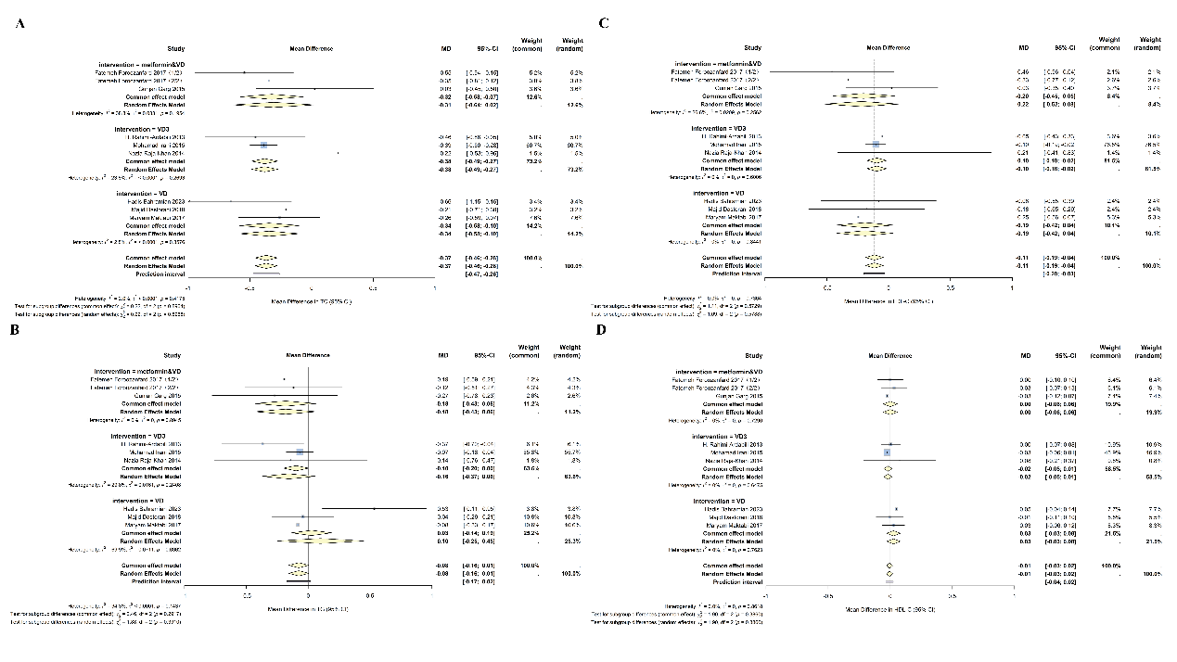
Supplementary Figure 3. Forest plots of subgroup analyses for TC, LDL-C, and HDL-C. Tests for subgroup differences indicated no statistically significant moderating effects among intervention types (metformin combined with vitamin D, vitamin D₃ alone, vitamin D alone) (all P > 0.05).
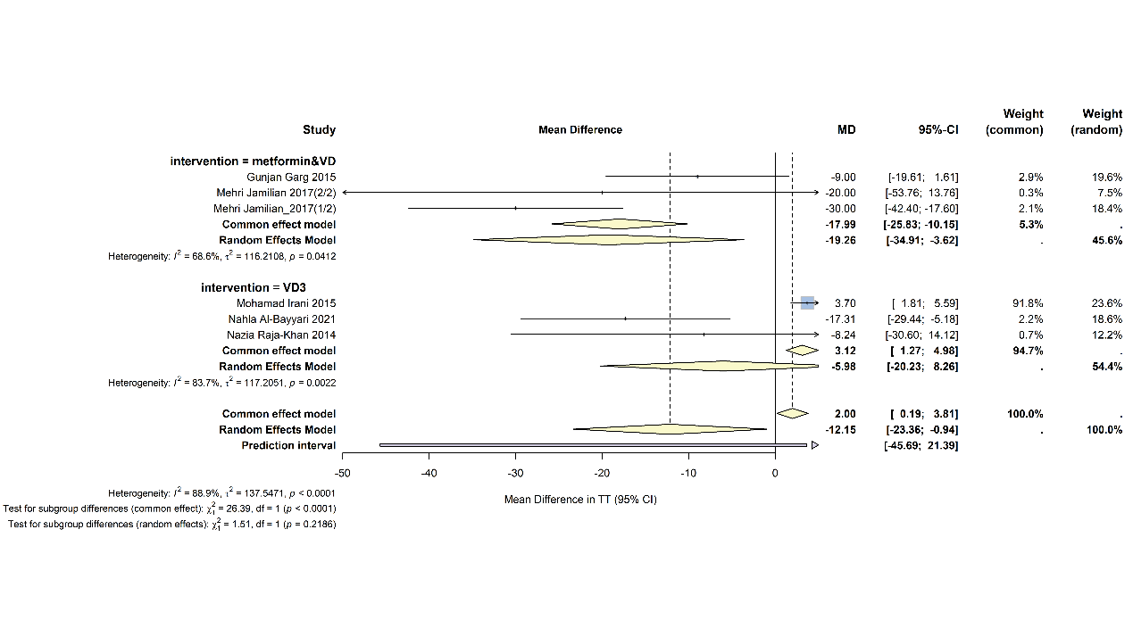
Supplementary Figure 4. Forest plots of subgroup analysis for TT levels. The combination therapy group showed a significant reduction in TT levels (MD = −19.26 ng/mL, 95% CI: −34.91 to −3.62); however, the test for subgroup differences indicated that the effect difference between the combination therapy and vitamin D₃ alone groups was not statistically significant (P > 0.05).

Meta-Regression Analysis Plot
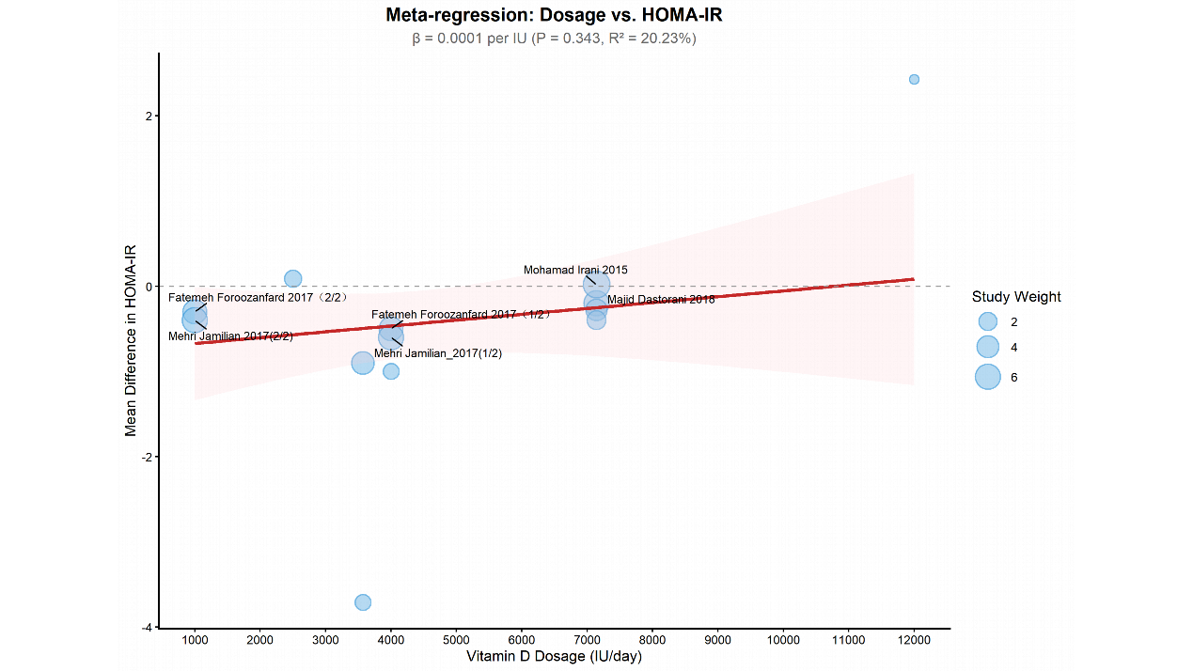
Supplementary Figure 5. Dose-response relationship between vitamin D supplementation dosage (IU/day) and MD in HOMA-IR. No significant association between vitamin D dosage and HOMA-IR improvement (β = 0.0001 per IU, P = 0.343, R² = 20.23%).

Leave-one-out Sensitivity Analysis Plots
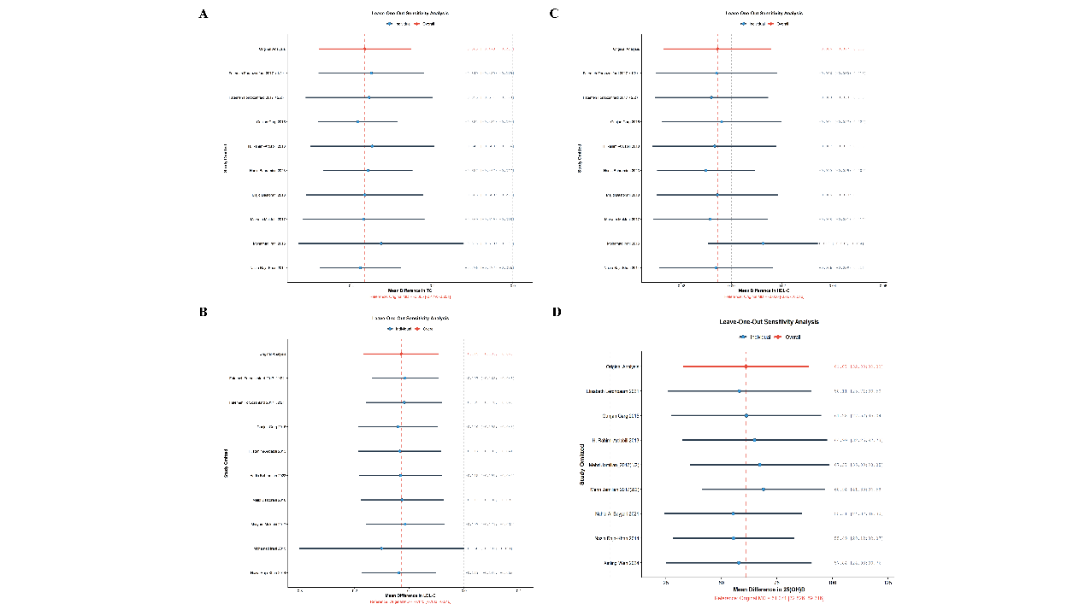
Supplementary Figure 6. Leave-one-out sensitivity for TC, LDL-C, HDL-C, and 25(OH)D. After sequential omission of each included study, the pooled effect estimates and 95% confidence intervals from the remaining studies remained consistent with the overall pooled result, with no change in the direction of effect across all iterations.

