Multimedia Appendix 1

Intervention Development and Materials

- Microinterventions development
- Intervention Modules and Categories of Digital Microinterventions
- Intervention example materials and screenshots
eReference
- Microinterventions development
Theoretical Framework
The 4-week microinterventions program development was informed by the 3P disease model^{[1]}, the digital micro-intervention framework^{[2]} and the problem-solving therapy framework^{[3]}.
The 3P disease model conceptualizes disease development through three interacting domains: predisposing, precipitating, and perpetuating factors. Predisposing factors include relatively stable physiological, psychological, and social characteristics (e.g., demographic background) that increase vulnerability to psychological distress and sleep problems. Precipitating factors refer to acute or chronic triggers, such as cancer treatment, physical symptoms, or emotional stress. Perpetuating factors involve maladaptive cognitive, behavioral, and emotional responses, such as poor sleep habits or sustained negative emotions that maintain or worsen these difficulties.
The digital micro-intervention model provides a theoretical framework for constructing a comprehensive digital intervention pathway and translating the comorbidity mechanisms between psychological distress and sleep disturbance into concrete, actionable intervention protocols. Based on the fundamental logic of “intervention event-decision rule-identification timing-evaluation and optimization,” the model pre-matches corresponding intervention content (i.e., intervention elements derived from evidence-based research and needs assessments) to the various factors within the 3P model. It then integrates these elements into personalized intervention combinations, using fixed trigger conditions as the identification mechanism. During implementation, the intervention employs continuous data logging and dynamic adjustment mechanisms to optimize content in a timely manner based on near-term assessment results (such as short-term participation and response to the intervention), allowing for flexible adjustments throughout the intervention process. Concurrently, the effectiveness of the intervention is comprehensively evaluated using long-term assessment indicators (such as long-term health outcomes and overall participation levels).
The problem-solving therapy framework provides a structured approach to helping individuals identify and manage distress-related problems. It was used as a content-development framework rather than as a therapist-delivered psychotherapy. Specifically, each domain-specific article was organized according to five problem-solving steps: problem identification, goal setting, brainstorming of possible options, decision-making, and action planning. This structure was intended to help patients clarify the specific source of distress, consider feasible coping strategies, evaluate available options, and develop a practical action plan. By embedding the PST framework into brief, accessible articles, the support package aimed to provide low-burden, self-guided problem-solving support for patients with diverse psychological distress and unmet needs.
Needs Assessment
A cross sectional study has been conducted to assess the needs and current comorbidity station of psychological distress and sleep disturbance among the adolescents and young adults with gynecologic cancer.
Based on the analysis of individual symptoms and comorbidity of psychological distress and sleep disturbance among the adolescents and young adults with gynecologic cancer are primarily associated with health insurance coverage, financial burden, disease knowledge, treatment, physical symptoms, and negative emotions. Specifically, regarding individual symptoms, 76.7% of patients experienced varying degrees of psychological distress, primarily stemming from physical symptoms, negative emotions, and financial burden. Over 40% of patients experienced sleep disturbances to varying degrees, primarily manifesting as adverse sleep behaviors such as difficulty falling asleep, impaired sleep maintenance, and reduced daytime functioning, and were influenced by factors including health insurance coverage, treatment modalities, and disease knowledge. Overall comorbidity was primarily associated with health insurance status and disease knowledge. Additionally, a significant association was found between psychological distress and sleep disturbances, and sleep disturbances served as an independent predictor of psychological distress. The key influencing factors identified in this phase of the study provide guidance for selecting intervention targets in the design of the next phase.
Analysis of Digital Intervention Preferences
Preliminary findings on facilitating and hindering factors of digital interventions among 158 adolescents and young adults with gynecologic cancer patients showed most (77.21%) recognized psychology’s impact on recovery, though over 70% were unfamiliar with online psychological services; 39.88% were willing to use such services and 37.97% neutral, with primary barriers including service credibility (39.87%), privacy concerns (32.38%) and cost (31.65%). Patients preferred APPs (37.97%) and online counseling (36.71%), with top content needs of emotion management (58.86%), family relationship improvement (52.53%) and social skill enhancement (51.27%) and favored video content (62.03%). Qualitative findings identified clear demand-driven motivation, friendly formats, solid digital capability, and social support as facilitating factors, while insufficient accessibility, trust/privacy concerns and psychological avoidance were hindering factors.
Literature Review
A review of the existing literature reveals that sleep disturbance are closely associated with psychological well-being. Digital micro-interventions based on CBT, mindfulness, and informational support strategies have demonstrated some effectiveness in improving psychological outcomes and have also shown positive effects on sleep in some studies. However, current research still has the following limitations: study participants are primarily drawn from the general population, with a lack of intervention studies targeting specific clinical groups such as cancer patients; intervention content often focuses on single psychological techniques, resulting in insufficient integration of mind and body; the level of personalization is limited, with most interventions lacking dynamic adjustment mechanisms based on individual status; intervention effects are primarily short-term, with insufficient long-term maintenance; and methodological quality varies widely, with few high-quality randomized controlled trials. In summary, this section provides a reference for the selection of intervention events and intervention design in the development of future research protocols.
- Extracted intervention components, theoretical frameworks, and outcome indicators of the included studied（n=10）
Dimension | Category | Specific Content | Studies (n/N)
Intervention components | CBT-related techniques | Thought records, behavioral activation, cognitive restructuring | 4/10
Intervention components | Mindfulness-oriented techniques | Mindfulness training, including breathing exercises and mindfulness meditation; breathing exercises | 4/10
Intervention components | Emotion-regulation techniques | Gratitude exercises, emotional imagery | —
Intervention components | Other intervention techniques | Psychoeducation, advice and feedback, resource provision | 3/10
Theory/framework | No explicit theory | Not specified | 6/10
Theory/framework | Theory-driven interventions | Digital micro-intervention framework, Health Action Process Approach, intergenerational transmission theory | 3/10
Theory/framework | Emerging framework | Just-in-time adaptive intervention framework | 1/10
Personalization | Standardized intervention | Fixed intervention content | 6/10
Personalization | Partially or highly personalized intervention | Tailored based on demographic characteristics, sleep-related features, or real-time data | 4/10
Outcome indicators | Sleep disturbance | Subjective sleep quality, measured by the Pittsburgh Sleep Quality Index (PSQI) | 2/10
Outcome indicators | Psychological distress | Anxiety, depression, and related psychological symptoms | 8/10
Calibration Strategies
Existing literature shows that digital micro-interventions have mostly been validated in general or non-specific disease populations. Their core components (e.g., CBT-I, breathing exercises, mindfulness meditation) are transdiagnostic, targeting shared psychological processes (e.g., insomnia perpetuating mechanisms, negative cognition, emotional regulation) and theoretically transferable to diverse patient groups. However, the adolescents and young adults with gynecologic cancer have distinct characteristics (e.g., treatment-related symptom burden, fertility-identity conflicts, disease uncertainty, financial stress), which may compromise intervention acceptability and effectiveness. Thus, micro-interventions validated only in general populations cannot be directly applied and require targeted adaptation. Guided by literature reviews and cross-sectional needs assessment, this study optimized established micro-interventions in content (integrating gynecological cancer symptom management and informational support), individualization (adjusting modules based on psychological distress and sleep disturbance feedback), and implementation procedures (accommodating patients’ treatment and nursing schedules) to enhance applicability and effectiveness in this specific group.
Development and Revision
In summary, based on the results of the cross-sectional survey, a literature review, and the team’s existing qualitative research findings, we identified the needs of adolescents and young adults with gynecologic cancer, the content and implementation details of effective micro-interventions, and the digital intervention formats preferred by this group, and developed a preliminary draft of the microinterventions program. The micro-intervention content primarily consists of three modules: a psychological distress support package, emotional regulation, and sleep behavior regulation. The intervention combines online and offline approaches, with the online component primarily based on the WeChat mobile platform. The rationale and categories for the selection of intervention modules and micro-intervention techniques are presented in eTable 2.
The microinterventions program was then revised through discussions with the oncology psychology research team and a Delphi expert survey, and subsequently adapted for digital implementation using existing digital platforms. Finally, the final draft was tested and refined among adolescents and young adults with gynecologic cancer in a clinical setting, resulting in the final version of the intervention protocol.

- Intervention Modules and Categories of Digital Microinterventions
- Intervention Modules and Categories of Digital Microinterventions
3P Model Domain | Characteristics / Factors | Intervention Module | Intervention Components (Microintervention Techniques) | Delivery Format | Microintervention Category
Predisposing factors | Type of health insurance  Financial burden Disease-related knowledge | Psychological distress support package | Psychological distress support package | Problem-solving strategies tailored to items from the distress problem checklist | Informational Supportive
Precipitating factors | Disease treatment  Physical burden  Acute emotional reactions | Psychological distress support package  Emotional regulation | Psychological distress support package  Breathing training  Mindfulness meditation  Emotion logging | Information support combined with skill-based exercises | Informational Symptom relief
Perpetuating factors | Maladaptive sleep behaviors  Persistent emotional symptoms | Sleep behavior regulation  Emotional regulation | Cognitive Behavioral Therapy for Insomnia (CBT-I)  Breathing training  Mindfulness meditation  Emotion logging | Feedback based on sleep status with behavioral adjustment suggestions and skill practice | Feedback Educational  Behavioral activation  Symptom relief

- Intervention example materials and screenshots
WeChat Official Account article | Example Materials and Screenshots | Online Link
The total intervention program’s introduction | 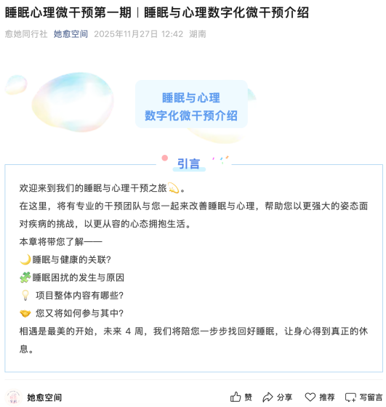 | https://mp.weixin.qq.com/s/3jHubykhAO1O_NJvInb9Hg
Psychological distress package module | 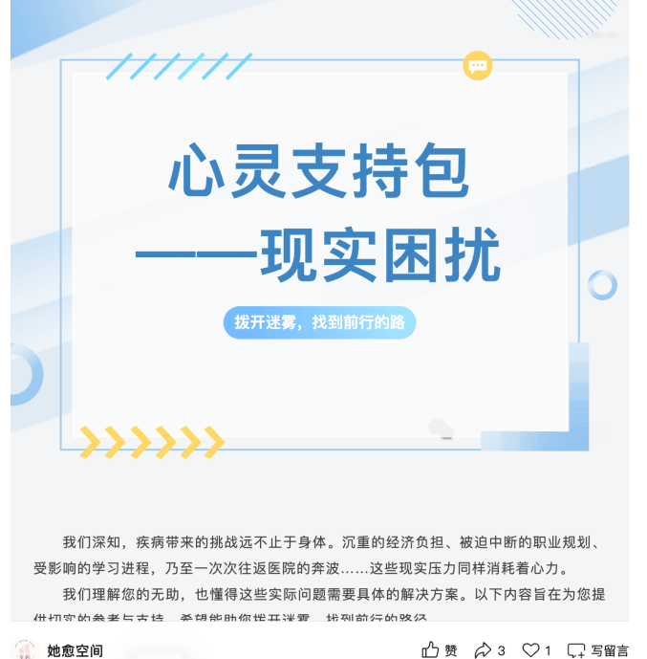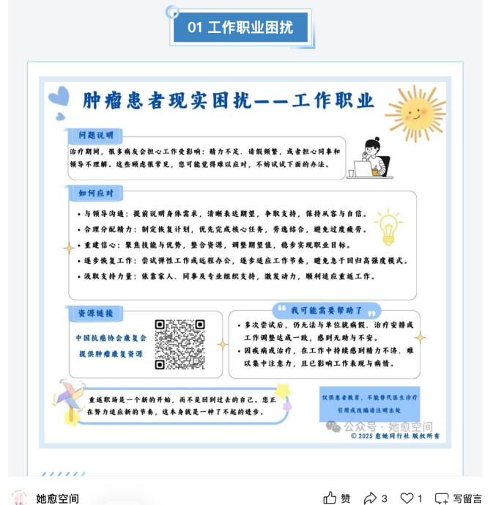 | https://mp.weixin.qq.com/s/ZKLcoA9EBIO3zuR-fnh9tQ
Emotion regulation module | 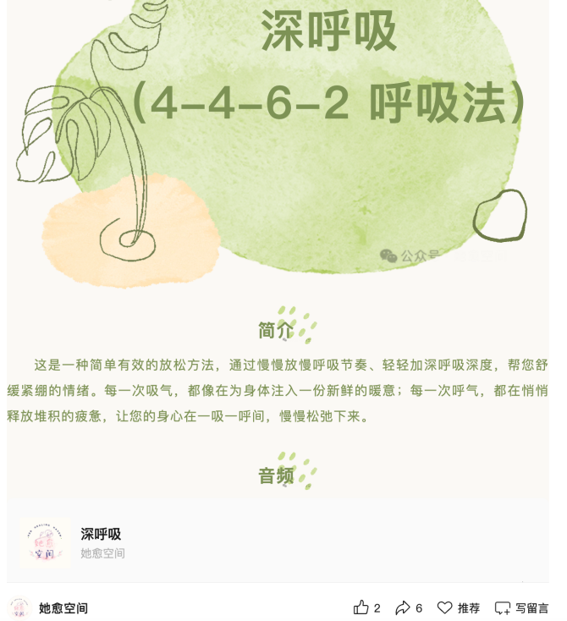 | https://mp.weixin.qq.com/s/-qzFBmstOFyTQx3jvkL5Lw
Sleep behavior regulation module | 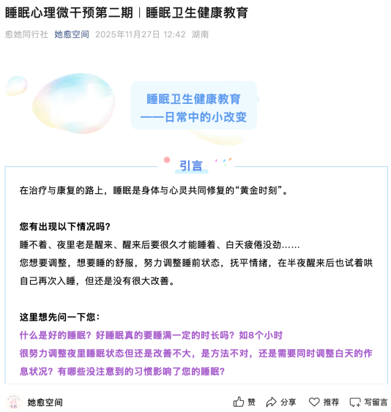 | https://mp.weixin.qq.com/s/937lxmsIubJVI9rm_hxy7A
Disease education (for both intervention and control group) | 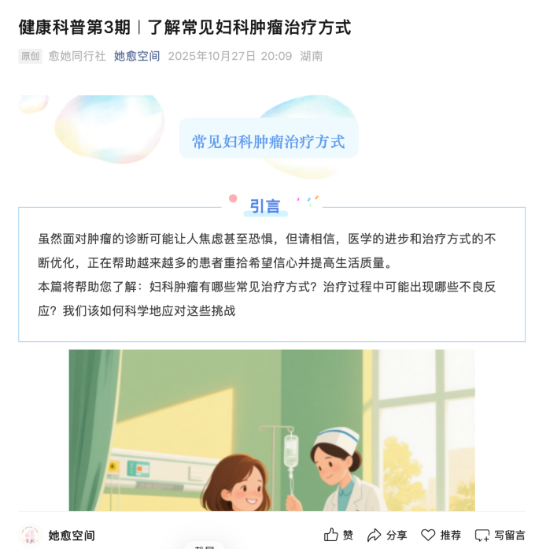 | https://mp.weixin.qq.com/s/E0O3mqEVMje_Tiudw9KuXg
Weekly sleep and emotion logging | 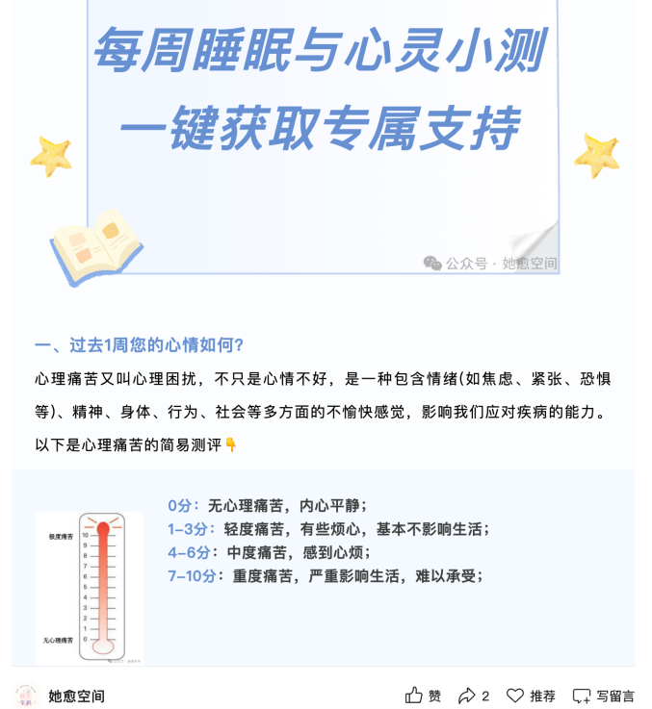 | https://mp.weixin.qq.com/s/nhFVNMrMlrZNABP1wTs88w

eReference

[1] Wright C D, Tiani A G, Billingsley A L, et al. A Framework for Understanding the Role of Psychological Processes in Disease Development, Maintenance, and Treatment: The 3P-Disease Model [J]. Frontiers in Psychology 2019, 10(0): 2498.
[2] Baumel A, Fleming T, Schueller S M. Digital Micro Interventions for Behavioral and Mental Health Gains: Core Components and Conceptualization of Digital Micro Intervention Care [J]. Journal of Medical Internet Research 2020, 22(10): e20631.
[3] Pierce D. Problem solving therapy - use and effectiveness in general practice [J]. Aust Fam Physician, 2012, 41(9): 676-679.

