Multimedia Appendix 2

Supplementary Measures and Results

- Measurement tool and time points
- Scores on the feasibility, acceptability, and appropriateness scale
- Weekly and post-intervention adherence
- Backend data on Wechat post visiting
- Baseline levels and between-group comparisons of outcomes
eReference
- Measurement tool and time points
- Measurement tool and time points
Variables |  | Measurement Instruments | Time Points
 |  | Measurement Instruments | T₀ | T₁ | T₂ | T₃
General data |  | Self-designed questionnaire on sociodemographic and disease characteristics | √
Evaluation of Intervention Process
Feasibility | Recruitment rate (%) | Calculated as the ratio (%) of the actual number of participants to the total number of screened individuals. | √
Feasibility | Consent rate (%) | Calculated as the ratio (%) of the actual number of participants to the total number of invited individuals. | √
Feasibility | Overall feasibility | Feasibility of Intervention Measure (FIM)^{[88]} |  | √
Feasibility | Retention rate (%) | Proportion (%) of participants retained at each follow-up time point relative to the total enrolled participants. |  | √ | √ | √
Feasibility | Attrition rate (%) | Proportion (%) of participants lost to follow-up at each time point relative to the total enrolled participants. |  | √ | √ | √
Feasibility | Short-term adherence | Weekly adherence to micro-interventions assessed by a self-designed questionnaire (0–3 scale: 0 = rarely, 1 = occasionally/<3 days, 2 = moderately/3–5 days, 3 = frequently/>5 days)
Feasibility | Long-term adherence | Given the multiple intervention components in this study, overall adherence to each micro-intervention module, sleep diary, and posted articles was calculated separately as the percentage (%) of completed items relative to total required items. |  | √
Feasibility | Intervention completion rate (%) | Proportion (%) of participants who completed the full intervention protocol relative to the total enrolled participants. |  | √
Acceptability | Intervention acceptability | Acceptability of Intervention Measure (AIM)^{[88]} |  | √
Acceptability | Intervention appropriateness | Intervention Appropriateness Measure (IAM)^{[88]} |  | √
Acceptability | Objective usage data | Intervention usage behavior recorded by the system backend. |  | √ | √ | √
Evaluation of Intervention Experience | Experience and suggestions | Semi-structured interviews |  | √
Evaluation of Intervention Outcomes
Primary outcome indicators | Psychological distress | Adolescent and Young Adult Psycho-Oncology Screening Tool (AYA-POST)^{[63]} | √ | √ | √ | √
 | Sleep disturbance | Pittsburgh Sleep Quality Index (PSQI)^{[65]} | √ | √ | √ | √
Secondary outcome indicators | Anxiety symptoms | Generalized Anxiety Disorder-7 (GAD-7) | √ | √ | √ | √
 | Depressive symptoms | Patient Health Questionnaire-9 (PHQ-9) | √ | √ | √ | √
Others
 | Weekly sleep status | Sleep diary
Note：*FIM, Feasibility of Intervention Measure; IAM, Intervention Appropriateness Measure; AIM, Acceptability of Intervention Measure; AYA-POST, the Adolescent and Young Adult Psycho-Oncology Screening Tool; PSQI, Pittsburgh sleep quality index; PHQ-9, Patient Health Questionnaire-9; GAD-7, Generalized Anxiety Disorder-7;
- Scores on the feasibility, acceptability, and appropriateness scale
- Scores on the perceived intervention feasibility, acceptability, and appropriateness scale
Item | Possible range | Actual range | Mean ± SD
Feasibility | 4～20 | 14 ~ 20 | 16.40 ± 1.90
I believe these sleep and psychological services can be implemented | 1 ~ 5 | 3 ~ 5 | 3.90 ± 0.74
I can follow these sleep and psychological services | 1 ~ 5 | 3 ~ 5 | 4.10 ± 0.57
I find these sleep and psychological services feasible | 1 ~ 5 | 4 ~ 5 | 4.20 ± 0.42
These sleep and psychological services are easy for me to perform | 1 ~ 5 | 4 ~ 5 | 4.20 ± 0.42
Acceptability | 4 ~ 20 | 14 ~ 20 | 16.60 ± 1.90
I approve of the provided sleep and psychological services | 1 ~ 5 | 4 ~ 5 | 4.20 ± 0.42
These sleep and psychological services are interesting to me | 1 ~ 5 | 4 ~ 5 | 4.20 ± 0.42
I like the provided sleep and psychological services | 1 ~ 5 | 3 ~ 5 | 4.10 ± 0.57
I am willing to accept these sleep and psychological services | 1 ~ 5 | 3 ~ 5 | 4.10 ± 0.57
Appropriateness | 4 ~ 20 | 16 ~ 20 | 16.80 ± 1.69
I find these sleep and psychological services appropriate | 1 ~ 5 | 4 ~ 5 | 4.20 ± 0.42
These sleep and psychological services suit me well | 1 ~ 5 | 4 ~ 5 | 4.20 ± 0.42
These sleep and psychological services are useful to me | 1 ~ 5 | 4 ~ 5 | 4.20 ± 0.42
These sleep and psychological services meet my needs | 1 ~ 5 | 4 ~ 5 | 4.20 ± 0.42

- Weekly and post-intervention adherence
- Proximal Adherence to the mHealth Microintervention Program During the 4-Week Intervention Period (N = 10)
Module | Item | Possible Score Range | Observed Score Range | Item Score, Mean ± SD
Psychological distress support package | Use of psychological distress support content | 0~3 | 1~3 | 1.81 ± 0.54
Emotion regulation module | Breathing exercise | 0~3 | 1~3 | 1.42 ± 0.65
Emotion regulation module | Mindfulness meditation | 0~3 | 1~3 | 1.38 ± 0.58
Emotion regulation module | Emotion logging | 0~3 | 1~3 | 1.13 ± 0.34
Sleep behavior regulation module | Attempted sleep adjustment according to CBT-I-informed recommendations | 0~3 | 1~3 | 1.79 ± 0.83
Note. CBT-I, cognitive behavioral therapy for insomnia; SD, standard deviation. Proximal adherence reflected the weekly frequency of participants’ use of each sleep or psychological regulation skill during the intervention period.

- Distal Adherence to the mHealth Microintervention Program at Post-Intervention (N = 10)
Module or Component | Expected Completion | Adherence Criterion | Adherence, %
Psychological distress support package | 56 support items | Self-selected use | 100
Emotion regulation module: breathing exercise | 1 time/day × 5 days/week × 4 weeks = 20 times | Completed on ≥3 days/week | 73
Emotion regulation module: mindfulness meditation | 1 time/day × 5 days/week × 4 weeks = 20 times | Completed on ≥3 days/week | 40
Emotion regulation module: Emotion logging | 1 time/day × 5 days/week × 4 weeks = 20 times | Completed on ≥3 days/week | 38
Sleep behavior regulation module: CBT-I-informed sleep adjustment recommendations | 1 time/day × 5 days/week × 4 weeks = 20 times | Completed on ≥3 days/week | 85
Sleep diary | 1 time/week × 4 weeks = 4 times | Completed all required sleep diaries | 80
Wechat post reading | 1–2 times/week × 4 weeks = 7 messages | Read all required Wechat posts | 100
Note. CBT-I, cognitive behavioral therapy for insomnia. In the intervention protocol, microintervention activities were scheduled for at least 5 days per week. Distal adherence reflected overall participation in intervention components at post-intervention.
- Backend data on Wechat post visiting

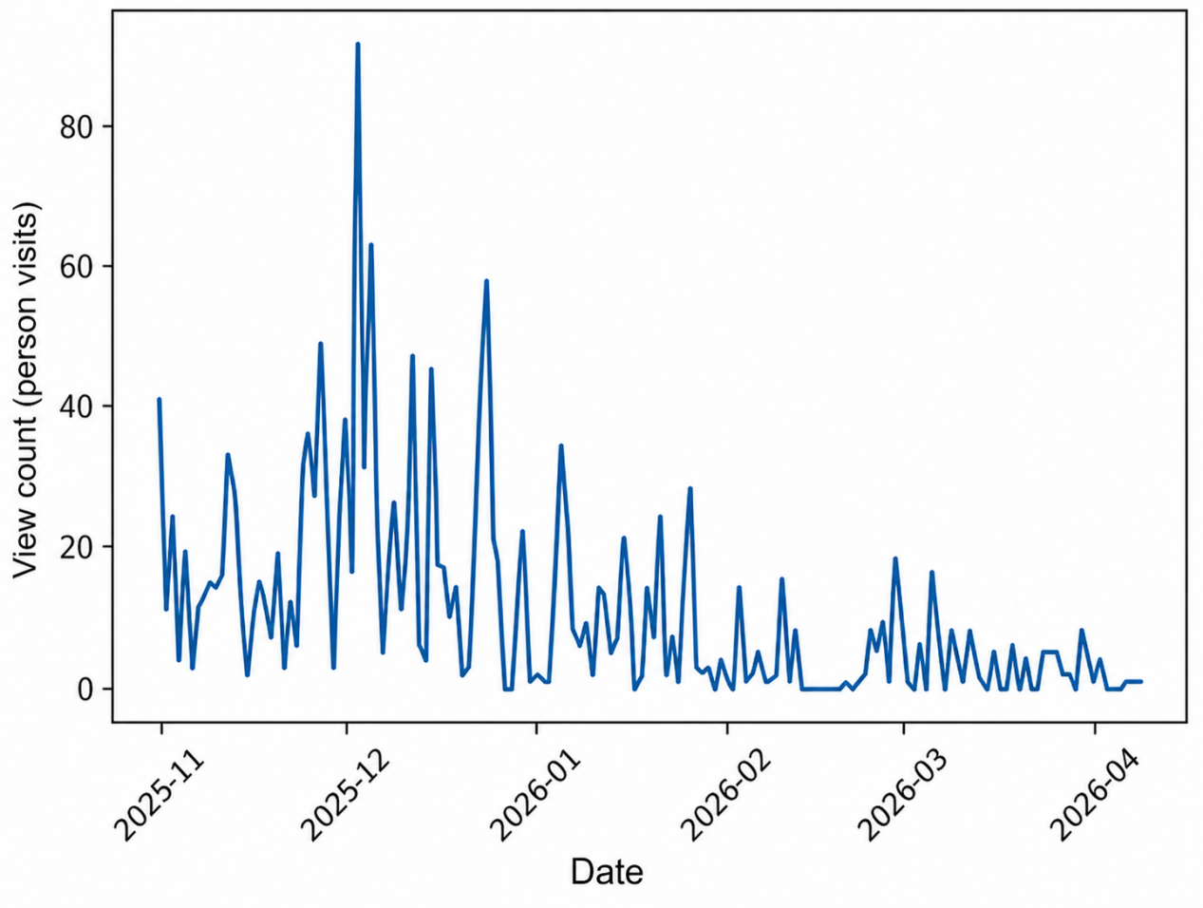
- Baseline levels and between-group comparisons of outcomes
- Baseline levels and between-group comparisons of outcomes（N=20）
Outcomes | Intervention group（n=10） | Control group（n=10） | Z/t | P
Overall psychological distress level (0~10) | 5.00 (1.00) | 5.20 (2.00) | -0.123 | 0.887ª
Overall psychological distress level (0~10) | 5.00 ± 0.94 | 5.20 ± 1.32 | -0.123 | 0.887ª
Psychological distress checklist
Practical | 8 (80.0%) | 8 (80.0%) |  | 1.000^{c}
Family | 7 (70.0%) | 6 (60.0%) |  | 1.000^{c}
Emotional | 10 (100.0%) | 10 (100.0%) |  | -
Social | 4 (40.0%) | 3 (30.0%) |  | 1.000^{c}
Physical | 10 (100.0%) | 8 (80.0%) |  | 0.474^{c}
Disease information related | 6 (60.0%) | 2 (20.0%) |  | 0.170^{c}
Depressive symptoms (PHQ-9) | 11.30 ± 6.04 | 5.20 ± 3.74 | 2.717 | 0.014^{*b}
Positive depression screening (≥10) | 6 (60.0%) | 1 (10.0%) |  | 0.057^{c}
Anxiety symptoms (GAD-7) | 9.10 ± 5.53 | 4.80 ± 3.52 | 2.075 | 0.053^{b}
Positive anxiety screening (≥10) | 4 (40.0%) | 2 (20.0%) |  | 0.628^{c}
Total PSQI score (mean ± SD) | 8.30 ± 2.98 | 6.60 ± 1.84 | 1.534^{b} | 0.142^{b}
PSQI group (n, %)
Mild sleep disturbance (5~10) | 9 (90.0%) | 10 (100.0%) |  | 1.000^{c}
Moderate to severe sleep disturbance (>10) | 1 (10.0%) | 0 (0) |  | -
PSQI subdimensions
- Sleep quality | 2.00 (0) | 1.50 (1) | 31.500 | 0.183ª
- Sleep latency | 2.00 (1) | 1.50 (2) | 35.000 | 0.259ª
- Sleep duration | 1.00 (1) | 0.00 (0) | 30.000 | 0.170ª
- Sleep efficiency | 0.50 (2) | 0.00 (0) | 32.000 | 0.141ª
- Sleep disturbance | 1.00 (1) | 1.00 (0) | 39.500 | 0.458ª
- Use of hypnotic medication | 0.00 (0) | 0.00 (0) | 45.000 | 1.000ª
- Daytime dysfunction | 1.00 (1) | 2.00 (1) | 28.500 | 0.132ª
Sleep diary
Wake-up time | 7.20 ± 1.18 | 6.65 ± 0.94 | 1.149 | 0.266^{b}
Bedtime / Sleep onset time | 22.35 ± 1.11 | 22.15 ± 0.67 | 0.489 | 0.631^{b}
Sleep duration | 7.25 ± 1.09 | 8.00 ± 0.67 | -1.861 | 0.083^{b}
Sleep efficiency | 0.83 ± 0.15 | 0.95 ± 0.11 | -2.092 | 0.051^{b}
Sleep latency, n (%)
< 15 minutes | 1 (10.0%) | 3 (30.0%)
15~30 minutes | 1 (10.0%) | 4 (40.0%)
30~60 minutes | 5 (50.0%) | 2 (20.0%)
> 60 minutes | 3 (30.0%) | 1 (10.0%)
Note: Normally distributed variables were expressed as mean ± standard deviation; non-normally distributed variables were expressed as median (interquartile range, IQR). ª Mann-Whitney U test; ^{b} independent-samples t-test; ^{c} Fisher’s exact test.
eReference
[1] Weiner B J, Lewis C C, Stanick C, et al. Psychometric assessment of three newly developed implementation outcome measures [J]. Implementation Science, 2017, 12(1): 108.
[2] Palmer S, Patterson P, Thompson K. A national approach to improving adolescent and young adult (AYA) oncology psychosocial care: the development of AYA-specific psychosocial assessment and care tools [J]. Palliative & Supportive Care, 2014, 12(3): 183-188.
[3] Patterson P, Mcdonald F E J, Allison K R, et al. The Clinical Utility of the Adolescent and Young Adult Psycho-Oncology Screening Tool (AYA-POST): Perspectives of AYA Cancer Patients and Healthcare Professionals [J]. Frontiers in Psychology 2022, 13(0): 872830.
[4] Qin N, Luo J, Li Y, et al. Translation and validation of the Chinese version of the adolescent and young adult psycho-oncology screening tool [J]. Asia-Pacific Journal of Oncology Nursing, 2025, 12(0): 100817.
[5] Buysse D J, Reynolds C F, Monk T H, et al. The Pittsburgh Sleep Quality Index: a new instrument for psychiatric practice and research [J]. Psychiatry Research, 1989, 28(2): 193-213.
[6] Wu H J, Chuang C M, Chien C H, et al. Changes in Depression and Sleep Quality and Associated Factors in Women Receiving Chemotherapy for Ovarian Cancer An Observational Study [J]. Cancer Nursing, 2022, 45(4): 271-279.
[7] Hinz A, Friedrich M, Schulte T, et al. The Pittsburgh Sleep Quality Index (PSQI) Applied to Cancer Patients: Psychometric Properties and Factors Affecting Sleep Quality [J]. Cancer investigation, 2025, 43(0): 1-11.
[8] Spitzer R L, Kroenke K, Williams J B, et al. A brief measure for assessing generalized anxiety disorder: the GAD-7 [J]. Archives of Internal Medicine, 2006, 166(10): 1092-1097.
[9] 王贝蒂. PHQ-9和GAD-7在恶性肿瘤患者中的应用研究 [D]; 中南大学, 2013.
[10] Kroenke K, Spitzer R L, Williams J B. The PHQ-9: validity of a brief depression severity measure [J]. Journal of General Internal Medicine, 2001, 16(9): 606-613.
[11] Cella D F, Tulsky D S, Gray G, et al. The Functional Assessment of Cancer Therapy scale: development and validation of the general measure [J]. J Clin Oncol, 1993, 11(3): 570-579.
[12] Cheung Y B, Goh C, Wee J, et al. Measurement properties of the Chinese language version of the functional assessment of cancer therapy-general in a Singaporean population [J]. Ann Acad Med Singap, 2009, 38(3): 225-229.

