Supplementary appendix
Contents
1. Supplementary Materials 2
1.1 Data Source and survey 2
China Health and Retirement Longitudinal Study (CHARLS) 2
English Longitudinal Study of Ageing (ELSA) 2
Health and Retirement Study (HRS) 2
1.2 Pregnancy loss 3
1.3 Depression 3
1.4 Adverse childhood experiences (ACEs) 4
2. Supplementary Tables 5
Table 1: Questionnaire Items of Each ACE indicator in CHLARS 5
Table 2: Questionnaire Items of Each ACE indicator in ELSA 6
Table 3: Questionnaire Items of Each ACE indicator in HRS 7
Table 4: Sample inclusion and exclusion in CHARLS across 5 waves 8
Table 5: Sample inclusion and exclusion in ELSA across 9 waves 9
Table 6: Sample inclusion and exclusion in HRS across 5-16 waves 10
Table 7: Sensitivity analysis: the association between pregnancy loss and depressive symptoms revealed by logistic mixed effects model in three cohorts 11
Table 8: Sensitivity analysis: the association between pregnancy loss and depressive symptoms revealed by logistic mixed effects model in three cohorts 11
Table 9: Sensitivity analysis: the association between pregnancy loss and depressive symptoms revealed by logistic mixed effects model in three cohorts 12
Figure 1: Sensitivity analysis: mediation of the association between adverse childhood experiences (ACE) and late-life depressive symptoms through pregnancy loss in three cohorts. Covariates included smoking and alcohol use. 13
Figure 2: Sensitivity analysis: mediation of the association between adverse childhood experiences (ACE) and late-life depressive symptoms through pregnancy loss in three cohorts. Participants were constricted with age less or equal to 65 years old. 14
Figure 3: Sensitivity analysis: mediation of the association between adverse childhood experiences (ACE) and late-life depressive symptoms through pregnancy loss in three cohorts. Models were refitted after imputation for missing data. 14
Reference 14

1. Supplementary Materials

1.1 Data Source and survey

China Health and Retirement Longitudinal Study (CHARLS)
Data were drawn from the China Health and Retirement Longitudinal Study (CHARLS), an ongoing, nationally representative cohort of community-dwelling adults aged 45 years or older in China. The national baseline survey was conducted from June 2011 to March 2012 using a multistage, stratified, probability-proportional-to-size sampling design and included approximately 17 700 respondents from 10 257 households in 450 villages or resident committees within 150 counties or districts across 28 provinces. Participants were reinterviewed in 2013, 2015, 2018, and 2020 via face-to-face, computer-assisted personal interviews conducted by trained interviewers. Additionally, a life history survey, including questions on early-life experiences related to family dynamics in Chinese families, was administered in 2014. All participants provided written informed consent. The study protocol was approved by the Biomedical Ethics Committee of Peking University (IRB00001052-11015).

English Longitudinal Study of Ageing (ELSA)
Data were obtained from the English Longitudinal Study of Ageing (ELSA), an ongoing, nationally representative panel study of adults aged 50 years or older living in private households in England. ELSA began in 2002 (Wave 1), with subsequent waves conducted biennially using face-to-face, computer-assisted personal interviews and self-completed questionnaires, and nurse visits approximately every 4 years. The original sample comprised 11 391 core participants and 708 additional respondents, mainly younger spouses or partners; refreshment samples have been added at later waves to maintain national representativeness. For this analysis, we used data from Waves 1–9 (fielded in 2018–2019 for Wave 9). Life-course information was collected in a retrospective Life History Interview at Wave 3 (2006–2007). Ethical approval for ELSA was obtained from the Multicentre/Medical Research Ethics Committee and subsequent relevant Research Ethics Committees.
Health and Retirement Study (HRS)
Data were drawn from Waves 5–16 (2000–2022) of the U.S. Health and Retirement Study (HRS), an ongoing, nationally representative, open cohort of adults aged 50 years or older and their spouses or partners. HRS began in 1992 and uses a multistage, stratified, area-probability sample design, with oversamples of Black and Hispanic households and an early oversample of Florida residents. To maintain national representativeness, new birth cohorts are added approximately every 6 years. Participants are interviewed biennially using computer-assisted in-person or telephone interviews; proxy respondents are used when necessary, and an exit interview is typically conducted with a proxy after participant death. Early-life and life-course experiences were assessed using the Cross-wave 2015–2019 Life History Mail Survey, which can be linked to core interview data. Survey weights account for differential selection probabilities and nonresponse. All participants provided informed consent. The study is conducted by the University of Michigan under institutional review board oversight and is supported by the National Institute on Aging (NIA U01AG009740).

1.2 Pregnancy loss
The primary exposure was pregnancy loss—defined as induced abortion, miscarriage (natural abortion), or stillbirth—ascertained with a single yes/no item in each cohort. In CHARLS, in pregnancy history, women were asked with the following question: Did you have induced abortion, natural abortion, or still birth before the first biological child was born/during the period between the n^{th} biological child and the (n+1)^{th} biological child were born/after the last biological child was born (Yes/No)? In ELSA, participants were asked with the question “Have you ever had a child that was not born alive? Include any miscarriages, abortions or stillbirths (Yes/No)”. In HRS, participants were ask: “Have you ever had a pregnancy (or experienced a partner’s pregnancy) that ended in a miscarriage, an induced abortion, or a stillbirth (Yes/No)”. Responses were dichotomized as yes (history of pregnancy loss) or no (no history of pregnancy loss) for analysis.

1.3 Depression
CHARLS. Depressive symptoms were assessed with the 10-item Center for Epidemiologic Studies Depression Scale (CESD-10)¹, frequently used for epidemiologic research as a validated screening tool. Respondents rated the frequency of symptoms during the prior week on a four-point scale (0–3), yielding total scores from 0 to 30 (higher scores indicate greater symptom burden). Clinically depressive symptoms were defined as CESD-10 ≥ 10¹. CESD-10 scores and self-reported health conditions were collected at baseline and at each follow-up wave.
ELSA and HRS. Depressive symptoms were measured with the eight-item CESD (CESD-8), a widely used instrument capturing negative affect and somatic symptoms over the past week, with high internal consistency and psychometric properties comparable to the original 20-item CES-D^{2,3}. Items are scored dichotomously (yes/no), producing totals from 0 (no symptoms) to 8 (all symptoms), with higher scores indicating greater symptom burden. A cut-off of ≥4 was used to indicate a positive depression screen⁴.

1.4 Adverse childhood experiences (ACEs)
Adverse childhood experiences (ACEs) were assessed in 3 cohorts. We grouped ACEs into 4 domains—threat, living instability, household dysfunction, and loss, to harmonize conceptually similar adversities across cohorts and to align with both established ACE measurement and more recent domain-based frameworks.
The household dysfunction domain reflects the original ACE conceptualization emphasizing family impairment (eg, substance use, mental illness, incarceration) as distinct from direct maltreatment⁵. The threat domain captures experiences involving harm or threat of harm (eg, abuse, violence exposure, bullying), consistent with dimensional models that distinguish threat-related adversity from other early-life exposures⁶. We defined living instability to represent disruptions in housing and living arrangements (eg, difficult living arrangements, separation/divorce, and household incarceration), consistent with public health descriptions of ACE-related instability and emerging evidence arguing for explicit inclusion of housing instability in ACE frameworks and its relevance to child and long-term mental health^{7,8}. Finally, we included loss (eg, parental or sibling death) as a distinct domain because bereavement has been associated with adverse mental and physical health outcomes⁹.
In CHARLS, we identified 12 ACE indicators, including 5 categorized as threat (physical abuse, emotional neglect, bullying, unsafe neighborhood, and domestic violence), 2 as living instability (incarcerated household member and parental separation or divorce), 3 as household dysfunction (household substance abuse, household mental illness, and parental disability), and 2 as loss (parental death and sibling death). In ELSA, 12 ACEs were derived, including 5 threat indicators (physical abuse, emotional abuse, sexual abuse, bullying, and adverse childhood health conditions), 3 living instability indicators (difficult living arrangement, separation from a parent, and parental separation or divorce), and 4 household dysfunction indicators (parental unemployment, parental conflict, household mental illness, and financial hardship). In HRS, 10 ACEs were identified, comprising 4 threat indicators (physical abuse, emotional neglect, trouble with police, and adverse childhood health conditions), 3 living instability indicators (difficult living arrangement, separation from a parent, and parental separation or divorce), 2 household dysfunction indicators (childhood poverty and household substance abuse), and 1 loss indicator (parental death). Detailed descriptions of each ACE item and the corresponding questionnaire items for the 3 cohorts are provided in Supplement Tables 1 to 3. Each ACE was coded as a binary variable (yes/no). A cumulative ACE score was calculated as the sum of endorsed items (range, 0-12 for CHARLS; 0-12 for ELSA; and 0-10 for HRS).

2. Supplementary Tables

Table 1: Questionnaire Items of Each ACE indicator in CHLARS
Types of ACE | Domain | Questionnaire Items
Threat | Physical abuse | When you were growing up, did your female/male guardian ever hit you? (often or sometimes)
 | Emotional neglect | How much love and affection did your female guardian give you while you were growing up? (rarely or never)
 | Emotional neglect | How much effort did your female guardian put into watching over you? (a little, or not at all)
 | Bullying | When you were a child, how often were you picked on or bullied by kids in your neighborhood? (often or sometimes)
 | Bullying | When you were a child, how often were you picked on or bullied by kids in your school? (often or sometimes)
 | Unsafe neighborhood | Was it safe being out alone at night in the neighborhood where you lived as a child? (not very safe or not safe at all)
 | Domestic violence | Have your father/mother ever beat up your mother/father? (often or sometimes)
Living instability | Incarcerated household member | During the years you were growing up, have your female/male guardian ever been arrested or sent to prison? (yes)
 | Parental separation or divorce | Were your biological parents divorced (including long separation due to emotional problems) before you were 17 years? (yes)
Household dysfunction | Parental disability | Did your female/male guardian have a long time being sick on bed when you were young? (yes)
 | Parental disability | Did your female/male guardian have a serious deformity when you were young? (yes)
 | Household substance abuse | During the years you were growing up, did your female/male guardian ever have alcoholism or drug? (yes)
 | Household mental illness | Did your female/male guardian have abnormality of mind when you were young? (yes)
 | Household mental illness | During the years you were growing up, had your female/male guardian often showed continued signs of sadness or depression? (during all or most of the childhood)
Loss | Parental death | Either of the parents was dead before participant was 17 years. (yes)
 | Sibling death | Any of the siblings was dead before participant was 17 years. (yes)
Abbreviation: ACEs: adverse childhood experiences.

Table 2: Questionnaire Items of Each ACE indicator in ELSA
Types of ACE | Domain | Questionnaire Items
Threat | Physical abuse | When you were aged under 16, were your physically abused by your parents? (yes)
 | Emotional abuse | Mother or mother figure seemed emotionally cold to me under 16. (Strongly agree or agree)
 | Emotional abuse | Father or father figure seemed emotionally cold to me under 16. (Strongly agree or agree)
 | Sexual abuse | Have you ever been a victim of sexual assault including rape or harassment) under 16? (yes)
 | Bully | Have you ever been a victim of serious physical attack or assault under 16? (yes)
 | Childhood adverse health conditions | Have you ever had a life-threatening illness or accident under age 16? (yes)
Living instability | Difficult living arrangement | Whether the respondent experienced a difficult living arrangement before age 16. A code of 1 is assigned if the respondent had ever lived in a children's home, orphanage, a boarding school, armed forces, mental hospital, other hospital, prisoner of war camp, borstal or prison.
 | Separated from parent | Were you ever separated from your mother for 6 months or longer before you were 16? (yes)
 | Parental separation or divorce | Did your parents permanently separate or divorce before you were 16? (yes)
Household dysfunction | Parental unemployment | When you were aged under 16, were either of your parents unemployed for more than 6 months when they wanted to be working? (yes)
 | Parental conflicts | When you were aged under 16, did your parents argue or fight very often? (yes)
 | Household mental illness | When you were aged under 16, did your parents drink excessively, take drugs or have mental health problems? (yes)
 | Financial hardship | Have you ever experienced severe financial hardship under 16? (yes)
Abbreviation: ACEs: adverse childhood experiences.

Table 3: Questionnaire Items of Each ACE indicator in HRS
Types of ACE | Domain | Questionnaire Items
Threat | Physical abuse | Before you were 18 years old, were you ever physically abused by either of your parents? (yes)
 | Emotional neglect | How much time and attention did your mother give you when you needed it? (a little or no at all)
 | Emotional neglect | How much effort did your mother put into watching over you and making sure you had a good upbringing? (a little or no at all)
 | Trouble with police | Before you were 18 years old, were you ever in trouble with the police? (yes)
 | Childhood adverse health conditions | Before you were age 16, did you ever miss a month or more of school because of a health condition? (yes)
Living instability | Difficult living arrangement | Before you were age 16, did you ever live in a children's home, orphanage, a foster family or a boarding school. A code of 0 is assigned if the respondent never lived in a children's home, orphanage, a foster family or a boarding school? (yes)
 | Separated from parent | Before you were age 16, were you ever separated from your mother/father for 6 months or longer? (yes)
 | Parental separation or divorce | Before you were age 16, did your biological or adoptive parents separate or divorce? (yes)
Household dysfunction | Childhood poverty | Now think about your family when you were growing up, from birth to age 16. Would you say your family during that time was financially poor?
 | Household substance abuse | Before you were 18 years old, did either of your parents drink or use drugs so often that it caused problems in the family? (yes)
Loss | Parental death | Before you were age 16, did one or both of your biological or adoptive parents die? (yes)
Abbreviation: ACEs: adverse childhood experiences.

Table 4: Sample inclusion and exclusion in CHARLS across 5 waves
Sample inclusion, exclusion | 2011 | 2013 |  | 2015 | 2018 |  | 2020
Sample inclusion, exclusion | Remain |  | Remain | Remain |  | Remain | Remain
Total sample (female) | 9227 |  | 9728 | 11030 |  | 10475 | 10302
Exclude those without demographic information and less than 45 years old | 8711 |  | 9292 | 9179 |  | 9427 | 10044
Depression
Exclude missing values in related scores | 8114 |  | 8406 | 8534 |  | 8550 | 9178
Depression + Pregnancy loss
Exclude missing values in related scores | 6786 |  | 7472 | 7496 |  | 7406 | 7837
Depression + Pregnancy loss + Covariates
Missing values in chronic disorders | 6651 |  | 7059 | 6656 |  | 7404 | 7837
Depression + Pregnancy loss + Covariates + ACEs
Missing values in ACEs | 6648 |  | 7059 | 6655 |  | 7402 | 7835

Table 5: Sample inclusion and exclusion in ELSA across 9 waves
Sample inclusion, exclusion | 2002 | 2004 |  | 2006 | 2008 |  | 2010 | 2012 | 2014 | 2016 | 2018
Sample inclusion, exclusion | Remain |  | Remain | Remain |  | Remain | Remain | Remain | Remain | Remain | Remain
Total sample (female) | 6764 |  | 5306 | 5472 |  | 6125 | 5705 | 5857 | 5366 | 4694 | 4881
Exclude those without demographic information and less than 50 years old | 5568 |  | 4506 | 4555 |  | 5231 | 4939 | 5076 | 4640 | 4100 | 4213
Depression
Exclude missing values in related scores | 5409 |  | 4429 | 4449 |  | 5067 | 4730 | 4864 | 4423 | 3934 | 4044
Depression + Pregnancy loss
Exclude missing values in related scores | 3074 |  | 3120 | 3721 |  | 3345 | 3155 | 2924 | 2619 | 2323 | 2070
Depression + Pregnancy loss + Covariates
Missing values in chronic disorders | 3073 |  | 3120 | 3721 |  | 3345 | 3155 | 2924 | 2619 | 2323 | 2070
Depression + Pregnancy loss + Covariates + ACEs
Missing values in ACEs | 3073 |  | 3120 | 3721 |  | 3345 | 3155 | 2924 | 2619 | 2323 | 2070

Table 6: Sample inclusion and exclusion in HRS across 5-16 waves
Sample inclusion, exclusion | 2000 | 2002 | 2004 |  | 2006 | 2008 |  | 2010 | 2012 | 2014 | 2016 | 2018 | 2020 | 2022
Sample inclusion, exclusion | Remain | Remain |  | Remain | Remain |  | Remain | Remain | Remain | Remain | Remain | Remain | Remain | Remain
Total sample (female) | 11467 | 10709 |  | 11777 | 10883 |  | 10193 | 12815 | 12014 | 11048 | 12247 | 10115 | 9334 | 7488
Exclude those without demographic information and less than 50 years old | 10982 | 10348 |  | 11071 | 10431 |  | 9874 | 12019 | 11459 | 10658 | 11610 | 9721 | 9069 | 6063
Depression
Exclude missing values in related scores | 10191 | 9542 |  | 10335 | 9877 |  | 9336 | 11373 | 10894 | 10137 | 11140 | 9406 | 8729 | 6063
Depression + Pregnancy loss
Exclude missing values in related scores | 3164 | 3301 |  | 4117 | 4293 |  | 4428 | 6125 | 6295 | 6380 | 7373 | 6921 | 6510 | 4513
Depression + Pregnancy loss + Covariates
Missing values in chronic disorders | 3164 | 3301 |  | 4117 | 4293 |  | 4428 | 6125 | 6295 | 6380 | 7373 | 6921 | 6510 | 4371
Depression + Pregnancy loss + Covariates + ACEs
Missing values in ACEs | 3164 | 3301 |  | 4117 | 4293 |  | 4428 | 6125 | 6295 | 6380 | 7373 | 6921 | 6510 | 4371

Table 7: Sensitivity analysis: the association between pregnancy loss and depressive symptoms revealed by logistic mixed effects model in three cohorts
Dataset | Models*
CHARLS (China)
Events, n (%) | 43.60%
OR (95% CI) | 1.13 (1.03-1.23)
P | 0.013
ELSA (England)
Events, n (%) | 25.35%
OR (95% CI) | 1.30 (1.10-1.53)
P | 0.002
HRS (USA)
Events, n (%) | 22.33%
OR (95% CI) | 1.17 (1.05-1.31)
P | 0.004
*Models were controlled with smoking and alcohol use.

Table 8: Sensitivity analysis: the association between pregnancy loss and depressive symptoms revealed by logistic mixed effects model in three cohorts
Dataset | Models*
CHARLS (China)
Events, n (%) | 42.27%
OR (95% CI) | 1.13 (1.01-1.26)
P | 0.027
ELSA (England)
Events, n (%) | 23.13%
OR (95% CI) | 1.27 (1.02-1.58)
P | 0.032
HRS (USA)
Events, n (%) | 24.23%
OR (95% CI) | 1.19 (1.05-1.35)
P | 0.006
*Models were restricted for participants age less and equal to 65 years old.

Table 9: Sensitivity analysis: the association between pregnancy loss and depressive symptoms revealed by logistic mixed effects model in three cohorts
Dataset | Models*
CHARLS (China)
Events, n (%) | 43.41%
OR (95% CI) | 1.12 (1.03-1.22)
P | 0.010
ELSA (England)
Events, n (%) | 26.43%
OR (95% CI) | 1.29 (1.10-1.52)
P | 0.002
HRS (USA)
Events, n (%) | 22.20%
OR (95% CI) | 1.16 (1.04-1.29)
P | 0.006
*Models were refitted using data after imputation.

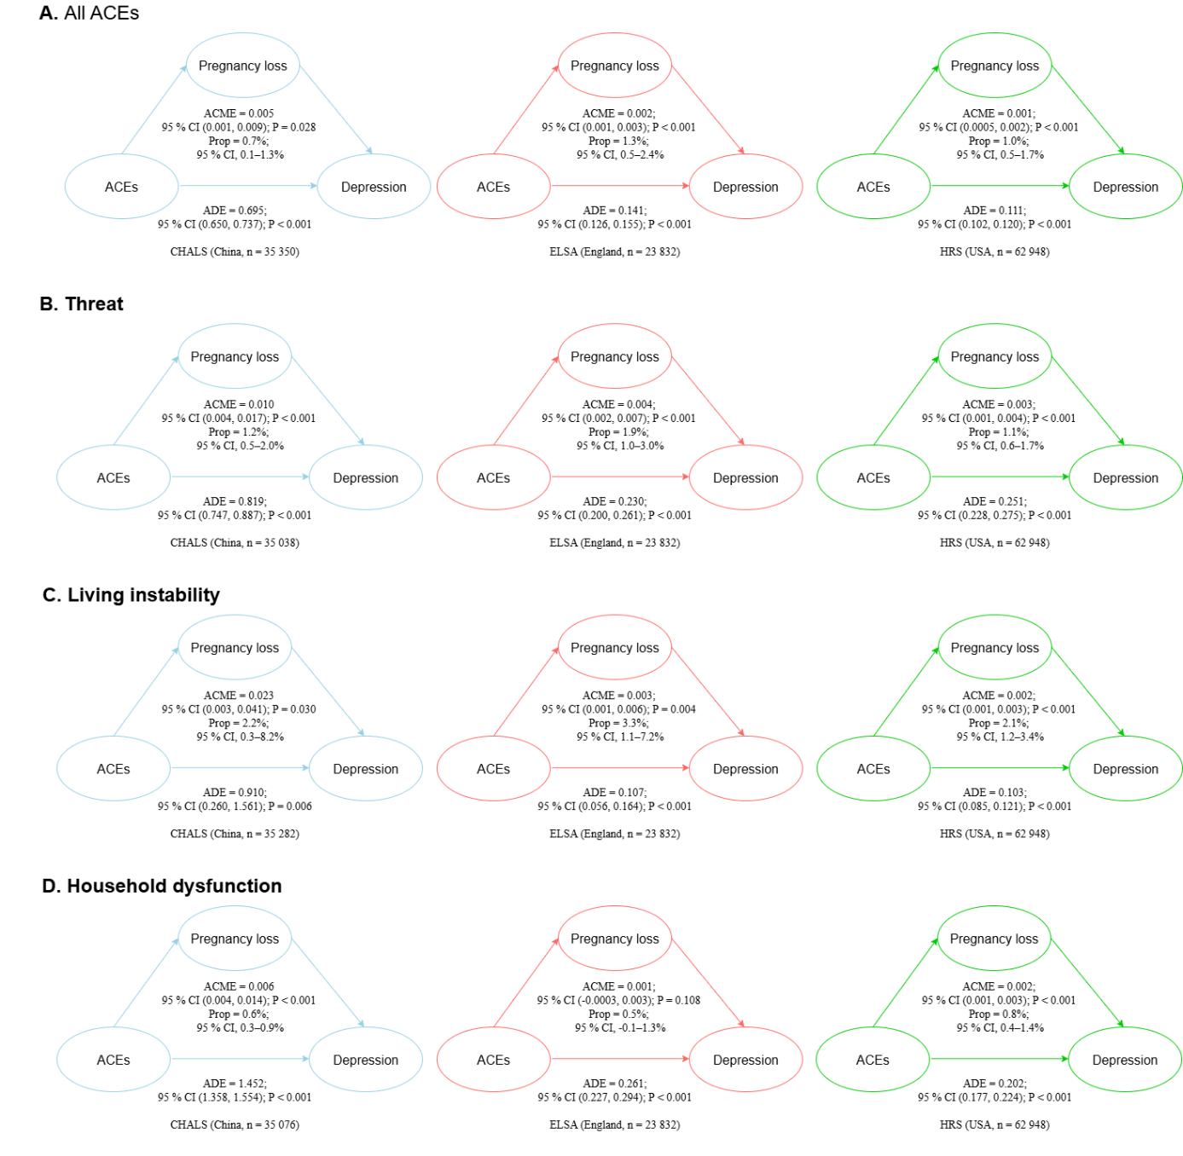

Figure 1: Sensitivity analysis: mediation of the association between adverse childhood experiences (ACE) and late-life depressive symptoms through pregnancy loss in three cohorts. Covariates included smoking and alcohol use.

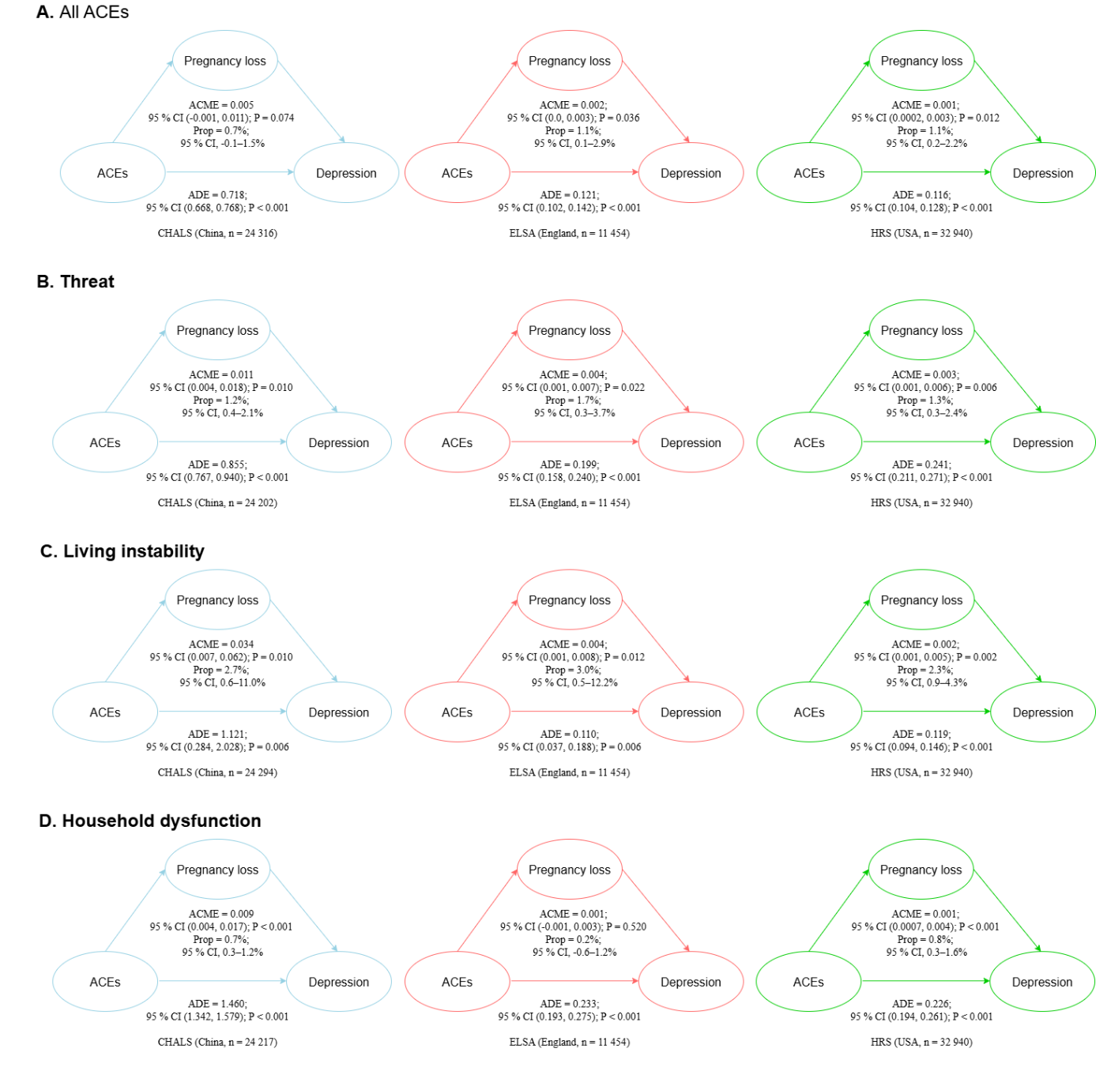

Figure 2: Sensitivity analysis: mediation of the association between adverse childhood experiences (ACE) and late-life depressive symptoms through pregnancy loss in three cohorts. Participants were constricted with age less or equal to 65 years old.

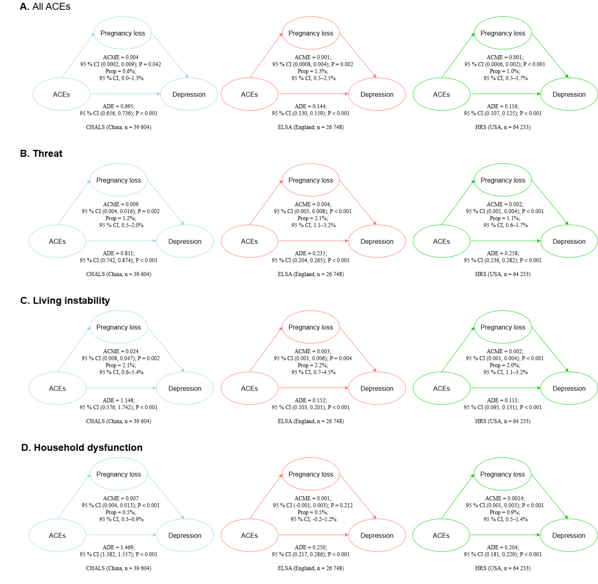

Figure 3: Sensitivity analysis: mediation of the association between adverse childhood experiences (ACE) and late-life depressive symptoms through pregnancy loss in three cohorts. Models were refitted after imputation for missing data.

Reference
1 Andresen EM, Malmgren JA, Carter WB, Patrick DL. Screening for Depression in Well Older Adults: Evaluation of a Short Form of the CES-D. American Journal of Preventive Medicine 1994; 10: 77–84.
2 Radloff LS. The CES-D Scale: A Self-Report Depression Scale for Research in the General Population. Applied Psychological Measurement 1977; 1: 385–401.
3 Turvey CL, Wallace RB, Herzog R. A revised CES-D measure of depressive symptoms and a DSM-based measure of major depressive episodes in the elderly. Int Psychogeriatr 1999; 11: 139–48.
4 Ofstedal, M., Fisher, G. G & Herzog, A. R. (2005). Documentation of Cognitive Functioning Measures in the Health and Retirement Study. University of Michigan.
5 Felitti VJ, Anda RF, Nordenberg D, et al. Relationship of childhood abuse and household dysfunction to many of the leading causes of death in adults. The Adverse Childhood Experiences (ACE) Study. Am J Prev Med 1998; 14: 245–58.
6 McLaughlin KA, Sheridan MA. Beyond Cumulative Risk: A Dimensional Approach to Childhood Adversity. Curr Dir Psychol Sci 2016; 25: 239–45.
7 Keen R, Chen JT, Slopen N, Sandel M, Copeland WE, Tiemeier H. Prospective Associations of Childhood Housing Insecurity With Anxiety and Depression Symptoms During Childhood and Adulthood. JAMA Pediatr 2023; 177: 818–26.
8 DeCandia CJ, Volk KT, Unick GJ. Evolving Our Understanding: Housing Instability as an ACE for Young Children. Advers Resil Sci 2022; 3: 365–80.
9 van Heijningen CJM, van Berkel SR, Rosinda SJ, Penninx BWJH, Alink LRA, Elzinga BM. Long-term effects of experiencing childhood parental death on mental and physical health: A NESDA study. Stress Health 2024; 40: e3322.

