Supplementary Materials

Ambipolar photoresponsive infrared detector arrays for energy-efficient in-sensor optoelectronic computing

Qianxi Yang¹, Hongkun Duan², Xiaolu Xia², Shaoyuan Zhou¹, Zixuan Yang¹, Tao Luo¹, Yixiao Niu³, Zhiyu Zhao³, Yi Cao¹, Yuyan zhang¹, Jianhua Jiang¹, Jianbing Zhang³, Ying Wang^{2,*}, Yongfeng Wang^{1,*} and Zhiyong Zhang^{1,*}

¹Key Laboratory for the Physics and Chemistry of Nanodevices and Center for Carbon-based Electronics, School of Electronics, Peking University, Beijing 100871, China.
²Key Laboratory of Luminescence & Optical Information Ministry of Education, School of Physical Science and Engineering, Beijing Jiaotong University, Beijing 100044, China.
³School of Integrated Circuits, Huazhong University of Science and Technology, Hubei 430074, China.
E-mail: yingw@bjtu.edu.cn; yongfengwang@pku.edu.cn; zyzhang@pku.edu.cn

Supplementary Fig. 1 Circuit schematic of the HGAFET-based sensing pixel. The circuit integrates a HGAFET with a CTIA-based front end, a threshold comparator for event generation, and a correlated double sampling (CDS) stage for intensity acquisition.

Supplementary Fig. 2 Fabrication process of a HGAFET. (a) Back-gate electrode (Ti/Au, 5/20 nm) on Si/SiO₂ substrate. (b) 15 nm HfO₂ back-gate dielectric deposited by ALD. (c) CNT film deposition and channel patterning via EBL/RIE. (d) Source/drain contact formation (Ti/Au, 30/40 nm) using EBL/EBE/lift-off. (e) 7 nm HfO₂ top-gate dielectric deposition by ALD. (f) ZnO thin film deposition. (g) PbS QD layer deposited by spin-coating.
Supplementary Fig. 3 SEM images of CNT films at nine positions across a 4-inch wafer. Scale bar: 1 μm.
Supplementary Fig. S3 shows representative SEM images of CNT films at nine randomly selected locations on a 4-inch wafer (a-i). Consistent film morphology across all positions confirms high uniformity of the CNT films at the wafer scale.

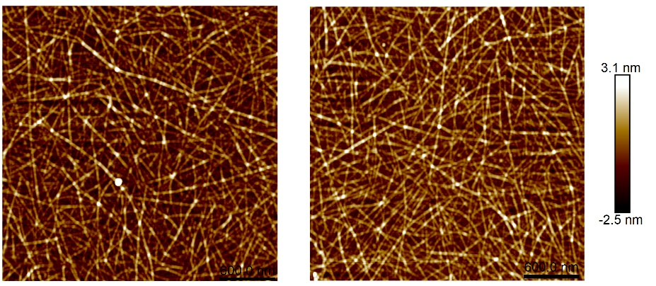
Supplementary Fig. 4 AFM images of CNT films on a 4-inch Si/SiO₂ wafer.

Supplementary Fig. 5 Output characteristics of Ti-contacted CNT FETs under low-bias conditions. (a) $V_{bg}$ swept from 0 to −2 V in −0.2 V steps. (b) $V_{bg}$ swept from 0 to 2 V in 0.2 V steps.

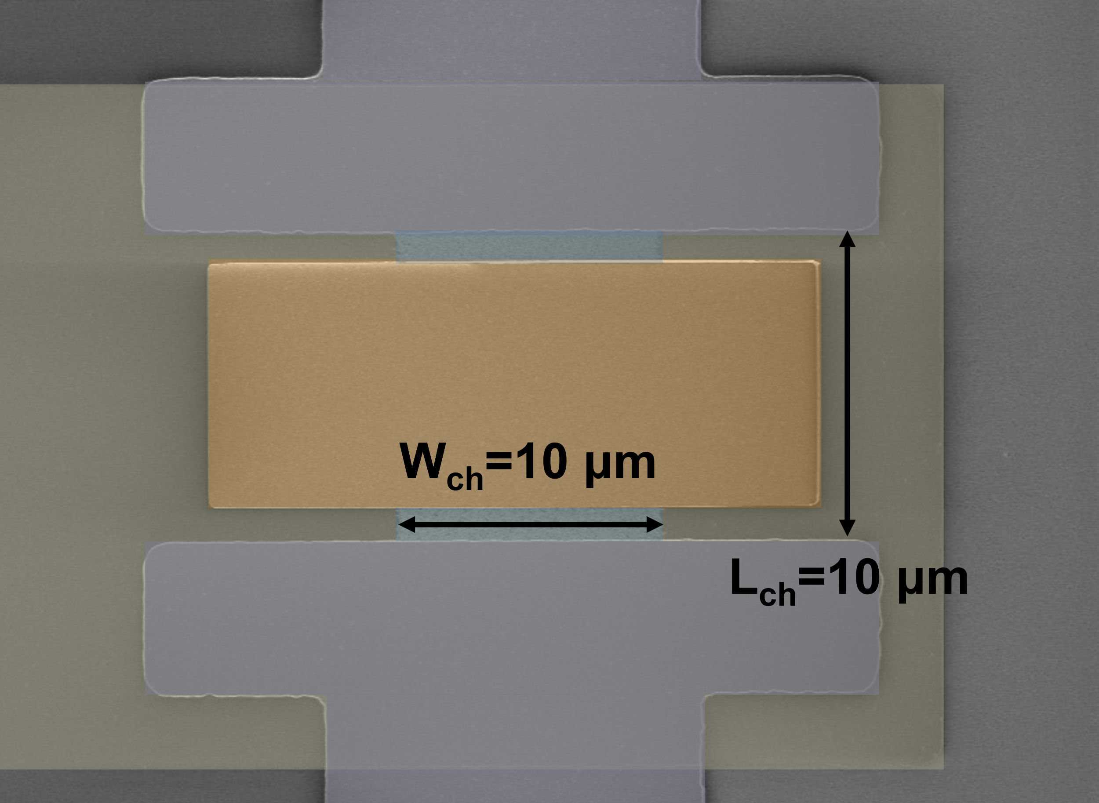
Supplementary Fig. 6 SEM image of HGAFET.
Supplementary Fig. 6 shows the channel geometry and ZnO-defined gate region used to determine the channel area (10 μm × 10 μm) and heterojunction gate length (8 μm).
Supplementary Fig. 7 Dual-gate modulation in reconfigurable CNT FETs. (a) Schematic of the dual-gated FET with back-gate and top-gate. (b) Log-scale top-gate transfer characteristics showing $V_{bg}$-induced transition from ambipolar to unipolar operation: p-type at large negative $V_{bg}$ and n-type at large positive $V_{bg}$, with corresponding threshold-voltage shifts. Linear-scale transfer curves in the (c) p-regime ($V_{bg}$= −4 to −9 V) and (d) n-regime ($V_{bg}$ = 0 to 5 V), showing $V_{bg}$-dependent enhancement of on-state current $I_{on}$ and transconductance $g_{m}$. Insets: $g_{m}$ versus $V_{bg}$, supporting the responsivity model.
Supplementary Fig. 7 illustrates the dual-gated CNT FET, where the top-gate length matches the photosensitive layer. Back-gate modulation ($V_{bg}$) enables dynamic reconfiguration between n-type and p-type operation. Increasing negative $V_{bg}$ induces upward band bending in the CNT, thickening the electron barrier while thinning the hole barrier, thereby enhancing hole concentration and transitioning the device to unipolar p-type operation, accompanied by a right-shifted threshold voltage and increased on-state current (Supplementary Fig. 7b, c). Conversely, positive $V_{bg}$ thins the electron barrier while thickening the hole barrier, increasing electron concentration and switching the device to n-type operation, with a left-shifted threshold (Supplementary Fig. 7b, d). Parameter extraction shows that larger |$V_{bg}$| enhances both $I_{on}$ and $g_{m}$ in both regimes. This gate-controlled modulation underpins the photoresponse model, where responsivity scales with the magnitude of $V_{bg}$.

Supplementary Fig. 8 Simulated photoresponse of dual-gated CNT transistors. (a) Back-gate transfer characteristics under incremental top-gate voltages ($V_{tg}$= 0 to −0.4 V) emulating photovoltage generation. The applied $V_{tg}$ mimics light-induced hole accumulation at the ZnO/HfO₂ interface. (b) Differential drain current (${ΔI}_{ds}$) versus $V_{bg}$ showing ambipolar behavior in both n-type and p-type regimes.
To validate the gate-tunable photoresponse mechanism, photovoltage generation was emulated via top-gate biasing. Applying a negative bias ($V_{tg}$ = 0 to −0.4 V, Supplementary Fig. 8a) at the metal top gate simulates carrier accumulation at the ZnO/HfO₂ interface under infrared illumination, producing a ~1.6 V rightward shift in the threshold voltage. Importantly, the extracted photocurrent, ${ΔI}_{ds}$ = $I_{ds}\left(V_{tg}\right)-I_{ds}\left(V_{tg}=0\right)$ (Supplementary Fig. 8b), exhibits highly symmetric bidirectional behavior, demonstrating balanced electron-hole transport and establishing the physical basis for polarity-symmetric photoresponse in the HGAFET (as discussed in Fig. 2).
Supplementary Fig. 9 Bidirectional infrared photoresponse of the HGAFET at 1300 nm. (a, b) Real-time photocurrent in the (a) p-type regime ($V_{bg}$ = −0.3 to −2 V) and (b) n-type regime ($V_{bg}$ = −0.2 to 2 V) under 4.16 nW cm⁻² to 1.92 μW cm⁻² illumination. (c, d) Extracted positive and negative photocurrents versus $P_{light}$ from (a) and (b). (e, f) Corresponding positive (e) and negative (f) responsivity versus $P_{light}$.
Supplementary Fig. 9a and 9b show the dynamic photocurrent responses in the p-type (hole-dominated, negative $V_{bg}$) and n-type (electron-dominated, positive $V_{bg}$) regimes, respectively. The $P_{light}$−dependent photocurrent curves in Supplementary Fig. 9c and 9d exhibit nearly symmetric positive and negative distributions, confirming balanced ambipolar transport. Corresponding responsivities in Supplementary Figure 9e and 9f exceed 10⁵ A W⁻¹ for both polarities, with continuous tunability through $V_{bg}$. These results demonstrate the HGAFET’s high-sensitivity detection and its intrinsic capability for flexible control of both response polarity and amplitude.

Supplementary Fig. 10 Gate-modulated noise characteristics of the HGAFET. (a, b) Frequency-dependent current noise spectra in the (a) p-type regime ($V_{bg}$ = −0.3 to −2 V) and (b) n-type regime ($V_{bg}$= 0 to 2 V). Dashed line indicates equipment noise floor (10⁻¹⁴ A Hz^{-1/2}, PDA FS380). (c) Current noise at 10 Hz as a function of $V_{bg}$ swept from −2 V to 2 V.
Supplementary Fig. 11 Time-resolved NPC and PPC response across the 640−1080 nm range (40 nm steps) at fixed $V_{bg}$ = −0.8 V and 0.5 V.

Supplementary Fig. 12 Gate-dependent photocurrent and responsivity across visible-SWIR wavelengths. Left column: Photocurrent versus $P_{light}$ at 650 nm (a), 950 nm (c), 1300 nm (e), 1550 nm (g), and 1700 nm (i). Right column: Corresponding responsivity at the same wavelengths: 650 nm (b), 950 nm (d), 1300 nm (f), 1550 nm (h), and 1700 nm (j).
Supplementary Table 1-1: Calibration of incident power density at 650 nm.
Supplementary Table 1-2: Calibration of incident power density at 950 nm.
Supplementary Table S-3: Calibration of incident power density at 1300 nm.
Supplementary Table 1-4: Calibration of incident power density at 1550 nm.
Supplementary Table 1-5: Calibration of incident power density at 1700 nm.
A series of aperture slots paired with neutral density filters (NE60A-B and NENIR60A, Thorlabs) were employed to attenuate optical power density across distinct spectral bands. Output power density was quantified using silicon photodetector (S120C, Thorlabs) and germanium photodetector (S122C, Thorlabs) connected to a power meter console (PM100D, Thorlabs), with attenuation factors calibrated against standard silicon and indium gallium arsenide photodiodes (FDS100 and FGA21, Thorlabs). The symbol (‘-’) in the calibration tables denotes signal levels below the detection limit.
Supplementary Fig. 13 Temporal response, bandwidth, and operational stability of the HGAFET under low-bias operation. (a, b) Normalized photocurrent rise ($T_{rise}$) and fall times ($T_{fall}$) in positive (a, $T_{rise}$ = 59 μs, $T_{fall}$ = 113 μs) and negative (b, $T_{rise}$ = 198 μs, $T_{fall}$ = 228 μs) response modes. (c, d) 3 dB bandwidths for positive (c, 1550 Hz) and negative (d, 537 Hz) modes; insets show normalized photocurrent attenuation versus modulation frequency. (e, f) Repeated photoresponse under repeated operation cycles.
By standard definition, the rise time ($T_{rise}$) is the duration for the photocurrent to increase from 10% to 90% of its steady-state value, while the fall time ($T_{fall}$) corresponds to the decrease from 90% to 10% (Supplementary Fig. 13a, b). Both response and recovery times are below 500 μs for positive and negative modes, meeting the real-time imaging requirements of high-frame-rate cameras (> 2,000 fps). The 3 dB bandwidth, defined as the modulation frequency at which the photoresponse drops to 70.7% of its peak, is 1550 Hz in the positive mode (Supplementary Fig. 13c) and 537 Hz in the negative mode (Supplementary Fig. 13d). After two months of storage under standard laboratory conditions (25 ± 2 °C, 45 ± 10% RH), the unpackaged HGAFET device was tested repeatedly. Supplementary Fig. 13e and 13f show highly consistent photocurrent waveforms in both positive and negative operation modes, demonstrating robust optoelectronic stability after extended storage and repeated operation.

Supplementary Fig. 14 Wafer-scale fabrication process of HGAFET arrays. (a) Deposition of back-gate interconnects. (b) ALD of 15 nm HfO₂ back-gate dielectric. (c) CNT film deposition and patterning. (d) EBE deposition of source/drain electrodes and bottom interconnects (Ti/Au, 30/40 nm). (e) CVD of 80 nm SiO₂ isolation layer. (f) EBE deposition of top interconnects (Ti/Au, 10/550 nm). (g) Deposition of top-gate dielectric (7 nm HfO₂). (h) Magnetron sputtering of 40 nm ZnO. (i) Spin-coating of PbS QDs.

Supplementary Fig. 15 Statistical distributions of HGAFET array performance. Gaussian fits for (a) subthreshold swing ($SS$) in p-type operation, (b) $SS$ in n-type operation, and (c) on/off ratio ($I_{on}/I_{off}$) for the 64 sampled devices from the wafer-scale arrays.

Supplementary Table 2-1. Statistical parameters of 64 HGAFETs. Threshold voltage $V_{th}$, subthreshold swing $SS$, and on/off ratio $I_{on}/I_{off}$ are summarized. Coefficient of variation ($C_{v}$) is defined as the standard deviation (σ) divided by the mean (µ).
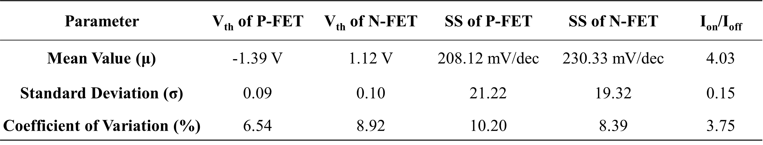

Supplementary Table 2-2. Photoresponse statistics of 64 random selected HGAFETs. Devices were measured at $V_{bg}$= −0.4 V for PPC and $V_{bg}$=0.2 V for NPC.
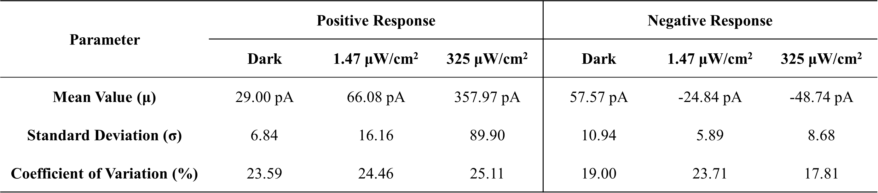

Supplementary Fig. 16 Representative 3 × 3 convolution kernels and corresponding gate-voltage assignments for the HGAFET array. The gate voltages applied to the HGAFET array define the analog weights used for in-sensor convolution operations, including Sobel, Prewitt, Laplacian, and mean filters, enabling spatial feature extraction directly at the pixel level.

Supplementary Fig. 17 Simulated edge feature extraction in low-light transportation scenes. Top row: original input images. Middle row: edge maps obtained via HGAFET-based in-sensor processing. Bottom row: edge maps obtained via conventional digital convolution for comparison.
To assess the practical performance of the HGAFET, we evaluated representative low-light transportation scenes, including cars, bikes, trains, pedestrians, and buses, using the Exclusively Dark Image Dataset¹. Compared with conventional digital convolution, HGAFET-based in-sensor processing yields clearer structural contours and better retention of weak features under low illumination, supporting the suitability of the device platform for low-light, resource-constrained vision applications.

Supplementary Fig. 18 (a-h) Gray-level distribution analysis for the augmented Yale Face Dataset under eight illumination conditions. Left: histograms of pixel intensity values. Right: corresponding cumulative distribution functions (CDFs), illustrating illumination variability across the eight illumination conditions.

The average grayscale values of the augmented Yale Face Database were computed from 1,320 standardized images. For each single-channel grayscale image $I$ of size $M×N$, the average brightness $θ$ is calculated as:
$$\begin{aligned}θ=\frac{1}{M×N}\sum_{i=0}^{M-1}{\sum_{j=0}^{N-1}{I\left(i,j\right)}}\#\left(1\right)\end{aligned}$$
where $I\left(i,j\right)$ represents the pixel intensity at position $\left(i,j\right)$. This procedure was applied independently to each image, producing the grayscale histogram and cumulative distribution functions for the dataset (Supplementary Fig. 18). The overall dataset brightness was then obtained by averaging the $θ$ values across all images, providing a representative metric of illumination conditions.

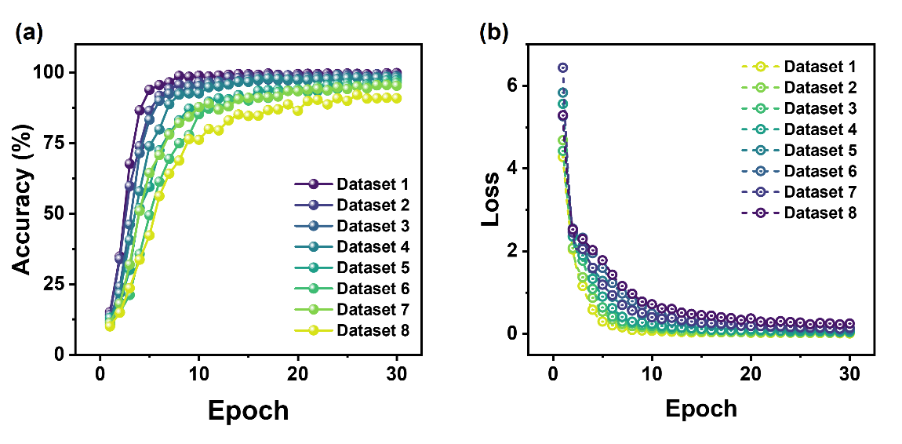
Supplementary Fig. 19 Training convergence of CNN using HGAFET-based in-sensor preprocessing. (a) Accuracy and (b) loss as a function of training epoch across the 8 illumination conditions, demonstrating stable convergence under varying brightness levels.
Supplementary Fig. 20 In-sensor motion-aware compression using frame differencing in a HGAFET array. (a) Irradiance mapping: Left—static background in Frame N (1.62 μW cm⁻²); Middle—composite illumination in Frame N+1 (background: 1.62 μW cm⁻², moving target: 3.61 mW cm⁻²); Right—extracted target contour. (b) Photocurrent response in a 6×8 subarray: Left—negative photocurrent under static background ($V_{bg}$>0, Frame N). Middle—positive photocurrent with moving target ($V_{bg}$<0, Frame N+1). Right—differential photocurrent after frame summation (motion mask). (c) Photocurrent distribution of static background regions (Frames N and N+1). (d) Photocurrent distribution of target-illuminated pixels in Frame N+1. (e) Statistical distribution of differential photocurrent, illustrating clear separation between static and motion-induced signals.

Supplementary Fig. 21 Motion masks generated by the HGAFET array are fed into a lightweight YOLOv8 network for efficient moving-object recognition, highlighting selective processing of motion-containing regions while suppressing static background.

Supplementary Note 1: Experimental Inference Latency and Computational Load of In-Sensor Motion-Aware Compression
In dynamic object detection systems, the evaluation of motion mask occupancy, inference latency, and computational load combines both experimental measurements and formal definitions. The methodology is outlined below:
1. Average Pixel Count of Motion Mask
The motion mask generated via inter-frame differencing highlights dynamic regions in the scene. Let $W$ and $H$ denote the width and height of each video frame, and $M_{t}$ the number of non-zero pixels in the motion mask of frame $t$. The average motion mask occupancy, or compression ratio $ρ$, is defined as:
$$\begin{aligned}ρ=\frac{1}{N}\sum_{t=1}^{N}{\frac{M_{t}}{W×H}}\#\left(2\right)\end{aligned}$$
where $N$ is the total number of frames analyzed.
2. Measurement of Inference Latency
Full frame detection latency ($T_{full}$): The time interval from raw frame input to the completion of detection output using conventional processing.
Motion-aware compression latency ($T_{motion}$): The duration encompassing motion region extraction and motion mask-based detection. The average latency is obtained by computing as the arithmetic mean of all frame-wise measurements.
3. Computational Load Model
The computational load is quantified using a floating-point operations (FLOPs) model, with separate formulations for full-frame and motion-aware detection.
(1) YOLOv8m Baseline Model
The YOLOv8m model consists of 259 trainable layers organized into a backbone network, feature fusion module, and detection head. The FLOPs for each convolutional layer are calculated as:
$$\begin{aligned}{FLOPs}_{l}=2×K_{h}×K_{w}×C_{in}×C_{out}×H_{out}×W_{out}\#(3)\end{aligned}$$
where $K_{h}×K_{w}$ is the convolutional kernel size, $C_{in}$and $C_{out}$ are the input and output channels, and $H_{out}×W_{out}$ is the output feature map size. The factor of 2 accounts for the multiply-accumulate (MAC) operations in each convolution.
The total computational load of the YOLOv8m model is then:
$$\begin{aligned}F_{total}=\sum_{l=1}^{259}{{FLOPs}_{l}}=79.3 GFLOPs\#\left(4\right)\end{aligned}$$
(2) Motion-Aware Detection
For frame t, the computational load scales proportionally with the fraction of active pixels in the motion mask:
$$\begin{aligned}F_{motion}=\frac{M_{t}}{W×H}×F_{total}\#\left(5\right)\end{aligned}$$
The average per-frame computational load is computed as:
$$\begin{aligned}F_{\frac{motion}{frame}}=\frac{1}{N}\sum_{t=1}^{N}{F_{motion}}\#\left(6\right)\end{aligned}$$
This formulation provides a quantitative measure of the efficiency gains from motion-aware compression compared to conventional full-frame processing.

Supplementary Note 2. Comprehensive Benchmark Metrics of HGAFET-based in-sensor motion-aware IKPs vs Established Motion Perception Architectures
1. Compression Efficiency
Compression efficiency quantifies the capability to eliminate redundant pixel data while preserving motion-critical features, defined as:
$$\begin{aligned}γ=1-\frac{1}{N}\sum_{t=1}^{N}{\frac{M_{t}}{W×H}}=1-ρ\#(7)\end{aligned}$$
The HGAFET-based architecture achieves a compression efficiency of 91.04% through symmetric bidirectional photoresponse, enabling sensor-level background suppression. This mechanism discards 91.04% of redundant scene data before downstream digital processing. Validation on 211-frame datasets demonstrates 16.18× reduction in inference latency and 72.99× lower computational load compared to full-frame processing at 720p resolution.
2. Recognition Accuracy
The HGAFET-based significantly enhances classification accuracy under low-light conditions due to its high-sensitivity. By performing feature extraction directly on input images during HGAFET-based operation, the model achieves effective convergence with merely 30 training epochs. Post-training evaluation on test datasets demonstrates robust recognition precision exceeding 90% across varying average grayscale values (simulating different illumination levels).
3. Computational Weights Range
The computational weights range (CWR) characterizes the dynamic operating span of weight modulation during convolutional operations, defined as:
$$\begin{aligned}CWR=20\log_{10}\left(\frac{w_{max}}{w_{min}}\right)=20\log_{10}\left(\frac{R_{max}}{R_{min}}\right)\#(8)\end{aligned}$$
where$\frac{w_{max}}{w_{min}}$represent maximum/minimum tunable weight, corresponding to$R_{max}$ (maximum responsivity) and $R_{min}$ (minimum responsivity). HGAFET-based in-sensor motion-aware IKPs achieves 104 dB (4.35–686857.66 A/W) via $V_{bg}$ modulation, representing significant enhancement over established motion perception architectures (18–54 dB). This advancement provides support for in-sensor MAC operations.
4. Throughput
Throughput quantifies the computation that a system can process within a given time period, measured in operations per second (OPS), with the HGAFET-based in-sensor motion-aware IKPs achieving 5,000 OPS. This metric is governed by switching dynamics, with response latencies below 250 μs (Supplementary Figure 13). Devices with slower response speeds exhibit proportionally reduced throughput due to prolonged switching latency.
5. Scalability
Scalability assessment evaluates manufacturable array density and integration potential. The HGAFET-based in-sensor motion-aware IKPs architecture was fabricated as HGAFET arrays on 4-inch silicon substrates using a lift-off process. Each wafer contains multiple functional dies, with individual die integrating 1,056 HGAFET devices. Featuring a pixel pitch of 10×10 μm, the advanced monolithic 3D integration scheme enables a projected integration density exceeding 10⁶ pixels/cm².

Supplementary Note 3. Expression for the Open-Circuit Photovoltage $V_{oc}$
Under illumination, the p-i-n heterojunction generates photocarriers that induce an open-circuit photovoltage given by
$$\begin{aligned}V_{oc}=\frac{k_{B}T}{q}ln\left(\frac{ηqAP_{light}}{hvI_{0}}+1\right)\#(9)\end{aligned}$$
where $k_{B}$ is the Boltzmann constant, $T$ is the temperature, $q$ is the elementary charge, $η$ is the external quantum efficiency, $A$ is the effective device area, $hv$ is the photon energy, and $I_{0}$ is the reverse saturation current of the heterojunction.

Table S3-1. Detailed performance parameters benchmarked in Figure 4e.

Table S3-2. Detailed performance parameters benchmarked in Figure 4f.

References
1. Loh, Y. P. & Chan, C. S. Getting to know low-light images with the Exclusively Dark dataset. Comput. Vis. Image. Und. 178, 30–42 (2019).
2. Xu, L. et al. Ultrasensitive dim-light neuromorphic vision sensing via momentum-conserved reconfigurable van der Waals heterostructure. Nat. Commun. 15, 9011 (2024).
3. Fu, J. et al. Bionic visual-audio photodetectors with in-sensor perception and preprocessing. Sci. Adv. 10, eadk8199 (2024).
4. Guo, T. et al. Reconfigurable phototransistors driven by gate-dependent carrier modulation in WSe₂/Ta₂NiSe₅ van der Waals heterojunctions. ACS Nano 19, 1302–1315 (2025).
5. He, W., Wu, D., Kong, L., Yu, P. & Yang, G. Giant negative photoresponse in van der Waals Graphene/AgBiP₂Se₆/Graphene trilayer heterostructures. Adv. Mater. 36, 2312541 (2024).
6. Ghosh, S. et al. Polarity-tunable photocurrent through band alignment engineering in a high-speed WSe₂/SnSe₂ diode with large negative responsivity. ACS Nano 16, 4578–4587 (2022).
7. Du, J. et al. Gate‐controlled polarity‐reversible photodiodes with ambipolar 2D semiconductors. Adv. Funct. Mater. 31, 2007559 (2021).
8. Jiang, J. et al. Wavelength-controlled photoconductance polarity switching via harnessing defects in doped PdSe₂ for artificial synaptic features. Small 20, 2306068 (2024).
9. Ma, J. et al. Vertical 1T’‐WTe₂/WS₂ Schottky‐barrier phototransistor with polarity‐switching behavior. Adv. Electron. Mater. 10, 2300672 (2024).
10. Han, Y. et al. Bipolar modulation in a self-powered ultra-wide photodetector based on Bi₂Se₃/AlInAsSb heterojunction for wavelength-sensitive imaging and encrypted optical communication. Adv. Mater. 37, 2416935 (2025).
11. You, J. et al. All-optic logical operations based on the visible-near infrared bipolar optical response. Adv. Sci. 11, 2404336 (2024).
12. Liu, J. et al. A near-infrared colloidal quantum dot imager with monolithically integrated readout circuitry. Nat. Electron. 5, 443–451 (2022).
13. Chen, Y. et al. Ultranarrow-bandgap small-molecule acceptor enables sensitive SWIR detection and dynamic upconversion imaging. Sci. Adv. 10, eadm9631 (2024).
14. Zhou, S. et al. Opto-electrical decoupled phototransistor for starlight detection. Adv. Mater. 37, 2413247 (2025).
15. Zhao, Y. et al. High-performance all-inorganic perovskite tandem photodetectors with Bi₂TeO₆ Layer enabled by enhanced dual pyro-phototronic effect for triple-encryption imaging sensing system with programmable logic gate. Adv. Mater. 37, e2414649 (2025).
16. Liu, T. et al. Optically controllable 2D material/complex oxide heterointerface. Adv. Sci. 7, 2002393 (2020).
17. Jiang, H. et al. Simultaneous achieving negative photoconductivity response and volatile resistive switching in Cs₂CoCl₄ single crystals towards artificial optoelectronic synapse. Light Sci. Appl. 13, 316 (2024).
18. Zeng, L.-H. et al. Multilayered PdSe₂/perovskite Schottky junction for fast, self-powered, polarization-sensitive, broadband photodetectors, and image sensor application. Adv. Sci. 6, 1901134 (2019).
19. Pi, L. et al. Broadband convolutional processing using band-alignment-tunable heterostructures. Nat. Electron. 5, 248–254 (2022).
20. Wu, G. et al. Ferroelectric-defined reconfigurable homojunctions for in-memory sensing and computing. Nat. Mater. 22, 1499–1506 (2023).

