Supplement Materials for
Al¹⁸F-AEEA-HER2-BCH affibody reveals clear PET imaging in newly diagnosed patients and relapsing metastatic patients with breast cancer: A pilot clinical translation study
Xiaoyi Guo¹, Jin Ding¹, Shuailiang Wang¹, Teli Liu¹, Guohong Song², Nina Zhou^{*,1}, Hua Zhu^{*,1}, Zhi Yang^{*,1}
¹Key Laboratory of Carcinogenesis and Translational Research (Ministry of Education/Beijing), NMPA Key Laboratory for Research and Evaluation of Radiopharmaceuticals (National Medical Products Administration), Department of Nuclear Medicine; Peking University Cancer Hospital & Institute, Beijing, China;
²Department of Breast Oncology, Peking University Cancer Hospital & Institute, Beijing, China;

*For correspondence or reprint contact either of the following:
Nina Zhou, Tel.: +86-10-88196191, Fax: +86-10-88196191, E-mail: 13681011804@163.com ;
Hua Zhu, Tel.: +86-10-88196195, Fax: +86-10-88196495, E-mail: zhuhuananjing@163.com;
Zhi Yang, Tel.: +86-10-88196196, Fax: +86-10-88196196, E-mail: pekyz@163.com.

Radiosynthesis
¹⁸F was loaded onto a quaternary methyl ammonium (QMA) cartridge and eluted with 0.3 mL of saline. Before labeling synthesis, we first premixed 100 μl ¹⁸F (0.37-3.7 GBq), 11 μl potassium hydrogen phthalate (KHP) (0.5 M, pH 4.0), 6 μl AlCl3 ( 2 mM), and 100 μl ethyl alcohol at room temperature for 5 min. Then, added 500 ug HER2-affibody-BCH (50 μl, 10 mg/ml), mixed well, and reacted at 100 ℃ for 15 min. After cooling to room temperature, the reaction mixture was diluted with 5 mL of H₂O, passed through a Sep-Pak C18-Light cartridge, and washed with 10 mL of H₂O. Then, the product was eluted from the Sep-Pak C18-Light cartridge with 0.6 mL of 80% EtOH. Passed through a sterile filter membrane (0.22 µm) and diluted with saline (HER2-affibody-BCH) for further studies.
Stability
The vitro stability was determined by incubating the radiotracer in saline or in 5% human serum albumin (HSA) at room temperature. For the vivo stability, 37 MBq of Al¹⁸F-HER2-BCH was injected to each of normal BALB/c female mice and sacrificed at 5 and 30 min. The blood and urine were collected and the radiotracer was extracted for radio-HPLC analysis respectively.
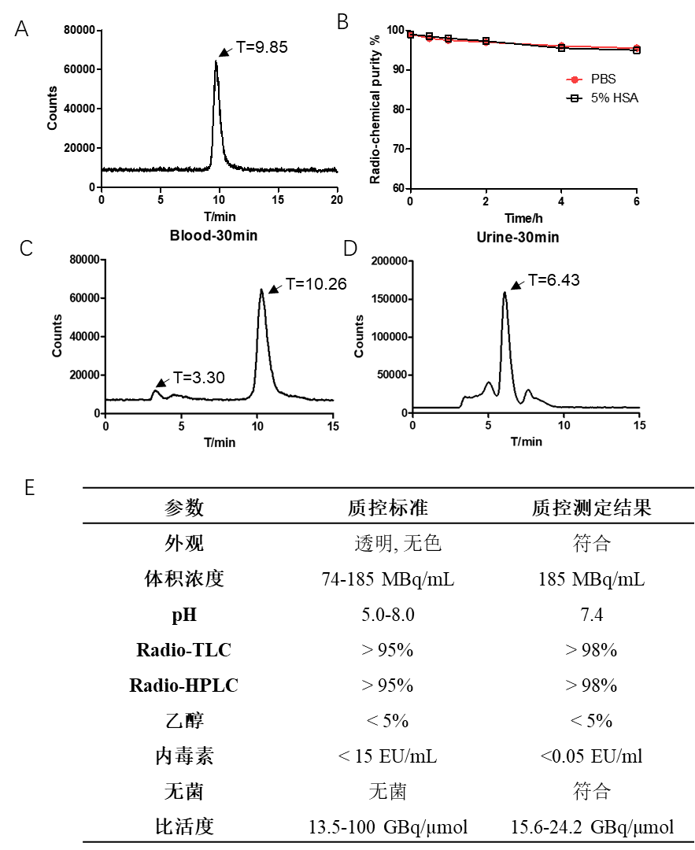
Fig S1. A Radio-HPLC of Al¹⁸F-HER2-BCH; B. In vitro stability of Al¹⁸F-HER2-BCH in PBS and 5% HAS; C. In vivo stability of Al¹⁸F-HER2-BCH in blood, D and urine at 30 min after injection; E. The quality control results of Al¹⁸F-HER2-BCH.
Cell Study
HER2 (+) NCI-N87 and HER2 (-) MDA-MB-231 cell lines were chosen for in vitro cell uptake study. NCI-N87 and MDA-MB-231 cell lines were plated in 24-well plates (1*10⁵ cells) 24 h before the experiment. Then, 0.5 mL of Al¹⁸F-HER2-BCH (74 KBq, 15.6-24.2 GBq/mmol) in fresh medium was added into each well. After incubating the cells with the radiotracer for 10 min, 30 min, 1 h, 2 h, 3 h and 4 h, the medium was removed, and the cells were washed twice with cold phosphate-buffered saline (PBS) (1 mL) and lysed with 0.5 ml 1 M NaOH. Then radioactivity was measured with a γ-counter. For the blocking experiment, cells were co-incubated with 50 µg HER2-affibody-BCH per well.
The Kd of Al¹⁸F-HER2-BCH was determined by adding different concentrations of radiotracer to N87 cells. After incubation for 2 h, the medium was removed, and the cells were washed twice with cold PBS and lysed with 0.35 ml, 1M cold NaOH. The details could be seen in supplemental materials.
Radiotoxicity
At 1, 2, 3, 4, 5, 6, and 7 d after injection, the mice were weighed, and blood obtained from the orbit was analyzed by the Animal Laboratory of Peking University Health Science Center. On d 7 after injection, blood biochemical tests (liver function and renal function) were performed at the Animal Laboratory of Peking University Health Science Center.

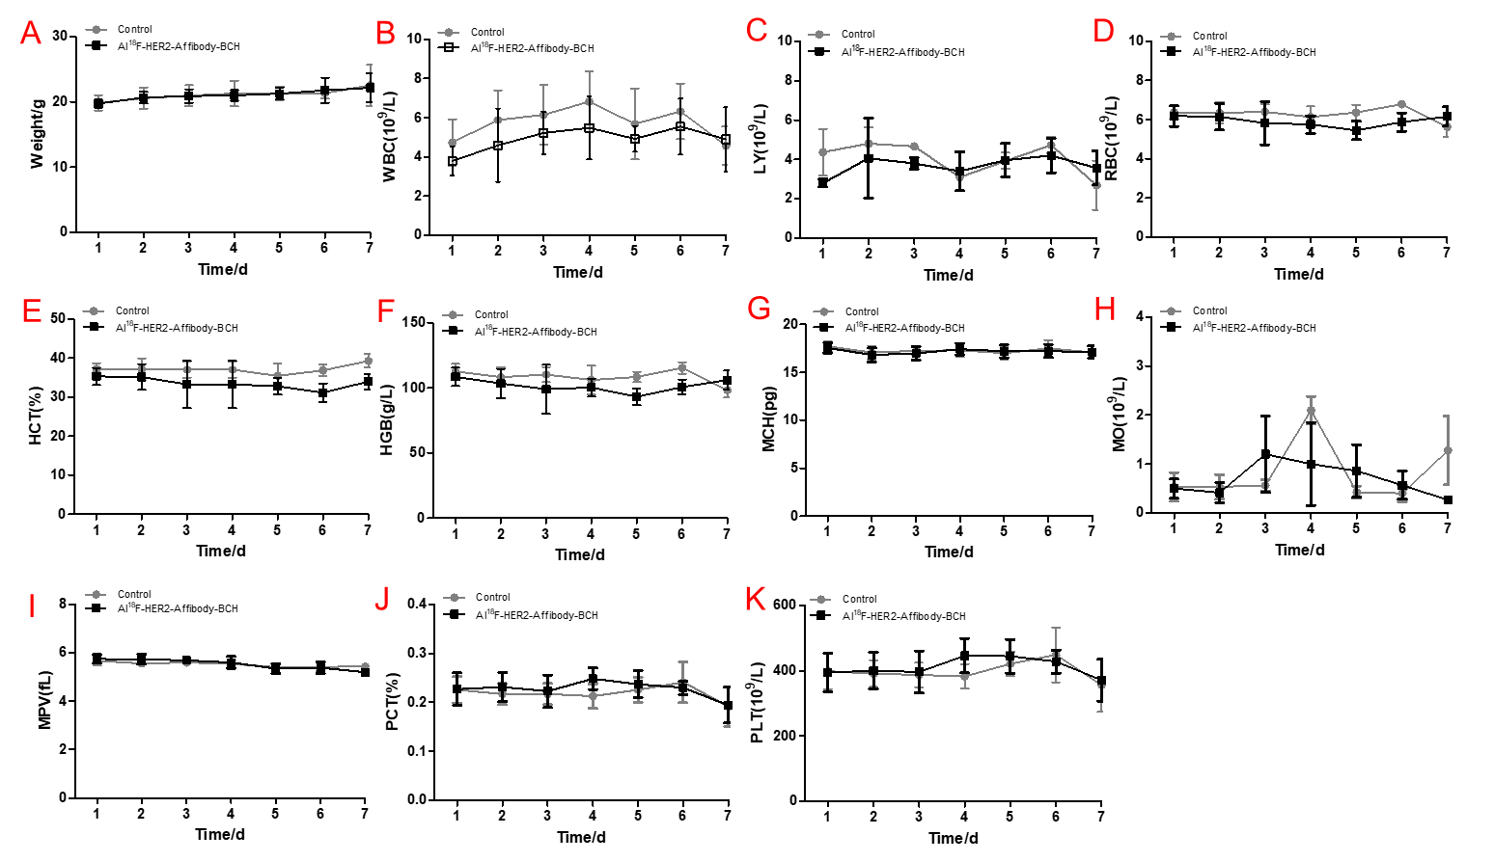
Fig S2. A: The weight of mice in radiotoxicity study of Al¹⁸F-HER2-BCH (n=7). B-K: Result of radiotoxicity studies of Al¹⁸F-HER2-BCH (40 mCi/kg). WBC (white blood count), LY (absolute value of lymphocytes), RBC (red blood cell count), HCT (hematocrit), HGB (hemoglobin), MCH (mean corpuscular hemoglobin), MO (absolute value of monocyte), MPV (mean platelet volume), PCT (platelet counts), PLT (platelet counts).

Test | Parameter | Control | Al¹⁸F-HER2-BCH
 | ALT | 27.74±7.47（U/L） | 24.94±3.88（U/L）
 | AST | 103.22±18.14（U/L） | 99.70±24.32（U/L）
Liver function test | ALP | 173.55±27.95（U/L） | 172.07±21.51（U/L）
 | TP | 24.99±1.57 (g/L) | 25.10±1.64 (g/L)
 | ALB | 16.06±0.90 (g/L) | 16.24±1.08 (g/L)
 | CREA | 10.87±0.84 (μmol/L) | 10.57±1.14 (μmol/L)
Renal function test | UA | 45.40±3.98 (μmol/L) | 44.06±1.14 (μmol/L)
 | UREA | 4.03±0.46 (mmol/L) | 3.86±0.26 (mmol/L)

Fig S3. The results of blood biochemical tests (liver function and renal function)

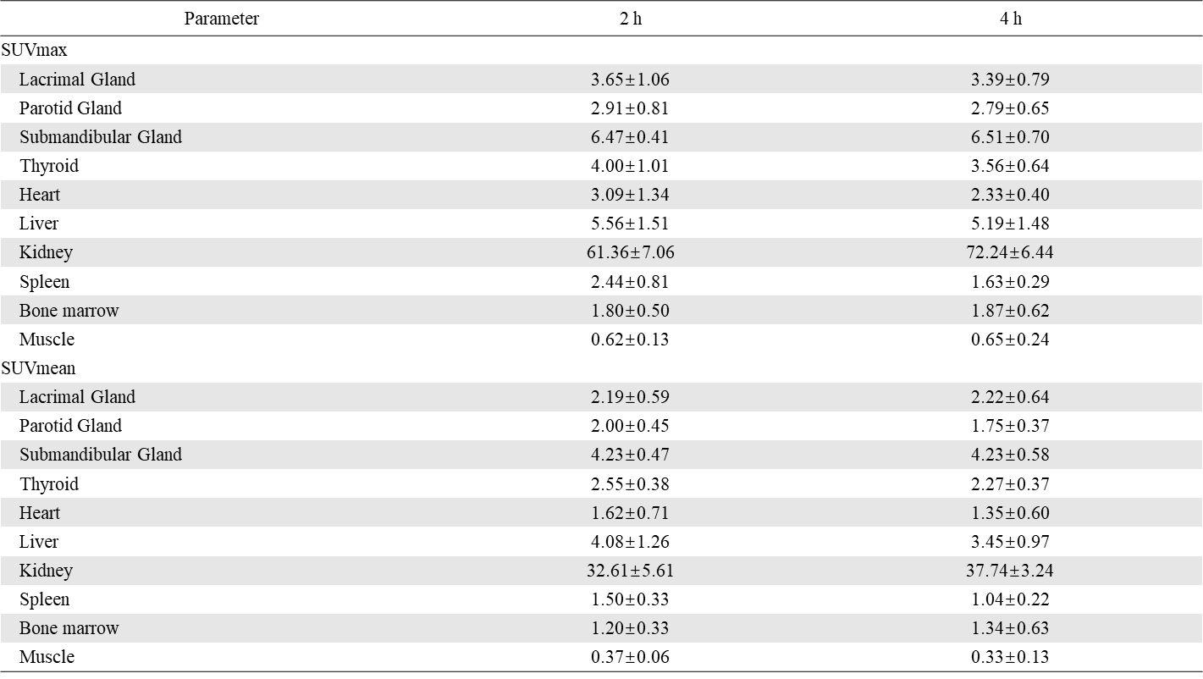
Fig S4. SUVmax and SUVmean at 2 h and 4 h after Al¹⁸F-HER2-BCH administration
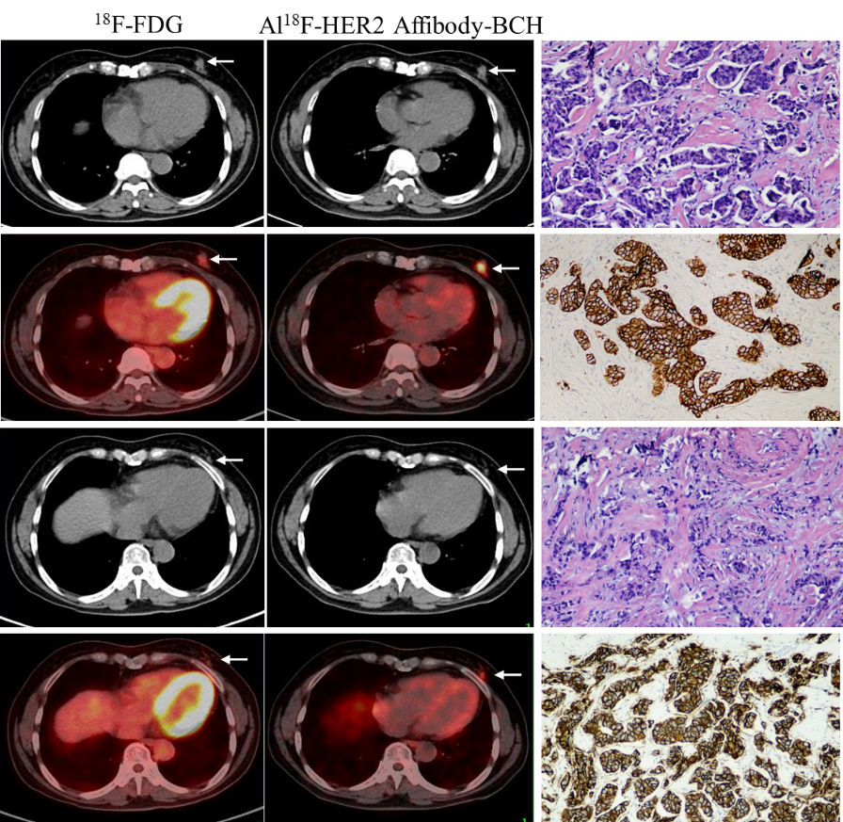
Fig S5. Left images from ¹⁸F-FDG PET/CT findings, medium images obtained at Al¹⁸F-HER2-BCH performed for further evaluation in lesions (arrows), the right of HE staining and IHC of primary breast cancer.

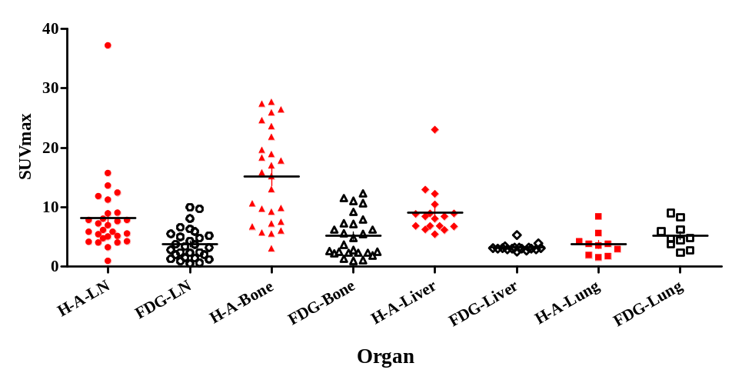
Fig S6. The SUVmax value of ¹⁸F-FDG and Al¹⁸F-HER2-BCH in lymph node metastases, bone metastases, liver metastases, and lung metastases. (Red represents Al¹⁸F-HER2-BCH, and black represents ¹⁸F-FDG).

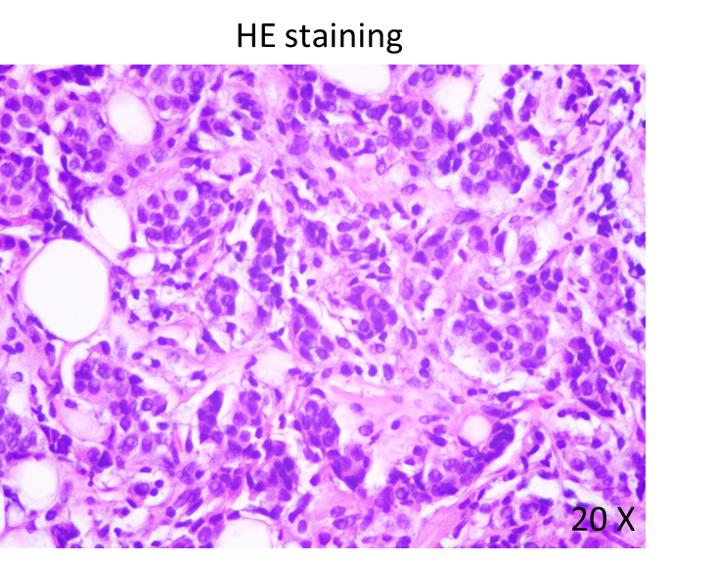
Fig S7. The HE staining result of HER2-negative breast cancer patient.

