Table 1. Comparative Results for newly diagnosis primary breast cancer of ¹⁸F-FDG PET and Al¹⁸F-HER2-BCH.
Table 2. Summary of lesions characteristics of ¹⁸F-FDG PET and Al¹⁸F-HER2-BCH.
Table 3. Comparative results for recurrence detection of ¹⁸F-FDG PET and Al¹⁸F-HER2-BCH accoding to the number of patients.

Table 1

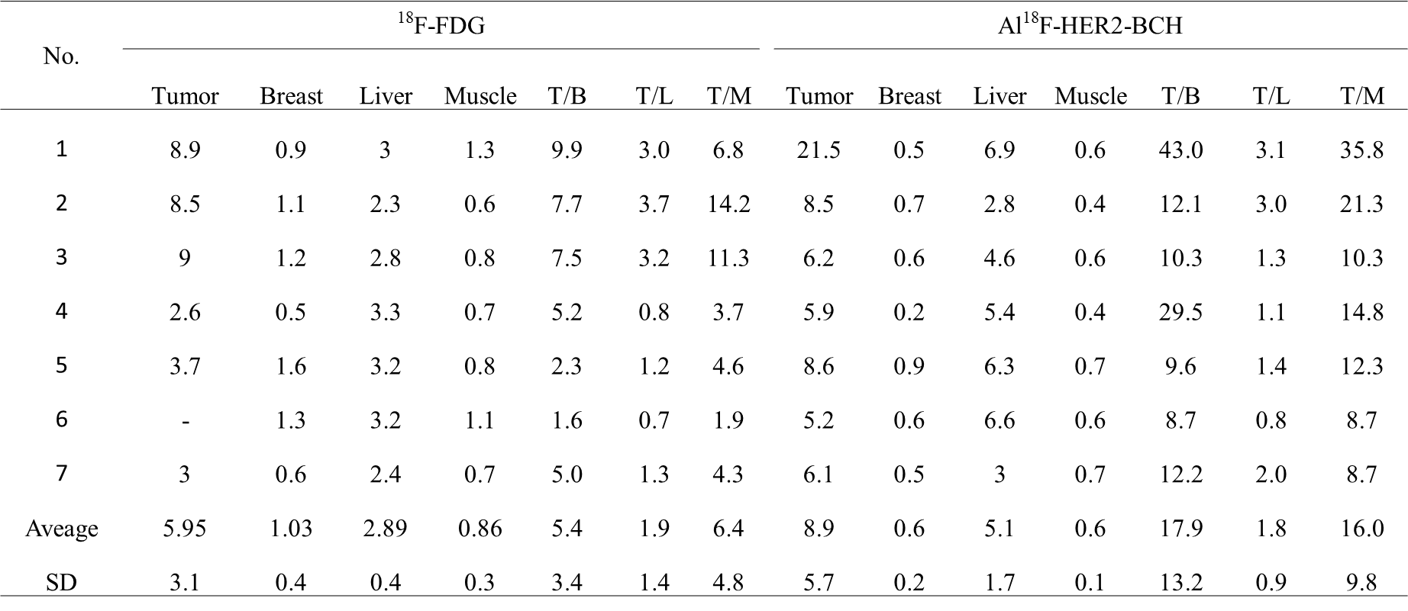

Table 2

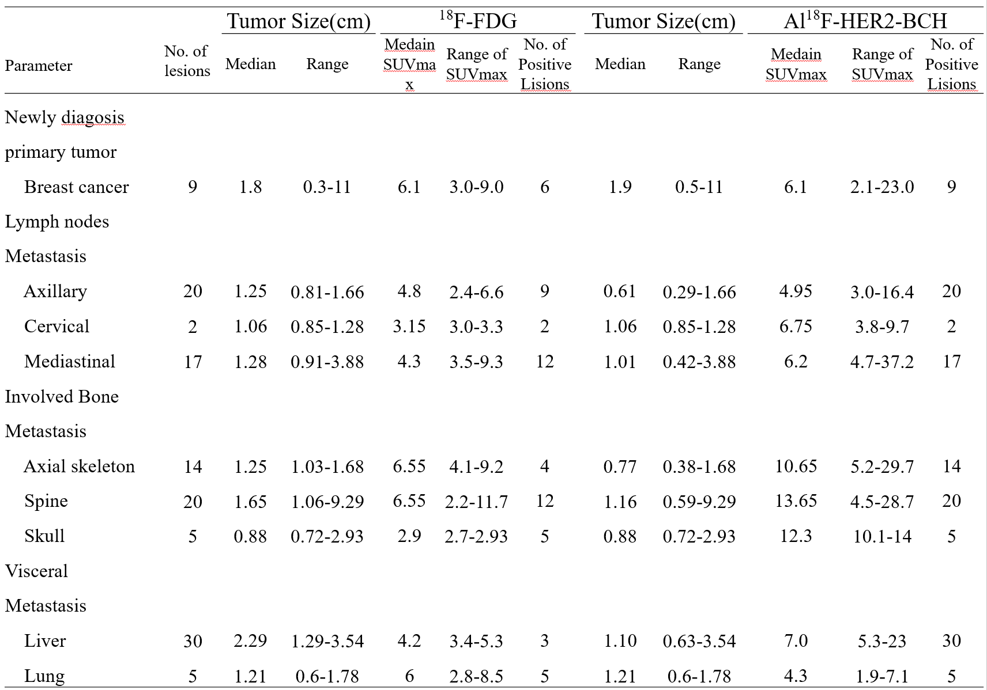

Table 3

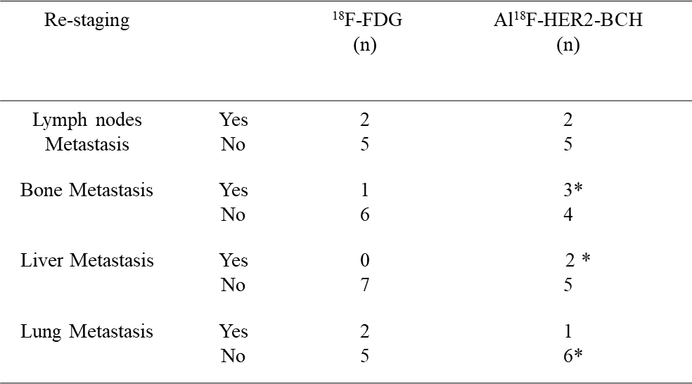
*, Al¹⁸F-HER2-BCH detected more lesions than ¹⁸F-FDG.

