Supplemental Information

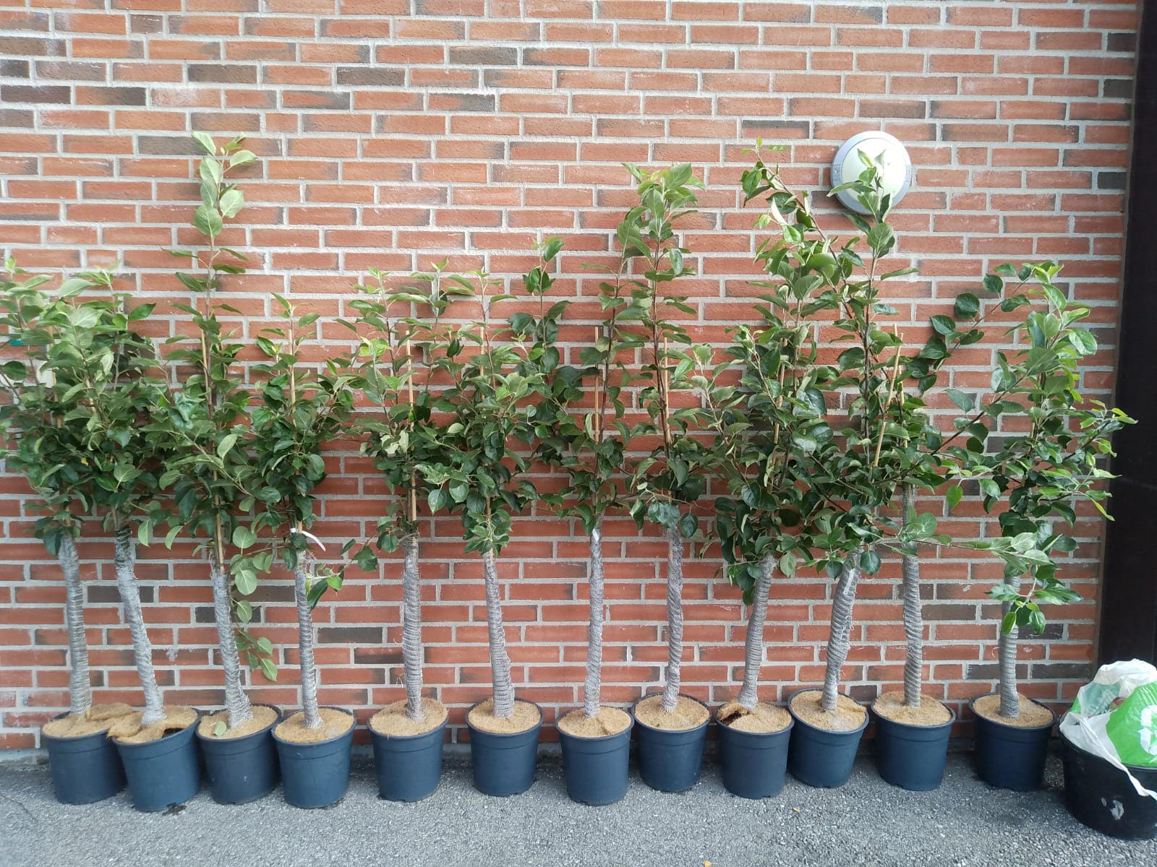

Fig. S1. Example set-up of apple trees guarded with a stainless steel tree guard. Guards were installed by twisting them around the stem of apple trees up to the canopy and secured with metal wire to prevent unravelling. All tree guards were installed before planting in August – November 2025.

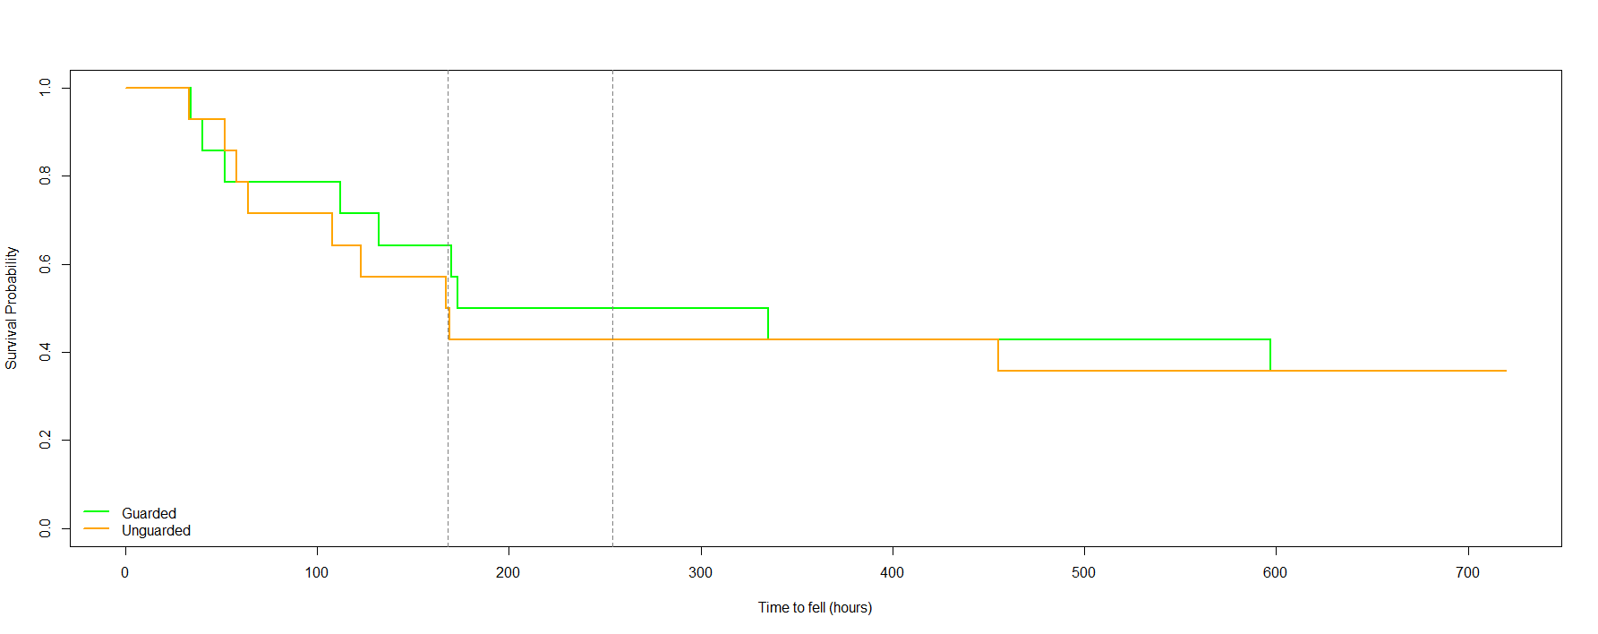
Fig. S2. Kaplan-Meier curve illustrates the timing of felling between apple trees guarded by mesh (green) and unguarded apple trees (orange). The dotted intercept indicates median felling times for each treatment (Unguarded median = 164 hours, guarded median = 254 hours).

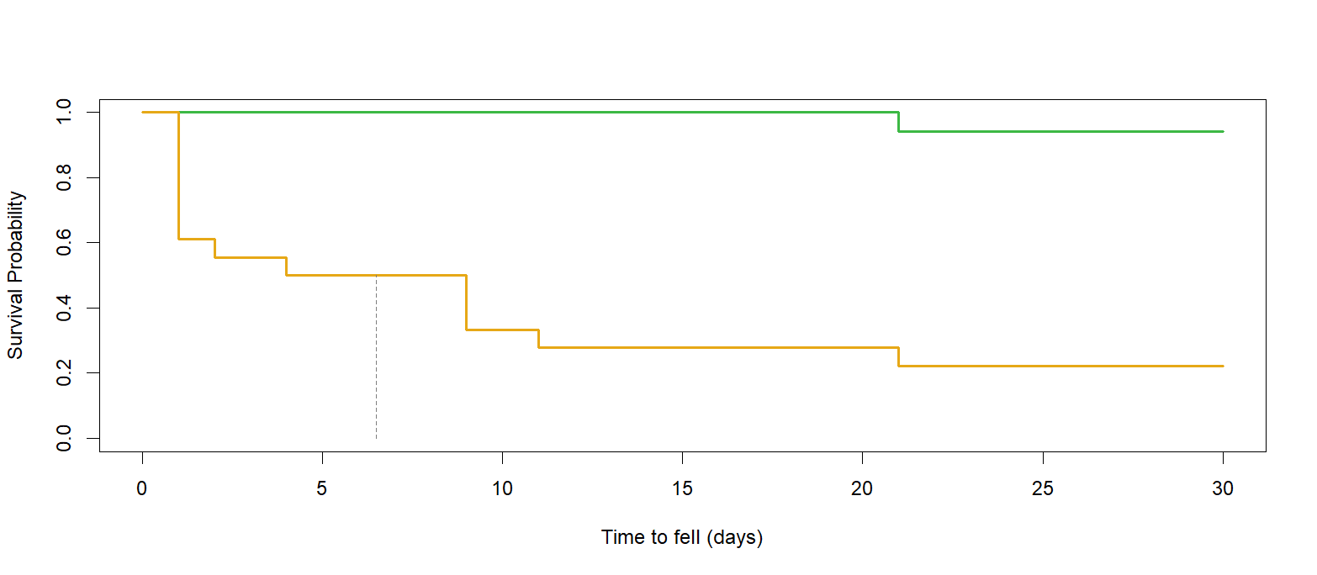

Fig. S3. Kaplan-Meier curve illustrates felling delay between aspen branches that employed guard meshes when compared with aspen branches that were not protected by a guard mesh. The dotted intercept indicates median felling time for unguarded trees (6.5 days).

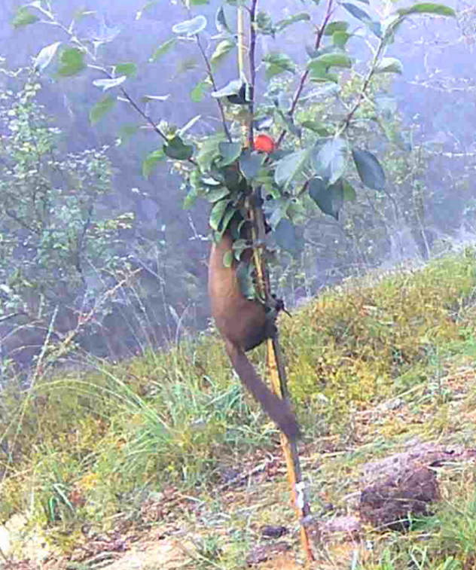
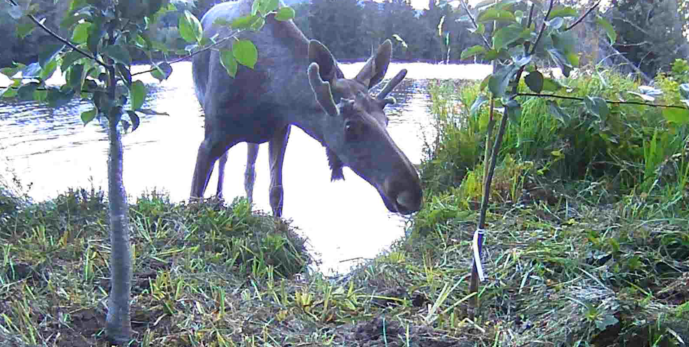
a
b

Fig. S4. Camera trap stills exhibiting example interactions of non-beaver species at unguarded apple trees including foraging behaviour by a pine marten (Martes martes) (a) and sniffing by a European moose (Alces alces) (b) in the Straumen river, South-Eastern Norway, 2025.

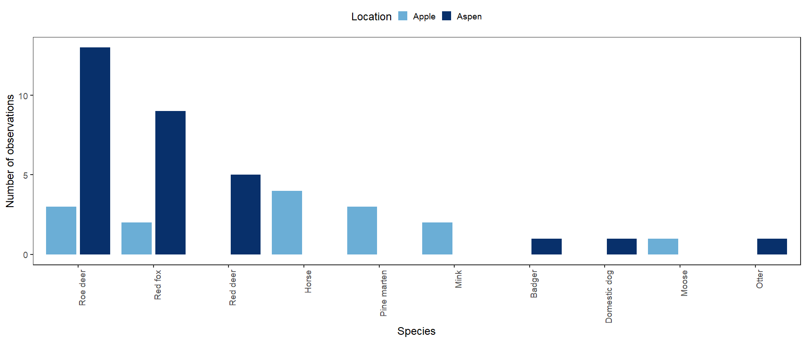
Fig. S5. The number of non-beaver species observations registered across all planting locations of both apple trees and aspen branches. Aspen branches overall had a higher number of visitors, with roe deer, red deer and foxes visiting notably more than any other species. Apple trees were visited evenly between most visiting species, except European moose (Alces alces) (N=1). Several species were recorded exclusively at one location.

