Supplementary Material 1
STROBE Statement—Checklist of items that should be included in reports of cross-sectional studies
 | Item No | Recommendation | Page  No
Title and abstract | 1 | (a) Indicate the study’s design with a commonly used term in the title or the abstract | 1-3 (abstract pages)
Title and abstract | 1 | (b) Provide in the abstract an informative and balanced summary of what was done and what was found | 1-3 (abstract pages)
Introduction
Background/rationale | 2 | Explain the scientific background and rationale for the investigation being reported | 4-6
Objectives | 3 | State specific objectives, including any prespecified hypotheses | 4-6
Methods
Study design | 4 | Present key elements of study design early in the paper | 7
Setting | 5 | Describe the setting, locations, and relevant dates, including periods of recruitment, exposure, follow-up, and data collection | 7-10
Participants | 6 | (a) Give the eligibility criteria, and the sources and methods of selection of participants | 7
Variables | 7 | Clearly define all outcomes, exposures, predictors, potential confounders, and effect modifiers. Give diagnostic criteria, if applicable | 7-11
Data sources/ measurement | 8* | For each variable of interest, give sources of data and details of methods of assessment (measurement). Describe comparability of assessment methods if there is more than one group | 8-10
Bias | 9 | Describe any efforts to address potential sources of bias | 7-11
Study size | 10 | Explain how the study size was arrived at | 7-8
Quantitative variables | 11 | Explain how quantitative variables were handled in the analyses. If applicable, describe which groupings were chosen and why | 10-11
Statistical methods | 12 | (a) Describe all statistical methods, including those used to control for confounding | 10-11
Statistical methods | 12 | (b) Describe any methods used to examine subgroups and interactions | 10-11
Statistical methods | 12 | (c) Explain how missing data were addressed | 10-11
Statistical methods | 12 | (d) If applicable, describe analytical methods taking account of sampling strategy | n/a
Statistical methods | 12 | (e) Describe any sensitivity analyses | 10-11
Results
Participants | 13* | (a) Report numbers of individuals at each stage of study—eg numbers potentially eligible, examined for eligibility, confirmed eligible, included in the study, completing follow-up, and analysed | 12
Participants | 13* | (b) Give reasons for non-participation at each stage | n/a
Participants | 13* | (c) Consider use of a flow diagram | n/a
Descriptive data | 14* | (a) Give characteristics of study participants (eg demographic, clinical, social) and information on exposures and potential confounders | 12
Descriptive data | 14* | (b) Indicate number of participants with missing data for each variable of interest | 8-9, 12-22
Outcome data | 15* | Report numbers of outcome events or summary measures | 12-22
Main results | 16 | (a) Give unadjusted estimates and, if applicable, confounder-adjusted estimates and their precision (eg, 95% confidence interval). Make clear which confounders were adjusted for and why they were included | 12-22
Main results | 16 | (b) Report category boundaries when continuous variables were categorized | n/a
Main results | 16 | (c) If relevant, consider translating estimates of relative risk into absolute risk for a meaningful time period | n/a
Other analyses | 17 | Report other analyses done—eg analyses of subgroups and interactions, and sensitivity analyses | 12-22
Discussion
Key results | 18 | Summarise key results with reference to study objectives | 23-25
Limitations | 19 | Discuss limitations of the study, taking into account sources of potential bias or imprecision. Discuss both direction and magnitude of any potential bias | 26
Interpretation | 20 | Give a cautious overall interpretation of results considering objectives, limitations, multiplicity of analyses, results from similar studies, and other relevant evidence | 23-26
Generalisability | 21 | Discuss the generalisability (external validity) of the study results | 26
Other information
Funding | 22 | Give the source of funding and the role of the funders for the present study and, if applicable, for the original study on which the present article is based | Included in separate form

Supplementary Material 2

Standard curve performance for Leptin assays
Plate | Model | R² | Calculated Top | Calculated Bottom | LLOQ (pg/mL) | ULOQ (pg/mL)
1 | 4-parameter logistic (4PL) | 0.999 | 1.13 × 10⁸ | 104.8 | 48.1 | 462,000
2 | 4-parameter logistic (4PL) | 0.990 | 7.64 × 10⁷ | 113.7 | 79.8 | 462,000

Standard curve performance for TNF-α assays
Plate | Model | R² | Calculated Top | Calculated Bottom | LLOQ (pg/mL) | ULOQ (pg/mL)
1 | 4-parameter logistic (4PL) | 0.999 | 2.02 × 10⁸ | 41.99 | 5.17 | 19,300
2 | 4-parameter logistic (4PL) | 0.997 | 5.42 × 10⁵ | 35.98 | 8.89 | 19,300

Standard curve performance for IL-6 assays
Plate | Model | R² | Calculated Top | Calculated Bottom | LLOQ (pg/mL) | ULOQ (pg/mL)
1 | 4-parameter logistic (4PL) | 0.999 | 4.81 × 10⁷ | 68.29 | 369.82 | 37,800
2 | 4-parameter logistic (4PL) | 0.998 | 8.77 × 10⁷ | 49.33 | 331.16 | 37,800

Standard curve performance for IL-1β assays
Plate | Model | R² | Calculated Top | Calculated Bottom | LLOQ (pg/mL) | ULOQ (pg/mL)
1 | 4-parameter logistic (4PL) | 0.994 | 1.95 × 10⁸ | 85.38 | 340.33 | 137,000
2 | 4-parameter logistic (4PL) | 0.999 | 7.73 × 10⁷ | 130.20 | 277.14 | 137,000

Supplementary Material 3
Matching of demographic and anthropometric characteristics between injured participants and their paired uninjured controls.
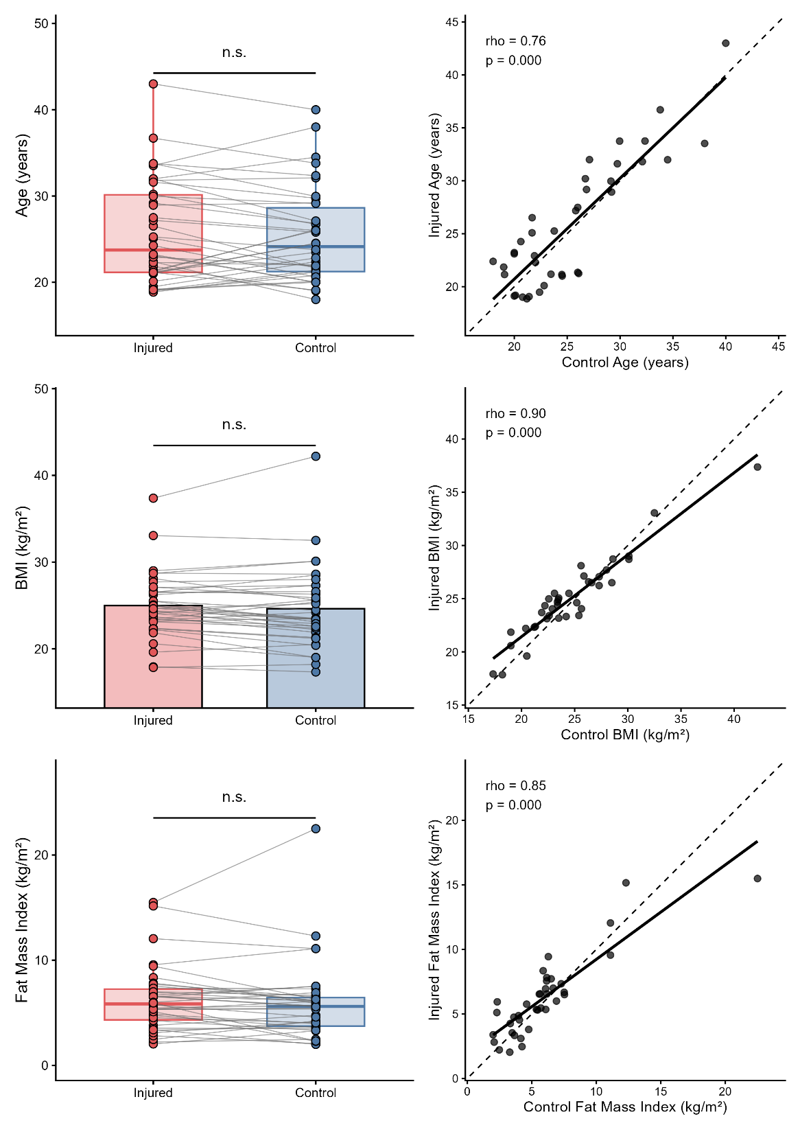
Paired dot plots (left column) and correlation plots (right column) demonstrate the matching fidelity for age, body mass index (BMI), and fat mass index (FMI) between injured participants and their controls. In paired plots, each line connects an injured participant (red) to their matched control (blue), with overlaid boxplots summarising group distributions. Paired comparisons showed no significant differences between groups for age, BMI, or FMI (all n.s.). Correlation plots (right column) show the relationship between matched pairs for each variable, with Spearman correlation coefficients (ρ) and associated p-values displayed. Solid black lines represent the fitted regression line; dashed lines represent the line of identity (perfect 1:1 matching).
Matching of body composition and aerobic fitness variables between injured participants and their paired uninjured controls.
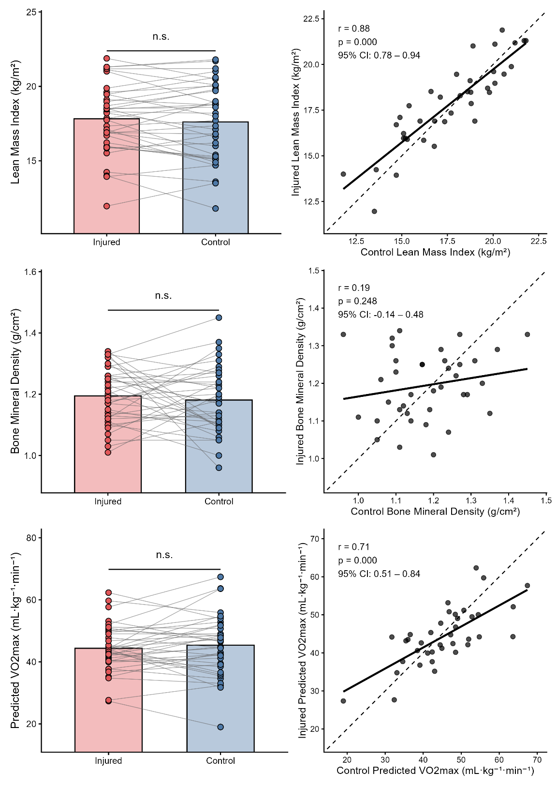
Paired dot plots (left column) and correlation plots (right column) demonstrate matching fidelity for lean mass index (LMI), bone mineral density (BMD), and predicted VO₂max between injured participants and their controls. In paired plots, each line connects an injured participant (red) with their matched control (blue), with overlaid boxplots showing group-level distributions. No significant differences were observed between groups for LMI, BMD, or predicted VO₂max (all n.s.). Correlation plots (right column) show associations between injured and control participants for each variable, with Pearson correlation coefficients (r), p-values, and 95% confidence intervals displayed. Solid black lines represent the fitted regression line; dashed lines represent the line of identity (perfect 1:1 matching).
Knee injury related impairments in KOOS clinical outcome scores.
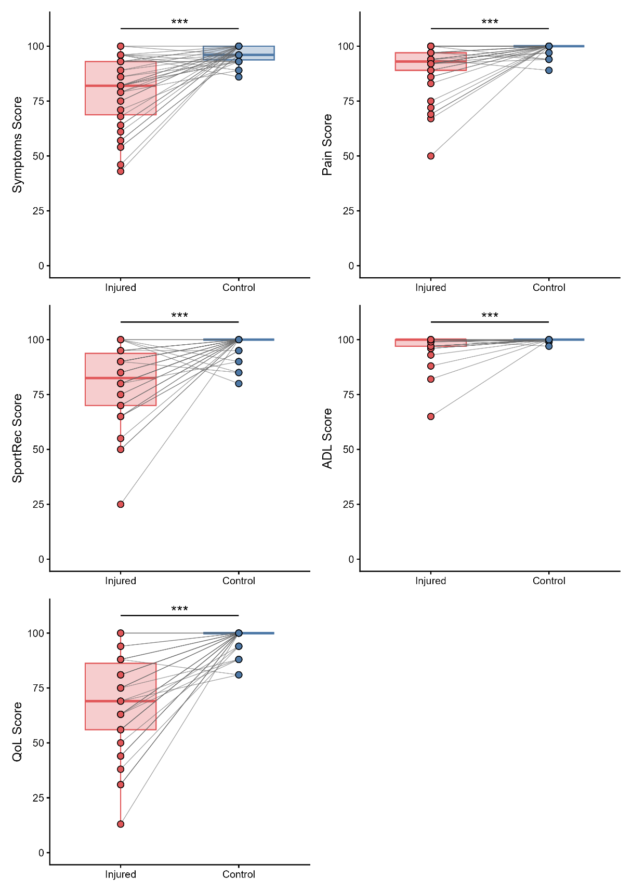
Paired dot plots with overlaid boxplots illustrate within-pair differences in KOOS Symptoms, Pain, Sport/Recreation, Activities of Daily Living (ADL), and Quality of Life (QoL) between injured participants (red) and their matched controls (blue). Each line represents an injured–control pair. All KOOS domains are scored from 0 to 100, with higher scores indicating fewer symptoms and better functional status. Across all five domains, injured participants reported significantly worse symptoms, pain, function, sports capability, and knee-related quality of life compared with matched controls (all p < 0.001). These findings confirm substantial and persistent knee-related impairments in individuals 1–7 years after intra-articular knee injury, despite being matched closely to controls on demographic and anthropometric characteristics.

Supplementary Material 4
Linear Regression Covariates for Single Biomarker Models and KOOS Domains
KOOS Domain | Covariate | Biomarker Model | β | 95% CI | p | Partial R² | N
ADL | Age (Years) | ARG | 0.44 | 0.05 to 0.83 | 0.03 | 0.14 | 38
 |  | C2M | 0.24 | -0.17 to 0.64 | 0.24 | 0.04 | 38
 |  | C3M | 0.21 | -0.18 to 0.60 | 0.28 | 0.04 | 38
 |  | COMP | 0.25 | -0.16 to 0.65 | 0.22 | 0.04 | 38
 |  | IL-1β | 0.06 | -0.23 to 0.36 | 0.66 | 0.01 | 28
 |  | IL-6 | 0.29 | -0.13 to 0.72 | 0.17 | 0.06 | 38
 |  | Leptin | 0.25 | -0.16 to 0.65 | 0.22 | 0.05 | 38
 |  | PRO-C2 | 0.28 | -0.09 to 0.66 | 0.13 | 0.07 | 38
 |  | PRO-C4 | 0.25 | -0.15 to 0.65 | 0.22 | 0.05 | 38
 |  | TNFα | 0.27 | -0.13 to 0.67 | 0.18 | 0.05 | 38
 | BMI (kg/m²) | ARG | 0.02 | -0.57 to 0.61 | 0.94 | 0.00 | 38
 |  | C2M | -0.15 | -0.80 to 0.51 | 0.65 | 0.01 | 38
 |  | C3M | -0.18 | -0.80 to 0.45 | 0.57 | 0.01 | 38
 |  | COMP | -0.17 | -0.83 to 0.49 | 0.61 | 0.01 | 38
 |  | IL-1β | -0.14 | -0.67 to 0.39 | 0.59 | 0.01 | 28
 |  | IL-6 | -0.46 | -1.39 to 0.48 | 0.33 | 0.03 | 38
 |  | Leptin | -0.28 | -1.12 to 0.56 | 0.50 | 0.01 | 38
 |  | PRO-C2 | -0.08 | -0.69 to 0.52 | 0.78 | 0.00 | 38
 |  | PRO-C4 | -0.20 | -0.87 to 0.48 | 0.55 | 0.01 | 38
 |  | TNFα | -0.15 | -0.78 to 0.49 | 0.64 | 0.01 | 38
 | Sex (Male/Female) | ARG | 3.31 | -1.38 to 8.00 | 0.16 | 0.06 | 38
 |  | C2M | 0.03 | -4.54 to 4.59 | 0.99 | 0.00 | 38
 |  | C3M | -0.24 | -4.60 to 4.13 | 0.91 | 0.00 | 38
 |  | COMP | 0.32 | -4.46 to 5.09 | 0.89 | 0.00 | 38
 |  | IL-1β | 1.36 | -2.47 to 5.19 | 0.47 | 0.02 | 28
 |  | IL-6 | 2.10 | -4.31 to 8.52 | 0.51 | 0.01 | 38
 |  | Leptin | -1.20 | -7.40 to 5.01 | 0.70 | 0.00 | 38
 |  | PRO-C2 | 1.55 | -2.88 to 5.98 | 0.48 | 0.02 | 38
 |  | PRO-C4 | -0.07 | -4.58 to 4.44 | 0.97 | 0.00 | 38
 |  | TNFα | -0.14 | -4.59 to 4.31 | 0.95 | 0.00 | 38
Pain | Age (Years) | ARG | 0.88 | 0.17 to 1.59 | 0.02 | 0.16 | 38
 |  | C2M | 0.66 | -0.03 to 1.34 | 0.06 | 0.10 | 38
 |  | C3M | 0.64 | -0.05 to 1.32 | 0.07 | 0.10 | 38
 |  | COMP | 0.69 | 0.01 to 1.37 | 0.048 | 0.11 | 38
 |  | IL-1β | 0.57 | -0.22 to 1.36 | 0.15 | 0.09 | 28
 |  | IL-6 | 0.82 | 0.11 to 1.52 | 0.03 | 0.15 | 38
 |  | Leptin | 0.70 | 0.02 to 1.38 | 0.04 | 0.12 | 38
 |  | PRO-C2 | 0.75 | 0.12 to 1.37 | 0.02 | 0.15 | 38
 |  | PRO-C4 | 0.68 | -0.01 to 1.37 | 0.05 | 0.11 | 38
 |  | TNFα | 0.67 | -0.03 to 1.36 | 0.06 | 0.10 | 38
 | BMI (kg/m²) | ARG | -0.02 | -1.10 to 1.05 | 0.97 | 0.00 | 38
 |  | C2M | -0.21 | -1.33 to 0.90 | 0.70 | 0.00 | 38
 |  | C3M | -0.23 | -1.33 to 0.87 | 0.67 | 0.01 | 38
 |  | COMP | -0.31 | -1.42 to 0.80 | 0.58 | 0.01 | 38
 |  | IL-1β | -0.05 | -1.46 to 1.36 | 0.95 | 0.00 | 28
 |  | IL-6 | -0.59 | -2.15 to 0.97 | 0.45 | 0.02 | 38
 |  | Leptin | -0.70 | -2.10 to 0.70 | 0.32 | 0.03 | 38
 |  | PRO-C2 | -0.09 | -1.09 to 0.91 | 0.86 | 0.00 | 38
 |  | PRO-C4 | -0.29 | -1.44 to 0.86 | 0.61 | 0.01 | 38
 |  | TNFα | -0.20 | -1.30 to 0.91 | 0.72 | 0.00 | 38
 | Sex (Male/Female) | ARG | 3.00 | -5.56 to 11.55 | 0.48 | 0.02 | 38
 |  | C2M | -0.58 | -8.36 to 7.20 | 0.88 | 0.00 | 38
 |  | C3M | -0.84 | -8.50 to 6.82 | 0.82 | 0.00 | 38
 |  | COMP | 0.62 | -7.41 to 8.65 | 0.88 | 0.00 | 38
 |  | IL-1β | -2.40 | -12.68 to 7.88 | 0.63 | 0.01 | 28
 |  | IL-6 | 1.89 | -8.85 to 12.63 | 0.72 | 0.00 | 38
 |  | Leptin | -4.71 | -15.11 to 5.70 | 0.36 | 0.03 | 38
 |  | PRO-C2 | 2.43 | -4.91 to 9.78 | 0.51 | 0.01 | 38
 |  | PRO-C4 | -0.72 | -8.40 to 6.97 | 0.85 | 0.00 | 38
 |  | TNFα | -0.71 | -8.43 to 7.01 | 0.85 | 0.00 | 38
QoL | Age (Years) | ARG | 0.63 | -0.89 to 2.14 | 0.40 | 0.02 | 38
 |  | C2M | 0.47 | -0.94 to 1.88 | 0.50 | 0.01 | 38
 |  | C3M | 0.44 | -0.98 to 1.86 | 0.53 | 0.01 | 38
 |  | COMP | 0.52 | -0.89 to 1.92 | 0.46 | 0.02 | 38
 |  | IL-1β | 0.32 | -1.20 to 1.83 | 0.67 | 0.01 | 28
 |  | IL-6 | 0.88 | -0.55 to 2.30 | 0.22 | 0.05 | 38
 |  | Leptin | 0.51 | -0.91 to 1.92 | 0.47 | 0.02 | 38
 |  | PRO-C2 | 0.61 | -0.74 to 1.95 | 0.37 | 0.02 | 38
 |  | PRO-C4 | 0.51 | -0.90 to 1.93 | 0.46 | 0.02 | 38
 |  | TNFα | 0.40 | -1.01 to 1.82 | 0.57 | 0.01 | 38
 | BMI (kg/m²) | ARG | -0.39 | -2.69 to 1.92 | 0.74 | 0.00 | 38
 |  | C2M | -0.46 | -2.75 to 1.83 | 0.69 | 0.00 | 38
 |  | C3M | -0.55 | -2.82 to 1.72 | 0.63 | 0.01 | 38
 |  | COMP | -0.72 | -3.01 to 1.57 | 0.53 | 0.01 | 38
 |  | IL-1β | -0.51 | -3.20 to 2.18 | 0.70 | 0.01 | 28
 |  | IL-6 | -1.37 | -4.51 to 1.77 | 0.38 | 0.02 | 38
 |  | Leptin | -1.04 | -3.98 to 1.89 | 0.47 | 0.02 | 38
 |  | PRO-C2 | -0.35 | -2.50 to 1.81 | 0.75 | 0.00 | 38
 |  | PRO-C4 | -0.75 | -3.11 to 1.61 | 0.52 | 0.01 | 38
 |  | TNFα | -0.49 | -2.75 to 1.77 | 0.66 | 0.01 | 38
 | Sex (Male/Female) | ARG | -0.67 | -18.98 to 17.63 | 0.94 | 0.00 | 38
 |  | C2M | -3.73 | -19.74 to 12.27 | 0.64 | 0.01 | 38
 |  | C3M | -3.56 | -19.44 to 12.31 | 0.65 | 0.01 | 38
 |  | COMP | -0.98 | -17.57 to 15.60 | 0.90 | 0.00 | 38
 |  | IL-1β | -10.00 | -29.63 to 9.63 | 0.30 | 0.05 | 28
 |  | IL-6 | 2.13 | -19.43 to 23.70 | 0.84 | 0.00 | 38
 |  | Leptin | -7.63 | -29.37 to 14.11 | 0.48 | 0.02 | 38
 |  | PRO-C2 | 1.46 | -14.38 to 17.31 | 0.85 | 0.00 | 38
 |  | PRO-C4 | -3.47 | -19.25 to 12.31 | 0.66 | 0.01 | 38
 |  | TNFα | -3.18 | -18.97 to 12.61 | 0.68 | 0.01 | 38
SportRec | Age (Years) | ARG | 1.52 | 0.52 to 2.52 | 0.00 | 0.22 | 38
 |  | C2M | 1.17 | 0.19 to 2.15 | 0.02 | 0.15 | 38
 |  | C3M | 1.14 | 0.17 to 2.10 | 0.02 | 0.15 | 38
 |  | COMP | 1.20 | 0.23 to 2.18 | 0.02 | 0.16 | 38
 |  | IL-1β | 1.04 | -0.01 to 2.10 | 0.05 | 0.16 | 28
 |  | IL-6 | 1.50 | 0.53 to 2.47 | 0.00 | 0.24 | 38
 |  | Leptin | 1.25 | 0.30 to 2.20 | 0.01 | 0.18 | 38
 |  | PRO-C2 | 1.31 | 0.44 to 2.18 | 0.00 | 0.22 | 38
 |  | PRO-C4 | 1.22 | 0.25 to 2.19 | 0.02 | 0.16 | 38
 |  | TNFα | 1.18 | 0.20 to 2.17 | 0.02 | 0.15 | 38
 | BMI (kg/m²) | ARG | -0.16 | -1.68 to 1.36 | 0.83 | 0.00 | 38
 |  | C2M | -0.46 | -2.04 to 1.13 | 0.56 | 0.01 | 38
 |  | C3M | -0.49 | -2.04 to 1.07 | 0.53 | 0.01 | 38
 |  | COMP | -0.55 | -2.14 to 1.04 | 0.49 | 0.01 | 38
 |  | IL-1β | -0.70 | -2.59 to 1.18 | 0.45 | 0.03 | 28
 |  | IL-6 | -1.56 | -3.70 to 0.57 | 0.15 | 0.07 | 38
 |  | Leptin | -1.37 | -3.34 to 0.59 | 0.16 | 0.06 | 38
 |  | PRO-C2 | -0.27 | -1.67 to 1.13 | 0.70 | 0.00 | 38
 |  | PRO-C4 | -0.65 | -2.27 to 0.98 | 0.42 | 0.02 | 38
 |  | TNFα | -0.43 | -2.00 to 1.14 | 0.58 | 0.01 | 38
 | Sex (Male/Female) | ARG | 1.76 | -10.33 to 13.84 | 0.77 | 0.00 | 38
 |  | C2M | -3.72 | -14.79 to 7.36 | 0.50 | 0.01 | 38
 |  | C3M | -4.19 | -15.05 to 6.66 | 0.44 | 0.02 | 38
 |  | COMP | -2.52 | -14.02 to 8.99 | 0.66 | 0.01 | 38
 |  | IL-1β | -6.56 | -20.31 to 7.18 | 0.33 | 0.04 | 28
 |  | IL-6 | 3.58 | -11.08 to 18.25 | 0.62 | 0.01 | 38
 |  | Leptin | -11.46 | -26.06 to 3.14 | 0.12 | 0.07 | 38
 |  | PRO-C2 | 0.85 | -9.42 to 11.13 | 0.87 | 0.00 | 38
 |  | PRO-C4 | -3.99 | -14.85 to 6.86 | 0.46 | 0.02 | 38
 |  | TNFα | -3.95 | -14.94 to 7.05 | 0.47 | 0.02 | 38
Symptoms | Age (Years) | ARG | 0.96 | -0.06 to 1.97 | 0.06 | 0.10 | 38
 |  | C2M | 0.85 | -0.10 to 1.80 | 0.08 | 0.09 | 38
 |  | C3M | 0.80 | -0.13 to 1.73 | 0.09 | 0.09 | 38
 |  | COMP | 0.87 | -0.08 to 1.82 | 0.07 | 0.10 | 38
 |  | IL-1β | 0.97 | -0.10 to 2.04 | 0.07 | 0.14 | 28
 |  | IL-6 | 1.17 | 0.26 to 2.09 | 0.01 | 0.18 | 38
 |  | Leptin | 0.90 | -0.03 to 1.84 | 0.06 | 0.10 | 38
 |  | PRO-C2 | 0.94 | 0.02 to 1.85 | 0.04 | 0.12 | 38
 |  | PRO-C4 | 0.94 | 0.03 to 1.84 | 0.04 | 0.12 | 38
 |  | TNFα | 0.81 | -0.14 to 1.76 | 0.09 | 0.08 | 38
 | BMI (kg/m²) | ARG | -0.70 | -2.25 to 0.84 | 0.36 | 0.03 | 38
 |  | C2M | -0.77 | -2.31 to 0.77 | 0.32 | 0.03 | 38
 |  | C3M | -0.85 | -2.35 to 0.64 | 0.25 | 0.04 | 38
 |  | COMP | -0.87 | -2.41 to 0.68 | 0.26 | 0.04 | 38
 |  | IL-1β | -0.11 | -2.01 to 1.80 | 0.91 | 0.00 | 28
 |  | IL-6 | -1.04 | -3.05 to 0.98 | 0.30 | 0.03 | 38
 |  | Leptin | -1.46 | -3.40 to 0.48 | 0.13 | 0.07 | 38
 |  | PRO-C2 | -0.68 | -2.14 to 0.78 | 0.35 | 0.03 | 38
 |  | PRO-C4 | -1.21 | -2.72 to 0.31 | 0.11 | 0.07 | 38
 |  | TNFα | -0.77 | -2.28 to 0.75 | 0.31 | 0.03 | 38
 | Sex (Male/Female) | ARG | -0.92 | -13.21 to 11.36 | 0.88 | 0.00 | 38
 |  | C2M | -2.73 | -13.48 to 8.03 | 0.61 | 0.01 | 38
 |  | C3M | -3.00 | -13.43 to 7.42 | 0.56 | 0.01 | 38
 |  | COMP | -1.67 | -12.88 to 9.54 | 0.76 | 0.00 | 38
 |  | IL-1β | -12.77 | -26.69 to 1.15 | 0.07 | 0.14 | 28
 |  | IL-6 | -1.17 | -15.02 to 12.67 | 0.86 | 0.00 | 38
 |  | Leptin | -8.09 | -22.48 to 6.29 | 0.26 | 0.04 | 38
 |  | PRO-C2 | 0.29 | -10.45 to 11.03 | 0.96 | 0.00 | 38
 |  | PRO-C4 | -2.81 | -12.91 to 7.30 | 0.58 | 0.01 | 38
 |  | TNFα | -2.51 | -13.10 to 8.08 | 0.63 | 0.01 | 38
Values represent unstandardised regression coefficients (β) with 95% confidence intervals (CI) for age (years), BMI (kg/m²), and sex (male/female) entered as covariates in separate models for each biomarker and KOOS domain. Partial R² reflects the proportion of variance uniquely explained by the covariate. Sample size (N) reflects available data for each biomarker; IL-1β analyses were conducted in a reduced subsample due to assay availability. Statistical significance was set at p < 0.05.

Supplementary Material 5

