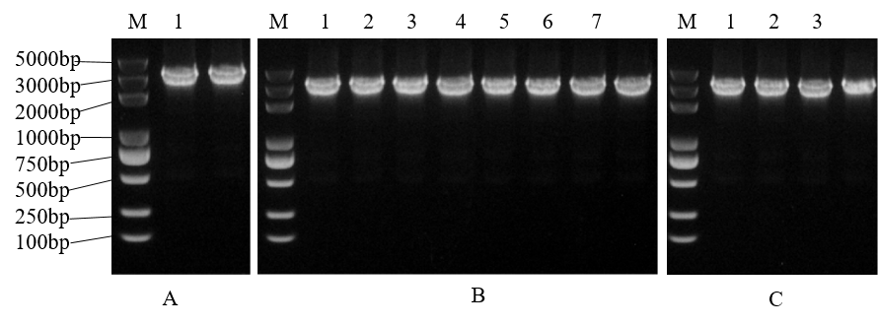
Fig. S1. PCR amplification and colony PCR verification of HORVU.MOREX.r3.6HG0622470.1 in Escherichia coli and Agrobacterium tumefaciens. (A) Amplification of the HORVU.MOREX.r3.6HG0622470.1 gene by high-fidelity PCR. M, DNA marker; lanes 1–2, PCR products showing a specific band at approximately 3042 bp. (B) Colony PCR verification of recombinant plasmids in Escherichia coli DH5α. M, DNA marker; lanes 1–8, positive clones showing specific bands of the expected size (~3042 bp). (C) Colony PCR verification of recombinant Agrobacterium tumefaciens GV3101. M, DNA marker; lanes 1–4, positive transformants showing specific bands corresponding to the target gene (~3042 bp).

