Micropore-Engineered Activated Carbons from Sunflower Pith for Enhanced CO₂ Capture
Sahand Saeidi Harzand¹, Alp Yürüm^{1,2}*
¹Materials Science and Nano Engineering Program, Sabanci University, Istanbul, Türkiye
²Sabanci University Nanotechnology Research and Application Center (SUNUM), Istanbul, Türkiye
*Corresponding author: alp.yurum@sabanciuniv.edu

Abstract
Biomass-derived activated carbons are attractive adsorbents for carbon dioxide capture because they combine low precursor cost, chemical robustness, moisture tolerance, and tunable microporosity. Here, sunflower stem pith, an agricultural residue with a naturally porous cellular structure, was converted to activated carbon through nitrogen carbonization followed by alkali hydroxide activation using either KOH or NaOH. Carbonization temperature and time-controlled char yield, and the progressive removal of lignocellulosic functional groups, while the activation chemistry determined the final pore architecture. The highest BET surface area was obtained for the NaOH-activated sample prepared from the 500 °C/120 min char (AC-4, 2948 m²g⁻¹), whereas the corresponding KOH-activated sample (AC-2) showed a lower BET surface area (2268 m²g⁻¹) but a higher micropore-to-total-pore-volume ratio (0.78) and a smaller average pore diameter (2.08 nm). CO₂ adsorption measurements at 25 °C up to 8 bar demonstrated that AC-2 outperformed the NaOH-activated analogues and the commercial activated carbon, reaching 13.92 mmol g⁻¹ at 8 bar, compared with 10.87 mmol g⁻¹ for AC-4 and 4.58 mmol g⁻¹ for the commercial sample. The adsorption capacity decreased with increasing temperature, and the isosteric heat analysis was consistent with exothermic physisorption. These findings show that the CO₂-capture performance of biomass-derived activated carbons should be optimized by pore-size engineering and micropore accessibility rather than by BET surface area alone. Sunflower pith is therefore a promising regional precursor for low-cost carbon adsorbents, especially for pressure-swing adsorption scenarios where high-pressure working capacity is important.

Keywords
Biomass-derived activated carbon; sunflower pith; CO₂ capture; KOH activation; NaOH activation; microporosity; pressure swing adsorption

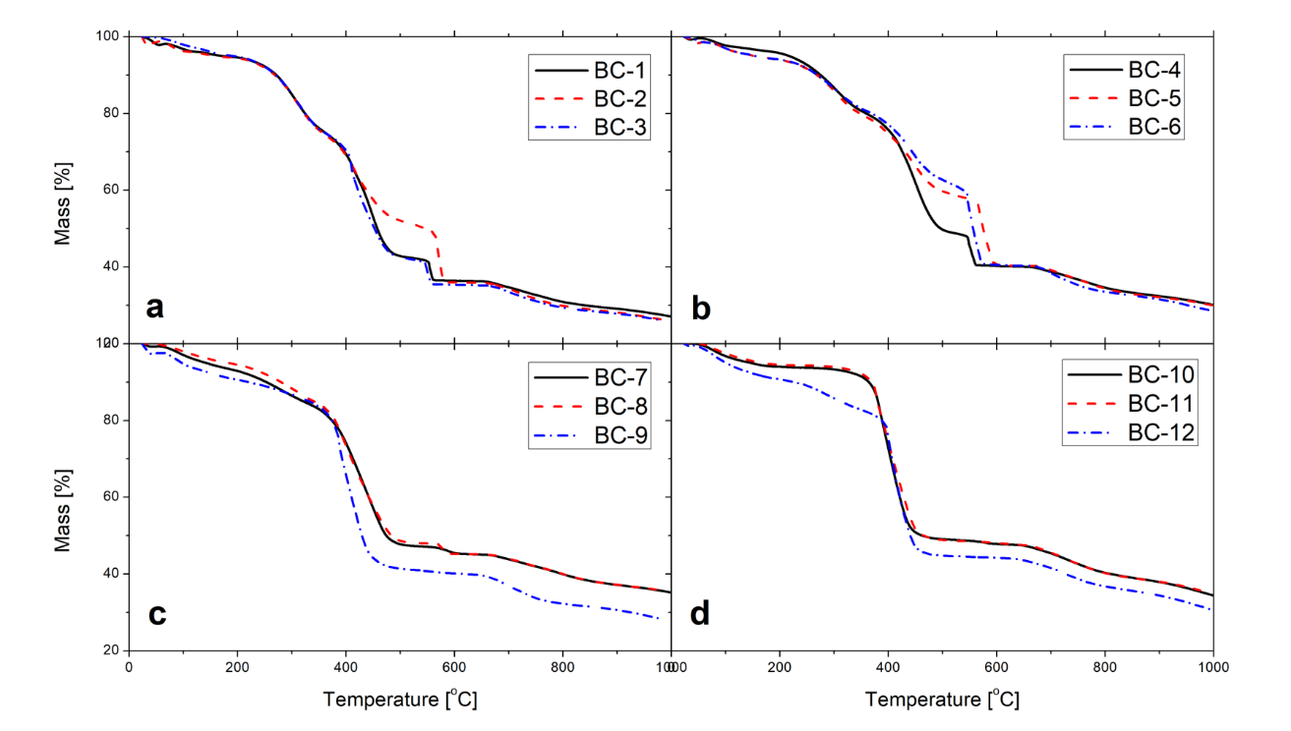
Figure S1. Ash content of bio-chars produced at a) 350 °C, b) 400 °C, c) 450 °C, d) 500 °C

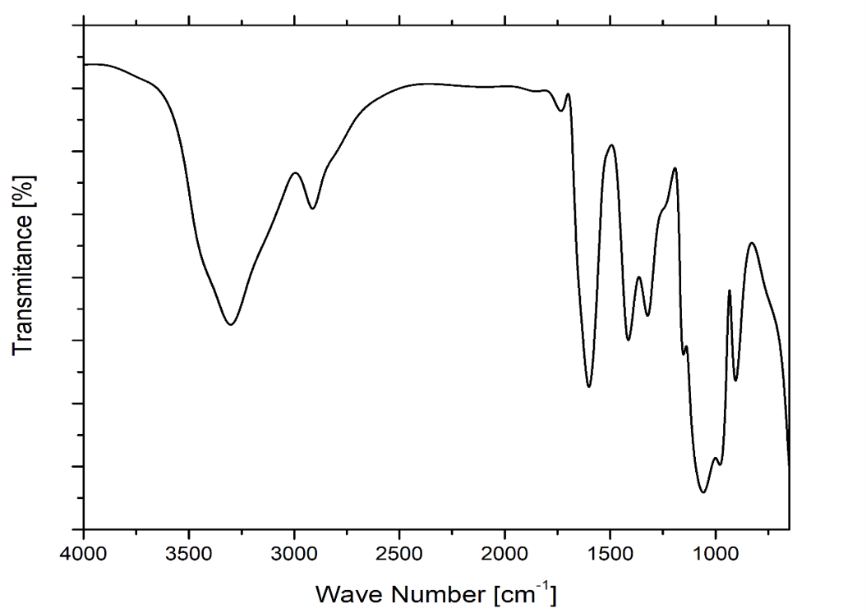
Figure S2. FTIR spectra of the biomass sample

Table S1. Functional groups of biomass sample determined by the FTIR
Wave Numbers [cm⁻¹] | Functional Groups
3331.41 | –OH Stretching
2902.7 | Aliphatic CH Stretching Vibration
1597.72 | Aromatic C=C Ring Stretching
1415.53 | Aromatic C=C Ring Stretching
1317.58 | Aliphatic CH₃ Deformation
1202.57 | Aromatic CO– Stretching
1021.88 | Aliphatic Ether C–O and Alcohol C–O Stretching
893.81 | Aromatic Ring

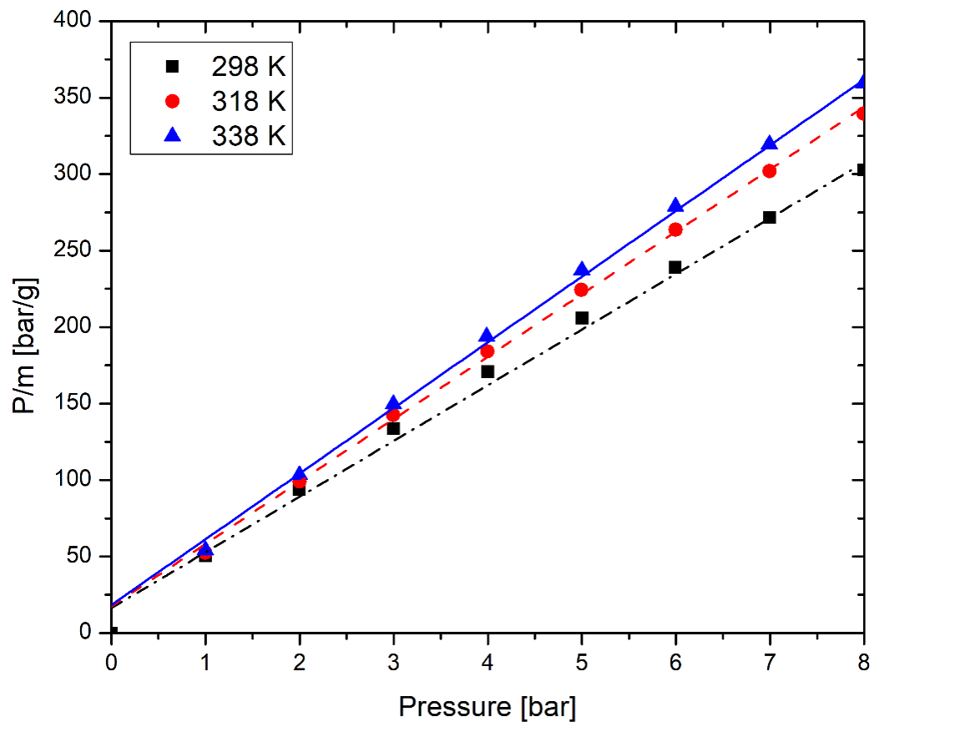
Figure S3. Plot of P/m versus P for different adsorption temperatures

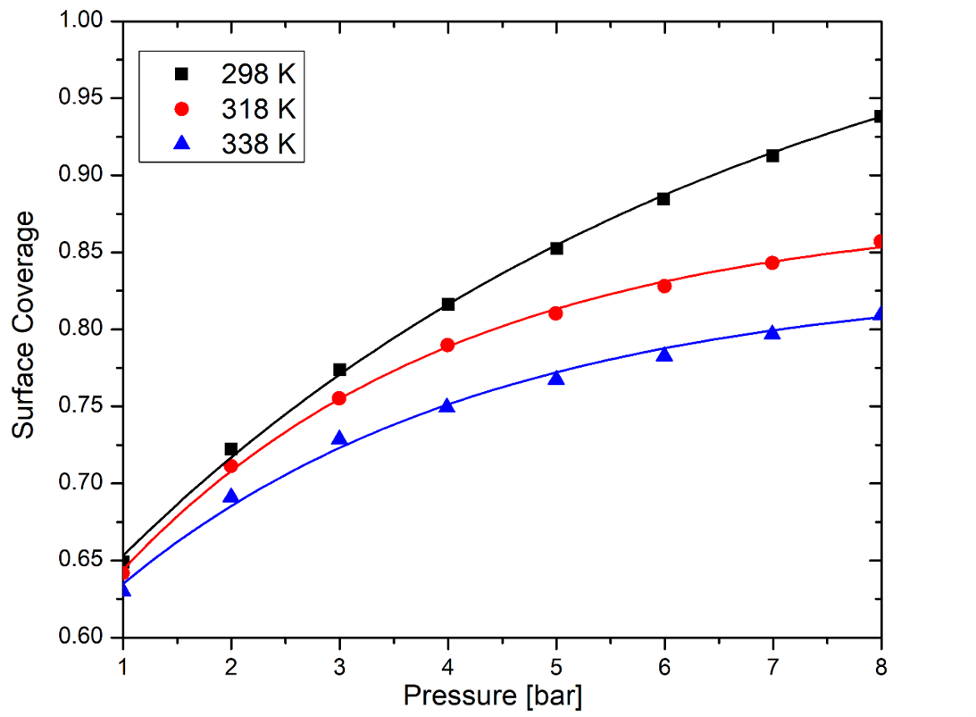
Figure S4. Langmuir adsorption isotherm (surface coverage versus pressure)

In the present sunflower-pith system, this provides a plausible explanation for the observed NaOH behavior. Na-containing species can strongly attack the accessible, oxygen-containing, defect-rich char framework, promoting deeper chemical etching, removal of oxygenated fragments, carbon gasification, and widening of initially narrow pores. This produces a larger total internal surface area, but it also shifts part of the pore network toward wider micropores and mesopores. KOH activation follows a related but not identical pathway. Potassium-derived species are widely associated with intercalation-assisted expansion of disordered carbon layers; metallic potassium generated during activation can penetrate between graphene-like domains and expand the turbostratic structure, while oxidation/gasification reactions generate porosity [1,2]. In this work, KOH did not maximize BET surface area, but it retained a larger fraction of micropore volume and produced smaller average pore diameters than NaOH. Thus, KOH appears to provide a more micropore-preserving activation pathway for sunflower-pith char, whereas NaOH produces stronger overall pore opening and widening.
This distinction is important for CO₂ capture because adsorption performance is not governed by BET surface area alone. Recent biomass-derived carbon studies for CO₂ capture show that sub-nanometer pores and polar oxygenated surface sites enhance CO₂ affinity, while different activation routes can produce different balances of ultramicroporosity, total pore volume, and surface chemistry [1]. Therefore, the higher BET surface area of the NaOH-activated samples should not automatically be interpreted as a superior CO₂-capture structure. Instead, the present results indicate that NaOH activation overdevelops or widens part of the sunflower-pith pore network, whereas KOH activation gives a more CO₂-relevant micropore-rich architecture. The key mechanistic conclusion is that NaOH and KOH both activate carbon through high-temperature alkali–carbon reactions, but their interaction with the turbostratic sunflower-pith char differs: NaOH promotes stronger framework etching and pore widening, while KOH better preserves narrow microporosity through intercalation-assisted expansion and controlled gasification. This explains why NaOH gives the highest BET surface area, whereas KOH gives the better pore architecture for CO₂ adsorption.

References
[1] B. Dziejarski, J. Serafin, D. F. Hernández-Barreto, E. Naumovska, J. Sreńscek-Nazzal, N. Klomkliang, E. Tam, R. Krzyżyńska, K. Andersson, and P. Knutsson, “Tailoring highly surface and microporous activated carbons from biomass via KOH, K₂C₂O₄ and KOH/K₂C₂O₄ activation for efficient CO₂ capture and CO₂/N₂ selectivity: Characterization, experimental and molecular simulation insights,” Chemical Engineering Journal, vol. 524, 169677, 2025.
[2] M. A. Lillo-Ródenas, D. Cazorla-Amorós, and A. Linares-Solano, “Understanding chemical reactions between carbons and NaOH and KOH: An insight into the chemical activation mechanism,” Carbon, vol. 41, no. 2, pp. 267–275, 2003.
[3] G. Dobele, T. Dizhbite, A. Volperts, A. Andersone, J. Telysheva, and G. Rossinskaja, “Thermochemical Activation of Wood with NaOH, KOH and H₃PO₄ for the Synthesis of Nitrogen-Doped Nanoporous Carbon for Oxygen Reduction Reaction,” Molecules, vol. 29, no. 10, 2238, 2024.

The commercial activated carbon provides a useful benchmark. Its BET surface area was only 754 m² g⁻¹ , with a total pore volume of 0.53 cm³ g⁻¹, a micropore volume of 0.18 cm³ g⁻¹, and an average pore diameter of 5.81 nm. This indicates a much larger contribution from mesopores compared with the sunflower-pith activated carbons. Although mesopores can improve diffusion and mass transfer in practical adsorption beds, they contribute less strongly to equilibrium CO₂ uptake than narrow micropores at moderate pressures. The synthesized biomass-derived carbons therefore offer two advantages over the commercial sample: much larger total accessible surface and, more importantly, a much higher fraction of microporosity. Recent reviews of biomass-derived activated carbons for CO₂ capture similarly identify micropore volume and pore-size matching as key factors distinguishing high-performing adsorbents from general-purpose commercial carbons [1,7].
The comparison with recent biomass-derived activated carbons further supports the significance of the present materials. Dziejarski et al. reported pine-wood-derived activated carbons prepared using KOH, K₂C₂O₄, and combined KOH/K₂C₂O₄ activation; their optimized co-activated carbon reached a BET surface area of 2029 m² g⁻¹ and a total pore volume of 1.028 cm³ g⁻¹, while KOH-activated carbon showed high CO₂ uptake due to extensive ultramicropore development [3]. These values are comparable to, or lower than, the textural properties obtained here for sunflower-pith-derived carbons, especially AC-2 and AC-4. A 2026 study on Parrotia persica wood also showed that the selection of activating agent and impregnation ratio strongly controls CO₂/N₂-relevant pore structures, again confirming that precursor–activator matching is central to adsorbent design [8]. Similarly, recent NaOH-activated avocado-seed carbons and KOH-functionalized oil-palm-derived adsorbents show that alkali activation can generate high-surface-area carbons, but the final adsorption performance depends on whether the activation strategy produces CO₂-accessible micropores rather than only high BET area [9,10].
The pore-size distribution results are therefore central to the mechanistic interpretation of the activation-agent effect. NaOH activation appears to have promoted broader pore opening, generating the largest total pore volume and highest surface area. KOH activation, in contrast, generated a narrower micropore-dominated structure. This explains why the KOH-activated samples should not be considered inferior because of their lower BET surface area. For CO₂ capture, particularly under pressure-driven adsorption conditions, the decisive structural feature is not the maximum possible surface area but the fraction of pore volume located in the micropore range and the accessibility of those pores to CO₂. Recent work on pore-size-controlled biomass activated carbons has shown that samples with similar BET surface areas but different pore-size distributions can show substantially different CO₂ adsorption behavior, demonstrating that pore-size distribution must be evaluated independently from surface area [11].

References for BET, 2024–2026 only
[1] S. Kundu, T. Khandaker, M. A. A. M. Anik, M. K. Hasan, P. K. Dhar, S. K. Dutta, M. A. Latif, and M. S. Hossain, “A comprehensive review of enhanced CO₂ capture using activated carbon derived from biomass feedstock,” RSC Advances, vol. 14, pp. 29693–29736, 2024.
[2] W. Wu, Y. Wang, and X. Hu, “Mass transfer driven pore engineering of activated carbon from the activation of biomass,” Green Chemistry, vol. 28, pp. 3486–3503, 2026.
[3] B. Dziejarski, J. Serafin, D. F. Hernández-Barreto, E. Naumovska, J. Sreńscek-Nazzal, N. Klomkliang, E. Tam, R. Krzyżyńska, K. Andersson, and P. Knutsson, “Tailoring highly surface and microporous activated carbons from biomass via KOH, K₂C₂O₄ and KOH/K₂C₂O₄ activation for efficient CO₂ capture and CO₂/N₂ selectivity: characterization, experimental and molecular simulation insights,” Chemical Engineering Journal, vol. 524, 169677, 2025.
[4] N. T. Tonu, S. Kundu, M. M. Islam, P. K. Dhar, T. Khandaker, M. A. A. M. Anik, S. K. Dutta, M. K. Hasan, and M. S. Hossain, “Fabrication of waste biomass-derived KOH activated carbon for enhanced CO₂ capture,” New Journal of Chemistry, vol. 48, pp. 20212–20224, 2024.
[5] Y. Mochizuki et al., “Pore properties and CO₂ adsorption performance of porous carbon materials prepared from biomass and coal,” Carbon Trends, 2025.
[6] A. Marangon et al., “Comparison of different activation methods for activated carbon production from bamboo biomass,” Carbon Capture Science & Technology, 2025.
[7] H. A. Asmaly et al., “Enhanced CO₂ capture using sustainable biomass-derived activated carbon,” Carbon Capture Science & Technology, 2026.
[8] M. Bandani et al., “Preparation and characterization of low-cost chemically activated porous carbon adsorbents from Parrotia persica wood for CO₂/N₂ separation,” Scientific Reports, 2026.
[9] J. Siemak et al., “Activated carbon for CO₂ adsorption from avocado seeds using sodium hydroxide activation,” Materials, vol. 17, 4157, 2024.
[10] S. N. Mohamed Saleh et al., “Enhanced CO₂ capture using KOH-functionalized oil palm ash-derived adsorbents,” Discover Applied Sciences, 2025.
[11] “Effect of pore size distribution of biomass activated carbon on CO₂ adsorption,” Journal of Chemical Technology & Biotechnology, 2024.

Overall, the textural analysis demonstrates that sunflower pith is an effective precursor for producing high-surface-area, micropore-rich activated carbons. NaOH activation is more effective for maximizing BET surface area and total pore volume, whereas KOH activation produces a more favorable microporous architecture for CO₂ adsorption. This distinction provides the structural basis for the later adsorption results: the best-performing adsorbent is not the material with the highest BET area, but the one with the most suitable micropore architecture. The activation-agent comparison therefore highlights the main design principle of this work: biomass-derived activated carbons for CO₂ capture should be optimized through controlled micropore engineering, not through indiscriminate surface-area maximization.
3.3 Morphological structure of carbonized samples
SEM analysis shows that the sunflower-pith-derived activated carbons retain an open, low-density morphology inherited from the pith precursor, but the two alkali hydroxides modify this framework differently (Figure 4). This interpretation is supported by the earlier sunflower-pith study of Baysal et al., where SEM/Micro-CT analysis showed that raw sunflower pith has a lamellar, flake-like network and that the carbonized sunflower-pith char retained this flake-like morphology with carbon flakes of approximately 200 nm thickness [1]. Therefore, the open morphology observed in the present AC samples should not be interpreted as a random fracture texture produced only during activation; it is partly inherited from the cellular/lamellar architecture of the original pith and then amplified by alkali-assisted pore development. In AC-2, the KOH-activated sample shows a wrinkled, porous, and relatively continuous carbon framework, suggesting that activation opened the char structure while preserving part of the original carbon skeleton. Similar behavior has been reported for KOH-activated sunflower-straw biochar, where SEM showed that activation made the surface rougher and produced a richer pore structure, while FTIR indicated that KOH activation changed both the surface chemistry and microstructure of sunflower-derived biochar [2].
In contrast, AC-4 appears more etched, irregular, and fragmented, which is consistent with the textural data showing that NaOH activation generated the highest BET surface area, largest total pore volume, and larger average pore diameter. A recent NaOH/KOH comparison on wood-derived carbons similarly reported slightly higher N₂ sorption and higher specific surface areas for NaOH-activated samples than for KOH-activated analogues, indicating that NaOH can produce stronger overall textural expansion in some lignocellulosic chars [3]. The SEM images alone cannot resolve micropores, so they should not be used as direct proof of the micropore fraction. However, they do support the broader mechanistic picture: both hydroxides strongly attack the sunflower-pith char, but KOH appears to preserve a more coherent porous carbon framework, whereas NaOH produces a more extensively etched and opened morphology. This interpretation is also consistent with recent discussions of biomass activation, where pore architecture is described as being controlled by activator infiltration, melting/diffusion, penetration depth, and interfacial reactions with biomass-derived carbon skeletons [4]. For CO₂ adsorption, the morphological difference should therefore be linked to the N₂ sorption results: the more open NaOH-derived morphology is consistent with higher total pore volume and pore widening, whereas the KOH-derived framework, although less expanded in total surface area, better retains the narrow micropore-rich structure required for strong CO₂ affinity. Recent CO₂-capture studies on K-based biomass activated carbons also show that high CO₂ uptake is associated with ultramicropore development rather than simply with the largest total surface area [5].

References
[1] M. Baysal, K. Bilge, B. Yılmaz, M. Papila, and Y. Yürüm, “Preparation of high surface area activated carbon from waste-biomass of sunflower piths: Kinetics and equilibrium studies on the dye removal,” Journal of Environmental Chemical Engineering, vol. 6, no. 2, pp. 1702–1713, 2018.
[2] S. Chang, L. Wang, and L. Yao, “Properties of Sunflower Straw Biochar Activated Using Potassium Hydroxide,” Molecules, vol. 30, no. 6, 1332, 2025.
[3] G. Dobele, T. Dizhbite, A. Volperts, A. Andersone, J. Telysheva, and G. Rossinskaja, “Thermochemical Activation of Wood with NaOH, KOH and H₃PO₄ for the Synthesis of Nitrogen-Doped Nanoporous Carbon for Oxygen Reduction Reaction,” Molecules, vol. 29, no. 10, 2238, 2024.
[4] W. Wu, Y. Wang, and X. Hu, “Mass transfer driven pore engineering of activated carbon from the activation of biomass,” Green Chemistry, vol. 28, pp. 3486–3511, 2026.
[5] B. Dziejarski, J. Serafin, D. F. Hernández-Barreto, E. Naumovska, J. Sreńscek-Nazzal, N. Klomkliang, E. Tam, R. Krzyżyńska, K. Andersson, and P. Knutsson, “Tailoring highly surface and microporous activated carbons from biomass via KOH, K₂C₂O₄ and KOH/K₂C₂O₄ activation for efficient CO₂ capture and CO₂/N₂ selectivity: Characterization, experimental and molecular simulation insights,” Chemical Engineering Journal, vol. 524, 169677, 2025.
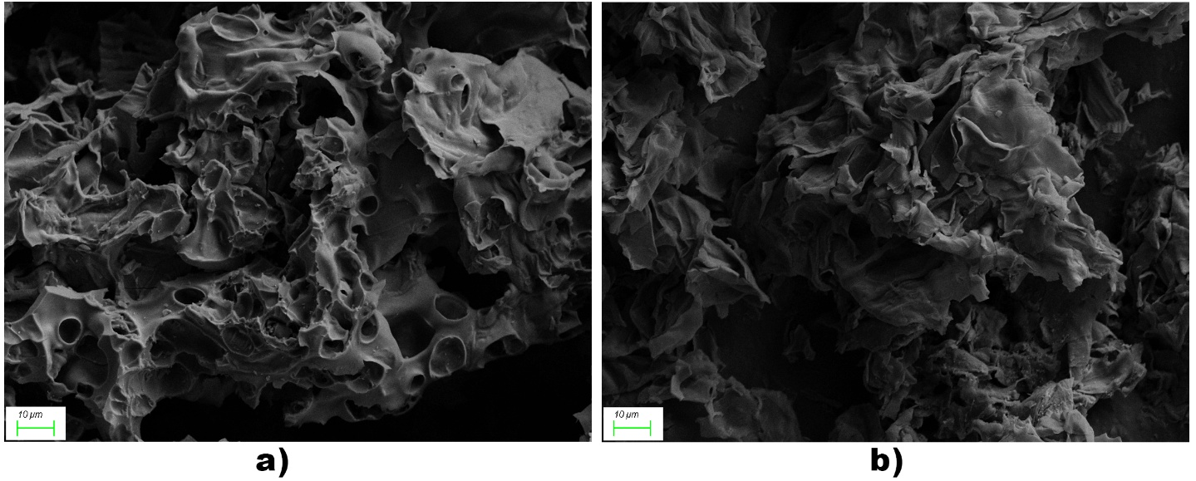
Figure 5. SEM images of a) AC-2, b) AC-4

3.4 CO₂ adsorption performance
The CO₂ adsorption isotherms confirm that sunflower-pith-derived activated carbons are substantially more effective than the commercial activated carbon, particularly at elevated pressure (Figure 6). At 8 bar and 25 °C, the commercial activated carbon adsorbed only 4.58 mmol CO₂ g⁻¹ , whereas all synthesized carbons showed markedly higher uptake. The best-performing sample was AC-2, the KOH-activated carbon obtained from the 120 min carbonized char, with an uptake of 13.92 mmol g⁻¹. AC-4, although it possessed the highest BET surface area among all samples, adsorbed 10.87 mmol g⁻¹. This result is the central structure–performance finding of the study: CO₂ uptake does not scale simply with total BET surface area. Instead, adsorption is governed by the balance between accessible pore volume and the fraction of narrow micropores that provide strong adsorption potentials for CO₂.
The comparison between AC-2 and AC-4 is especially important. AC-4 had the highest BET surface area and total pore volume, indicating that NaOH activation produced the strongest overall textural expansion. However, AC-4 also had a larger average pore diameter and a lower micropore/total pore-volume ratio than AC-2. This suggests that part of the NaOH-generated surface area belongs to wider pores that contribute less strongly to CO₂ adsorption per unit pore volume. In contrast, AC-2 had a lower BET surface area but a higher micropore fraction and smaller average pore diameter, which are more favorable for CO₂ adsorption because the overlapping adsorption potentials from opposing pore walls enhance the interaction with the quadrupolar CO₂ molecule. This interpretation agrees with recent CO₂-capture studies showing that high adsorption capacity in biomass-derived activated carbons is associated with ultramicropore development rather than simply with maximum BET surface area. Dziejarski et al. reported that a KOH-activated biomass carbon achieved the highest CO₂ uptake among their samples because of extensive ultramicropore development, while a co-activated sample with favorable overall textural properties did not necessarily give the highest uptake [1]. Similarly, recent reviews emphasize that optimization of pore diameter and structure, not surface area alone, is crucial for improving CO₂ capture by biomass-derived activated carbons [2].
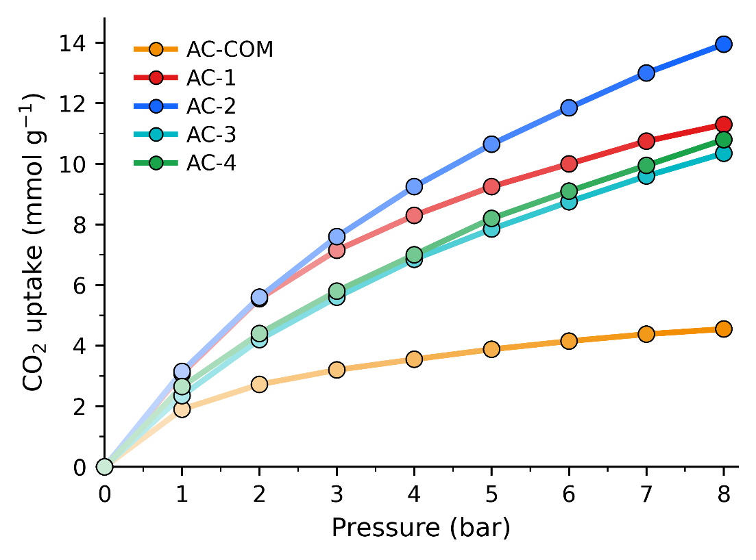
Figure 6. CO₂ adsorption isotherms on AC samples
The commercial activated carbon provides a useful baseline for evaluating the synthesized materials. Although commercial carbons are often effective general-purpose adsorbents, the commercial sample used here had a much lower surface area, lower micropore volume, and larger average pore diameter than the sunflower-pith-derived carbons. Its lower CO₂ uptake therefore reflects not only lower total porosity but also less favorable pore-size matching for CO₂. The improvement is particularly clear at 8 bar: AC-2 adsorbed approximately three times more CO₂ than the commercial sample. This demonstrates that the sunflower-pith precursor, combined with alkali activation, generates a pore architecture more suitable for pressure-driven CO₂ adsorption than the commercial reference carbon.
The values in Table 5 should also be interpreted in terms of precursor, activation route, and pressure. At 8 bar and 25 °C, AC-2 reached 13.92 mmol g⁻¹, which is higher than several biomass-derived activated carbons reported under similar elevated-pressure conditions, including Arundo donax-derived KOH-activated carbons with reported uptakes of 3.00-11.17 mmol g⁻¹ and coconut-shell-derived activated carbon with 7.72 mmol g⁻¹. It is also higher than the unmodified H₃PO₄-activated eucalyptus carbon listed in the table, 10.12 mmol g⁻¹, but slightly lower than the ammonia-treated eucalyptus carbon, 14.06 mmol g⁻¹. This comparison shows that sunflower-pith-derived AC-2 is not merely better than the commercial carbon; it is competitive with high-performing biomass-derived adsorbents reported for elevated-pressure CO₂ capture. The eucalyptus sample with the highest uptake likely benefits from additional nitrogen/amine-related surface modification or more favorable ultramicropore development, whereas the present AC-2 achieves comparable performance without post-synthetic nitrogen functionalization. That is an important practical advantage because it keeps the synthesis route simpler.
Table 5. Comparison of the adsorption capacity of the synthesized AC samples at 8 bars and 25 °C
Adsorbent | Activation / treatment | CO₂ uptake (mmol g⁻¹) | Reference
Eucalyptus wood carbon | H₃PO₄, unmodified | 10.12 | Heidari et al. [14]
Eucalyptus wood carbon | H₃PO₄ + NH₃ at 400 °C | 3.96 | Heidari et al. [14]
Eucalyptus wood carbon | H₃PO₄ + NH₃ at 800 °C | 14.06 | Heidari et al. [14]
Arundo donax carbon | KOH 0:1 | 3.00 | Singh et al. [13]
Arundo donax carbon | KOH 1:1 | 5.93 | Singh et al. [13]
Arundo donax carbon | KOH 2:1 | 7.12 | Singh et al. [13]
Arundo donax carbon | KOH 3:1 | 11.17 | Singh et al. [13]
Coconut shell carbon | Steam | 7.72 | Singh and Kumar [15]
Commercial AC | Coal-based commercial AC | 4.58 | This work
AC-2 | Sunflower pith, KOH | 13.92 | This work
AC-4 | Sunflower pith, NaOH | 10.87 | This work

The pressure dependence further supports the pore-structure interpretation. At low pressure, the difference between samples prepared from 60 and 120 min carbonized chars was modest, especially for the NaOH-activated carbons. This indicates that the strongest adsorption sites, probably narrow micropores, are already populated early in the adsorption process. At higher pressure, however, the effect of carbonization time became more visible for KOH activation. Extending the carbonization time from 60 to 120 min increased the 8 bar CO₂ uptake of the KOH-activated carbon by approximately 23%. This suggests that the more completely carbonized precursor interacts more favorably with KOH during activation, producing not only strong low-pressure adsorption sites but also a larger accessible micropore volume that can be filled at elevated pressure. This distinction between low-pressure affinity and high-pressure capacity is consistent with recent biomass-carbon literature, where high-pressure CO₂ uptake is understood to benefit from both strong adsorption in narrow micropores and sufficient accessible pore volume [1,3].
Temperature-dependent CO₂ adsorption of AC-2 further confirms the physisorptive and exothermic character of the adsorption process (Figure 7). The uptake decreased as adsorption temperature increased, which is expected because higher temperature weakens the effective CO₂–surface interaction and reduces equilibrium adsorption. Similar behavior is widely reported for biomass-derived activated carbons. For example, recent olive-stone and almond-shell activated carbons showed reduced breakthrough time and adsorption performance at higher temperature, consistent with the exothermic nature of CO₂ adsorption [4]. A recent optimized date-palm-leaflet activated carbon also showed decreasing uptake with temperature, with reported capacities of 6.71 mmol g⁻¹ at 0 °C, 4.21 mmol g⁻¹ at 25 °C, and 2.6 mmol g⁻¹ at 50 °C [3]. Therefore, the temperature response of AC-2 is consistent with physical adsorption in microporous carbon rather than irreversible chemisorption.
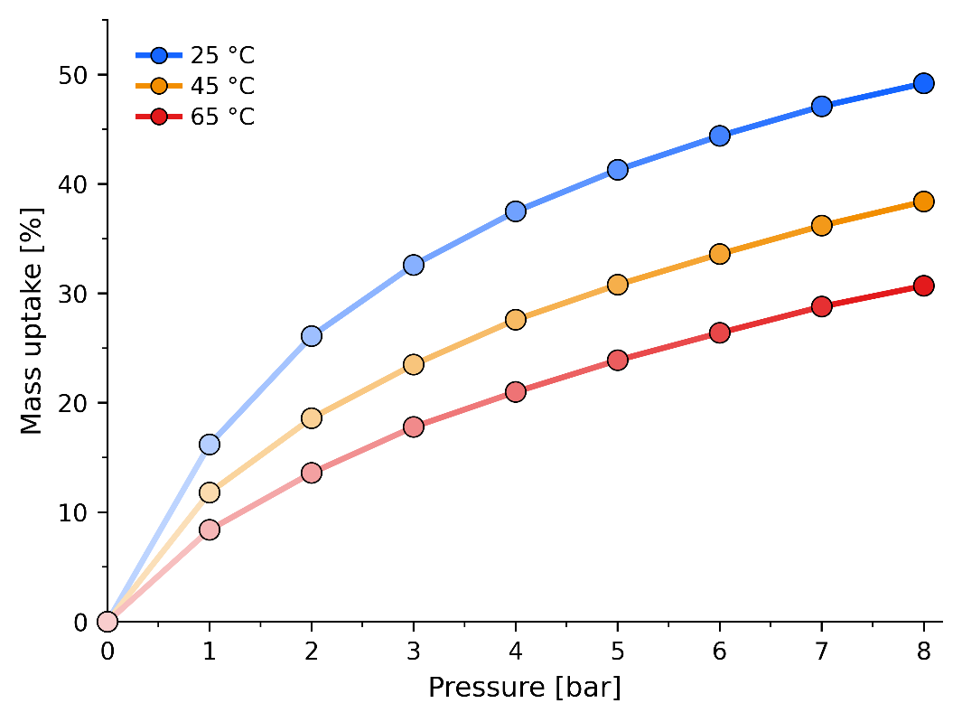
Figure 7. CO₂ adsorption isotherms on AC-2 at different temperatures

Overall, the CO₂ adsorption results show that sunflower-pith-derived activated carbons are promising elevated-pressure CO₂ adsorbents. The best sample, AC-2, combines high uptake, a simple biomass-derived synthesis route, and a micropore-rich structure produced by KOH activation. The comparison with AC-4 demonstrates that maximizing BET surface area is not sufficient; excessive pore widening can reduce the fraction of adsorption-relevant micropores. The comparison table therefore supports the main conclusion of the work: sunflower pith can be converted into a competitive CO₂ adsorbent, but the activation strategy must be optimized for micropore architecture rather than total surface area alone.

References used here
[1] B. Dziejarski, J. Serafin, D. F. Hernández-Barreto, E. Naumovska, J. Sreńscek-Nazzal, N. Klomkliang, E. Tam, R. Krzyżyńska, K. Andersson, and P. Knutsson, “Tailoring highly surface and microporous activated carbons from biomass via KOH, K₂C₂O₄ and KOH/K₂C₂O₄ activation for efficient CO₂ capture and CO₂/N₂ selectivity: Characterization, experimental and molecular simulation insights,” Chemical Engineering Journal, vol. 524, 169677, 2025.
[2] S. Kundu, T. Khandaker, M. A. A. M. Anik, M. K. Hasan, P. K. Dhar, S. K. Dutta, M. A. Latif, and M. S. Hossain, “A comprehensive review of enhanced CO₂ capture using activated carbon derived from biomass feedstock,” RSC Advances, vol. 14, pp. 29693–29736, 2024.
[3] E. H. Al-Ghurabi, M. M. Boumaza, W. Al-Masry, and M. Asif, “Optimizing the synthesis of nanoporous activated carbon from date-palm waste for enhanced CO₂ capture,” Scientific Reports, vol. 15, 17132, 2025.
[4] V. Rahimi et al., “Evaluating the performance of carbon-based adsorbents fabricated from renewable biomass precursors for post-combustion CO₂ capture,” Separation and Purification Technology, 2024.

For practical CO₂ capture, high adsorption capacity alone is not sufficient; the adsorbent must also retain its capacity during repeated adsorption–desorption cycles. In pressure-swing or vacuum-swing adsorption processes, the material is exposed repeatedly to CO₂ uptake and regeneration steps, and any irreversible adsorption, pore blocking, framework degradation, or slow desorption can progressively reduce working capacity. Therefore, cyclic stability is an important indicator of whether the adsorption process is predominantly reversible physisorption and whether the pore network remains accessible after regeneration. Activated carbons are generally attractive in this respect because their rigid carbon framework, chemical stability, and relatively low adsorption enthalpy allow regeneration by pressure reduction or mild thermal/vacuum treatment [1,2].
To evaluate the recyclability of the best-performing sample, AC-2 was subjected to 10 consecutive CO₂ adsorption–desorption cycles at 25 °C, with desorption carried out under vacuum at 0.01 mbar (Figure 8). The uptake retention remained very high throughout cycling, decreasing only from 100.0% in the first cycle to 97.8% after the tenth cycle. This corresponds to a total capacity loss of only 2.2%, while the average retention over all cycles was 98.8%. The small cycle-to-cycle variations, such as the slight increase from cycle 3 to cycle 4, are within the expected range of experimental fluctuation and do not indicate continuous deactivation. The high retention confirms that CO₂ adsorption on AC-2 is largely reversible under the applied regeneration conditions and that the microporous network remains stable and accessible during repeated use.
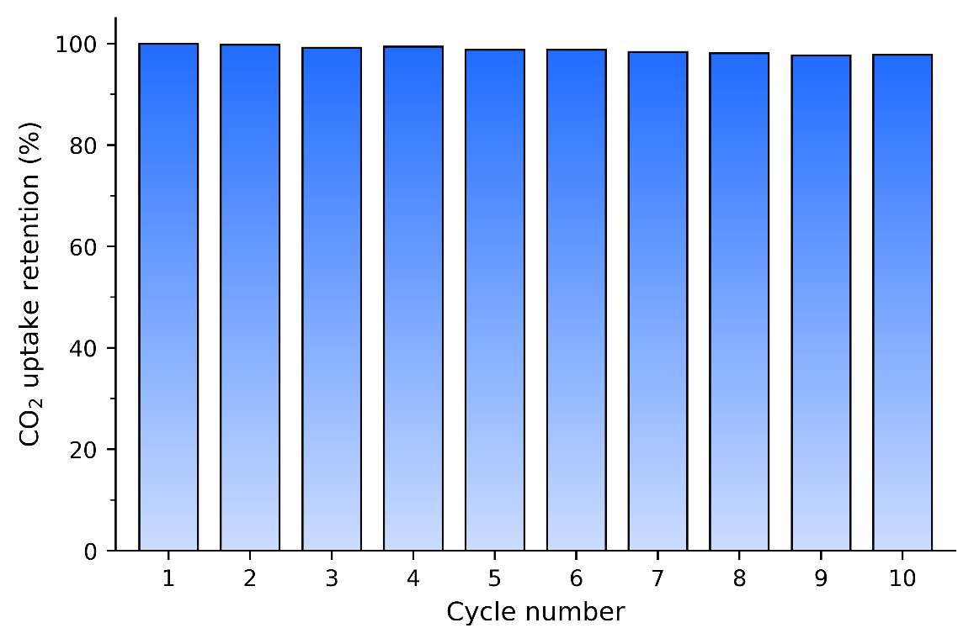
Figure 8. Recyclability performance of AC-2

This stability is consistent with recent reports on biomass-derived activated carbons. Dziejarski et al. reported adsorption–desorption cycling of KOH- and K₂C₂O₄-activated biomass carbons at 25 °C for 20 cycles and observed no measurable capacity loss, with a maximum standard deviation of approximately 0.09 mmol g⁻¹, which they attributed to stable physisorption within persistent ultramicropores [1]. Moussa et al. also evaluated olive-stone-derived porous carbons over six adsorption–desorption cycles under CO₂/N₂ gas mixtures and reported that KOH-activated samples maintained almost complete stability, whereas some metal-modified samples showed slight capacity decreases in later cycles [2]. Compared with these reports, the 97.8% retention of AC-2 after 10 cycles demonstrates competitive regeneration stability and supports the conclusion that the sunflower-pith-derived activated carbon behaves as a robust physisorbent. Although longer cycling tests under mixed-gas and humid conditions would be useful for future process validation, the present 10-cycle vacuum-regeneration test provides strong initial evidence for the reusability of AC-2 in repeated CO₂ capture operation.

References
[1] B. Dziejarski, R. Faust, J. Serafin, R. Krzyżyńska, K. Andersson, P. Knutsson, “Tailoring highly surface and microporous activated carbons (ACs) from biomass via KOH, K₂C₂O₄ and KOH/K₂C₂O₄ activation for efficient CO₂ capture and CO₂/N₂ selectivity: characterization, experimental and molecular simulation insights,” Chemical Engineering Journal, 524, 169677, 2025.
[2] M. Moussa, T. Bohli, C. Pevida, N. Querejeta, A. Ouederni, “Valorization of Olive Stone Biomass into Graphitic-Like Carbon for Cyclic and Selective CO₂ Adsorption Under Postcombustion Conditions,” Environmental Engineering Science, 43, 110–122, 2026.

3.5 Isosteric heat of adsorption and adsorption energetics
The adsorption energetics of AC-2 were evaluated from CO₂ adsorption isotherms collected at 298, 318, and 338 K, because this sample showed the highest uptake among the synthesized activated carbons. The CO₂ uptake decreased with increasing adsorption temperature, confirming that adsorption is exothermic. The isotherms were first treated using a Langmuir-based surface-coverage analysis. From the linearized P/m versus P plots, the monolayer adsorption masses were calculated as 27.47 mg at 298 K, 24.50 mg at 318 K, and 23.31 mg at 338 K (Figure SX). These monolayer values were then used to convert the adsorption data into surface coverage, θ, as a function of pressure (Figure SX2).
The isosteric heat was calculated from Clausius-Clapeyron plots of ln P versus 1/T at fixed surface coverage. For θ = 0.80, θ = 0.75, and θ = 0.70, the adsorption enthalpies were ΔH = -13.88, -8.73, and -6.55 kJ mol⁻¹, respectively. These can also be expressed as positive heat-of-adsorption magnitudes Q_{st}. The negative sign of ΔH confirms the exothermic nature of CO₂ adsorption on AC-2, while the low magnitudes indicate that the interaction is dominated by physical adsorption rather than chemisorption.
These values are lower than many recent values reported for biomass-derived activated carbons. Kuloglija et al. calculated isosteric heats of adsorption for KOH-activated pine- and birch-derived carbons using fixed loading, reporting values from 16.6 to 29.4 kJ mol⁻¹, which they described as consistent with physisorption of CO₂ on activated carbons [1]. Dziejarski et al. reported higher Q_{st} values of 26-36 kJ mol⁻¹ for K-based biomass activated carbons and described them as strong physisorption; their simulations also linked enhanced CO₂ affinity to sub-nanometer pores and carbonyl-rich surfaces [2]. Al-Ghurabi et al. reported an even higher value of 35 kJ mol⁻¹ at low CO₂ loading for optimized date-palm-waste activated carbon, attributing it to energetically heterogeneous nanopore sites and preferential micropore filling [3]. Compared with these recent studies, AC-2 shows weaker apparent adsorption energetics, even though it has high CO₂ uptake at elevated pressure.
This comparison suggests that AC-2 does not achieve its high 8 bar CO₂ capacity because of unusually strong binding sites. Instead, its performance is mainly associated with pressure-driven filling of its accessible microporous structure. This is consistent with the textural results: AC-2 has a high micropore fraction and a smaller average pore diameter than the NaOH-activated sample, but its calculated adsorption enthalpy remains low. In practical terms, this can be advantageous. Materials with higher Q_{st} may show stronger low-pressure affinity and selectivity, but they can require more energy for regeneration. The relatively low Q_{st} values of 13.88, 8.73, and 6.55 kJ mol⁻¹ suggest that CO₂ adsorbed on AC-2 should be releasable by pressure reduction, vacuum, or mild heating. Thus, AC-2 should be described as a high-capacity, pressure-responsive physisorbent rather than a strongly binding chemisorptive adsorbent.

References
[1] S. Kuloglija, I.-M. Kropik, A. E. G. Ahmed, V. Kalman, A. Windbacher, C. Jordan, A. Konior, N. Abbaspour, N. Steinacher, F. Winter, D. Tomasetig, E. Lamprinidou, and M. Harasek, “Isotherms and kinetics of CO₂ adsorption on biochar-based activated carbon for sustainable climate solutions,” Separation and Purification Technology, vol. 382, 136079, 2026. DOI: 10.1016/j.seppur.2025.136079.
[2] B. Dziejarski, J. Serafin, D. F. Hernández-Barreto, E. Naumovska, J. Sreńscek-Nazzal, N. Klomkliang, E. Tam, R. Krzyżyńska, K. Andersson, and P. Knutsson, “Tailoring highly surface and microporous activated carbons from biomass via KOH, K₂C₂O₄ and KOH/K₂C₂O₄ activation for efficient CO₂ capture and CO₂/N₂ selectivity: Characterization, experimental and molecular simulation insights,” Chemical Engineering Journal, vol. 524, 169677, 2025. DOI: 10.1016/j.cej.2025.169677.
[3] E. H. Al-Ghurabi, M. M. Boumaza, W. Al-Masry, and M. Asif, “Optimizing the synthesis of nanoporous activated carbon from date-palm waste for enhanced CO₂ capture,” Scientific Reports, vol. 15, 17132, 2025. DOI: 10.1038/s41598-025-00498-1.

Structure–performance descriptor for CO₂ uptake
The CO₂ adsorption results show that the sunflower-pith-derived activated carbons cannot be evaluated using BET surface area alone. Although AC-4 exhibited the highest BET surface area and micropore volume, AC-2 delivered the highest CO₂ uptake. This inversion indicates that adsorption performance is not controlled simply by the total amount of internal surface generated during activation, but by how effectively that porosity is distributed within CO₂-accessible micropores. In other words, the relevant structural factor is not only the quantity of micropore volume, but also the degree of confinement imposed on CO₂ molecules by the pore walls. This observation motivated the use of a simple textural descriptor to examine the combined effect of micropore volume and average pore diameter on CO₂ adsorption.
As a first approximation, micropore volume was normalized by pore diameter. This approach has a direct geometrical basis. For idealized slit-like or cylindrical pores, internal surface area scales approximately with pore volume divided by pore width. Therefore, V_{micro}/d_{avg} already contains an implicit surface-area contribution and may be interpreted as a rough proxy for micropore-associated internal surface area. This is important because the total BET surface area is not necessarily equivalent to CO₂-effective surface area. BET area can include contributions from wider micropores and small mesopores, which increase total surface area but do not necessarily provide the strongest adsorption sites for CO₂. Therefore, the descriptor was constructed around the microporous domain rather than the total BET surface area.
However, V_{micro}/d_{avg} alone does not fully represent the strong influence of pore-size confinement. CO₂ adsorption in narrow carbon micropores is enhanced by the overlap of adsorption potentials from opposing pore walls. As the pore width increases, this overlap weakens nonlinearly, reducing the adsorption affinity of the pore even if the pore still contributes to total surface area or total pore volume. Therefore, the descriptor was generalized as:
$$D_{n}=\frac{V_{micro}}{d_{avg}^{n}}$$
where n is an empirical confinement-sensitivity exponent. For the sunflower-pith activated carbons, the 8 bar CO₂ uptake was best represented by n=3, giving the descriptor D₃=V_{micro}/d_{avg}³ (Figure 9). This descriptor correctly identifies AC-2 as the most favorable adsorbent and explains why AC-4, despite having the highest BET surface area and micropore volume, shows lower CO₂ uptake: its larger average pore diameter weakens the confinement contribution. Therefore, the descriptor number is not presented as a universal adsorption equation, but as a confinement-weighted micropore descriptor that captures the main structure–performance trend within this internally consistent synthesis series.
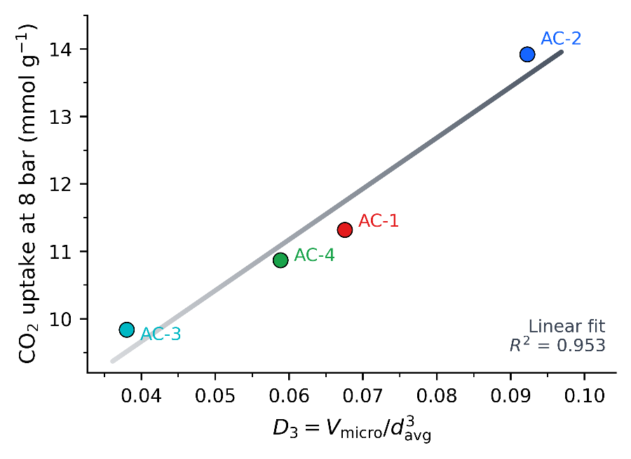
Figure 9. Descriptor fit of sunflower-pith AC at 8 bar

The same analysis was repeated using the 1 bar CO₂ uptake values obtained from the adsorption isotherms. At 1 bar, the best mathematical exponent increased to approximately n=5, although n=3 still produced a reasonable correlation. This pressure dependence is physically meaningful. At low pressure, adsorption occurs preferentially in the strongest adsorption sites, namely narrow micropores and ultramicropores where wall-potential overlap is most significant. Under these conditions, pore width exerts a stronger effect on uptake, and a larger exponent is expected. At higher pressure, once the strongest adsorption sites are progressively occupied, additional micropore volume contributes more strongly to total capacity, and the pore-width penalty becomes less dominant. Thus, the exponent n should be viewed as a condition-dependent confinement parameter rather than as a fixed material constant.
This interpretation is consistent with recent literature. Dan et al. investigated PET-derived activated carbons prepared by microwave activation and showed that activation time strongly affects textural properties and CO₂ uptake. Their study reported that the optimum PET-derived carbon was not simply the most extensively activated material, but the material with the most favorable balance of micropore volume, pore width, and CO₂ uptake [1]. When their reported CO₂-derived micropore volume and characteristic pore width were examined using the related descriptor W_{0,CO2}/L₀^{n}, a strong pore-width-weighted correlation was obtained. This supports the conclusion that CO₂ uptake in activated carbons is governed by the combined effect of micropore volume and pore-size confinement, rather than by total surface area alone.
A second comparison was made using the olive-stone-derived carbon study by Moussa et al. In that work, CO₂ uptake was measured at 0 °C and 1 bar for olive-stone-based carbons. For that dataset, the descriptor fits with an n number of 0.5. This does not contradict the present analysis. Instead, it shows that temperature and adsorption energy also affect the number. In the olive-stone study, CO₂ adsorption was performed at 0 °C, meaning that it is much easier to adsorb under these conditions [2].
Taken together, these comparisons show that the exponent n should not be treated as a universal number. It can vary with pressure, temperature, precursor structure, activation method, and the pore-volume metric used. If the pore-volume term is a broad N₂-derived micropore volume, a stronger pore-width penalty may be required because not all micropores contribute equally to CO₂ adsorption. If the pore-volume term is already CO₂-derived or restricted to ultramicropores, a weaker additional pore-width penalty may be sufficient. Activation chemistry and precursor structure can further modify this relationship by affecting pore accessibility, pore tortuosity, surface polarity, residual inorganic species, and the distribution of oxygen-containing functional groups. Therefore, this equation should be considered a semi-quantitative structure performance descriptor rather than a predictive universal model.
Despite these limitations, the descriptor analysis strengthens the mechanistic interpretation of the present work. The superior performance of AC-2 is not an accidental consequence of high surface area, nor can it be explained by total pore volume alone. Instead, AC-2 provides the most favorable balance between micropore volume and pore confinement. The descriptor provides a compact way to visualize this balance and to compare related activated carbons within a controlled synthesis series. Its value is not in replacing adsorption isotherms, but in offering a first-pass screening metric for identifying activated carbons in which the generated porosity is not only abundant, but also appropriately confined for CO₂ adsorption.

References
[1] E. Dan, A. J. McCue, D. Dionisi, C. Fernández Martín, “Towards low-cost and sustainable activated carbon production: Influence of microwave activation time on yield and CO₂ uptake of PET-derived adsorbents,” Journal of CO₂ Utilization, 83, 102807, 2024. DOI: 10.1016/j.jcou.2024.102807.
[2] M. Moussa, T. Bohli, C. Pevida, N. Querejeta, A. Ouederni, “Valorization of Olive Stone Biomass into Graphitic-Like Carbon for Cyclic and Selective CO₂ Adsorption Under Postcombustion Conditions,” Environmental Engineering Science, 43, 110–122, 2026. DOI: 10.1177/15579018251412055.

4. Conclusion
Sunflower pith was demonstrated as an effective low-cost agricultural precursor for producing high-surface-area activated carbons for CO₂ capture. Carbonization converted the naturally cellular pith structure into a carbon-rich framework, while increasing carbonization temperature and residence time progressively lowered char yield through dehydration, devolatilization, cleavage of oxygenated/aliphatic moieties, and development of a more carbonized aromatic structure. Although the directly carbonized biochars retained only limited surface area, they provided a suitable reactive carbon framework for subsequent alkali activation. Chemical activation transformed these low-surface-area chars into highly porous activated carbons, increasing the BET surface area from below 6 m²g⁻¹ for the biochars to above 2000 m²g⁻¹ for all synthesized activated carbons.
The key finding of this work is that CO₂ adsorption performance was not governed by BET surface area alone. NaOH activation generated the largest total surface area and pore volume, with AC-4 reaching 2948 m²g⁻¹, but this did not translate into the highest CO₂ uptake. Instead, the KOH-activated AC-2 showed the best adsorption performance, reaching 13.92 mmol g⁻¹ at 25 °C and 8 bar, substantially exceeding both the commercial activated carbon and the NaOH-activated analogues. This result demonstrates that the quality of the pore architecture is more important than simple surface-area maximization. The superior behavior of AC-2 is attributed to its more favorable balance of micropore volume, micropore fraction, and smaller average pore diameter, which provides stronger confinement for CO₂ while maintaining sufficient accessible pore volume.
The comparison between KOH and NaOH activation, therefore, provides a clear mechanistic design message. NaOH activation appears to promote more extensive pore widening and total pore development, whereas KOH activation produces a more CO₂-effective microporous network in sunflower-pith-derived carbon. The inversion between BET surface area and CO₂ uptake highlights the importance of targeted micropore engineering, especially for adsorbents intended for pressure-swing or vacuum-swing CO₂ capture. Temperature-dependent adsorption measurements further confirmed the exothermic and predominantly physical nature of CO₂ adsorption, while the cyclic adsorption–desorption test of AC-2 showed high regeneration stability, retaining 97.8% of its initial uptake after 10 cycles under vacuum desorption. These results indicate that AC-2 combines high capacity, reversible adsorption, and promising structural stability during repeated use.
To quantify this structure–performance relationship, a confinement-weighted micropore descriptor, D_{n}=V_{micro}/d_{avg}³ was introduced. Although not proposed as a universal predictive equation, the descriptor captured the internal trend of the sunflower-pith-derived carbons and showed that the superior uptake of AC-2 arises from the combined effect of micropore volume and pore-size confinement. This analysis provides a practical screening concept for comparing related activated carbons where BET surface area alone fails to explain CO₂ adsorption behavior.
Overall, this study establishes sunflower pith as a promising biomass precursor for regenerable CO₂-capture activated carbons and shows that alkali activation chemistry can be used to tune the pore network toward CO₂-selective confinement. The work also emphasizes that future development of biomass-derived activated carbons should move beyond reporting high BET surface area as the primary performance indicator. Instead, pore-size distribution, micropore fraction, average pore diameter, adsorption energetics, and cyclic working capacity should be considered together.

References
[1] International Energy Agency, CO₂ Emissions in 2024, Global Energy Review 2025, IEA, Paris, 2025.
[2] International Energy Agency, Carbon Capture, Utilisation and Storage, IEA, Paris, 2024.
[3] S. Kundu, T. Khandaker, M. A. M. Anik, M. K. Hasan, P. K. Dhar, S. K. Dutta, M. A. Latif, M. S. Hossain, A comprehensive review of enhanced CO₂ capture using activated carbon derived from biomass feedstock, RSC Advances, 2024, DOI: 10.1039/D4RA04537H.
[4] C. Quan, Y. Zhou, J. Wang, C. Wu, N. Gao, Biomass-based carbon materials for CO₂ capture: A review, Journal of CO₂ Utilization 68 (2023) 102373.
[5] N. Abuelnoor, A. AlHajaj, M. Khaleel, L. F. Vega, M. R. M. Abu-Zahra, Activated carbons from biomass-based sources for CO₂ capture applications, Chemosphere 282 (2021) 131111.
[6] M. S. Khosrowshahi, S. S. Ghasemi, M. Safdari, et al., Natural products derived porous carbons for CO₂ capture, Advanced Science 10 (2023) 2304289.
[7] M. Oschatz, M. Antonietti, A search for selectivity to enable CO₂ capture with porous adsorbents, Energy & Environmental Science 11 (2018) 57-70.
[8] M. Baysal, K. Bilge, B. Yılmaz, M. Papila, Y. Yürüm, Preparation of high surface area activated carbon from waste-biomass of sunflower piths: Kinetics and equilibrium studies on dye removal, Journal of Environmental Chemical Engineering, 2018.

