Pituitary hormones circulate as immunoglobulin-associated macro-complexes in mammals

Akifumi Takaki¹, Keisuke Sato¹, Shinobu Yasuo¹, Keisuke Ikegami¹*
1 Laboratory of Regulation in Metabolism and Behavior, Faculty of Agriculture, Kyushu University, 744 Motooka, Nishi-ku, Fukuoka, 819-0395, Japan

*Correspondence: Keisuke Ikegami, Ph.D.
Laboratory of Regulation in Metabolism and Behavior, Faculty of Agriculture, Kyushu University, 744 Motooka, Nishi-ku, Fukuoka, 819-0395, Japan
Phone: +81 92 802 4598
Email: ikegami.keisuke.271@m.kyushu-u.ac.jp

The authors have declared that no conflict of interest exists.

Extended Data Figures
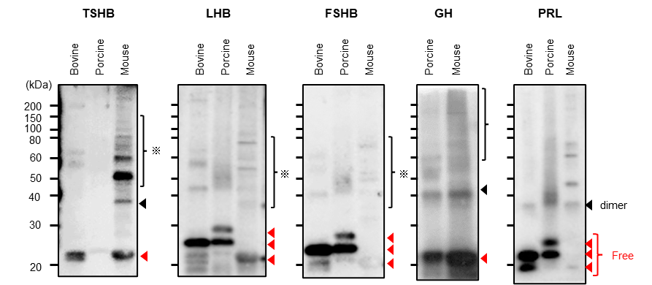
Extended Data Figure 1 Confirmation of cross-reactivity in anti-pituitary hormone antibodies.
To evaluate antibody cross-reactivity among species, Western blot analyses were performed using primary antibodies against canine TSHB (1:1,000), chicken LHB (1:5,000), human FSHB (1:1,000), human GH (1:100,000), and ovine PRL (1:1,000). Protein extracts from bovine, porcine, and mouse pituitaries were subjected to SDS–PAGE, followed by immunoblotting with each antibody. The monomeric forms (Free; indicated in red) were cross-species conservation observed here indicates that macro-hormone formation is unlikely to be a rare immunological phenomenonently detected across species depending on antibody specificity. In agreement with previous reports, both GH and PRL antibodies additionally recognized higher-molecular-weight dimeric forms (dimer; indicated in black). These results confirm the expected pattern of cross-reactivity for each antibody and validate their utility for comparative analyses across mammalian species.

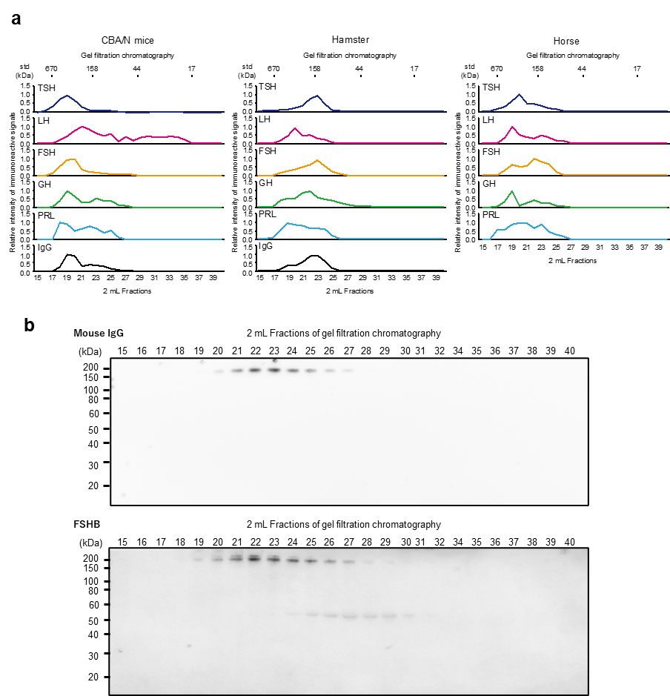
Extended Data Figure 2 Gel filtration chromatography analysis and immune blot analysis.
(a) Gel filtration chromatography revealed mainly existence of pituitary hormones as high molecular weight “macro” forms in CBA/N mice, hamster, and horse. (b) Non-gel filtration chromatography of CBA/N mice serum probed with antibodies against FSHB and mouse IgG. The relative proportions of the macro-complexes were comparable to those of IgG. The illustrations were created using Adobe Illustrator.

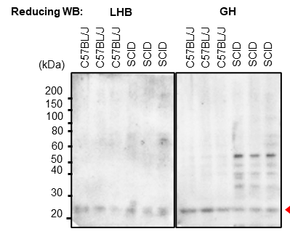

Extended Data Figure 3 Normal expression levels of pituitary LH and GH in C57BL/6J mice and immunodeficient SCID mice.
Immunoblot analysis revealed normal LHB and GH levels in the pituitary glands of C57BL/6J and immunodeficient SCID mice. Monomers with the same molecular weight were detected (red arrowhead).

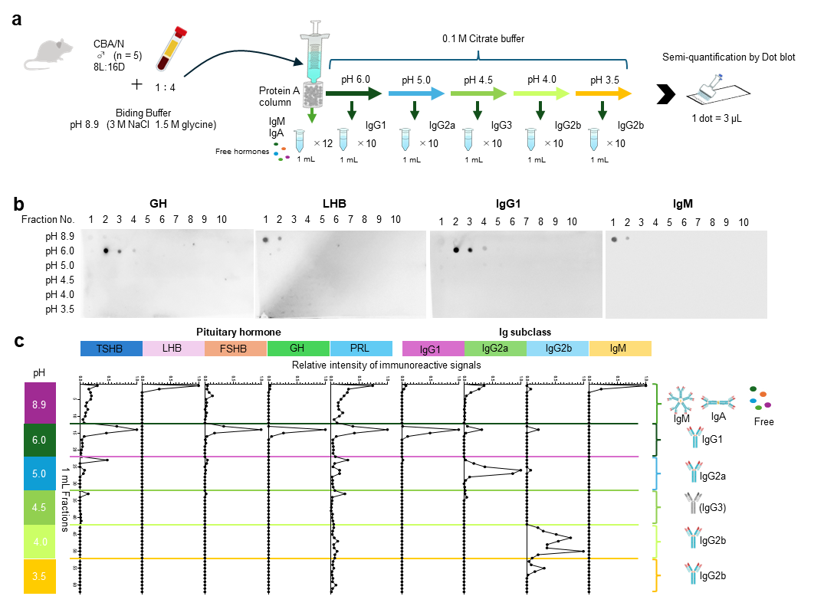
Extended Data Figure 4 Separation of mouse serum by Protein A column with stepwise pH.
(a) Schematic representation of immunoglobulin class separation using a Protein A column. Serum from CBA/NSlc mice (males, n = 5, 8L:16D) include full types of Ig subclass was applied to the column and sequentially eluted with citrate buffers of decreasing pH to obtain IgA/IgM, IgG1, IgG2a, IgG3, and IgG2b fractions. These fractions were subsequently subjected to semi-quantitative dot blot analysis (1 dot = 3-5 μL). (b) Represented photos of dot blot analysis using anti-GH, LHB, IgG1, or IgM antibodies. (c) Semi-quantitative comparison of each pituitary hormone signal across immunoglobulin subclasses. Relative signal intensities for each hormone and Ig subclass are shown, enabling comparison of subclass-dependent detection patterns. Many pituitary hormones bind to IgG1 except LH. Free hormones, IgA, IgG1, IgG2a, IgG2b, IgG3, and IgM are represented according to the color scheme. The illustration incorporates materials from TogoTV (DBCLS), licensed under CC BY 4.0.

