Supplementary Information
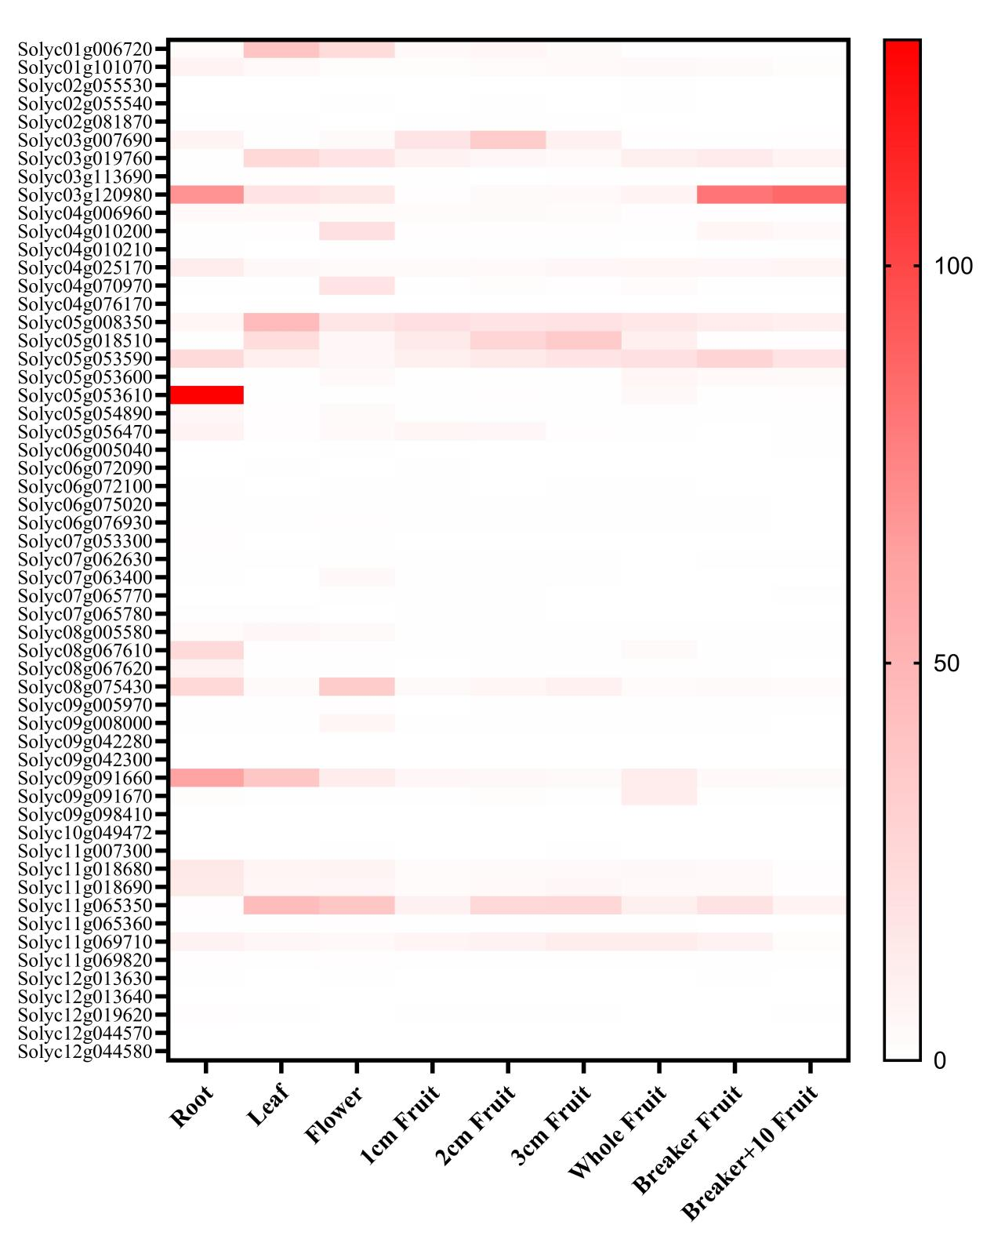
Figure S1 Heatmap of expression levels of ABCG gene family members in different tissues of Heinz 1706.

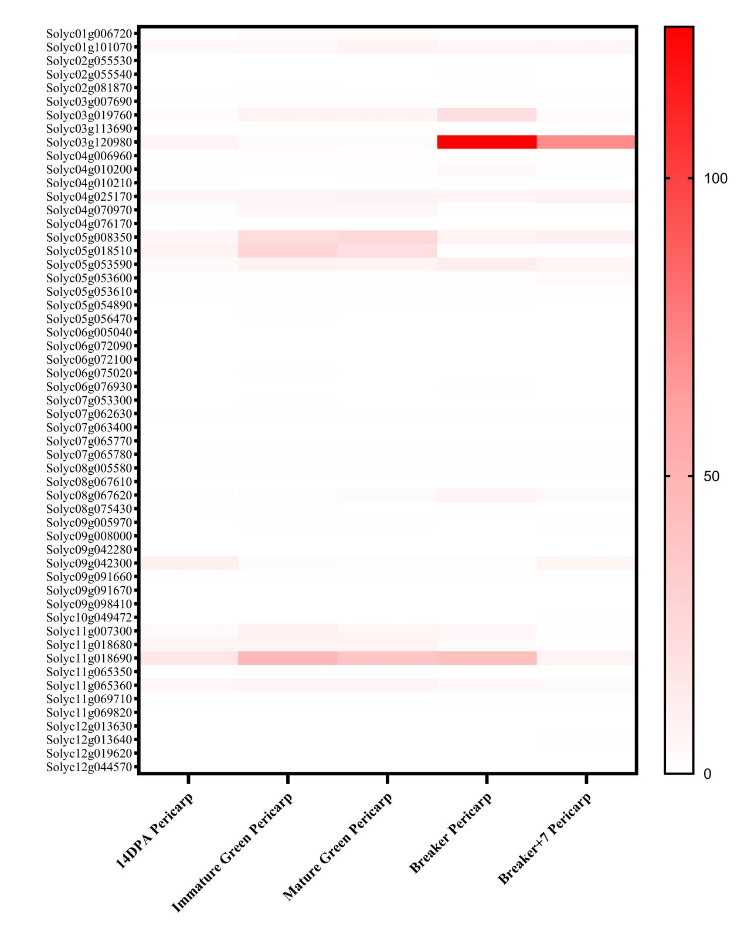
Figure S2 Heatmap of expression levels of ABCG gene family members in different tissues of Alisa Craig.

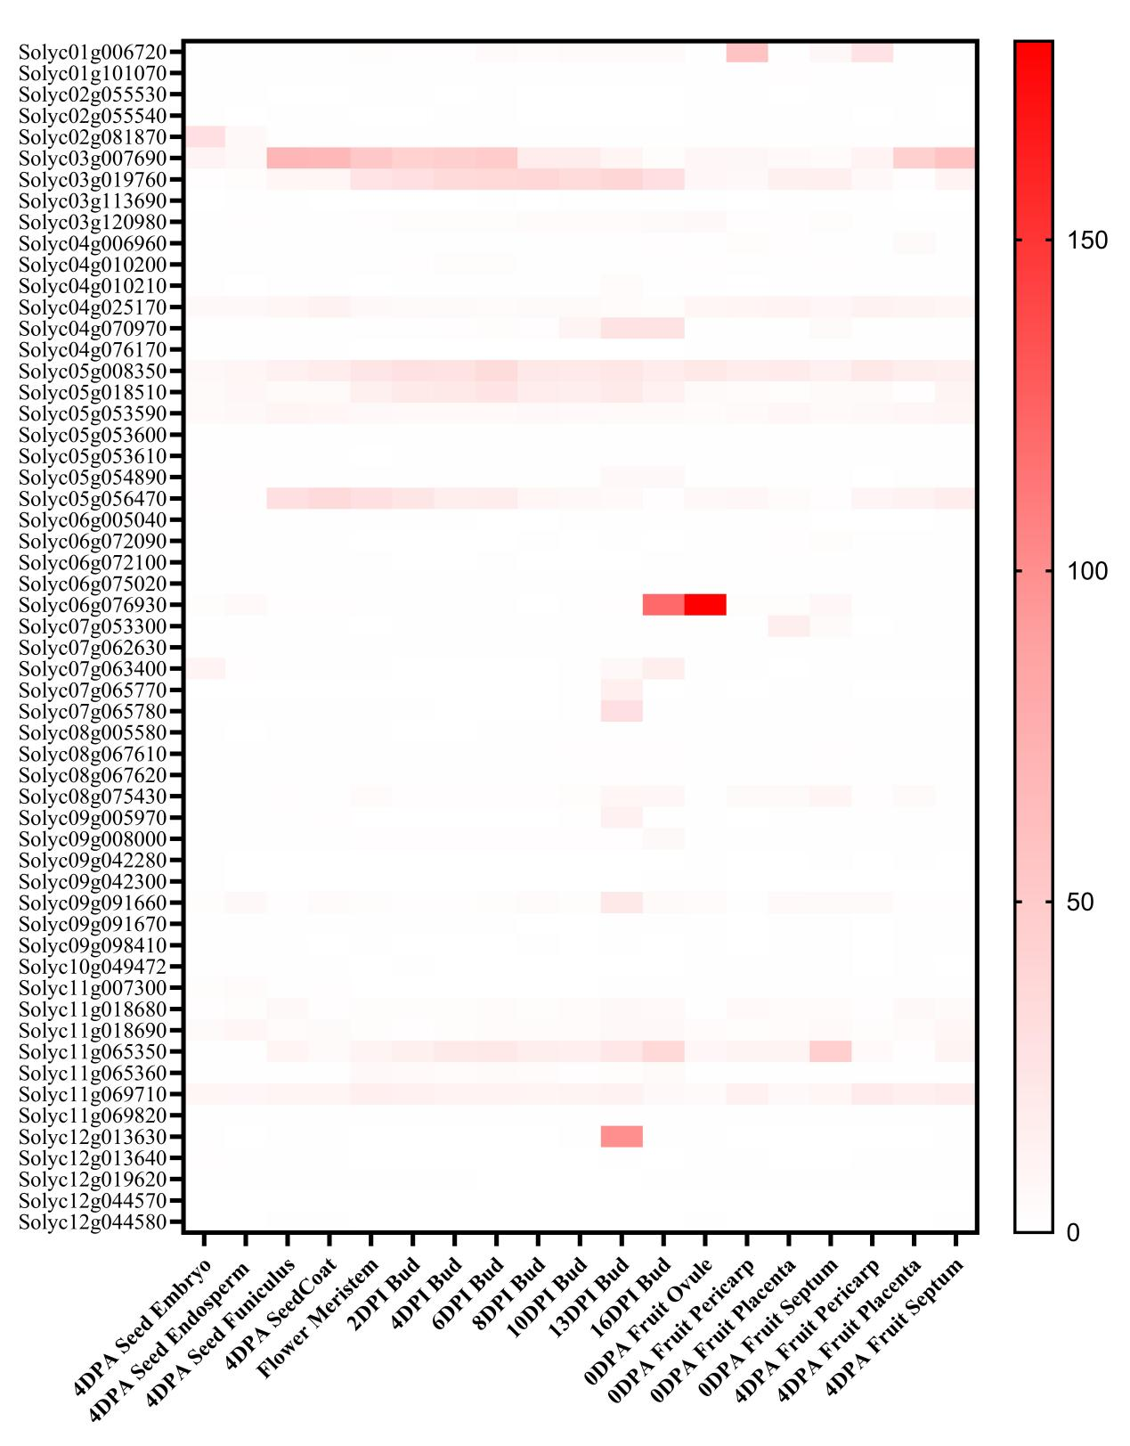
Figure S3 Heatmap of expression levels of ABCG gene family members in different tissues of LA1589.

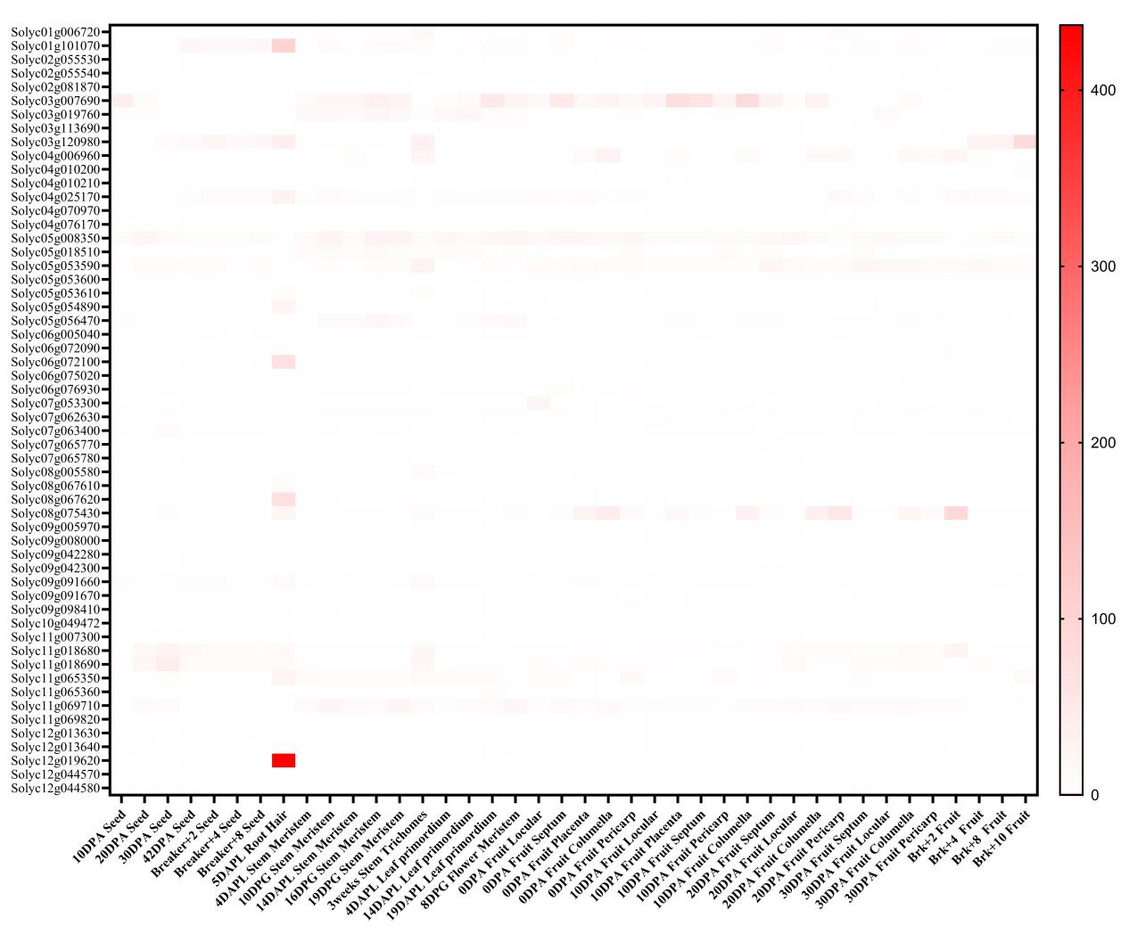
Figure S4 Heatmap of expression levels of ABCG gene family members in different tissues of M82.

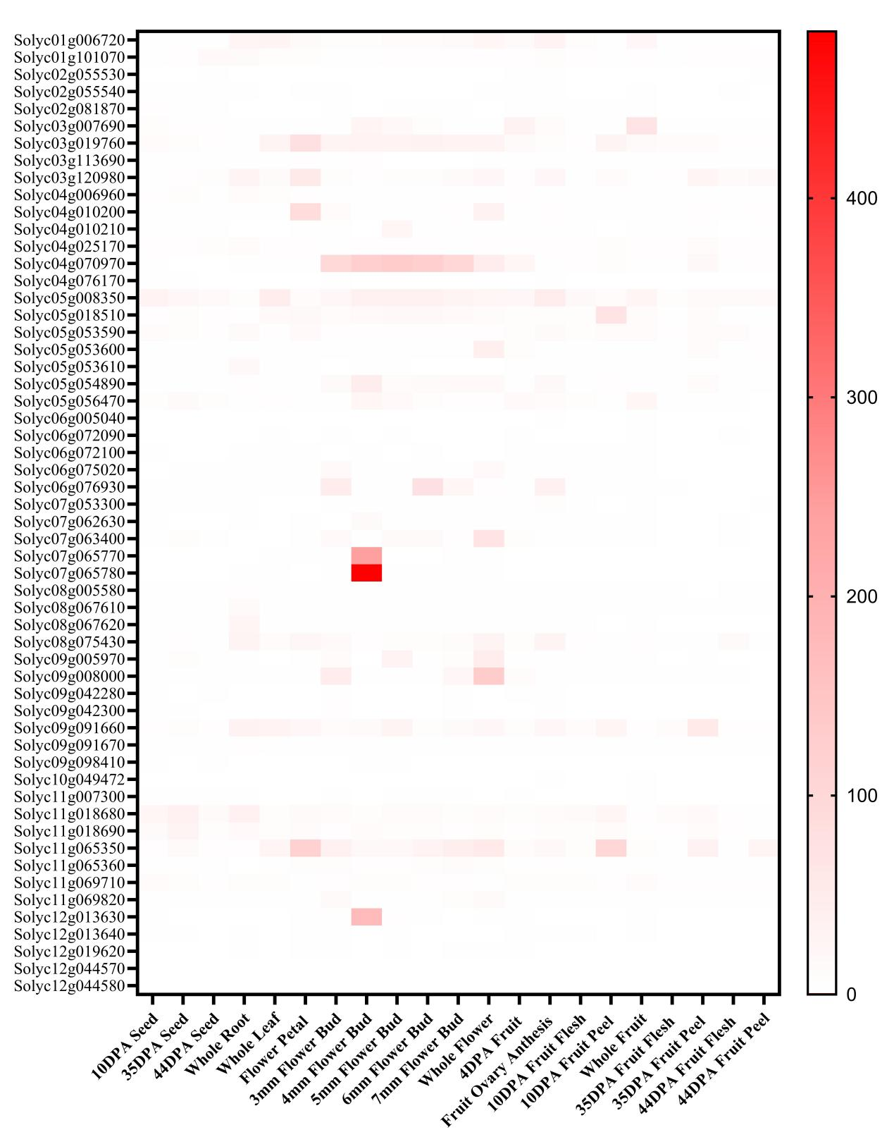
Figure S5 Heatmap of expression levels of ABCG gene family members in different tissues of Micro-Tom.

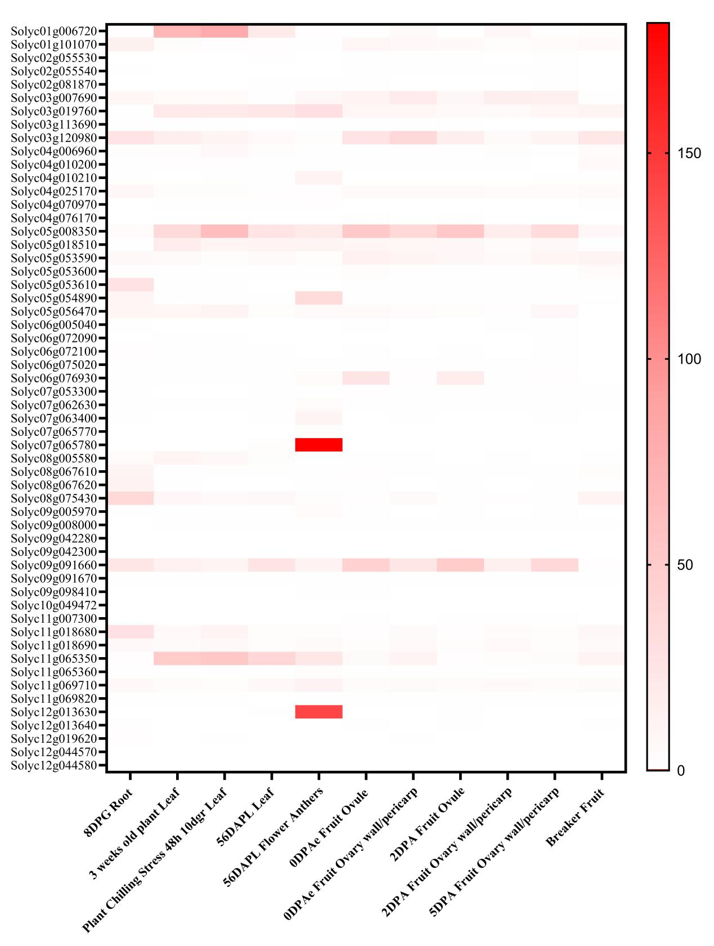
Figure S6 Heatmap of expression levels of ABCG gene family members in different tissues of MoneyMaker.

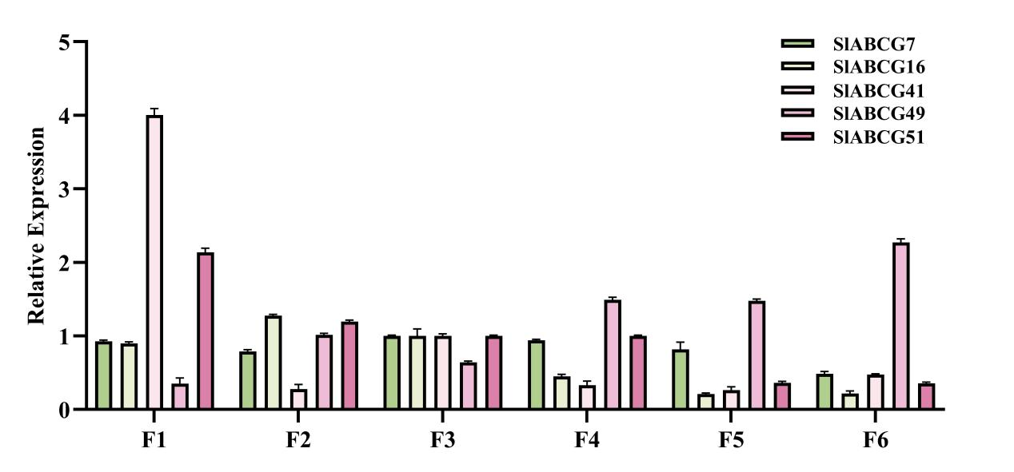
Figure S7 Expression levels of SlABCG7, SlABCG16, SlABCG41, SlABCG49, SlABCG51 at different stages of floral organ development.
Total RNA was extracted from floral organs at different developmental stages selected by AC. F1 (microspore mother cell stage), F2 (tetrad stage), F3 (middle uninucleate stage), F4 (late uninucleate stage), F5 (binuclear stage), and F6 (mature pollen stage).

Table S1. Conserved motifs of SlABCG family proteins.

Motif name | Motif color | Width | Sequences
Motif 1 |  | 25 | CADTIVGDEMJRGISGGZRKRVSIG
Motif 2 |  | 33 | VELVANPSJLFLDEPTSGLDSTSAAIVMRTLRN
Motif 3 |  | 29 | SGYVTQDDILSPHLTVEETLVFSALLRLP
Motif 4 |  | 26 | JTALMGPSGAGKTTLLDALAGRLTGG
Motif 5 |  | 32 | ADTGRTVVCTIHQPSSRIFELFDELJLLSRGG
Motif 6 |  | 50 | LSVPPPGSKDLHFETQYSQSFFTQFMACLWKQHLSYWRNPSYTAVRFFFT
Motif 7 |  | 26 | QERTVFYRERAAGMYRLSPYALAQTL
Motif 8 |  | 34 | FVPRPRIPIWWIWYYYLSPVAWTLYGLLASZFGD
Motif 9 |  | 50 | YNGHELHEFVPQRTSAYISQHDLHIGEMTVRETLEFSARCQGVGSRYEML
Motif 10 |  | 50 | FKCPERKGVADFLQEVTSKKDQZQYWARKBEPYRFITVKEFAEAFQSFHV
Motif 11 |  | 50 | FMDEISTGLDSSTTYQIVNSLRQSVHJLKGTAVISLLQPAPETYBLFDDI
Motif 12 |  | 50 | SCHLIKYFESIPGVPKIKEGYNPATWMLEVTSSSQEMRLGVDFAEJYKNS
Motif 13 |  | 50 | VFALGGFILSRDDVKKWWIWGYWISPLMYSQNAILVNEFLGKRWKHIAPN
Motif 14 |  | 29 | KLPVFYKQRDLLFYPAWAYALPTWILKIP
Motif 15 |  | 29 | GMVLPFEPLSITFDBVVYSVDMPQEMKEQ
Motif 16 |  | 29 | FEWTAAKFFWYLFFMFFTLLYFTFYGMMT
Motif 17 |  | 50 | VPYDKSKSHPAALTTKKYGIGKKELLKACAEREFLLMKRNSFVYIFKTFQ
Motif 18 |  | 41 | RKMFVEEVMELVELTPLRSALVGLPGVNGLSTEQRKRLTIA
Motif 19 |  | 41 | RREKEANIKPDPDIDIYMKASAVEGQEANVVTDYVLKILGL
Motif 20 |  | 41 | DEDNEKFLLKLKNRIDRVGJDLPTIEVRYEHLNIEADAYVG

Table S2. Wild-type tomato genomic information.
Genome Abbr | Genome  ID | Accessions | Species | Chromosomes | Conting N50(Mb) | Scaffold N50(Mb) | Assemble genome size(Mb) | Gene number
AC | Alisa Craig | LA2838A | Solanum lycopersicum | 12 | 24.95 | 67.955 | 809.081 | 36165
LA1464 | LA1464 | LA1464 | Solanum lycopersicum  var.cerasiforme | 12 | 2.513 | 62.622 | 778.271 | 32941
LA1589 | Viru to Galumga | LA1589 | Solaum pimpinellifolium | 12 | 0.005 | - | 739 | 38065
LA2157 | LA2157 | LA2157 | Solanum arcanum | - | 0.221 | - | 724.487 | -
LA1969 | LA1969 | LA1969 | Solanum chilense | 12 | 0.425 | 67.666 | 916.718 | 34375
LA1028 | LA1028 | LA1028 | Solanum chmielewskii | 12 | 2.002 | 61.827 | 770.015 | 31613
LA1331 | LA1331 | LA1331 | Solanum corneliomulleri | 12 | 0.449 | 64.291 | 876.903 | 31692
LA0436 | LA0436 | LA0436 | Solanum galapagense | 12 | 15.538 | 67.63 | 804.442 | 32773
LA1777 | LA1777 | LA1777 | Solanum habrochaites | 12 | 0.546 | 68.069 | 959.698 | 32386
LA2591 | LA2591 | LA2591 | Solanum lycopersicoides | 12 | 0.579 | 91.091 | 1200.819 | 32295
LA0247 | LA0247 | LA0247 | Solanum neorickii | 12 | 2.079 | 60.281 | 778.271 | 32831
LA0716 | LA0716 | LA0716 | Solanum pennellii | 12 | 0.002 | 1.741 | 942.595 | 44966
LA0446 | LA0446 | LA0446 | Solanum peruvianum | 12 | 0.678 | 64.491 | 867.47 | 31877

Table S3. Primer sequences used in this study.
q-SlABCG7 | F:5’-TTTGCCACATTTAACCATTCTTCA-3’
q-SlABCG7 | R:5’-ATCTCTCTGCATAACCAAAAGAAG-3’
q-SlABCG16 | F:5’-TGACGGGTTTAGTAGGTCGTG-3’
q-SlABCG16 | R:5’-AATGCCATAATCCCACGGGT-3’
q-SlABCG41 | F:5’-TTTCCTTACAGCGTATGCCC-3’
q-SlABCG41 | R:5’-CACACCTGCAACGACTGGA-3’
q-SlABCG49 | F:5’-ACGCTATCAAACAAAATGGAGAC-3’
q-SlABCG49 | R:5’-AGTTTCTCTCCGCCAGGAAT-3’
q-SlABCG51 | F:5’-TGCCAGGACCAGTATGGATG-3’
q-SlABCG51 | R:5’-GAGCCCCTGAAATAAAGACGC-3’

