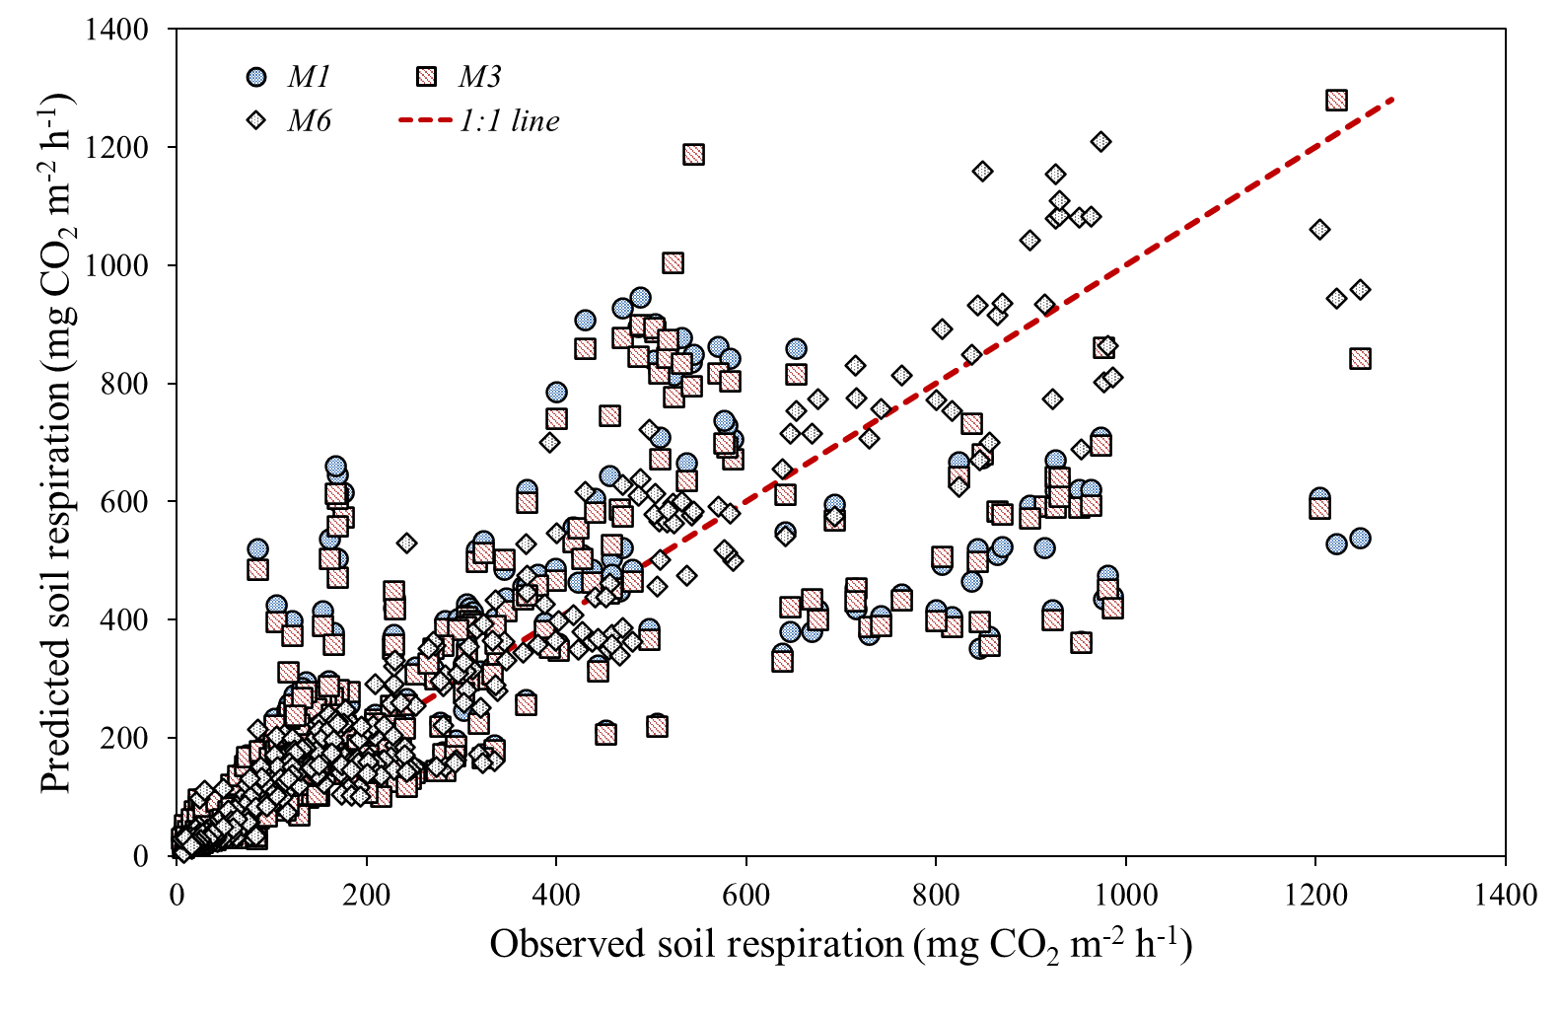
Figure S1. Observed versus predicted soil respiration for selected candidate models.
Observed daily soil respiration was compared with predicted values from the temperature-only model (M1), the temperature, soil moisture content, and precipitation model (M3), and the year-season-specific temperature-response model (M6). The dashed line indicates the 1:1 relationship between observed and predicted soil respiration. Soil respiration is expressed as mg CO₂ m⁻² h⁻¹. M1 represents the baseline temperature-response model, M3 represents the extended non-seasonal model including soil moisture content and precipitation, and M6 represents the year-season-specific diagnostic model.

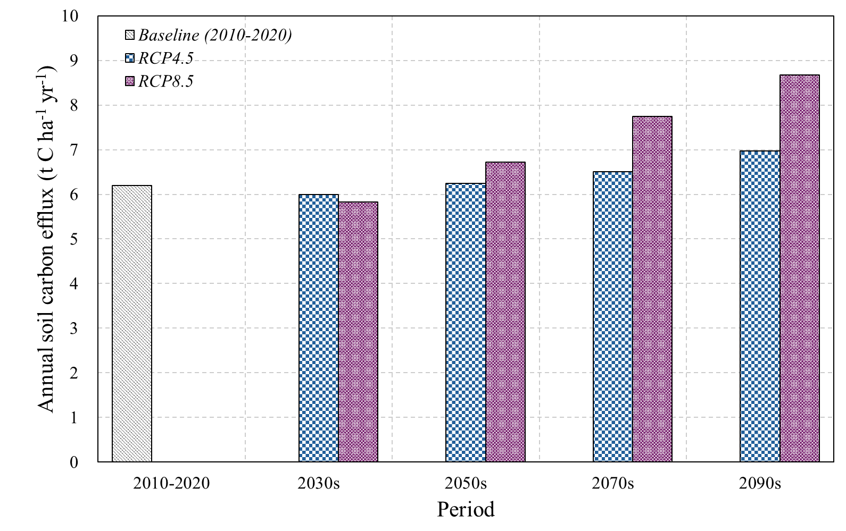
Figure S2. Comparison of baseline and future temperature-driven estimates of annual soil carbon efflux.
Baseline values represent the annualized April–December 2010 estimate, the full-year 2011 observed estimate, and model-based annual estimates for 2012–2020. Future values represent decadal mean annual soil carbon efflux estimated under RCP4.5 and RCP8.5 for the 2030s, 2050s, 2070s, and 2090s. All values are expressed as t C ha⁻¹ yr⁻¹. Future estimates were derived from monthly climate scenario data, reconstructed soil temperature at 5 cm depth, and the calibrated temperature-response model.

