Supplementary material

eFigure 1. Flowchart of participant selection in CHARLS 1
eTable 1. Model fit statistics for group-based trajectory modeling 2
eFigure 2. Comparison of depression scores between patients with and without chronic diseases 3
eFigure 3. Kaplan-Meier estimates for depressive symptoms events with vs. without hypertension 4
eFigure 4. Kaplan-Meier estimates for depressive symptoms events with vs. without diabetes mellitus 4
eFigure 5. Kaplan-Meier estimates for depressive symptoms events with vs. without dyslipidemia 5
eFigure 6. Kaplan-Meier estimates for depressive symptoms events with vs. without lung disease 5
eFigure 7. Kaplan-Meier estimates for depressive symptoms events with vs. without asthma 6
eFigure 8. Kaplan-Meier estimates for depressive symptoms events with vs. without liver disease 6
eFigure 9. Kaplan-Meier estimates for depressive symptoms events with vs. without cardiovascular disease 7
eFigure 10. Kaplan-Meier estimates for depressive symptoms events with vs. without stroke 7
eFigure 11. Kaplan-Meier estimates for depressive symptoms events with vs. without kidney disease 8
eFigure 12. Kaplan-Meier estimates for depressive symptoms events with vs. without digestive disease 8
eFigure 13. Kaplan-Meier estimates for depressive symptoms events with vs. without memory disease 9
eFigure 14. Kaplan-Meier estimates for depressive symptoms events with vs. without rheumatism 9
eFigure 15. Kaplan-Meier estimates for depressive symptoms events with different disease model 10
eTable 2. Mediation analysis of sleep duration and cognition in the association between chronic diseases and depressive symptoms 11

Participants at baseline from CHARLS
(N = 17708)
Participants with exclusion criteria
were excluded (N = 6648)
Man (N = 2357)
Not yet menopausal (N = 593)
Presence of tumor or cancer (N = 401)
C-reactive protein > 20 mg/L (N = 3297)
Initially eligible participants
(N = 11060)
Finally included participants
(N = 6337)
Participants with missing essential data were excluded (N = 6485)
Missing age data (N = 234)
Missing CESD-10 scores (N = 764)
Missing chronic disease data (N = 2615)
Missing other variables data (N = 2872)
IDS
(N = 1250)
NDS
(N = 3939)
PDS
(N = 517)
RDS
(N = 631)

eFigure 1. Flowchart of participant selection in CHARLS

Abbreviations: BMI, Body Mass Index; CESD-10, 10-item Center for Epidemiologic Studies Depression Scale; IDS, Increasing depressive symptoms; NDS, No depressive symptoms; PDS, Persistently severe depressive symptoms; RDS, Remitting depressive symptoms.

eTable 1. Model fit statistics for group-based trajectory modeling
G | loglik | npm | BIC | %.class1 | %.class2 | %.class3 | %.class4 | %.class5 | %.class6 | %.class7
model1 | -63495.47 | 5 | 127033.7 | 100 | NA | NA | NA | NA | NA | NA
model2 | -63270.16 | 9 | 126617.2 | 77.37934 | 22.62066 | NA | NA | NA | NA | NA
model3 | -63094.29 | 13 | 126299.7 | 73.94844 | 13.99496 | 12.0566 | NA | NA | NA | NA
model4 | -62957.55 | 17 | 126060.4 | 16.10777 | 65.0126 | 10.73852 | 8.141113 | NA | NA | NA
model5 | -62957.55 | 21 | 126094.6 | 63.67513 | 16.99942 | 0 | 11.164954 | 8.160496 | NA | NA
model6 | -62957.55 | 25 | 126128.8 | 62.62842 | 0 | 17.48401 | 0 | 11.707695 | 8.17988 | NA
model7 | -62957.55 | 29 | 126163 | 57.10409 | 0 | 0 | 0 | 20.93429 | 13.76236 | 8.199263

Model fit statistics including log-likelihood values, number of parameters (npm), Bayesian Information Criterion (BIC), and proportional class sizes were evaluated for group-based trajectory modeling (GBTM) with 1 to 7 trajectory groups. With an increasing number of groups, the log-likelihood value gradually improved. The BIC value decreased continuously until the 4-group model (Model4) and began to increase afterward, indicating that model fit did not improve further with additional groups. Meanwhile, some trajectory classes in models with five or more groups showed extremely small or zero proportions, suggesting potential model overfitting. Based on the comprehensive consideration of model fit indices, interpretability, and class proportionality, the 4-group trajectory model (Model4) was determined as the optimal solution for subsequent analyses.

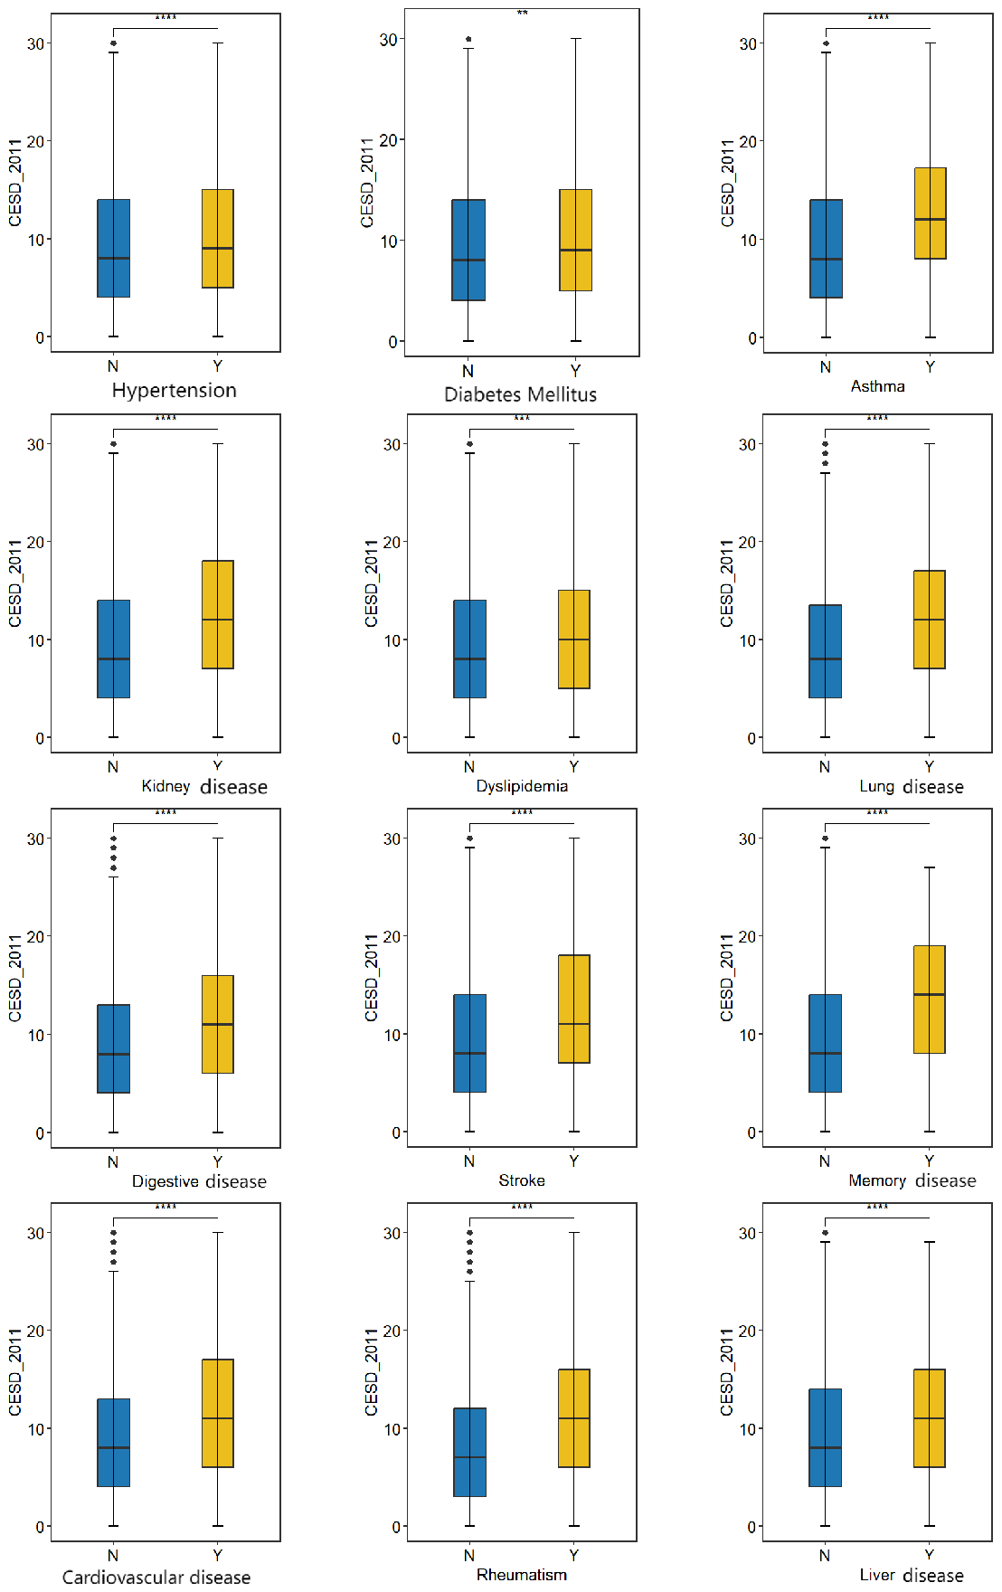

eFigure 2. Comparison of depression scores between patients with and without chronic diseases

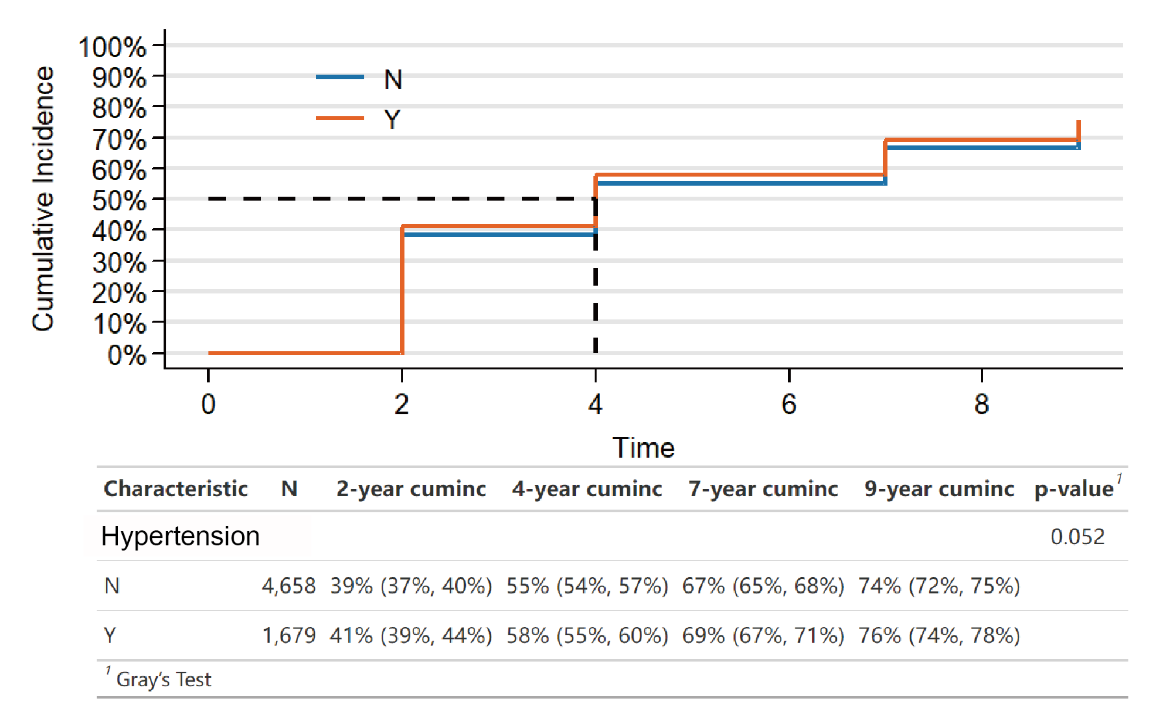

eFigure 3. Kaplan-Meier estimates for depressive symptoms events with vs. without hypertension

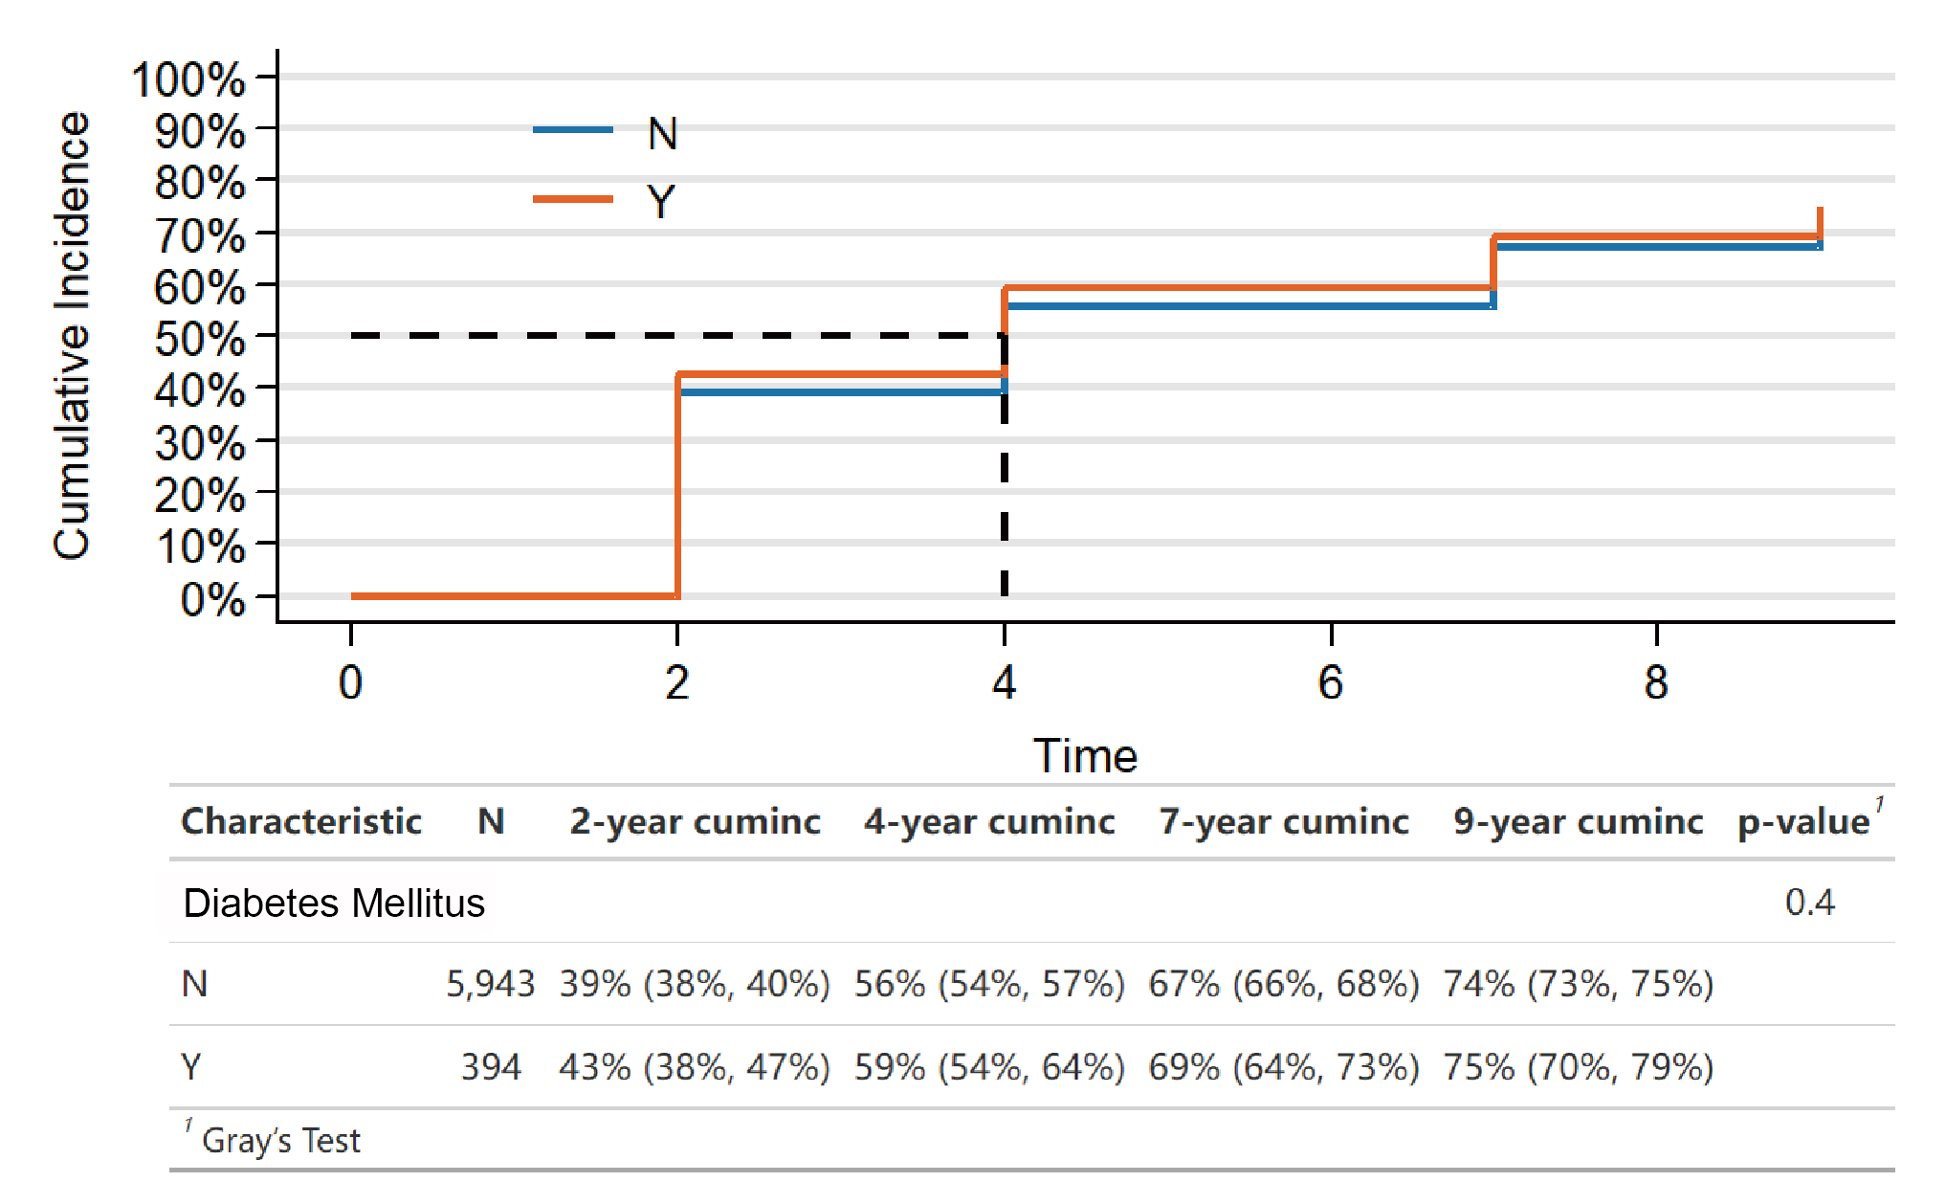

eFigure 4. Kaplan-Meier estimates for depressive symptoms events with vs. without diabetes mellitus

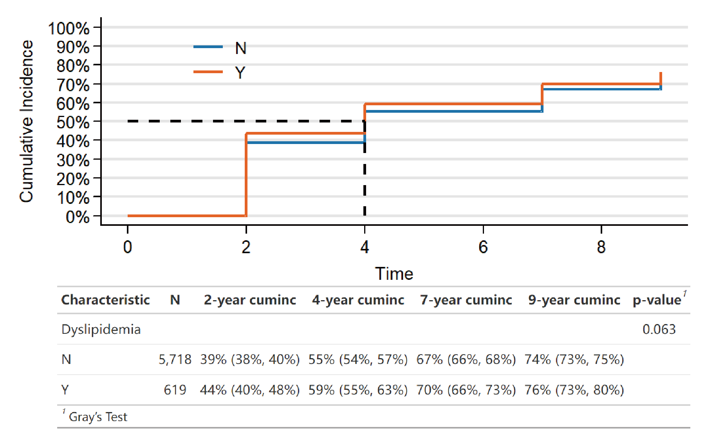

eFigure 5. Kaplan-Meier estimates for depressive symptoms events with vs. without dyslipidemia

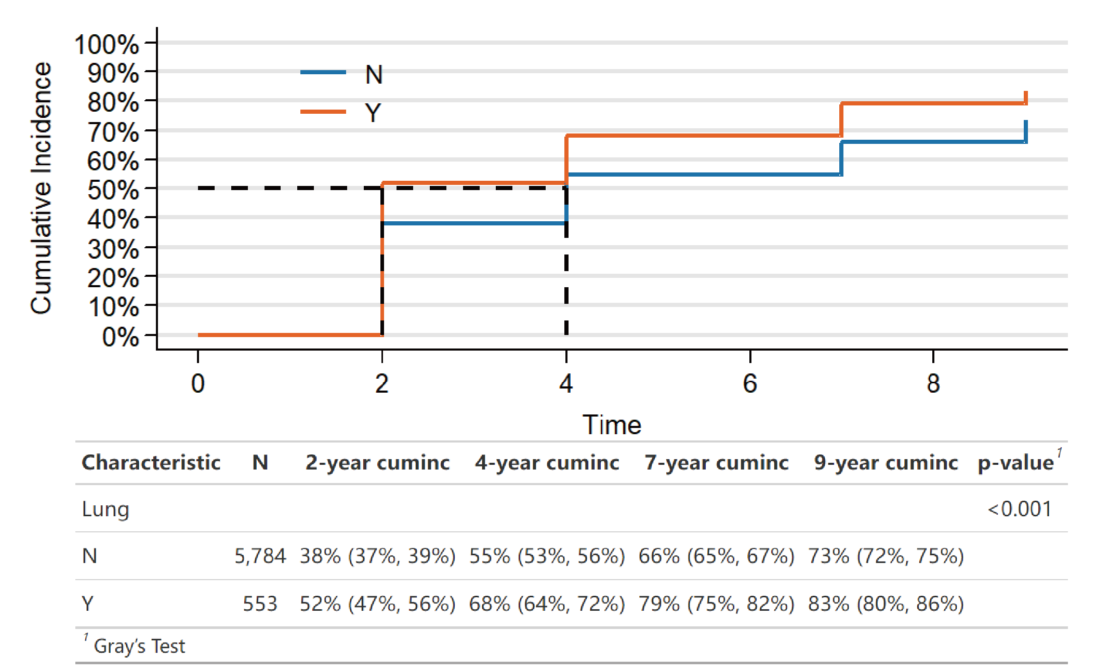

eFigure 6. Kaplan-Meier estimates for depressive symptoms events with vs. without lung disease

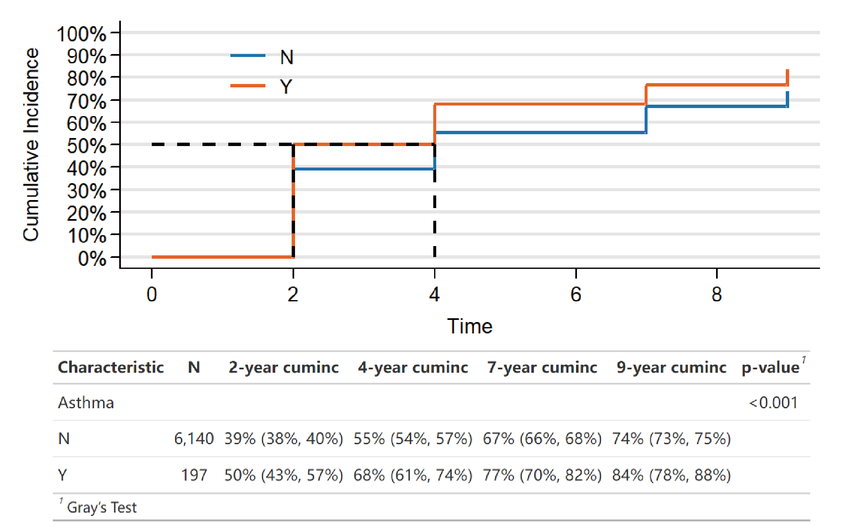

eFigure 7. Kaplan-Meier estimates for depressive symptoms events with vs. without asthma

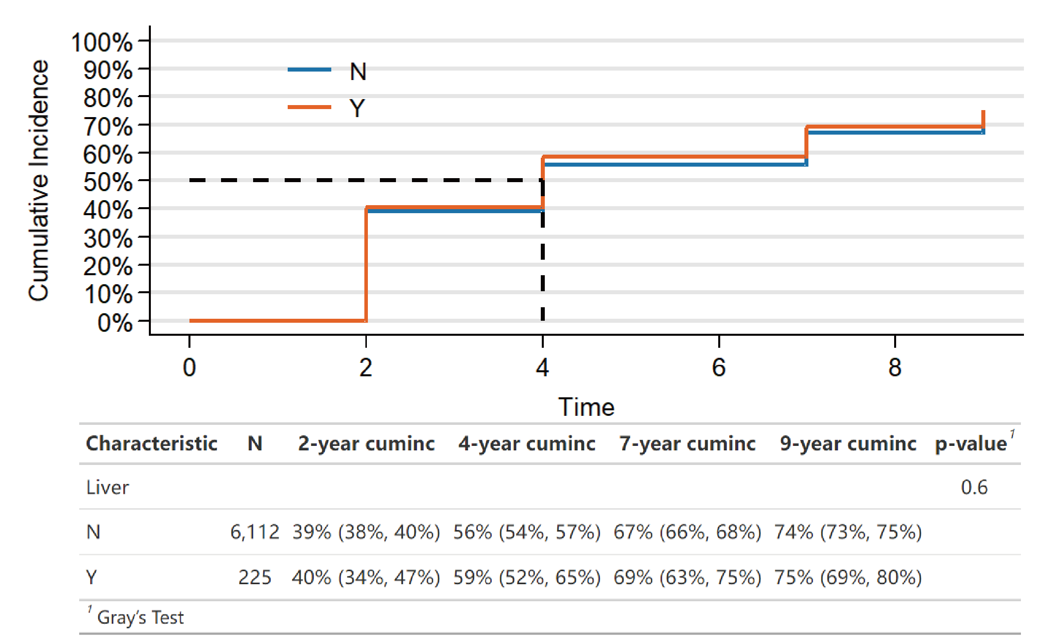

eFigure 8. Kaplan-Meier estimates for depressive symptoms events with vs. without liver disease

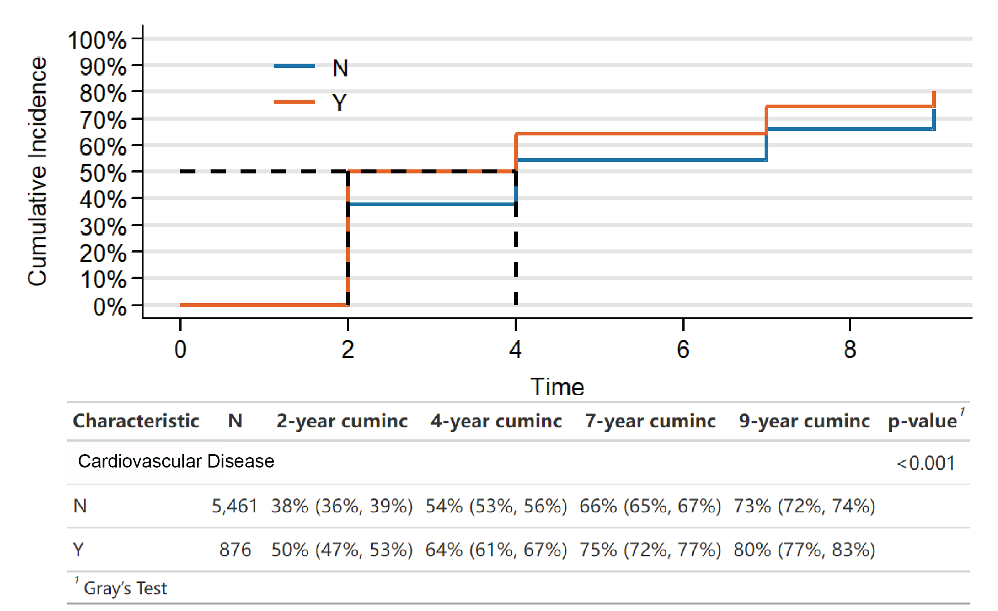

eFigure 9. Kaplan-Meier estimates for depressive symptoms events with vs. without cardiovascular disease

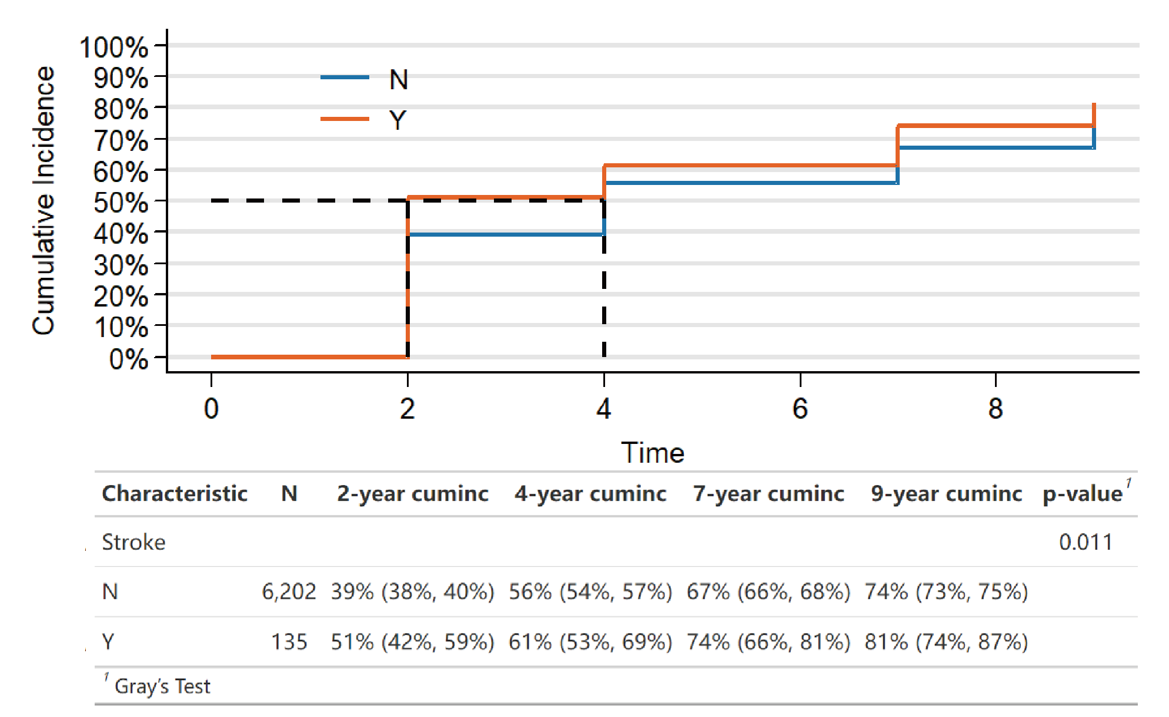

eFigure 10. Kaplan-Meier estimates for depressive symptoms events with vs. without stroke

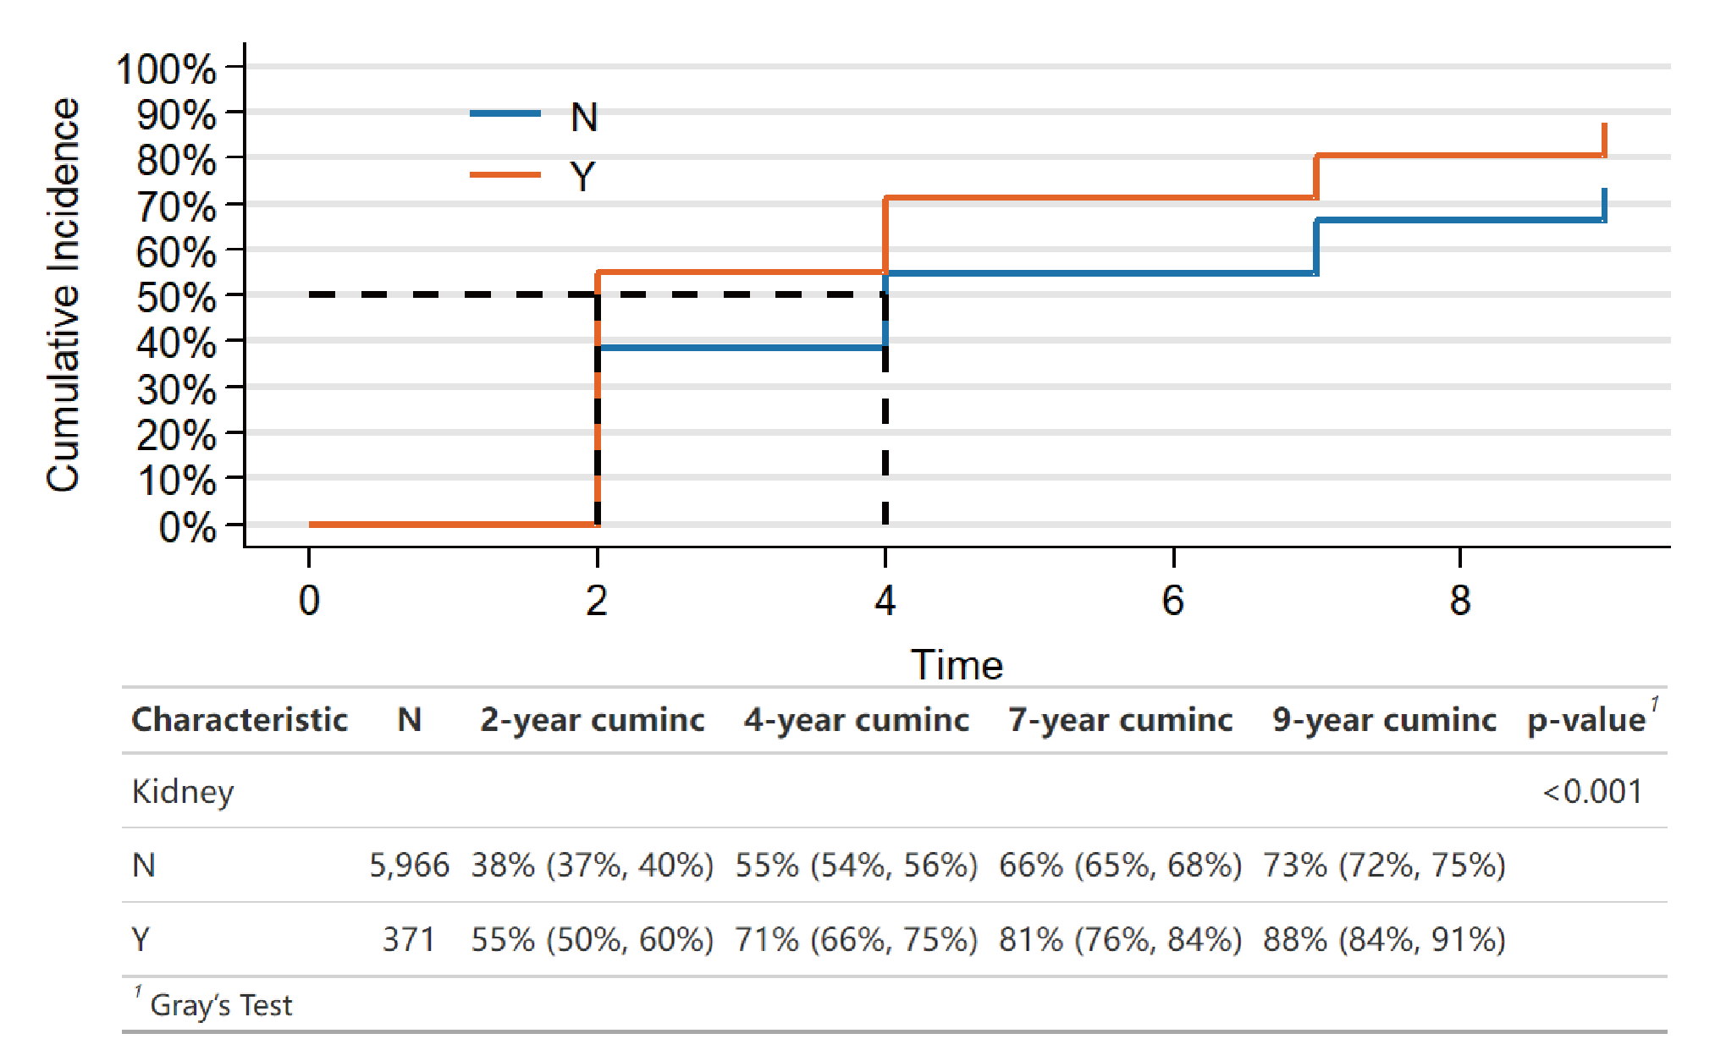

eFigure 11. Kaplan-Meier estimates for depressive symptoms events with vs. without kidney disease

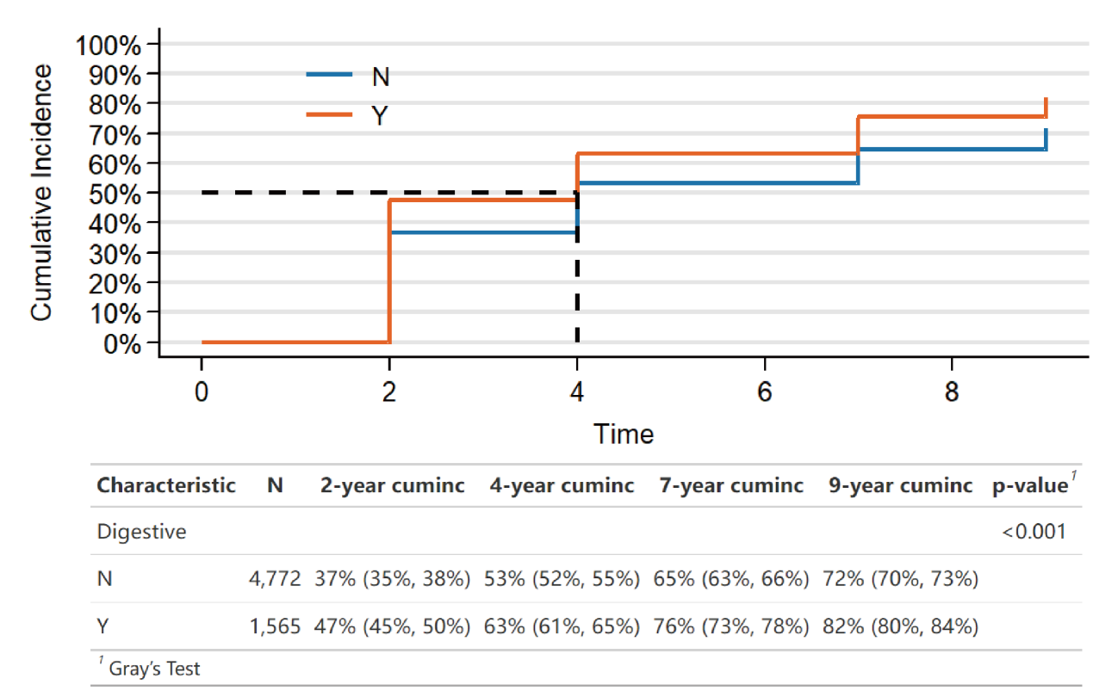

eFigure 12. Kaplan-Meier estimates for depressive symptoms events with vs. without digestive disease

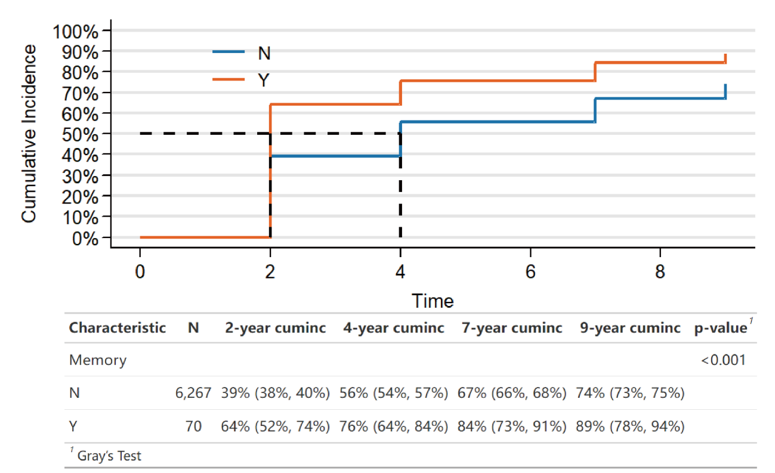

eFigure 13. Kaplan-Meier estimates for depressive symptoms events with vs. without memory disease

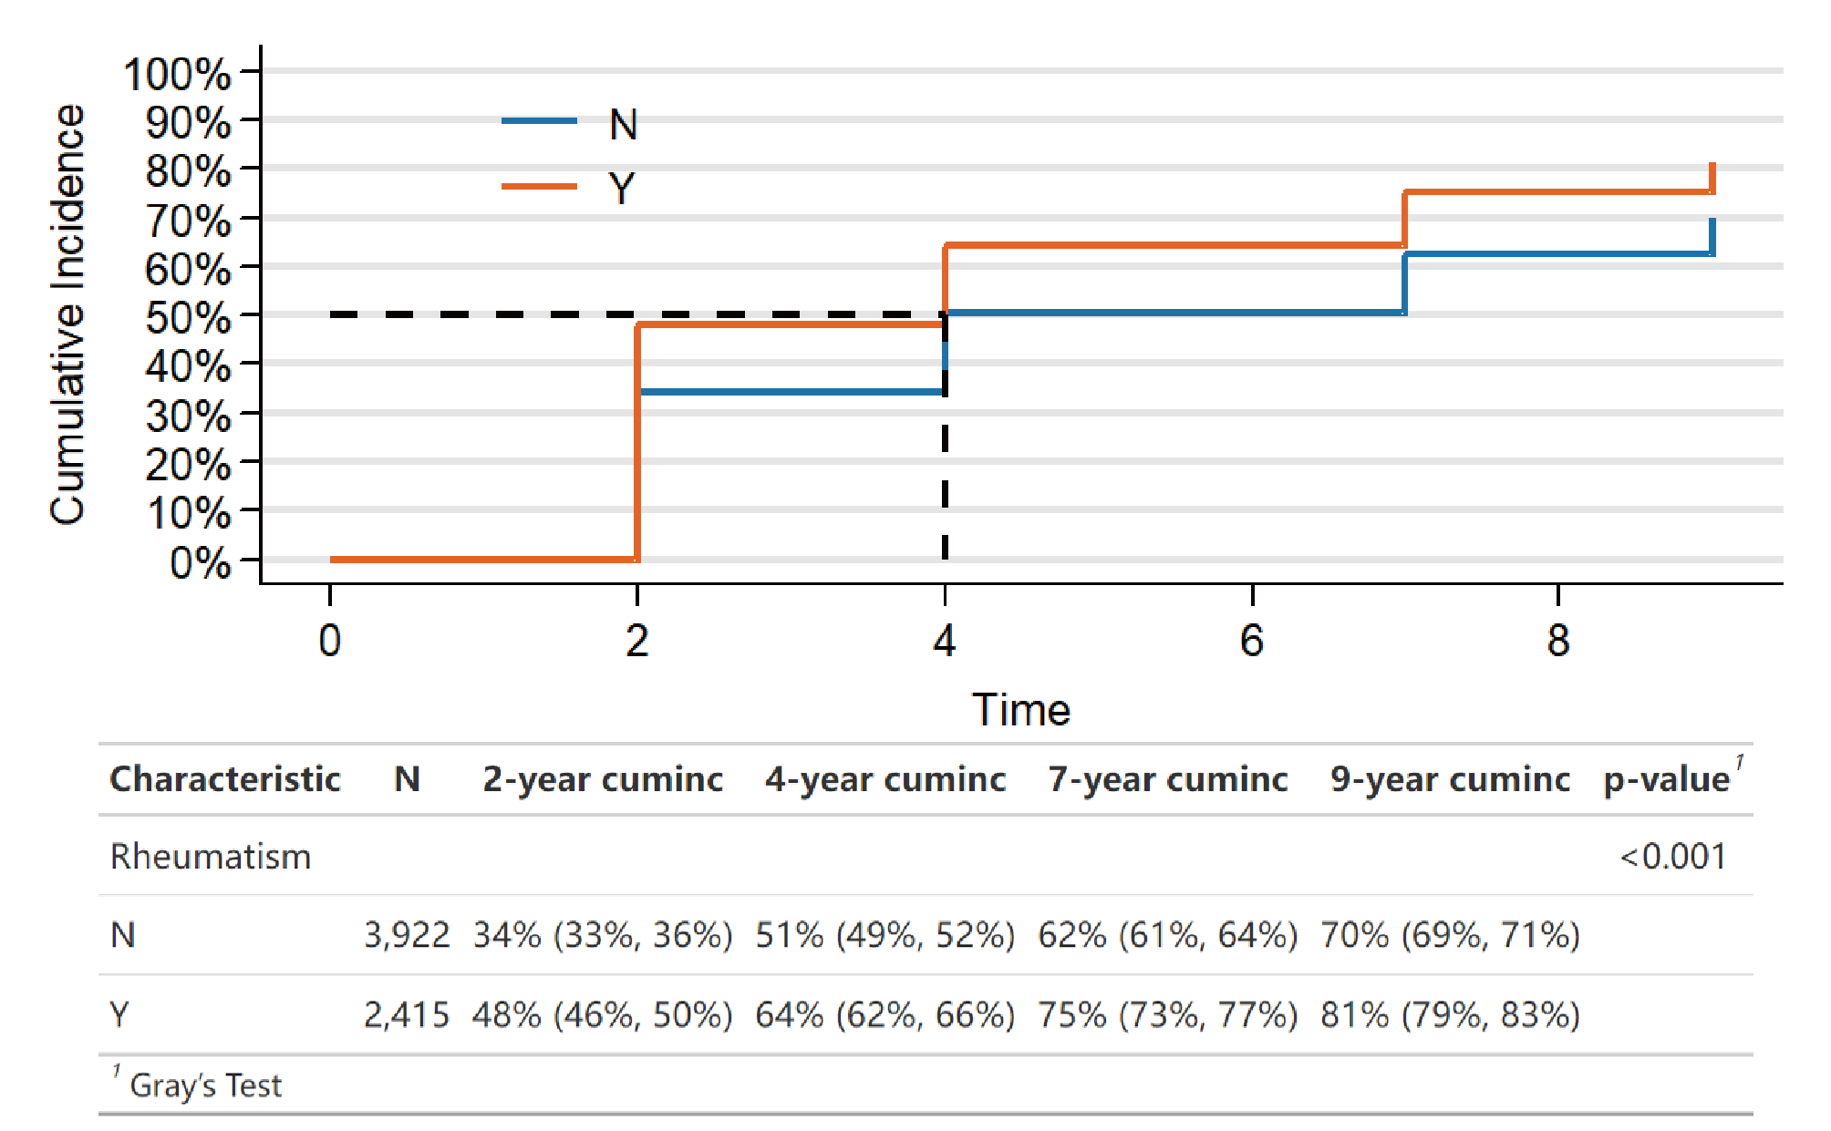

eFigure 14. Kaplan-Meier estimates for depressive symptoms events with vs. without rheumatism

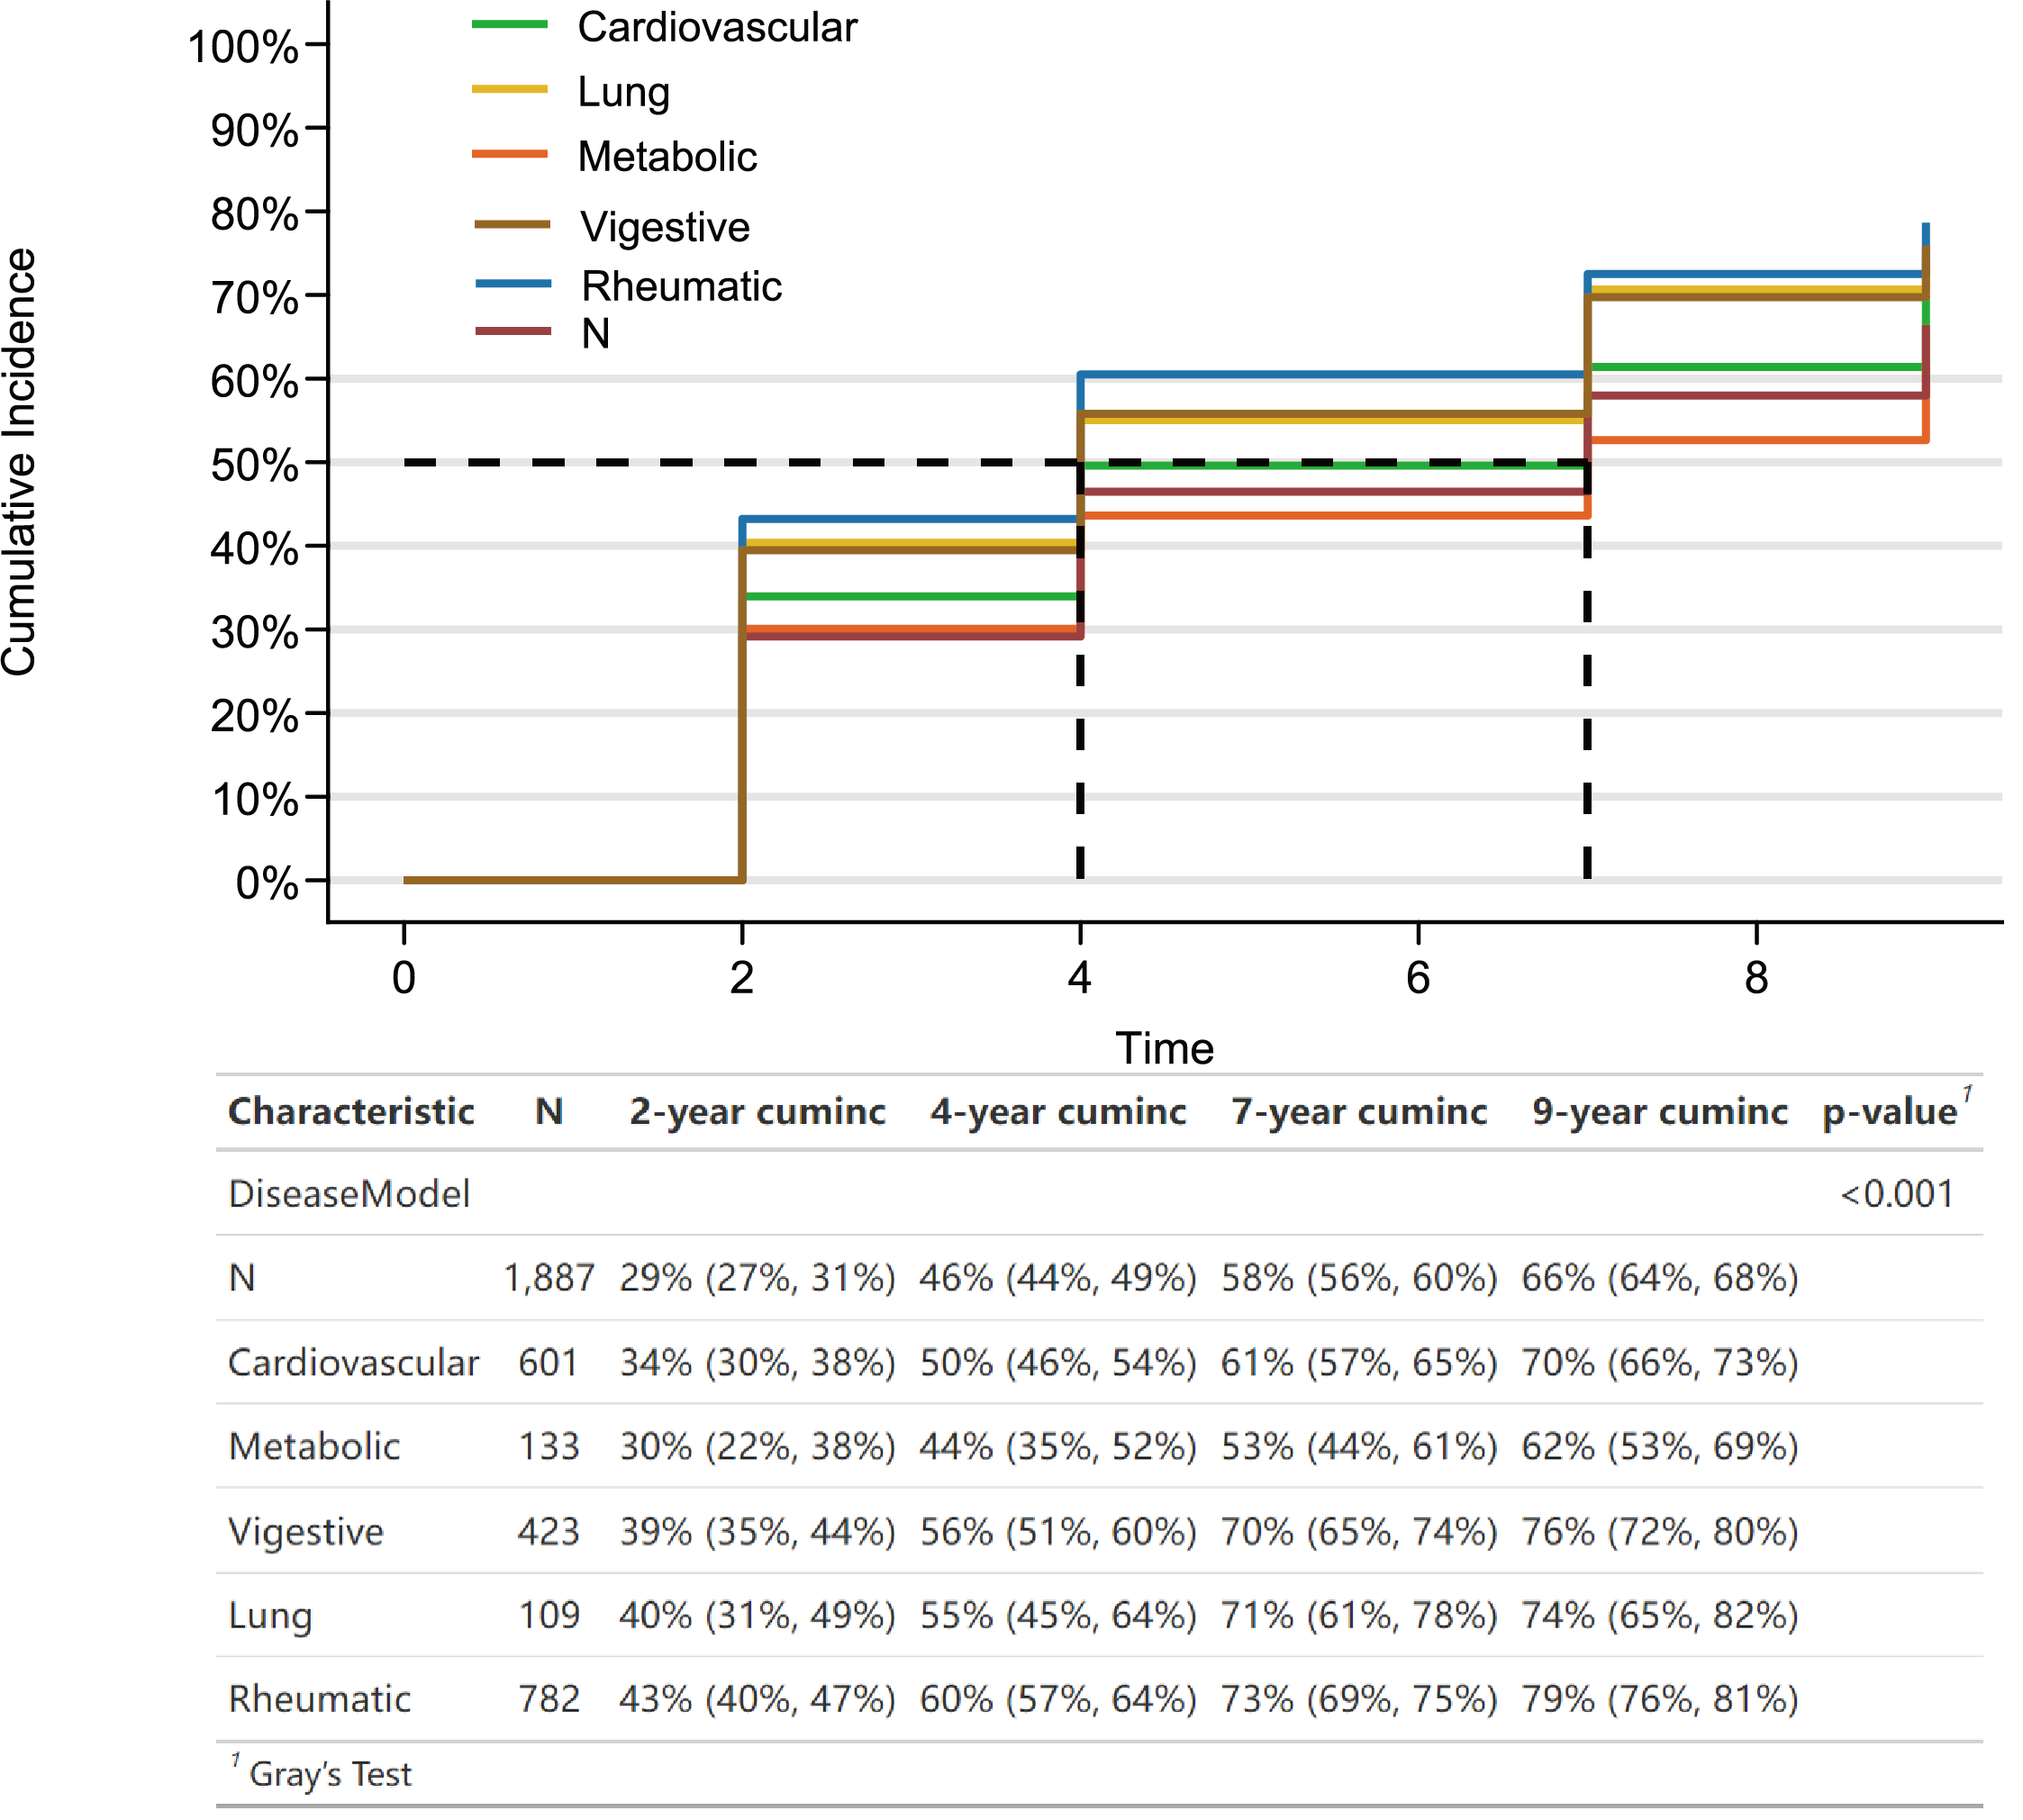

eFigure 15. Kaplan-Meier estimates for depressive symptoms events with different disease model

eTable 2. Mediation analysis of sleep duration and cognition in the association between chronic diseases and depressive symptoms
Path | Indirect effect |  | Direct effect |  | Total effect |  | Percentage of indirect effect (%)
Path | Effect (95 % CI) | P | Effect (95 % CI) | P | Effect (95 % CI) | P | Percentage of indirect effect (%)
Chronic diseases → Sleep duration → CESD-10 | 0.209 (0.171, 0.245) | <.001 | 1.079 (0.963, 1.199) | <.001 | 1.288 (1.172, 1.4) | <.001 | 16.221
Chronic diseases → Congnition → CESD-10 | 0.097 (0.064, 0.129) | <.001 | 1.191 (1.086, 1.304) | <.001 | 1.288 (1.183, 1.403) | <.001 | 7.55

This table presents the mediation analysis examining whether sleep duration and cognitive function mediate the association between chronic diseases and depressive symptoms measured by the CESD-10 scale. The indirect effect, direct effect, total effect, and the percentage of indirect effect are reported with 95% confidence intervals (CI) and P-values.

