Supplementary File 4

Abbreviations
CRP C-reactive protein
EPDS Edinburgh Postnatal Depression Scale
GEE Generalized estimating equations
IL-18 Interleukin-18
ISI Insomnia Severity Index
NMDA N-methyl-D-aspartate
PCA Patient-controlled analgesia
PSQI Pittsburgh Sleep Quality Index
SD Standard deviation
TAP Transversus abdominis plane
VAS Visual analog scale

Figure 2
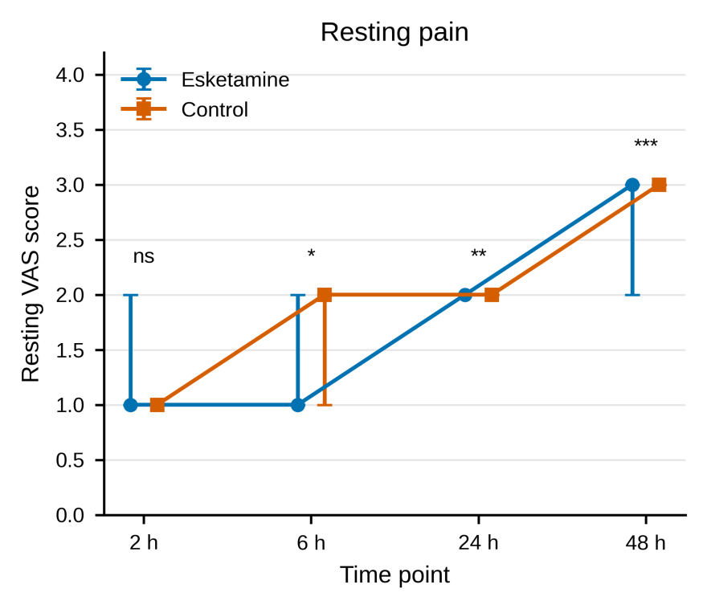
Fig. 2 Resting VAS pain scores at 2, 6, 24, and 48 h after surgery. Values are median (P₂₅, P₇₅); error bars indicate interquartile ranges. Between-group comparisons are shown above each time point. ns, not significant; *P < 0.05; **P < 0.01; ***P < 0.001.
Figure 3
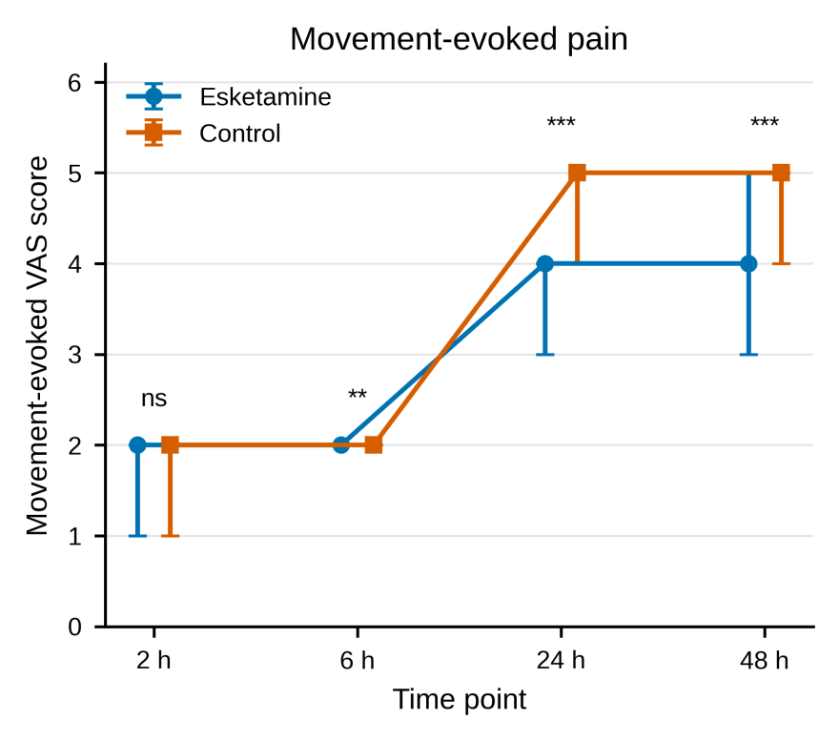
Fig. 3 Movement-evoked VAS pain scores at 2, 6, 24, and 48 h after surgery. Values are median (P₂₅, P₇₅); error bars indicate interquartile ranges. Between-group comparisons are shown above each time point. ns, not significant; **P < 0.01; ***P < 0.001.
Figure 4

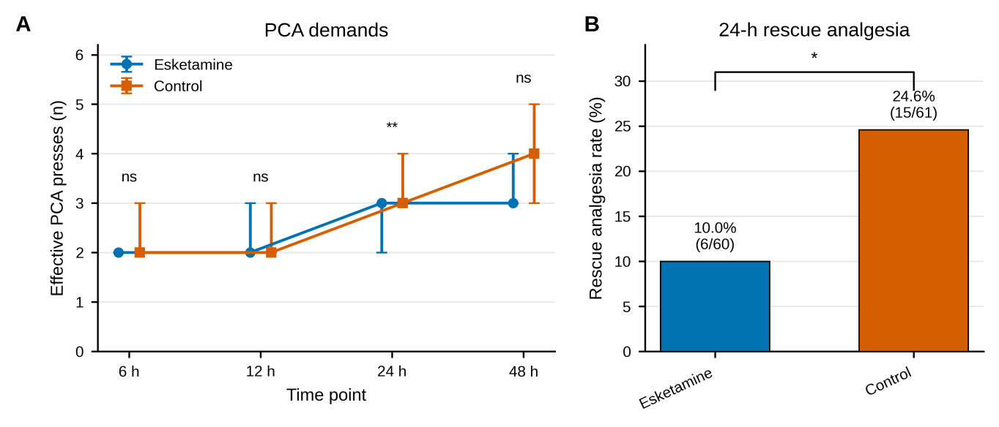
Fig. 4 Effective PCA presses and rescue analgesia. (A) Effective PCA presses from 6 to 48 h after surgery; values are median (P₂₅, P₇₅). (B) Incidence of rescue analgesia within 24 h after surgery; bar labels show percentage and n/N. ns, not significant; *P < 0.05; **P < 0.01.
Figure 5

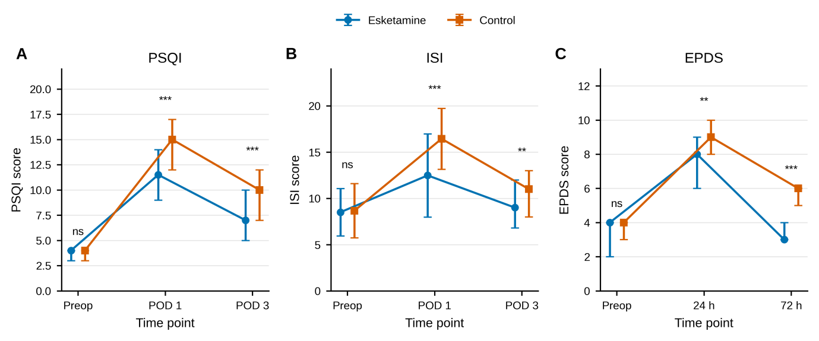
Fig. 5 Perioperative sleep and mood-related scores. (A) PSQI; (B) ISI; (C) EPDS. Values are displayed as the table-reported central estimate with dispersion [median (P₂₅, P₇₅) or mean ± SD]; error bars represent the corresponding dispersion. ns, not significant; **P < 0.01; ***P < 0.001.
Figure 6

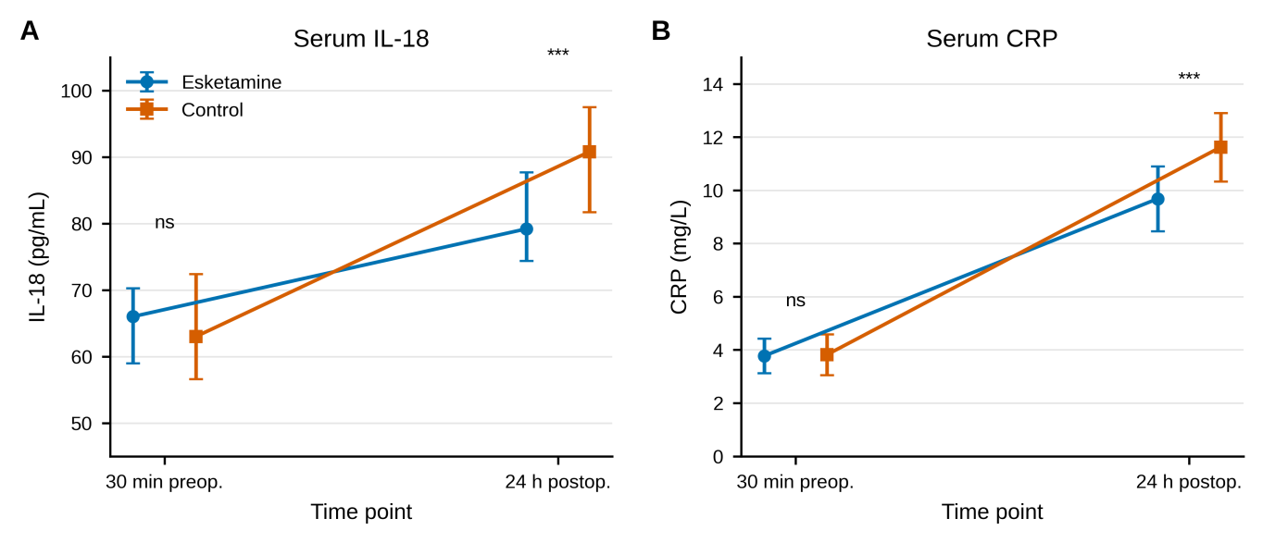
Fig. 6 Serum inflammatory marker trajectories. (A) IL-18; (B) CRP, measured 30 min before surgery and 24 h after surgery. Values are median (P₂₅, P₇₅) for IL-18 and mean ± SD for CRP. ns, not significant; ***P < 0.001.

