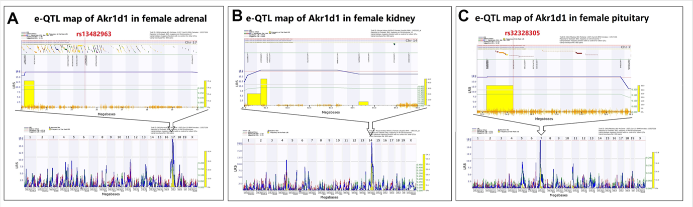 Supplementary Fig. S1 eQTL mapping of Akr1d1 expression in female adrenal gland, kidney, and pituitary gland datasets. (A) eQTL map of Akr1d1 expression in the female adrenal gland dataset. A suggestive eQTL signal was detected on chromosome 17, with rs13482963 located near the peak region. (B) eQTL map of Akr1d1 expression in the female kidney dataset. A suggestive eQTL signal was detected on chromosome 14. (C) eQTL map of Akr1d1 expression in the female pituitary gland dataset. A suggestive eQTL signal was detected on chromosome 7, with rs32328305 located near the peak region.
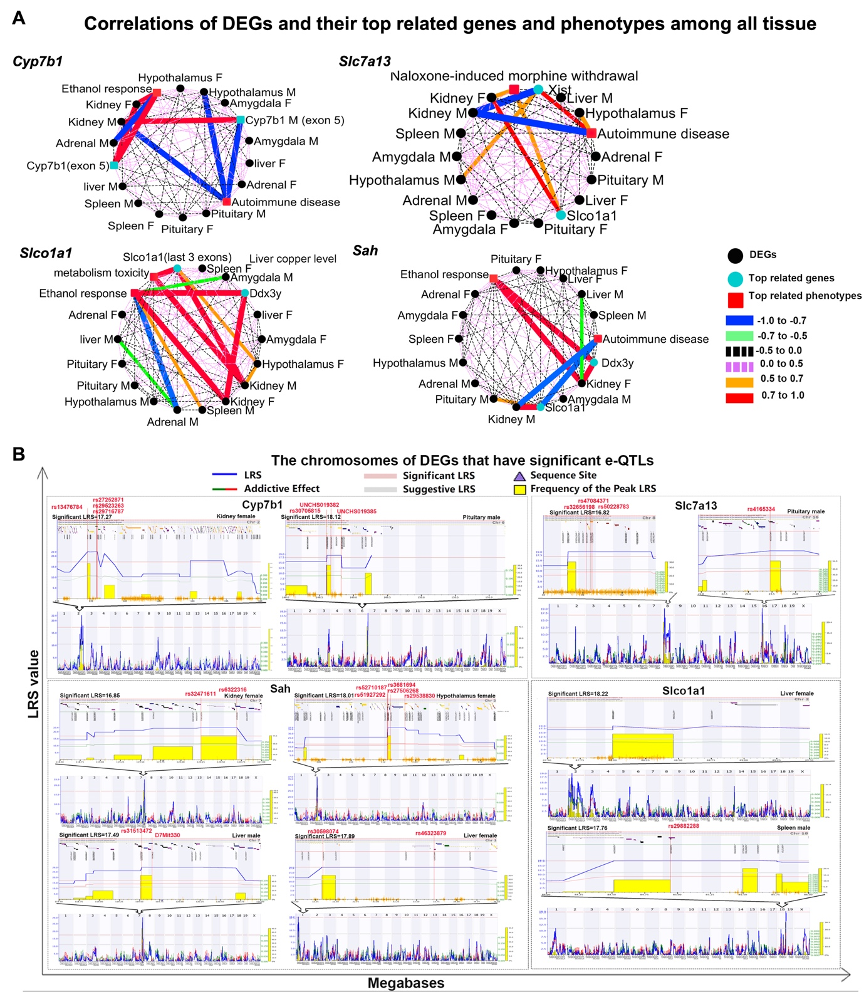
Supplementary Fig. S2 Correlation networks and eQTL mapping of kidney-associated EDEGs. (A) Correlation networks of kidney-associated EDEGs and their top-associated genes and phenotypes across tissues. Networks are shown for Cyp7b1, Slc7a13, Slco1a1, and Sah/Acsm3. Black nodes represent DEGs, cyan nodes represent top-associated genes, and red square nodes represent top-associated phenotypes. Edge color and thickness indicate Pearson correlation strength: blue, strong negative correlation; green, moderate negative correlation; black dashed, slight negative correlation; purple dashed, slight positive correlation; orange, moderate positive correlation; and red, strong positive correlation.(B) eQTL mapping of kidney-associated EDEGs across selected tissues and sexes. Genome-wide eQTL scans are shown for loci with suggestive or significant LRS signals. The lower plots show genome-wide scans, and the upper plots show enlarged candidate regions around peak LRS signals. Red labels indicate SNPs located near peak LRS regions. Blue lines indicate LRS values, green lines indicate additive effects, horizontal lines indicate suggestive and significant LRS thresholds, and yellow bars indicate peak LRS frequency. These analyses were used to identify candidate-associated genomic regions and should be interpreted as exploratory.

