Supporting Information

Table S1 Mire complexes included in the study. Mire complexes in Set 1 were sampled in the years 2003 (before restoration) and 2007 (1–3 years after restoration) whereas mire complexes in Set 2 were sampled in the years 2010 (before restoration) and 2014 (1–3 years after restoration). Mire complexes in both Sets were sampled in 2022. The restoration year for each mire complex and the years when vegetation data were gathered are shown. Distance (m) shows the average distance of the two transect centroids in restored sites to those in pristine sites.
Mire complex | Set | Restoration year | Vegetation data | Distance (m)
Etelä-Kulhanvuori | 1 | 2003 | 2003, 2007, 2023 | 235
Heinäsuo | 1 | 2005 | 2003, 2007, 2023 | 534
Juurikkasuo | 1 | 2004 | 2003, 2007, 2023 | 720
Kansanneva | 2 | 2013 | 2023 | 1164
Kauhaneva | 2 | 2013 | 2023 | 1481
Kiemanneva | 1 | 2004 | 2003, 2007, 2023 | 392
Kukilankeidas | 2 | 2011 | 2023 | 669
Lauhanvuori | 2 | 2012 | 2023 | 946
Oudonrimmet | 2 | 2013 | 2023* | 667
Pirjatanneva | 2 | 2010 | 2023 | 434
Pitkäsneva | 2 | 2013 | - | 992
Pitkäsuo | 2 | 2013 | 2023 | 742
Pohjois-Kulhanvuori | 1 | 2004 | 2003, 2007, 2023 | 341
Pyhä-Häkki | 2 | 2011 | 2023 | 466
Rapalahdensuo | 1 | 2005 | 2003, 2007, 2023 | 504
Ristisuo | 1 | 2005 | 2003, 2007, 2023 | 381
Tiaissuo | 1 | 2005 | 2003, 2007, 2023 | 403
Väljänneva | 1 | 2005 | 2003, 2007, 2023 | 500
* The restored site was not accessible in 2023

Table S2 Butterfly species observed during the study. The species abbreviation, scientific name, whether the species is considered as a mire-specialist [at least 50% of the Finnish population in mires according to Pöyry (2001)], the mean temperature within species range [‘Range temp’ from Schweiger et al. (2014], and the total number of individuals observed during the study. If the species is near threatened or endangered, the IUCN status (near threatened = NT, vulnerable =VU) is given according to Hyvärinen et al. (2019). The species shown in bold were modeled individually in the study (please see the Materials and Methods)
Species abbreviation | Species scientific name | Mire-specialist | Range temp | Total no. Of individuals
Agla.io | Aglais io |  | 8.84 | 9
Agla.urti | Aglais urticae |  | 8.12 | 5
Agri.opti | Agriades optilete | x | 4.19 | 605
Apha.hype | Aphantopus hyperantus |  | 7.9 | 1
Apor.crat | Aporia crataegi |  | 9.14 | 5
Bolo.aqui | Boloria aquilonaris | x | 4.17 | 434
Bolo.euno | Boloria eunomia | x | 3.45 | 304
Bolo.euph | Boloria euphrosyne |  | 6.95 | 604
Bolo.frei | Boloria freija (NT) | x | 1.33 | 43
Bolo.frig | Boloria frigga (NT) | x | 1.57 | 56
Bolo.sele | Boloria selene |  | 6.93 | 19
Bren.ino | Brenthis ino |  | 6.86 | 359
Call.rubi | Callophrys rubi |  | 8.57 | 930
Cart.pala | Carterocephalus palaemon (VU) |  | 6.9 | 1
Cart.silv | Carterocephalus silvicola |  | 5.19 | 4
Cela.argi | Celastrina argiolus |  | 9.14 | 92
Coen.pamp | Coenonympha pamphilus (NT) |  | 8.96 | 22
Coen.tull | Coenonympha tullia | x | 6.36 | 227
Coli.pala | Colias palaeno | x | 3.62 | 515
Ereb.embl | Erebia embla (NT) | x | 1.77 | 37
Ereb.lige | Erebia ligea |  | 5.51 | 57
Gone.rham | Gonepteryx rhamni |  | 8.81 | 55
Lasi.petr | Lasiommata petropolitana (NT) |  | 5.07 | 12
Lept.sina | Leptidea sinapis |  | 9.11 | 1
Lyca.virg | Lycaena virgaureae |  | 7.27 | 4
Meli.atha | Melitaea athalia |  | 8.27 | 12
Nymp.anti | Nymphalis antiopa |  | 7.61 | 15
Oene.jutt | Oeneis jutta (NT) | x | 2.85 | 230
Papi.mach | Papilio machaon |  | 9.28 | 7
Pier.bras | Pieris brassicae |  | 9.29 | 0
Pier.napi | Pieris napi |  | 8.21 | 26
Pleb.argu/idas | Plebejus argus/idas |  | 7.65 | 4524
Poly.c-al | Polygonia c-album |  | 8.6 | 9
Pyrg.cent | Pyrgus centaureae (NT) | x | 1.13 | 13
Pyrg.malv | Pyrgus malvae |  | 8.74 | 10
Spey.agla | Speyeria aglaja |  | 7.79 | 3
Thym.line | Thymelicus lineola |  | 8.69 | 2
Vane.atal | Vanessa atalanta |  | 9.07 | 1
Vane.card | Vanessa cardui |  | 9.04 | 6
Table S3 Larval food plants of the butterfly species modeled individually in the study. The species abbreviation, scientific name, whether the species is considered as a mire-specialist [at least 50% of the Finnish population in mires according to Pöyry (2001)], whether the species is monophagous (M), polyphagous (P) or oligophagous (O), and their larval food plant(s) in Finland (Silvonen 2024).
Species abbreviation | Species scientific name | Mire-specialist | M/P/O | Larval food plant
Agri.opti | Agriades optilete | x | monophagous | Vaccinium uliginosum, V. myrtillus
Bolo.aqui | Boloria aquilonaris | x | monophagous | Vaccinium oxycoccos
Bolo.euno | Boloria eunomia | x | oligophagous | Vaccinium uliginosum, possibly Andromeda polifolia
Bolo.euph | Boloria euphrosyne |  | oligophagous | Vaccinium uliginosum, V. myrtillus, Viola
Bolo.frei | Boloria freija | x | oligophagous | Vaccinium uliginosum, Rubus chamaemorus, Andromeda polifolia
Bolo.frig | Boloria frigga | x | oligophagous | Vaccinium uliginosum, Rubus chamaemorus
Bolo.sele | Boloria selene |  | monophagous | Viola (e.g. V. canina, V. riviniana, V. palustris)
Bren.ino | Brenthis ino |  | oligophagous | Filipendula ulmaria, Vaccinium uliginosum, Rubus chamaemorus
Call.rubi | Callophrys rubi |  | polyphagous | Vaccinium, Fabaceae
Cela.argi | Celastrina argiolus |  | polyphagous | Frangula alnus, Ribes, Prunus, Vaccinium
Coen.tull | Coenonympha tullia | x | oligophagous | Carex, Eriophorum vaginatum, Poaceae
Coli.pala | Colias palaeno | x | monophagous | Vaccinium uliginosum
Ereb.embl | Erebia embla | x | oligophagous | Eriophorum vaginatum, Carex or Poaceae
Ereb.lige | Erebia ligea |  | oligophagous | Poaceae
Gone.rham | Gonepteryx rhamni |  | Oligophagous | Frangula alnus, Rhamnus catharticus
Nymp.anti | Nymphalis antiopa |  | oligophagous | Salix, rarely Populus tremula or Betula
Oene.jutt | Oeneis jutta | x | oligophagous | Carex, Eriophorum vaginatum
Pier.napi | Pieris napi |  | oligophagous | Brassicaceae
Pleb.argu/idas | Plebejus argus/idas |  | oligophagous | Calluna, Vaccinium uliginosum, Fabaceae

Silvonen K (2024) The early stages of butterflies and moths of Finland. Part 1, Papilionoidea, Lasiocampoidea, Bombycoidea (incl. Sphingidae), Drepanidae, Notodontidae, Lymantriinae, Arctiinae and Nolidae. Hyönteistarvike TIBIALE Oy, Helsinki. 648 p.

Table S4 General linear models for community restoration response. The response variable is community response to restoration, based on either occupancy or abundance. The explanatory variables are Set (being the only variable in the model and with every other variable ), vegetation variables (log-transformed number of saplings/small trees/tall trees, cover of hummock (%)), the distance between the restored and pristine community before restoration as modeled in latent variable modeling (Community), the distance between the transects in the restored sites and those in pristine sites, and the cover of pristine area (%) within the 500m buffer (Pristine). For each model, the values for the integer and the explanatory variables in the model, degrees of freedom (df), log-likelihood (logLik), Akaike Information Criteria corrected for small sample size (AICc), difference between the given model and the best model in the set (delta), Aikaike weight, and multiple and adjusted R² are given. The residuals of the best models for both response variables did not show spatial autocorrelation (Moran’s I test for distance-based autocorrelation; for occupancy observed value = -0.16, expected = -0.07, sd = 0.21, p = 0.666; for abudance observed value = -0.23, expected = -0.07, sd = 0.21, p = 0.441).
Restoration response | Integer |  | Set |  | Variable |  |  | df | logLik | AICc | delta | weight | R²
Restoration response | Mean | SE | Mean | SE | Name | Mean | SE |  |  |  |  |  | multiple | adjusted
Occupancy | -0.35 | 0.15 | -0.07 | 0.13 | Pristine | 0.03 | 0.01 | 4 | 1.9 | 8.2 | 0.0 | 0.978 | 0.65 | 0.59
 | 0.71 | 0.26 | -0.18 | 0.17 | Tall trees | -0.25 | 0.11 | 4 | -2.6 | 17.2 | 9.0 | 0.011 | 0.36 | 0.25
 | 0.19 | 0.15 | -0.22 | 0.19 |  |  |  | 3 | -5.2 | 18.6 | 10.4 | 0.005 | 0.09 | 0.02
 | -0.34 | 0.40 | -0.18 | 0.19 | Hummock | 0.01 | 0.01 | 4 | -4.1 | 20.2 | 12.0 | 0.002 | 0.22 | 0.09
 | 0.06 | 0.21 | -0.27 | 0.2 | Community | 0.09 | 0.12 | 4 | -4.8 | 21.6 | 13.4 | 0.001 | 0.14 | 0.00
 | 0.38 | 0.35 | -0.20 | 0.2 | Small trees | -0.07 | 0.12 | 4 | -5.0 | 22.0 | 13.8 | 0.001 | 0.12 | -0.03
 | 0.32 | 0.25 | -0.16 | 0.22 | Saplings | -0.09 | 0.15 | 4 | -5.0 | 22.0 | 13.8 | 0.001 | 0.12 | -0.03
Abundance | 0.69 | 0.29 | 0.08 | 0.19 | Tall trees | -0.29 | 0.12 | 4 | -4.1 | 20.3 | 0.0 | 0.457 | 0.31 | 0.20
 | 0.09 | 0.15 | 0.03 | 0.21 |  |  |  | 3 | -6.9 | 22.1 | 1.8 | 0.186 | 0.00 | -0.08
 | -0.27 | 0.24 | 0.13 | 0.2 | Pristine | 0.02 | 0.01 | 4 | -5.1 | 22.2 | 1.9 | 0.177 | 0.22 | 0.09
 | 0.30 | 0.23 | 0.13 | 0.23 | Community | -0.16 | 0.14 | 4 | -6.2 | 24.3 | 4.0 | 0.061 | 0.10 | -0.05
 | 0.47 | 0.38 | 0.08 | 0.22 | Small trees | -0.15 | 0.13 | 4 | -6.2 | 24.4 | 4.2 | 0.057 | 0.09 | -0.06
 | -0.19 | 0.48 | 0.05 | 0.22 | Hummock | 0.00 | 0.01 | 4 | -6.7 | 25.4 | 5.1 | 0.035 | 0.03 | -0.13
 | 0.10 | 0.29 | 0.03 | 0.25 | Saplings | -0.01 | 0.17 | 4 | -6.9 | 25.9 | 5.6 | 0.028 | 0.01 | -0.16

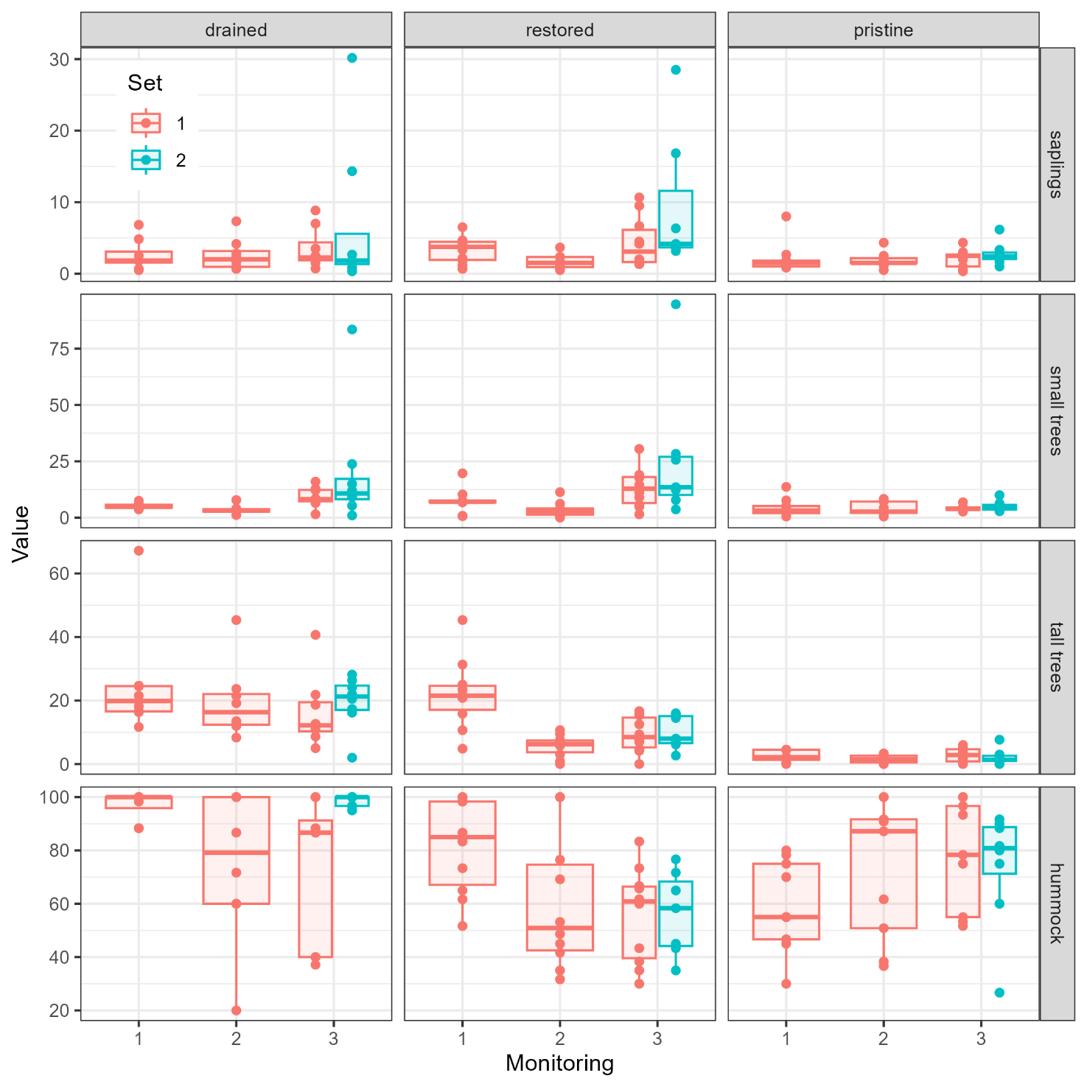
Fig. S1 Vegetation variables in drained, pristine and restored sites in different monitorings (1 = before restoration, 2 = 1–3 years after restoration, 3 = 9–19 years after restoration). Values are for number of saplings (height < 1.5m), number of small trees (height 1.5–3 m), and number of tall trees (height > 3 m) are means of six circular plots of 100 m² (three along each two transect in a site). Hummock cover (%) is the mean of the six sampling squares (5 m × 5 m) situated in the middle of each circular plot. Monitorings 1 and 2 include data on the 9 mires sampled in 2003 and 2007 (Set 1), whereas monitoring 3 includes data on 17 mires sampled in 2023 (Set 2; see Table S1). The thick line corresponds to the median, and the lower and upper hinges to the 25th and 75th percentiles. The upper/lower whisker extends to the largest/smallest value that is at a maximum 1.5× distance between the 25th and 75th percentiles. Data are shown as individual points.

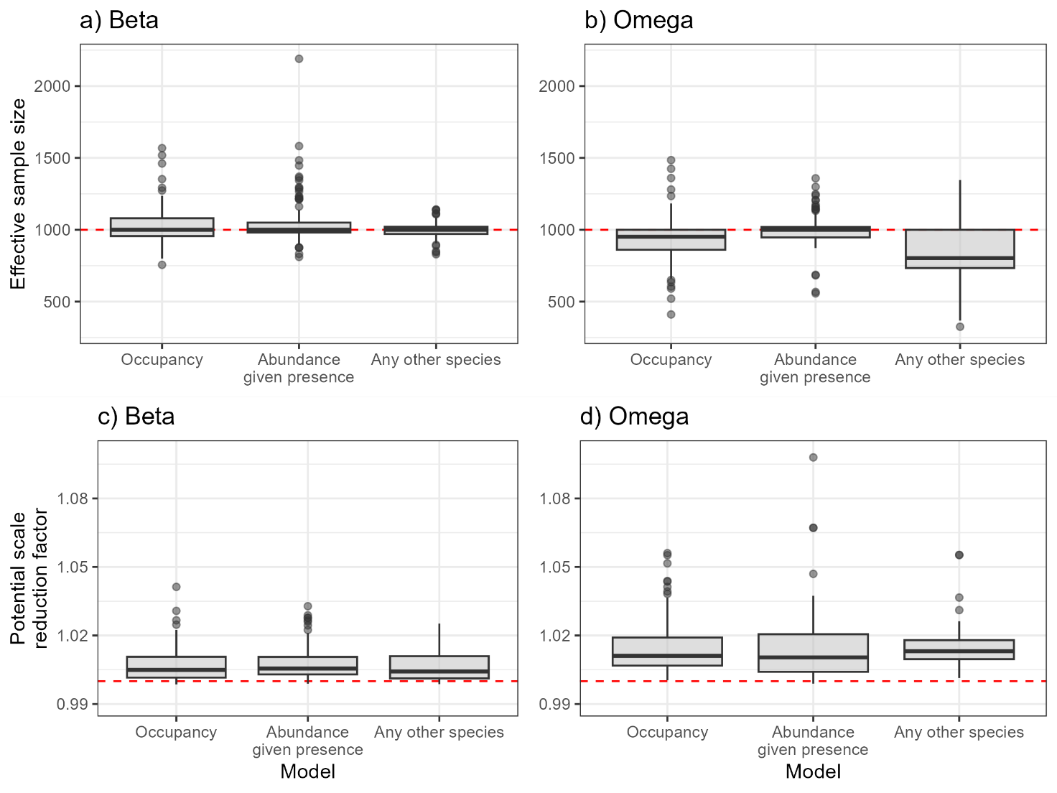
Fig. S2 Model convergence of the key parameters of hmsc-modeling. Effective sample size (a,b) and potential scale reduction factor (c,d) for beta (a,c), and omega (b,d) parameters. The parameters were well converged: the effective sample size was close to 1,000 and potential scale reduction factor was generally well below 1.1. The thick line corresponds to the median, and the lower and upper hinges to the 25th and 75th percentiles. The upper/lower whisker extends to the largest/smallest value that is at a maximum 1.5× distance between the 25th and 75th percentiles. Other data points (‘outliers’) are shown as individual points.

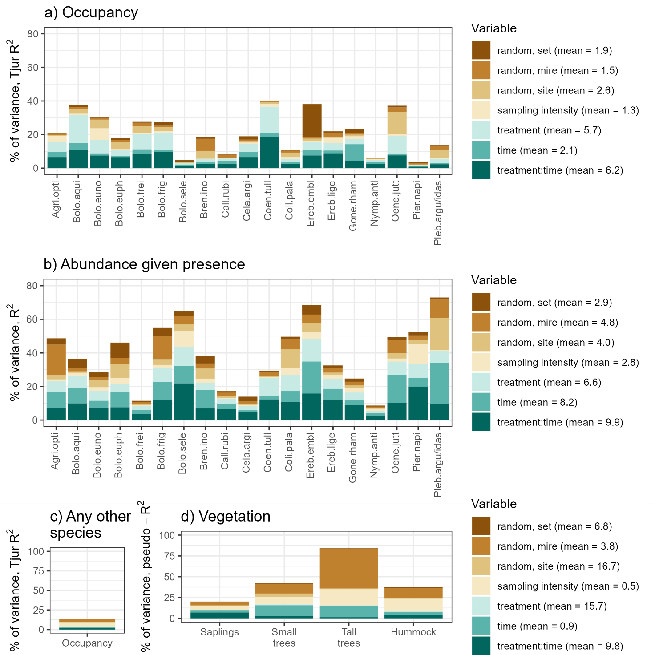
Fig. S3 Variance partition for models for species occupancy (a), abundance given presence (b), occupancy of any other species (occupancy at least one of the 19 generalist species not modeled individually) (c) and vegetation characteristics (d). The mean percentage explained by a given variable is shown in the legend.
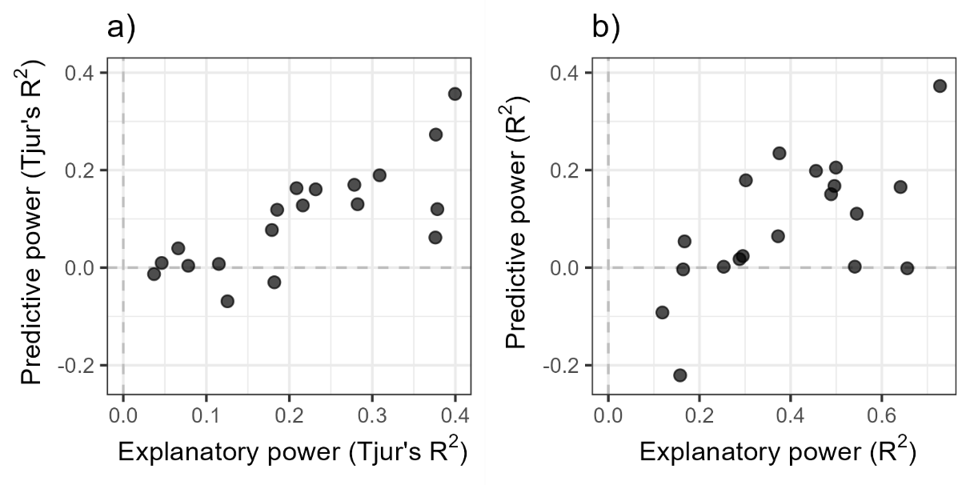
Fig. S4 Explanatory and predictive powers based on four-fold cross-validation for species occupancy model (a) and abundance given presence model (b).

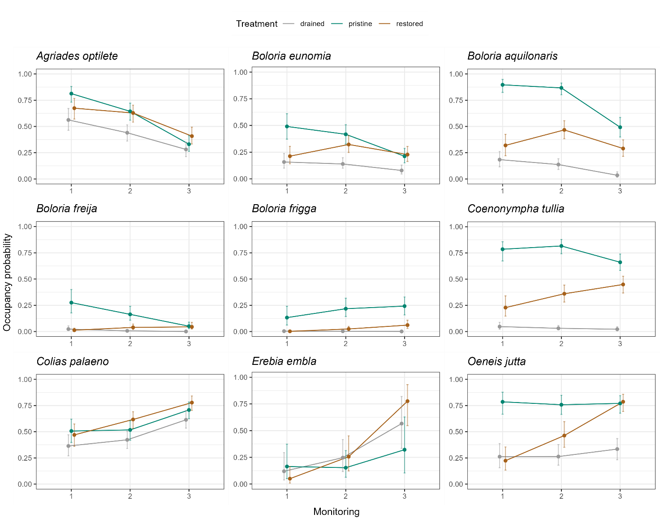
Fig. S5 The occupancy probability of mire specialist species in different treatments and monitorings (1 = before restoration, 2 = 1–3 years after restoration, 3 = 9–19 years after restoration). The lines represent the predicted median value, and the whiskers represent the 25–75% quantiles for each treatment and monitoring.

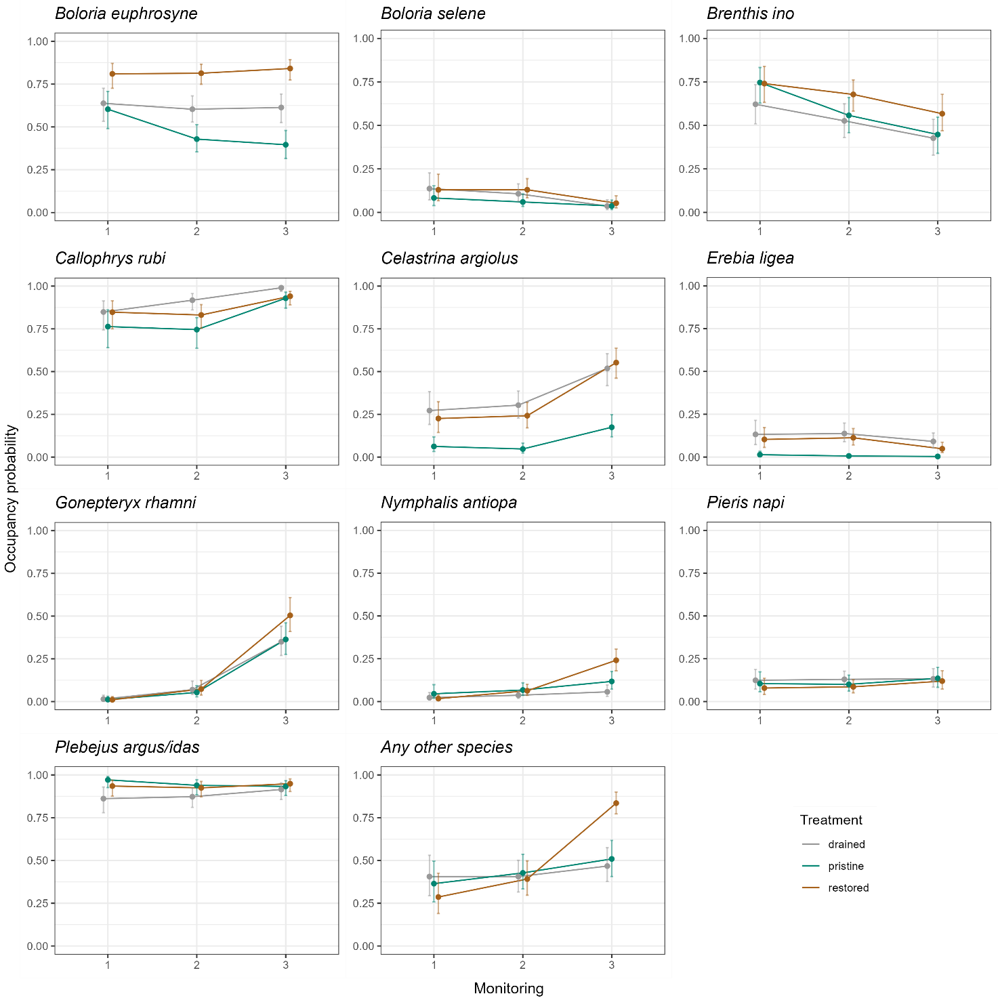
Fig. S6 The occupancy probability of generalist species in different treatments and monitorings (1 = before restoration, 2 = 1–3 years after restoration, 3 = 9–19 years after restoration). The lines represent the predicted median value and the whiskers represent the 25–75% quantiles for each treatment and monitoring.

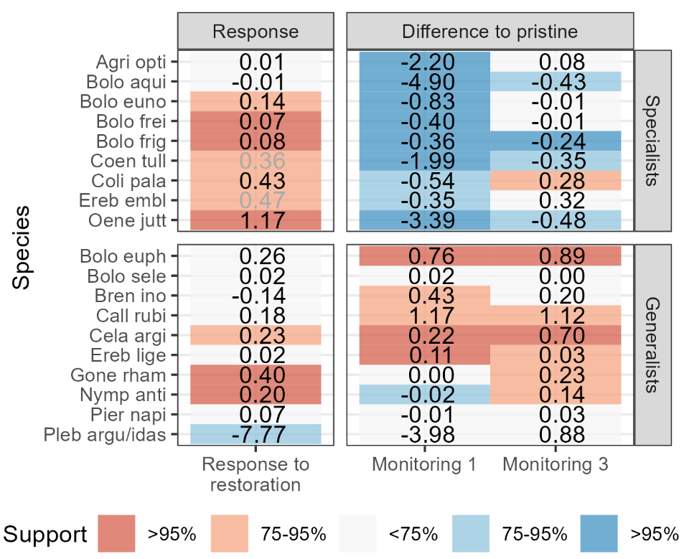
Fig. S7 Mire-specialist species and generalist species’ responses to restoration and the differences of species abundance in restored sites when compared to pristine sites in the monitorings 1 and 3. Species response shows the relative change in abundance from before-restoration (monitoring 1) to 9–19 years after restoration (monitoring 3) in restored vs. drained sites. Response to restoration is positive if abundance increases more (or decreases less) in restored sites than in drained sites and negative if it increases less (or decreases more) in restored sites than in drained sites. The grey font are for species that differ in the initial abundance in drained and restored sites. Differences to pristine are absolute measures, describing whether abundance in restored sites differ from those in pristine sites before restoration (monitoring 1) or 9–19 years after restoration (monitoring 3). It is positive if the abundance in restored sites is higher than in pristine sites, and negative if the occupancy probability is lower. Support shows the posterior probability of the value being positive/negative. Full names of the species are presented in Table S2.

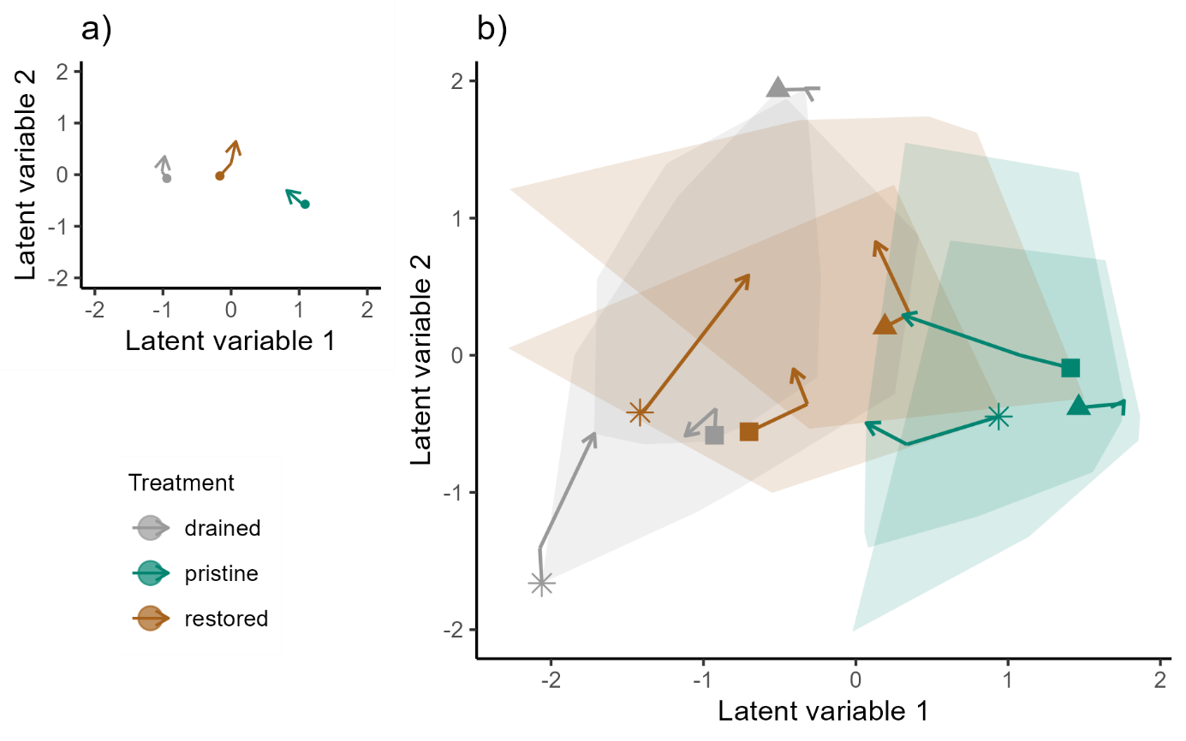
Fig. S8 The average change of community composition from before restoration (filled symbol) to 9–19 years after restoration (the head of the arrow) for a given treatment (a), and the change of drained, restored and pristine sites from three individual mires (marked as cross, filled square and triangle) (b), from the model-based ordination of species occupancies. In addition, the convex hulls representing all sites in all treatments before restoration and 9–19 years after restoration are shown. Time point of 1–3 years after restoration is shown as an angle in the arrow. The treatment of the site is denoted by the color (drained = grey, pristine = green, restored = brown). Response to restoration in each restored is the change in distance to drained control site (monitoring 3 – monitoring 1) minus a change in distance to pristine control site (monitoring 3 – monitoring 1). Hence, a positive community response shows that the species composition of a restored site changed more towards its pristine control site than drained control site. Conversely, a negative community response shows that the composition changed more towards a drained site than a pristine site. The filled symbols represent two mires having contrasting long-term responses to restoration: Tiaissuo (filled square) has the most positive and Pitkäsuo filled triangle has the most negative (1.015 and -0.497, respectively, in Fig. 2 in the main text). Yet, these two restored sites hosted the same mire-specialist species at the final monitoring, showing that the response to restoration reflects the additional benefits gained from the restoration actions, not the absolute restoration outcome, and is dependent on changes in pristine and drained sites (for which the population trends based on three points can not be considered reliable). Accordingly, response to restoration does not measure if a restored site differentiates from both pristine and drained sites (Hobbs et al., 2009, Kreyling et al. 2021).
Hobbs, R. J., Higgs, E. & Harris, J. A. Novel ecosystems: implications for conservation and restoration. Trends Ecol. Evol. 24, 599–605 (2009).
Kreyling, J. et al. Rewetting does not return drained fen peatlands to their old selves. Nat. Commun. 12, 5693 (2021).

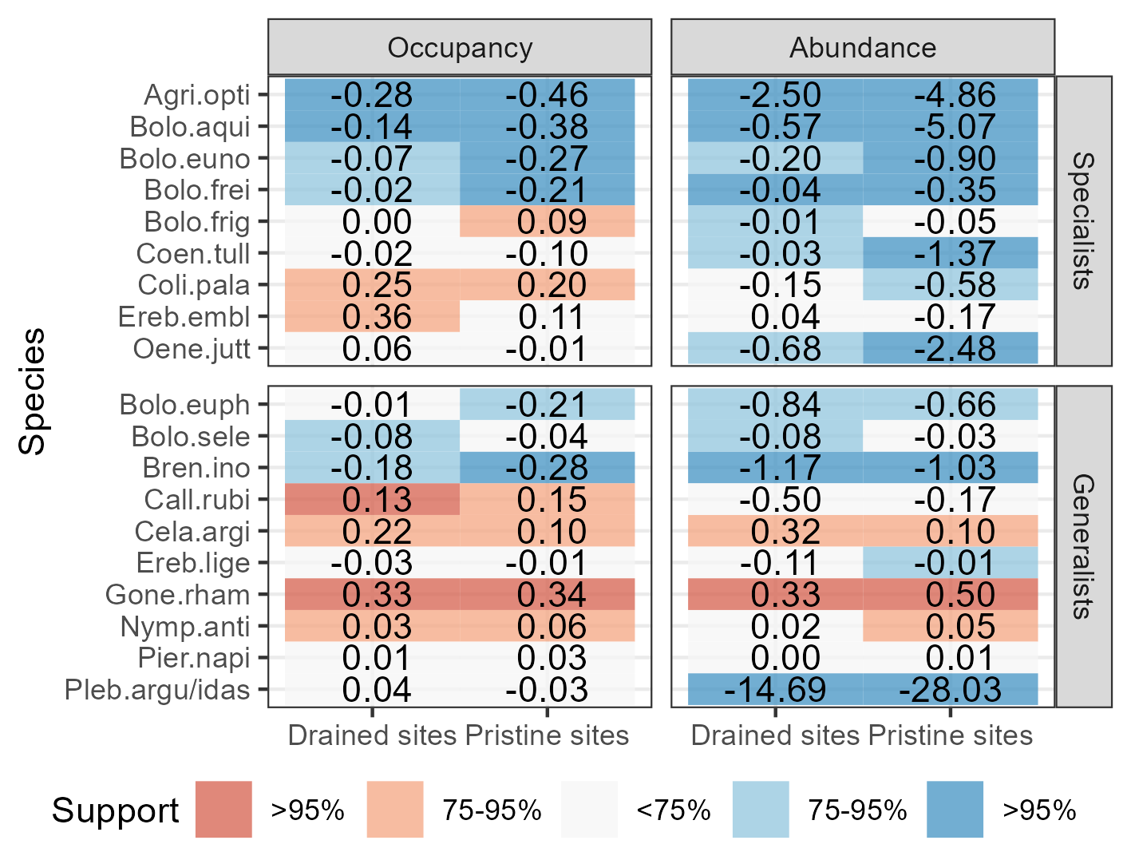

Fig. S9 Absolute changes in species occupancy probability and abundance (occupancy probability x abundance, given presence) in drained sites and in pristine sites. Support shows the posterior probability of the value being positive/negative. Full names of the species are presented in Table S2.

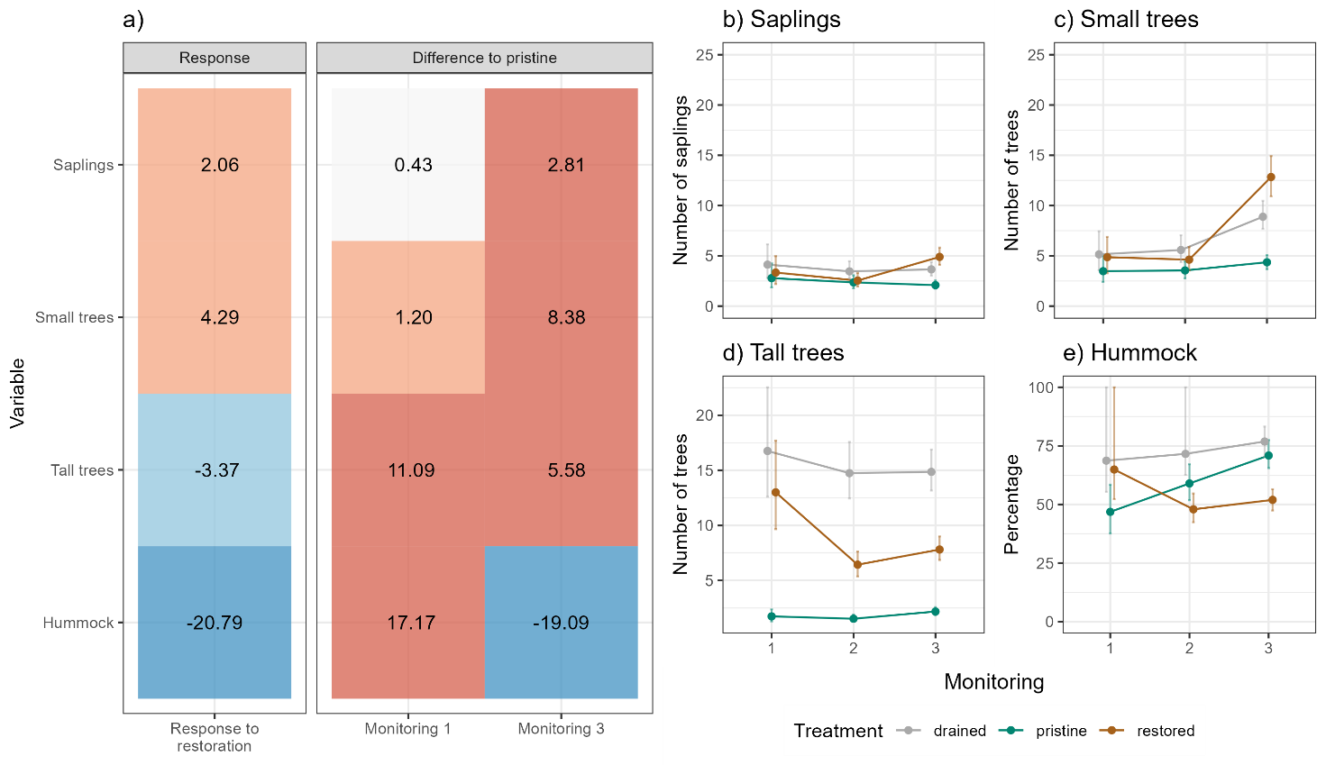
Fig S10 Vegetation responses to restoration and final difference of species abundance in restored sites when compared to pristine sites. Vegetation variables are number of saplings (trees < 1.5 m), number of small trees (1.5–3 m), number of tall trees (>3 m), and percentage cover of hummock. Response shows the relative change from before-restoration (monitoring 1) to 9–19 years after restoration (monitoring 3) in restored vs. drained sites. Response to restoration is positive if variable increases more (or decreases less) in restored sites than in drained sites and negative if it increases less (or decreases more) in restored sites than in drained sites. Differences to pristine are absolute measures, describing whether variable in restored sites differ from those in pristine sites before restoration (monitoring 1) or 9–19 years after restoration (monitoring 3). It is positive if the variable in restored sites is higher than in pristine sites, and negative if the is lower. Support shows the posterior probability of the value being positive/negative.

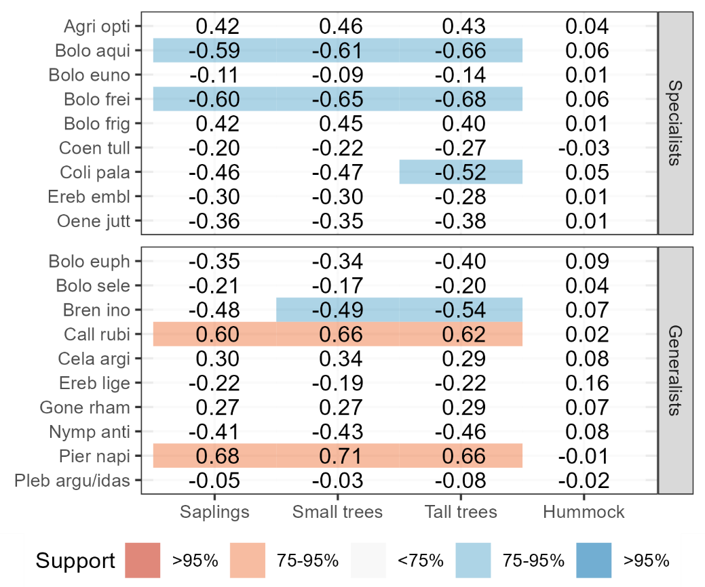
Fig. S11 Sample-level associations between species occupancy probability and vegetation variables (number of saplings, small and tall trees; cover of hummock), after controlling for the effects of time, treatment and their interaction. Support shows the posterior probability of the value being positive/negative. Full names of the species are presented in Table S2.

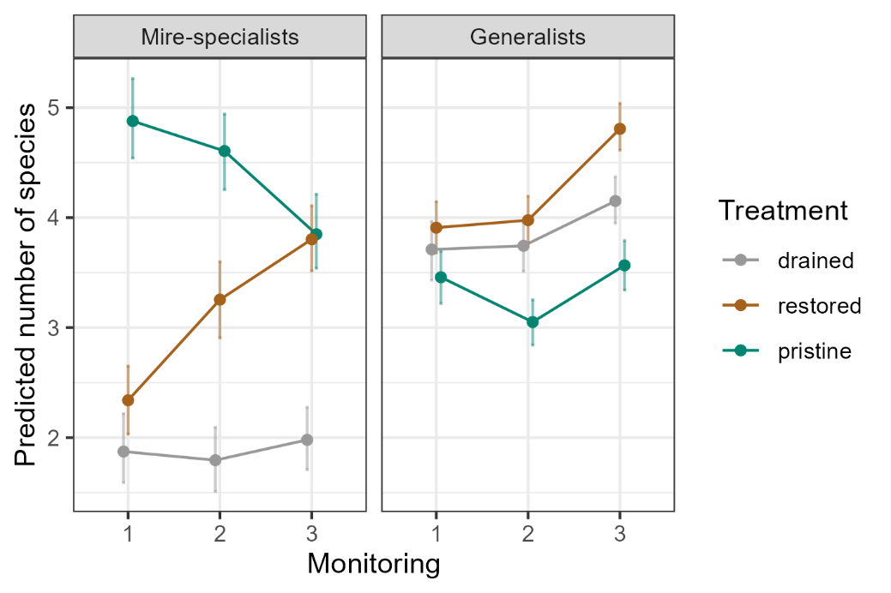
Fig. S12 Predicted number of mire-specialist species and generalist species in different treatments and monitorings (1 = before restoration, 2 = 1–3 years after restoration, 3 = 9–19 years after restoration). The lines represent the predicted median value and the whiskers represent the 25–75% quantiles for each treatment and monitoring.

