Equation S1.
(1) Mean square electronic radius:
$$〈r^{2}〉=\frac{1}{N}\int{ρ(r){\left|r\right|}^{2}}dr$$
(2) Quadrupole moment tensor
$$Q_{ij}=\int{ρ(r)\left(3r_{i}r_{j}-δ_{ij}r^{2}\right)}dr$$
(3) Traceless quadrupole tensor
$$Q_{ij}^{t}=Q_{ij}-\frac{1}{3}Tr(Q)δ_{ij}$$
(4) Quadrupole anisotropy parameter
$$Q_{aniso}=\sqrt{\frac{{(λ_{1}-λ_{2})}^{2}+{(λ_{2}-λ_{3})}^{2}+{(λ_{3}-λ_{1})}^{2}}{2}}$$
(5) Traceless quadrupole anisotropy
$$Q_{aniso}^{t}=\sqrt{\frac{{(λ_{1}^{t}-λ_{2}^{t})}^{2}+{(λ_{2}^{t}-λ_{3}^{t})}^{2}+{(λ_{3}^{t}-λ_{1}^{t})}^{2}}{2}}$$

Based on this confidence assessment, the predicted structure was considered suitable for subsequent docking calculations.

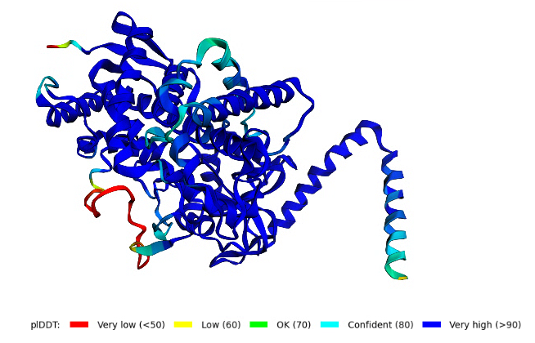
Figure S2. Predicted structures of target proteins
As shown in Figure S2, the predicted protein structure of Candida krusei exhibits predominantly high confidence levels, as indicated by the pLDDT color scale. Most regions of the model are colored in blue, corresponding to confident (pLDDT ≥ 80) or very high confidence (pLDDT ≥ 90), suggesting reliable backbone geometry and local structural accuracy.

The model was generated using a protein structure prediction algorithm, and confidence levels are represented according to the pLDDT color scale: very low (<50, red), low (50–60, orange), moderate (60–70, yellow), confident (70–80, green), and very high (>80, blue). Regions with higher confidence are shown in blue, whereas regions with lower confidence are represented in warmer colors.

Tables S3 and S4 provide the raw electronic structure data obtained directly from density functional theory (DFT) calculations. These values constitute the primary data used to derive the electronic structure descriptors and to perform the statistical analyses presented in the main text.

Table S3 DFT-derived energetic and electronic structure descriptors calculated for the investigated molecules.
Self-consistent field (SCF) energy, electronic energy (EE), zero-point energy (ZPE), zero-point energy–corrected electronic energy (E_ZPE), enthalpy (H), Gibbs free energy (G), anisotropic polarizability (α_aniso), nuclear–electron attraction energy (E_N), kinetic energy of electrons (KE), and frontier orbital energies (HOMO and LUMO) were extracted from Gaussian output files of the optimized structures. All values were obtained from density functional theory calculations and are reported in the units indicated in the table.
file | SCF_energy_Ha | EE_kcal_mol | ZPE_Ha | E_ZPE_Ha | H_Ha | G_Ha | Alpha_aniso_au | EN_Ha | KE_Ha | HOMO_eV | LUMO_eV
AZCuala | -2648.14 | -1661730 | 0.268934 | -2647.87 | -2647.85 | -2647.92 | 403.42 | -10490.8 | 2640.291 | -7.58681 | -0.71375
AZCuarg | -2930.98 | -1839215 | 0.38398 | -2930.59 | -2930.56 | -2930.65 | 381.659 | -12851.4 | 2921.543 | -7.5898 | -0.71267
AZCuasn | -2816.87 | -1767614 | 0.296703 | -2816.58 | -2816.55 | -2816.63 | 397.191 | -12005.4 | 2808.945 | -7.6766 | -0.64627
AZCuasp | -2836.74 | -1780080 | 0.284655 | -2836.45 | -2836.43 | -2836.51 | 394.719 | -11868.5 | 2828.094 | -7.6083 | -0.74124
AZCugln | -2856.19 | -1792286 | 0.325693 | -2855.86 | -2855.84 | -2855.92 | 392.784 | -12139.3 | 2847.304 | -7.5996 | -0.71348
AZCuglu | -2876.06 | -1804754 | 0.313196 | -2875.75 | -2875.72 | -2875.8 | 382.884 | -12189.6 | 2867.157 | -7.6015 | -0.71865
AZCugly | -2608.82 | -1637057 | 0.240509 | -2608.58 | -2608.56 | -2608.62 | 408.071 | -10075 | 2601.24 | -7.58218 | -0.73389
AZCuhis | -2873.19 | -1802951 | 0.322325 | -2872.86 | -2872.84 | -2872.92 | 408.472 | -12467.3 | 2864.139 | -7.59307 | -0.72301
AZCuile | -2766.08 | -1735744 | 0.354262 | -2765.73 | -2765.7 | -2765.79 | 392.842 | -11736.3 | 2757.43 | -7.58817 | -0.71076
AZCuleu | -2766.08 | -1735744 | 0.354642 | -2765.73 | -2765.71 | -2765.79 | 399.716 | -11747.8 | 2757.427 | -7.58871 | -0.72872
AZCulys | -2821.45 | -1770484 | 0.372818 | -2821.07 | -2821.05 | -2821.13 | 396.373 | -12074.8 | 2812.545 | -7.58844 | -0.70886
AZCumet | -3124.97 | -1960948 | 0.327225 | -3124.64 | -3124.62 | -3124.7 | 399.802 | -12810.6 | 3115.896 | -7.5947 | -0.71865
AZCuphe | -2879.19 | -1806720 | 0.351405 | -2878.84 | -2878.82 | -2878.9 | 420.493 | -12716.7 | 2869.962 | -7.59225 | -0.71947
AZCuser | -2723.36 | -1708936 | 0.274544 | -2723.09 | -2723.07 | -2723.14 | 385.387 | -10976.8 | 2715.224 | -7.60749 | -0.76518
AZCuthr | -2762.68 | -1733611 | 0.302009 | -2762.38 | -2762.36 | -2762.44 | 397.059 | -11422.8 | 2754.272 | -7.60177 | -0.74478
AZCutrp | -3010.78 | -1889292 | 0.381327 | -3010.4 | -3010.37 | -3010.46 | 469.353 | -14035.1 | 3000.812 | -7.54055 | -0.72954
AZCuval | -2726.77 | -1711073 | 0.325472 | -2726.44 | -2726.42 | -2726.5 | 396.345 | -11331.6 | 2718.38 | -7.58191 | -0.7094
AZLala | -1008.93 | -633113 | 0.286703 | -1008.64 | -1008.62 | -1008.69 | 394.486 | -5474.35 | 1004.233 | -6.23984 | -2.71379
AZLarg | -1291.83 | -810638 | 0.399955 | -1291.43 | -1291.41 | -1291.5 | 416.798 | -7863.07 | 1285.785 | -6.23331 | -2.72332
AZLasn | -1177.7 | -739020 | 0.313799 | -1177.39 | -1177.37 | -1177.45 | 417.01 | -6692.32 | 1172.306 | -6.28583 | -2.73311
AZLasp | -1197.58 | -751493 | 0.301269 | -1197.28 | -1197.26 | -1197.34 | 374.59 | -6738.22 | 1192.122 | -6.24855 | -2.71624
AZLgln | -1217.04 | -763704 | 0.341895 | -1216.7 | -1216.67 | -1216.76 | 421.283 | -6961.89 | 1211.401 | -6.24719 | -2.70862
AZLglu | -1236.91 | -776173 | 0.329259 | -1236.58 | -1236.56 | -1236.64 | 402.251 | -7005.58 | 1231.219 | -6.24991 | -2.70998
AZLgly | -969.609 | -608439 | 0.258534 | -969.351 | -969.331 | -969.401 | 408.332 | -5125.26 | 965.1414 | -6.27549 | -2.73175
AZLhis | -1234.03 | -774365 | 0.338405 | -1233.69 | -1233.67 | -1233.75 | 420.52 | -7287.78 | 1228.292 | -6.24148 | -2.72685
AZLile | -1126.9 | -707142 | 0.370392 | -1126.53 | -1126.51 | -1126.59 | 375.864 | -6597.74 | 1121.541 | -6.27195 | -2.71678
AZLleu | -1126.91 | -707148 | 0.370335 | -1126.54 | -1126.52 | -1126.6 | 413.505 | -6580.43 | 1121.538 | -6.23494 | -2.70454
AZLlys | -1182.28 | -741891 | 0.388978 | -1181.89 | -1181.86 | -1181.95 | 399.006 | -6896.33 | 1176.676 | -6.27195 | -2.73121
AZLmet | -1485.8 | -932356 | 0.343976 | -1485.46 | -1485.43 | -1485.52 | 382.871 | -7629.08 | 1479.97 | -6.12909 | -2.71134
AZLphe | -1240.04 | -778138 | 0.367436 | -1239.67 | -1239.65 | -1239.73 | 427.794 | -7457.38 | 1234.211 | -6.27549 | -2.73393
AZLser | -1084.18 | -680333 | 0.291456 | -1083.89 | -1083.87 | -1083.94 | 381.935 | -5941.03 | 1079.227 | -6.28828 | -2.72685
AZLthr | -1123.51 | -705012 | 0.319356 | -1123.19 | -1123.17 | -1123.24 | 408.846 | -6307.23 | 1118.329 | -6.28066 | -2.74128
AZLtrp | -1371.65 | -860724 | 0.39605 | -1371.25 | -1371.23 | -1371.32 | 452.201 | -8638.3 | 1365.238 | -5.70133 | -2.73148
AZLval | -1087.58 | -682464 | 0.342471 | -1087.23 | -1087.21 | -1087.29 | 371.92 | -6213.84 | 1082.433 | -6.24066 | -2.70127
Cuala | -2307.62 | -1448053 | 0.177988 | -2307.44 | -2307.43 | -2307.48 | 164.217 | -8094.89 | 2301.626 | -7.82953 | -0.63239
ClCuala | -3226.84 | -2024871 | 0.158753 | -3226.68 | -3226.66 | -3226.72 | 181.518 | -11239.4 | 3219.559 | -7.86001 | -0.73688
ClCuleu | -3344.79 | -2098886 | 0.24443 | -3344.54 | -3344.52 | -3344.59 | 178.484 | -12457.9 | 3336.699 | -7.86083 | -0.73661
Cuser | -2382.85 | -1495261 | 0.184035 | -2382.67 | -2382.65 | -2382.71 | 168.857 | -8537.89 | 2376.58 | -7.85457 | -0.68355
ClCuser | -3302.07 | -2072080 | 0.165091 | -3301.9 | -3301.89 | -3301.95 | 184.191 | -11715.1 | 3294.512 | -7.88749 | -0.80437
ClCuthr | -3341.39 | -2096755 | 0.192475 | -3341.2 | -3341.18 | -3341.25 | 182.263 | -12155.9 | 3333.559 | -7.8796 | -0.78369
Cuval | -2386.21 | -1497367 | 0.233255 | -2385.97 | -2385.96 | -2386.02 | 197.905 | -8845.94 | 2379.916 | -7.83198 | -2.21882

Table S4 Cartesian components of quadrupole moment tensors and traceless quadrupole tensors obtained from DFT calculations.
The table lists the Cartesian components (XX, YY, ZZ, XY, XZ, and YZ) of the quadrupole moment tensor (Q) and the corresponding traceless quadrupole tensor (Qᵗ) for each investigated molecule. These tensor components were obtained from DFT-calculated electron densities and were subsequently used to derive eigenvalues and anisotropy parameters described in the main text and Supporting Information.
file | Q_XX | Q_YY | Q_ZZ | Q_XY | Q_XZ | Q_YZ | Qᵗ _XX | Qᵗ _YY | Qᵗ _ZZ | Qᵗ _XY | Qᵗ _XZ | Qᵗ _YZ
AZCuala | -196.483 | -126.029 | -141.58 | -25.2162 | 7.992 | 0.3444 | -41.7856 | 28.6682 | 13.1174 | -25.2162 | 7.992 | 0.3444
AZCuarg | -185.638 | -183.955 | -167.755 | -15.8985 | 44.2236 | 1.1131 | -6.5223 | -4.8386 | 11.3609 | -15.8985 | 44.2236 | 1.1131
AZCuasn | -161.125 | -133.634 | -154.613 | 31.6454 | 38.1444 | 2.0963 | -11.3344 | 16.1568 | -4.8225 | 31.6454 | 38.1444 | 2.0963
AZCuasp | -219.954 | -119.567 | -164.963 | -6.1766 | -7.8556 | -12.5896 | -51.793 | 48.5943 | 3.1987 | -6.1766 | -7.8556 | -12.5896
AZCugln | -236.124 | -163.763 | -149.076 | -27.9582 | 28.323 | 9.2986 | -53.1363 | 19.2246 | 33.9117 | -27.9582 | 28.323 | 9.2986
AZCuglu | -213.85 | -155.983 | -157.481 | -13.4623 | 20.8935 | 2.5241 | -38.0785 | 19.7886 | 18.2899 | -13.4623 | 20.8935 | 2.5241
AZCugly | -191.485 | -122.412 | -134.648 | 29.2468 | -0.0804 | 0.0284 | -41.9698 | 27.1026 | 14.8672 | 29.2468 | -0.0804 | 0.0284
AZCuhis | -178.664 | -157.075 | -153.164 | 4.2971 | 38.7647 | -1.802 | -15.6961 | 5.8928 | 9.8033 | 4.2971 | 38.7647 | -1.802
AZCuile | -206.007 | -143.131 | -166.872 | -10.919 | 26.2025 | -4.0423 | -34.0034 | 28.8726 | 5.1308 | -10.919 | 26.2025 | -4.0423
AZCuleu | -216.318 | -144.94 | -157.759 | -16.7836 | 4.475 | -5.8538 | -43.3122 | 28.0659 | 15.2463 | -16.7836 | 4.475 | -5.8538
AZCulys | -232.493 | -154.879 | -157.665 | 16.3559 | 16.1174 | 2.9492 | -50.8139 | 26.8003 | 24.0136 | 16.3559 | 16.1174 | 2.9492
AZCumet | -204.874 | -156.198 | -166.586 | 4.6049 | 10.0664 | 13.0374 | -28.9884 | 19.6884 | 9.2999 | 4.6049 | 10.0664 | 13.0374
AZCuphe | -215.159 | -169.089 | -166.914 | 1.7009 | 25.546 | 9.2333 | -31.438 | 14.6318 | 16.8062 | 1.7009 | 25.546 | 9.2333
AZCuser | -203.027 | -132.089 | -142.721 | -25.1897 | 28.8159 | 6.6293 | -43.7477 | 27.1897 | 16.558 | -25.1897 | 28.8159 | 6.6293
AZCuthr | -213.217 | -133.001 | -151.189 | -20.5593 | 21.692 | 6.093 | -47.4145 | 32.8016 | 14.6129 | -20.5593 | 21.692 | 6.093
AZCutrp | -194.397 | -199.785 | -177.362 | -24.6194 | 27.493 | 3.0601 | -3.8822 | -9.2704 | 13.1526 | -24.6194 | 27.493 | 3.0601
AZCuval | -202.278 | -135.776 | -159.242 | -16.2729 | 23.3326 | 0.7435 | -36.513 | 29.9896 | 6.5235 | -16.2729 | 23.3326 | 0.7435
AZLala | -102.825 | -100.926 | -137.703 | -3.5583 | 6.7829 | 8.3629 | 10.9935 | 12.8919 | -23.8854 | -3.5583 | 6.7829 | 8.3629
AZLarg | -204.439 | -119.681 | -158.245 | 11.9803 | -10.1325 | 3.7106 | -43.6508 | 41.1076 | 2.5433 | 11.9803 | -10.1325 | 3.7106
AZLasn | -149.962 | -129.614 | -140.645 | 5.2768 | 6.4828 | 9.0601 | -9.8887 | 10.4598 | -0.5711 | 5.2768 | 6.4828 | 9.0601
AZLasp | -162.793 | -136.423 | -166.214 | -15.1179 | -3.6757 | -14.16 | -7.6498 | 18.72 | -11.0702 | -15.1179 | -3.6757 | -14.16
AZLgln | -134.792 | -177.245 | -147.9 | 20.0396 | 25.5128 | 14.9095 | 18.52 | -23.9329 | 5.4129 | 20.0396 | 25.5128 | 14.9095
AZLglu | -167.188 | -162.435 | -154.611 | 22.9392 | -9.8546 | -12.8756 | -5.7763 | -1.0238 | 6.8002 | 22.9392 | -9.8546 | -12.8756
AZLgly | -189.747 | -95.8007 | -126.956 | -12.2089 | -9.5962 | -2.0124 | -52.2459 | 41.7005 | 10.5454 | -12.2089 | -9.5962 | -2.0124
AZLhis | -179.112 | -130.794 | -140.743 | 13.9397 | 6.9002 | 2.1268 | -28.8957 | 19.4223 | 9.4734 | 13.9397 | 6.9002 | 2.1268
AZLile | -187.671 | -117.96 | -159.199 | -2.5853 | -23.597 | 7.9228 | -32.7273 | 36.9831 | -4.2558 | -2.5853 | -23.597 | 7.9228
AZLleu | -171.015 | -146.472 | -157.697 | -15.8222 | -19.033 | -10.0154 | -12.6204 | 11.9228 | 0.6976 | -15.8222 | -19.033 | -10.0154
AZLlys | -197.61 | -160.408 | -134.761 | 18.9797 | 19.3557 | -14.4483 | -33.3501 | 3.852 | 29.4981 | 18.9797 | 19.3557 | -14.4483
AZLmet | -159.471 | -147.588 | -180.341 | 3.2061 | -9.9947 | 5.9791 | 2.9954 | 14.8788 | -17.8742 | 3.2061 | -9.9947 | 5.9791
AZLphe | -195.852 | -169.457 | -139.559 | 15.8061 | 11.1037 | -12.8116 | -27.5628 | -1.1675 | 28.7302 | 15.8061 | 11.1037 | -12.8116
AZLser | -184.968 | -116.404 | -137.954 | -22.4545 | -2.9103 | 5.0263 | -38.5263 | 30.0378 | 8.4885 | -22.4545 | -2.9103 | 5.0263
AZLthr | -193.44 | -124.685 | -143.721 | -11.1492 | -8.5124 | 6.2414 | -39.4915 | 29.2642 | 10.2273 | -11.1492 | -8.5124 | 6.2414
AZLtrp | -176.218 | -196.923 | -152.127 | 25.3966 | 11.5839 | 2.1912 | -1.1284 | -21.8339 | 22.9623 | 25.3966 | 11.5839 | 2.1912
AZLval | -133.119 | -121.502 | -141.641 | 16.7928 | -3.3849 | 5.7703 | -1.0313 | 10.5853 | -9.554 | 16.7928 | -3.3849 | 5.7703
Cuala | -135.812 | -79.5607 | -94.2955 | -2.3427 | 7.1861 | -1.6596 | -32.5894 | 23.6621 | 8.9273 | -2.3427 | 7.1861 | -1.6596
ClCuala | -185.919 | -110.503 | -116.309 | -2.7418 | -3.8985 | 0.444 | -48.3415 | 27.0739 | 21.2676 | -2.7418 | -3.8985 | 0.444
ClCuleu | -199.395 | -135.117 | -135.856 | 11.8169 | 8.9552 | -3.4244 | -42.6059 | 21.6724 | 20.9334 | 11.8169 | 8.9552 | -3.4244
Cuser | -140.055 | -94.7276 | -98.3631 | -7.1502 | -0.7343 | -2.3534 | -29.0067 | 16.3211 | 12.6856 | -7.1502 | -0.7343 | -2.3534
ClCuser | -191.261 | -126.673 | -121.694 | -9.0552 | 2.3729 | -3.567 | -44.7186 | 19.8699 | 24.8487 | -9.0552 | 2.3729 | -3.567
ClCuthr | -196.21 | -132.522 | -128.359 | -7.0246 | 6.8073 | -1.8412 | -43.846 | 19.8415 | 24.0045 | -7.0246 | 6.8073 | -1.8412
Cuval | -138.349 | -97.1434 | -108.675 | 7.4833 | 11.7066 | -4.6856 | -23.6264 | 17.5791 | 6.0473 | 7.4833 | 11.7066 | -4.6856

The fully optimized geometries of all amino acid Schiff base ligands and their corresponding Cu(II) complexes were obtained at the level of theory described in Section 2.2 of the main manuscript. Frequency calculations confirmed that all structures correspond to true minima on the potential energy surface (no imaginary frequencies).
The Cartesian coordinates of all optimized structures are provided in standard XYZ format in the accompanying file (ESM_1.xyz). Each structure is labeled consistently with the identifiers used throughout the manuscript.

Table S5 summarizes the interaction energy descriptors derived from the six-direction water-probe model. For each Cu(II) complex, a single water molecule was positioned at six predefined orientations around the Cu center, and the corresponding interaction energies were evaluated. The descriptors reported in Table S5 include the minimum interaction energy (ΔE_min), the mean interaction energy (ΔE_mean), and the interaction energy range (ΔE_range), which reflects the directional anisotropy of solvent interaction.
To generate probe configurations in a reproducible manner, an automated Python workflow was employed. The oxygen atom of the water molecule was initially placed at a Cu–O distance of 4.5 Å from the metal center. The distance was incrementally increased in 0.5 Å steps when necessary, up to a maximum distance of 7.0 Å. For each distance, the water molecule was rotated around the Cu–O axis in 15° increments to identify the orientation that maximized the minimum interatomic distance between the probe and the complex.
A steric screening criterion was applied to ensure physically meaningful configurations. Specifically, a target minimum interatomic distance of 1.35 Å was imposed between any probe atom and complex atom. If this threshold was not satisfied for any of the six predefined orientations, the Cu–O distance was increased and the procedure repeated. A warning threshold of 1.20 Å was used to flag near-contact situations. For each complex, a single Cu–O distance was selected such that all six orientations satisfied the steric requirement.
The internal geometry of the water probe was fixed throughout the calculations, with an O–H bond length of 0.96 Å and an H–O–H angle of 104.5°. The bisector of the water molecule was oriented away from the Cu center to avoid unrealistic penetration of the electron density.
Single-point energies were computed at the wB97XD/def2-TZVP level of theory with SMD solvation (water) using Gaussian. The same computational setup was applied consistently to (i) the isolated complex, (ii) the isolated water molecule, and (iii) each complex–water configuration to ensure cancellation of systematic errors.
The interaction energy for each orientation $i$was defined as:
$$∆E_{int}=E_{complex+H_{2}O}-(E_{complex}+E_{H_{2}O})$$
From the six interaction energies per complex, ΔE_min, ΔE_mean, and ΔE_range were calculated and used as probe-derived descriptors in the statistical validation framework.

Molecular electrostatic potential (MEP) analysis was performed using Multiwfn on the optimized structures obtained from Gaussian calculations. Formatted checkpoint (.fchk) files were used as input.
Electrostatic potential values were computed on the van der Waals (vdW) molecular surface. A grid density parameter of 0.001 was employed to ensure sufficient spatial resolution. From the surface analysis output, the following descriptors were extracted:
- Vmin (kcal mol⁻¹), representing the most negative electrostatic potential on the vdW surface
- Vmax (kcal mol⁻¹), representing the most positive electrostatic potential
- ΔV (= Vmax − Vmin), reflecting the degree of electrostatic heterogeneity
- Molecular polarity index (MPI, eV), a surface-integrated scalar descriptor derived from the MEP distribution
All reported values were obtained directly from the statistical summary generated by Multiwfn and correspond to vdW surface properties.

Table S5. MEP- and water-probe-derived descriptors for Cu(II) complexes.
Molecular electrostatic potential (MEP) descriptors were computed on the van der Waals surface of each optimized complex using Multiwfn: the minimum and maximum surface potentials (V_min, V_max), the potential difference (ΔV = V_max − V_min), and the molecular polarity index (MPI). Water-probe descriptors were derived from single-point interaction energy calculations for one $H_{2}O$ molecule placed at six predefined orientations around the Cu center. From the six interaction energies, ΔE_min, ΔE_mean, and ΔE_range (max − min) were computed (units as indicated).
Label | Vmin (kcal mol⁻¹) | Vmax (kcal mol⁻¹) | ΔV (kcal mol⁻¹) | MPI (eV) | ΔEmin (kcal mol⁻¹) | ΔEmean (kcal mol⁻¹) | ΔErange (kcal mol⁻¹)
AZCu-ala | -67.63 | 110.944 | 178.574 | 0.854291 | -0.089 | 42.936 | 145.34
AZCu-arg | -64.608 | 112.1 | 176.708 | 0.904929 | -48.161 | -10.626 | 68.339
AZCu-asn | -77.469 | 99.732 | 177.201 | 1.028546 | -1.404 | 3.284 | 22.498
AZCu-asp | -70.19 | 101.17 | 171.36 | 1.010315 | -0.095 | 8.982 | 43.532
AZCu-gln | -71.142 | 111.338 | 182.48 | 1.052833 | -37.675 | 15.449 | 123.201
AZCu-glu | -65.294 | 112.878 | 178.172 | 0.877003 | -48.353 | 18.299 | 182.517
AZCu-gly | -67.517 | 111.688 | 179.205 | 0.894167 | -0.113 | 6.719 | 21.731
AZCu-his | -64.732 | 106.674 | 171.407 | 0.820796 | -1.833 | 14.365 | 35.279
AZCu-ile | -67.613 | 109.18 | 176.793 | 0.781159 | 1.026 | 9.077 | 39.214
AZCu-leu | -67.763 | 108.202 | 175.966 | 0.776583 | -0.158 | 28.764 | 66.699
AZCu-lys | -68.147 | 107.312 | 175.458 | 0.826261 | -0.683 | 35.371 | 96.138
AZCu-met | -63.453 | 109.543 | 172.996 | 0.775619 | -1.758 | 58.114 | 163.784
AZCu-phe | -66.171 | 107.058 | 173.229 | 0.748132 | -37.925 | 1.121 | 70.295
AZCu-ser | -77.395 | 114.135 | 191.53 | 0.970716 | -0.142 | 5.466 | 28.756
AZCu-thr | -77.703 | 113.034 | 190.736 | 0.944009 | -0.999 | 18.659 | 70.873
AZCu-trp | -65.535 | 104.31 | 169.845 | 0.755652 | -16.294 | 0.19 | 44.137
AZCu-val | -67.703 | 110.579 | 178.282 | 0.80806 | -47.858 | -14.444 | 61.593
Cl-Cu-ala | -66.203 | 110.378 | 176.582 | 0.976229 | -1.937 | 14.506 | 90.752
Cl-Cu-leu | -66.444 | 107.92 | 174.365 | 0.872463 | -0.366 | 123.797 | 742.927
Cl-Cu-ser | -58.005 | 117.385 | 175.39 | 0.987223 | -0.552 | 47.387 | 278.86
Cl-Cu-thr | -58.288 | 116.407 | 174.695 | 0.946356 | -0.34 | 76.513 | 409.701
Cu-ala | -70.33 | 102.507 | 172.837 | 1.01346 | -36.362 | -2.622 | 56.638
Cu-ser | -61.119 | 107.326 | 168.444 | 1.028486 | 0.144 | 35.492 | 177.417
Cu-val | -70.858 | 120.999 | 191.856 | 0.913041 | 0.095 | 57.212 | 188.364

Fig.S6 presents the complete RMSE ranking for complex-only models. While MEP and probe-derived descriptors showed competitive predictive capacity, global anisotropy-related descriptors consistently yielded lower cross-validated RMSE values. Species-specific RMSE analyses (Fig. S7) further confirm that these trends are generally preserved across bacterial strains, although minor variations are observed.
Across the screened candidates, quadrupole anisotropy (Q_aniso/Qᵗ_aniso), isotropic polarizability (α_iso), and the mean square electronic radius (⟨r²⟩) remained among the most stable predictors, whereas ESP-derived metrics (V_min, V_max, ΔV, MPI) and water-probe interaction summaries (ΔE_min/ΔE_mean/ΔE_range) formed a second tier with comparable but generally higher RMSE. Scatter plots (Fig. S8) provide a qualitative view of these relationships, showing that MEP and probe descriptors capture activity-relevant variation for specific complexes but tend to exhibit broader dispersion and more non-linear patterns than the global electronic descriptors. Taken together, Figs. S6–S8 support the conclusion that antibacterial performance in this series is governed primarily by intrinsic electronic anisotropy, with surface electrostatics and localized solvent-facing interaction propensity contributing as complementary factors rather than dominant single predictors.

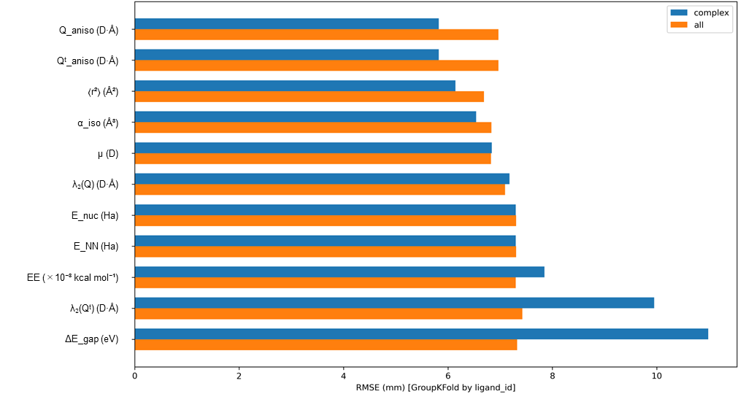
Figure S6. Descriptor screening based on GroupKFold cross-validated RMSE (complex vs all).
Top-ranked descriptors were selected according to the lowest RMSE obtained for the complex subset (“complex”, blue bars) and compared against the full dataset including both complexes and ligands (“all”, orange bars). RMSE values were computed from univariate regression models using GroupKFold cross-validation grouped by ligand identity (ligand_id). Lower RMSE indicates more stable predictive performance.
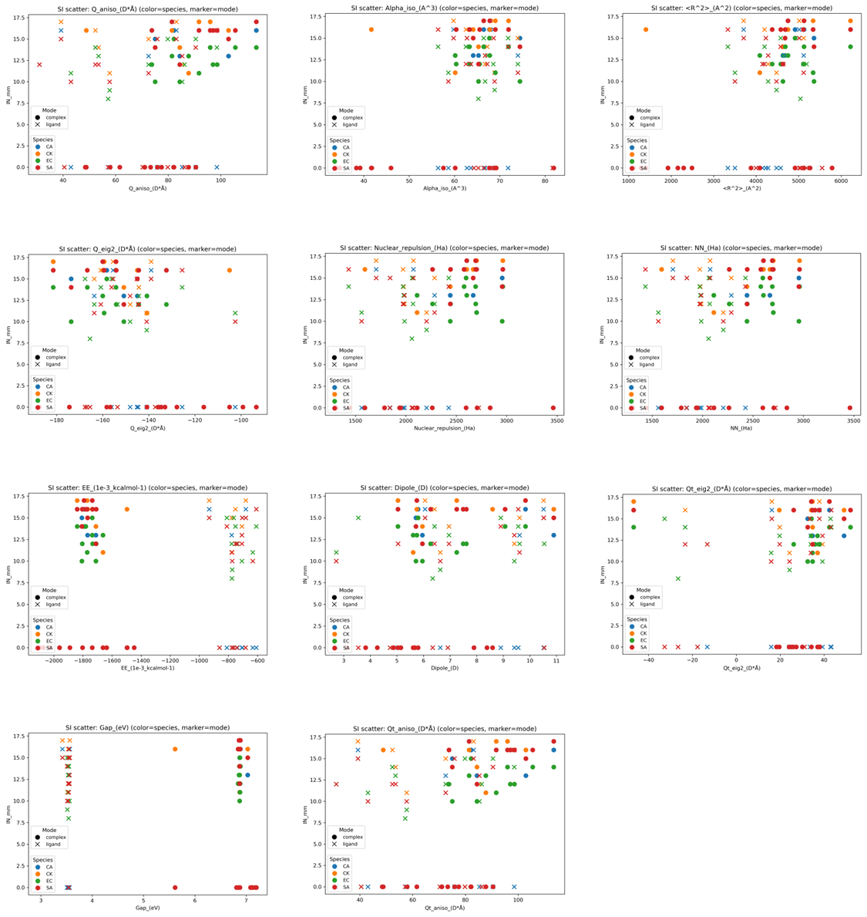
Figure S7. Scatter plots of antibacterial activity (IN_mm) versus representative electronic descriptors for complexes and ligands.
Data points are colored by microbial species (EC, SA, CA, CK) and marker shapes indicate molecular type (complex vs ligand). These plots visualize the distributional differences between complex- and ligand-only data and support the mode-aware validation discussed in the main text.
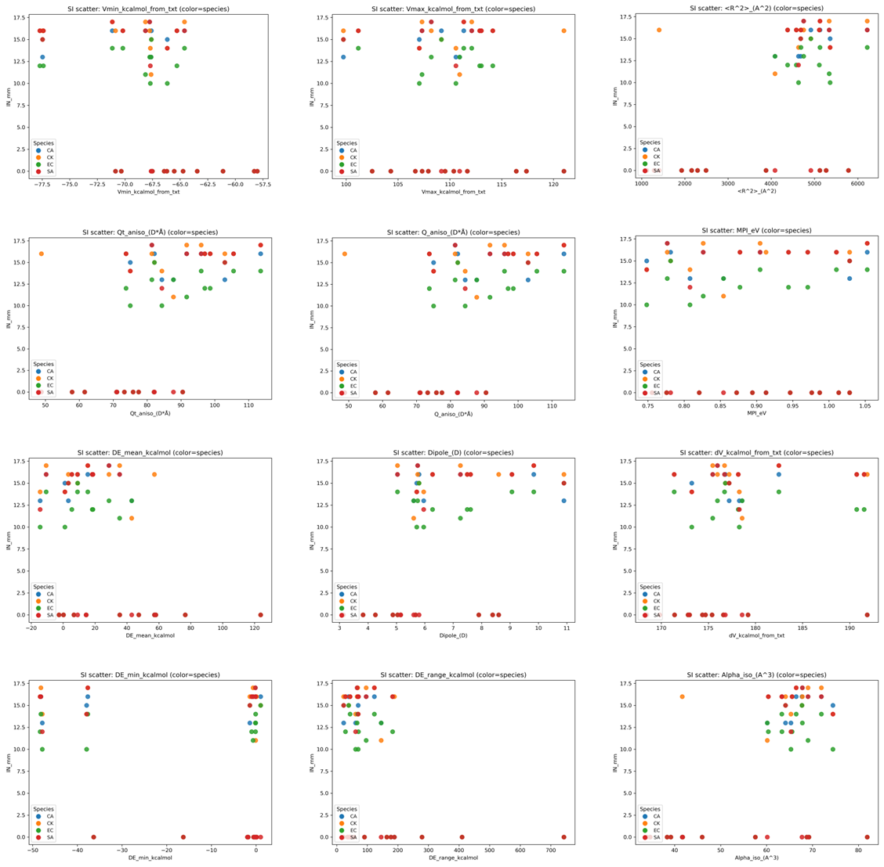
Figure S8. Scatter plots of antibacterial activity (IN_mm) versus MEP- and water-probe-derived descriptors (complex-only).
MEP descriptors (V_min, V_max, ΔV, MPI) and water-probe interaction energy summaries (ΔE_min, ΔE_mean, ΔE_range) are plotted against IN_mm for the complex dataset. Points are colored by microbial species. These plots complement the RMSE screening and provide qualitative assessment of the descriptor–activity relationships.

