Supplementary Figure 1
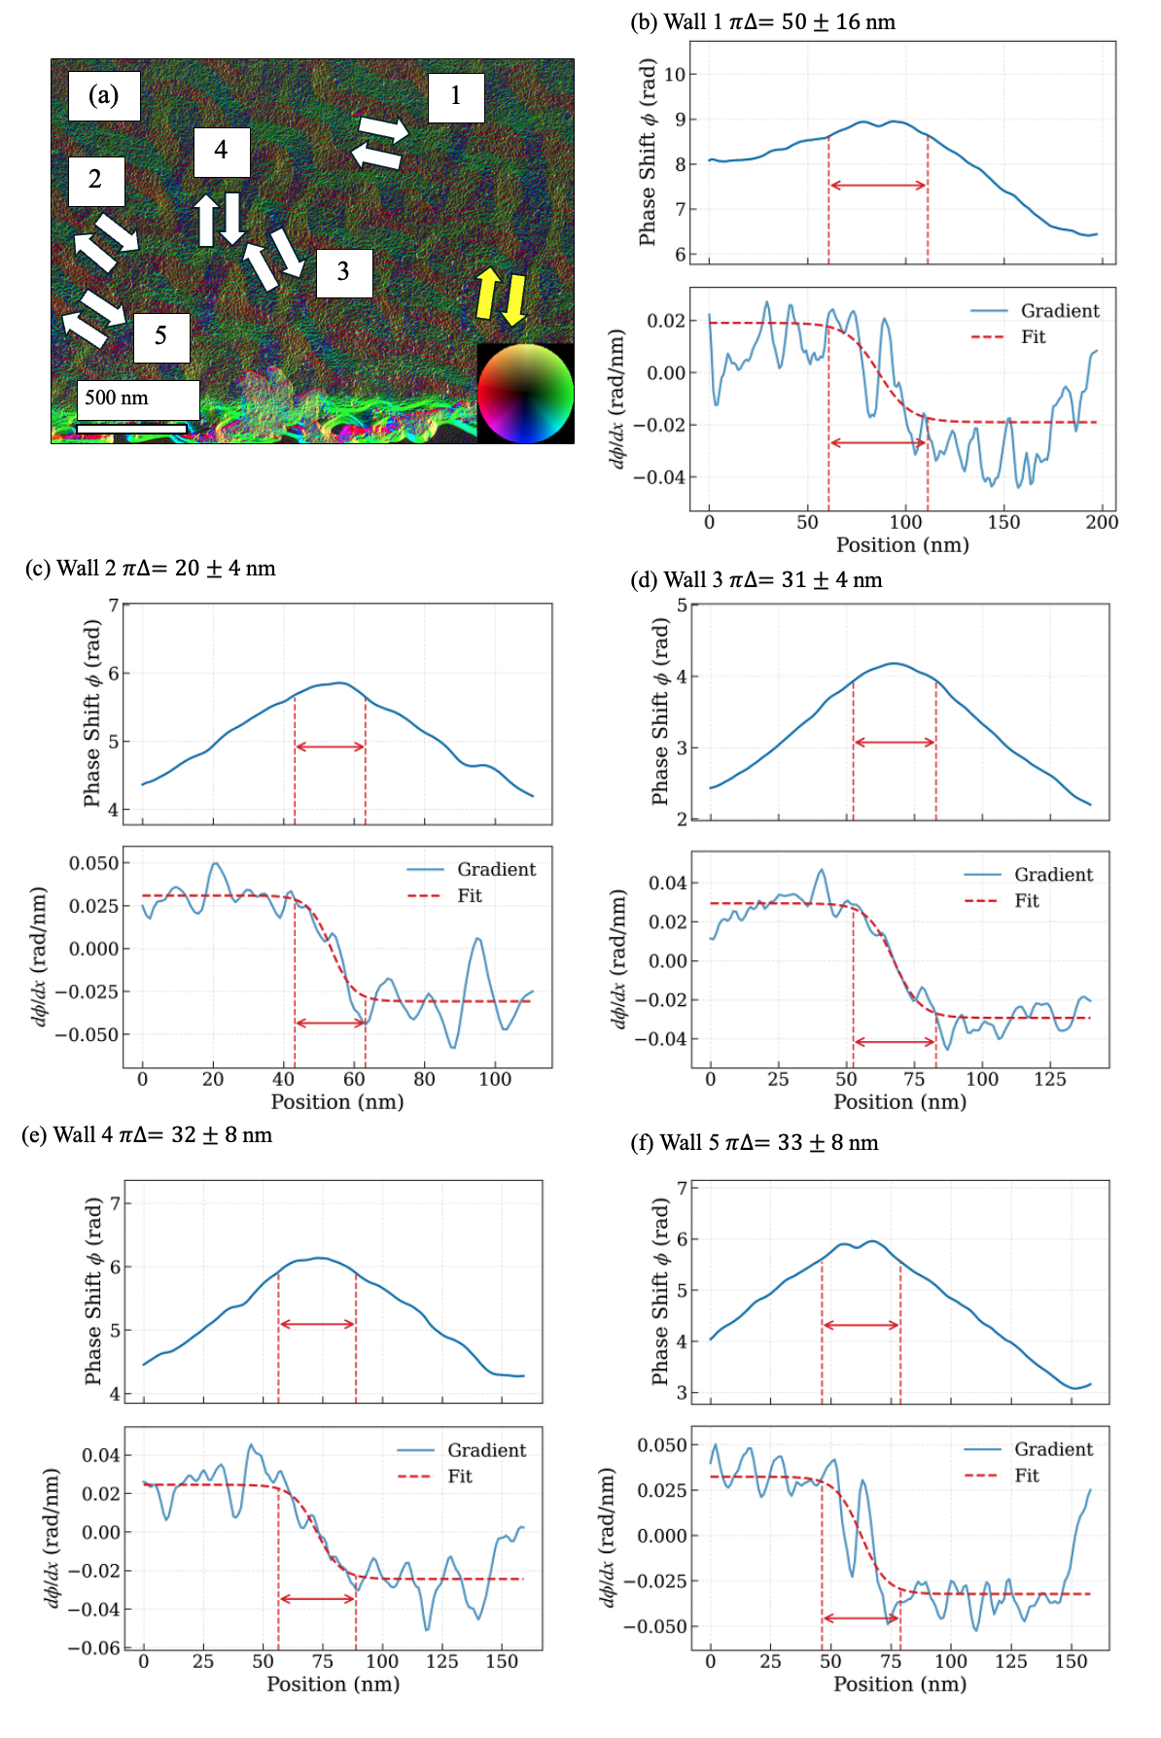
Supplementary Figure 1 – (a) Induction map in vector map representation with white arrows depicting the 180-degree domain walls identified and analyzed in this work. Each of the walls was analyzed in (b-f). The yellow arrow depicts the domain wall analyzed in the main text.

Supplementary Figure 2
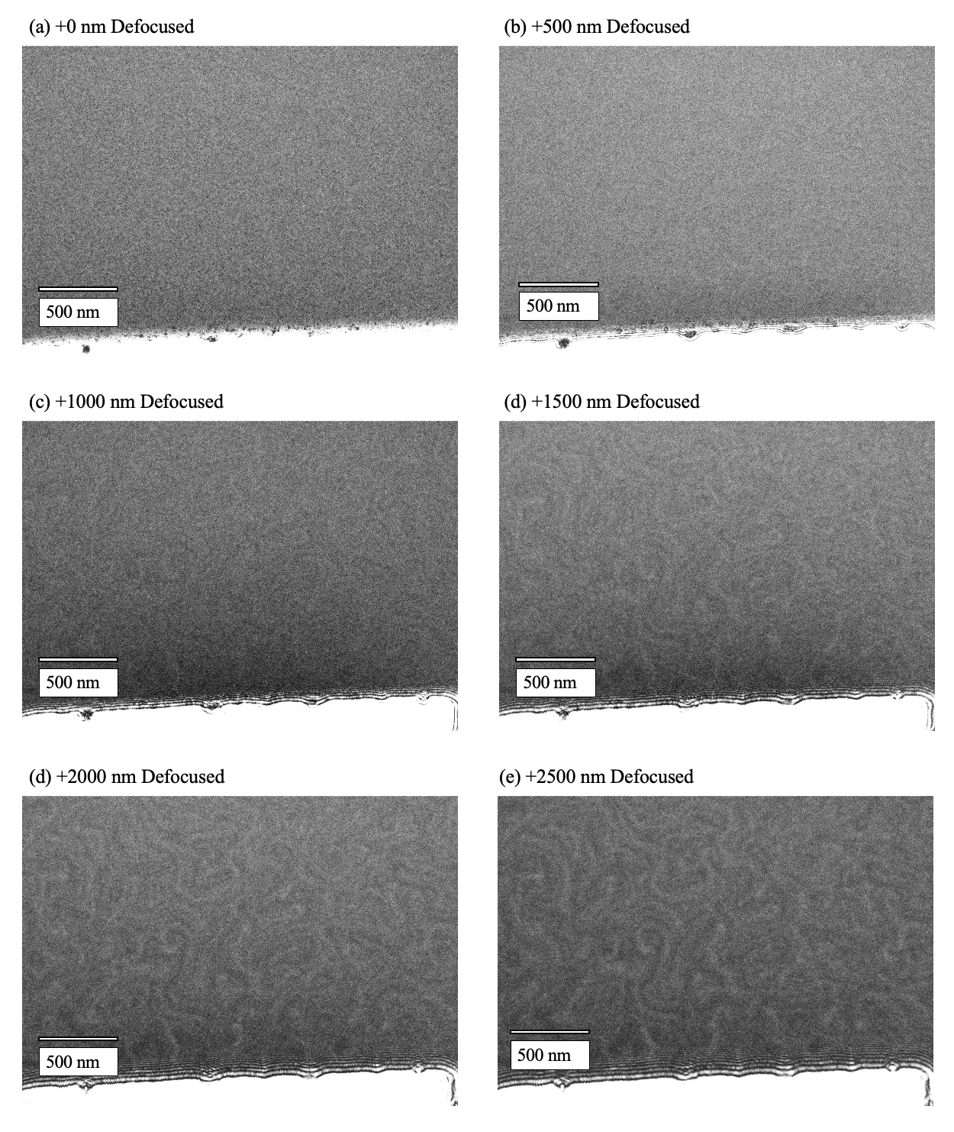
Supplementary Figure 2 – (a-e) Lorentz-TEM image analyzed for domain wall width in this study, taken at 0 to +2500 nm defocused.

