Supplementary information

Progressive Neuroinvasive and Neurodegenerative Disease Due to Potosi Virus in an Immunosuppressed Adult

In the format provided by the authors and unedited

Supplementary data for Villalba, Davis, Nakamura, et al. Progressive Neuroinvasive and Neurodegenerative Disease Due to Potosi Virus in an Immunosuppressed Adult

This supplement has been provided by the authors to give readers additional information about the work

Supplementary Tables

Supplementary Table 1. Gross neuropathological findings at autopsy
Anatomical structure | Finding
Brain (weight) | 1,085 g (low for age and sex), consistent with reduced brain volume
Cerebral hemispheres (overall) | Generalized cerebral atrophy, with mild symmetric frontal lobe predominance; no edema or herniation
Cerebral hemispheres (coronal sections) | Possible focal white matter lesion adjacent to the right lateral ventricle near the caudate
Ventricular system | Mild-to-moderate symmetric enlargement of the lateral ventricles, consistent with hydrocephalus ex vacuo
Leptomeninges | Patchy subarachnoid hemorrhages: right frontal lobe (2 foci), left temporal lobe (1 focus), bilateral occipital lobes (1 focus each); largest 2·0 × 0·1 cm
Cerebellum | Mild symmetric superior cerebellar atrophy
Brainstem | No lesions identified on axial sections
Dura mater | Intact, no lesions
Sagittal sinus | Patent
Base of brain | No hemorrhage; no aneurysm identified
Circle of Willis | No evidence of atherosclerosis
Basal ganglia and diencephalon | No gross lesions
Spinal cord and coverings | No gross abnormalities

Supplementary Table 2. Associations of Potosi viral replication density and microglial density with viral RNA density
We performed two regression models to assess the relationship between Potosi viral RNA density, Potosi viral replication density and microglial density. Model 1 included a linear regression model assessing the relationship between log10-transformed replication density (POTV_{Rep-index}) and log10-transformed viral RNA density (POTV_{RNA-index}) across 75 regions. Coefficients represent the change in viral RNA density associated with replication signal. Model 2 included a multivariable regression evaluating the independent associations of replication density and microglial density, with viral RNA density, all were log10-transformed. Results are adjusted for both predictors simultaneously. Robust standard errors (HC3) were applied.
Replication regression model 1: Regression results, summary, and diagnostics
Variable | Estimate | SE |  |  | t |  | p-value | CI [2·5%] | CI[97·5%] | VIF
-Intercept | -0·0.557 | 0·26 |  |  | -2·13 |  | 0·033 | -1·07 | -0·04 | -
-log-transformed POTV_{Rep-index} | 0·309 | 0·10 |  |  | 3·07 |  | 0·002 | 0·11 | 0·51 | 1
Model type: Multiple linear regression (log-transformed outcome)  Regression method: Ordinary Least squares (OLS) regression with HC3 heteroskedasticity-consistent covariance matrix estimator  Dependent variable: log-transformed POTV_{RNA-index}  No. observations: 75  Degrees of freedom (residuals): 73 |  |  |  | Number of predictors: 1  p-value (overall model): p = 0·0018  R²: 0·057593  Adjusted R²: 0·044684  AICc: 121·5526
Replication and inflammatory model 2: Regression results – Model summary and diagnostics
Variable | Estimate |  | SE |  |  | t | p-value | CI [2·5%] | CI[97·5%] | VIF
-Intercept | -0·145 |  | 0·36 |  |  | -0·40 | 0·69 | -0·85 | 0·56 | -
-log-transformed POTV_{Rep-index} | 0·306 |  | 0·10 |  |  | 3·06 | 0·002 | 0·11 | 0·50 | 1·0
-log-transformed Iba1_{index} | -0·305 |  | 0·20 |  |  | -1·51 | 0·131 | -0·70 | 0·09 | 1·0
Model type: Multiple linear regression (log-transformed outcome)  Regression method: Ordinary Least squares (OLS) regression with HC3 heteroskedasticity-consistent covariance matrix estimator  Dependent variable: log-transformed POTV_{RNA-index}  No. observations: 75  Degrees of freedom (residuals): 72 |  |  |  | Number of predictors: 2  p-value (overall model): p = 0·0003  R²: 0·106  Adjusted R²: 0·081  AICc: 119·77

Supplementary Table 3. Regression models. Neuroanatomical, functional, and inflammatory determinants of viral RNA density (POTV_{RNA-index})
We performed two regression models assessing the relationship between Potosi viral RNA density and various neuroanatomical, functional and inflammatory variables. Model 1 includes a multivariable linear regression model examining the association between log10-transformed viral RNA density (log10-transformed POTV_{RNA-index}) and neuroanatomical and functional characteristics across 75 CNS regions. Basal ganglia/subcortical nuclei served as the reference category. Coefficients represent adjusted differences in viral RNA density relative to the reference group. Model 2 includes a multivariable model examining log10-transformed viral RNA density in relation to CNS neuroanatomical and functional, log10-transformed replication density, and log10-transformed microglial density. This model evaluates whether anatomical and inflammatory factors independently contribute to regional RNA density. Robust standard errors (HC3) were applied.
Neuroanatomical and functional regression model 1: Results, summary, and diagnostics:
Variable | Estimate | SE | t |  | p-value | CI [2·5%] | CI[97·5%] | VIF
CNS Functional system [reference = Basal ganglia / subcortical nuclei ]
-Intercept | -0·495 | 0·41 | -1·21 |  | 0·23 | -1·30 | 0·31 | -
-Cerebellar Cortex | 0·200 | 0·21 | 0·96 |  | 0·34 | -0·21 | 0·61 | 2·07
-Cortical area (neocortex/allocortex) | -0·615 | 0·23 | -2·64 |  | 0·008 | -1·07 | -0·16 | 3·91
-Hippocampal formation and limbic system | -0·913 | 0·24 | -3·79 |  | 0·0002 | -1·39 | -0·44 | 3·58
-Meninges/coverings | -1·080 | 0·41 | -2·62 |  | 0·009 | -1·89 | -0·27 | 3·64
-Ventricular system / subependymal zone | -1·021 | 0·31 | -3·33 |  | 0·0008 | -1·62 | -0·42 | 2·34
-White matter tracts / interconnection | -0·703 | 0·33 | -2·11 |  | 0·035 | -1·36 | -0·05 | 7·33
-Non-cortical integrative system / nuclei | -0·412 | 0·23 | -1·81 |  | 0·071 | -0·86 | 0·04 | 1·93
Proximity to subarachnoid space or ventricles
-Close to these spaces | -0·312 | 0·27 | -1·17 |  | 0·24 | -0·83 | 0·21 | 3·94
-Far from these spaces | -0·071 | 0·15 | -0·47 |  | 0·64 | -0·37 | 0·23 | 3·33
Neuron-containing neuroanatomical regions | -0·203 | 0·27 | -0·75 |  | 0·45 | -0·73 | 0·33 | 4·02
Model type: Multiple linear regression (log-transformed outcome)  Regression method: Ordinary Least squares (OLS) regression with HC3 heteroskedasticity-consistent covariance matrix estimator  Dependent variable: log-transformed POTV_{RNA-index}  No. observations: 75  Degrees of freedom (residuals): 64 |  |  |  | Number of predictors: 10  p-value (overall model): p < 0·0001  R²: 0·441368  Adjusted R²: 0·354081  AICc: 104·3555
Integrated anatomical functional, and inflammatory regression model 2: Results, summary, and diagnostics
Variable | Estimate | SE | t |  | p-value | CI [2·5%] | CI[97·5%] | VIF
CNS Functional system [reference = Basal ganglia / subcortical nuclei ]
-Intercept | 0·37 | 0·56 | 0·66 |  | 0·51 | -0·73 | 1·47 | -
-Cerebellar Cortex | -0·002 | 0·31 | -0·005 |  | 0·99 | -0·60 | 0·60 | 2·98
-Cortical area (neocortex/allocortex) | -0·58 | 0·24 | -2·37 |  | 0·018 | -1·06 | -0·09 | 3·94
-Hippocampal formation and limbic system | -0·83 | 0·25 | -3·34 |  | 0·0008 | -1·32 | -0·34 | 3·72
-Meninges/coverings | -1·28 | 0·43 | -2·98 |  | 0·003 | -2·12 | -0·44 | 3·80
-Ventricular system / subependymal zone | -0·93 | 0·35 | -2·66 |  | 0·008 | -1·62 | -0·24 | 2·52
-White matter tracts / interconnection | -0·59 | 0·32 | -1·85 |  | 0·06 | -1·21 | 0·03 | 7·45
-Non-cortical integrative system / nuclei | -0·32 | 0·29 | -1·09 |  | 0·27 | -0·88 | 0·24 | 1·95
Proximity to subarachnoid space or ventricles
-Close to these spaces | -0·25 | 0·26 | -0·98 |  | 0·33 | -0·75 | 0·25 | 3·98
-Far from these spaces | -0·04 | 0·15 | -0·29 |  | 0·77 | -0·34 | 0·25 | 3·47
Neuron-containing neuroanatomical regions | -0·19 | 0·24 | -0·78 |  | 0·44 | -0·67 | 0·29 | 4·12
log-transformed POTV_{Rep-index} | 0·20 | 0·11 | 1·88 |  | 0·059 | -0·008 | 0·42 | 1·21
log-transformed Iba1_{index} | -0·30 | 0·23 | -1·30 |  | 0·19 | -0·76 | 0·15 | 2·30
Model type: Multiple linear regression (log-transformed outcome)  Regression method: Ordinary Least squares (OLS) regression with HC3 heteroskedasticity-consistent covariance matrix estimator  Dependent variable: log-transformed POTV_{RNA-index}  No. observations: 75  Degrees of freedom (residuals): 62 |  |  |  | Number of predictors: 12  p-value (overall model): p < 0·0001  R²: 0·459173  Adjusted R²: 0·354496  AICc: 107·7029

Supplementary Table 4. Integrated neuroanatomical, functional, and inflammatory model of viral RNA density (POTV_{RNA-index}) restricted to neuron-containing regions
Multivariable regression limited to neuron-containing regions (n=42), assessing associations between viral RNA density and neuroanatomical and functional factors, log10-transformed replication density, log10-transformed microglial density, and histopathological indices of neurodegeneration (NL score, vacuolation index) and neuroinflammation (NPS score). Robust standard errors (HC3) were used.
Neuroanatomical, functional, and inflammatory regression model: Results, summary, and diagnostics
Variable | Estimate | SE |  | t | p-value | CI [2·5%] | CI[97·5%] | VIF
CNS Functional system [reference = Basal ganglia / subcortical nuclei ]
-Intercept | -0·17 | 1·87 |  | -0·09 | 0·93 | -3·83 | 3·49 | -
-Cerebellar Cortex | -0·29 | 0·80 |  | -0·37 | 0·71 | -1·86 | 1·27 | 10·1
-Cortical area (neocortex/allocortex) | -0·52 | 0·37 |  | -1·39 | 0·16 | -1·25 | 0·21 | 5·2
-Hippocampal formation and limbic system | -0·82 | 0·31 |  | -2·65 | 0·008 | -1·42 | -0·21 | 4·8
-Ventricular system / subependymal zone | -1·76 | 0·80 |  | -2·19 | 0·028 | -3·34 | -0·19 | 3·8
-Non-cortical integrative system / nuclei | -0·24 | 0·45 |  | -0·54 | 0·59 | -1·11 | 0·63 | 2·7
Proximity to subarachnoid space or ventricles
-Close to these spaces | 0·10 | 0·38 |  | 0·27 | 0·79 | -0·64 | 0·85 | 5·0
-Far from these spaces | 0·18 | 0·32 |  | 0·54 | 0·59 | -0·46 | 0·81 | 5·7
log-transformed POTV_{Rep-index} | 0·16 | 0·12 |  | 1·33 | 0·18 | -0·07 | 0·38 | 1·1
log-transformed Iba1_{index} | -0·20 | 0·68 |  | -0·29 | 0·77 | -1·53 | 1·13 | 3·4
NL score | -0·28 | 0·33 |  | -0·86 | 0·39 | -0·93 | 0·36 | 3·1
NPS score | -0·16 | 0·31 |  | -0·51 | 0·61 | -0·77 | 0·45 | 7·4
Vacuolation_{index} | 0·83 | 0·86 |  | 0·96 | 0·34 | -0·86 | 2·51 | 2·6
Model type: Multiple linear regression (log-transformed outcome)  Regression method: Ordinary Least squares (OLS) regression with HC3 heteroskedasticity-consistent covariance matrix estimator  Dependent variable: log-transformed POTV_{RNA-index}  No. observations: 42  Degrees of freedom (residuals): 29 |  |  | Number of predictors: 12  p-value (overall model): p = 0·00046  R²: 0·618  Adjusted R²: 0·461  AICc: 78·68

Supplementary Table 5. Neuroanatomical and functional determinants of viral replication density (POTV_{Rep-index})
Multivariable linear regression examining associations between log10-transformed replication density (_{Rep-index}) and neuroanatomical and functional characteristics across 75 CNS regions. Robust standard errors (HC3) were applied.
Neuroanatomical and functional regression model: Results, summary, and diagnostics
Variable | Estimate | SE |  | t | p-value | CI [2·5%] | CI[97·5%] | VIF
CNS Functional system [reference = Basal ganglia / subcortical nuclei ]
-Intercept | -2·50 | 0·49 |  | -5·06 | <0·0001 | -3·47 | -1·53 | -
-Cerebellar Cortex | -0·22 | 0·35 |  | -0·63 | 0·53 | -0·90 | 0·46 | 2·1
-Cortical area (neocortex/allocortex) | -0·69 | 0·57 |  | -1·21 | 0·23 | -1·82 | 0·44 | 3·3
-Hippocampal formation and limbic system | -1·12 | 0·56 |  | -2·01 | 0·044 | -2·21 | -0·03 | 3·6
-Meninges/coverings | 0·53 | 0·51 |  | 1·03 | 0·30 | -0·48 | 1·54 | 2·1
-Ventricular system / subependymal zone | -2·57 | 1·83 |  | -1·41 | 0·16 | -6·14 | 1·01 | 2·3
-White matter tracts / interconnection | -0·49 | 0·32 |  | -1·51 | 0·13 | -1·12 | 0·15 | 3·9
-Non-cortical integrative system / nuclei | -0·45 | 0·54 |  | -0·83 | 0·41 | -1·52 | 0·62 | 1·9
Proximity to subarachnoid space or ventricles
-Close to these spaces | 0·18 | 0·59 |  | 0·30 | 0·77 | -0·99 | 1·34 | 3·2
-Far from these spaces | 0·45 | 0·56 |  | 0·81 | 0·42 | -0·65 | 1·55 | 2·9
Model type: Multiple linear regression (log-transformed outcome)  Regression method: Ordinary Least squares (OLS) regression with HC3 heteroskedasticity-consistent covariance matrix estimator  Dependent variable: log-transformed POTV_{Rep-index}  No. observations: 75  Degrees of freedom (residuals): 65 |  |  | Number of predictors: 9  p-value (overall model): p = 0·03  R²: 0·158694  Adjusted R²: 0·042206  AICc: 307·2975

Supplementary Table 6. Neuroanatomical, functional, and inflammatory determinants of viral Replication Efficiency (RepEff)
Multivariable regression models examining regional replication efficiency (RepEff), defined as the log-scale difference between replication and viral RNA densities, in relation to CNS functional systems and proximity to CSF interfaces, and microglial density (Iba1_{index}). Robust standard errors (HC3) were used. Model 2 evaluates whether inflammatory context contributes independently to regional replication efficiency.
Neuroanatomical and functional regression model 1: Results, summary, and diagnostics
Variable | Estimate | SE |  | t | p-value | CI [2·5%] | CI[97·5%] | VIF
CNS Functional system [reference = Basal ganglia / subcortical nuclei ]
-Intercept | -1·42 | 0·26 |  | -5·45 | <0·0001 | -1·92 | -0·91 | -
-Cerebellar Cortex | -0·42 | 0·33 |  | -1·24 | 0·21 | -1·07 | 0·24 | 2·1
-Cortical area (neocortex/allocortex) | 0·14 | 0·28 |  | 0·51 | 0·61 | -0·41 | 0·70 | 3·3
-Hippocampal formation and limbic system | 0·22 | 0·32 |  | 0·70 | 0·49 | -0·41 | 0·85 | 3·5
-Meninges/coverings | 1·03 | 0·30 |  | 3·48 | 0·0005 | 0·45 | 1·60 | 2·1
-Ventricular system / subependymal zone | 0·45 | 0·69 |  | 0·65 | 0·52 | -0·91 | 1·81 | 2·3
-White matter tracts / interconnection | 0·06 | 0·29 |  | 0·20 | 0·84 | -0·51 | 0·62 | 3·9
-Non-cortical integrative system / nuclei | 0·07 | 0·58 |  | 0·13 | 0·90 | -1·06 | 1·21 | 1·9
Proximity to subarachnoid space or ventricles
-Close to these spaces | -0·02 | 0·28 |  | -0·05 | 0·96 | -0·57 | 0·54 | 3·2
-Far from these spaces | 0·08 | 0·15 |  | 0·52 | 0·60 | -0·21 | 0·37 | 2·9
Model type: Multiple linear regression (log-transformed outcome)  Regression method: Ordinary Least squares (OLS) regression with HC3 heteroskedasticity-consistent covariance matrix estimator  Dependent variable: RepEff  No. observations: 75  Degrees of freedom (residuals): 65 |  |  | Number of predictors: 9  p-value (overall model): p < 0·0001  R²: 0·176816  Adjusted R²: 0·062837  AICc: 156·2069
Neuroanatomical, functional, and inflammatory regression model 2: Results, summary, and diagnostics
Variable | Estimate | SE |  | t | p-value | CI [2·5%] | CI[97·5%] | VIF
CNS Functional system [reference = Basal ganglia / subcortical nuclei ]
-Intercept | -2·17 | 0·67 |  | -3·24 | 0·001 | -3·48 | -0·86 | -
-Cerebellar Cortex | 0·05 | 0·50 |  | 0·10 | 0·92 | -0·93 | 1·04 | 3·0
-Cortical area (neocortex/allocortex) | 0·23 | 0·29 |  | 0·79 | 0·43 | -0·33 | 0·79 | 3·3
-Hippocampal formation and limbic system | 0·33 | 0·33 |  | 0·98 | 0·33 | -0·32 | 0·97 | 3·6
-Meninges/coverings | 1·36 | 0·43 |  | 3·18 | 0·001 | 0·52 | 2·20 | 2·4
-Ventricular system / subependymal zone | 0·50 | 0·67 |  | 0·75 | 0·45 | -0·81 | 1·81 | 2·3
-White matter tracts / interconnection | 0·04 | 0·29 |  | 0·16 | 0·88 | -0·52 | 0·61 | 3·9
-Non-cortical integrative system / nuclei | 0·03 | 0·56 |  | 0·04 | 0·97 | -1·12 | 1·17 | 1·9
Proximity to subarachnoid space or ventricles
-Close to these spaces | -0·03 | 0·29 |  | -0·12 | 0·91 | -0·61 | 0·54 | 3·2
-Far from these spaces | 0·007 | 0·17 |  | 0·04 | 0·97 | -0·33 | 0·35 | 2·9
log-transformed Iba1_{index} | 0·53 | 0·43 |  | 1·24 | 0·22 | -0·31 | 1·37 | 2·2
Model type: Multiple linear regression (log-transformed outcome)  Regression method: Ordinary Least squares (OLS) regression with HC3 heteroskedasticity-consistent covariance matrix estimator  Dependent variable: RepEff  No. observations: 75  Degrees of freedom (residuals): 64 |  |  | Number of predictors: 10  p-value (overall model): p = 0·004  R²: 0·220123  Adjusted R²: 0·098267  AICc: 154·9066

Supplementary Table 7. Neuroanatomical, functional, and virologic determinants of viral Antigen Density (POTV_{Ag-index})
We performed two regression models to assess the relationship between Potosi viral antigen density and various neuroanatomical, functional and virologic variables. Model 1 includes a multivariable linear regression examining the association between log10-transformed viral antigen density (POTV_{Ag-index}) and neuroanatomical and functional characteristics across 75 CNS regions. Basal ganglia/subcortical nuclei served as the reference category. Model 2 includes a regression model evaluating whether viral RNA density and replication density are associated with viral antigen density (POTV_{Ag-index}) (all log10-transformed). Robust standard errors (HC3) were used in both models.
Neuroanatomical and functional regression model 1: Results, summary, and diagnostics
Variable |  | Estimate |  | SE |  | t | p-value | CI [2·5%] | CI[97·5%] | VIF
CNS Functional system [reference = Basal ganglia / subcortical nuclei ]
-Intercept |  | 0·49 |  | 0·28 |  | 1·75 | 0·08 | -0·058 | 1·02 | -
-Cerebellar Cortex |  | -0·49 |  | 0·37 |  | -1·33 | 0·18 | -1·21 | 0·23 | 2·1
-Cortical area (neocortex/allocortex) |  | -0·01 |  | 0·28 |  | -0·04 | 0·97 | -0·56 | 0·53 | 3·3
-Hippocampal formation and limbic system |  | 0·37 |  | 0·27 |  | 1·37 | 0·17 | -0·16 | 0·91 | 3·6
-Meninges/coverings |  | 0·19 |  | 0·28 |  | 0·67 | 0·50 | -0·37 | 0·75 | 2·1
-Ventricular system / subependymal zone |  | 0·61 |  | 0·40 |  | 1·52 | 0·13 | -0·18 | 1·40 | 2·3
-White matter tracts / interconnection |  | -0·03 |  | 0·28 |  | -0·11 | 0·92 | -0·57 | 0·51 | 3·9
-Non-cortical integrative system / nuclei |  | 0·40 |  | 0·38 |  | 1·06 | 0·30 | -0·34 | 1·13 | 1·9
Proximity to subarachnoid space or ventricles
-Close to these spaces |  | -0·27 |  | 0·22 |  | -1·24 | 0·22 | -0·71 | 0·16 | 3·2
-Far from these spaces |  | -0·45 |  | 0·15 |  | -2·95 | 0·003 | -0·75 | -0·15 | 2·9
Model type: Multiple linear regression (log-transformed outcome)  Regression method: Ordinary Least squares (OLS) regression with HC3 heteroskedasticity-consistent covariance matrix estimator  Dependent variable: log-transformed POTV_{Ag-index}  No. observations: 75  Degrees of freedom (residuals): 65 |  |  |  |  | Number of predictors: 9  p-value (overall model): p < 0·0001  R²: 0·480325  Adjusted R²: 0·40837  AICc: 69·89541
Virologic regression model 2: Results, summary, and diagnostics
Variable | Estimate |  | SE |  |  | t | p-value | CI [2·5%] | CI[97·5%] | VIF
-Intercept | -0.0914· |  | 0·16 |  |  | -0·56 | 0·57 | -0·41 | 0·23 | -
-log-transformed POTV_{RNA-index} | -0·24 |  | 0·11 |  |  | -2·25 | 0.025· | -0·45 | -0·03 | 1·1
-log-transformed POTV_{Rep-index} | -0·01 |  | 0·03 |  |  | -0·46 | 0·65 | -0·07 | 0·04 | 1·1
Model type: Multiple linear regression (log-transformed outcome)  Regression method: Ordinary Least squares (OLS) regression with HC3 heteroskedasticity-consistent covariance matrix estimator  Dependent variable: log-transformed POTV_{Ag-index}  No. observations: 75  Degrees of freedom (residuals): 72 |  |  |  |  | Number of predictors: 2  p-value (overall model): p = 0·0543  R²: 0·093475  Adjusted R²: 0·068294  AICc: 94·52711

Supplementary Table 8. Integrated neuroanatomical, functional, virologic, and inflammatory model of viral antigen density (POTV_{Ag-index})
Multivariable regression examining viral antigen density (POTV_{Ag-index}) in relation to CNS functional systems, proximity to CSF interfaces, viral RNA density, replication density, and microglial density (all log10-transformed). Robust standard errors (HC3) were applied.
Regression results – Model summary and diagnostics
Variable | Estimate | SE |  | t | p-value | CI [2·5%] | CI[97·5%] | VIF
CNS Functional system [reference = Basal ganglia / subcortical nuclei ]
-Intercept | 0·59 | 0·36 |  | 1·65 | 0·099 | -0·11 | 1·28 | -
-Cerebellar Cortex | -0·51 | 0·39 |  | -1·30 | 0·19 | -1·27 | 0·26 | 3·0
-Cortical area (neocortex/allocortex) | 0·03 | 0·28 |  | 0·11 | 0·91 | -0·52 | 0·58 | 3·6
-Hippocampal formation and limbic system | 0·45 | 0·27 |  | 1·66 | 0·098 | -0·08 | 0·98 | 4·6
-Meninges/coverings | 0·22 | 0·30 |  | 0·76 | 0·45 | -0·36 | 0·82 | 2·8
-Ventricular system / subependymal zone | 0·71 | 0·40 |  | 1·77 | 0·08 | -0·08 | 1·50 | 2·9
-White matter tracts / interconnection | 0·01 | 0·28 |  | 0·04 | 0·97 | -0·54 | 0·56 | 4·2
-Non-cortical integrative system / nuclei | 0·43 | 0·38 |  | 1·14 | 0·26 | -0·31 | 1·18 | 2·0
Proximity to subarachnoid space or ventricles
-Close to these spaces | -0·26 | 0·23 |  | -1·12 | 0·26 | -0·72 | 0·20 | 3·2
-Far from these spaces | -0·45 | 0·16 |  | -2·83 | 0·005 | -0·77 | -0·14 | 3·0
log-transformed POTV_{RNA-index} | 0·07 | 0·10 |  | 0·66 | 0·51 | -0·13 | 0·26 | 1·8
log-transformed POTV_{Rep-index} | 0·01 | 0·03 |  | 0·41 | 0·68 | -0·05 | 0·08 | 1·2
log-transformed Iba1_{index} | -0·01 | 0·18 |  | -0·06 | 0·96 | -0·36 | 0·34 | 2·3
Model type: Multiple linear regression (log-transformed outcome)  Regression method: Ordinary Least squares (OLS) regression with HC3 heteroskedasticity-consistent covariance matrix estimator  Dependent variable: log-transformed POTV_{Ag-index}  No. observations: 75  Degrees of freedom (residuals): 62 |  |  | Number of predictors: 12  p-value (overall model): p < 0·0001  R²: 0·486875  Adjusted R²: 0·387561  AICc: 77·47379

Supplementary Table 9. Integrated neuroanatomical, functional, and inflammatory model of viral antigen residual (AgResidual)
Multivariable regression examining our antigen discordance index (AgResidual) in relation to CNS functional systems, proximity to CSF interfaces, and microglial density (all log10-transformed). The antigen discordance index (AgResidual) represents the residual antigen signal after accounting for regional genomic RNA and replication densities. Robust standard errors (HC3) were applied.

Regression results – Model summary and diagnostics
Variable | Estimate | SE |  | t | p-value | CI [2·5%] | CI[97·5%] | VIF
CNS Functional system [reference = Basal ganglia / subcortical nuclei ]
-Intercept | 0·45 | 0·35 |  | 1·29 | 0·20 | -0·23 | 1·13 | -
-Cerebellar Cortex | -0·46 | 0·38 |  | -1·18 | 0·24 | -1·21 | 0·30 | 3·0
-Cortical area (neocortex/allocortex) | -0·15 | 0·26 |  | -0·58 | 0·56 | -0·67 | 0·36 | 3·3
-Hippocampal formation and limbic system | 0·12 | 0·27 |  | 0·44 | 0·66 | -0·41 | 0·64 | 3·6
-Meninges/coverings | -0·07 | 0·27 |  | -0·26 | 0·80 | -0·61 | 0·47 | 2·4
-Ventricular system / subependymal zone | 0·33 | 0·40 |  | 0·83 | 0·41 | -0·45 | 1·12 | 2·3
-White matter tracts / interconnection | -0·15 | 0·27 |  | -0·56 | 0·57 | -0·68 | 0·38 | 3·9
-Non-cortical integrative system / nuclei | 0·29 | 0·35 |  | 0·81 | 0·42 | -0·41 | 0·98 | 1·9
Proximity to subarachnoid space or ventricles
-Close to these spaces | -0·30 | 0·23 |  | -1·34 | 0·18 | -0·75 | 0·14 | 3·2
-Far from these spaces | -0·42 | 0·16 |  | -2·63 | 0·009 | -0·73 | -0·11 | 2·9
log-transformed Iba1_{index} | -0·08 | 0·20 |  | -0·38 | 0·70 | -0·46 | 0·31 | 2·2
Model type: Multiple linear regression (log-transformed outcome)  Regression method: Ordinary Least squares (OLS) regression with HC3 heteroskedasticity-consistent covariance matrix estimator  Dependent variable: AgResidual  No. observations: 75  Degrees of freedom (residuals): 64 |  |  | Number of predictors: 10  p-value (overall model): p < 0·0001  R²: 0·338672  Adjusted R²: 0·23534  AICc: 75·86883

Supplementary Table 10. Neuroanatomical and neurodegenerative determinants of viral replication efficiency (RepEff)
We performed two regression models evaluating the association between replication efficiency (RepEff) and neuroanatomical and neurodegenerative variables. Model 1 includes a linear regression examining the association between tissue vacuolation index (Vacuolation_{index}) and replication efficiency across 70 regions. Model 2 includes a multivariable regression examining replication efficiency in relation to neuroanatomical groups and tissue vacuolation index. Robust standard errors (HC3) were used for both models.
Tissue Vacuolation regression model 1: Results, summary, and diagnostics
Variable | Estimate | SE |  | t | p-value | CI [2·5%] | CI[97·5%] | VIF
-Intercept | -0·93 | 0·14 |  | -6·86 | <0·0001 | -1·20 | -0·67 | -
-Vacuolation_{index} | -0·02 | 0·008 |  | -2·34 | 0·02 | -0·03 | -0·003 | 1
Model type: Multiple linear regression (log-transformed outcome)  Regression method: Ordinary Least squares (OLS) regression with HC3 heteroskedasticity-consistent covariance matrix estimator  Dependent variable: RepEff  No. observations: 70  Degrees of freedom (residuals): 68 |  |  | Number of predictors: 1  p-value (overall model): p = 0·022  R²: 0·065958  Adjusted R²: 0·052222  AICc: 133·6475
Neuroanatomical and neurodegenerative regression model 2: Results, summary, and diagnostics
Variable | Estimate | SE |  | t | p-value | CI [2·5%] | CI[97·5%] | VIF
CNS Neuroanatomical groups with tissue vacuolation
-Intercept | -1·12 | 0·34 |  | -3·33 | 0·0008 | -1·77 | -0·46 | -
-Cerebellar Cortex | 1·21 | 0·29 |  | 0·41 | 0·68 | -0·46 | 0·70 | 6·9
-Cerebellar white matter and tracts | 0·08 | 0·13 |  | 0·65 | 0·51 | -0·17 | 0·33 | 6·5
-Non-cortical integrative system / nuclei | 0·27 | 0·64 |  | 0·43 | 0·67 | -0·97 | 1·52 | 4·8
-Cortical grey matter (neocortex/allocortex) | 0·44 | 0·23 |  | 1·93 | 0·05 | -0·006 | 0·89 | 9·3
-Hippocampal formation and limbic system | 0·34 | 0·23 |  | 1·50 | 0·13 | -0·10 | 0·79 | 12·0
-Ventricular / Subependymal zone | 0·66 | 0·74 |  | 0·89 | 0·38 | -0·79 | 2·11 | 6·3
-White matter tracts / interconnection | 0·12 | 0·18 |  | 0·68 | 0·49 | -0·23 | 0·48 | 15·8
- Basal ganglia / subcortical nuclei | -0·02 | 0·32 |  | -0·07 | 0·94 | -0·65 | 0·60 | 5·9
Proximity to subarachnoid space or ventricles
-Close to these spaces | 0·17 | 0·27 |  | 0·62 | 0·53 | -0·37 | 0·71 | 3·8
-Far from these spaces | 0·07 | 1·43 |  | 0·48 | 0·63 | -0·21 | 0·35 | 4·1
Vacuolation_{index} | -0·02 | 0·01 |  | -2·03 | 0·04 | -0·05 | -0·0009 | 2·3
Model type: Multiple linear regression (log-transformed outcome)  Regression method: Ordinary Least squares (OLS) regression with HC3 heteroskedasticity-consistent covariance matrix estimator  Dependent variable: RepEff  No. observations: 70  Degrees of freedom (residuals): 58 |  |  | Number of predictors: 11  p-value (overall model): p = 0·008  R²: 0·147038  Adjusted R²: -0·01473  AICc: 152·5856

Supplementary Table 11. Integrated mechanistic model of viral replication efficiency (RepEff)
Comprehensive multivariable regression examining viral replication efficiency (RepEff) in relation to neuroanatomical groups, tissue vacuolation, and microglial density. This model evaluates the combined contribution of structural and inflammatory factors to regional replication dynamics. Robust standard errors (HC3) were used.
Regression results – Model summary and diagnostics
Variable | Estimate | SE |  | t | p-value | CI [2·5%] | CI[97·5%] | VIF
CNS Neuroanatomical groups with tissue vacuolation
-Intercept | -1·28 | 0·40 |  | -3·25 | 0·001 | -2·06 | -0·51 | -
-Cerebellar Cortex | 0·11 | 0·33 |  | 0·34 | 0·74 | -0·54 | 0·76 | 6·9
-Cerebellar white matter and tracts | -0·30 | 0·41 |  | -0·74 | 0·46 | -1·11 | 0·50 | 6·8
-Non-cortical integrative system / nuclei | -0·26 | 0·78 |  | -0·34 | 0·74 | -1·79 | 1·26 | 5·2
-Cortical grey matter (neocortex/allocortex) | 0·30 | 0·36 |  | 0·84 | 0·40 | -0·40 | 1·00 | 9·4
-Hippocampal formation and limbic system | 0·19 | 0·31 |  | 0·63 | 0·53 | -0·41 | 0·80 | 12·1
-Ventricular / Subependymal zone | 0·24 | 0·69 |  | 0·35 | 0·72 | -1·12 | 1·61 | 6·7
-White matter tracts / interconnection | -0·12 | 0·32 |  | -0·38 | 0·70 | -0·76 | 0·51 | 16·2
- Basal ganglia / subcortical nuclei | -0·26 | 0·42 |  | -0·61 | 0·54 | -1·09 | 0·57 | 6·0
Proximity to subarachnoid space or ventricles
-Close to these spaces | 0·19 | 0·33 |  | 0·57 | 0·57 | -0·46 | 0·83 | 3·8
-Far from these spaces | 0·05 | 0·22 |  | 0·20 | 0·84 | -0·39 | 0·48 | 4·1
Vacuolation_{index} | -0·02 | 0·01 |  | -1·90 | 0·058 | -0·04 | 0·0007 | 2·3
log-transformed Iba1_{index} | 0·01 | 0·008 |  | 1·21 | 0·23 | -0·006 | 0·026 | 1·6
Model type: Multiple linear regression (log-transformed outcome)  Regression method: Ordinary Least squares (OLS) regression with HC3 heteroskedasticity-consistent covariance matrix estimator  Dependent variable: RepEff  No. observations: 70  Degrees of freedom (residuals): 57 |  |  | Number of predictors: 12  p-value (overall model): p = 0·16  R²: 0·226128  Adjusted R²: 0·063207  AICc: 148·8004

Supplementary Table 12. Interaction models evaluating the association between POTV viral density, cellular density, and tissue vacuolation in the Granule Cell layer of the Cerebellum.
Classical OLS estimates and heteroskedasticity-consistent HC3 robust estimates for the interaction models predicting Vacuolation_{index}. Models were performed to evaluate whether the association between POTV RNA density and tissue vacuolation (Vacuolation_{index}) was moderated by cellular density. Partial R² values represent the unique contribution of each predictor to explained variance. VIF values quantify variance inflation due to multicollinearity. Bootstrap resampling was performed by sampling ROIs with replacement and refitting the interaction model 2000 times. Reported values include the original OLS estimate, bootstrap mean, bootstrap standard deviation, and percentile-based 95% confidence intervals.

Classic OLS model 1: Results, summary, and diagnostics
Variable | Estimate | SE |  | t |  | p-value | CI [2·5%] | CI[97·5%] |  | VIF | Partial R²
Log-transformed RNA density (POTV_{RMA-index}) | 3·92 | 1·25 |  | 3·14 |  | 0·002 | 1·45 | 6·40 |  | 4·6 | 0·09
Cellular density (Cells/µm²) | -635·46 | 253·07 |  | -2·51 |  | 0·014 | -1137·30 | -133·62 |  | 8·4 | 0·06
Interaction [log-transformed POTV_{RMA-index} x Cells/µm²] | -218·91 | 86·72 |  | -2·52 |  | 0·013 | -390·89 | -46·93 |  | 15·8 | 0·06
Intercept | 17·71 | 2·99 |  | 5·92 |  | <0·0001 | 11·78 | 23·65 |  | - | -
Model type: Multiple linear regression (log-transformed outcome)  Regression method: Ordinary Least squares (OLS)  Dependent variable: Vacuolation_{index}  No. observations: 108  Degrees of freedom (residuals): 104 |  |  | Number of predictors: 3  p-value (overall model): p = 0·0097  R²: 0·103444  Adjusted R²: 0·077582  AICc: 659·039
HC3 Robust Regression model 2: Results, summary, and diagnostics
Variable | Estimate | SE |  | t |  | p-value | CI [2·5%] | CI[97·5%] |  | VIF | Partial R²
Log-transformed RNA density (POTV_{RMA-index}) | 3·92 | 0·98 |  | 4·00 |  | 0·0001 | 1·98 | 5·87 |  | 4·6 | 0·09
Cellular density (Cells/µm²) | -635·46 | 277·75 |  | -2·79 |  | 0·0063 | -1087·09 | -183·83 |  | 8·4 | 0·06
Interaction [log-transformed POTV_{RMA-index} x Cells/µm²] | -218·91 | 65·94 |  | -3·32 |  | 0·0012 | -349·67 | -88·15 |  | 15·8 | 0·06
Intercept | 17·71 | 2·60 |  | 6·80 |  | <0·0001 | 12·55 | 22·87 |  | - | -
Model type: Multiple linear regression (log-transformed outcome)  Regression method: OLS regression with HC3 heteroskedasticity-consistent covariance matrix estimator  Dependent variable: Vacuolation_{index}  No. observations:  Degrees of freedom (residuals):104 |  |  | Number of predictors: 3  p-value (overall model): p < ·  R²: : 0·103444  Adjusted R²: 0·077582  AICc: 659·039
Bootstrap model 3: Resampling-based inference for the interaction model (2,000 resamples)
Variable | OLS Estimate | Bootstrap Mean |  |  | Bootstrap SD |  | Bootstrap CI [2·5%] |  | Bootstrap CI [95·5%]
Log-transformed RNA density (POTV_{RMA-index}) | 3·92 | 4·06 |  |  | 1·09 |  | 2·04 |  | 6·41
Cellular density (Cells/µm²) | -635·46 | -686·47 |  |  | 294·20 |  | -1469·06 |  | -197·237
Interaction [log-transformed POTV_{RMA-index} x Cells/µm²] | -218·91 | -239·14 |  |  | 101·09 |  | -535·02 |  | -95·95
Intercept | 17·71 | 18·04 |  |  | 2·84 |  | 12·99 |  | 24·19
Number of bootstrap resamples: 2,000
Random seed: 42
Sampling scheme: nonparametric bootstrap, resampling ROIs with replacement
Interaction coefficient bootstrap probability $β_{interaction}<0$: 0.9985

Supplementary Table 13. PC component scores and cluster assignments for individual tissue samples in neuron-containing neuroanatomical regions.
To identify phenotypic compartments, we performed agglomerative hierarchical clustering using Ward’s minimum variance method on the top three principal component (PC1–PC3) scores, derived from the principal component analysis (PCA) of histological, and virological features in neuron containing neuroanatomical regions. The resulting cluster assignment (1-4) is shown. See methods for details of PC component derivation and clustering.
Neuron-containing neuroanatomical region | PC1 | PC2 | PC3 | Cluster_k4
Frontal lobe
Frontal cortex – molecular layer | -0.6507599 | -0.5881408 | -0.5836118 | 4
Frontal cortex – pyramidal/granular layers | -2.2431376 | -0.3676635 | -0.1225367 | 4
Basal ganglia/Insula
Insular cortex | -0.1969523 | -0.2450507 | 0.5505767 | 4
Claustrum | -0.7941108 | -1.5404269 | -1.1526332 | 4
Putamen | -0.9476116 | -1.5061322 | 0.1115483 | 4
Caudate nucleus (head) | -0.5511619 | -1.0866612 | 3.3668681 | 3
Subependymal zone – frontal horn | -2.8359558 | 0.8659677 | 5.6270428 | 3
Hippocampal formation & temporal lobe
Caudate nucleus (tail) | -1.0877825 | 0.1670712 | -0.0848958 | 4
Subependymal zone – temporal horn (caudate interface) | -1.84915 | 5.4558527 | -1.2333164 | 2
Subependymal zone – temporal horn (collateral eminence) | -0.7344167 | 5.2429099 | -1.211076 | 2
Dentate gyrus – molecular layer | 0.8224487 | 0.0233011 | -0.2855905 | 4
Dentate gyrus – granule cell layer | -0.5136792 | 1.2236264 | -1.3181827 | 4
CA4 | -0.6376368 | -1.439844 | -2.0643811 | 4
CA3 – molecular layer | -0.7786515 | -0.7230777 | -0.1175425 | 4
CA3 – pyramidal layer | -0.5607762 | -0.9590095 | -1.1651361 | 4
CA3 – polymorphic layer | -1.1375943 | -0.9652957 | -0.5319423 | 4
CA2 – molecular layer | 0.1744042 | -0.4152822 | 0.5536792 | 4
CA2 – pyramidal layer | -0.0602719 | -1.1226603 | -0.348897 | 4
CA2 – polymorphic layer | -1.0381615 | -1.0565142 | 0.1398323 | 4
CA1 – molecular layer | -1.1235304 | -1.1878978 | -0.6946483 | 4
CA1 – pyramidal layer | -0.8286598 | -0.4018344 | -0.6096624 | 4
CA1 – polymorphic layer | -1.5083912 | -0.6138042 | -0.805171 | 4
Subiculum | -0.7392388 | 0.1263456 | 0.6036282 | 4
Presubiculum–parasubiculum | 0.8809497 | -0.0997893 | -1.4200884 | 4
Entorhinal cortex – grey matter | 0.0709285 | -0.0499449 | -1.4978965 | 4
Perirhinal cortex – grey matter | -0.4376362 | -1.2047551 | -0.983005 | 4
Parahippocampal gyrus (collateral sulcus) – grey matter | -0.2905654 | -0.3851287 | -1.3246912 | 4
Fusiform gyrus – grey matter | 0.3660056 | -0.4893531 | 0.0786176 | 4
Inferior temporal gyrus – grey matter | -0.4732484 | -0.1848515 | -0.3203839 | 4
Lateral geniculate nucleus | 0.0747159 | -0.0754316 | -0.2728189 | 4
Pons (middle–upper)
Subependymal zone – fourth ventricle (anterior) | 0.5862832 | 0.9969868 | 0.3560764 | 4
Periaqueductal gray | -0.6842138 | 0.0748518 | 0.215505 | 4
Trigeminal nuclei | -0.2316067 | 0.1941175 | -0.0279339 | 4
Reticular formation / central tegmental tract | -1.8204948 | -1.8958442 | 0.8182556 | 4
Pontine nuclei | -3.1634168 | 2.0602432 | 1.7854477 | 3
Dentate nucleus | 1.9184274 | 0.2282191 | 0.3191712 | 4
Cerebellum, lingula, vermis and hemispheres
Cerebellar cortex – molecular layer | 3.9807702 | 0.1671807 | 0.9567031 | 1
Cerebellar cortex – Purkinje cell layer | 3.3984555 | 0.7315596 | -0.2077568 | 1
Cerebellar cortex – granule cell layer | 4.7369547 | 0.4911764 | 1.3580315 | 1
Cerebellar lingula – molecular layer | 3.4896997 | 0.0592807 | 0.7690001 | 1
Cerebellar lingula – Purkinje cell layer | 4.0178355 | 0.4703538 | 0.0807175 | 1
Cerebellar lingula – granule cell layer | 3.4009341 | 0.0253495 | 0.6930966 | 1
Supplementary Table 14. PC component scores and cluster assignments for individual tissue samples in Pan-CNS model including all parenchymal neuroanatomical regions (excluding leptomeninges).
To identify phenotypic compartments, we performed agglomerative hierarchical clustering using Ward’s minimum variance method on the top three principal component (PC1–PC3) scores, derived from the principal component analysis (PCA) of histological, and virological features of a pan-CNS model including all parenchymal neuroanatomical regions except the leptomeninges. The resulting cluster assignment (1-3) is shown. See methods for details of PC component derivation and clustering.

CNS Neuroanatomical region (Pan-CNS) | PC1 | PC2 | PC3 | Cluster_k3
Frontal lobe
Frontal cortex – molecular layer | -0·173647781266482 | -0·496396990114272 | -0·16583520896908 | 3
Frontal cortex – pyramidal/granular layers | 1·55271937089721 | -0·47387141931384 | 0·314516271747127 | 3
Frontal white matter | 0·813121417922415 | -1·41347625898913 | 0·194953899348495 | 3
Basal ganglia/Insula
Insular cortex | -0·496920078201388 | -0·086787888237467 | 1·93967600072222 | 1
Extreme capsule | 0·236316753127487 | -1·39164520797888 | -0·87157291979128 | 3
Claustrum | -0·474576744993168 | -1·10839564505824 | -1·3677590674624 | 3
External capsule | -0·207001653453623 | -1·80509713111376 | -1·49218760093228 | 3
Putamen | 0·0447927308301905 | -1·32272148358898 | 0·10817661422736 | 3
Internal capsule | 0·0845568993088922 | -1·48295733500746 | -0·71725455969291 | 3
Caudate nucleus (head) | 0·514663584002425 | -1·25711723035798 | 2·96130970744311 | 3
Subependymal zone – frontal horn | 4·51058313421404 | -1·62947705692773 | 4·74372061338069 | 3
Hippocampal formation & temporal lobe
Optic tract | 0·337452183831184 | -0·527783248379417 | 0·807248715357462 | 3
Stria terminalis | 0·465269501214723 | -0·896507156985516 | -0·34893210605118 | 3
Caudate nucleus (tail) | 0·477061557859529 | 1·37622702992782 | 0·393216825288601 | 3
Subependymal zone – temporal horn (caudate interface) | 3·84268265595942 | 5·93002084373792 | -1·5806120512424 | 2
Subependymal zone – temporal horn (collateral eminence) | 3·00376122009808 | 4·21660024359049 | -0·51747228367455 | 2
Anterior commissure | 0·320867119678541 | -0·46461090303844 | -0·96262064686370 | 3
Tapetum | -0·164714361291427 | -0·714945954186557 | -0·32901464740161 | 3
Optic radiations | -0·422640588899565 | -0·539364454100806 | -0·96168532117212 | 3
Inferior longitudinal fasciculus | 0·341422055368062 | -0·907139145186115 | 1·87375600969369 | 3
Temporal stem | -1·16248960864677 | -0·527550636511859 | -0·10886385072664 | 3
Fimbria | 0·6847594569503 | 0·900901532708275 | -1·12392618636265 | 3
Fornix | -0·410949480427064 | 0·0096023407894677 | -0·59620256748373 | 3
Dentate gyrus – molecular layer | -1·79960533829895 | 1·06150930990656 | 1·95937181964594 | 1
Dentate gyrus – granule cell layer | 0·512885856548321 | 0·903964824736221 | 0·272664336881867 | 3
CA4 | -0·995411207073683 | -0·45088084981457 | -1·2888955090506 | 3
CA3 – molecular layer | 0·500078676215597 | -0·949002531865493 | -0·94786218794766 | 3
CA3 – pyramidal layer | -0·077186547103960 | -0·32852443301912 | -1·157865270203 | 3
CA3 – polymorphic layer | 0·875927381299372 | -0·788368853407166 | -1·08934103455206 | 3
CA2 – molecular layer | -0·418787657764697 | -0·039800091773534 | 0·184294824167267 | 3
CA2 – pyramidal layer | -0·441178144738425 | -0·536867624804437 | -0·78188672621772 | 3
CA2 – polymorphic layer | 0·585688458353524 | -0·73840131731849 | -0·46247495538960 | 3
CA1 – molecular layer | 0·0331986407689201 | -0·069812896642902 | -1·13684095929542 | 3
CA1 – pyramidal layer | 0·0763315350999696 | 0·332670226984066 | -0·56112107683952 | 3
CA1 – polymorphic layer | 0·950715508614636 | -0·554720292177382 | -0·45320045391128 | 3
Subiculum | 0·0738888487789941 | 1·23756415318308 | 2·21443448407384 | 1
Presubiculum–parasubiculum | -1·48127761467211 | 1·1686162974689 | -0·34810969832400 | 1
Entorhinal cortex – grey matter | -0·987406148132005 | 1·33120738038513 | -0·58039222544520 | 1
Entorhinal white matter | -0·611312521078086 | -0·442327224299339 | -1·70279542668229 | 3
Perirhinal cortex – grey matter | -0·792638516180582 | -0·2004586300796 | -0·19348257726275 | 3
Parahippocampal white matter | 0·505671716628848 | -0·838773723740422 | -1·21435491673774 | 3
Parahippocampal gyrus (collateral sulcus) – grey matter | -0·282094765861363 | 0·195719951589328 | -1·28094489972722 | 3
Fusiform gyrus – grey matter | -1·20998996541748 | 0·315591132901061 | 0·877683148151789 | 1
Fusiform gyrus – white matter | -0·038236073723122 | -1·33125705216572 | -1·08607588488367 | 3
Inferior temporal gyrus – grey matter | -0·051380536603566 | 0·643699387629249 | -0·32217356215869 | 3
Inferior temporal gyrus – white matter | 0·177005091852592 | -1·42711099397786 | -0·46950496808374 | 3
Lateral geniculate nucleus | -0·022624477040895 | 0·469786894520803 | -1·16651127210576 | 3
Pons (middle–upper)
Trochlear nerve decussation (superior medullary velum) | -1·91770122747485 | 0·684580315110329 | -0·27085529114361 | 1
Subependymal zone – fourth ventricle (posterior/lateral) | -1·59189393677391 | 1·1450480464759 | 0·158688898022651 | 1
Subependymal zone – fourth ventricle (anterior) | 0·258687857838795 | 1·31296177210433 | -0·43422919163973 | 3
Periaqueductal gray | 0·764750113964711 | 0·723554808022547 | 0·276102284071557 | 3
Trigeminal nuclei | 0·421356901456363 | 0·55536538996901 | -0·24196067265137 | 3
Medial longitudinal fasciculus | 1·61398252860561 | 0·416434257788499 | -0·32254061960167 | 3
Superior cerebellar peduncle (brachium conjunctivum) | 0·330970478060051 | -1·05465782382597 | 0·66340422928037 | 3
Lateral lemniscus | 1·80702367981281 | 0·250611421854436 | 0·167272857201029 | 3
Medial lemniscus | 1·15653709998422 | -1·76646046855497 | 0·767561004308713 | 3
Reticular formation / central tegmental tract | 1·34585347160362 | -2·25144572037798 | 0·15664226612153 | 3
Pontocerebellar tracts | 0·769063970547891 | -1·84105210756096 | 0·231030399348774 | 3
Corticospinal, corticopontine, and corticobulbar tracts | 0·531449382616648 | -1·54728318196679 | 1·17963125891165 | 3
Pontine nuclei | 4·55627773547663 | 2·07726322219817 | 1·47980343854696 | 2
Middle cerebellar peduncle (brachium pontis) | 2·15917385141375 | 0·207568440959618 | -0·39755203426613 | 3
Cerebellum, lingula, vermis and hemispheres
Dentate nucleus | -1·13821952148907 | 0·610783800589954 | -0·48218187748977 | 1
Cerebellar deep white matter | -0·647661006088901 | -0·808590753318753 | -0·33443386184260 | 3
Cerebellar folial white matter | -1·11613126929839 | 0·27671621698054 | -0·91584191432985 | 1
Cerebellar cortex – molecular layer | -3·74923631536438 | 1·75127695442389 | 3·00738355259022 | 1
Cerebellar cortex – Purkinje cell layer | -2·16814238258947 | 1·10832481210233 | 0·832480816293635 | 1
Cerebellar cortex – granule cell layer | -3·99934011281402 | 1·86174041599598 | 1·57834425294373 | 1
Cerebellar lingula – molecular layer | -2·64100572663208 | 0·628946238553199 | 0·140756952362136 | 1
Cerebellar lingula – Purkinje cell layer | -2·81282537656985 | 0·629392671351057 | 1·03236343627511 | 1
Cerebellar lingula – granule cell layer | -2·73232174084103 | 0·677391381229769 | 0·270879169201688 | 1

Supplementary Table 15. Mean PC component scores by tissue cluster in neuron-containing neuroanatomical regions and all CNS Neuroanatomical regions.
Mean scores for each variable component (PC1-PC3) are shown per cluster. Values reflect distinct histopathological and virological profiles across clusters in a hierarchical clustering model performed in neuron-containing neuroanatomical regions, and in a pan-CNS model including all neuroanatomical regions except the leptomeninges. These differences support the presence of biologically meaningful tissue compartments defined by unsupervised clustering.

Neuron-containing regions only model
Clusters | Number of neuron-containing neuroanatomical regions | PC1 | PC2 | PC3
1 | 6 | 3.837 | 0.324 | 0.608
2 | 2 | -1.292 | 5.349 | -1.222
3 | 3 | -2.184 | 0.613 | 3.593
4 | 31 | -0.448 | -0.467 | -0.387
Pan-CNS model
Clusters | Number of neuroanatomical regions | PC1 | PC2 | PC3
1 | 16 | -1.861 | 0.9 | 0.713
2 | 3 | 3.801 | 4.075 | -0.206
3 | 51 | 0.36 | -0.522 | -0.212

Supplementary Table 16.

Sample | L segment |  | M segment |  | S segment
 | % coverage | Average coverage* | % coverage | Average coverage* | % coverage | Average coverage*
Frontal lobe  (right) | 62.6 | 2.26 | 60.9 | 1.52 | 87.2 | 4.6
Basal ganglia/Insula  (right) | 57.4 | 2.55 | 60.7 | 1.53 | 87.2 | 8.61
Hippocampal formation & temporal lobe  (right) | 42.9 | 1.58 | 61.3 | 1.22 | 87.6 | 2.8
Pons  (middle–upper) | 40.1 | 1.2 | 38.2 | 0.32 | 85.4 | 2.64
Cerebellum  (vermis and hemispheres) | 88.2 | 20.59 | 88.43 | 21.56 | 88.5 | 57.77
% coverage refers to the horizontal coverage of base pairs when compared to the reference genome of POTV strain IL94-1899 (GenBank accessions numbers: NC_043645, NC_043646 and NC_043647).
*Average depth of coverage of every nucleotide position with a reported base call

Supplementary table 17. Consensus nucleotide and amino acid changes in POTV across CNS regions compared with the 1899 reference strain
Genomic segment | Nucleotide position | Reference strain (1899) | Sample origin (CNS region)* |  |  |  |  | Protein | Protein position | Reference strain (1899) | Sample origin (CNS region)*
Genomic segment | Nucleotide position | Reference strain (1899) | Frontal lobe | Basal ganglia/Insula | Hippocampus & temporal lobe | Pons | Cerebellum | Protein | Protein position | Reference strain (1899) | Frontal lobe | Basal ganglia/Insula | Hippocampus & temporal lobe | Pons | Cerebellum)
Genomic segment | Nucleotide position | Nucleotide base code |  |  |  |  |  | Protein | Protein position | Amino acid (1-letter code)
L | 192 | G | - | - | - | - | A | L | 47 | V | - | - | - | - | I
L | 275 | G | - | - | - | - | A | L | 74 | P | - | - | - | - | P
L | 299 | T | - | - | - | - | C | L | 82 | I | - | - | - | - | I
L | 386 | T | - | - | - | - | C | L | 111 | S | - | - | - | - | S
L | 393 | C | - | - | - | - | T | L | 114 | L | - | - | - | - | L
L | 458 | G | - | - | - | - | A | L | 135 | T | - | - | - | - | T
L | 614 | C | - | - | T | - | T | L | 187 | F | - | - | F | - | F
L | 854 | C | - | - | T | - | T | L | 267 | G | - | - | G | - | G
L | 902 | G | - | - | A | - | A | L | 283 | L | - | - | L | - | L
L | 940 | C | - | - | A | - | C | L | 296 | T | - | - | K | - | T
L | 993 | A | - | G | G | - | G | L | 314 | N | - | D | D | - | D
L | 1000 | G | - | A | A | - | A | L | 316 | R | - | K | K | - | K
L | 1010 | T | - | C | C | - | C | L | 319 | S | - | S | S | - | S
L | 1015 | C | - | C | A | - | C | L | 321 | T | - | T | N | - | T
L | 1022 | A | - | G | G | - | G | L | 323 | K | - | K | K | - | K
L | 1175 | C | C | C | - | - | T | L | 374 | T | T | T | - | - | T
L | 1207 | C | C | A | - | - | C | L | 385 | A | A | D | - | - | A
L | 1307 | T | - | C | C | - | C | L | 418 | F | - | F | F | - | F
L | 1342 | A | - | G | G | - | A | L | 430 | K | - | R | R | - | K
L | 1446 | C | - | T | T | - | T | L | 465 | L | - | L | L | - | L
L | 1631 | A | - | - | - | - | G | L | 526 | R | - | - | - | - | R
L | 1679 | C | - | - | - | - | T | L | 542 | A | - | - | - | - | A
L | 1823 | C | - | - | - | - | T | L | 590 | S | - | - | - | - | S
L | 1871 | T | - | - | - | - | C | L | 606 | V | - | - | - | - | V
L | 1970 | C | - | - | - | - | T | L | 639 | S | - | - | - | - | S
L | 2321 | C | T | - | - | - | T | L | 756 | G | G | - | - | - | G
L | 2414 | C | - | - | - | - | T | L | 787 | S | - | - | - | - | S
L | 2504 | C | - | - | - | - | T | L | 817 | H | - | - | - | - | H
L | 2555 | T | - | - | - | - | C | L | 834 | T | - | - | - | - | T
L | 2651 | G | - | - | - | - | A | L | 866 | R | - | - | - | - | R
L | 2738 | G | - | - | - | - | A | L | 895 | E | - | - | - | - | E
L | 2819 | A | G | G | G | G | G | L | 922 | L | L | L | L | L | L
L | 2852 | G | A | A | A | A | A | L | 933 | Q | Q | Q | Q | Q | Q
L | 2869 | A | G | G | G | G | G | L | 939 | K | R | R | R | R | R
L | 3296 | C | T | - | - | - | T | L | 1081 | I | I | - | - | - | I
L | 3338 | C | - | - | - | - | T | L | 1095 | T | - | - | - | - | T
L | 3345 | A | - | - | - | - | G | L | 1098 | S | - | - | - | - | G
L | 3346 | G | - | - | - | - | A | L | 1098 | S | - | - | - | - | N
L | 3377 | C | - | - | - | - | T | L | 1108 | G | - | - | - | - | G
L | 3449 | A | G | - | - | - | G | L | 1132 | V | V | - | - | - | V
L | 3536 | T | - | - | - | - | C | L | 1161 | V | - | - | - | - | V
L | 3647 | G | A | - | - | - | A | L | 1198 | G | G | - | - | - | G
L | 3722 | T | C | C | - | - | C | L | 1223 | G | G | G | - | - | G
L | 3752 | G | A | A | - | - | A | L | 1233 | L | L | L | - | - | L
L | 3803 | A | T | T | - | - | T | L | 1250 | A | A | A | - | - | A
L | 3827 | A | - | G | - | - | G | L | 1258 | Q | - | Q | - | - | Q
L | 3839 | T | - | C | - | - | C | L | 1262 | H | - | H | - | - | H
L | 3939 | A | - | C | - | - | C | L | 1296 | N | - | H | - | - | H
L | 3980 | G | - | A | - | - | A | L | 1309 | E | - | E | - | - | E
L | 4004 | C | - | T | - | - | T | L | 1317 | P | - | P | - | - | P
L | 4022 | G | - | A | - | - | A | L | 1323 | L | - | L | - | - | L
L | 4053 | C | - | T | - | - | T | L | 1334 | L | - | L | - | - | L
L | 4202 | A | - | G | - | - | G | L | 1383 | E | - | E | - | - | E
L | 4280 | A | - | G | - | - | G | L | 1409 | T | - | T | - | - | T
L | 4409 | G | T | - | - | - | G | L | 1452 | K | N | - | - | - | K
L | 4465 | G | A | - | - | - | - | L | 1471 | S | N | - | - | - | -
L | 4478 | G | A | - | - | - | A | L | 1475 | Q | Q | - | - | - | Q
L | 4748 | G | - | A | A | A | A | L | 1565 | S | - | S | S | S | S
L | 4718 | C | - | - | - | T | - | L | 1555 | D | - | - | - | D | -
L | 4880 | T | C | C | C | C | C | L | 1609 | T | T | T | T | T | T
L | 4884 | C | A | A | A | A | A | L | 1611 | L | I | I | I | I | I
L | 4964 | T | C | C | - | C | C | L | 1637 | D | D | D | - | D | D
L | 4997 | G | A | A | - | A | A | L | 1648 | K | K | K | - | K | K
L | 5012 | C | T | T | - | T | T | L | 1653 | T | T | T | - | T | T
L | 5170 | G | C | - | C | - | C | L | 1706 | C | S | - | S | - | S
L | 5288 | G | A | A | A | - | A | L | 1745 | V | V | V | V | - | V
L | 5358 | A | C | C | C | - | C | L | 1769 | N | H | H | H | - | H
L | 5495 | A | G | - | - | - | G | L | 1814 | L | L | - | - | - | L
L | 5534 | T | - | - | - | - | C | L | 1827 | T | - | - | - | - | T
L | 5618 | C | - | - | T | - | T | L | 1855 | T | - | - | T | - | T
L | 5639 | T | - | - | C | - | C | L | 1862 | T | - | - | T | - | T
L | 5650 | C | - | - | T | - | T | L | 1866 | F | - | - | F | - | F
L | 5846 | T | C | C | - | - | C | L | 1931 | L | L | L | - | - | L
L | 5901 | T | G | - | - | - | G | L | 1950 | S | A | - | - | - | A
L | 5915 | G | A | - | - | - | A | L | 1954 | E | E | - | - | - | E
L | 5924 | G | A | - | - | - | A | L | 1957 | R | R | - | - | - | R
L | 5936 | T | C | - | - | - | C | L | 1961 | N | N | - | - | - | N
L | 6189 | G | - | - | - | - | A | L | 2046 | A | - | - | - | - | T
L | 6323 | T | - | - | - | - | C | L | 2090 | S | - | - | - | - | S
L | 6189 | G | - | - | - | - | A | L | 2046 | A | - | - | - | - | T
L | 6323 | T | - | - | - | - | C | L | 2090 | S | - | - | - | - | S
L | 6341 | C | - | - | - | - | T | L | 2096 | G | - | - | - | - | G
L | 6407 | C | - | - | - | - | T | L | 2118 | G | - | - | - | - | G
L | 6440 | A | - | - | - | - | G | L | 2129 | L | - | - | - | - | L
L | 6485 | T | - | - | - | - | C | L | 2144 | H | - | - | - | - | H
L | 6512 | C | - | - | - | - | T | L | 2153 | D | - | - | - | - | D
L | 6596 | A | - | - | - | - | G | L | 2181 | K | - | - | - | - | K
M | 412 | C | C | - | - | - | T | M | 113 | C | C | - | - | - | C
M | 502 | C | - | - | - | - | T | M | 143 | T | - | - | - | - | T
M | 712 | C | - | - | - | - | T | M | 213 | T | - | - | - | - | T
M | 725 | G | - | - | - | - | A | M | 218 | A | - | - | - | - | T
M | 742 | G | - | - | - | - | A | M | 223 | L | - | - | - | - | L
M | 785 | C | - | - | - | - | T | M | 238 | L | - | - | - | - | L
M | 862 | C | - | - | - | - | T | M | 263 | S | - | - | - | - | S
M | 1005 | A | - | G | - | G | G | M | 311 | K |  | R | - | R | R
M | 1032 | C | T | T | - | - | C | M | 320 | T | I | I | - | - | T
M | 1034 | C | - | C | - | - | A | M | 321 | L | - | L | - | - | I
M | 1071 | G | - | A | - | A | G | M | 333 | G | - | E | - | E | G
M | 1097 | T | - | G | - | T | T | M | 342 | S | - | A | - | S | S
M | 1105 | A | - | G | - | G | G | M | 344 | E | - | E | - | E | E
M | 1177 | A | - | - | - | G | A | M | 368 | T | - | - | - | T | T
M | 1195 | A | - | - | - | G | A | M | 374 | V | - | - | - | V | V
M | 1300 | C | - | - | - | - | T | M | 409 | S | - | - | - | - | S
M | 1315 | A | - | - | - | - | G | M | 414 | K | - | - | - | - | K
M | 1348 | C | - | - | - | - | T | M | 425 | N | - | - | - | - | N
M | 1387 | A | - | - | - | - | G | M | 438 | P | - | - | - | - | P
M | 1392 | G | - | - | - | - | A | M | 440 | G | - | - | - | - | D
M | 1490 | G | - | - | - | - | A | M | 473 | E | - | - | - | - | K
M | 1516 | A | - | - | - | - | G | M | 481 | A | - | - | - | - | A
M | 1618 | T | - | - | - | - | C | M | 515 | G | - | - | - | - | G
M | 1631 | T | - | - | - | - | C | M | 520 | L | - | - | - | - | L
M | 1657 | T | - | - | - | - | C | M | 528 | S | - | - | - | - | S
M | 1729 | A | - | - | - | - | G | M | 552 | K | - | - | - | - | K
M | 1795 | T | - | - | - | - | C | M | 574 | L | - | - | - | - | L
M | 1957 | T | - | - | G | - | G | M | 628 | N | - | - | K | - | K
M | 2038 | A | - | - | G | - | G | M | 655 | G | - | - | G | - | G
M | 2242 | C | - | - | T | - | T | M | 723 | P | - | - | P | - | P
M | 2350 | A | - | - | G | - | G | M | 759 | P | - | - | P | - | P
M | 2386 | C | - | - | T | - | T | M | 771 | C | - | - | C | - | C
M | 2398 | T | - | - | C | - | C | M | 775 | P | - | - | P | - | P
M | 2404 | C | - | - | T | - | T | M | 777 | Y | - | - | Y | - | Y
M | 2443 | C | - | - | A | - | A | M | 790 | N | - | - | K | - | K
M | 2575 | C | T | - | - | - | T | M | 834 | I | I | - | - | - | I
M | 2578 | T | A | - | - | - | A | M | 835 | F | L | - | - | - | L
M | 2788 | C | - | - | - | - | T | M | 905 | N | - | - | - | - | N
M | 2809 | G | - | - | - | - | A | M | 912 | S | - | - | - | - | S
M | 2815 | G | - | - | - | - | A | M | 914 | K | - | - | - | - | K
M | 2836 | G | - | - | - | - | A | M | 921 | V | - | - | - | - | V
M | 2974 | A | C | - | - | - | C | M | 967 | Q | H | - | - | - | H
M | 3067 | T | C | - | - | - | C | M | 998 | N | N | - | - | - | N
M | 3100 | A | G | - | - | - | G | M | 1009 | V | V | - | - | - | V
M | 3253 | A | G | - | - | - | G | M | 1060 | T | T | - | - | - | T
M | 3301 | T | C | - | - | - | C | M | 1076 | G | G | - | - | - | G
M | 3346 | A | - | - | - | - | G | M | 1091 | K | - | - | - | - | K
M | 3409 | G | A | - | - | - | A | M | 1112 | R | R | - | - | - | R
M | 3463 | G | A | - | - | - | A | M | 1130 | E | E | - | - | - | E
M | 3509 | C | T | - | - | - | T | M | 1146 | L | L | - | - | - | L
M | 3790 | T | - | - | T | - | A | M | 1239 | T | - | - | T | - | T
M | 3841 | G | - | - | A | - | A | M | 1256 | K | - | - | K | - | K
M | 4005 | A | - | - | G | - | G | M | 1311 | K | - | - | R | - | R
M | 4066 | C | - | - | T | - | T | M | 1331 | C | - | - | C | - | C
M | 4072 | A | - | - | G | - | G | M | 1333 | K | - | - | K | - | K
M | 4092 | G | - | - | A | - | A | M | 1340 | G | - | - | E | - | E
M | 4144 | T | - | - | C | - | C | M | 1357 | S | - | - | S | - | S
M | 4171 | T | C | - | T | - | C | M | 1366 | C | C | - | C | - | C
M | 4195 | G | A | - | A | - | A | M | 1374 | R | R | - | R | - | R
M | 4228 | A | G | - | G | - | G | M | 1385 | L | L | - | L | - | L
M | 4301 | G | A | - | - | - | A | M | 1410 | V | I | - | - | - | I
M | 4306 | C | T | - | - | - | T | M | 1411 | Y | Y | - | - | - | Y
M | 4403 | C | T | - | - | - | T | 3'UTR | 5 | N/A | N/A | N/A | N/A | N/A | N/A
M | 4417 | T | C | - | - | - | C | 3'UTR | 9 | N/A | N/A | N/A | N/A | N/A | N/A
M | 4517 | T | C | - | - | - | C | 3'UTR | 43 | N/A | N/A | N/A | N/A | N/A | N/A
S | 101 | C | T | T | T | T | C | S | 9 | V | V | V | V | V | V
S | 136 | T | C | C | C | C | C | S | 21 | I | T | T | T | T | T
S | 145 | T | C | C | C | C | C | S | 24 | V | A | A | A | A | A
S | 197 | C | C | C | C | C | T | S | 41 | I | I | I | I | I | I
S | 203 | C | T | T | - | T | T | S | 43 | Y | Y | Y | - | Y | Y
S | 209 | A | G | G | - | G | G | S | 45 | K | K | K | - | K | K
S | 215 | C | T | T | - | T | T | S | 47 | R | R | R | - | R | R
S | 404 | G | A | - | A | - | A | S | 110 | V | V | - | V | - | V
S | 441 | A | G | - | G | - | G | S | 123 | I | V | - | V | - | V
S | 527 | C | T | - | T | - | T | S | 151 | F | F | - | F | - | F
S | 628 | A | G | - | G | - | A | S | 185 | Y | C | - | C | - | Y
S | 761 | T | C | - | C | C | C | S | 229 | F | F | - | F | F | F
S | 769 | G | A | - | A | A | G | S | 232 | S | N | - | N | N | S
S | 891 | T | - | - | C | - | C | 3'UTR | 39 | N/A | N/A | N/A | N/A | N/A | N/A
S | 101 | C | T | T | T | T | C | NSs | 3 | S | L | L | L | L | L
S | 136 | T | C | C | C | C | C | NSs | 15 | L | L | L | L | L | L
S | 145 | T | C | C | C | C | C | NSs | 18 | L | L | L | L | L | L
S | 197 | C | C | C | C | C | T | NSs | 35 | S | S | S | S | S | F
S | 203 | C | T | T | - | T | T | NSs | 37 | T | I | I | - | I | I
S | 209 | A | G | G | - | G | G | NSs | 39 | K | R | R | - | R | R
S | 215 | C | T | T | - | T | T | NSs | 41 | A | V | V | - | V | V
S | 404 | G | A | - | A | - | A | 3'UTR | 2 | N/A | N/A | N/A | N/A | N/A | N/A
S | 441 | A | G | - | G | - | G | 3'UTR | 14 | N/A | N/A | N/A | N/A | N/A | N/A
S | 527 | C | T | - | T | - | T | 3'UTR | 43 | N/A | N/A | N/A | N/A | N/A | N/A
S | 628 | A | G | - | G | - | A | 3'UTR | 77 | N/A | N/A | N/A | N/A | N/A | N/A
S | 761 | T | C | - | C | C | C | 3'UTR | 121 | N/A | N/A | N/A | N/A | N/A | N/A
S | 769 | G | A | - | A | A | G | 3'UTR | 124 | N/A | N/A | N/A | N/A | N/A | N/A
S | 891 | T | - | - | C | - | C | 3'UTR | 164 | N/A | N/A | N/A | N/A | N/A | N/A
Green cells indicate no nucleotide or amino acid change relative to the reference strain. Blue cells indicate a nucleotide or amino acid change relative to the historical POTV strain 1899 (GenBank accession numbers MF066368–MF066370).

* Sample laterality: frontal lobe (right), basal ganglia/insula (right), hippocampus and temporal lobe (right), pons (middle–upper), cerebellum (vermis and hemispheres).

Supplementary Table 18. Consensus nucleotide changes level between the specimen sources.
 |  | Sample origin (CNS region) |  |  |  |  |  |  | Sample origin (CNS region)
 |  | Cerebellum  (vermis and hemispheres) | Frontal lobe  (right) | Basal ganglia/Insula  (right) | Hippocampus & temporal lobe (right) | Pons  (middle–upper) |  |  | Cerebellum  (vermis and hemispheres) | Frontal lobe  (right) | Basal ganglia/Insula  (right) | Hippocampus & temporal lobe (right) | Pons  (middle–upper)
Genomic segment | Nucleotide position | Nucleotide base code |  |  |  |  | Protein | Protein position | Amino acid (1-letter code)
L | 940 | C | - | - | A | - | L | 296 | T | - | - | K | -
L | 1015 | C | - | C | A | - | L | 321 | T | - | T | N | -
L | 1175 | T | C | C | - | - | L | 374 | T | T | T | - | -
L | 1207 | C | C | A | - | - | L | 385 | A | A | D | - | -
L | 1342 | A | - | G | G | - | L | 430 | K | - | R | R | -
L | 4409 | G | T | - | - | - | L | 1452 | K | N | - | - | -
M | 412 | T | C | - | - | - | M | 113 | C | C | - | - | -
M | 1032 | C | T | T | - | - | M | 320 | T | I | I | - | -
M | 1034 | A | - | C | - | - | M | 321 | I | - | L | - | -
M | 1071 | G | - | A | - | A | M | 333 | G | - | E | - | E
M | 1097 | T | - | G | - | T | M | 342 | S | - | A | - | S
M | 1177 | A | - | - | - | G | M | 368 | T | - | - | - | T
M | 1195 | A | - | - | - | G | M | 374 | V | - | - | - | V
M | 3790 | A | - | - | T | - | M | 1239 | T | - | - | T | -
M | 4171 | C | C | - | T | - | M | 1366 | C | C | - | C | -
S | 101 | C | T | T | T | T | S | 9 | V | V | V | V | V
S | 197 | T | C | C | C | C | S | 41 | I | I | I | I | I
S | 628 | A | G | - | G | - | S | 185 | Y | C | - | C | -
S | 769 | G | A | - | A | A | S | 232 | S | N | - | N | N
S | 197 | T | C | C | C | C | NSs | 35 | F | S | S | S | S
S | 628 | A | G | - | G | - | 3'UTR | 77 | N/A | N/A | N/A | N/A | N/A
S | 769 | G | A | - | A | A | 3'UTR | 124 | N/A | N/A | N/A | N/A | N/A
"-" indicates no sequence data available at this position
N/A indicates that the nucleotide change occurs outside of the CDS and therefore does not correspond to an amino acid

Supplementary Table 19. Specimens used in the study and evaluated central nervous system neuroanatomical regions and subregions
Specimen. Tissue source  (right hemisphere unless stated) | Anatomical compartment | Evaluated regions and subregions
Frontal lobe | Cortex | Leptomeninges; cortical grey matter (molecular layer, granular/pyramidal layers); cortical white matter
Basal ganglia / insula | Cortex & deep nuclei | Insular leptomeninges; insular grey matter; claustrum; putamen; caudate nucleus (head and tail)
Basal ganglia / insula | White-matter tracts | Extreme capsule; external capsule; internal capsule
Basal ganglia / insula | Ventricular zone | Subependymal layer (lateral ventricle, frontal horn)
Hippocampal formation & temporal lobe | Meninges & ventricular structures | Temporal lobe leptomeninges; choroid plexus (choroid fissure); subependymal layers of temporal horn
Hippocampal formation & temporal lobe | White-matter tracts | Optic tract; stria terminalis; tapetum; optic radiations; inferior longitudinal fasciculus; temporal stem; anterior commissure; fimbria; fornix
Hippocampal formation & temporal lobe | Hippocampus proper | Dentate gyrus (molecular; granule; polymorphic layers); CA4; CA3–CA1 (molecular, pyramidal, polymorphic layers); subiculum; presubiculum/parasubiculum
Hippocampal formation & temporal lobe | Parahippocampal cortices | Entorhinal cortex (grey matter); perirhinal cortex (grey matter); entorhinal/perirhinal white matter; parahippocampal gyrus/collateral sulcus (grey and white matter)
Hippocampal formation & temporal lobe | Temporal neocortex | Fusiform gyrus (grey, white matter); inferior temporal gyrus (grey, white matter)
Hippocampal formation & temporal lobe | Thalamic nucleus | Lateral geniculate nucleus
Pons (middle–upper) | Brainstem nuclei and grey matter | Central grey stratum; trigeminal nerve nuclei; pontine nuclei
Pons (middle–upper) | Brainstem tegmentum | Medial longitudinal fasciculus; lateral lemniscus/spinal lemniscus; medial lemniscus/trigeminal lemniscus; pontocerebellar tracts; corticospinal, corticopontine, corticobulbar tracts
Pons (middle–upper) | White-matter tracts | Superior cerebellar peduncles; middle cerebellar peduncles (brachium pontis)
Pons (middle–upper) | Ventricular structures | Subependymal layers of the fourth ventricle (anterior, posterior, lateral)
Pons (middle–upper) | Cranial nerve decussation | Decussation of trochlear nerve (IV) rootlets / superior medullary velum
Cerebellum | Deep nuclei & white matter | Dentate nucleus; deep white matter; folial white matter
Cerebellum | Cerebellar cortex, Lingula | Molecular layer; Purkinje cell layer; granule cell layer
Cerebellum | Cortex, Vermis and hemispheres | Molecular layer; Purkinje cell layer; granule cell layer
Cerebellum | Meninges | Cerebellar leptomeninges (hemispheres)

Supplementary Table 20. Histological features and indices recorded across central nervous system neuroanatomical regions and subregions
Category | Histological Feature / Index | Description/measurement type
Numerical indices | POTV Antigen density  (POTV_{Ag-index}) | Quantitative index of viral antigen burden (OBV IHC)
Numerical indices | POTV Antigen spatial variability  (POTV_{Ag-SD}) | Within-region heterogeneity of viral antigen distribution
Numerical indices | Microglial density index  (Iba1_{index}) | Quantitative measure of Iba1 IHC+ cells (microglial density)
Numerical indices | Microglial density spatial variability (Iba1_{SD}) | Within-region heterogeneity of Iba1+ cells
Semiquantitative indices | Neuronal loss score  (NL score) | Ordinal neuropathological score of neuronal loss
Semiquantitative indices | Neuronal loss score variability  (NL_{SD}) | Spatial variability of neuronal loss
Semiquantitative indices | Neuronophagia-Satellitosis score (NPS score) | Ordinal score of neuronophagia and neuronal satellitosis
Semiquantitative indices | Neuronophagia-Satellitosis spatial variability (NPS_{SD}) | Spatial variability of neuronophagia and neuronal satellitosis
Rule-based pixel quantification | Tissue Vacuolation index  (Vacuolation_{index}) | Quantitative pixel-classifier–derived measure of tissue vacuolation
Rule-based pixel quantification | Tissue Vacuolation spatial variability  (Vacuolation_{SD}) | Spatial variability of tissue vacuolation
Machine-learning–derived pixel classifiers | POTV RNA density  (POTV_{RNA-index}) | Pixel-classifier–derived index of viral RNA burden based on S gene segment sense ISH signals
Machine-learning–derived pixel classifiers | POTV Replication density  (POTV_{Rep-index}) | Pixel-classifier–derived index of viral replication based on L gene segment antisense ISH signals
Other histological features | Microhemorrhages | Presence of parenchymal hemorrhages
Other histological features | Perivascular hemosiderin | Presence of perivascular hemosiderin deposition
Other histological features | Perivascular infiltrates | Presence of perivascular inflammatory infiltrates
Other histological features | Chronic multiple sclerosis plaque | Presence of areas of complete myelin loss
Model-derived indices and Composite scores | Antigen Residual (AgResidual) | Antigen levels exceeding (or falling below) those expected from viral RNA measurements
Model-derived indices and Composite scores | Replication efficiency (RepEff) | Replicative RNA intermediates signals relative to viral genomic RNA burden
Model-derived indices and Composite scores | Chronic damage consolidation score (ChronicDamage) | Composite histologic chronic damage consolidation score integrating injury magnitude and spatial homogeneity in neuron containing regions.
POTV: Potosi virus; IHC: Immunohistochemistry; OBV: Orthobunyavirus; Iba1: ionized calcium-binding adapter molecule 1; ISH: in-situ hybridisation.

Supplementary Table 21. Primary antibodies and pretreatments used in immunohistochemistry.
Microorganism / cell marker | Antibody/Clone | Dilution | Source | Pretreatment
CD20 | Monoclonal | 1:200 | Leica | ARE
Ionizing calcium-binding adaptor molecule 1 (Iba1) | Polyclonal | 1:200 | Biocare Medical | ARE
Escherichia coli* | Polyclonal | 1:50 | SSI Diagnostica | AR
NeuN (RNA binding protein fox-1 homolog 3).  Clone EPR12763 | Monoclonal | 1:1,000 | Abcam | ARE
Prion Protein (Clone 12F10) | Monoclonal | 1:1,000 | Cayman Chemical | PK
AR: antigen retrieval. ARE: antigen retrieval with EDTA. PK: proteinase K. *Escherichia coli antibody reacts against Escherichia coli O18:H1, O157:H6, O18:H7, H10, O26:H11, O121:H19, O88:H25, H28, H29, H40, H51. Cross reacts with Clostridium spp., Shigella spp., Enterobacter spp., Salmonella enterica, Serratia marcescens, Proteus spp. Does not cross react with Pseudomonas aeruginosa, Klebsiella pneumoniae, Streptococcus pneumoniae, and Acinetobacter baumannii.

Supplementary Table 22. Semiquantitative histologic grading in CNS FFPE specimens
Scoring system | Categories | Description of categories | Scoring
Neuronal loss score  (NL score) | Mild | ≤20% dead neurons per D-HPF | 1
Neuronal loss score  (NL score) | Moderate | 20–79% dead neurons per D-HPF | 2
Neuronal loss score  (NL score) | Severe | ≥80% dead neurons per D-HPF | 3
Neuronal loss spatial variability  (NL_{SD}) | — | Standard deviation of NL scores across up to 10 D-HPFs within each region or subregion | —
Neuronophagia-satellitosis score  (NPS score) | None | No active foci of neuronophagia or neuronal satellitosis | 1
Neuronophagia-satellitosis score  (NPS score) | Very rare | 1 focus of neuronophagia and/or neuronal satellitosis per D-HPF | 2
Neuronophagia-satellitosis score  (NPS score) | Rare | 2–3 foci per D-HPF | 3
Neuronophagia-satellitosis score  (NPS score) | Abundant | 4–9 foci per D-HPF | 4
Neuronophagia-satellitosis score  (NPS score) | Diffuse | >10 foci per D-HPF | 5
Neuronophagia-satellitosis spatial variability  (NPS_{SD}) | — | Standard deviation of NPS scores across up to 10 D-HPFs within each region or subregion | —
D-HPF: digital high-power field. Each D-HPF corresponded to a fixed screen viewport measuring 1,073 × 654 pixels at 40× magnification. Semiquantitative scoring was performed in whole-slide images using 10 D-HPFs per region or subregion, with scoring categories applied independently to each D-HPF. NL and NPS scores represent the mean semiquantitative score across the 10 D-HPFs, while spatial variability reflects the standard deviation across fields.

Supplementary Table 23. Classification of CNS Regions and subregions by Functional System and Neuroanatomical Groups used in this study for regression modeling

Panel A. CNS Functional Systems
 | Categories | Regions included (n=75)
 | Ventricular system / Ependymal structures | Subependymal layer (lateral ventricle, frontal horn); Subependymal layers of temporal horn (collateral eminence, caudate interface); Choroid plexus (choroid fissure); Subependymal layers of the fourth ventricle (anterior, posterior, lateral)
 | Leptomeninges / Coverings | Frontal lobe leptomeninges; Insular leptomeninges; Temporal lobe leptomeninges; Cerebellar leptomeninges (hemispheres)
 | Cortical area (neocortex/allocortex) | Frontal lobe cortical grey matter (molecular layer, granular/pyramidal layers); Insular grey matter; Entorhinal cortex (grey matter); entorhinal/perirhinal white matter; Perirhinal cortex (grey matter); Parahippocampal gyrus/collateral sulcus (grey and white matter); Fusiform gyrus (grey, white matter); Inferior temporal gyrus (grey, white matter)
 | Hippocampal formation / limbic system | Dentate gyrus (molecular; granule; polymorphic layers); CA4; CA3–CA1 (molecular, pyramidal, polymorphic layers); subiculum; Presubiculum/parasubiculum; Fimbria; Fornix
 | Basal ganglia / subcortical nuclei | Claustrum; Putamen; Caudate nucleus (head and tail); Lateral geniculate nucleus
 | White matter tracts / interconnection | Extreme capsule; External capsule; Internal capsule; Optic tract; Stria Terminalis; Anterior commissure; Frontal lobe white matter; Tapetum; Optic radiations; Inferior longitudinal fasciculus; Temporal stem; Decussation of trochlear nerve (IV) rootlets / superior medullary velum; Medial longitudinal fasciculus; Superior cerebellar peduncles; Lateral lemniscus/Spinal lemniscus; Medial lemniscus/Trigeminal lemniscus; Pontocerebellar tracts; corticospinal, corticopontine, corticobulbar tracts; Middle cerebellar peduncles (brachium pontis); Cerebellar deep white matter; Cerebellar folial white matter
 | Non-cortical integrative systems / nuclei | Central grey stratum; Trigeminal nerve nuclei; Reticular formation/Central Tegmental Tract; Pontine nuclei; Dentate nucleus
 | Cerebellar cortex | Cerebellar cortex, Lingula (Molecular layer; Purkinje cell layer; granule cell layer); Cerebellar cortex, Vermis and hemispheres (Molecular layer; Purkinje cell layer; granule cell layer)
Panel B. CNS Neuroanatomical Groups
 | Categories | Regions included (n=70)
 | Cortical grey matter (neocortex/allocortex) | Frontal lobe cortical grey matter (molecular layer, granular/pyramidal layers); Insular grey matter; Entorhinal cortex (grey matter); perirhinal cortex (grey matter); parahippocampal gyrus/collateral sulcus (grey matter); Fusiform gyrus (grey matter); Inferior temporal gyrus (grey matter)
 | Subependymal zone | Subependymal layer (lateral ventricle, frontal horn); Subependymal layers of temporal horn (collateral eminence, caudate interface); Subependymal layers of the fourth ventricle (anterior, posterior, lateral)
 | Hippocampal formation | Dentate gyrus (molecular; granule; polymorphic layers); CA4; CA3–CA1 (molecular, pyramidal, polymorphic layers); subiculum; presubiculum/parasubiculum
 | Deep nuclei (Basal ganglia / subcortical nuclei) | Claustrum; Putamen; Caudate nucleus (head and tail); Lateral geniculate nucleus
 | Non-cerebellar white matter tracts | Frontal lobe white matter; Extreme capsule; External capsule; Internal capsule; Optic tract; Stria Terminalis; Anterior commissure; Tapetum; Optic radiations; Inferior longitudinal fasciculus; Temporal stem; Fimbria; Fornix; Entorhinal/perirhinal white matter; Parahippocampal gyrus/collateral sulcus (white matter); Fusiform gyrus (white matter); Inferior temporal gyrus (white matter); Decussation of trochlear nerve (IV) rootlets / superior medullary velum; Medial longitudinal fasciculus; Lateral lemniscus/Spinal lemniscus; Medial lemniscus/Trigeminal lemniscus; corticospinal, corticopontine, corticobulbar tracts
 | Non-cortical nuclei (brainstem and cerebellum) | Central grey stratum; Trigeminal nerve nuclei; Reticular formation/Central Tegmental Tract; Pontine nuclei; Dentate nucleus
 | Cerebellar cortex | Cerebellar cortex, Lingula (Molecular layer; Purkinje cell layer; granule cell layer); Cerebellar cortex, Vermis and hemispheres (Molecular layer; Purkinje cell layer; granule cell layer)
 | Cerebellar white matter and tracts | Superior cerebellar peduncles; Pontocerebellar tracts; Middle cerebellar peduncles (brachium pontis); Cerebellar deep white matter; Cerebellar folial white matter

Supplementary Figures

Supplementary Figure 1. Gross appearance of the brain at postmortem examination
(A) Sequential coronal sections of the cerebral hemispheres. The brain shows reduced overall volume with symmetric enlargement of the lateral ventricles, consistent with hydrocephalus ex vacuo. No focal mass lesions or large territorial hemorrhages are identified on gross examination.

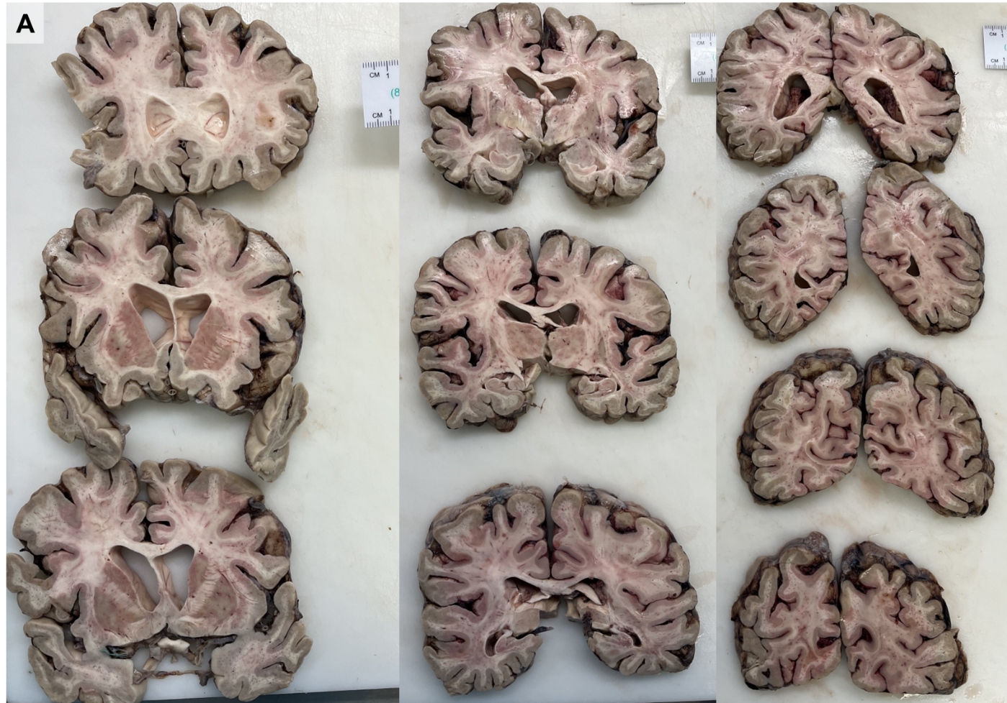

Supplementary Figure 2. Histopathological evidence of Escherichia coli sepsis and parenchymal seeding within the CNS.
(A) An H&E-stained section of the frontal white matter shows intravascular basophilic bacilliform bacterial colonies that can be visualised by light microscopy. Immunohistochemistry testing using a polyclonal antibody against Escherichia coli (see Supplementary Table 5), highlights bacterial antigens across multiple CNS regions. (B-C) Sections of the internal capsule show numerous intravascular bacilli highlighted by IHC, as well as bacterial antigens within areas of parenchymal spillage (arrows). (D-E) IHC-stained sections of the putamen show bacilli localised to the capillary wall, subendothelial spaces, and perivascular spaces.

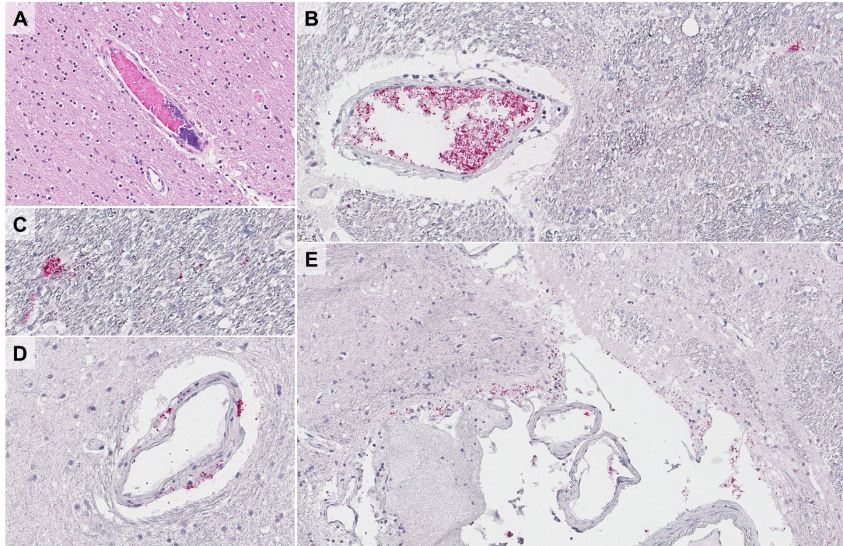

Supplementary Figure 3: Formalin-fixed paraffin-embedded tissue-optimized POTV-specific RT-PCR.
RT-PCR analysis followed by sanger sequencing shows: (A) Specific Potosi virus amplification from RNA purified from patient formalin-fixed paraffin-embedded (FFPE) tissue: (a) right frontal lobe, (b) right basal ganglia, (c) right hippocampus, (d) pons, (e) cerebellar vermis & hemisphere. (B) Blast result against Core nucleotide database using sequences from (a) identified Potosi virus at 99.28% identity. (C) Sequence alignment with Potosi virus genome identified from blast. No variations were identified among amplified sequences from the 5 tissues.

Supplementary Figure 4: Quantification of viral RNA and replication across CNS regions and subregions using machine-learning derived pixel classifiers.
(A) Representative screenshot of QuPath annotation workflow showing region-of-interest (ROI) selection and pixel-classifier–based segmentation used to derive quantitative metrics. Two machine-learning derived classifiers were calculated: the POTV RNA density (POTV_{RNA-index}), and the POTV replication density (POTV_{Rep-index}). (B) Quantification of viral signal across 75 neuroanatomical regions of the CNS using the POTV_{RNA-index}, and (C) the POTV_{Rep-index}. Values on the x-axes represent classifier-derived pixel density (pixels/µm²) for each subregion. Subregions are clustered based on major CNS regions (frontal cortex, basal ganglia, hippocampus, pons, and cerebellum). (D) Comparison of POTV_{RNA-index} and POTV_{Rep-index} across major CNS regions (frontal cortex, basal ganglia, hippocampus, pons, and cerebellum). POTV RNA density (POTV_{RNA-index}) values were significantly higher than POTV replication density (POTV_{Rep-index}) across all regions. Statistical analysis was performed using a Kruskal–Wallis test (overall p < 0.0001) followed by pairwise Mann–Whitney U tests. Significance is indicated as *p < 0.05, **p < 0.001, ***p < 0.0001. (E) Scatterplot demonstrating weak but significant correlation between POTV RNA density and POTV replication density across all sampled regions (Spearman’s r: ρ = 0·33, p = 0·0037).
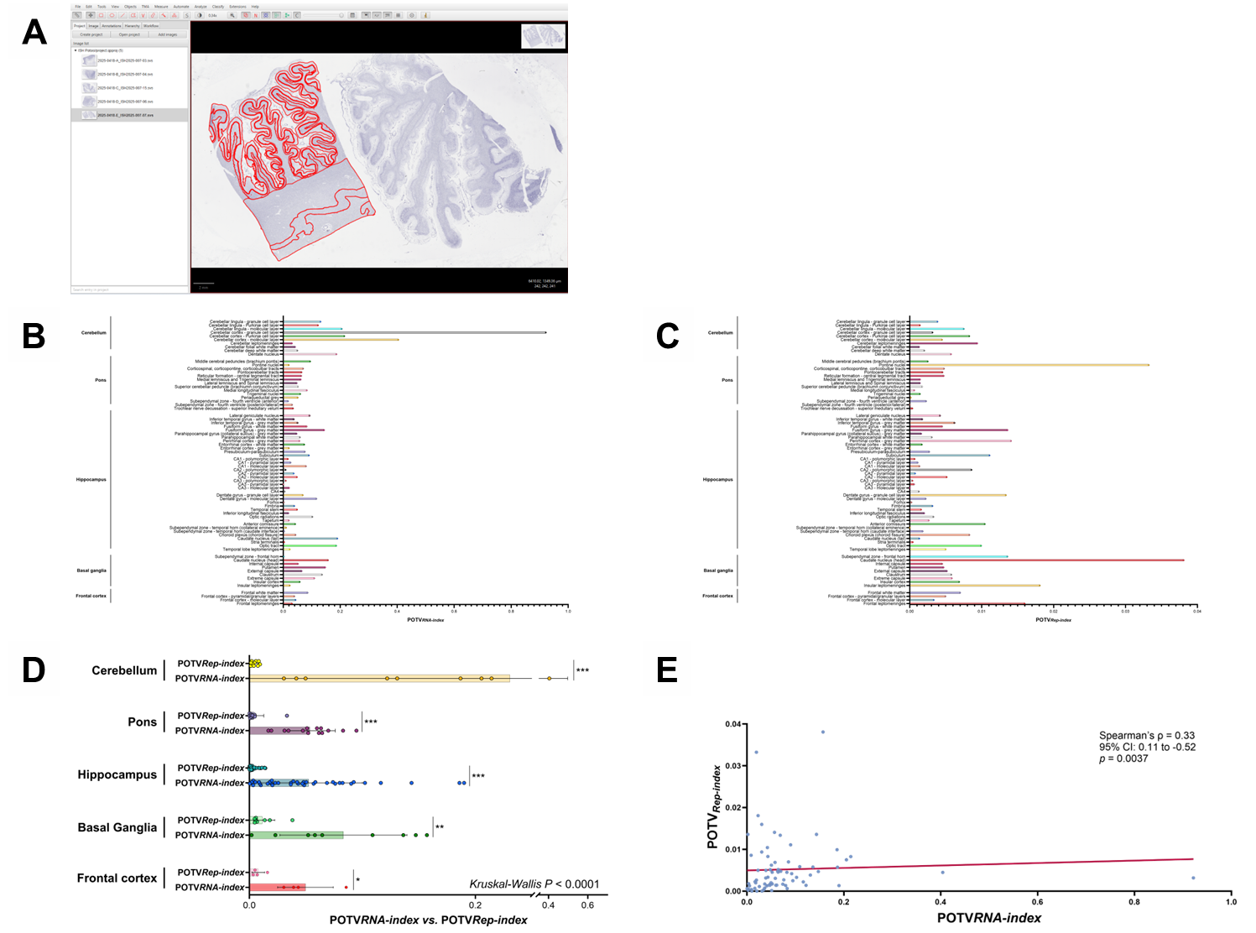

Supplementary Figure 5: Semiquantitative and quantitative histomorphometric assessment of neuroinflammation and neurodegeneration across CNS regions
(A-D) Semiquantitative and quantitative histological assessment of neuroinflammation and neurodegeneration was performed across 75 neuroanatomical regions of the CNS, using (A) a digital histomorphometric pathologist-derived score quantifying microglial density in whole slide images [Iba1_{index}], (B) a semiquantitative score detecting perineuronal inflammatory features including neuronophagia and neuronal satellitosis [NPS score], (C) a semi-quantitative score for neuronal loss [NL score], and (D) a rule-based pixel classifier used to derive a quantitative index of tissue vacuolation (Vacuolation_{index}). (E) Comparison of histomorphometric scores and indices between cerebellar subregions and all other CNS subregions.

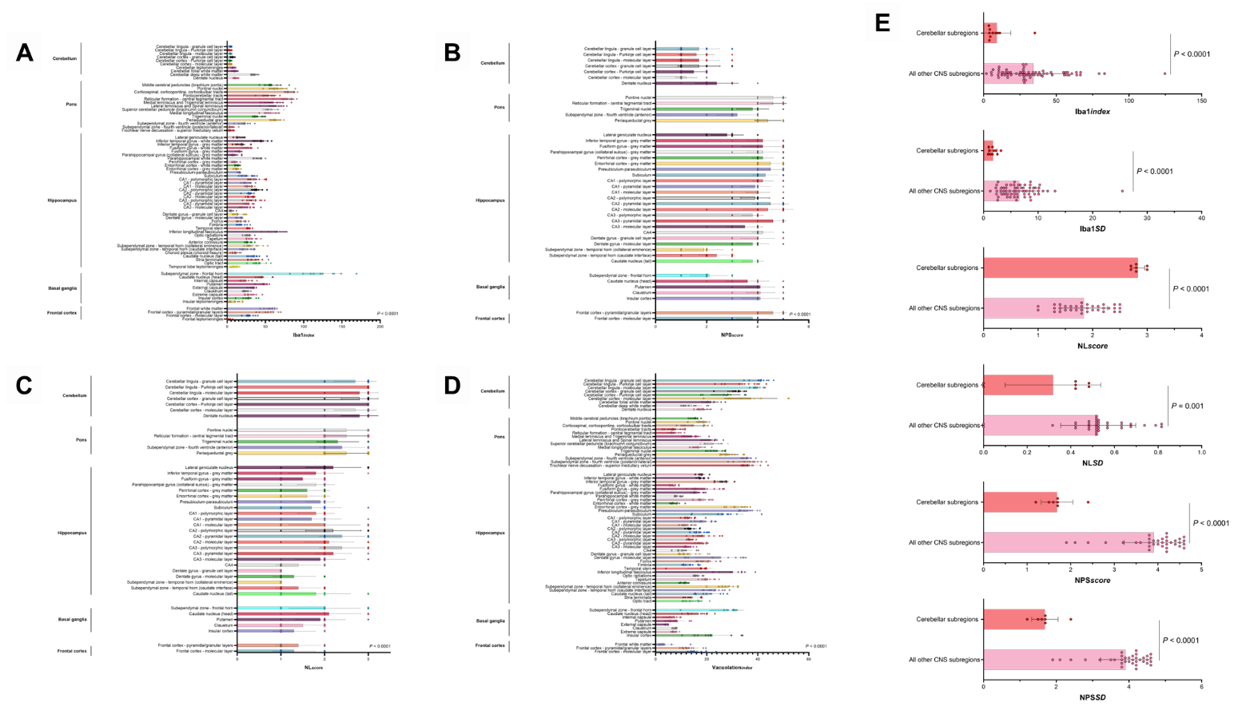

Supplementary Figure 6: POTV viral antigen dynamics across the CNS
(A–E) Immunohistochemistry using a cross-reactive monoclonal antibody against the orthobunyavirus nucleoprotein highlights strongly immunoreactive phagocytic cells in regions adjacent to cerebrospinal fluid (CSF) interfaces. These include the subependymal space along the ventricular surfaces of the lateral ventricles, including the (A) frontal horn and (B) temporal horn, as well as the (C) choroid plexus. (D–E, fusiform gyrus and frontal cortex, respectively) Immunoreactive phagocytic cells and endothelial cells are also observed within perivascular spaces throughout the CNS, including Virchow–Robin spaces (not shown). (F) Pathologist-derived quantification of viral antigen across 75 neuroanatomical regions of the CNS using the POTV_{Ag-index}. Values on the x-axis represent antigen density (immunoreactive cells per 10 high-power fields [HPF], as described in Supplementary Methods) for each subregion. Subregions are grouped by major CNS regions (frontal cortex, basal ganglia, hippocampus, pons, and cerebellum). (G–H) Comparative analyses of POTV antigen density (POTV_{Ag-index}) between CNS subregions located adjacent to, or distant from, subarachnoid spaces and ventricular surfaces demonstrate significantly higher antigen density in regions proximal to CSF interfaces (all comparisons p < 0.0001). (I–J) An antigen discordance index (AgResidual), representing residual antigen signal after accounting for regional genomic RNA and replication densities, was calculated. Comparative analyses show significantly higher AgResidual values in CNS subregions proximal to CSF interfaces compared with regions located distantly. Bar graphs depict mean POTV_{Ag-index} or AgResidual values across groups. Each dot represents the average value for an individual CNS subregion, as applicable. Statistical analyses in panels F–J were performed using the Kruskal–Wallis test for multiple comparisons, or by Mann–Whitney U tests for pairwise comparisons, as appropriate.

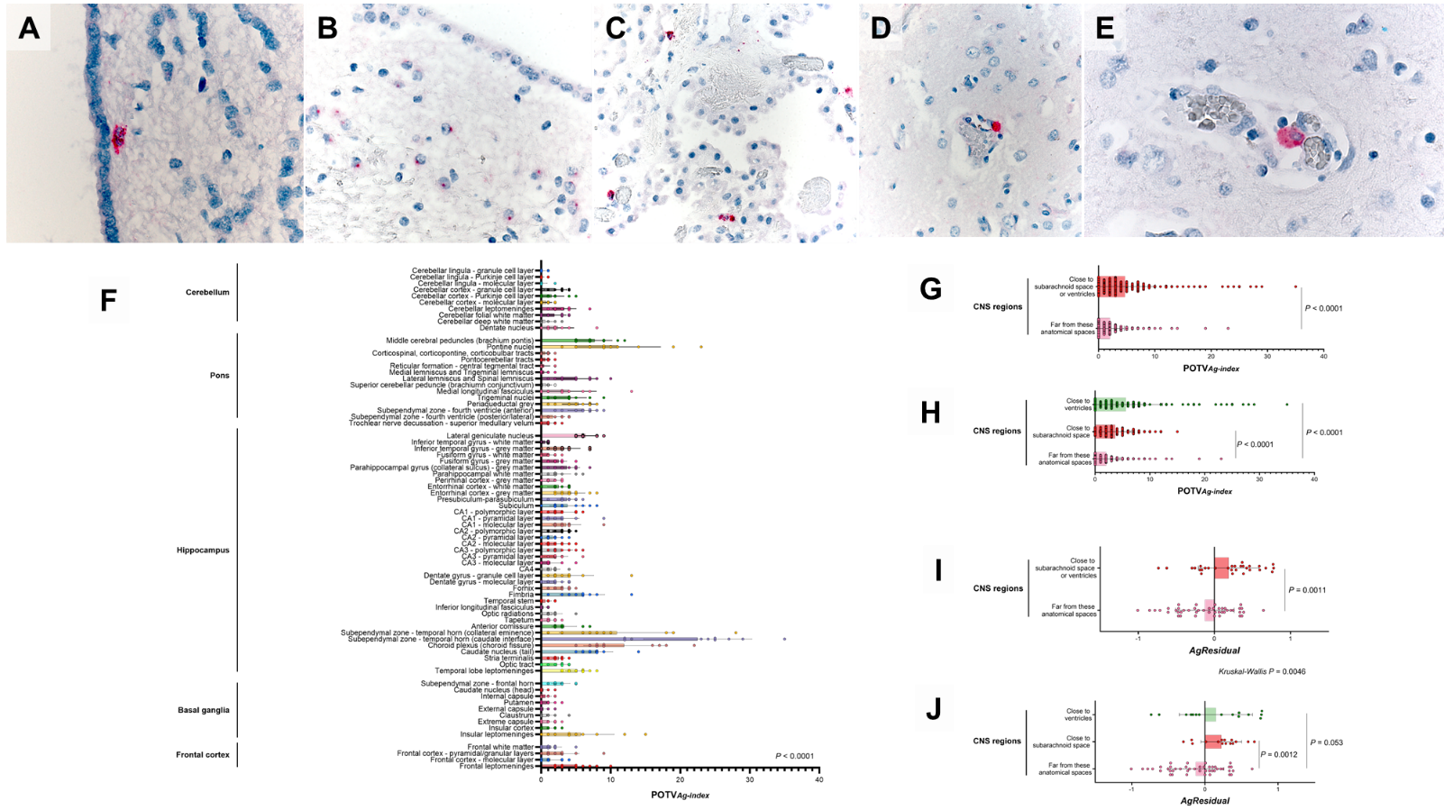

Supplementary figure 7: Marginal effects of viral burden and cellular density on vacuolation index within the Cerebellar Granule cell layer.
A marginal effects plot shows that the positive association between viral burden and vacuolation is strongest at lower cellular density and becomes progressively attenuated at higher cellular density. Predicted vacuolation index from the interaction model evaluating the relationship between viral burden and cellular density across regions of interest within the cerebellar Granule Cell layer (GCL). POTV viral density was log-transformed as log10(ISH/µm² + 1×10⁻⁶) to account for skewness and zero values. Lines represent predicted vacuolation values calculated from the fitted regression model at three representative levels of cellular density: low cellular density (mean − 1 SD), mean cellular density, and high cellular density (mean + 1 SD).

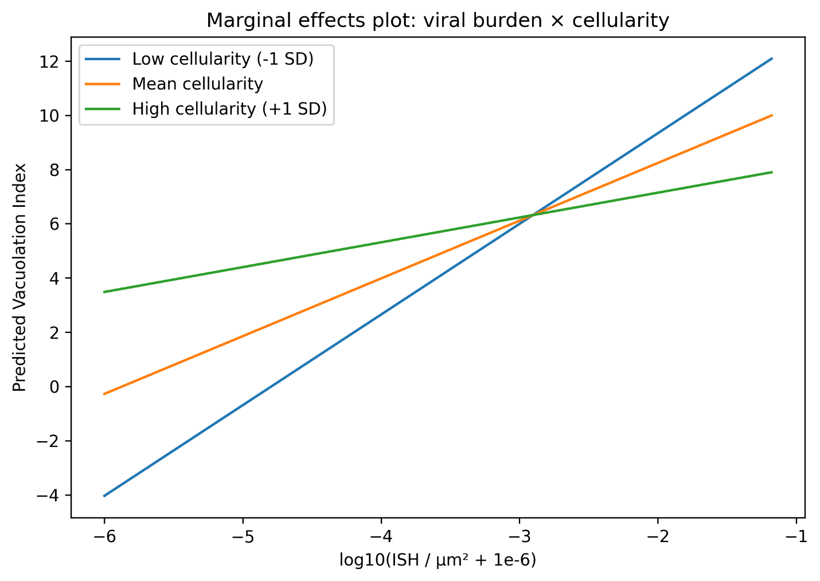

Supplementary Figure 8: Elbow plot of Ward linkage distances supporting a four-cluster solution in neuron-containing CNS regions
Elbow plot depicting Ward linkage distances across successive merge steps from hierarchical clustering of principal component scores (PC1–PC3) in neuron-containing CNS regions. The y-axis shows the Ward linkage distance (a measure of dissimilarity between merged clusters), and the x-axis represents the merge step. A pronounced inflection (“elbow”) is observed corresponding to a four-cluster solution, indicating diminishing returns in cluster separation with further merging. Based on this criterion, a four-cluster model was selected as an optimal balance between model complexity and explanatory structure, capturing major axes of histopathological variation without over-partitioning.

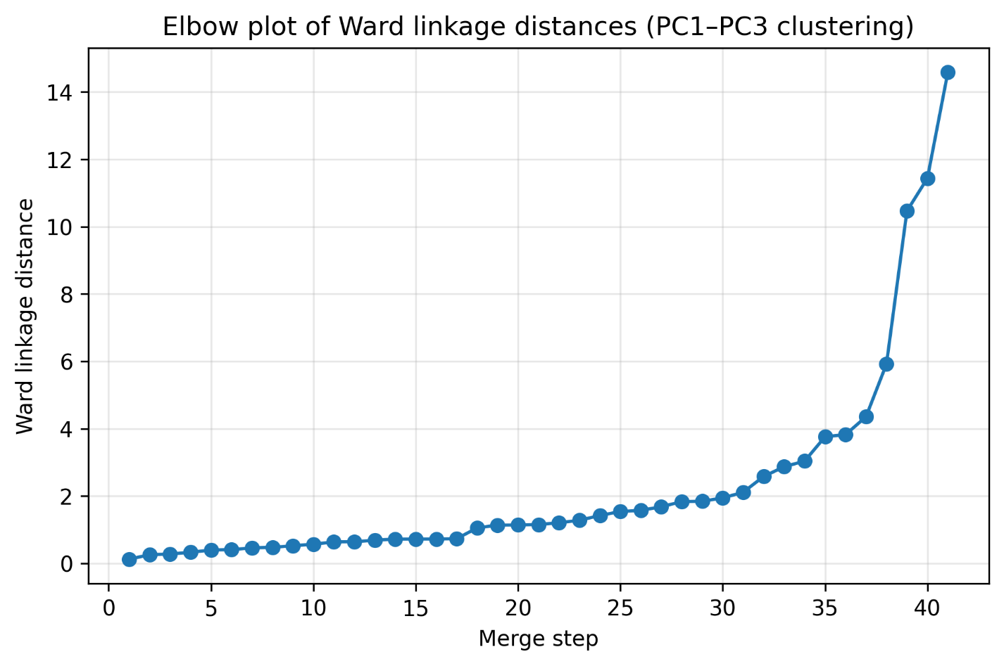

Supplementary Figure 9: Pan-CNS principal component analysis and hierarchical clustering identify three distinct histopathological compartments across all brain subregions
Hierarchical clustering identifies three histopathologically distinct tissue compartments across all parenchymal CNS subregions (n = 70; leptomeningeal subregions excluded). Quantitative histomorphometric features, including viral RNA density (ISH signals of probes targeting the S sense genomic region, POTV_{RNA-index}), viral replication density (ISH signals of probes targeting the L antisense subgenomic RNA replicative intermediates, POTV_{Rep-index}), viral antigen density and viral antigen spatial variability (POTV_{Ag-index}, and POTV_{Ag-SD}), microglial activation metrics (Iba1_{index}, and iba1_{SD}), and tissue vacuolation (Vacuolation_{index}) as a marker of neurodegeneration (see Supplementary Table 2), were subjected to principal component analysis (PCA) for dimensionality reduction (Supplementary Table 18). The first three principal components (PC1–PC3) were used for (A) unsupervised hierarchical clustering using Ward’s minimum variance method. The optimal number of clusters (k = 3) was determined by (B) linkage distance (elbow) analysis. Across CNS regions, PCA of virological and histopathological features revealed major axes of variation capturing coordinated differences in viral activity, immune response, and tissue injury. PC1, PC2, and PC3 represent distinct but partially overlapping axes of pathological variation: PC1 reflects immune activation and antigen burden (microglial activation and antigen density relative to persistent viral RNA density), PC2 captures antigen-associated tissue injury and vacuolation, and PC3 reflects replication-associated injury and spatial heterogeneity. A dendrogram (left) shows hierarchical relationships among CNS subregions and is aligned with a heatmap displaying normalized PC1–PC3 scores (z-scores) for each CNS subregion (rows). Colored bars adjacent to the heatmap indicate cluster assignments: cluster 1 (blue), cluster 2 (orange), and cluster 3 (green). The heatmap columns (PC1–PC3) reflect the relative positioning of each CNS subregion along the principal component axes and illustrate consistent intra-cluster profiles and marked inter-cluster divergence. Hierarchical clustering in the reduced PCA space (Ward method on PC1–PC3) resolved discrete CNS-wide compartments, indicating that the infection did not manifest as a single uniform pathological state across the brain. Instead, CNS subregions segregated into phenotypes characterized by distinct combinations of virological and inflammatory signatures, consistent with geographic heterogeneity and potentially distinct coexisting temporal states of infection within the CNS at the time of death. Cluster 1 (n = 16) comprises CNS subregions with features of chronic injury and persistent viral RNA, characterized by elevated viral RNA density (POTV_{RNA-index}), low viral replication density (POTV_{Rep-index}), marked tissue spongiosis (elevated Vacuolation_{index}), and relatively low microglial activation (lower Iba1_{index}, and iba1_{SD}). These regions are consistent with a post-replicative, chronic injury state. Cluster 2 (n = 3) comprises antigen-enriched compartments characterized by high viral antigen density and spatial variability (POTV_{Ag-Index}, and POTV_{Ag-SD}) without proportionally elevated viral RNA. These regions likely represent sites of viral clearance with prominent phagocytic activity, often adjacent to CSF interfaces, or in areas with increased neuronophagia (e.g., pontine nuclei). Cluster 3 (n = 51) comprises replication-active inflammatory compartments, with higher viral replication (POTV_{Rep-index}), increased microglial activation (higher Iba1_{index}, and iba1_{SD}), and moderate viral RNA density (POTV_{RNA-index}). These regions likely reflect replication-permissive neuroimmune interaction zones.

