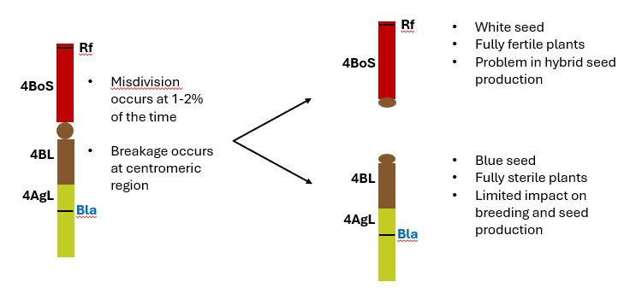

Extended Data Fig. 1 Illustration showing misdivision of the BLA chromosome at centromere, resulting in white fertile and blue sterile seed.

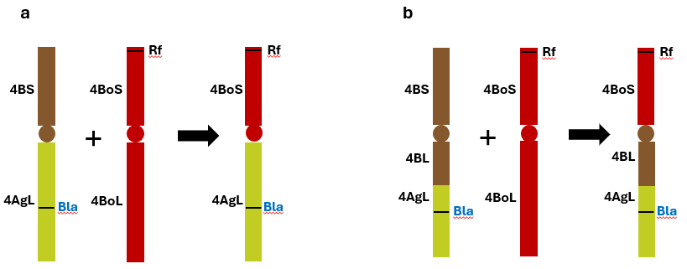

Extended Data Fig. 2 Models on the generation of BLA chromosome. a, The BLA chromosome generation through Robertsonian translocation between a whole-arm translocation T4BS.4AgL and chromosome 4Bo of Triticum boeoticum proposed by Li (2023). b, The correct model of BLA chromosome development where T4BoS.4BL-4AgL was generated through Robertsonian translocation between a translocation of T4BS.4BL-4AgL and chromosome 4Bo of T. boeoticum.

Extended Data Fig. 3 Markers for the BLA system. a, Marker 4BS-HX detects the Probus deletion. Agarose gel showing the bands amplified on Chinese Spring (CS; wildtype), CS Nulli-Tetra (NT) group 4 lines, blue fertile lines (Probus homozygous plant with BLA chromosome), white sterile lines (Probus homozygous plant without BLA chromosome), and white fertile lines (no Probus deletion). b, A QIAxcel gel image showing segregation of Probus and BLA chromosome in six progenies of BLA backcross lines (BC₁F₂) using markers 4BS-HX, ThMYC4E, and Rf-Ms1. c, Electropherogram of QIAxcel image of samples B6, B7, and B8 in b. Marker 4BS-HX can identify the homozygous Probus (B6, no 4BS-HX peak), the heterozygous Probus (B8, the 4BS-HX peak is lower than the 50% of the 4A,4D-HX peak), and the wildtype without Probus deletion (B7).

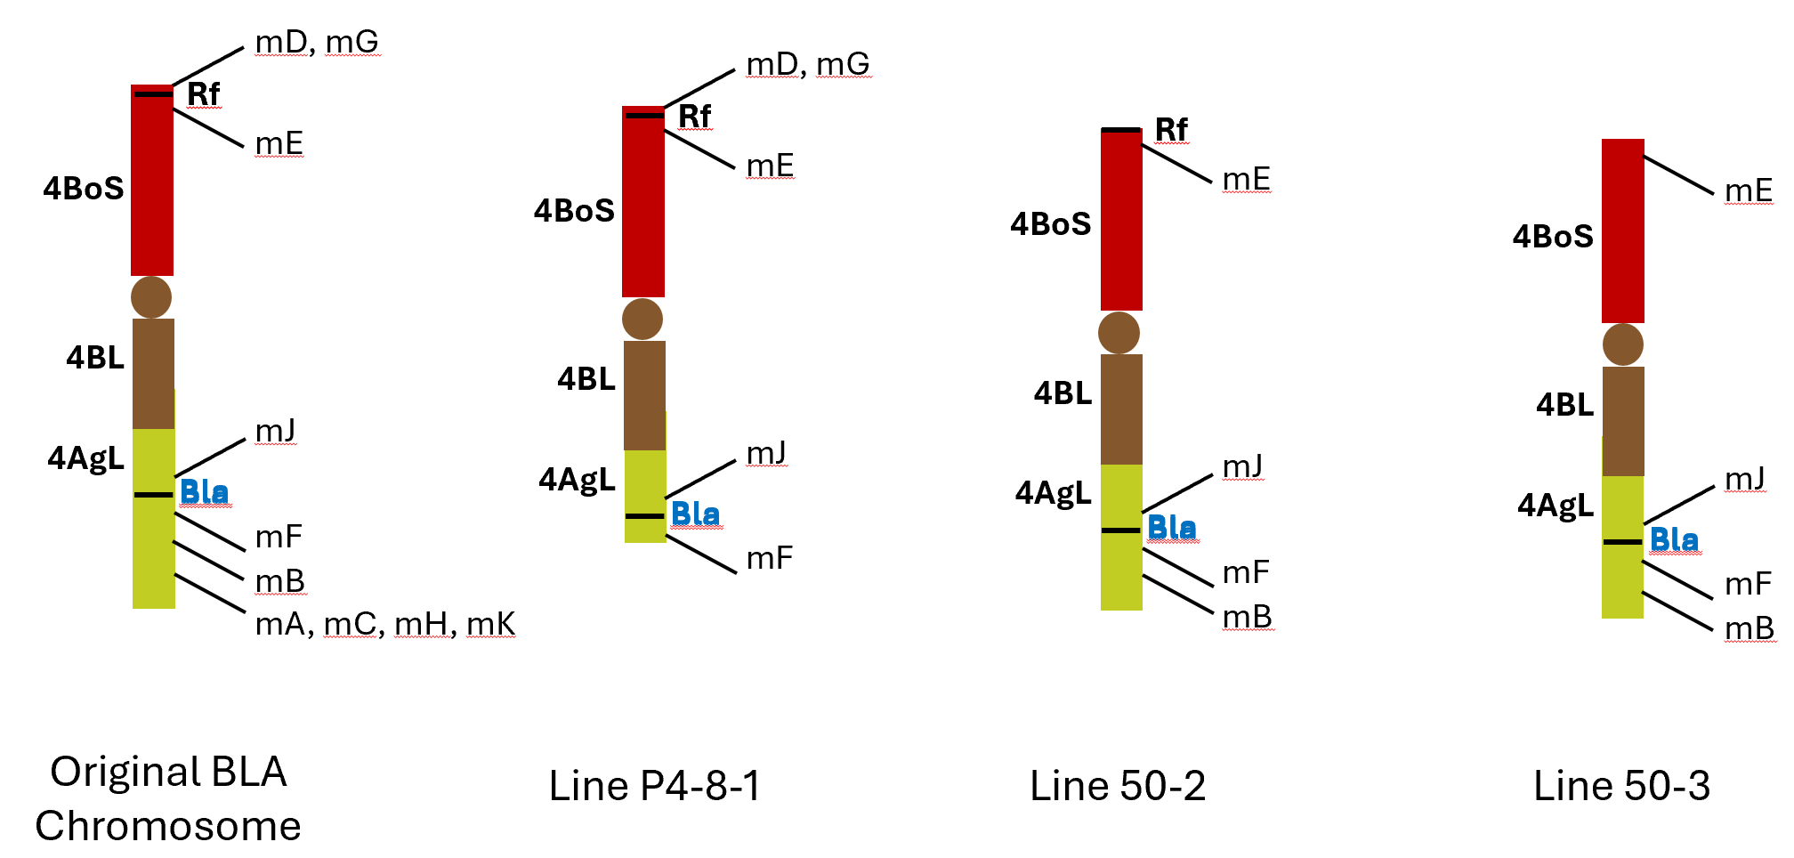

Extended Data Fig. 4 Alien specific markers A to K. BLA lines (original and deletion lines*), confirmed by cytology and phenotyping, were screened using alien-specific markers A to K. The approximate locations of these markers were determined. Note: Marker F could be on either side of the blue aleurone gene; it is co-segregating with blue phenotype. *Deletion lines were generated from homoeologous recombination under the ph1b condition. The chromosome structures were confirmed by FISH and GISH cytological analyses and molecular markers. Phenotyping determined the presence or absence of blue color locus.

Extended Data Fig. 5 Genotyping of the BLA elements in IR349 and the original BLA. a, Five IR349 sister lines and the original BLA line contain Rf-Ms1, the Probus deletion, and the three-gene cluster. Chinese Spring does not have any of them. Co-dominant markers were used for these three elements. b, Both MYC616 and MYB618 are present in five IR349 sister lines and the original BLA line. Gene specific markers were used for these two genes.

Extended Data Table 1. Types and frequencies of progeny from self-pollinating a monosomic addition line
Eggs | Pollen
Eggs | 21 chromosomes | 22 chromosomes
Eggs | 96% (81-99) | 4% (1-19)
21 chromosomes | 42 chromosomes (white) | 43 chromosomes (single blue)
75% (61-86) | 72% (49-85) | 3% (0.6-16)
22 chromosomes | 43 chromosomes (single blue) | 44 chromosomes (double blue)
25% (14-39) | 24% (11-39) | 1% (0.1-7)
Modified after Morris and Sears³⁹

Extended Data Table 2. Summary of oligo design on the four key BLA system loci
Locus | Chromosome Region | Probe Count | True Range (nt) | Probe Density  (Probes/kb)
Locus_1_Ms1 | chrBLA:3132784-3234532 | 778 | 94,454 | 8.24
Locus_2_3-gene cluster | chrBLA:479952968-480157005 | 451 | 202,017 | 2.23
Locus_3_MYC_616 | chrBLA:616586904-616689632 | 390 | 102,376 | 3.81
Locus_4_MYB_618 | chrBLA:617970289-618071327 | 266 | 95,088 | 2.8

Extended Data Table 3. Probus related SNPs and their corresponding genomic positions.
Index on iSelect 90K SNP bead chip | SNP id | SNP name | Position in Probus | Position on 4B (bp) (IWGSC RefSeq v1.0)
32857 | IWB32857 | GENE-2267_230 | outside deletion | 10,591,726
69062 | IWB69062 | Tdurum_contig25403_648 | inside deletion | 11,675,463
33641 | IWB33641 | GENE-3866_301 | inside deletion | 12,230,352
80662 | IWA7268 | wsnp_Ku_c7180_12403155 | inside deletion | 12,891,978
34257 | IWB34257 | GENE-4933_1085 | inside deletion | 14,122,723
73600 | IWB73600 | Tdurum_contig82942_681 | inside deletion | 15,416,556
49194 | IWB49194 | Kukri_rep_c106598_114 | inside deletion | 16,056,985
27329 | IWB27329 | Excalibur_c52594_88 | outside deletion | 16,059,211

Extended Data Table 4. Primers for molecular markers.
Marker Name | Primer Name | Primer Sequence (5' to 3') | Marker Type
Probus | 4BS-HX-F2 | GCTCGTTGTCTTCATGCC | Codominant
 | 4BS-HX-R2 | AGCTTCTCGTCCTTCTAAGC
Rf-Ms1 | Ms1BoEx3-F2 | GCCGCGGCGACCTCGT | Specific
 | Ms1m-R | ACTCAGAGGATGAGGTAGAGGCCGAT
ThMYC4E | ThMYC4ESpF | CTCCCAGTCAGGAACAGC | Specific
 | ThMYC4ESpR | GGTGACAGTGAGGCGGTT
Alien_mA | 5565329F | TGCAGTGATCCCGATGCCG | Specific
 | 5565329R | CTCGGTGCGATGTGTGG
Alien_mB | 5570804F | TGCAGGATTTTCCACTGATTAAC | Specific
 | 5570804R | CGGAGGTGGTACGCGGTG
Alien_mC | 5564956F | TGCAGAACTACCAGAATCTTTATCGG | Specific
 | 5564956R | CTGTGAAACCAAGCACCCATAATC
Alien_mD | 5008421F | TGCAGAGCAAGAGCAACATTCAA | Specific
 | 5008421R | CGGTCAATGTATAAACCACGTGC
Alien_mE | 3573220F | TGCAGTCAGTCAACGATGG | Specific
 | 3573220R | GTCTCACGTGCAGCGCA
Alien_mF | 5565375F | TGCAGTTTCTATCATGTCCACG | Specific
 | 5565375R | ATCTCGGGTTTATCTTCAGGG
Alien_mG | 1861695F | TGCAGGTGTGCTACTTAGGGC | Specific
 | 1861695R | CGGACCTTGCCCTGAGGAG
Alien_mH | 5571044F | TGCAGTGGAAAGTGCGGC | Specific
 | 5571044R | CGGTAGATAGAAGATGAGACTTTACC
Alien_mJ | 5570850F | TGCAGGCGGTCCTGGACAGG | Specific
 | 5570850R | CGGCCGCCCTCACCACAC
Alien_mK | 5565089F | TGCAGCATTGGCAAATAACAC | Specific
 | 5565089R | GGTTGCATTCTCTGTGTATCAC
Rf-Ms1-CD | Rf-CD-F335: | CGAAGGTACGCGCACG | Codominant
 | Rf-CD-R740: | AGCAGGCAAATACCATAGTCGAAC
3-gene-CD | F35H-CD-F919: | CTAGGGTAAACCACACACACATAC | Codominant
 | F35H-CD-R1088: | CGCCGTGAACAGGTTCTG
IWA7268 (Probus) | 7268-Allele X | GAAGGTGACCAAGTTCATGCTAGGGCTAAAGCAATAACTGGGAAATT | KASP
 | 7268-Allele Y | GAAGGTCGGAGTCAACGGATTGGGCTAAAGCAATAACTGGGAAATC
 | 7268-Common | ATCGGCTATGACAAGTACATGGAATTCAT
IWB34257 (Probus) | 34257-Allele X | GAAGGTGACCAAGTTCATGCTAATTCTTCTGATGTTAATGCTTATATTTTACTA | KASP
 | 34257-Allele Y | GAAGGTCGGAGTCAACGGATTAATTCTTCTGATGTTAATGCTTATATTTTACTG
 | 34257-Common | ACAACATTTTCACACATTTTGAGTTCTGTA
 | SC_76_MYB480 F | CGAAGACAAAATGGCGAAGGAAGGGGTGAAGA | Cloning
 | SC_77_MYB480 R | CGAAGACAAAAGCTTAACTCGATGATGTGTGAGAGTTGG | MYB480
 | SC_78_MYB618 F | CGAAGACAAAATGGGGAGGATGGCGAAGGAA | Cloning
 | SC_79_MYB618 R | CGAAGACAAAAGCTTAATCCGGCATCTCCACAGAGTTTA | MYB618
 | SC_80_MYC480 F1 | CGAAGACAAAATGCGGGAAATAGCTACTCAGCAG | Cloning
 | SC_81_MYC480 R1 | CGAAGACAATGATCCATCTATCTTCGAGAGGATG | MYC480
 | SC_82_MYC480 F2 | CGAAGACAAATCATGGACGAGCCCTTTGAGTTTA
 | SC_83_MYC480 R2 | CGAAGACAACTCCCGGCGCCTTCTCTC
 | SC_84_MYC480 F3 | CGAAGACAAGGAGAAACTCAACGAGATGTTCCTG
 | SC_85_MYC480 R3 | CGAAGACAAAAGCCTATATAGCTTTCTGAAGCGCTTCGGT
 | SC_86 MYC616 F1 | CGAAGACAAAATGCGGGAAATAGCTACTCAGCG | Cloning
 | SC_87_MYC616 R1 | CGAAGACAACTCCCGGCGCCTTCTCTCT | MYC616
 | SC_88_MYC616 F2 | CGAAGACAAGGAGAAACTCAACGAGATGTTCCTG
 | SC_89_MYC616 R2 | CGAAGACAAAAGCCTATATAGCTTTCTGAAGTGTTTCGGTGAT

