Extended Data Fig.1 Support for the invasion-related hypotheses across spatial scales.
Summary matrix showing support for the three invasion-related hypotheses across global, biogeographic realm, and Palearctic ecoregion scales. H1 (masking) tests whether invasion obscures the classical positive diversity–stability relationship; H2 (destabilization) tests whether invasion reduces temporal community stability; and H3 (reshaping) tests whether invasion modifies the slope or form of the diversity–stability relationship. Cells are coded using both colour and symbols: ● indicates statistically significant support, ○ indicates patterns consistent with the hypothesis but not statistically significant, and – indicates no support. Support categories are based on predefined model comparisons using likelihood-ratio tests and ΔAIC (see Methods and Extended Data Tables 1–4; Supplementary Tables 3–30).

Extended Data Fig.2 Principal component analysis of diversity metrics.
Three Hill diversity metrics were calculated for each time series, based on the temporal mean across annual community observations: species richness (q = 0), the exponential of Shannon diversity (q = 1), and the inverse Simpson diversity (q = 2). These metrics were summarized using principal component analysis (PCA) on standardized variables. a, Contribution of each diversity metric to the first principal component (PC1). The red dashed line indicates the expected average contribution under equal weighting. b, Correlation circle showing the relationships of the three diversity metrics with the first two principal components. All three metrics loaded strongly and positively on PC1, indicating that they captured a common underlying diversity gradient. DiversityPCA1 was therefore used as the multivariate diversity axis in subsequent analyses.
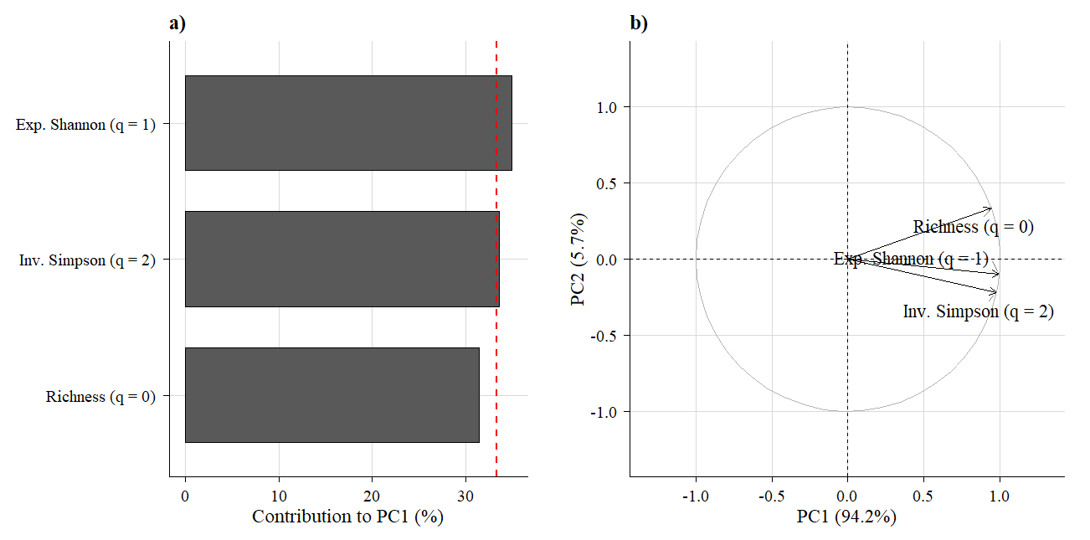
Extended Data Fig.3 Principal component analysis of invasion descriptors.
Invasion intensity within invaded communities was summarized using five descriptors: the overall ratio of non-native to native species richness pooled across the full time series, the mean annual proportion of non-native abundance, the temporal range in non-native abundance proportion, the temporal variance in non-native abundance proportion, and the temporal trend in non-native abundance proportion estimated as the slope of a linear regression against calendar year. These descriptors were summarized using principal component analysis (PCA) on standardized variables. a, Contribution of each invasion descriptor to the first principal component (PC1). The red dashed line indicates the expected average contribution under equal weighting. b, Correlation circle showing the relationships of the invasion descriptors with the first two principal components. Together, these variables captured complementary aspects of invasion, including taxonomic dominance, numerical dominance, and temporal dynamics. InvasionPCA1 was therefore used as the continuous invasion-intensity gradient in subsequent analyses.
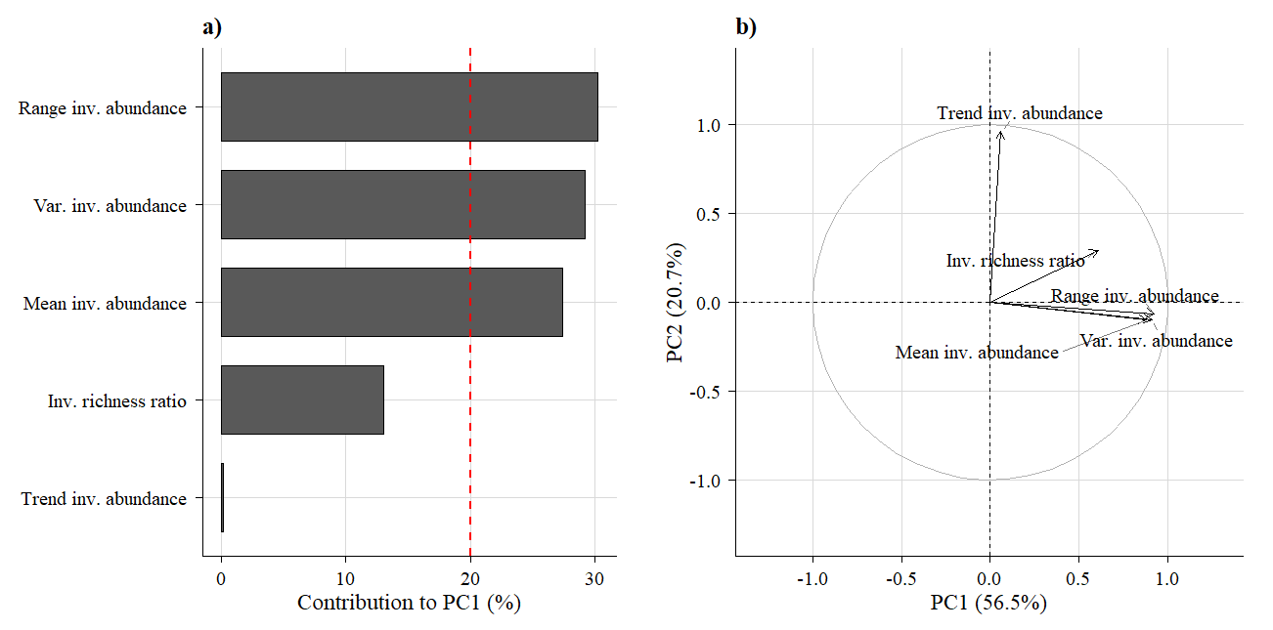

Extended Data Table.1 Global model comparisons for invasion-state GAMs.
Global generalized additive models (GAMs) testing whether invasion state alters biodiversity–stability relationships across all communities. Models correspond to those defined in the Methods: m0, diversity only; m1, diversity plus invasion state; m2, invasion-state-specific diversity smooths plus invasion state; and m3, invasion-state-specific diversity smooths plus invasion state and biogeographic realm as a random-effect smooth. Panel a reports overall model fit statistics, including Akaike’s Information Criterion (AIC), ΔAIC relative to the best-supported model in this table, residual degrees of freedom, and residual deviance. Panel b reports likelihood-ratio tests for sequential comparisons between nested models. ΔAIC values are calculated relative to the best-supported model within each table (ΔAIC = AIC_model − AIC_min). These comparisons test whether invasion state alters the form of biodiversity–stability relationships and whether incorporating biogeographic context improves model fit. In all tables, Stability denotes temporal community stability (TCS), Diversity denotes Diversity_{PCA1}, and Invasion_gradient denotes Invasion_{PCA1}.
a, Model fit statistics
Model | Formula | df | AIC | ΔAIC | Resid_df | Resid_dev
m0 | Stability ~ s(Diversity) | 5.9585 | 6971.258 | 60.2053 | 3519.266 | 1486.703
m1 | Stability ~ s(Diversity) + Invasion_state | 6.9553 | 6973.048 | 61.9957 | 3518.277 | 1486.617
m2 | Stability ~ s(Diversity, by = Invasion_state) + Invasion_state | 10.0426 | 6940.632 | 29.5796 | 3515.402 | 1470.426
m3 | Stability ~ s(Diversity, by = Invasion_state) + Invasion_state + s(BioRealm, bs = "re") | 13.0004 | 6911.052 | 0 | 3512.746 | 1455.69
b, Sequential model comparisons
Comparison | Df_diff | Dev_diff | P_value
m0 vs m1 | 1.004 | 0.08571 | 0.651
m1 vs m2 | 3.299 | 16.19 | 2.6E-08
m2 vs m3 | 3.509 | 14.74 | 1.88E-07
Extended Data Table.2 Global model outputs for invasion-state GAMs.
Global generalized additive models (GAMs) testing whether invasion state alters biodiversity–stability relationships across all communities. Models correspond to those defined in the Methods: m0, diversity only; m1, diversity plus invasion state; m2, invasion-state-specific diversity smooths plus invasion state; m3, invasion-state-specific diversity smooths plus invasion state and biogeographic realm as a random-effect smooth; and m4, pooled diversity smooth plus invasion-state-specific deviations from the pooled relationship. Panel a reports parametric coefficients for linear terms. Panel b reports the significance of smooth terms, including estimated degrees of freedom (edf), reference degrees of freedom (Ref.df), F statistics, and approximate P values. Panel c reports overall model fit statistics. In m4: Stability ~ s(Diversity) + s(Diversity, by = Invasion_state), significant deviation of the non-invaded smooth but not the invaded smooth indicates that the pooled global relationship is more similar to the invaded pattern than to the non-invaded pattern.
a, Parametric coefficients
Model | Term | Estimate | Std_Error | Statistic | P_value
m0 | (Intercept) | 1.621 | 0.01095 | 148.1 | <1E-16
m1 | (Intercept) | 1.614 | 0.01685 | 95.82 | <1E-16
m1 | Invasion_state (invaded) | 0.01577 | 0.02906 | 0.5429 | 0.5873
m2 | (Intercept) | 1.76 | 0.03521 | 49.99 | <1E-16
m2 | Invasion_state (invaded) | -0.0869 | 0.0414 | -2.099 | 0.03588
m3 | (Intercept) | 1.789 | 0.1095 | 16.34 | <1E-16
m3 | Invasion_state (invaded) | -0.09821 | 0.04211 | -2.332 | 0.01974
m4 | (Intercept) | 1.691 | 0.01701 | 99.41 | <1E-16
b, Smooth-term significance
Model | Term | edf | Ref_df | F | P_value
m0 | s(Diversity) | 3.734 | 3.959 | 7.294 | 5.49E-06
m1 | s(Diversity) | 3.723 | 3.955 | 7.168 | 6.64E-06
m2 | s(Diversity): Invasion_state (non-invaded) | 2.787 | 3.065 | 11.22 | 6.32E-07
m2 | s(Diversity): Invasion_state (invaded) | 3.811 | 3.978 | 8.993 | 1.38E-06
m3 | s(Diversity): Invasion_state (non-invaded) | 2.852 | 3.113 | 12.49 | <1E-16
m3 | s(Diversity): Invasion_state (invaded) | 3.79 | 3.972 | 10.14 | 2.66E-07
m3 | s(BioRealm, bs = "re") | 2.613 | 4 | 8.214 | <1E-16
m4 | s(Diversity) | 3.851 | 3.987 | 15.32 | <1E-16
m4 | s(Diversity): Invasion_state (non-invaded) | 1.002 | 1.004 | 27.9 | 9.06E-07
m4 | s(Diversity): Invasion_state (invaded) | 0.005773 | 0.01058 | 0.02271 | 0.9876
c, Model fit summary
Model | Adj_R2 | Deviance_explained | REML | Scale | n
m0 | 0.008877 | 0.009927 | 3493 | 0.4224 | 3524
m1 | 0.008656 | 0.009985 | 3495 | 0.4225 | 3524
m2 | 0.01865 | 0.02077 | 3482 | 0.4183 | 3524
m3 | 0.02775 | 0.03058 | 3470 | 0.4144 | 3524
m4 | 0.01705 | 0.01841 | 3480 | 0.419 | 3524

Extended Data Table.3 Global model comparisons for invasion-intensity GAMs within invaded communities.
Generalized additive models (GAMs) fitted to invaded communities only, testing whether invasion intensity modifies biodiversity–stability relationships. Models correspond to those defined in the Methods: m5, diversity only; m6, additive smooths of diversity and invasion intensity; m7, additive smooths plus a diversity × invasion-intensity interaction surface; and m8, the same interaction model including biogeographic realm as a random-effect smooth. Panel a reports overall model fit statistics, including Akaike’s Information Criterion (AIC), ΔAIC relative to the best-supported model in this table, residual degrees of freedom, and residual deviance. ΔAIC values are calculated relative to the best-supported model within each table (ΔAIC = AIC_model − AIC_min). Panel b reports likelihood-ratio tests for sequential comparisons between nested models. These comparisons were used to evaluate whether invasion intensity explains additional variation in temporal community stability, whether invasion intensity reshapes the diversity–stability relationship, and whether biogeographic context further improves model fit.
a, Model fit statistics
Model | Formula | df | AIC | ΔAIC | Resid_df | Resid_dev
m5 | Stability ~ s(Diversity) | 5.9577 | 3147.897 | 67.5506 | 1548.268 | 684.9681
m6 | Stability ~ s(Diversity) + s(Invasion_gradient) | 9.1677 | 3120.375 | 40.0287 | 1545.58 | 670.16
m7 | Stability ~ s(Diversity) + s(Invasion_gradient) + te(Diversity, Invasion_gradient) | 15.7539 | 3114.542 | 34.1954 | 1540.363 | 662.0086
m8 | Stability ~ s(Diversity) + s(Invasion_gradient) + te(Diversity, Invasion_gradient) + s(BioRealm, bs = "re") | 17.1198 | 3080.346 | 0 | 1539.313 | 646.453
b, Sequential model comparisons
Comparison | Df_diff | Dev_diff | P_value
m5 vs m6 | 3.733 | 14.81 | 2.92E-07
m6 vs m7 | 7.955 | 8.151 | 0.01249
m7 vs m8 | 1.682 | 15.56 | 5.04E-09
Extended Data Table.4 Global model outputs for invasion-intensity GAMs within invaded communities.
Generalized additive models (GAMs) fitted to invaded communities only, testing whether and how invasion intensity influences biodiversity–stability relationships. Models correspond to those defined in the Methods: m5, diversity only; m6, additive smooths of diversity and invasion intensity; m7, additive smooths plus a diversity × invasion-intensity interaction surface; and m8, the same interaction model including biogeographic realm as a random-effect smooth. Panel a reports parametric coefficients for linear terms. Panel b reports the significance of smooth terms, including estimated degrees of freedom (edf), reference degrees of freedom (Ref.df), F statistics, and approximate P values. Panel c reports overall model fit statistics. In the interaction models, the tensor-product smooth te(Diversity, Invasion intensity) captures whether the effect of biodiversity on temporal community stability changes across the invasion gradient.
a, Parametric coefficients
Model | Term | Estimate | Std_Error | Statistic | P_value
m5 | (Intercept) | 1.615 | 0.01688 | 95.66 | <1E-16
m6 | (Intercept) | 1.615 | 0.01671 | 96.63 | <1E-16
m7 | (Intercept) | 1.615 | 0.01664 | 97.06 | <1E-16
m8 | (Intercept) | 1.627 | 0.1353 | 12.03 | <1E-16
b, Smooth-term significance
Model | Term | edf | Ref_df | F | P_value
m5 | s(Diversity) | 3.732 | 3.958 | 6.053 | 4.97E-05
m6 | s(Diversity) | 3.736 | 3.958 | 7.812 | 4.05E-05
m6 | s(Invasion_gradient) | 2.684 | 3.209 | 10 | 1.84E-06
m7 | s(Diversity) | 1 | 1.001 | 0.8417 | 0.3593
m7 | s(Invasion_gradient) | 2.852 | 3.312 | 2.973 | 0.03211
m7 | te(Diversity, Invasion_gradient) | 7.785 | 9.441 | 4.025 | 3.11E-05
m8 | s(Diversity) | 1.001 | 1.001 | 1.847 | 0.1748
m8 | s(Invasion_gradient) | 1.022 | 1.034 | 7.508 | 0.006534
m8 | te(Diversity, Invasion_gradient) | 7.958 | 9.842 | 4.804 | 5.63E-07
m8 | s(BioRealm, bs = "re") | 2.707 | 4 | 10.6 | <1E-16
c, Model fit summary
Model | Adj_R2 | Deviance_explained | REML | Scale | n
m5 | 0.01669 | 0.01905 | 1580 | 0.4424 | 1553
m6 | 0.03627 | 0.04026 | 1569 | 0.4336 | 1553
m7 | 0.04477 | 0.05193 | 1566 | 0.4298 | 1553
m8 | 0.06658 | 0.07421 | 1549 | 0.42 | 1553

