Supplementary material for:

Cudney-Valenzuela et al. Scale dependency of arboreal mammals’ responses to landscape spatial changes in a fragmented rainforest. Landscape Ecology

Table S1. Species-specific body mass range. All weights were obtained from Ceballos and Oliva (2006)ª
Common name | Species | Weight (g)
Black howler monkey | Alouatta pigra | 5500 - 8000
Geoffroy’s Spider monkey | Ateles geoffroyi | 5740 - 6880
Northern tamandua | Tamandua mexicana | 3200 - 7000
White-nosed coati | Nasua narica | 4000 - 6000
Kinkajou | Potos flavus | 1400 - 4600
Mexican hairy dwarf porcupine | Coendou mexicanus | 1500 - 3000
Common opossum | Didelphis marsupialis | 565 - 1610
Gray squirrel | Sciurus aureogaster | 432 - 690
Gray four-eyed opossum | Philander opossum | 300 - 600
Wooly opossum | Caluromys derbianus | 245 - 370
Deppe’s squirrel | Sciurus deppei | 200 - 300
Mexican mouse opossum | Marmosa mexicana | 29 - 92
ªCeballos G, Oliva G (2006) Los mamíferos silvestres de México. Comisión Nacional para el Conocimiento y Uso de la Biodiversidad. Fondo de Cultura Económica. Ciudad de México, México.

Table S2. Percentage of explained deviance and SoE of each mammal-landscape association for each landscape variable. AIC = Akaike Information Criterion. AIC null = AIC value of the null model. Models with a ΔAIC > 2 with the null model are marked in bold.
Species | Landscape metric | Scale of Efect | Explained deviance (%) | AIC | AIC null
Alouatta pigra | Forest Cover | 1100 | 28.8 | 85.42 | 96.62
 | Matrix Openness | 200 | 2.33 | 97.55
 | Patch Density | 600 | 0.95 | 98.18
 | Edge Density | 1200 | 8.01 | 94.48
Ateles geoffroyi | Forest Cover | 500 | 13.68 | 82.08 | 87.97
 | Matrix Openness | 1300 | 3.88 | 87.73
 | Patch Density | 1000 | 30.45 | 72.42
 | Edge Density | 1300 | 42.43 | 65.52
Caluromys derbianus | Forest Cover | 600 | 12.99 | 79.81 | 80.9
 | Matrix Openness | 1300 | 6.14 | 81.44
 | Patch Density | 200 | 46.45 | 72.18
 | Edge Density | 200 | 15.21 | 78.1
Coendou mexicanus | Forest Cover | 200 | 4.84 | 61.29 | 60.64
 | Matrix Openness | 400 | 16.74 | 57.97
 | Patch Density | 300 | 9.91 | 59.87
 | Edge Density | 1300 | 16.91 | 57.92
Didelphis marsupialis | Forest Cover | 400 | 1.44 | 58.66 | 56.79
 | Matrix Openness | 300 | 10.13 | 57.89
 | Patch Density | 1000 | 18.21 | 57.17
 | Edge Density | 1000 | 34.35 | 55.74
Marmosa mexicana | Forest Cover | 200 | 1.52 | 67.9 | 66.18
 | Matrix Openness | 200 | 6.82 | 66.93
 | Patch Density | 200 | 4.01 | 67.45
 | Edge Density | 1300 | 11.58 | 66.07
Nasua narica | Forest Cover | 200 | 2.22 | 54.25 | 52.85
 | Matrix Openness | 400 | 4.8 | 53.56
 | Patch Density | 300 | 7.32 | 52.87
 | Edge Density | 200 | 5.63 | 53.33
Philander opossum | Forest Cover | 200 | 14.78 | 68.16 | 72.08
 | Matrix Openness | 1300 | 3.52 | 72.67
 | Patch Density | 1000 | 22.6 | 65.02
 | Edge Density | 1300 | 32.12 | 61.22
Potos flavus | Forest Cover | 400 | 41.8 | 82.31 | 89.93
 | Matrix Openness | 500 | 19.93 | 87.34
 | Patch Density | 400 | 28.79 | 85.3
 | Edge Density | 400 | 28.79 | 85.48
Sciurus aureogaster | Forest Cover | 700 | 32.79 | 57.62 | 60.77
 | Matrix Openness | 1000 | 2.53 | 62.37
 | Patch Density | 200 | 26.26 | 58.65
 | Edge Density | 200 | 15.6 | 60.32
Sciurus deppei | Forest Cover | 700 | 5.52 | 108.39 | 108.67
 | Matrix Openness | 700 | 20.82 | 102.06
 | Patch Density | 400 | 2.73 | 109.54
 | Edge Density | 400 | 3.87 | 109.07
Tamandua mexicana | Forest Cover | 500 | 50.32 | 40.72 | 45.68
 | Matrix Openness | 600 | 16.47 | 45.4
 | Patch Density | 600 | 23.56 | 44.42
 | Edge Density | 300 | 19.56 | 44.98

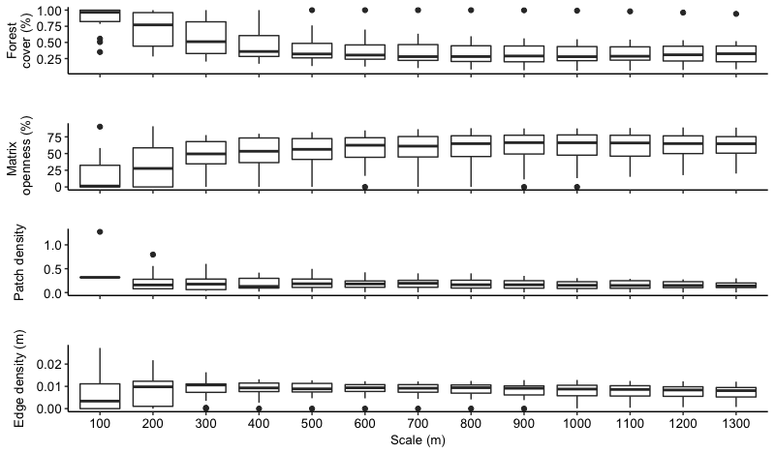

Fig. S1. Spatial configuration of study landscapes considering 13 concentric buffers (range = 100 – 1300 m radius) surrounding 20 forest patches in the Lacandona rainforest, Mexico.

